Mt. St. Helens and Other Subduction Zone Volcanoes
Part I: Mt. St. Helens Ashfall Eruption
Part II: Mt. St. Helens Topographic Profiles
Part III: Volcanoes at Subduction Zones

An original laboratory exercise
by Eileen Herrstrom
herrstro@illinois.edu
2018

Context

- The audience for this activity is an undergraduate class on introductory physical geology, geography or quantitative reasoning.
- Students must know how to read topographic maps, have general knowledge of volcanic eruptions and plate tectonics, and understand how to use the formula “distance = rate x time” in Excel. For one option, students must know how to use Google Earth (placemarks, ruler).
- This laboratory activity follows lectures on volcanoes and falls near the middle of the course.

Objectives

- The content and concept goals for this activity include identifying the segmentation of the Andean continental volcanic arc in terms of the locations of volcanoes, the depth distribution of earthquakes, and the angle of subduction.
- Higher order thinking skills involve measuring the arc-trench distance for seven arcs around the world and calculating the subduction angle using the arctangent function in Excel
- Other skills goals for this activity consist of interpreting and explaining a graph of subduction angle for various arcs and using Excel and Google Earth (optional).

Notes

Part I and Part II listed above are presented as separate activities on SERC with their individual contexts and objectives. The objectives on this page apply specifically to Part III. Together, these three activities constitute a complete laboratory exercise that takes ~1.5-2 hours to finish.

Part III offers two alternatives: Option 1 uses Google Earth to obtain information about various volcanoes, and Option 2 provides a PDF with Google Earth images illustrating the same information.
Volcanoes at Subduction Zones
Option 1: Google Earth

Overview

In this exercise, you use Google Earth to study variations in the Andes continental volcanic arc and to compare it with arcs above other subduction zones around the world.

Learning Objectives

- Identify segments of the Andes volcanic arc associated with differences in subduction
- Measure the arc-trench distances for several volcanic arcs
- Graph and analyze variations in the angle of subduction around the world

The Cordillera of the Andes

The Andean Cordillera extends along the entire western margin of South America; it is part of a longer cordillera stretching from North America through Central America and south to Antarctica. “Cordillera” is a Spanish word adopted by geologists to refer to a large mountain range. These mountains include the highest peak in the Americas: Mt. Aconcagua in Argentina, which rises almost 7000 m (23,000 ft) above sea level. The Andes also contain the mountain peak farthest from the center of the Earth: Chimborazo in Ecuador, located on the equatorial bulge of the planet. In fact, the highest volcanoes in the world are part of the Andean Cordillera as a result of the Nazca and Antarctic Plates subducting beneath western South America.

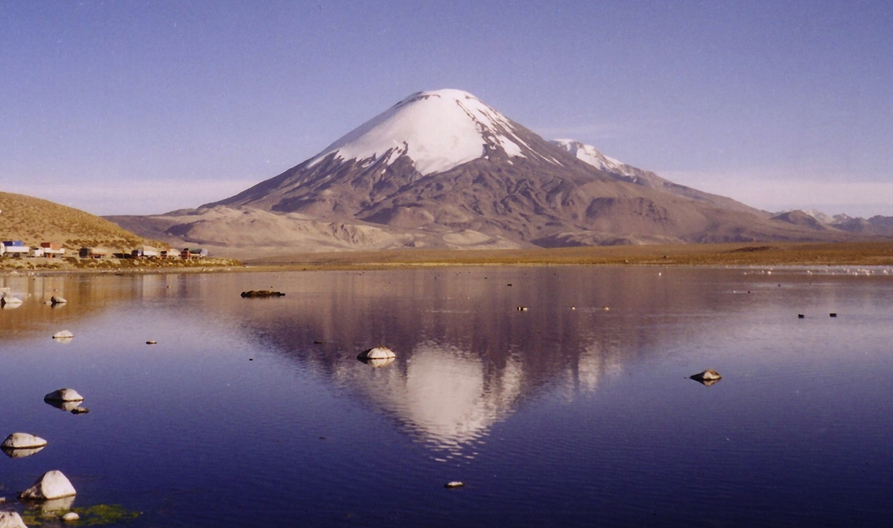

Figure 1. Parinacota stratovolcano and Lake Chungara on the border between Chile and Bolivia.
https://commons.wikimedia.org/wiki/File:Parinacota.jpg
Volcanic Arcs and Subduction

Each volcano in an arc system – such as the Andes of South America or the Cascades in the northwestern United States and southwestern Canada – is located above a zone of melting. Partial melting triggered by subduction produces magma that feeds eruptions at the surface and builds volcanoes. Geologists who study volcanic arcs in general have learned that melting occurs when the top of the subducting plate reaches a depth of approximately 100 to 120 km. The reasons for this relationship are complex, but basically, it is because subduction carries water into the mantle, which lowers the melting temperature of mantle rock and causes part of the rock to melt.
In this exercise, you first observe differences between various parts of the the Andean continental volcanic arc along the west coast of South America. Volcanoes of the Andes have formed due to subduction of the Nazca Plate beneath South America. Later, you view other volcanic arcs in comparison.

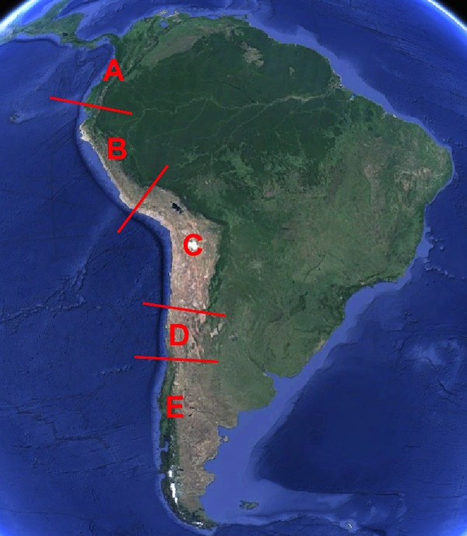
1. Open the file of Google Earth file “Volcanoes_and_Subduction_Zones.kmz” that accompanies this exercise. Check the Lines folder, open it, and then double-click on Line 1. In the Layers panel, open the Primary Database folder and the Gallery folder. Check the Volcanoes box to turn on their locations.
You should now be looking at the southern end of the Andean Volcanic Arc of South America. Volcanoes are not distributed uniformly along the length of the volcanic arc. Four lines separate the Andes into five sections, only some of which contain volcanoes. Slowly scan northward and observe the locations of volcanoes.

Referring to the letters in Figure 2, list all sections that contain volcanoes.

Figure 2. Segmentation of the Andes.
Screenshot from Google Earth

Earthquakes in the Nazca Plate

Keep Volcanoes and the Lines folder checked, and now also check the folder named “USGS Earthquakes.” (You do not need to open the folder; it contains a long list of quake data.) This folder plots earthquake epicenters in the descending Nazca Plate. The legend shows that the size of each epicenter's circle corresponds to magnitude of the quake, and color of the circle indicates depth to the focus.

2. Scan along the mountains, and you should see that most of the epicenters overlapping volcanoes have the same color. In other words, volcanoes are located above foci with approximately the same depth. What is the depth range for most earthquakes that occur directly beneath volcanoes?

Volcanoes and the Angle of Subduction

Why are volcanoes grouped in only certain sections of the Andes? Why are some areas not experiencing volcanic activity? The answer to these questions depends on the geometry of the subduction zone. In Fig. 3(a), water from the subducting plate can move into the overlying asthenosphere and cause partial melting of the mantle. In Fig. 3b, however, the subduction angle is so shallow that the descending plate remains in contact with the lithosphere far inland. The composition, temperature, and pressure of lithospheric mantle are different from those of asthenospheric mantle. In the second case, the right conditions for partial melting do not occur.

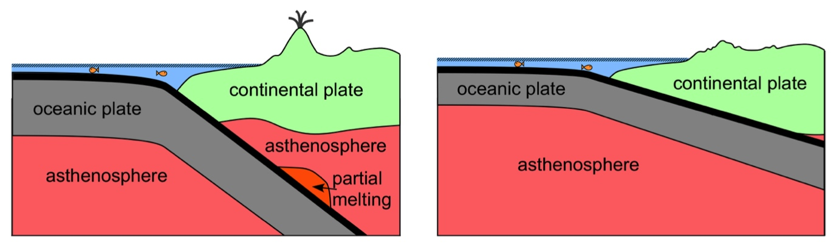
(a)
(b)

Figure 3. (a) Steeply subducting plate reaches the zone of partial melting, so volcanism occurs.
(b) Plate subducting at a shallow angle does not reach zone of partial melting, so no volcanism occurs.

In Google Earth, zoom out so that you can see the entire western edge of South America. Recall that the green epicenters coincide with the position of volcanoes. Visually compare the distances between the oceanic trench and the volcanic arc in segments A, C, and E with the distances in segments B and D. You should observe that the distance from the trench to the green epicenters is different in segments B and D than in the other segments.

3. Given the observation in the paragraph above, is the subduction angle of the Nazca Plate in segments B and D greater than or less than the subduction angle in segments A, C, and E?

A Look at Other Volcanic Arcs

As we have just noted, not every plate (or even every part of a plate) subducts at the same angle, but the depth of melting remains uniform from place to place. If a subducting plate descends steeply into the mantle, then it reaches the zone of melting not far from the convergent boundary, and the volcanic arc is relatively close to the oceanic trench. On the other hand, if a plate subducts at a shallow angle, then it reaches the zone of melting farther away from the convergent boundary, and the distance between the arc and trench is relatively greater. If the subduction angle is extremely shallow, as in parts of the Andean subduction zone, the requirements for partial melting are not met, and no volcanism occurs.
In the remainder of this exercise, you will use Google Earth to measure arc-trench distances for several convergent boundaries. You will also need to open the Excel file that accompanies this exercise, where you will enter the data into the “Subduction Data” worksheet. Finally, you will calculate the subduction angles and compare locations.

4. In Google Earth, check and open the “Other Subduction Zones” folder. Double-click on the Mt. St. Helens placemark to fly to the Cascades volcanic arc. Use the Ruler to measure the distance (in km) between the volcano and the oceanic trench. Enter the distance in cell F4 of the “Subduction Data” worksheet in the spreadsheet file and on this page.

5. Double-click on the Masaya placemark to fly to the Middle America volcanic arc. Use the Ruler to measure the distance (in km) between the volcano and the oceanic trench. Enter the distance in cell F5 of the “Subduction Data” worksheet and on this page.

6. Double-click on the Pinatubo placemark to fly to the Java volcanic arc. Use the Ruler to measure the distance (in km) between the volcano and the oceanic trench. Enter the distance in cell F6 of the worksheet and on this page.

7. Continue flying to the rest of the volcanoes in the “Subduction Data” worksheet and filling in the arc-trench distance for each. Which volcano is farthest from its oceanic trench?

Angle of Subduction

In a subduction zone, the oceanic trench, volcanic arc, and zone of melting form the vertices of a right triangle. Let  be the angle between the Earth’s surface and the top of the descending plate. The trignometric function tangent of  equals the opposite side divided by the adjacent side. In Fig. 4, the depth to the zone of melting is the side of the triangle that is opposite to the angle θ, and the arc-trench distance is the side of the triangle that is adjacent to θ.
In this case, the equation becomes: tan     D. To solve for , we must use the inverse tangent (tan⁻¹) function from trignometry, also written as the arctangent. Then  = arctan (120/D), which gives  in units of radians. To express the angle in degrees, multiply the right side of the equation by 180/

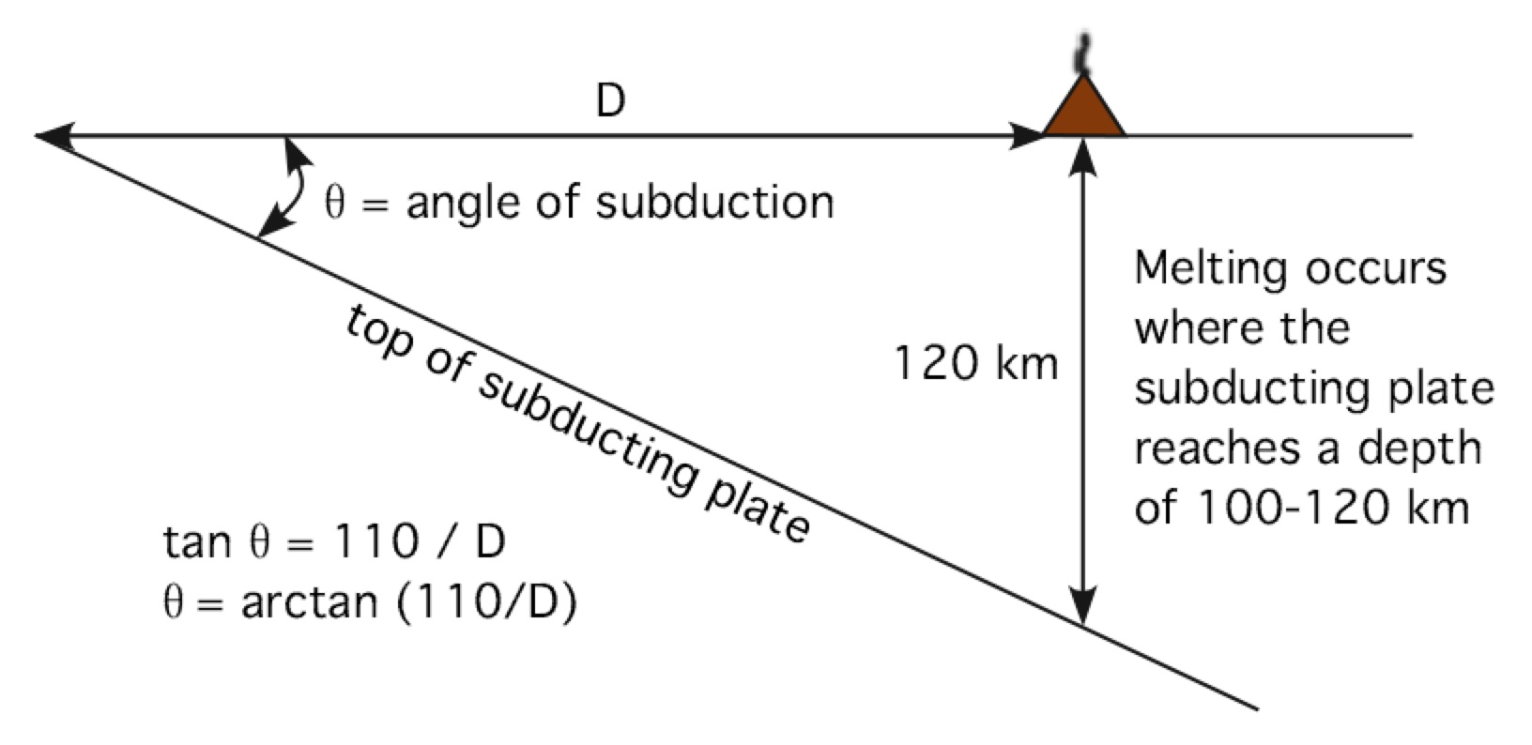

Figure 4. Cross-sectional view of subduction zone geometry.

8. To calculate the angle of subduction for the Cascades subduction zone, enter this formula into cell G4: =ATAN(F4/120)*180/PI(). Fill down to row 10. Which convergent boundary has the largest angle of subduction? What is its angle of subduction?

9. Which convergent boundary has the smallest angle of subduction? What is its angle of subduction?

10. Click on the “Subduction Graph” tab at the bottom of the Excel window. If you looked at this worksheet before entering the arc-trench distances, you would have seen only a vertical red line and the zone of melting. Now, however, you should see a line for each subduction zone you visited in Google Earth. The origin of the graph [upper left corner, with coordinates (0,0)] represents the oceanic trench, and the sloping lines show the tops of the subducting plates. Does a larger arc-trench distance correspond to a larger or smaller angle of subduction? Explain your answer.

Volcanoes at Subduction Zones
Option 2: Google Earth Imagery

Overview

In this exercise, you use Google Earth imagery to study variations in the Andes continental volcanic arc and compare it with arcs above other subduction zones around the world.

Learning Objectives

- Identify segments of the Andes volcanic arc associated with differences in subduction
- Measure the arc-trench distances for several volcanic arcs
- Graph and analyze variations in the angle of subduction around the world

The Cordillera of the Andes

The Andean Cordillera extends along the entire western margin of South America; it is part of a longer cordillera stretching from North America through Central America and south to Antarctica. “Cordillera” is a Spanish word adopted by geologists to refer to a large mountain range. These mountains include the highest peak in the Americas: Mt. Aconcagua in Argentina, which rises almost 7000 m (23,000 ft) above sea level. The Andes also contain the mountain peak farthest from the center of the Earth: Chimborazo in Ecuador, located on the equatorial bulge of the planet. In fact, the highest volcanoes in the world are part of the Andean Cordillera as a result of the Nazca and Antarctic Plates subducting beneath western South America.

Figure 1. Parinacota stratovolcano and Lake Chungara on the border between Chile and Bolivia.
https://commons.wikimedia.org/wiki/File:Parinacota.jpg
Volcanic Arcs and Subduction

Each volcano in an arc system – such as the Andes of South America or the Cascades in the northwestern United States and southwestern Canada – is located above a zone of melting. Partial melting triggered by subduction produces magma that feeds eruptions at the surface and builds volcanoes. Geologists who study volcanic arcs in general have learned that melting occurs when the top of the subducting plate reaches a depth of approximately 100 to 120 km. The reasons for this relationship are complex, but basically, it is because subduction carries water into the mantle, which lowers the melting temperature of mantle rock and causes part of the rock to melt.
In this exercise, you first observe differences between various parts of the the Andean continental volcanic arc along the west coast of South America. Volcanoes of the Andes have formed due to subduction of the Nazca Plate beneath South America. Later, you view other volcanic arcs in comparison.

1. Open the file of Google Earth images (PDF) that accompanies this exercise. The first page of this file shows the Andean continental volcanic arc of South America. Volcanoes are not distributed uniformly along the length of the volcanic arc. Four lines separate the Andes into five sections, only some of which contain volcanoes. Slowly scan the image and observe the locations of volcanoes.
Referring to the letters in Figure 2, list all sections that contain volcanoes.

Figure 2. Segmentation of the Andes.
Screenshot from Google Earth

Earthquakes in the Nazca Plate

The second page of the PDF illustrates earthquake epicenters in the descending Nazca Plate and the overlying South America Plate. The size of each circle corresponds to magnitude of the quake, and the color of the circle indicates depth to the focus. Zoom in and scan along the mountains, and you should see that most of the epicenters overlapping volcanoes have the same color. In other words, volcanoes are located above foci with approximately the same depth.

2. What is the depth range for most earthquakes that occur directly beneath volcanoes?

Volcanoes and the Angle of Subduction

Why are volcanoes grouped in only certain sections of the Andes? Why are some areas not experiencing volcanic activity? The answer to these questions depends on the geometry of the subduction zone. In Fig. 3(a), water from the subducting plate can move into the overlying asthenosphere and cause partial melting of the mantle. In Fig. 3b, however, the subduction angle is so shallow that the descending plate remains in contact with the lithosphere far inland. The composition, temperature, and pressure of lithospheric mantle are different from those of asthenospheric mantle. In the second case, the right conditions for partial melting do not occur.

(b)
(a)

Figure 3. (a) Steeply subducting plate reaches the zone of partial melting, so volcanism occurs.
(b) Plate subducting at a shallow angle does not reach zone of partial melting, so no volcanism occurs.

On page two of the PDF, zoom out so that you can see the entire western edge of South America. Recall that the green epicenters coincide with the position of volcanoes. Visually compare the distances between the oceanic trench and the volcanic arc in segments A, C, and E with the distances in segments B and D. You should observe that the distance from the trench to the green epicenters is different in segments B and D than in the other segments.

3. Given the observation in the paragraph above and the illustrations in Fig. 3, is the subduction angle of the Nazca Plate in segments B and D greater than or less than the subduction angle in segments A, C, and E?

A Look at Other Volcanic Arcs

As we have just noted, not every plate (or even every part of a plate) subducts at the same angle, but the depth of melting remains uniform from place to place. If a subducting plate descends steeply into the mantle, then it reaches the zone of melting not far from the convergent boundary, and the volcanic arc is relatively close to the oceanic trench. On the other hand, if a plate subducts at a shallow angle, then it reaches the zone of melting farther away from the convergent boundary, and the distance between the arc and trench is relatively greater. If the subduction angle is extremely shallow, as in parts of the Andean subduction zone, the requirements for partial melting are not met, and no volcanism occurs.
In the remainder of this exercise, you will use Google Earth images to measure arc-trench distances for several convergent boundaries. You will also need to open the Excel file that accompanies this exercise, where you will enter distances into the “Subduction Data” worksheet. Finally, you will calculate the subduction angles and compare locations.

4. In the PDF, look at Mt. St. Helens (page 3). The Ruler tool in Google Earth has been used to measure the distance (in km) between the volcano and the Cascades oceanic trench. Enter the distance in cell F4 of the “Subduction Data” worksheet in the spreadsheet file and on this page.

5. Look at Masaya (page 4) along the Middle America volcanic arc. The Ruler tool in Google Earth has been used to measure the distance (in km) between the volcano and the oceanic trench. Enter the distance in cell F5 of the “Subduction Data” worksheet and on this page.

6. Look at Pinatubo (page 5) along the Java volcanic arc. The Ruler tool in Google Earth has been used to measure the distance (in km) between the volcano and the oceanic trench. Enter the distance in cell F6 of the worksheet and on this page.

7. Continue looking at the rest of the volcanoes in the PDF worksheet and filling in the arc-trench distance for each in the “Subduction Data” worksheet. Which volcano is farthest from its oceanic trench?

Angle of Subduction

In a subduction zone, the oceanic trench, volcanic arc, and zone of melting form the vertices of a right triangle. Let  be the angle between the Earth’s surface and the top of the descending plate. The trignometric function tangent of  equals the opposite side divided by the adjacent side. In Fig. 4, the depth to the zone of melting is the side of the triangle that is opposite to the angle θ, and the arc-trench distance is the side of the triangle that is adjacent to θ.
In this case, the equation becomes: tan     D. To solve for , we must use the inverse tangent (tan⁻¹) function from trignometry, also written as the arctangent. Then  = arctan (120/D), which gives  in units of radians. To express the angle in degrees, multiply the right side of the equation by 180/

Figure 4. Cross-sectional view of subduction zone geometry.

8. To calculate the angle of subduction for the Cascades subduction zone, enter this formula into cell G4: =ATAN(110/F4)*180/PI(). Fill down to row 10. Which convergent boundary has the largest angle of subduction? What is its angle of subduction?

9. Which convergent boundary has the smallest angle of subduction? What is its angle of subduction?

10. Click on the “Subduction Graph” tab at the bottom of the Excel window. If you looked at this worksheet before entering the arc-trench distances, you would have seen only a vertical red line and the zone of melting. Now, however, you should see a line for each subduction zone you visited in Google Earth. The origin of the graph (upper left corner, with coordinates (0,0)) represents the oceanic trench, and the sloping lines show the top of the subducting plate. Does a larger arc-trench distance correspond to a larger or smaller angle of subduction? Explain your answer.

