Exploring Spreadsheets with Microsoft Excel
Part I: Earthquakes in October 2011
Part II: Excel Charts
Part III: Spreadsheet Formulas

An original laboratory exercise by
Eileen Herrstrom
University of Illinois at Urbana-Champaign
herrstro@illinois.edu
2018

Context

- The audience for this activity is an undergraduate class on introductory physical geology or quantitative reasoning.
- Students must have basic knowledge about earthquakes (magnitude, depth, and epicenter) spreadsheets (cell names, entering formulas) and Earth’s interior layers.
- This activity follows lectures on on earthquakes and using the layered Earth and occurs near the beginning of the term.

Goals

- The content and concept goals for this activity include becoming familiar with the layout of an Excel spreadsheet, practicing several basic techniques for manipulating spreadsheet data, and interpreting a graph of earthquake data.
- Higher order thinking skills for this activity involve adjusting axis scales to clearly illustrate data in a chart, surveying other types of charts available in Excel and investigating their features, and using tables and charts to answer questions about Earth’s interior composition.
- Other skills for this activity consist of calculating the volumes of Earth’s interior layers as percentages of the total volume, using relative and absolute names in formulas, and explaining the difference between relative and absolute cell names.

Exploring Spreadsheets
Part I: Earthquakes in October 2011

Overview

In this first part of the exercise, you work with data on earthquakes and a chart based on these data in order to explore the potential of computer spreadsheets.

Learning Objectives

- Become familiar with the layout of an Excel spreadsheet
- Practice several basic techniques for manipulating spreadsheet data
- Interpret a graph of earthquake data

Why Use a Spreadsheet?

Think about the many sets of data you may encounter in your daily activities. You may track your finances, follow statistics for your favorite sport, watch stock market trends, or pay attention to weather records such as temperature and precipitation. News reports often include graphs that you must understand in order to follow an argument. And of course, scientists use graphs to summarize and convey information and to support hypotheses.
Before the days of computers, people had to record data and perform calculations by hand. In fact, the original use of the word “computer” was to describe a person whose job was doing arithmetic! At that time, a spreadsheet was a piece of paper with ruled lines forming rows and columns where data could be written in. Today, most people use computer spreadsheets in the form of software such as Microsoft Excel™, but the basic idea remains the same.

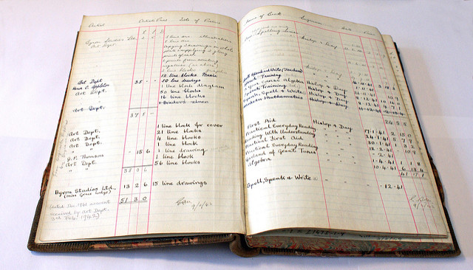

Figure 1.1 Paper spreadsheet bound in an old style ledger book.
https://www.flickr.com/photos/30239838@N04/4268190563/in/photostream/
Holmes McDougall CC2
Computer Spreadsheets

This exercise provides basic information about using computer spreadsheets in Microsoft Excel™. Most of the remaining laboratory activities will be based on spreadsheets, and the work is designed to illustrate more features of these useful programs as the semester progresses. In addition, there will be exam questions regarding the mechanics of working with spreadsheets.
Open the file that accompanies this exercise. The file name extension is “.xls” or “.xlsx,” and the entire file is referred to as a workbook. Within the file are one or more worksheets, each of which is a separate table of rows and columns. Worksheets are named on tabs located near the bottom of the screen. Within a worksheet, rows are numbered from 1 to a maximum of 1048576. A total of 16384 columns are labeled A-Z, then AA-AZ to ZA-ZZ, and finally AAA-AAZ and so on through XFD. That makes 17,179,869,184 cells in all!

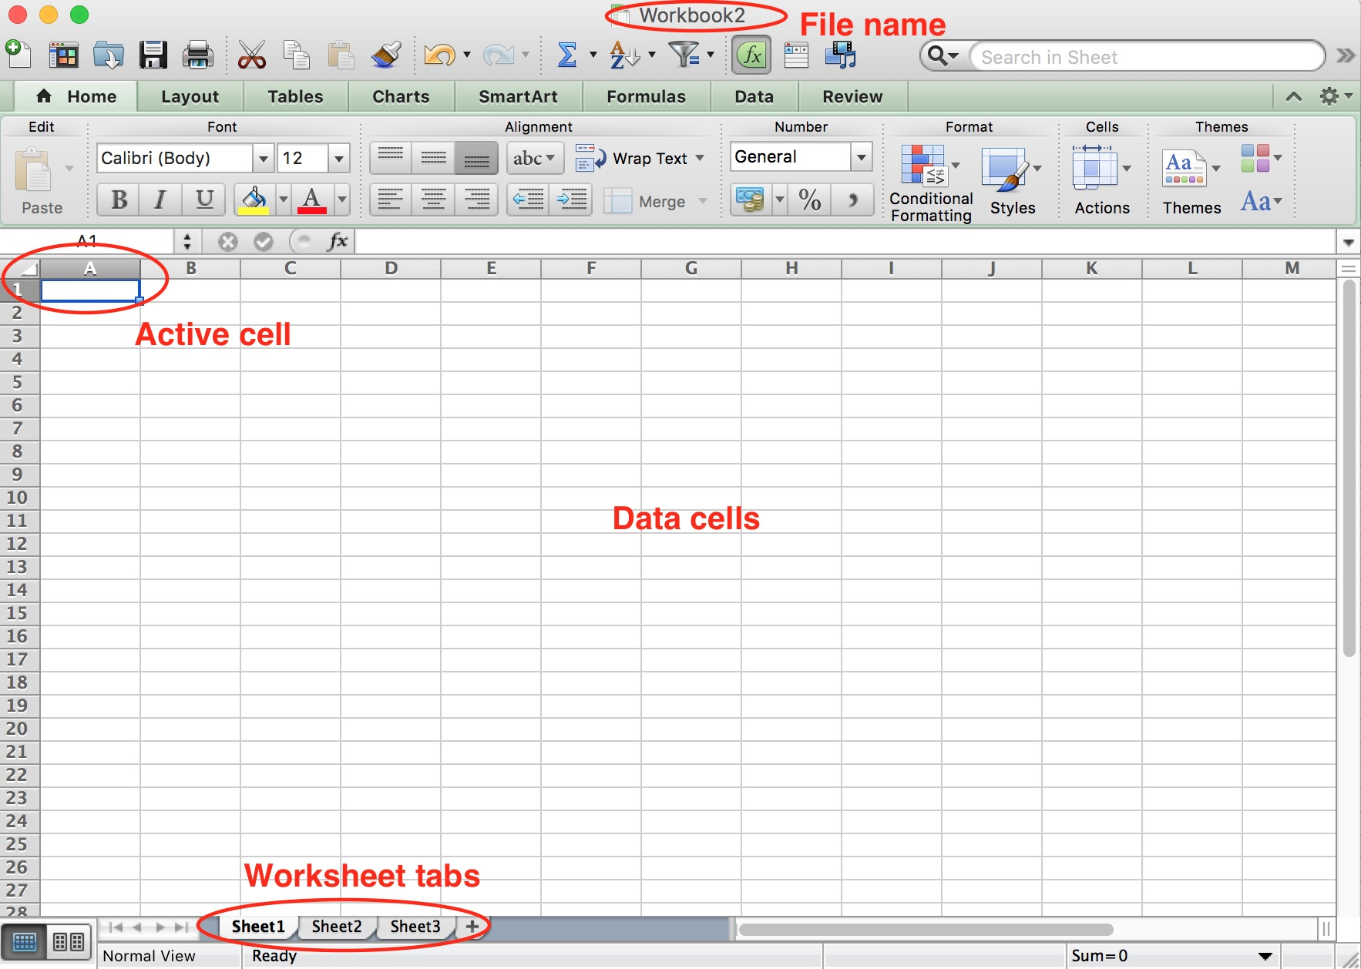

Figure 1.2 Screen shot of Excel window.

One Month in 2011

Using the U.S. Geological Survey (USGS) Earthquake Hazards Program, it is possible to search a vast catalog of earthquake data. The map below (Fig. 1.3) plots the epicenters for earthquakes with magnitude ≥4 that occurred around the world between October 1, 2011, at 00:00:00 (midnight) and October 31, 2011, at 23:59:59 (one second before midnight). This search returned 1065 epicenters. Many more quakes occurred during this month, but most of them had magnitudes <4 and were not included in the search. Plotting epicenters on a map is one way to visualize data. Another way is to enter the data in a computer spreadsheet, where the data can be rearranged, searched, graphed, or used for calculations.

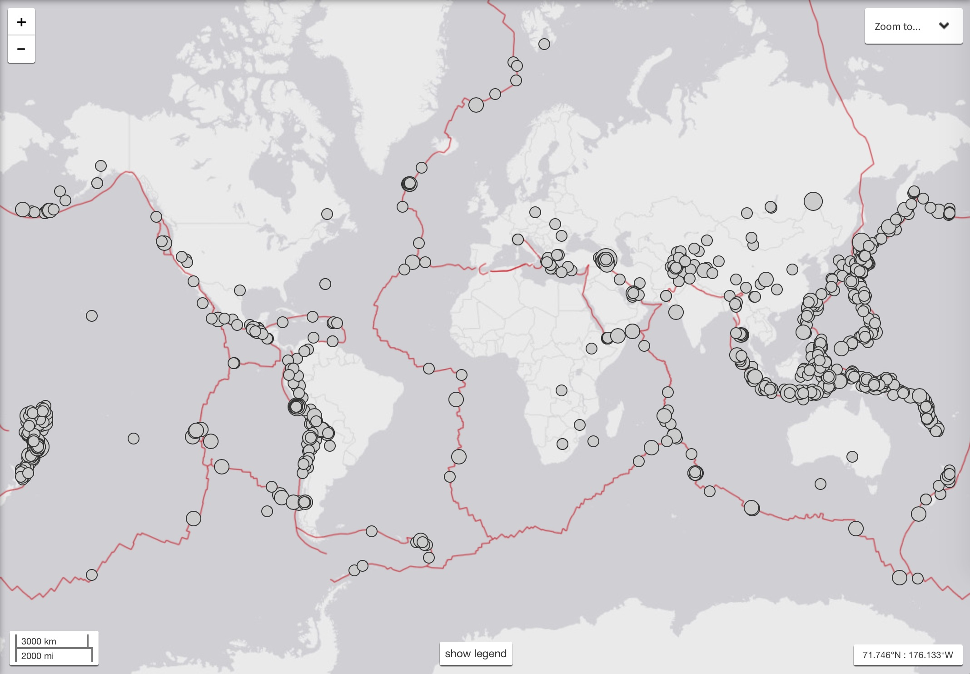

Figure 1.3 Each circle marks an epicenter, and the size of the circle corresponds to the magnitude of the earthquake. Red lines indicate tectonic plate boundaries.
https://earthquake.usgs.gov/earthquakes/search/

1. The worksheet named “EQ data” should be showing when you open the file, but if not, click on this tab at the bottom of the window. Scroll down to the end of the data. How many earthquakes are listed in this worksheet?

2. How many cells contain earthquake data? (Multiply the number of data rows by the number of data columns.)

3. What information is entered in cell F3?

4. Highlight the data for October 8, then scan through the “Depth” column (column E). What is the row containing the deepest earthquake on this date?

5. What was the depth of the deepest earthquake on October 8?

6. Give the range of cells that contain all data for earthquakes that occurred on October 23.

Graphs (Charts)

One of the most powerful capabilities of a spreadsheet is the production of graphs or charts from tables of data. As you probably already know, graphs and charts are important aids in convincing people of your point of view, and not only in science. This is a skill that will help you both as a student and later in your life.

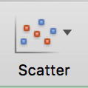
Scatter charts: For scientific and engineering purposes, scatter charts are the type most commonly used. A scatter plot shows how one quantity varies as a function of another quantity. To see a scatter chart, click on the “Scatter charts” tab to go to the next worksheet. There you will see a graph of the latitude and longitude of each earthquake epicenter in the “Cell names” worksheet. In other words, this scatter chart is actually like a map (Fig. 1.3).

7. Right-click on the chart, and a pop-up menu appears. Choose “Select Data” and a window opens. In the box for X-values, you should see this formula: ='Cell names'!$D$4:$D$1068. This means that the X-values for the scatter chart are entered in the worksheet “Cell names,” in column D, rows 4-1068. Cancel the pop-up window, and go back to the Cell names worksheet. If X-values are in column D, do they represent latitude or longitude?

8. The Y-axis is in the middle of the chart (vertical line marked 0). If you consider that the chart is a world map, then the Y-axis represents the prime meridian of longitude (which passes through England). Using the same sort of reasoning, what is the geographic name for the X-axis in this chart?

9. The epicenters between longitude 0° and -30° (0-30° W) are scattered along the Mid-Atlantic Ridge in the middle of the Atlantic Ocean. Farther west, what geographic feature is represented by the line of epicenters located between latitudes 0° to -30° (0-30° S) and longitudes -60° to -90° (60-90° W)?

10. Locate the letters “A-D” on the map, each of which is nearly surrounded by earthquake epicenters. Match each letter to its geographic region. Hint: Compare the scatter chart with Fig. 1.3.

Caribbean Sea

Indian Ocean

Mediterranean Sea

Philippine Sea
Exploring Spreadsheets
Part II: Excel Charts

Overview

In this part of the exercise, you explore other types of charts that are available in Excel, including triangular diagrams for plotting three components.

Learning Objectives

- Adjust the axis scale to clearly illustrate data in a chart
- Survey other types of charts available in Excel and investigate their features
- Use tables and charts to answer questions about Earth’s interior composition

Charts (Graphs)

Excel provides a wide variety of chart types, as well as the ability to create custom charts. The main forms are illustrated in Fig. 2.1: column charts, line charts, pie charts, bar charts, area charts, scatter charts, and a group of other charts including several more complicated types. Note that each chart type in Fig. 2.1 shows a small downward-pointing arrow next to the chart symbol; click on the arrows to open a drop-down menu showing variations on the main chart type. For example, in an area chart, you may select either and 2D or 3D version, and in a line chart, you may choose to show only points or only a line connecting the points or both points and lines. It is also possible to show more than one line or area on a single chart and to add a second Y-axis on the right side of the chart.

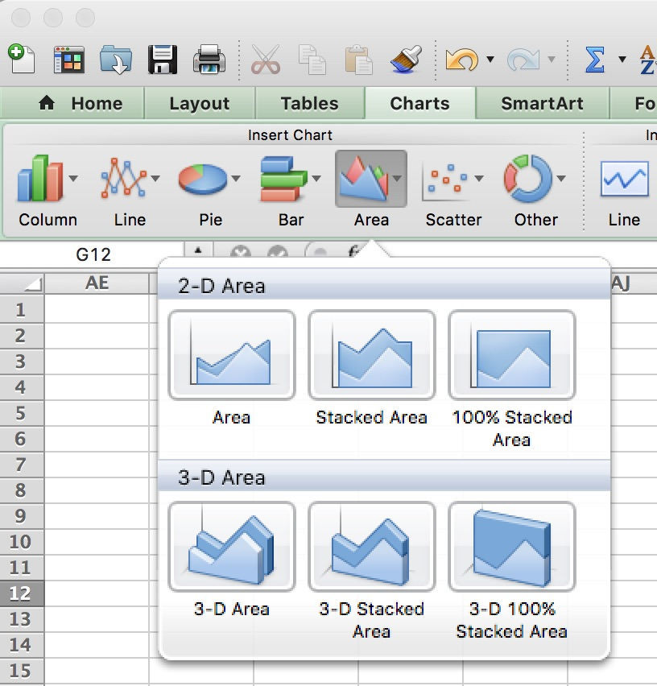

Figure 2.1 Screen shot of the Insert Charts section of the Charts tab on the ribbon in Excel for Mac computers and the choices for area charts.
Charts in Excel

In Part I, you looked at a scatter chart and the data used to plot the chart. In Part II, you have the opportunity to check out other types of Excel charts. All of the charts in this exercise have already been created. If you wish to make a chart of your own, highlight the data, click on the “Charts” tab on the ribbon, and select the type of chart from the ones available. The chart is automatically inserted on the worksheet with the data, but it can be moved elsewhere if needed.

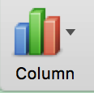
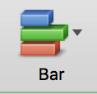
Column and Bar charts: In Excel, Column charts show data vertically, and Bar charts plot data horizontally, but both work in similar ways. Click on the worksheet called “Column charts” to see the October 2011 earthquake data grouped by magnitude.

1. How many columns appear in this column chart?

2. Why are some magnitude ranges missing?

3. In order to see all columns, double-click on the Y-axis. In the pop-up window titled “Format Axis,” select the option for a logarithmic scale. How many columns are visible now?

These results illustrate the importance of the order of magnitude. If all values to be plotted are in the same size range, use a linear scale on the X- or Y-axis. If some data values are much larger than others, use a logarithmic scale.

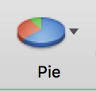
Pie charts: A pie chart is a circular graph usually used to present percentage data, such as the proportions of freshmen, sophomores, juniors, and seniors in the total student body. Click on the “Pie charts” tab at the bottom of the window. This worksheet shows the most abundant chemical elements in the Earth’s crust, mantle, and core. Beneath the data rows are three pie charts illustrating the compositions of Earth’s main interior layers.

6. Based on the left and middle charts, what is the main difference between the composition of the crust and the composition of the mantle?

7. Based on the middle and right charts, what is the main difference between the composition of the mantle and the composition of the core?

8. a. Now let's play with Excel! Move the cursor over one of the charts until the “Chart Area” tag pops up. Describe or draw the appearance of the cursor.

b. With this cursor, you may select the chart by clicking once. How does the appearance of the chart change to show that it has been selected?

c. With the cursor on the Chart Area, hold the left mouse button down and move the cursor. What happens to the chart?

d. Place the cursor over one of the wedges in the chart, hold the right button down and move the cursor. What happens to the wedge?

e. Move the cursor over a corner of the chart until the cursor changes to a line segment with arrows on each end. Hold the button down and move the cursor. What happens to the chart?

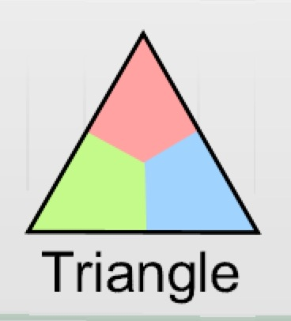
Triangle Diagrams: All of the graphs we've looked at so far have shown two variables; what if you have more than two? One way to handle data for three variables is to use a 3D chart, but these are hard to visualize and hard to represent on a 2D page. If the three variables add up to 100%, they may be conveniently shown on a triangular graph. Geologists often use triangle diagrams to illustrate the compositions of rocks and minerals.
Open the worksheet “Triangles,” where you will find descriptive data for several related rocks. The top vertex of the triangle represents a rock composed of pure sand; the right vertex, a rock made of pure clay; and the left vertex, a rock consisting entirely of pebbles (fragments of pre-existing rocks). Rocks that contain a mixture of sand, clay, and pebbles plot within the triangle. Only one sample, Md1, is plotted on the graph right now. This sample is closest to the left vertex and farthest from the right vertex. Thus, Md1 is a mixture that contains mostly clay with some sand and a few pebbles.

9. a. Highlight cells F28:G28, and put the cursor on the lower right corner. When the cursor changes appearance, hold down the mouse button and drag down to row 42. Don’t worry about how to calculate X and Y; the spreadsheet is really plotting a scatter chart, but it's been disguised as a triangle! What is the X value for sample Ss3?

b. What is the Y value for sample Gr1?

10. Look at the triangle to see where different rocks plot. Is this triangle diagram useful for distinguishing one kind of rock from another? Explain your answer.

Exploring Spreadsheets
Part III: Spreadsheet Formulas

Overview

In this final part of the exercise, you use a spreadsheet to perform calculations and learn two different ways of using cell names in formulas.

Learning Objectives

- Calculate the volumes of Earth’s interior layers as percentages of the total volume
- Use relative and absolute cell names in formulas
- Explain the differences between relative and absolute cell names

Calculating with a Spreadsheet

In addition to producing graphs, spreadsheets are good for performing calculations. To add two numbers, you could type this formula into cell A3 (Fig. 3.1), which is the active cell: =4+85. Then hit Enter, and the cell shows the sum of 89. The equal sign is very important, because it tells Excel to carry out a sequence of algebraic operations. Every formula begins with “=”. If you plan to do many calculations, or if you want to change the numbers used, you could use the names of the cells containing the values “4” and “85,” instead of the numbers themselves. The formula has been typed into cell A3, and once you hit Enter, the sum of 89 will show there instead. You can always see the formula again by either clicking once on A3 and looking in the formula bar or double-clicking on A3.

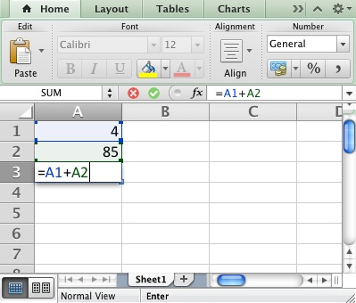

Figure 3.1 Screen shot from Excel showing how to enter a formula using cell names.
Earth’s Interior Layers

The outermost layer of planet Earth is the crust, which comes in two varieties: continental crust (variable thickness with an average of ~35) and oceanic crust (constant thickness of ~10 km). Beneath the crust is the mantle, which contains several sublayers. The uppermost mantle together with the crust forms the lithosphere. Below the lithosphere lie the asthenosphere and then a transition zone. The rest of the mantle is simply called the lower mantle. Within the mantle is the core, which again has two parts: an outer core of liquid iron and an inner core of solid iron.

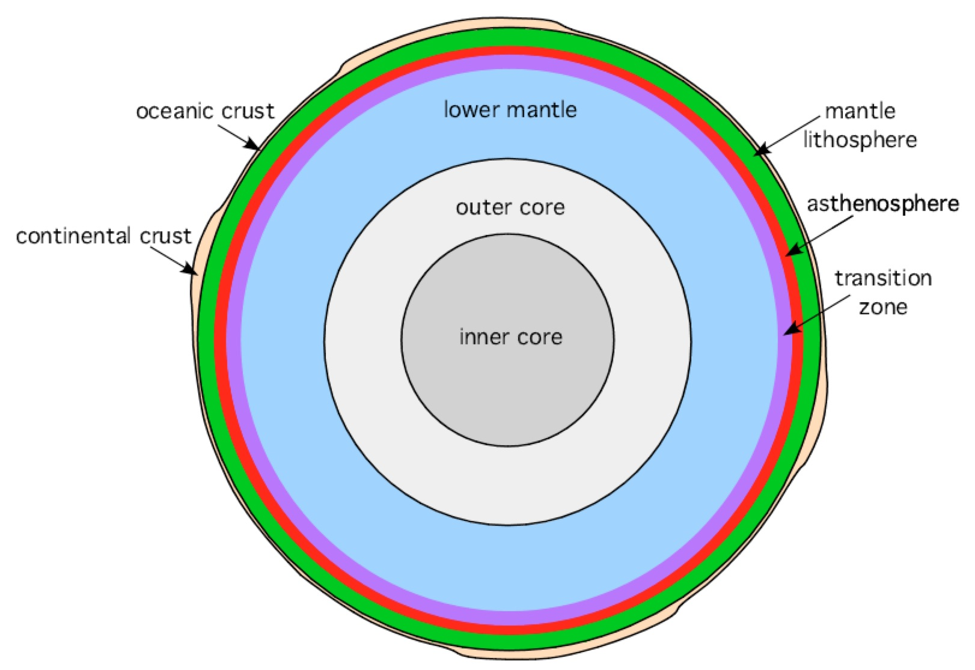

Figure 3.2 The interior layers of the Earth (not to scale).

1. Go to the “Volume” worksheet. In cell C12, enter this formula: =C5+C6+C7+C8+C9+C10+C11. The sum of the thicknesses of all Earth’s interior layers equals the radius of the Earth. What is the radius?

2. In cell D5, enter this formula: =C5/C12*100. This calculation gives the thickness of the continental crust as a percentage of the entire radius of the Earth. Continental crust equals what percent of the radius?

3. Select cell D5, and place the cursor over the lower right corner of the cell (the cursor changes appearance). Holding the mouse button down, drag to cell D11. This action fills cells D6:D11 with the same formula that you typed into cell D5. What value appears in cell D7?

4. As you see, there is a problem! Division by zero is undefined. What happened?? Double-click on D7 to check its formula. What is the formula in D7?
5. What is the formula in D10?

Relative and Absolute Names

What went wrong? Go back to the formula originally typed in cell D5, that is, =C5/C12*100. Excel interprets both C5 and C12 as relative names, so the formula implies the following: take the value of the cell one column to the left of the current cell and divide that by the value of the cell that is located seven rows below and one column to the left of the current cell. If you apply the same reasoning to cell D6, the formula will divide the value in cell C6 by the value in cell C13, which is zero (the computer interprets an empty cell to have a value of zero). The computer gets very upset when you try to do this!
In order to divide each individual thickness by the Earth's radius, you must use an absolute address, which means that the formula always looks to a specific cell for the number to use. An absolute name is written with a “$” before the column letter and/or the row number. Thus, you need to change the formula in cell D5 to =C5/$C$12*100. This formula contains both a relative name (C5) and an absolute name ($C$12). Repeat the drag and fill procedure used previously. You should not obtain the division by zero error again, and the values in D5:D11 should now be correct.

6. Which of Earth’s interior layers accounts for the largest percentage of the total volume?

Using Names in Formulas

Suppose that the active cell is C6, and there you enter the formula =B2+1. Relative to C6, cell B2 is one column to the left and four rows up (Fig. 3.3). Next, you copy the formula from C6 into cell F12. To calculate the formula in cell F12, Excel uses the value in the cell that is one column to the left and four rows up from F12, which is cell E8. It is also possible to use a combination of absolute and relative names for a cell; $C12 and C$12 are both acceptable names in a spreadsheet.

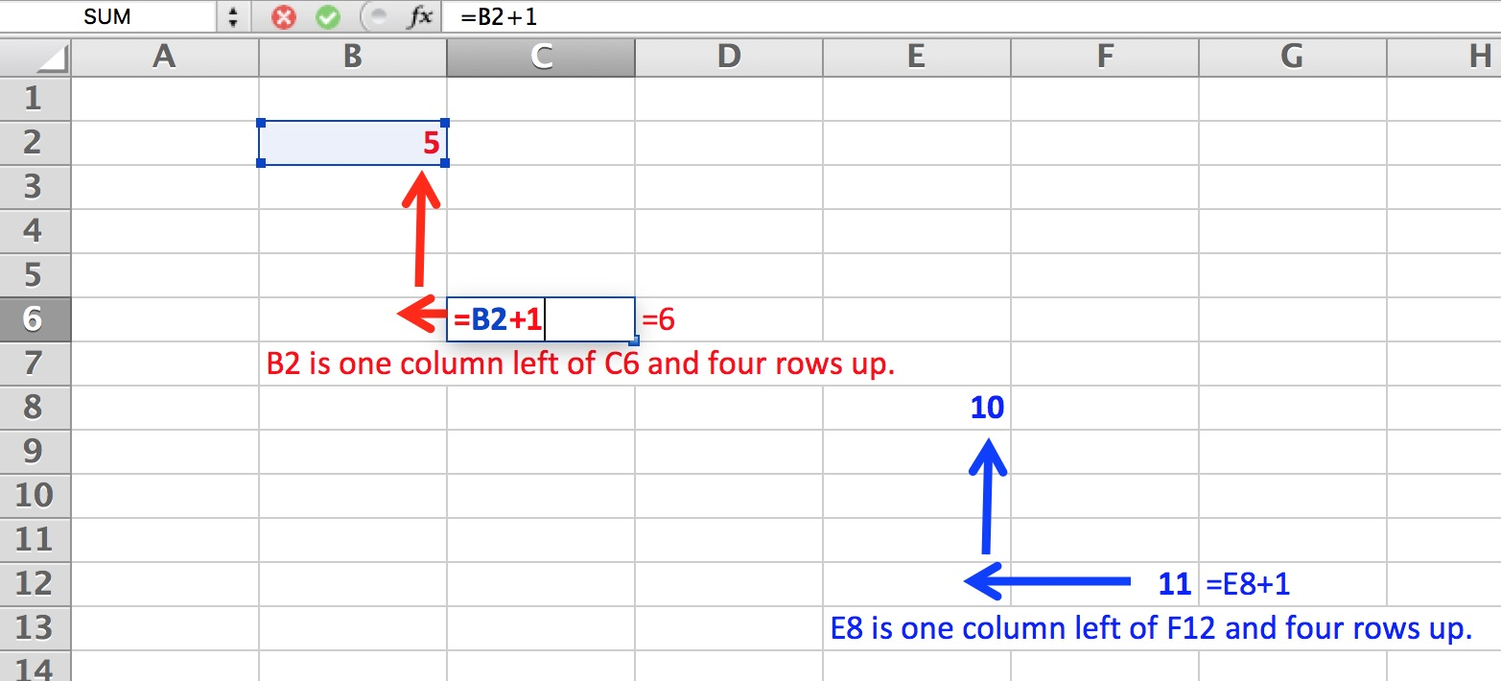

Figure 3.3 Screen shot from Excel illustrating relative names.

7. Suppose the active cell is B4, and there you enter a formula that contains the cell name $A2. Relative to B4, cell A2 is one column to the left and 2 rows up. However, the formula uses an absolute column address, so Excel always refers to column A, no matter where the formula is copied. Then, you copy the formula into cell D9. To calculate the formula in cell D9, Excel will use the value in what cell?

8. Suppose the active cell is H10, and there you enter a formula that contains the cell name F$2. Fill in the blanks below with numbers, and circle either “left” or “right” and either “up” or “down”.

Relative to H10, cell F2 is _____ columns to the left / right and _____ rows up / down.

9. Next, you copy the formula into cell J20. To calculate the formula in cell J20, Excel will use the value in what cell?

10. Check the correct column to show which descriptions apply to relative names and which to absolute names.

Characteristics | Absolute address | Relative address
Excel always uses the value in a specific cell
Equivalent to rise/run (slope) for a line
Formula uses $ with row or column
May lead to division by 0 errors
Points to cells at set distances from active cell
Reference changes with dragging and filling
Results are consistent
Similar to an ordered pair in an X-Y system

