Plate Tectonics with Maps and Spreadsheets
Part I: Plate Boundaries
Part II: Anatomy of a Plate Boundary
Part III: The Hawaiian Hotspot Track

An original laboratory exercise by
Eileen Herrstrom
University of Illinois at Urbana-Champaign

herrstro@illinois.edu

2018

Context

- The audience for this activity is an undergraduate class on introductory physical geology or quantitative reasoning.
- The skills and concepts that students must have mastered include general knowledge about plate tectonics (seafloor spreading, subduction, hotspots) and basic tasks in Microsoft Excel (highlighting and searching data, using the ribbon).
- This is a laboratory exercise that follows several lectures on aspects of plate tectonics and is situated near the beginning of the course.

Goals

- The content and concept goals for this activity include becoming familiar with the plate tectonic map of the world, understanding the interactions that characterize the different types of plate boundaries, and determining the relative motions around a triple junction.
- The higher order thinking skills goals for this activity involve analyzing data for earthquakes along western South America creating and formatting these data as a vertical cross-section, and interpreting the chart in terms of the Nazca-South America convergent plate boundary.
- Other skills goals for this activity consist of creating a chart for age vs. distance along the Hawaiian archipelago, assessing the correlation between these two variables, and interpreting the chart to determine the rate of movement of the Pacific Plate

Plate Tectonics with Maps and Spreadsheets

Part I: Plate Boundaries

Overview

In this first part of the exercise, you explore the plate map of the world and consider various types of relative movement between the plates on either side of a boundary. The highest mountain ranges and the deepest parts of the oceans also occur along the three types of plate boundaries.

Learning Objectives

- Become familiar with the plate tectonic map of the world
- Understand the interactions that characterize the different types of plate boundaries
- Determine the relative motions around a triple junction

How Fast Do Plate Move?

According to the theory of plate tectonics, Earth's lithosphere is composed of sections called plates that move around the surface of the Earth and interact along their boundaries. Plate boundaries are where many of the important geologic processes occur, such as volcanism and earthquakes.
The average rate of plate movement is approximately 5 cm/yr (about as fast as fingernails grow). This rate is perceptible but only over a long time. You cannot see your nails growing from minute to minute, but you notice the increase after a couple of months. Similarly, you cannot stand and watch plates move because they are too slow. In the past 10-15 years, however, it has become possible to measure plate motions by using the Global Positioning System (GPS).

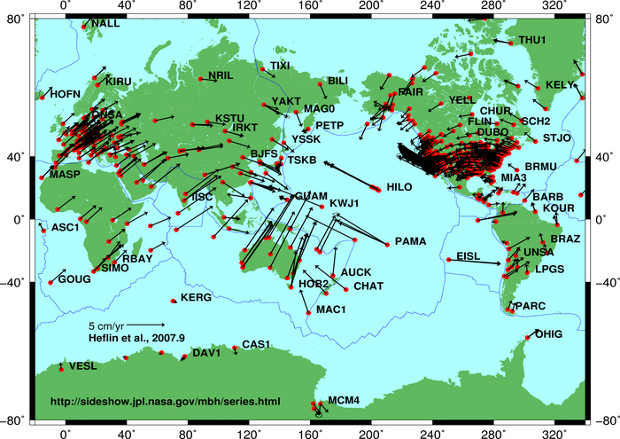

Figure 1.1. Red dots indicate locations where GPS measurements are taken regularly. The black arrows point in the direction of motion, and the length of the arrow represents velocity.
https://en.wikipedia.org/wiki/File:Global_plate_motion_2008-04-17.jpg

Types of Plate Boundaries

Geologists recognize three basic types of plate boundaries or margins:

Divergent boundaries: These boundaries are marked by an oceanic ridge (a submarine mountain range that extends into all major oceans). At the crest of the ridge, the plates move away from each other, and hot molten rock rises to fill the spaces in between. New oceanic crust forms at the ridge and then moves laterally away on both sides. The ridge is under tension (extensive stress) as the plates pull apart.

Convergent boundaries: Along these boundaries, two plates move toward each other. Eventually, one plate yields, bends downward, and descends into the mantle, and thus old crust is destroyed. This process is known as subduction. Due to the downward bending, a narrow deep trough forms at Earth's surface. This plate boundary is under compression (compressive stress) as the plates move together.

Transform boundaries: These boundaries are defined by large faults (breaks in rock along which there has been movement) called transform faults. One plate slides past the other; no new crust is formed and no old crust is destroyed. Transform boundaries are under shear stress (i.e., pressure is directed parallel to the boundary).

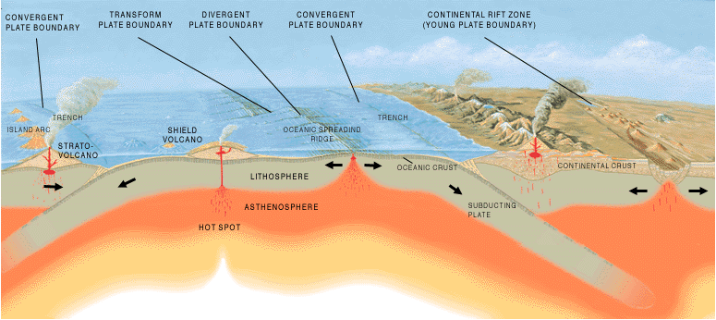

Figure 1.2. Block diagram of tectonic plates and plate boundaries.
https://en.wikipedia.org/wiki/File:Tectonic_plate_boundaries.png

Plate Map and Names

Open the World Tectonic Map (PDF) associated with this exercise. Note that the map uses different symbols to represent the different kinds of plate boundaries: a single line shows a transform boundary, a double line represents a divergent boundary, and a line with teeth shows a convergent boundary (Fig 1.3). Rates of spreading, convergence, and slippage are shown for some boundaries. Plate names are commonly abbreviated as follows:

AF - Africa  AM - Amur  AN - Antarctica  AR - Arabian  AU - Australia  CA - Caribbean  CL - Caroline | CO - Cocos  EU - Eurasia  FJ - Fiji  IN - India  JF - Juan de Fuca  NA - North America  NZ - Nazca | OK - Okhotsk  PA - Pacific  PS - Philippine  SA - South America  SC - Scotia  SO - Somalia

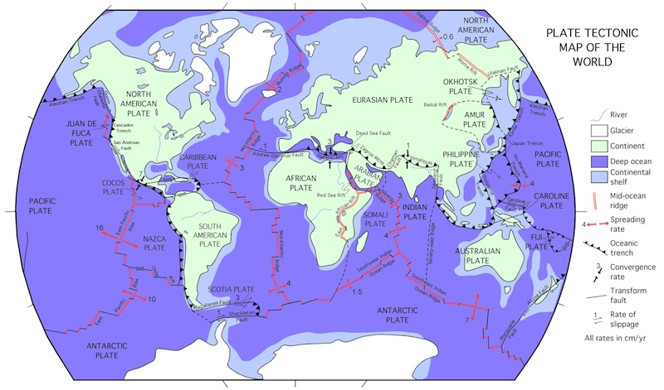

Figure 1.3. Tectonic plates, plate boundaries, and relative rates of motion.
After https://core2.gsfc.nasa.gov/research/lowman/lowman.html

1. A plate may consist of oceanic lithosphere or continental lithosphere or both. For example, the South American Plate includes both types of lithosphere. Name two other plates also contain both continental and oceanic lithosphere.

2. The Philippine Plate contains only oceanic lithosphere. Name two other plates that are strictly oceanic (entire plate is covered by oceans).

3. Name one plate that consists mostly of continental lithosphere.

4. Fill in the table below for the following plate boundaries, giving the type of boundary, its geographic name, the rate of relative movement across the boundary, and the type of stress:
Between the Scotia and Antarctic Plates south of South America
Between the Indian and Somali Plates south of the Arabian Peninsula
Between the Philippine and Pacific Plates north of Australia

Plate Boundary | SC-AN south of South America | IN-SO south of the Arabian Peninsula | PS-PA north of  Australia
Type (circle one) | Convergent  Divergent  Transform | Convergent  Divergent  Transform | Convergent  Divergent  Transform
Name
Rate
Stress (circle one) | Shear  Extension  Compression | Shear  Extension  Compression | Shear  Extension  Compression

5. Which mid-ocean ridge labeled on the map is spreading the slowest? At what rate is the slowest ridge spreading?

6. Which mid-ocean ridge is spreading the fastest? At what rate is the fastest ridge spreading?

7. Now look at the East Pacific map (page 2 in the PDF that accompanies this exercise). This map shows more detail about plate tectonic features than the world map does. What is the spreading rate of the East Pacific Rise (EPR) south of the Chile Rift?

8. Note that the spreading rate for the EPR in question #8 is not equal to the rate you found previously (question #7). This seems contradictory – the EPR appears to be spreading at two different rates! What other plate is involved here?

9. Go to http://www.unavco.org/software/geodetic-utilities/plate-motion-calculator/plate-motion-calculator.html/. Enter latitude 41°S (-41 in the first box of the Latitude block) and longitude 90°W (-90 in the first box of the Longitude block). Scroll down past all the other blocks and submit. What is the spreading rate for the Chile Rift here? Express your answer in cm/yr and round to the nearest whole number.
Triple Junctions

A place where three plates meet is called a triple junction. The relative motions of any pair of plates around a triple junction must be consistent. For example, the plate motions around the Afar triple junction (southeast end of Red Sea) are as follows:
Motion of AR relative to AF along the Red Sea Rift = ~17 mm/yr
Motion of AF relative to SO along the East Africa Rift Zone = ~14 mm/yr
Motion of the AR relative to SO along the Gulf of Aden Rift = ~ 3 mm/yr
These relative motions are consistent because 3 + 14 = 17.

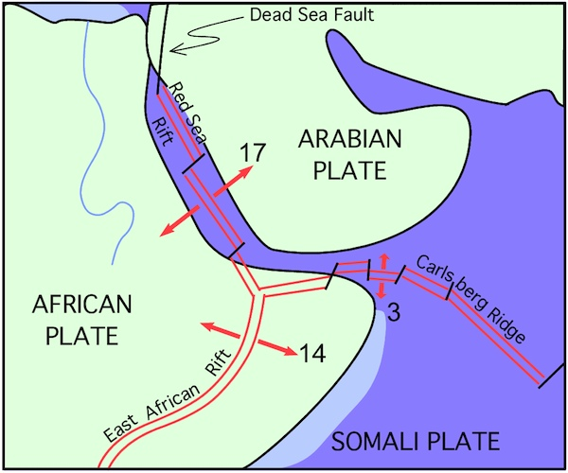

Figure 1.4. Afar triple junction where the African, Arabian, and Somali Plates meet.

10. The place where the Chile Rift intersects with the EPR is called the Juan Fernandez triple junction. In previous questions, you found rates of sea-floor spreading for each pair of ridges around this triple junction. Are the rates consistent? In this case, “consistency” means that the motion of PA relative to NZ (question #6) must be equal to the combined motions of PA relative to AN (question #7) and AN relative to NZ (question #9). Explain your answer.

Plate Tectonics with Maps and Spreadsheets

Part II: Anatomy of a Plate Boundary

Overview

In this part of the exercise, you examine earthquake data from the Peru-Chile Trench in order to visualize earthquakes along a convergent boundary.

Learning Objectives

- Inspect data for earthquakes along western South America
- Graph these data and format the chart as a vertical cross-section
- Interpret the chart in terms of the Nazca-South America convergent plate boundary

Earthquakes and Plate Boundaries

A world map showing earthquake epicenters (Fig. 2.1) reveals that epicenters are not scattered randomly or evenly across the globe. Instead, epicenters cluster along lines such as the narrow line that runs from north to south through the middle of the Atlantic Ocean and the thick lines along the western margin of the Pacific Ocean. Epicenters on this map mark the boundaries between plates, and the lines of epicenters outline the plates. Why are most earthquakes confined to plate boundaries? The plates consist of stiff blocks of lithosphere, which jostle each other, stick together, and then suddenly let go, producing an earthquake.

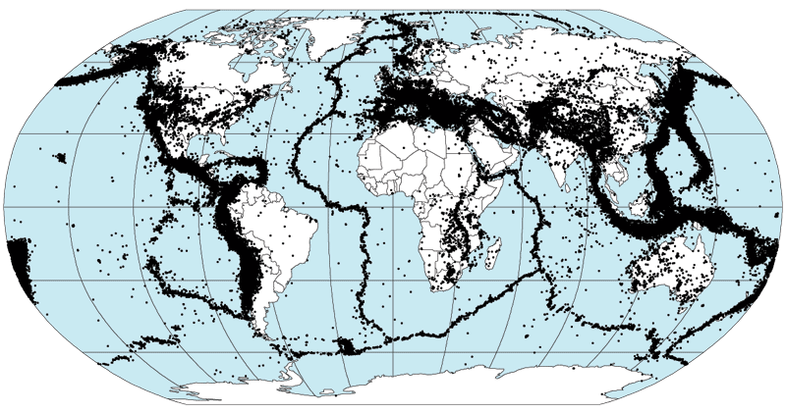

Figure 2.1. Epicenters for >350,000 earthquakes that occurred between 1963 and 1998.
https://commons.wikimedia.org/wiki/File:Quake_epicenters_1963-98.png

Convergent Boundaries

Earthquakes occur along all plate boundaries. At divergent boundaries, the earthquakes are mostly shallow-focus (i.e., the rock breaks first near the surface of the Earth). On the other hand, earthquakes at convergent boundaries may occur at much greater depths. Review the terminology for this type of convergent boundary, as illustrated in Fig. 2.2.

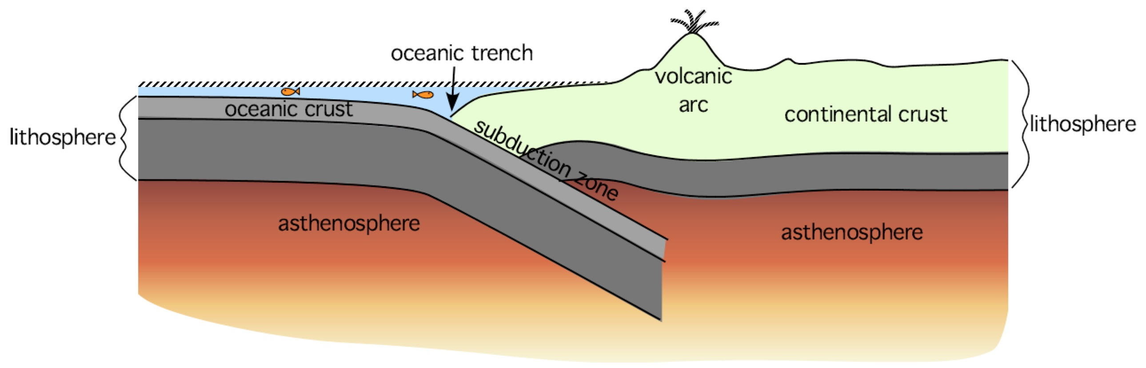

Figure 2.2. Vertical cross-section of an ocean-continent convergent boundary.

In this exercise, you work with information from a collection of earthquakes that have occurred since 1900 beneath the Andean continental volcanic arc in South America. The epicenters are located between latitudes 20° - 30° S and longitudes 63° - 74° W. Thus, some earthquakes occurred within the continental lithosphere of the South American Plate, and some occurred within the oceanic lithosphere of the Nazca Plate.
Open the spreadsheet for this exercise. The “Data” worksheet should show when you open the file, but if it does not, click on the tab at the bottom. The latitude and longitude in column A and B give the location of the epicenter of an earthquake; the number in column C gives the depth of the focus; and column D holds the magnitude.

1. In cell C253, enter this formula: =MAX(C5:C252). What is the maximum focal depth for an earthquake in Chile, as listed in the file?

2. In cell C254, enter this formula: =MIN(C5:C252). What is the minimum focal depth?

How to Graph Earthquake Foci

The Andes Mountains extend approximately north-south, so if you move in an east-west direction, you are going across the arc. Click on the “Graph” tab at the bottom of the spreadsheet to see the depth data plotted in an east-west cross-section, i.e., showing the variation in earthquake depth across the arc. (Remember that a cross-section is like a vertical slice through the Earth; it shows what you would see in a cliff face.) Points on the graph trace out the two plates converging at this boundary: the Nazca Plate to the west and the South American Plate to the east. In order to see the relationships more clearly, follow these steps:
1. Select the chart, then click on the Chart Layout tab (on the ribbon). Click on the “Gridlines” icon, then choose Vertical Gridlines, and finally select Major & Minor Gridlines.
2. Double-click on the Y-axis, then in the pop-up window, select Scale. Check the box for “Values in reverse order.”
3. Double-click on the X-axis, then in the pop-up window, select Scale. Enter “-76” in the box labeled “Vertical axis crosses at”.
3. The diagonal band of earthquakes that extends from the surface to great depth represents the Nazca Plate descending into the mantle. Select the red line to the left of the chart. Drag it onto the graph so that it runs just above the slanting band of points. The high end of the line should intersect the X-axis. This line marks the top of the Nazca Plate, as it subducts beneath South America.

3. The shallow earthquakes between 69° and 63° west longitude (X-values of -69 to -63) occurred within the overriding South American Plate. Thus, the deepest of these shallow foci mark the bottom of the lithosphere in this area. Approximately how thick is the South American Plate at longitude ~68° W (-68)?

4. At what longitude is the Nazca Plate near the surface of the Earth? In other words, where does the red line intersect the X-axis?

5. At what longitude does the deepest earthquake in the Nazca Plate occur? In other words, what is the X-value of the lowest point on the graph?

6. Toward which direction does the Nazca Plate subduct into the mantle? In other words, which way does the red line slope downwards?

7. There are two approximately triangular areas on the graph with no earthquakes – one above the descending plate and one below it. These areas represent the part of the mantle that is too soft and hot for earthquakes to occur. What is the name of this layer?

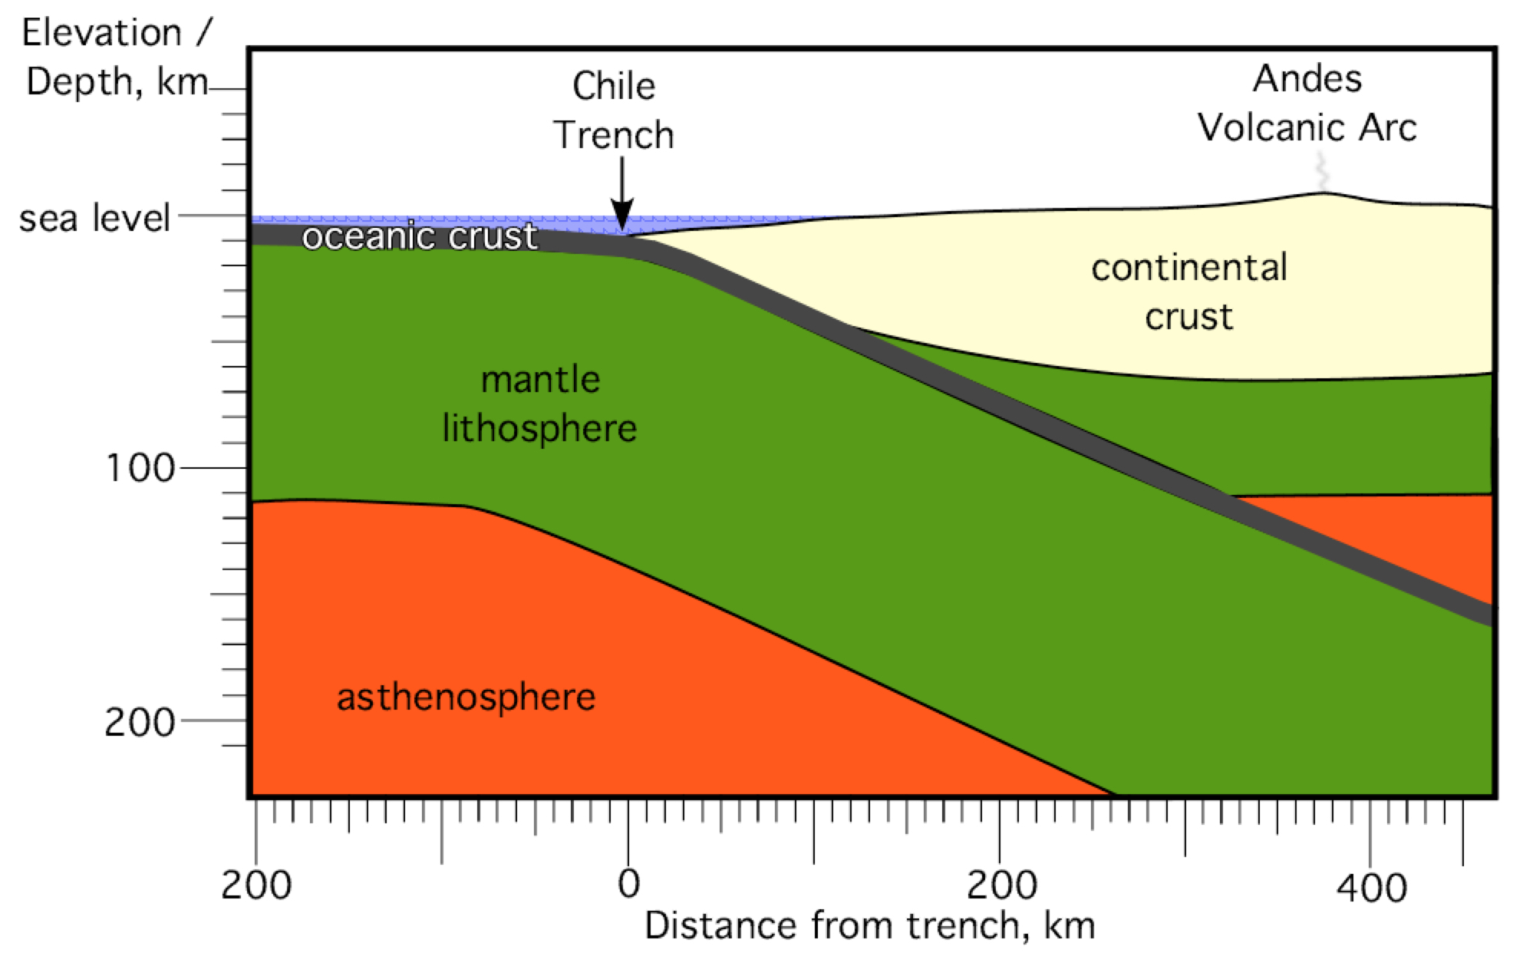

Figure 2.3. Cross-section of the subduction zone in western South America. The horizontal and vertical scales are equal, so all layers appear in their true proportions. The continental volcanic arc is located at the position labeled “Andes.”

8. Geologists have learned that in volcanic arcs, the volcanoes usually form above the point where the descending plate reaches a specific depth. According to Fig. 2.3, how deep is the top of the subducting oceanic crust, directly beneath the Andes continental arc? Alternatively, you may use the enlarged version of this figure in Excel. Click on the “Fig. 2.3” tab in the spreadsheet.

9. Now look again at the graph in Excel (“Graph” tab). What is the longitude of the point where the top of the descending Nazca Plate reaches the depth you found in question #8? In other words, for question #8, you found the Y-value of a point on the red line. What is the X-value of this point?

10. On the East Pacific map (PDF), does your answer to question #9 give approximately the correct longitude for where the volcanoes of the Andes continental volcanic arc are found?

Plate Tectonics with Maps and Spreadsheets

Part III: The Hawaiian Hotspot Track

Overview

In this third part of the exercise, you work with age data for volcanoes – islands, atolls, and seamounts – anchored by the active volcanoes on the Big Island of Hawaii.

Learning Objectives

- Create a chart for age vs. distance along the Hawaiian archipelago
- Assess the correlation, if any, between these two variables
- Interpret the chart to determine the rate of movement of the Pacific Plate

Volcanoes of the Pacific Ocean

When geologists first started studying volcanic islands in the Pacific Ocean in the 1800s, they noticed two different types. Along the western and northern margins were curved lines of islands (red lines in Fig. 3.1) where any volcano along the line might erupt. In contrast were straight segments of islands in the middle of the ocean (white lines in Fig. 3.1) where only the volcano at the southeast end of the line was actively erupting and the volcanoes became older toward the northwest. This difference in volcanic islands would not be explained until the advent of plate tectonics in the 1960s.

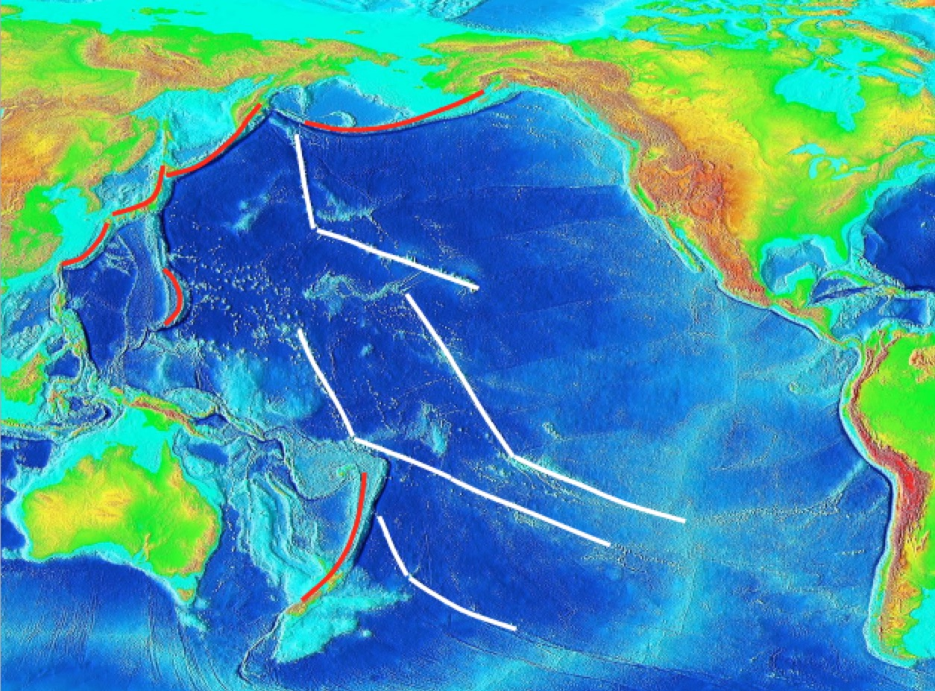

Figure 3.1. Bathymetry of the Pacific Ocean floor.
https://commons.wikimedia.org/wiki/File:Pacific_elevation.jpg
What is a Hotspot?

In plate tectonics, a hotspot is an active volcano at the end of a chain of volcanoes that become older away from the hotspot. A prime example is the Hawaiian Islands and Emperor Seamounts, which comprise a chain of oceanic mountains that may have formed as a result of the Pacific Plate moving over a stationary plume in the mantle. A mantle plume is considered an upwelling column of hot rock that begins deep within the Earth. Ascending hot rock partially melts and supplies lava to erupt at the surface and form a volcano. As the plate continues to move, the active volcano leaves the plume and becomes extinct, while a new volcano forms above the plume. Data on the ages of the volcanoes, plus the distances measured along the mountain chain, yield information about the velocity of plate motion over the mantle plume.

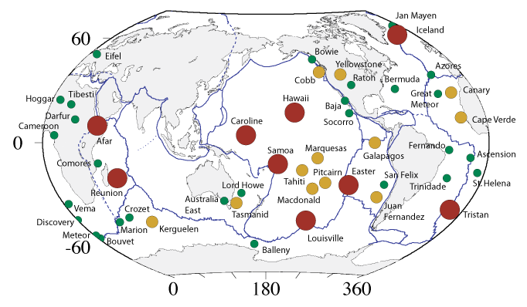
Figure 3.2. Hotspots around the world.
https://commons.wikimedia.org/wiki/File:CourtHotspots.png

Graphing the Data

Open the “Hawaii” worksheet in the spreadsheet associated with this exercise. This worksheet holds data from the Hawaii Islands-Emperor Seamounts chain. Ages are given in column B in millions of years. Distances in column C have been measured along the chain starting from the active volcano Kilauea on the “Big Island” of Hawaii. Follow the procedure below to produce a scatter chart of these two data columns.
  - Highlight cells B4:C18.
  - Click on the “Charts” tab on the ribbon. Insert a scatter chart.
  - You may change the horizontal or vertical grid lines, adjust the size of your graph, or click to remove the legend.

1. If the data points are randomly scattered across the graph, then there is no relationship between distance and age. If the points are arranged approximately along a line, then there is a correlation between distance and age. Does your graph show a correlation between distance and age?

2. The closer the points lie to a single line, the better the correlation is. Choose the best word to describe the correlation: perfect, good, moderate, poor.

3. Data points that align are known as linear, i.e., the two variables are related by the equation of a line: y = ax + b, where a = slope of the line and b = y-intercept. On your graph, what are the measurement units for x?

4. What are the measurement units for y?

5. In algebra, slope = a = rise / run = vertical change / horizontal change. On your graph, what are the units for the slope of a line?

Plate Velocity

To determine a number for velocity, you must find an equation for the best-fit line. There are mathematical ways to draw a best-fit line for this data set, i.e., one that comes closest to passing through all of the points. The slope of the best-fit line gives the velocity, or rate of movement, of the Pacific Plate over the mantle plume for the past 64.7 Ma. In Excel, a curve that best matches a set of points is called a trendline. Follow these steps to add a trendline to your graph.

- Select your graph, and click on the “Chart Layout” tab on the ribbon.
- Choose a linear trend from the “Trendlines” menu on the ribbon.
- Open the Trendlines menu again, and select “Trendline Options.” In the pop-up window, select “Options” and check “Display equation on chart.” The line and its equation appear on your graph. If necessary, you can highlight the equation and move it anywhere within the chart. Or you can format the font so that you can read the equation more easily.

6. What is the equation of your trendline?

7. The slope of your trendline represents the velocity of the Pacific Plate. What is the approximate rate of plate movement from your equation? Include the proper units, which you found in question #5.

8. Plate velocities are often given in units of centimeters per year. Change your velocity in question #8 to these commonly used units. (1 km = 100,000 cm)

9. Look at the points and line again. The fit of the line would actually be better if you used two line segments instead of a single line. The line segments have different slopes, which means that either the average rate of motion for the Pacific Plate has changed or the hotspot itself has moved. If the Pacific Plate changed direction, approximately when did the change occur (at what time do the two line segments intersect)?

10. Did the average rate of movement of the Pacific Plate increase or decrease? In other words, which line segment has the steeper slope: the younger segment or the older segment?

