**Relative and Absolute Geologic Time with Maps and Spreadsheets**

**Part I: Relative Ages**

**Part II: Absolute Ages**

**Part III: Combining Relative and Absolute Ages**

An original laboratory exercise by

Eileen Herrstrom

University of Illinois at Urbana-Champaign

herrstro@illinois.edu

2018

**Context**

* The audience for this activity is an undergraduate class on introductory physical geology or quantitative reasoning.
* Students must know how to read vertical cross sections, interpret unconformities, and and use Microsoft Excel (enter formulas, fill down, make charts).
* This activity is a laboratory exercise that follows lectures on relative and isotopic dating and falls near the middle of the course.

**Goals**

* The content and concept goals for this activity include defining the main stratigraphic principles used to determine relative ages, explaining the concept of an unconformity and how it relates to the ages of rocks, and applying these principles to decipher the relative ages of geologic units and features.
* Higher order thinking skills goals for this activity involve calculating parent and daughter fractions during radioactive decay for three isotopic systems, constructing an Excel chart to illustrate the decay of parent isotopes, and explaining the relation between the decay constant and half-life of a radioactive isotope.
* Other skills goals for this activity include determining ages for three rocks using isotopic methods, inferring the ages of undateable rocks by combining absolute and relative methods, and interpreting the Geologic Column/Time Scale in relative and absolute terms.

**Relative and Absolute Geologic Time with Maps and Spreadsheets**

**Part I: Relative Ages**

**Overview**

Relative dating of geologic features involves putting geological events in a correct time sequence from oldest to youngest. In this part of the exercise, you learn and apply the concepts geologists use to determine the relative ages of rocks.

**Learning Objectives**

* Be able to define the main stratigraphic principles used to determine relative ages
* Explain the concept of an unconformity and how it relates to the ages of rocks
* Apply these principles to decipher the relative ages of geologic units and features

**The Story of a Planet**

Much of what we know about the geologic history of Earth is based on information in rocks now exposed at Earth's surface. Research into Earth history is much like research into human history, but instead of searching through accounts written on sheets of paper as historians might do, geologists examine layers of rock.

In the early days of geology as a science (1700s), a Scotsman named James Hutton looked at the outcrop below (Fig. 1.1) and concluded that a very long time must have passed between the formation of the lower vertical rock layers and the formation of the upper reddish rock layers. His friend later wrote “The mind seemed to grow giddy by looking so far back into the abyss of time”.

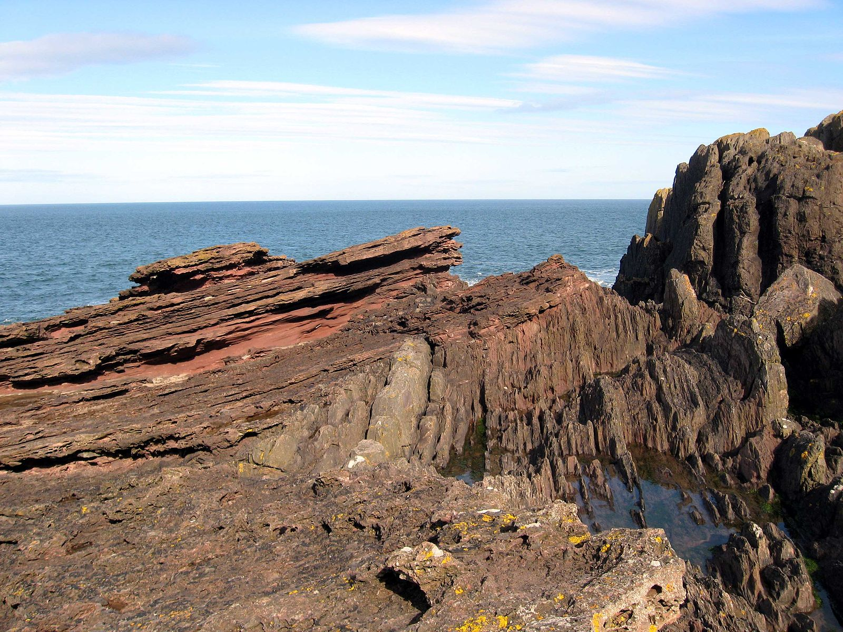

**Figure 1.1.** Hutton’s Unconformity on the southeast coast of Scotland.

<https://commons.wikimedia.org/wiki/File:Siccar_Point_red_capstone_closeup.jpg>

**Stratigraphic Principles**

When people first began interpreting rocks, geologic history could be determined only in a relative sense, i.e., which rock layer (or other feature such as a fault) is older and which is younger. Deciphering the sequence of ages represented by the rocks in an area is called relative dating. Constructing a relative age sequence involves the following ideas, known as *stratigraphic principles* ("stratigraphic" comes from "strata," or layers).

Original horizontality states that most sedimentary rocks form from sediment that is deposited by water or wind in horizontal layers. Therefore, if layers are tilted or folded, they must have been changed at some time after they were deposited.

Superposition says that new layers of rock are always formed on top of older ones. Thus, the youngest rocks are always found in the uppermost layer. The rocks underneath become progressively older as you go down in the stack. Because of the principle of superposition, it is possible to determine the relative age of each layer in a road cut or cliff face.

Unconformities are gaps in the rock record, representing times during which either no rocks were deposited, or existing rocks were eroded. The contact between older, eroded layers and younger, overlying layers is often irregular, so that unconformities are usually easy to recognize.

Angular unconformities are contacts where younger rocks have been deposited horizontally on top of older rocks that had been tilted or folded. Across the resulting contact, the beds on one side of the angular unconformity are at an angle to the beds below it (i.e., not all the rock layers are parallel to one another).

Cross-cutting relations states that any feature which cuts across a second feature is younger than the second feature. For example, if a fault cuts across rock layers, then the fault is younger than the rocks. If rocks are tilted or folded, the time of deformation is younger than the rocks. Unconformities and igneous intrusions can also cut across pre-existing layers.

Figure 1 represents a vertical cross section, i.e., what you would see in a cliff face or road cut. The rock units and events are numbered according to stratigraphic principles.

Layer #1 is the oldest, with #2 - #5 deposited successively on top of it. Then all five layers were tilted during time #6. Erosion followed, producing the angular unconformity #7. Layers #8 and #9 were deposited above the unconformity. Finally, the igneous dike #10 was intruded, cutting across the older layers.

**Figure 1.2.** Relative dating by stratigraphic principles.

**An Application of Stratigraphic Relations to Planetary Geology**

Open the spreadsheet for this exercise, and look at the image in the Europa worksheet. This is a view of the icy surface of one of Jupiter's moons, taken on December 20, 1996, by the Galileo spacecraft. The image is about 13 km by 18 km (8 x 11 miles) and is illuminated by the Sun from the east (right).

The left side shows a flat smooth area, about 3.2 km (2 miles) across that resulted from flooding over sets of ridges and grooves. The smooth area contrasts with a patch of rough terrain farther east, to the right of the prominent ridge system in the middle. This rugged patch is 4 km (2.5 miles) across and represents localized disruption of the complex network of ridges in the area. Small impact craters occur throughout the image.

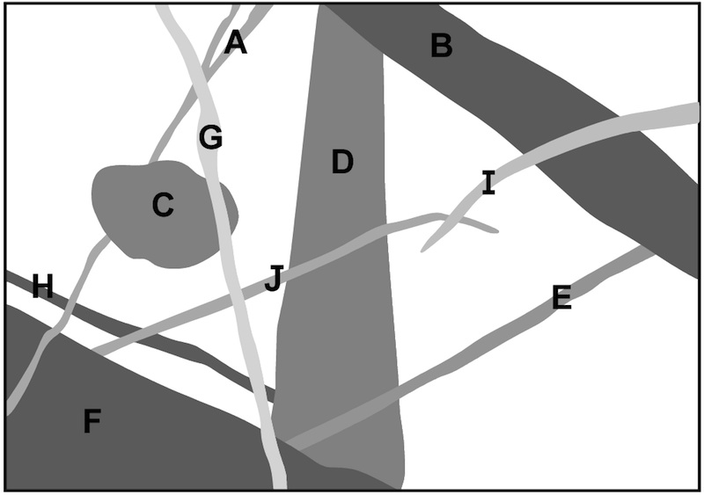

**Figure 1.3.** Sketch of the Europa image with several features labeled.

1. Figure 1.3 shows ten features from the Europa image. Which of the labeled features is the youngest? In other words, which labeled feature cuts across all the other labeled features?

2. In Figure 1.3, which labeled feature is the oldest? In other words, which labeled feature is cut by all the other labeled features?

3. Refer to Figures 1.2 and 1.3. Use the principle of cross-cutting relations to put features A-F in order according to their relative ages (1 = oldest, 6 = youngest).

**Unconformities**

In Fig. 1.2, look more closely at feature #7 – the irregular surface. Any two rock units are separated by a **contact**, which appears on the cross section as a line between the layers. In fact, a contact is a 3-dimensional surface that separates one rock layer from another. Geologists normally assume that there had been continuous deposition between one sedimentary rock layer and the next. If this assumption is correct, the contact between the layers is described as conformable.

Sometimes, however, an interval of time occurs when no sediments are deposited, or when rocks that had formed are completely eroded away. Either situation produces a contact that represents a gap in time, known as an unconformable contact, or an unconformity. An unconformity is usually indicated on a cross section by an uneven or wavy line. [Wikipedia](https://en.wikipedia.org/wiki/Unconformity) illustrates unconformities:

* **Angular unconformity**- Rock layers above the unconformity are not parallel to rock layers below the unconformity. Feature #7 is therefore an angular unconformity.
* **Disconformity**- Rock layers above the unconformity are parallel to rock layers below the unconformity. This type of unconformity can be difficult to identify.
* **Nonconformity**- Rock layers above the unconformity are sedimentary, while rock layers below the unconformity are igneous or metamorphic.

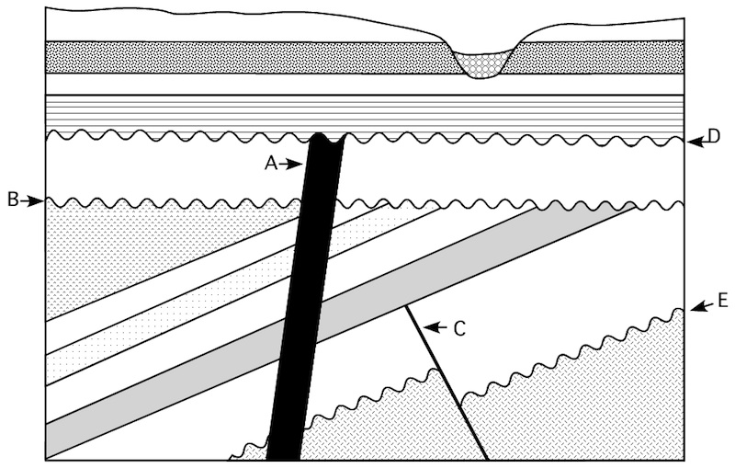

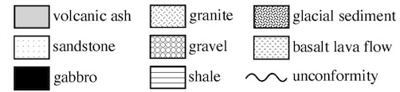

**Figure 1.4.** Cross-section showing various geological units and features.

4. Number the eight rocks below in order of increasing age, with 1 = oldest and 8 = youngest using the cross section in Fig. 1.4.

Basalt lava flow Gravel

Gabbro Sandstone

Glacial sediment Shale

Granite Volcanic ash

5. Features A-E on Fig. 1.4 represent an angular unconformity, a dike, a disconformity, a fault, and a nonconformity. Match A-E to the correct descriptions below.

Angular unconformity Dike (igneous intrusion)

Disconformity Fault

Nonconformity

6. Which feature is older: A or C? Which stratigraphic principle did you use to answer this question?

7. Match each statement about Fig. 1.4 to the stratigraphic principle that explains it.

Fossils in the sandstone have simpler forms than fossils in the shale. Superposition

Feature E and the overlying layers were tilted after their formation. Fossil succession

Feature B is older than feature D. Original horizontality

**Organizing Rocks Into the Geologic Column**

After almost two centuries of work on figuring out the sequences of different rock units and on establishing correlations among rock units, geologists have divided Earth's history into intervals of time based on major geological events. Certain fossils occur within each time interval, and intervals often begin or end with extinction events. As shown on Figure 6, the largest divisions are called eons, each of which is subdivided into eras. Eras in turn consist of sections called periods, which contain smaller sections, known as epochs.

Each section of the Geologic Column has been named for a geographic location or a geologic feature. All rocks, from anywhere on Earth, can be fit into their relative position in the Geologic Column, but there is no place on Earth where the entire Column is represented, because unconformities are present everywhere. The terminology and order of eras and periods were established during the 1800s, and thus, all time relations in Fig. 1.5 represent relative ages.

**EONOTHEM ERATHEM SYSTEM SERIES**

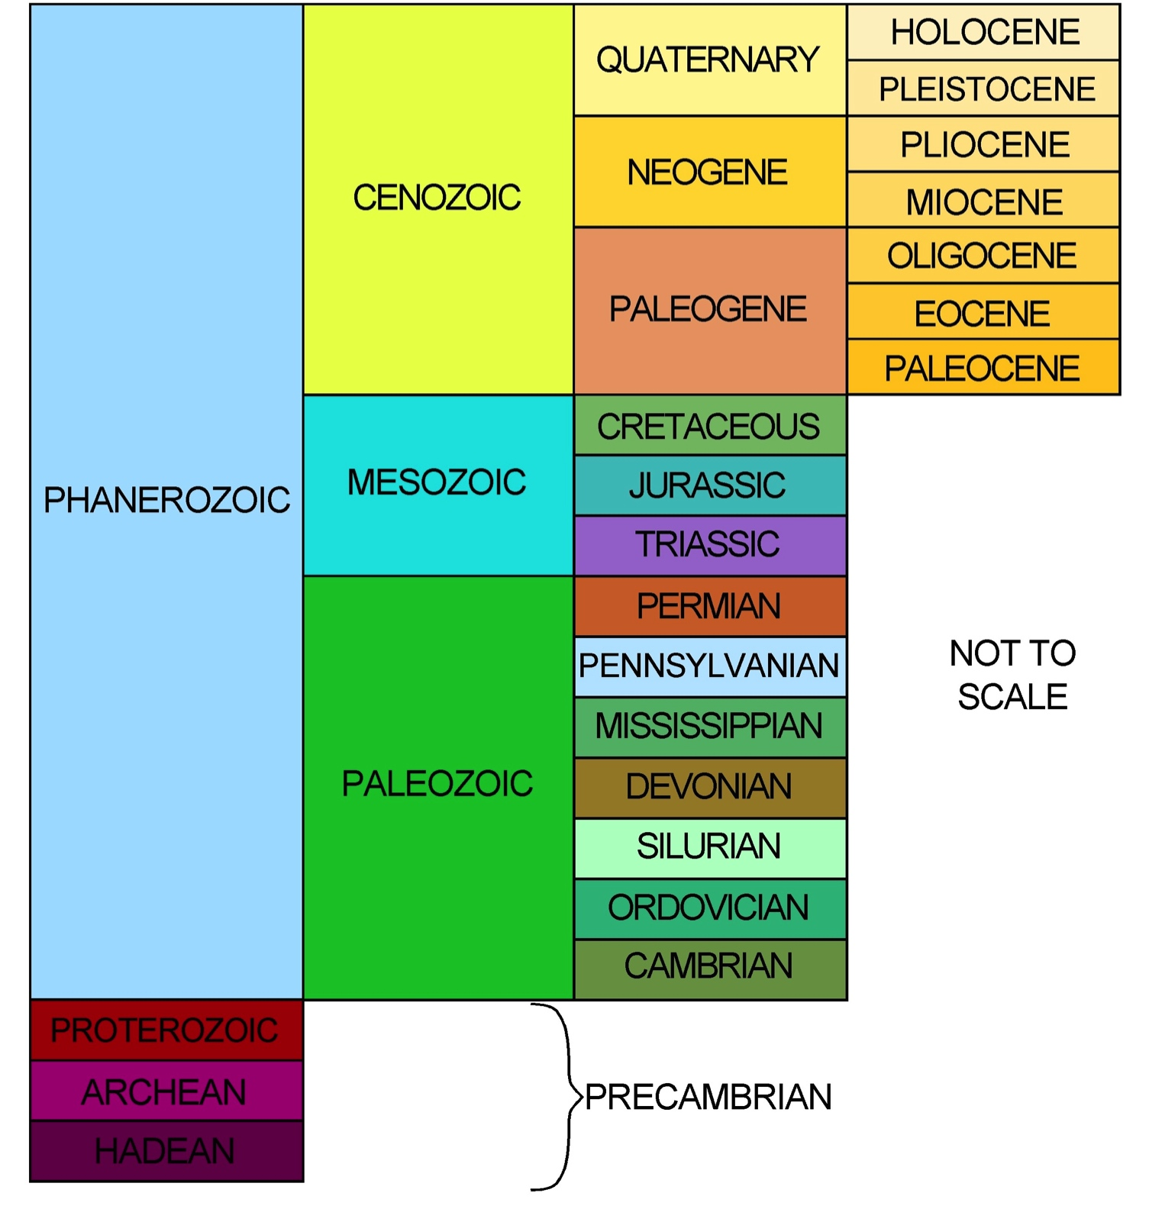

**Figure 1.5.** The Geologic Column for arranging rocks in relative order.

8. Most people have heard of the Jurassic System because of the Jurassic Park movies. Jurassic rocks plus the rocks in the systems before and after the Jurassic contain dinosaur fossils. Which erathem of the Geologic Column contains rocks from the “Age of Dinosaurs”?

9. Rocks forming today belong to the most recent series in the Geologic Column. What are the names of this series and the system, erathem, and eonothem that contain these recent rocks?

10. Rocks from the Proterozoic and Archean Eonothems are informally referred to as Precambrian rocks. How do you think this term originated?

**Relative and Absolute Geologic Time with Maps and Spreadsheets**

**Part II: Absolute Ages**

**Overview**

In contrast to relative dating, absolute dating yields a number (years or often Ma = mega-anna = millions of years). In this exercise, you learn and apply the equations geologists use to determine the absolute ages of rocks.

**Learning Objectives**

* Demonstrate radioactive decay for three isotopic systems
* Construct an Excel chart illustrating the decay of parent isotopes
* Explain the relation between the decay constant and half-life of a radioactive isotope

**The Oldest Piece of the Earth**

Geologists are on a continual hunt for older rocks and keep pushing back the age of the "oldest" bit of continental crust, an honor that is currently held by a crystal of the mineral zircon. It is part of a sample collected from a metamorphosed sandstone in western Australia. Figure 2.1 is a cathodoluminescence (CL) image, produced by irradiating a thin section with an electron beam to make it glow. The inner area is the oldest part, with an absolute age of almost 4.4 Ga (giga-anna) or 4,400,000,000 years! Considering that the age of the Earth itself is ~4.54 Ga, this crystal dates back almost to our planet's beginning. There may be still older pieces of rock, somewhere; but the older they are, the fewer exist, and the harder it is to find them.

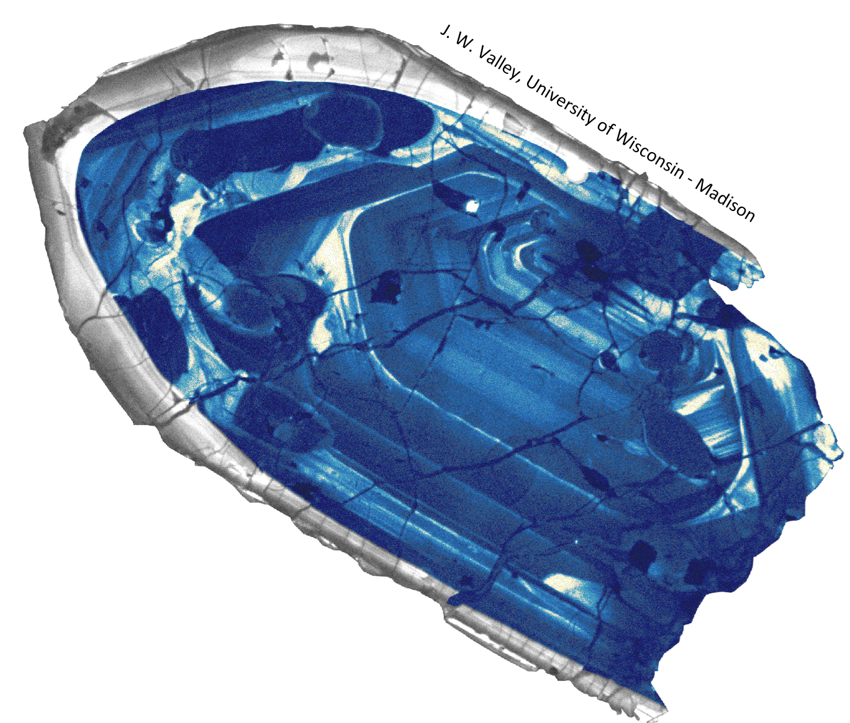

**Figure 2.1.** CL image of a 400-micron zircon. This is the oldest known (4.4 Ga) zircon from Earth. These results support evidence for a cool early Earth that was habitable for life by 4.3 Ga, only 250 million years after the formation of Earth and 800 Myr before the oldest known microfossils.

(Credit: John Valley, University of Wisconsin-Madison. Used by permission.)

<http://geoscience.wisc.edu/geoscience/people/faculty/john-valley/john-valley-incle-on-zircons/>

**Absolute Ages**

Quantitative geological age is determined by using the decay of radioactive isotopes that are incorporated into the minerals of a rock. When a mineral first forms, it has some initial concentration of a radioactive parent isotope, which over time decays to the stable daughter product. Different isotope systems are useful over different spans of time, so it is necessary to choose a specific isotope for a particular age determination.

Consider a mineral containing an initial amount *N0* of a radioactive parent isotope. After a period of time *t*, the remaining amount of parent *P* is *N(t)*:

*–t*

*N(t) = P = N0 e* (1)

Here, λ is the decay constant, which is related to the half-life as λ describes how quickly the parent isotope decays (λ = (ln 2) / half-life). The decay constant can be measured in the laboratory and is different for each isotope system. In this exercise, you work with several isotope systems commonly used for isotopic dating. The potassium-argon (K-Ar) system involves the decay of 40K to the gas 40Ar; this system can be used only if the gaseous daughter product has not escaped from the sample. The uranium-lead (U-Pb) system measures age based on the decay of 238U to stable 206Pb. Radiocarbon (14C) dating uses the decay of 14C incorporated into organic tissue to nitrogen (14N) after the organism dies. The decay constants λ for each system are given in the table below.

|  |  |  |
| --- | --- | --- |
|  | **Isotope System** | **λ (units = 1/year)** |
|  | 40K - 40Ar | 5.81 × 10-10 |
|  | 238U - 206Pb | 1.55125 × 10-10 |
|  | 14C - 14N | 1.209 × 10-4 |

1. In the spreadsheet for this exercise, open the “Radioactive Decay” worksheet. In equation (1), let *N0* = 1, as entered in B6:D6. Calculate the fraction of the remaining parent isotope *P*, after the time *t* specified in column A. To do this, enter equation (1) into cell B7, with a relative cell name for *N0*, an absolute column name for *t* and an absolute row name for *λ*: =B6*EXP(-B$3*$A7)

Highlight cell B7 and fill down to B21, then release the cursor. Now highlight B7:B21 and drag to fill C7:D21. What amount of radioactive potassium remains after 5 billion years?

2. What amount of radioactive uranium remains after 1 billion years?

3. What amount of radioactive carbon remains after 20,000 years?

4. Highlight cells A5:D21 and produce a smoothed marked scatter chart showing the three isotopic systems. Format the scale on the Y-axis with max = 1 and min = 0. Format the scale on the X-axis with max = 10,000,000,000 (1E+10), min = 0, and major unit = 2,000,000,000 (2E+09). Describe the shape of the 40K-40Ar curve.

5. Describe the shape of the 238U-206Pb curve.

6. Describe the shape of the 14C-14N curve.

7. Which system shows the fastest decrease in the parent isotope?

8. Reformat the scale on the X-axis with max = 50,000 years, min = 0, and major unit = 10,000 years. Describe the shapes of the 238U-206Pb curve and the 14C-14N curve. (The 40K-40Ar curve is hidden beneath the 238U-206Pb curve.)

9. Based on these views of the graph, does the parent isotope decay faster or slower as the decay constant decreases?

10. In general, would an isotopic system with a smaller decay constant be more useful for dating younger or older rocks? Explain your answer.

**Relative and Absolute Geologic Time with Maps and Spreadsheets**

**Part III: Combining Relative and Absolute Ages**

**Overview**

Isotopic dating cannot be applied to every rock. In this part of the exercise, you calculate isotopic ages with the age equation and learn how to determine the possible range of ages for rocks that cannot be dated isotopically.

**Learning Objectives**

* Determine ages for three samples using isotopic methods
* Infer the ages of undateable rocks by combining absolute and relative methods
* Interpret the Geologic Time Scale in absolute terms

**Which Rocks are Good for Isotopic Dating?**

You may have noticed in Part II that all of the rocks for which you found isotopic ages were igneous or metamorphic. Why were these samples chosen? The reason is that this method works only for samples that meet certain requirements. First, the rock must contain radioactive elements. Second, the specific mineral crystals that include radioactive atoms must have formed at the same time as the rock itself.  
 Igneous rocks, for example, start as liquid rock, and crystals form as the magma cools and hardens; therefore, the minerals are the same age as the rock itself. Further, igneous minerals such as feldspar and mica frequently contain radioactive elements.

What about sedimentary rocks? Remember that clastic ones form by the accumulation of sediment that becomes lithified. Thus, the clasts in a rock such as conglomerate are older than the rock itself. For chemical sedimentary rocks, the minerals form at the same time as the rock, but unfortunately, they seldom contain radioactive elements.

For metamorphic rocks, it is often but not always possible to use isotopic techniques. The processes of metamorphism are complex, and some rocks have been metamorphosed more than once. It can be very challenging to interpret the results of isotopic measurements for metamorphic rocks.

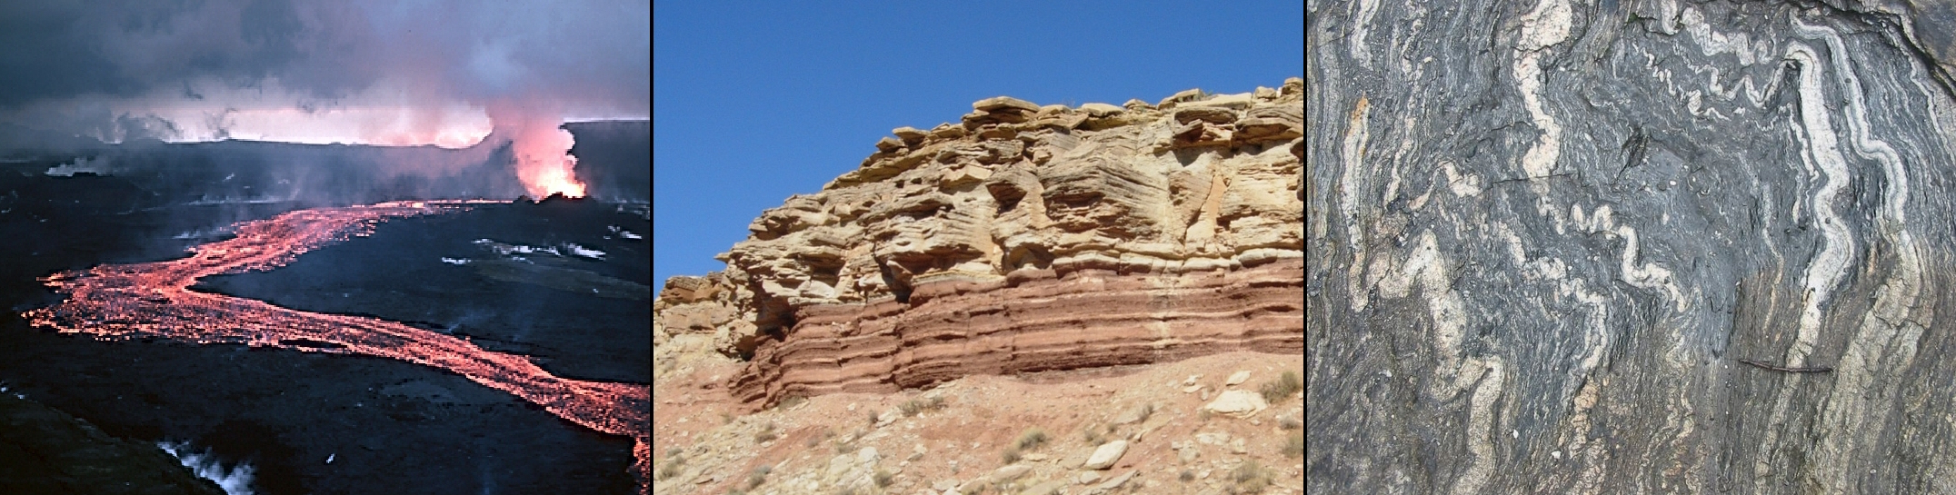

**Figure 3.1.** Left to right: Igneous rocks are good for isotopic dating; sedimentary are poor for dating; and metamorphic rocks may or may not be good for dating.

<https://commons.wikimedia.org/wiki/File:Lava_flow_at_Krafla,_1984.jpg>

<https://commons.wikimedia.org/wiki/File:Triassic_Utah.JPG>

<https://commons.wikimedia.org/wiki/File:Migma_ss_2006.jpg>

**Isotopic Dating**

As the number of parent atoms (*P*) decreases, the number of daughter atoms (*D*) increases. Because the total mass of the system must stay the same, *P + D = N0* at any time *t.* Substituting this equation into equation (1) in part II and rearranging yields:

*t* = ln ( 1 + *D/P* )

** (2)

In equation (2), “ln” means “natural logarithm”, or logarithm to the base e, where e is an irrational number (2.71828…). Geologists use equation (2) to calculate the isotopic age of a rock. Laboratory procedures involve measuring the masses of the parent and the daughter isotopes within a rock sample using a mass spectrometer. Once a radioactive system is chosen, *λ* is known. Thus, all values on the right-hand side of equation (2) are known, and the rock sample may be dated.

Open the spreadsheet for this exercise, and go to the “Isotopic Dating” worksheet. Three isotopic systems are listed in column A (A9:A11), and their decay constants are entered in column B (B9:B11). The next three questions present laboratory measurements of a parent and a daughter isotope in three geologic samples. Enter these values in columns C and D (C9:D11). Make sure to put the parent isotope in column C and the daughter isotope in column D. Recall that a number such as 2.50 × 10-5 is entered into Excel as “2.50E-5”.

In cell E9, enter equation (2) in the form: =ln(1+D9/C9)/B9, then fill down to E11.

1. A Precambrian metamorphic rock from the Canadian Shield contains abundant plagioclase feldspar and micas. One mica crystal contains 2.43 × 10-5 grams of radioactive 40K and 5.66 × 10-5 grams of stable 40Ar. What is the age of the crystal? Express your answer in Ga (giga-anna = billions of years).

2. A sample of basalt retrieved from the bottom of the Atlantic Ocean approximately 1000 km east of New York City contains 4.27 × 10-5 grams of radioactive 238U and 1.15 × 10-6 grams of stable 206Pb. What is the age of the basalt? Express your answer in Ma (mega-anna = millions of years).

3. A piece of a tree trunk found in glacial till from the Ice Age contains 9.8 × 10-3 grams of radioactive 14C and 3.17 × 10-2 grams of 14N. Approximately how old is the tree? Express your answer to the nearest hundred years.

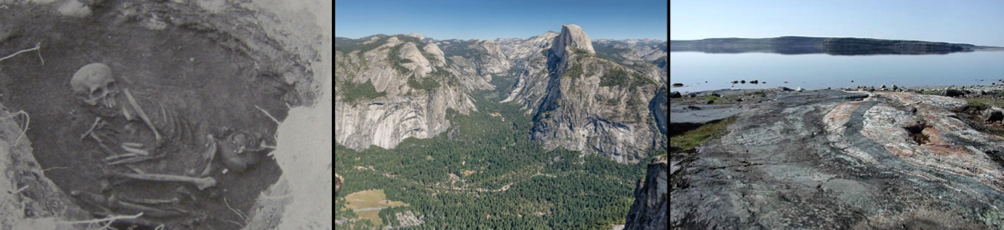

**Figure 3.2.** Left to right: Human bones dated by 14C: Yosemite rocks dated by U-Pb; Canadian rocks dated by K-Ar.

<https://commons.wikimedia.org/wiki/File:Harrington-cherokee-grave-tn1.jpg>

<http://commons.wikimedia.org/wiki/File:Panoramic_Overview_from_Glacier_Point_over_Yosemite_Valley_2013_Alternative.jpg>

<http://commons.wikimedia.org/wiki/File:Nuvvuagittuq_belt_rocks.jpg>

4. The table lists isotopic ages for several rock units from Fig. 3.3. For each geologic material, check the isotopic system to use for dating the rock or sediment. Note: more than one system may be possible for a single sample.

|  |  |  |  |  |
| --- | --- | --- | --- | --- |
| **Rock Formation** | **Age (Ma)** | **Isotopes** | | |
| **40K-40Ar** | **238U-206Pb** | **14C-14N** |
| wood in glacial sediment | 0.04 |  |  |  |
| gabbro | 237 |  |  |  |
| basalt | 385 |  |  |  |
| volcanic ash | 510 |  |  |  |
| granite | 1,500 |  |  |  |





**Figure 3.3.** Cross-section showing various geological units and features.

5. On the cross section, the fault is younger than the granite (1,500 Ma) but older than the volcanic ash (510 Ma). Therefore, we can **bracket** the age of the fault as 1,500 – 510 Ma. Use the ages above to bracket the absolute ages of these other geologic features:

angular unconformity

gravel

sandstone

shale

6. Note that the range of possible ages for the fault stretches across about a billion years! This is not very helpful, but sometimes the bracketing method yields a smaller range and thus a better approximation of the age of some feature. From your answers in question #5, is the age of the sandstone more or less precise than the age of the angular unconformity? Explain your answer.

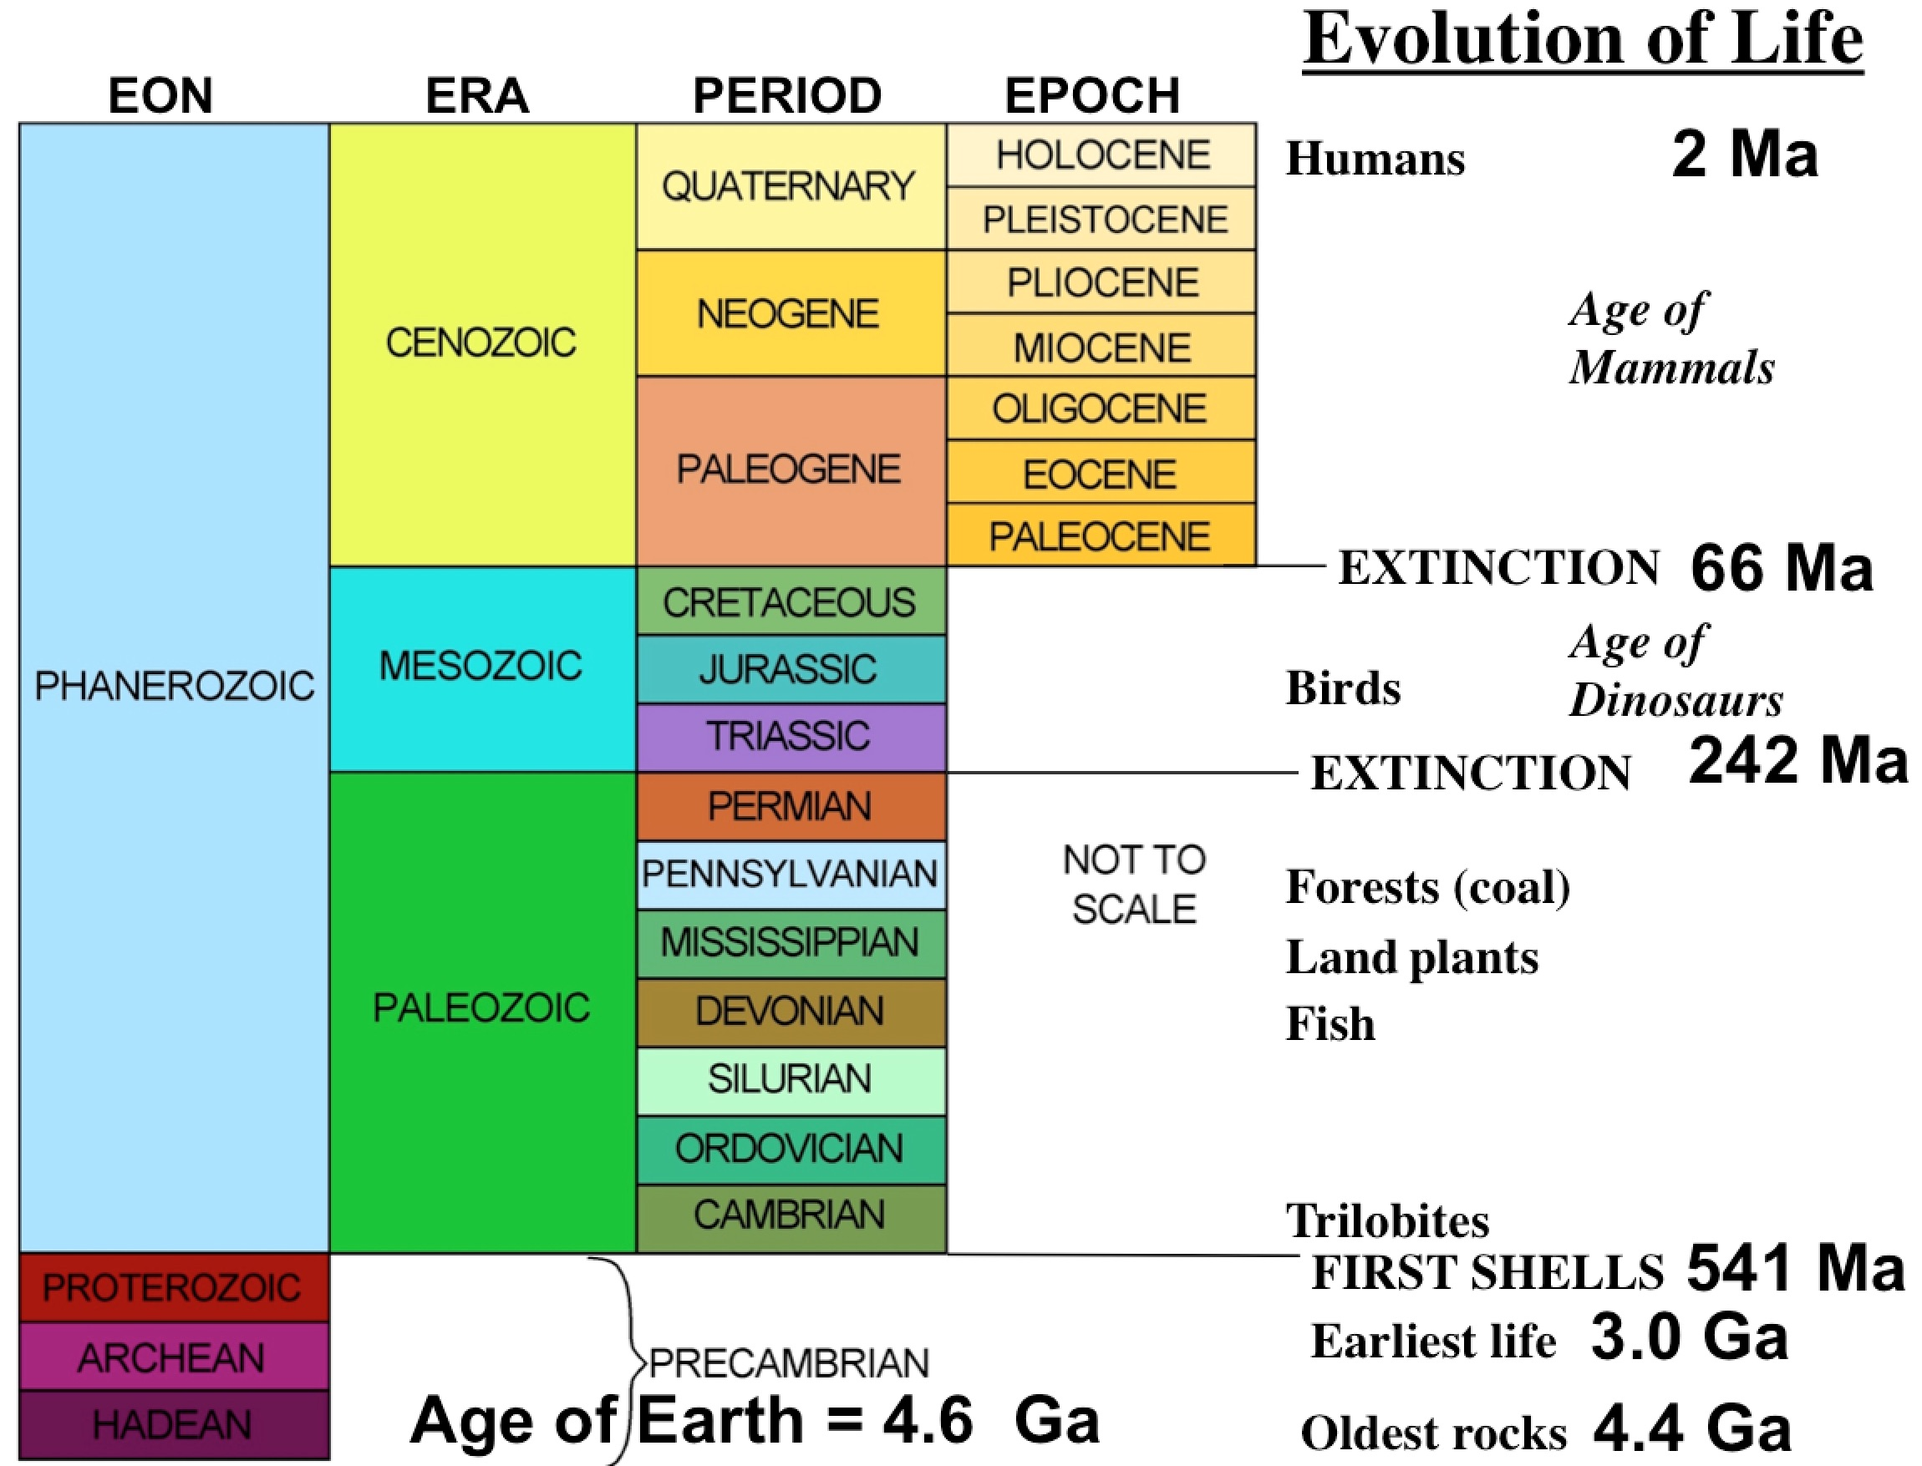

**Figure 3.4.** The Geologic Time Scale (Geologic Column with absolute ages added).

7. In Part I, you found that dinosaurs lived on Earth in the Mesozoic Era. During this time, many species – and even larger classification groups such as genera, families, and orders – evolved and then later became extinct. For how long did dinosaurs rule the Earth in the Triassic, Jurassic, and Cretaceous Periods?

8. Precambrian rocks have few or no fossils. The fossils that are present in these old rocks are small, even microscopic, and most had soft bodies. In contrast, rocks from the Cambrian Period (and younger periods) have abundant fossils large enough to see and with hard shells or exoskeletons. Paleontologists refer to this change in the number and character of fossils as the “Explosion of Life.” When did the Explosion of Life occur?

9. What percentage of Earth’s total history is represented by Precambrian time, i.e., the Hadean, Archean, and Proterozoic Eons?

10. The innermost part of the zircon shown in Fig. 2.1 (Part II) has an isotopic age of 4.4 Ga. During which eon of the Geologic Time Scale did the zircon’s core form?

**Another Look at Geologic/Astronomic Time**

For a humorous visual portrayal of time and history as we know it, visit “Putting Time in Perspective” <http://www.waitbutwhy.com/2013/08/putting-time-in-perspective.html> by Tim Urban. Although it is a few years out of date, the majority of the timelines remain accurate.