Boneyard Creek and Other Extra Credit Exercises

Original and adapted extra credit activities by
Eileen Herrstrom
University of Illinois at Urbana-Champaign
herrstro@illinois.edu
2019

Context

- The audience for this activity is an undergraduate class on introductory physical geology or quantitative reasoning for non-majors.
- Students must know concepts from lectures and be able to manipulate data in an Excel spreadsheet.
- These activities are optional extra credit or homework assignments that follow lectures on various topics. As such, they are scattered throughout the course.

Goals

- The content and concept goals for these activities are generally to supplement lecture topics, lab work, and readings and to provide opportunities for students to apply their learning independently. Individual activity pages list specific goals.
- Higher order thinking skills goals for various activities involve interpreting graphs, identifying minerals and rocks, reading topographic maps, searching the internet for data and other information, and using Excel.

Table of Contents

- Listening to Earthquakes with the US Geological Survey . . . . 2
- The Interior Layers of the Earth . . . . . . . . . . . . . . . . . . . . . . . . . 6
- The Movements of Tectonic Plates . . . . . . . . . . . . . . . . . . . . . . 10
- Identifying Minerals by their Physical Properties . . . . . . . . . . . 19
- A Campus Rock Tour . . . . . . . . . . . . . . . . . . . . . . . . . . . . . . . . 23
- Cycling Through Rock Types . . . . . . . . . . . . . . . . . . . . . . . . . . 27
- A Road Rally in Peoria IL . . . . . . . . . . . . . . . . . . . . . . . . . . . . . 32
- Volcano Search . . . . . . . . . . . . . . . . . . . . . . . . . . . . . . . . . . . . . . 36
- Relative Dating in Geology . . . . . . . . . . . . . . . . . . . . . . . . . . . . 40
- Streamflow Data for Boneyard Creek, Urbana IL . . . . . . . . . . . 44

Listening to Earthquakes at the USGS

An extra credit exercise adapted by
Eileen Herrstrom
University of Illinois at Urbana-Champaign
herrstro@illinois.edu
2019

Context

- The audience for this activity is an undergraduate class on introductory physical geology or quantitative reasoning for non-majors.
- Students must have general knowledge about seismic waves and be able to distinguish different pitches in audio recordings.
- This activity is an optional extra credit exercise that follows lectures on earthquakes and Earth’s interior and falls near the beginning of the course.

Goals

- The content and concept goals for this activity include determining how the length of a fault, the type of material, the distance to the epicenter and the magnitude of an earthquake affect the frequency of seismic waves.
- Higher order thinking skills goals for this activity involve comparing seismic records for quakes with one feature changing and the others held constant and predicting frequency (pitch) based on earthquake or seismogram characteristics.

Reference

Michael, A., and D. Ross, Listening to Earthquakes: US Geological Survey: Online resource – Accessed 7 June 2019
https://earthquake.usgs.gov/learn/topics/listen/index.php

Listening to Earthquakes at the USGS

Overview

In this activity, you listen to sounds produced by seismic waves and note how they change according to magnitude, distance, and rock materials.

Learning Objectives

- Determine how the length of a fault, the type of material, the distance to the epicenter and the magnitude of an earthquake affect the frequency of seismic waves
- Compare seismic records for quakes with one feature changing and the others held constant
- Predict frequency (pitch) based on earthquake or seismogram characteristics.

Vibrations in the Earth

Seismologists say that the Earth “rings like a bell” after an earthquake as seismic waves travel through the crust and mantle and even the core (Fig. 1). Because thousands of earthquakes occur every year, shaking is almost continuous, although it varies in strength at different times and places. The U.S. Geological Survey (USGS) has developed a series of recordings from seismograms. When you listen to the audio, you can actually hear the “ringing”, and changes in pitch correspond to differences in the earthquake or the situation of the seismometer.

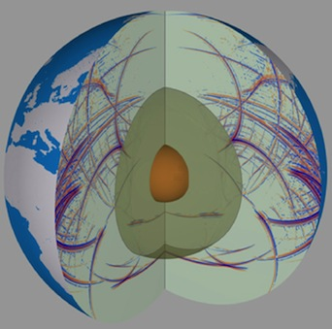
Figure 1. Model of seismic waves propagating throughout the Earth.
https://www.geophysik.uni-muenchen.de/research/seismology

Earthquakes and Sounds

Go to the USGS “Listening to Earthquakes” website at the following URL: https://earthquake.usgs.gov/learn/topics/listen/index.php. Read the Introduction, and then work your way through all the pages:
- Fault Length Effects
- Distance Effects
- Rock Type Effects
- Multiple Earthquakes
- Earthquake Sounds for Fun
- Earthquake Music
Carefully listen to the various recordings, and use what you read and hear to answer the questions below.

1. Why are these audio files “speeded up” with respect to the actual earthquake vibrations?

2. On the Fault Length page, which earthquake occurred on the shorter fault, Earthquake One or Earthquake Two? How can you tell?

3. On the Distance page, which seismometer was closer to the earthquake epicenter, Seismometer One or Seismometer Two? How can you tell?

4. On the Rock Type page, which seismometer was on hard rock, Seismometer One or Seismometer Two? How can you tell?

5. On the Multiple Earthquakes page, which seismogram records small triggered earthquakes, Parkfield or Geysers? How can you tell?

6. On the Earthquake Sounds for Fun page, consider the 1992 Landers earthquake with magnitude 7.3. Which seismogram records small triggered earthquakes, the one recorded at Parkfield or the one recorded at Long Valley Caldera (Mammoth Lakes)?

7. On the Earthquake Sounds for Fun page, consider the 1992 Petrolia (near Eureka) earthquakes. Based on the magnitudes, which audio is higher pitched, that of the magnitude 6.5 earthquake or that of the magnitude 6.3 earthquake? Give one possible reason for your answer.

8. On the Earthquake Sounds for Fun page, consider the 1994 magnitude 5 Parkfield earthquake. Which audio is higher pitched, the one recorded at Parkfield or the one recorded at Hollister? Verify your answer by listening to the two recordings. Give one possible reason for your answer.

9. On the Earthquake Sounds for Fun page, consider the magnitude 2 Parkfield earthquake. Based on the rock types, which audio should be higher pitched, the one on hard rock or the one on chewed-up, fault zone rock? Verify your answer by listening to the two recordings.

10. On the Earthquake Music page, what four instruments are used in the quartet? Why were these instruments chosen?

The Interior Layers of the Earth

An original extra credit exercise by
Eileen Herrstrom
University of Illinois at Urbana-Champaign
herrstro@illinois.edu
2019

Context

- The audience for this activity is an undergraduate class on introductory physical geology or quantitative reasoning for non-majors.
- Students must know definitions of crust, mantle and core, have general knowledge about P- and S-waves, and be able to manipulate data in an Excel spreadsheet.
- This activity is an optional extra credit exercise that follows lectures and a laboratory exercise on rocks and falls near the beginning of the course.

Goals

- The content and concept goals for this activity include creating an Excel chart showing how P-wave velocity changes in the first 100 km depth below the Earth’s surface.
- Higher order thinking skills goals for this activity involve interpreting a formatted chart of seismic velocities versus depth and explaining the charts of velocity and density changes with depth in terms of Earth’s internal layers.

The Interior Layers of the Earth

Overview

In this activity, you work with spreadsheet data and graphs that illustrate the changes in velocities of seismic waves and in density from the surface to the center of the Earth.

Learning Objectives

- Create an Excel chart showing how P-wave velocity changes in the first 100 km depth
- Interpret a formatted chart of seismic velocities versus depth
- Explain the charts of velocity and density changes with depth in terms of Earth’s internal layers

How Can We Peer Inside the Earth?

Andrija Mohorovičić, a scientist working in Croatia in the early 1900s, made an important discovery by studying earthquake data: seismic waves travel faster through denser rock and more slowly through rock that is less dense. Because seismic waves generated by an earthquake can travel through the Earth and because these waves bounce off or change direction as they cross a boundary within the Earth, they can be detected in many places around the world. P-waves and S-waves can therefore probe the Earth as X-rays probe the human body. At the same time, other geologists were performing laboratory experiments on different materials at high temperature and pressure to determine which materials best matched the seismic waves. Thus, scientists built upon Mohorovičić’s work and developed a picture of the Earth’s whole interior.

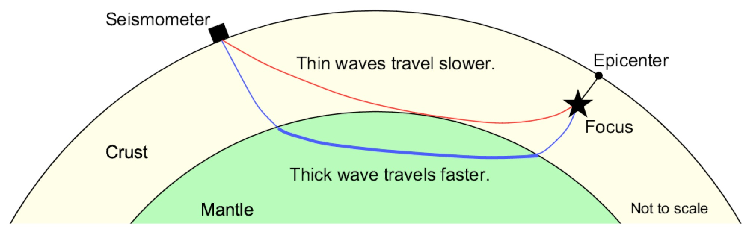
Figure 1. The seismic wave that follows the blue path arrives at the seismometer before the wave that follows the red path, even though the blue distance is longer that the red distance. The wave following the blue path, however, passes through deeper and denser rock and therefore travels faster than the wave that travels the red path.

Part I: Graphing the Data

Open the workbook file that accompanies this activity. The first worksheet of this file holds data about the rocks at different depths within the Earth: velocity of P-waves (column B), velocity of S-waves (column C), and density (column D).
Your first task is to graph the data. Follow these steps to use Excel for graphing:

- Highlight the data to be graphed, i.e., cells A4:B16.
- On the ribbon, click on the Chart tab.
- Select the type of chart. When you click on any chart icon such as "Scatter," a window pops up that illustrates the variations available. Choose the subtype “Straight marked scatter”.
- As soon as you click on your selection, the chart appears in the worksheet.
- Print your graph and attach it to this sheet for submission.

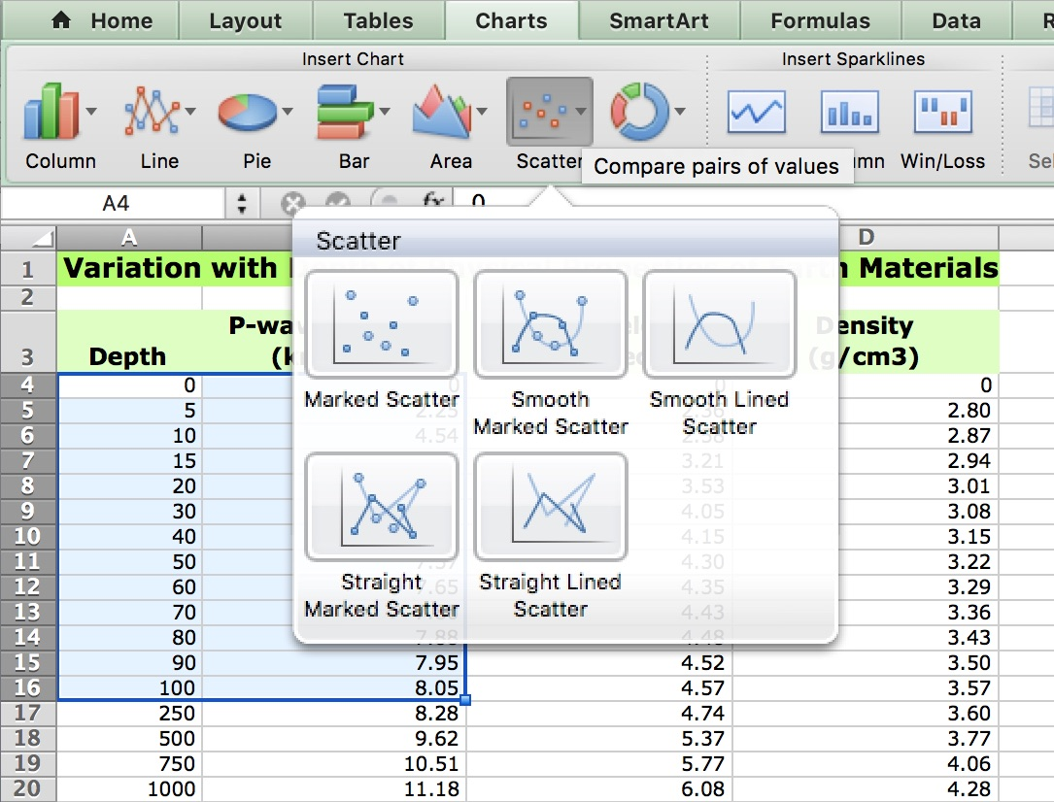
Figure 2. Screenshot of an Excel worksheet with data highlighted and Chart tab open.

1. What variable is plotted on the X-axis? What variable is plotted on the Y-axis?

2. Your graph should show that some points lie along one line segment and others lie along a different line segment. At approximately what depth do the two segments intersect?

3. Congratulations! You have identified an important feature of the Earth – a boundary that has been named in honor of its discoverer: the Mohorovičić discontinuity (the Moho, for short). What two parts of the Earth’s interior are separated by the Moho?

Part II: Interpreting the Data

The rest of the questions refer to graphs of the complete data set. Click on the “Velocity vs. Depth” tab at the bottom of the main window to see a graph of P- and S-wave velocities from the surface to the center of the Earth. Similarly, the “Density vs. Depth” tab leads to a graph showing how density changes with depth.

4. As depth increases from 500 km to 2500 km, how do the velocities of P-waves and S-waves change? Circle one:

Increase gradually / Increase abruptly / Decrease gradually / Decrease abruptly

5. As depth increases from 500 km to 2500 km, how does the density change? Circle one:

Increases gradually / Increases abruptly / Decreases gradually / Decreases abruptly

6. How does the P-wave velocity change between 2750 and 3000 km?

Increases gradually / Increases abruptly / Decreases gradually / Decreases abruptly

7. How does density change between 2750 and 3000 km?

Increases gradually / Increases abruptly / Decreases gradually / Decreases abruptly

8. What happens to S-wave velocity between 2750 and 3000 km?

Increases gradually / Increases abruptly / Decreases gradually / Decreases abruptly

9. Why do S-waves disappear between 2750 and 3000 km?

10. What changes occur in density and in both velocities at a depth of about 5200 km?

Increase gradually / Increase abruptly / Decrease gradually / Decrease abruptly

The Movements of Tectonic Plates

An original extra credit exercise by
Eileen Herrstrom
University of Illinois at Urbana-Champaign
herrstro@illinois.edu
2019

Context

- The audience for this activity is an undergraduate class on introductory physical geology or quantitative reasoning for non-majors.
- Students must know details of plate tectonics: what is a plate, what are the three types of plate boundaries, what are hotspots.
- This activity is an optional extra credit exercise that follows lectures and laboratory exercises on plate tectonics and falls near the beginning of the course.

Goals

- The content and concept goals for this activity include explaining the difference between relative and absolute plate motions and determining the type of plate boundary based on relative motions.
- Higher order thinking skills goals for this activity involve deducing the relative motions between plates based on absolute movements.

The Movements of Tectonic Plates

Overview

This activity explores different ways to describe plate motions around the surface of the Earth. Various descriptions depend on the specific frame of reference for observation.

Learning Objectives

- Explain the difference between relative and absolute plate motions
- Determine the type of plate boundary based on relative motions
- Deduce the relative motions between plates based on absolute movements

What Is a Plate?

In the theory of plate tectonics, which developed in the 1960s, Earth’s lithosphere is composed of sections called “plates.” These plates move around the surface of the Earth and interact along their boundaries. Plate boundaries are where many of the important geologic processes occur, such as volcanism and earthquakes. The highest mountain ranges and the deepest parts of the oceans also occur along plate boundaries. At divergent boundaries, two plates move away from each other as new oceanic lithosphere forms along a mid-ocean ridge. At convergent boundaries, two plates move toward each other as old oceanic lithosphere subducts into the mantle at an oceanic trench. At transform boundaries, two plates slide past each other; no new lithosphere forms, and no old lithosphere is destroyed.

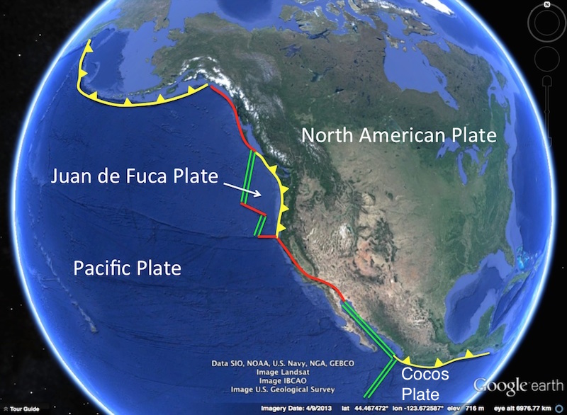
Figure 1. This view shows four plates and various types of boundaries: divergent = double green lines; convergent = yellow toothed lines; transform = red lines.
Screenshot from Google Earth
How Do Plates Move?

There are two ways of expressing how plates move across the surface of the Earth.
- One way to describe plate movement is to identify the relative motion between two plates.
  - Definition: the motion of one plate relative to another, across their mutual boundary
  - Example: using marine magnetic anomalies to determine the rate of sea-floor spreading
- Another way to describe plate movement is to consider the absolute movement of a single plate with respect to some fixed frame of reference.
  - Definition: the motion of one plate relative to the global grid of latitude and longitude, or as viewed from space
  - Example: using the age and distance of Hawaiian volcanoes to determine how fast the Pacific Plate moves over the Hawaii hotspot

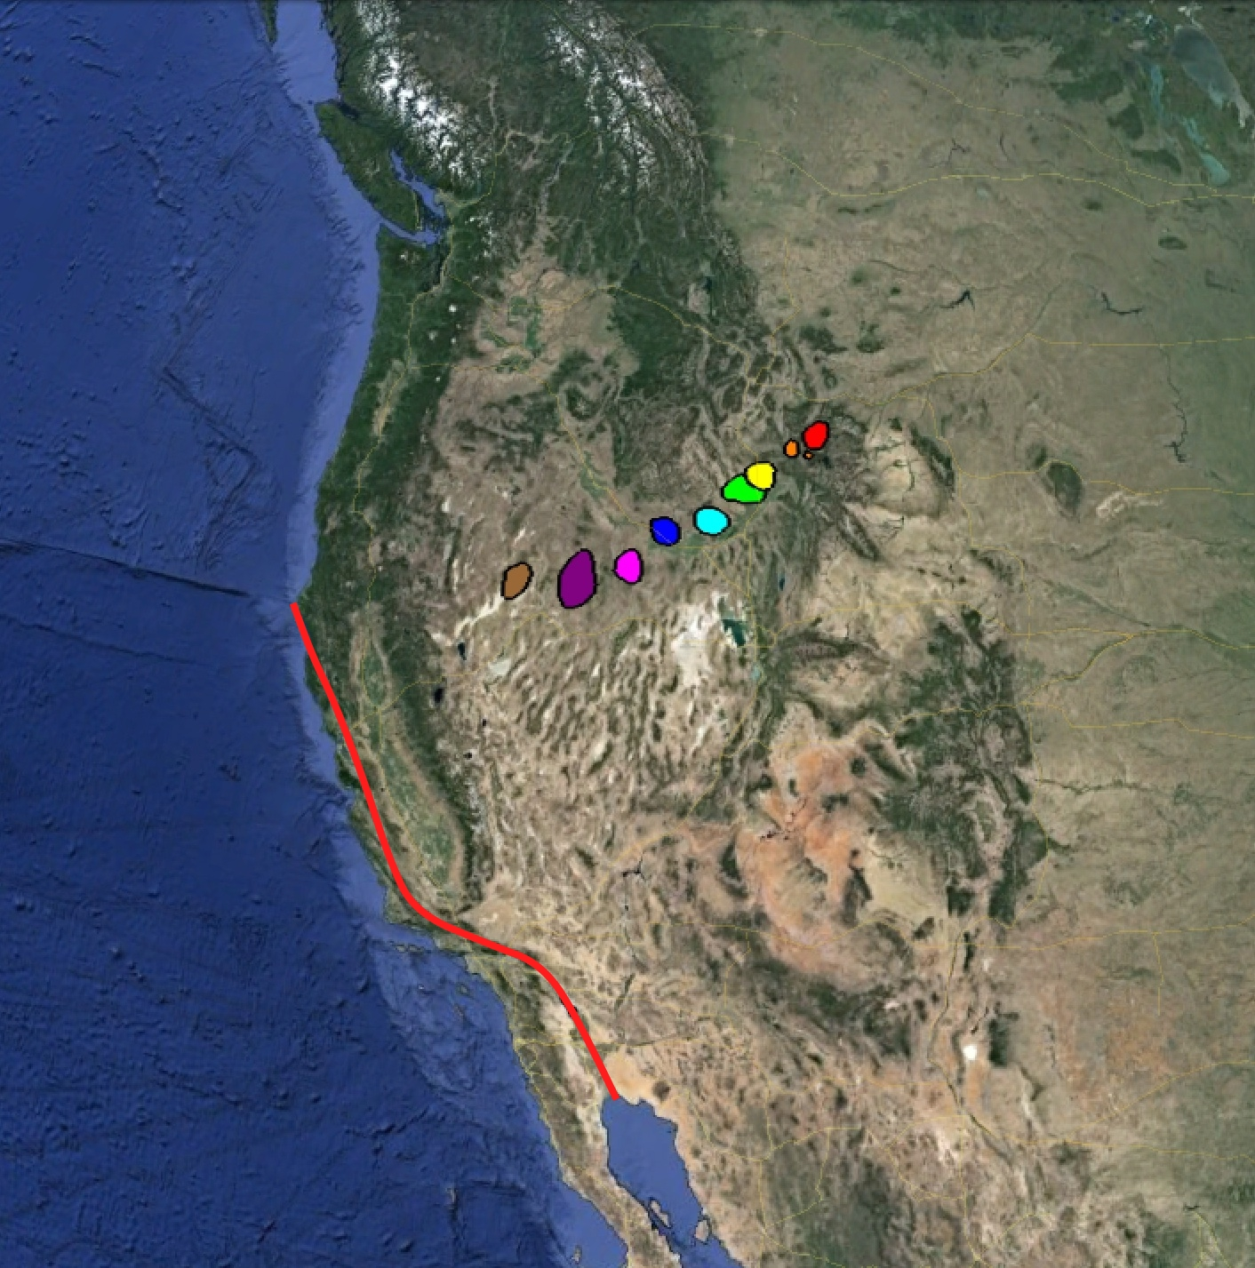
Figure 2. Traces of relative and absolute plate motions in western North America. The red line marks the San Andreas Fault. The colored areas represent a series of volcanic rocks (red = youngest, brown = oldest).
Screenshot from Google Earth

1. In Fig. 2, the colored areas mark volcanic rocks that erupted successively as the North American Plate moved over the Yellowstone hotspot. Are these volcanic rocks a trace of relative motion or an indication of absolute movement?

2. In Fig. 2, the red area represents the youngest rocks, and the brown area shows the oldest rocks. If these volcanic rocks formed as the continent moved over a stationary hotspot, toward which direction is the North American Plate moving?

3. In Fig. 2, the San Andreas Fault marks a transform boundary between the North American Plate and the Pacific Plate. Is this fault a trace of relative motion or an indication of absolute movement?

4. In Fig. 2, if you stand on one side of the San Andreas Fault, the other side appears to be moving toward the right. Toward which direction is the Pacific Plate moving with respect to the North American Plate?

Frame of Reference for a Mid-Ocean Ridge

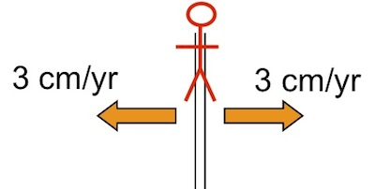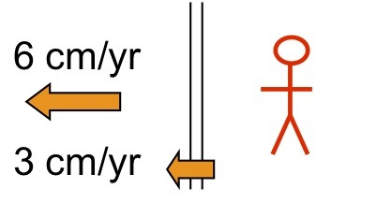
a. Stationary ridge with plates moving away. b. Stationary plate with ridge and plate moving away.
Figure 3. Two map views showing a mid-ocean ridge separating two plates. In both cases, the spreading rate is 6 cm/yr.

Consider a divergent boundary. When we have looked at mid-ocean ridges before, we have implicitly held the ridge position constant. This interpretation is like standing on the ridge itself, which is actually possible in a place such as Iceland. If you are standing on the Mid-Atlantic Ridge in Iceland, the ridge appears to be fixed in position; and the plates on either side are moving away. Assume that the spreading rate is 6 cm/yr (Fig. 3), that is, the ocean is widening by 6 cm every year. From your perspective on the ridge, each plate is moving away at a rate of 3 cm/yr.
Now, suppose you travel to the east coast of Iceland, where you would be standing on the Eurasian Plate. From this viewpoint, the plate that you are on appears to be fixed in position (Fig. 4). Both the other plate and the ridge itself are moving away from you. The ridge moves at 3 cm/yr, because your plate grows by this much each year. So does the other plate, which means it is moving away from you at 6 cm/yr. The ocean still becomes 6 cm wider every year, but the amount and direction of motion appear different, depending on where you stand. This difference explains why this way of expressing plate movements is called relative motion: it is relative to your frame of reference.
Frame of Reference for a Transform Fault

Similar distinctions apply along transform boundaries: we can consider relative motion with respect to one plate, the other plate, or the boundary itself. Like mid-ocean ridges, most transform faults are under the oceans, but several prominent transform boundaries are on land. If you stand on the eastern side of the San Andreas Fault, for example, you are on the North American Plate, which seems to be stationary. Meanwhile, the Pacific Plate appears to be moving past you to your right. However, if you stand on the western side of the San Andreas Fault, you are on the Pacific Plate, which seems to be stationary. Now, the North American Plate appears to be moving past you to your right.
Suppose some distinctive feature develops across a transform fault. It could be a fresh lava flow or even a highway or a building. This new feature is represented by the blue circle (Fig. 4). For 3 million years, the plates slide past each other along the boundary, until the top half of the blue feature is located 120 km to the west of the bottom half. Using the equation Rate = Distance / Time (R = D/T), the plates have been moving at an average rate of 4 cm/yr since the blue feature formed.
Note that when we discuss relative plate motions, we always use average values over, say, the past 50 million years. In fact, plate motion is episodic; plates are motionless for a long time, and then they suddenly move, generating an earthquake. This process occurs at mid-ocean ridges, oceanic trenches, and transform faults.

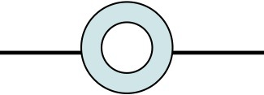

a. The blue circle forms while the fault is not moving.
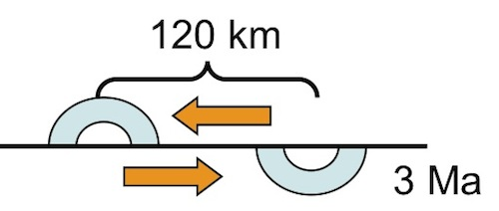
b. Movement along the fault breaks the blue circle apart.

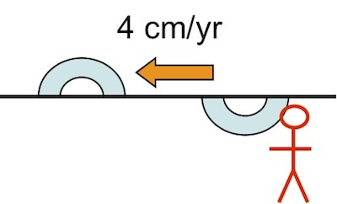
c. Rate of movement = distance/age of blue circle
Figure 4. In this map view, the blue circle is offset along a transform fault.
But which plate moved, and how far? If you are standing on the southern plate, it seems fixed and the northern plate appears to be moving west at 4 cm/yr. But walk over to the northern plate, and it now seems fixed, while the other plate moves east at 4 cm/yr. Or you could watch from the space station, and both plates might appear to be moving at 2 cm/yr in opposite directions. It’s all relative.

Can You Identify the Boundaries?

Consider these motions of Plates A and C relative to Plate B (Fig. 5). If you are standing on Plate B, Plate A is moving 2 cm/yr toward the west, and Plate C is moving 6 cm/yr toward the east.
What type of plate boundary separates A and B? How about B and C?

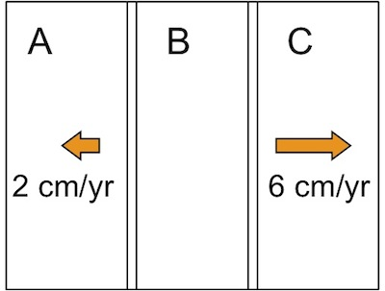
a. A, B, and C are three separate plates. b. Plates A and C move away from B.
Figure 5. Map views of three hypothetical plates with Plate B stationary.

Because Plates A and C are moving away from B, both boundaries are divergent. Plate A and Plate B each grow by 1 cm/yr along their boundary as sea-floor spreading occurs at 2 cm/yr. The mid-ocean ridge itself moves 1 cm to the west every year—relative to Plate B. Plate B and Plate C each grow by 3 cm/yr along their boundary as sea-floor spreading occurs at 6 cm/yr. This mid-ocean ridge moves 3 cm to the east every year—relative to Plate B. Thus, the width of Plate B increases by 4 cm/yr (1 cm along the west side and 3 cm along the east side).

Relative and Absolute Motions

When a boundary is described as divergent, this is always implied to be in relative terms. Absolute motions, however, may be very different. Consider a mid-ocean ridge that is spreading at a rate of 6 cm/yr, relative to the ridge itself (Fig. 6, blue arrows). One way to produce this amount of spreading would be for the ridge to be stationary and the absolute motion of each plate to be 3 cm/yr in opposite directions (red arrows). In this special case, relative and absolute motions coincide.
It is also possible, however, that both plates are moving in the same direction, as illustrated. If Plate M is moving westward at 8 cm/yr, and Plate N is moving west at 2 cm/yr, the ridge is still spreading at 6 cm/yr. But this time, the ridge is also moving to the west, at 5 cm/yr. Where does this rate come from? If the ridge is spreading symmetrically, as they usually do, then every year it moves 2 cm along with Plate N, plus another 3 cm because of the new ocean floor added along the western edge of Plate N.

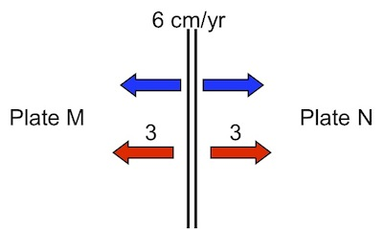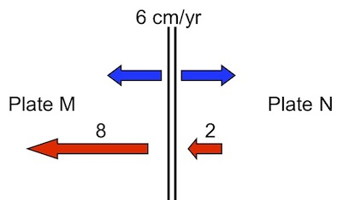
a. If M is moving west and N east, then relative b. If M and N are moving west at different
and absolute motions are identical. rates, then relative motion is the same as in (a).
Figure 6. Blue arrows represent relative motion, and red arrows indicate absolute motion.

Absolute Plate Motions from GPS Satellites

Both marine magnetic anomalies and displacements along transform faults can be used to calculate rates of plate motion, but both give relative motions. They describe only the motions of two plates along their mutual boundary.
Absolute values apply to a reference frame that is independent of Earth's surface. The grid of lines of latitude and longitude is such a framework, because it does not depend on where a measurement is taken (the equator does not move as you travel around the world). Or you could think of observing the Earth from space (Fig. 7).
Recall that the average rate of plate movement is ~5 cm/yr (about how fast fingernails grow). This movement is perceptible but only over a long time. You cannot see your nails growing from minute to minute, but you notice the increase after a couple of months. Similarly, you cannot stand and watch plates move, because they are too slow. In the past 10 to 15 years, however, it has become possible to measure plate motions by using the Global Positioning System satellites, as shown below.

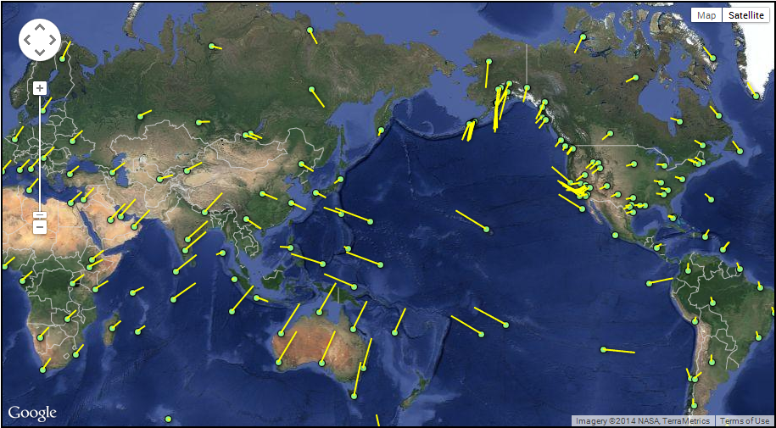
Figure 7. Dots mark measuring points, and yellow lines show direction and rate of absolute motion.
http://sideshow.jpl.nasa.gov/post/series.html
5. In Fig. 8, A, B, and C represent three different tectonic plates. Relative to B, A is moving 2 cm/yr toward the west, and C is moving 6 cm/yr toward the east. What type of boundary separates B and C?

Convergent boundary Divergent boundary Transform boundary Impossible to tell

Figure 8. Rectangles represent three separate plates, and B is stationary.

6. In Fig. 8, A, B, and C identify three different tectonic plates. Relative to B, A is moving 2 cm/yr toward the west, and C is moving 6 cm/yr toward the east. What type of boundary separates A and C?

Convergent boundary Divergent boundary Transform boundary Impossible to tell

7. In Fig. 9, if Plate M is moving toward the east at 1 cm/yr and Plate N is also moving east but at 7 cm/yr, what is the relative rate of sea-floor spreading along the ridge that separates M and N?

6 cm/yr 5 cm/yr 4 cm/yr 3 cm/yr

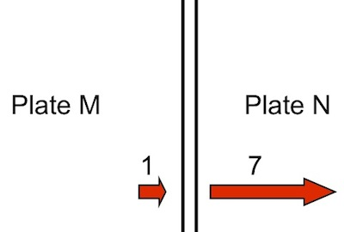
Figure 9. Absolute motions of two plates separated by a mid-ocean ridge.

8. In Fig. 9, if the absolute motion of plate M is toward the east at 1 cm/yr and the absolute motion of Plate N is also east but at 7 cm/yr, what is the rate of absolute motion for the mid-ocean ridge?

4 cm/yr toward the east 5 cm/yr toward the west

5 cm/yr toward the east 3 cm/yr toward the west

9. In Fig. 10, if the absolute motion of plate M is 5 cm/yr toward the east and the absolute motion of plate N is 2 cm/yr toward the east, what type of boundary separates M and N?

Convergent boundary Divergent boundary Transform boundary Impossible to tell

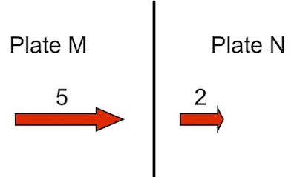
Figure 10. Absolute motions of two plates separated by a plate boundary.

10. In Fig. 10, if the absolute motion of Plate M is 5 cm/yr toward the east and the absolute motion of Plate N is 2 cm/yr toward the east, what is the relative rate of motion between M and N across their boundary?

Identifying Minerals by their Physical Properties

An extra credit exercise adapted by
Eileen Herrstrom
University of Illinois at Urbana-Champaign
herrstro@illinois.edu
2019

Context

- The audience for this activity is an undergraduate class on introductory physical geology or quantitative reasoning for non-majors.
- Students must understand physical properties of minerals and be able to apply them to identify unknown samples.
- This activity is an optional extra credit exercise that follows lectures and a laboratory exercise on minerals and falls near the beginning of the course.

Goals

- The content and concept goals for this activity include reviewing the definitions of mineral properties and a chart of common rock-forming minerals.
- Higher order thinking skills goals for this activity involve determining physical properties for a variety of minerals and utilizing the properties to name the samples.

Reference

Harwood, R., 2011, Mineral Physical Properties and Identification: Online resource – Accessed 21 June 2019
http://profharwood.x10host.com/GEOL101/Labs/Minerals/index.htm
Identifying Minerals by their Physical Properties

Overview

In this activity, you use the mineral identification website developed by Richard Harwood at Black Hawk College, Moline IL, to determine the names of unknown minerals.

Learning Objectives

- Review the definitions of mineral properties and a chart of common rock-forming minerals
- Determine physical properties for a variety of minerals
- Utilize the physical properties to name the sample

About Minerals

A mineral is defined as a naturally occurring inorganic solid with a definable chemical composition and an orderly crystal structure. The composition and structure produce a set of characteristics that is unique for each mineral. Deciphering the composition and structure can be time-consuming and expensive, but physical properties are quick and easy to discover.

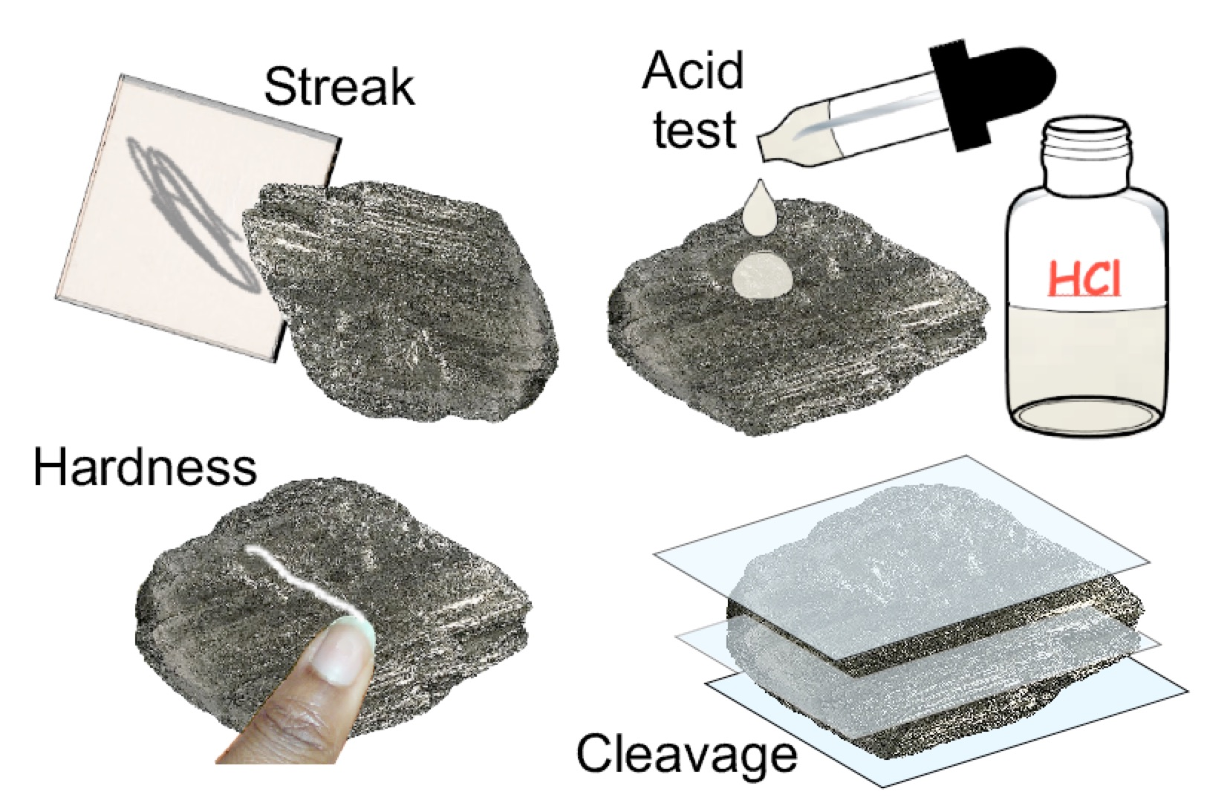
Figure 1. Four tests for physical properties of an unknown mineral.

Instructions

Go to the Earth Science Lab: Mineral Physical Properties and Identification online tool at <http://profharwood.x10host.com/GEOL101/Labs/Minerals/index.htm>. Review the Mineral Physical Properties information described on the first page.
- At the bottom of the page, select a sample between 2 and 20 to identify. You may identify up to 10 minerals (except for Sample 1, which is the example).
- Run tests on the sample using the Physical Properties Testing buttons (Fig. 1).
- Fill out the Mineral Identification Worksheet (Fig. 1) by clicking the buttons next to each property. Then, identify the sample. If you need to, refer to the main page of the lab where mineral properties are listed.
- Check your answers by selecting the Grade Identification button. Modify as necessary until you have correctly determined the properties and named the sample.
- When you have correctly identified the sample and see the Congratulations box, take a screenshot of the worksheet and paste it into a Microsoft Word document by following the instructions below. Your screenshot MUST show the Congratulations box in order for you to receive credit.

Windows Screenshot Instructions

- Press the Print Screen key on your keyboard. It is normally located in the upper-right corner of the keyboard. It may be labeled Prt Scn. The screenshot is now in the clipboard.
- Open a new document in Microsoft Word.
- Go to the Edit menu and choose Paste.

Mac OSX Screenshot Instructions

- Press the Command + Shift + 3 keys on your keyboard. The screenshot is now saved as a file on your desktop.
- Open a new document in Microsoft Word.
- Go to the Insert menu and choose Picture.
- Navigate to the Desktop and choose the screenshot file.

Additional Assistance

- Taking Screenshots in Windows
  - http://graphicssoft.about.com/cs/general/ht/winscreenshot.htm
- Taking Screenshots in Mac OSX
  - http://guides.macrumors.com/Taking_Screenshots_in_Mac_OS_X

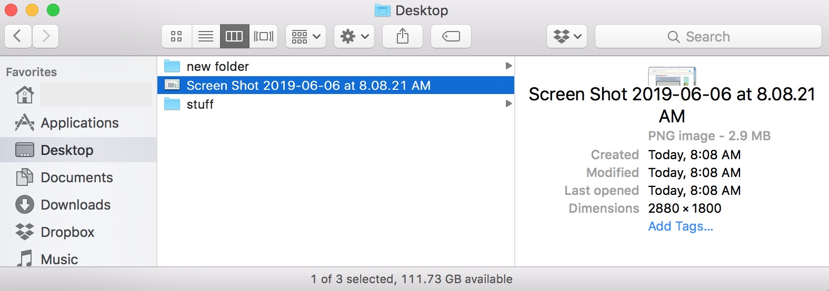
Figure 2. Windows PrtScn (left) and Mac Screenshot on the desktop (right).

Example: Sample 1

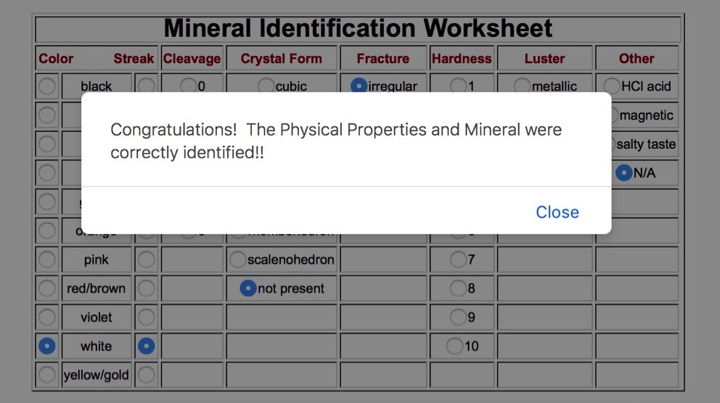
Figure 3. Screenshot showing successful identification of Sample 1.

Paste additional screenshots into your Microsoft Word document for each sample you identify. Every correct identification is worth 1 point, up to a total of 10 extra credit points possible. Save and submit your Microsoft Word document according to the instructions.

A Campus Rock Tour

An original extra credit exercise by
Eileen Herrstrom
University of Illinois at Urbana-Champaign
herrstro@illinois.edu
2019

Context

- The audience for this activity is an undergraduate class on introductory physical geology or quantitative reasoning for non-majors.
- Students must know how to identify igneous, metamorphic, and sedimentary rocks.
- This activity is an optional extra credit exercise that follows lectures and a laboratory exercise on rocks and falls near the middle of the course.

Goals

- The content and concept goals for this activity include discovering the diversity of building stones on campus and determining rock names and types.
- Higher order thinking skills goals for this activity involve observing and recording details of composition and texture for several building stones.

A Campus Rock Tour

Overview

In this activity, you explore the many variations in the university’s basic building scheme of classic red brick and tan limestone.

Learning Objectives

- Discover the diversity of building stones on campus
- Determine the rock names and types for several of the building stones
- Record details of composition and texture for several building stones

Building Stones

The Natural Resources Building, home of the Illinois State Geological Survey on the University of Illinois campus in Urbana, is constructed of bricks and a variety of building stones. From the slate (metamorphic) roof to the limestone (sedimentary) doorframes to the granite (igneous) stairs, the structure showcases geological features. Inside are still more rocks, including marble (metamorphic) and dolomite (sedimentary) walls and trim.

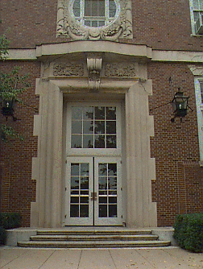
Figure 1. East entrance to the Natural Resources Building in Urbana.
https://www.isgs.illinois.edu/content/natural-resources-building-east-entrance-exterior

Instructions

Several campus locations are described below and marked on the map (Fig. 2). At these locations are examples of various kinds of rocks. Go to each place and examine the rock there. Name the rock, give its major type (igneous, sedimentary, or metamorphic) and answer the question about it. Rock names to choose from: gabbro, gneiss, granite, limestone, sandstone, slate.

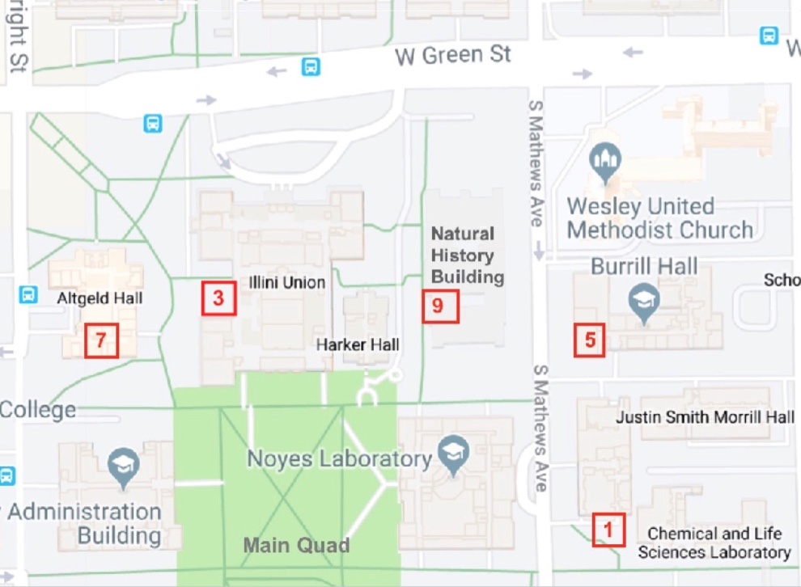
Figure 2. Map showing part of the U of I campus with rock locations marked.
https://map.illinois.edu/view

1. Location: Sculpture at the SW corner of the Chemical and Life Sciences Laboratory. What are the name and type of this rock?

Rock type: igneous / sedimentary / metamorphic

2. How many different minerals are present in this rock?

3. Location: Pavement around the fountain west of the union. What are the name and type of this rock?

Rock type: igneous / sedimentary / metamorphic

4. Is this rock foliated or non-foliated?

5. Location: Black rock forming the foundation stone of Burrill Hall. What are the name and type of this rock?

Rock type: igneous / sedimentary / metamorphic

6. What is the grain size in this rock?

7. Location: Building stones of Altgeld Hall. Find an area to examine that is not covered by lichens (the dark streaks). What are the name and type of this rock?

Rock type: igneous / sedimentary / metamorphic

8. Is this rock clastic or chemical?

9. Location: Foundation stone for the Natural History Building. What are the name and type of this rock?

Rock type: igneous / sedimentary / metamorphic

10. What are the unusual grains in this rock?

Cycling Through Rock Types

An original extra credit exercise by
Eileen Herrstrom
University of Illinois at Urbana-Champaign
herrstro@illinois.edu
2019

Context

- The audience for this activity is an undergraduate class on introductory physical geology or quantitative reasoning for non-majors.
- Students must know know about the three major rock types, the processes that form them, and the tectonic setting where they form.
- This activity is an optional extra credit exercise that follows lectures and a laboratory exercise on rocks and falls near the middle of the course.

Goals

- The content and concept goals for this activity include describing the three major types of rocks and the processes that form them.
- Higher order thinking skills goals for this activity involve modifying the basalt rock cycle for sandstone and marble and interpreting the cyclic nature of changes in rocks over geologic time using the general concept of the rock cycle.

Cycling Through Rock Types

Overview

In this activity, you use the rock cycle diagram developed by Fritof Fryxell at Augustana College, Rock Island IL, to trace Earth materials around the rock cycle.

Learning Objectives

- Describe the three major types of rocks and the processes that form them
- Modify the basalt rock cycle for sandstone and marble
- Interpret the cyclic nature of changes in rocks over geologic time using the general concept of the rock cycle

Where Do Rocks Form?

A rock is an aggregate of mineral grains or of fragments of previously existing rocks, or it is a mass of natural glass. Rocks can form in a variety of ways (Fig. 1) – through freezing of a melt, by cementation of loose grains, by precipitation from water solutions, or from changes that happen in response to temperature and pressure underground. Rocks preserve a record of the conditions under which they developed (known as the environment of formation). Thus, interpretation of rocks enables a geologist to decipher the history of the Earth.

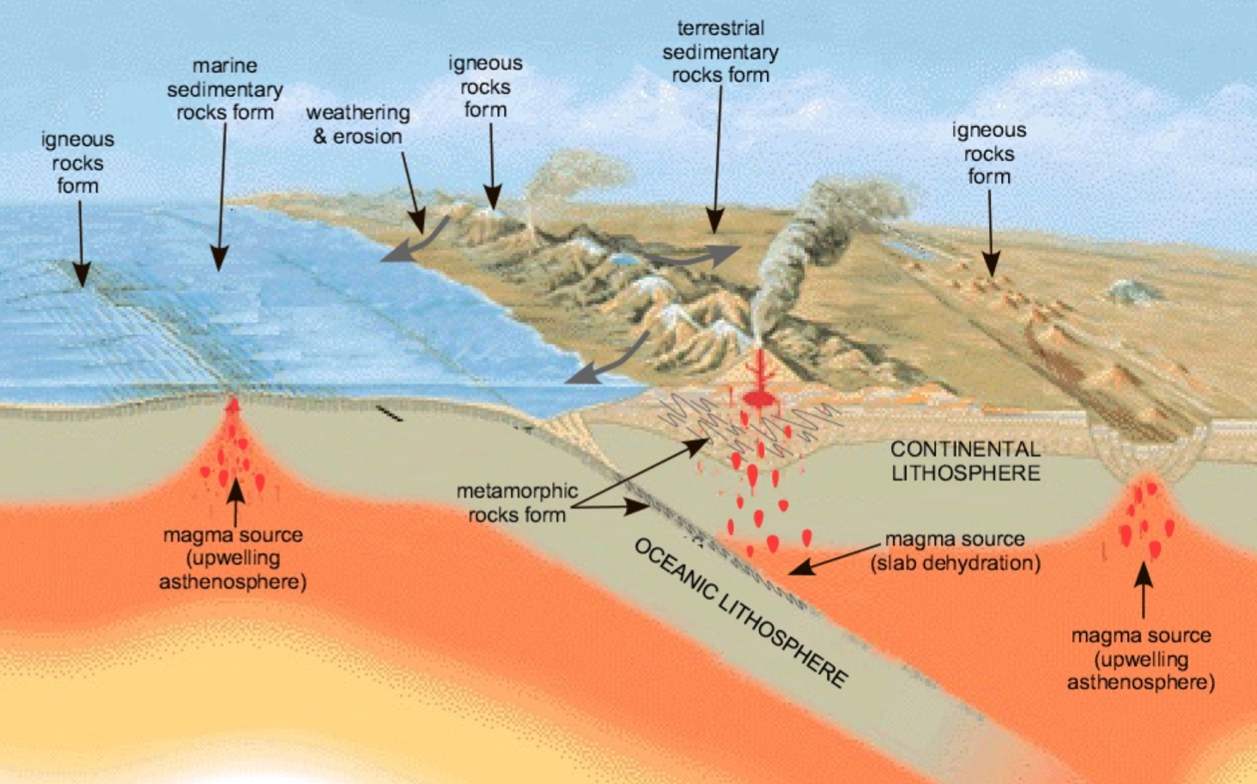
Figure 1. Environments of formation for the three major types of rocks.
Modified after https://commons.wikimedia.org/wiki/File:Tectonic_plate_boundaries.png and https://commons.wikimedia.org/wiki/File:Rock_cycle_nps.PNG
Major Rock Types

Geologists struggled for a century with the question of how to classify rocks, trying out several different systems. They finally concluded that the best method is based on how they formed. Rock composition and texture (Fig. 2) provide the basis for this classification, for these characteristics reflect the process of formation:
- Igneous rocks form through the cooling and solidification of molten rock, which originates by partial melting of preexisting rock in the mantle or lower crust. Molten rock may cool underground or erupt through a volcano and cool at the surface.
- Sedimentary rocks form at or near the surface of the Earth in two basic ways:
  - When grains of preexisting rocks accumulate, are buried, and then are cemented together by minerals that precipitate out of groundwater.
  - When minerals precipitate out of water directly (by physical processes alone) or through the life function of an organism, and form a solid mass or are cemented together later.
- Metamorphic rocks form when preexisting rocks are subjected to physical (e.g., temperature and pressure) and/or chemical conditions within the Earth that are significantly different from the conditions under which they first formed. The texture and/or composition of the original rock changes in response to the new conditions in the solid state (without melting).

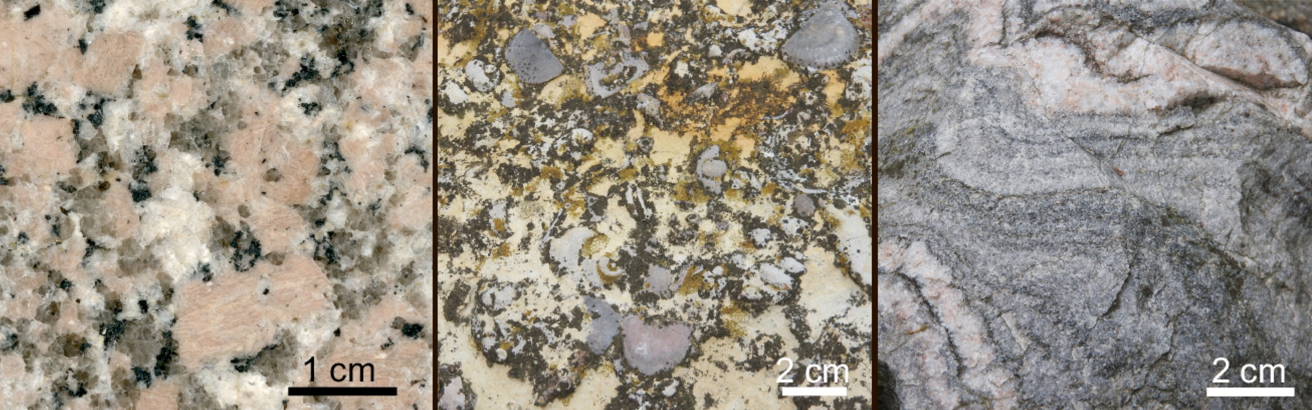
Figure 2. Granite (igneous rock, left), limestone with fossils (sedimentary rock, middle), and gneiss (metamorphic rock, right).

The Rock Cycle

On our dynamic planet, rocks do not survive forever. Nature recycles materials, so that the materials in one rock form new rocks through a series of steps called the rock cycle (Fig. 3). Loosely, this concept says that any rock may be changed into a new rock of any type, via the appropriate processes.
- If any existing rock (igneous, sedimentary, or metamorphic) is weathered and eroded and its pieces are transported, deposited, and lithified, a new sedimentary rock forms.
- If any existing rock (igneous, sedimentary, or metamorphic) is affected by heat, pressure, and/or fluids, a new metamorphic rock forms.
- If any existing rock (igneous, sedimentary, or metamorphic) is melted and then cooled, crystallized, and solidified, a new igneous rock forms.

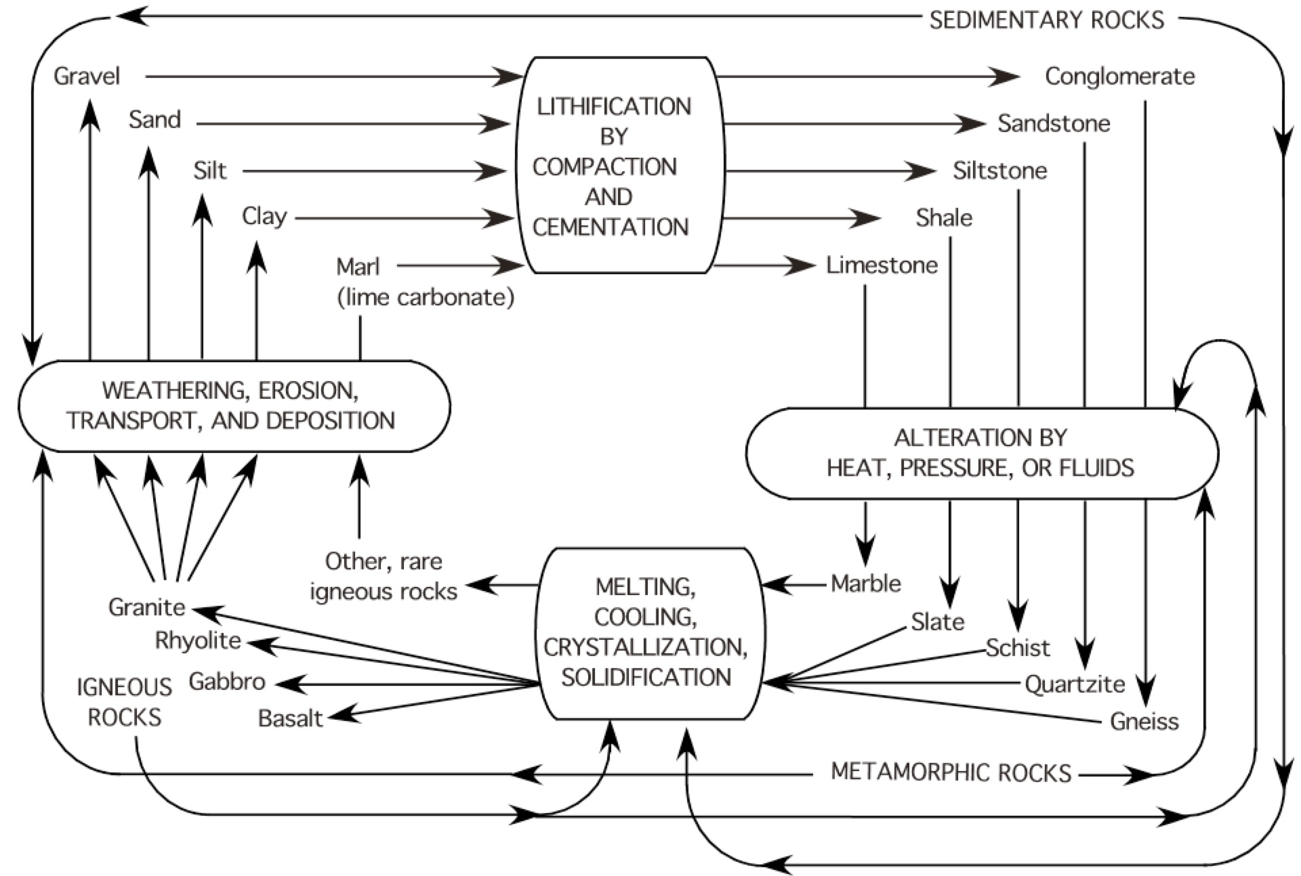
Figure 3. The rock cycle as drawn by Fryxell (1955). This diagram is more complicated than other representations of the rock cycle because it attempts to show more of the natural complexity.

Study Fig. 3 and try to trace a sediment such as gravel through the rock cycle. Note that sedimentary rocks can be weathered, etc., to form new sedimentary rocks; metamorphic rocks can be affected by heat, etc., to form new metamorphic rocks, and igneous rocks can be melted, etc., to form new igneous rocks.
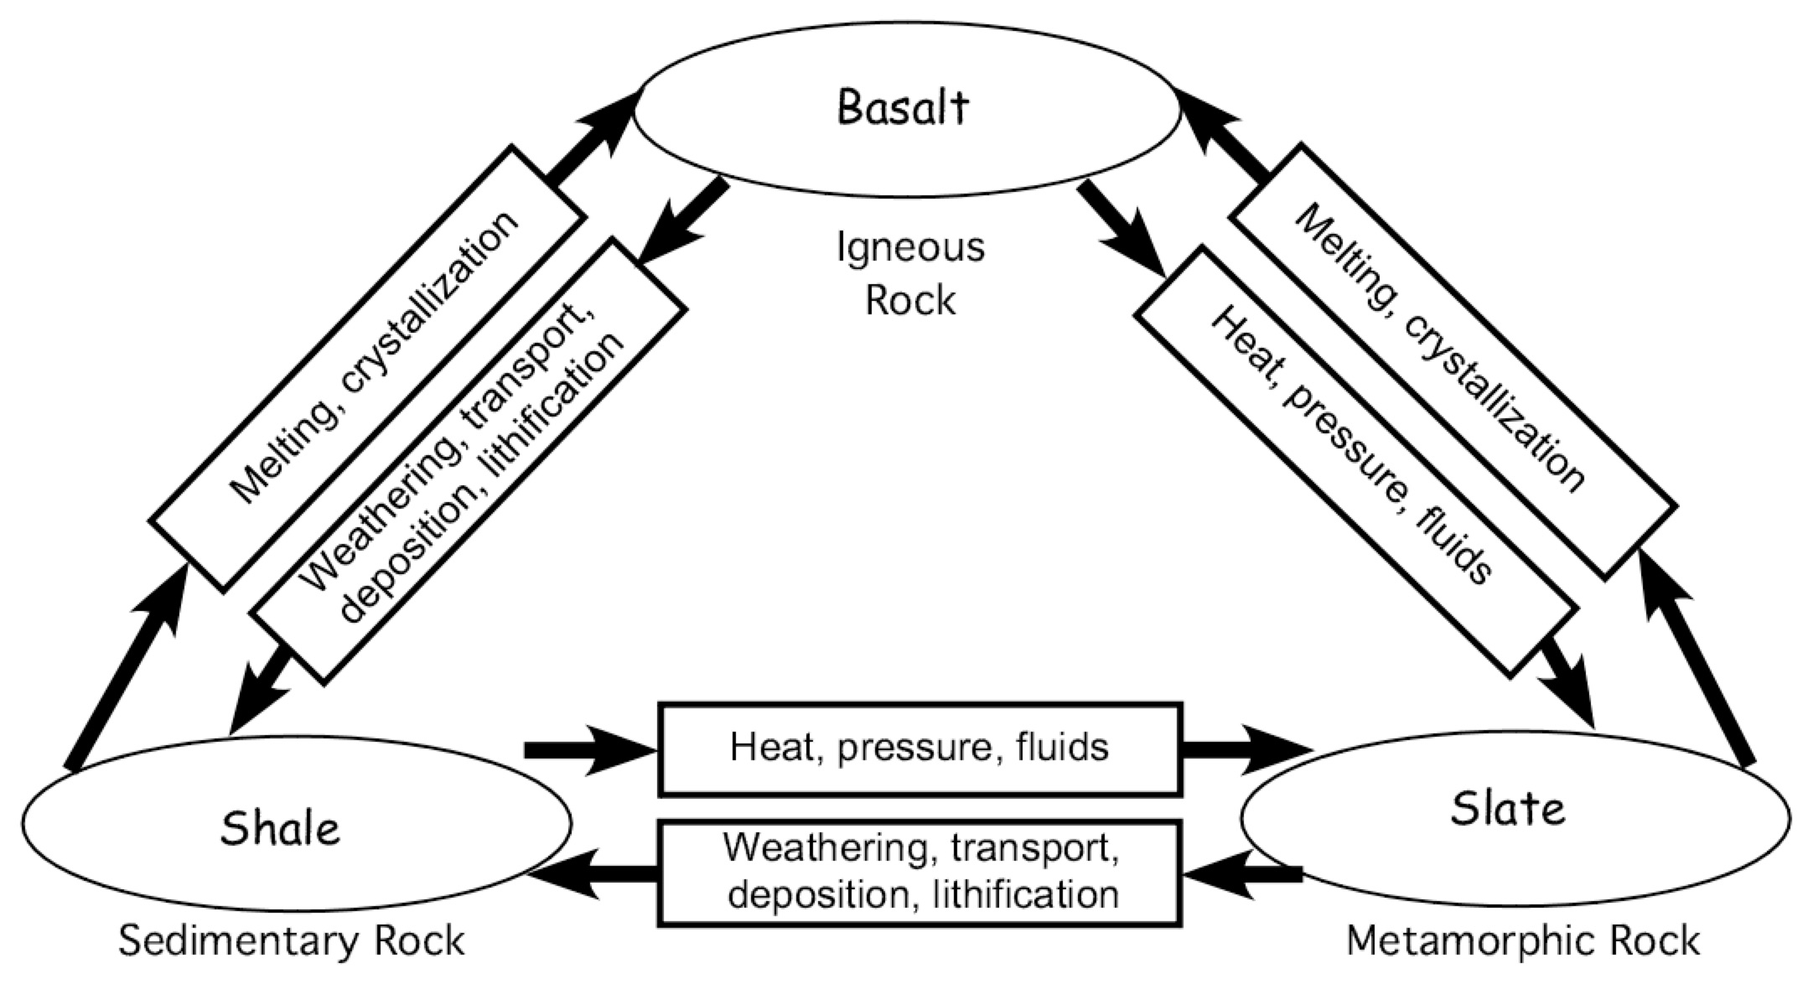
Figure 4. One possible route through the rock cycle.
1. Fill in the rock cycle below, starting and ending with sandstone. Write rock names in the ovals and processes in the rectangles.
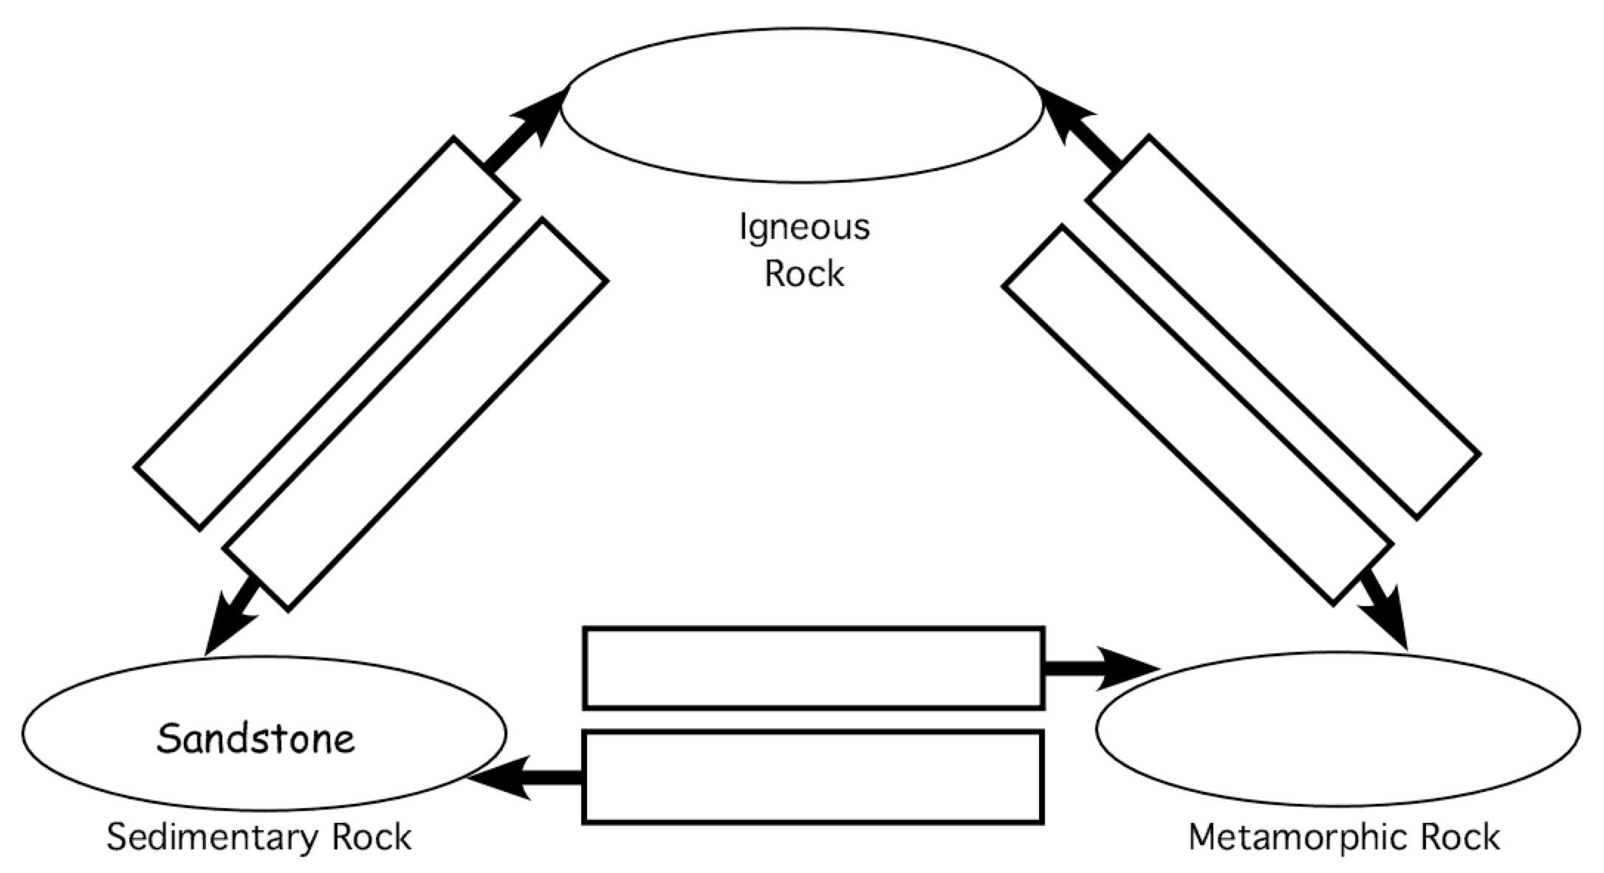

2. The sandstone rock cycle diagram is incomplete. Add arrows to finish drawing the diagram.

3. Fill in the rock cycle below, starting and ending with marble. Add arrows to complete the diagram. Make sure to include the arrows showing one rock transforming into a new rock of the same type.

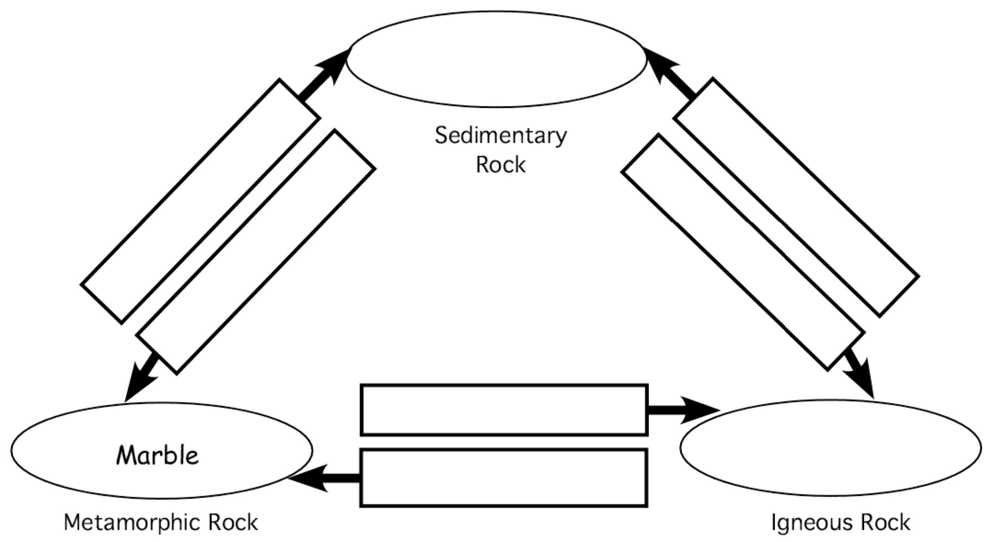
A Road Rally in Peoria IL

A laboratory exercise adapted by
Eileen Herrstrom
herrstro@illinois.edu
2019

Context

- The audience for this activity is an undergraduate class on introductory physical geology or quantitative reasoning for non-majors.
- The skills and concepts that students must have mastered involve reading a topographic map.
- This is a homework or extra credit activity that follows a laboratory exercise on topographic maps and falls near the middle of the course.

Goals

- The content and concept goals for this activity include locating various points across the topographic map and reading elevations.
- The higher order thinking skills goals for this activity involve interpreting contour lines to visualize the shape of the landscape and calculating distances and relief.

Reference

Kirchner, J.G., and Searight, T.K., 1989, A Road Rally as a Topographic Map Exercise: Journal of Geological Education, v. 37, pp. 7-9.

A Road Rally in Peoria IL

Overview

In this activity, you trace highways, calculate relief, visualize the landscape, and identify natural and artificial features on a topographic map.

Learning Objectives

- Locate various points across the topographic map and read elevations
- Interpret contour lines to visualize the shape of the landscape
- Calculate distances and relief

Navigating with a Topographic Map

Google Earth displays the landscape on your computer screen, and your phone can give you directions to almost any place. So why bother with maps? Topographic maps or quadrangles, published by the U.S. Geological Survey (USGS), are a fundamental tool for geologists and serve as the basis for developing geological maps. The Land Ordinance of 1785 mandated the systematic measurement of public lands; during the 200+ years since this legislation was passed, the USGS has surveyed and mapped more than 6 million km² (1.5 billion acres) covering most of the country. Now, both new and old topo maps are available on the USGS website at <https://ngmdb.usgs.gov/topoview/viewer/ - 12/40.6874/-89.6876>, so you could download the quadrangles for your own neighborhood and see how it has changed through time.

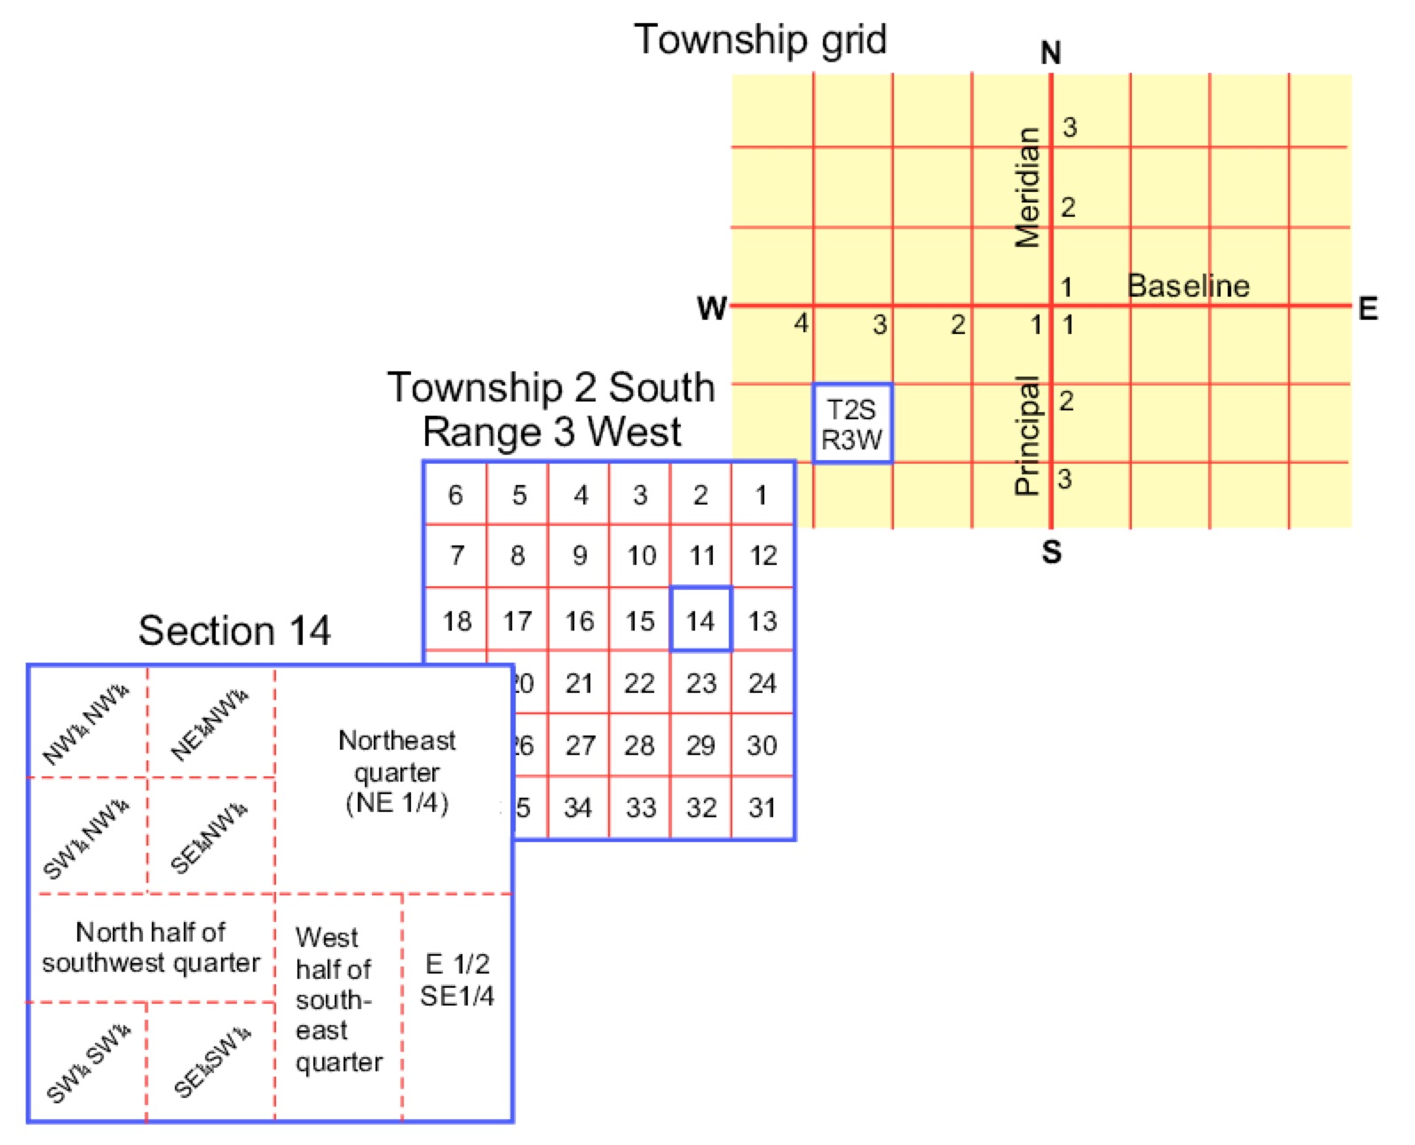
Figure 1. The Public Land Survey System created a grid of townships and ranges, which are subdivided into sections, quarter sections and quarter quarter sections.
After https://commons.wikimedia.org/wiki/File:Systemic_numbering_in_the_Public_Land_Survey_System.gif
What is a Road Rally?

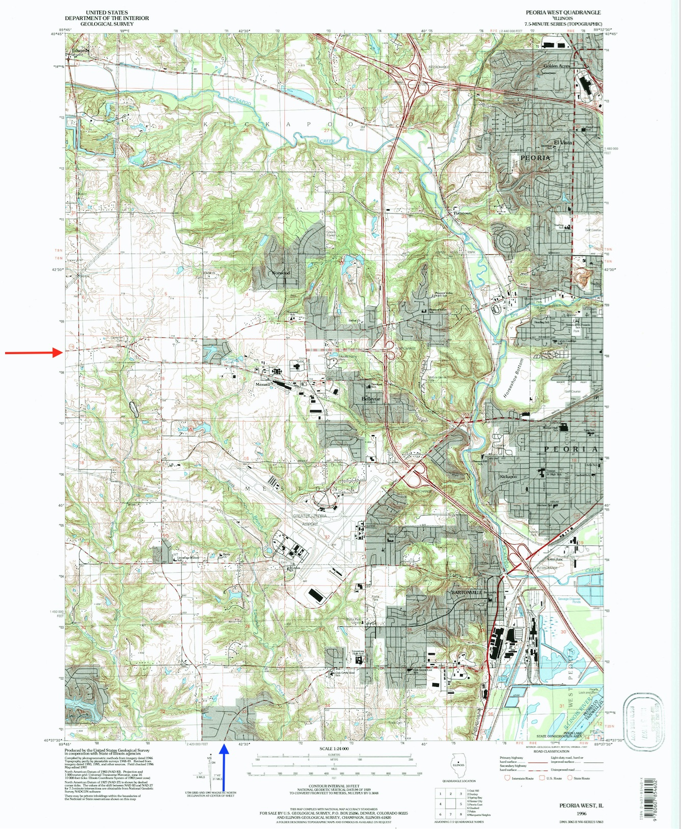
A road rally is a car sport in which participants compete to travel a route over public roads as quickly as possible. This activity is an imaginary road rally; instead of driving the route, you trace it around the Peoria West IL quadrangle. Different files of the quadrangle, as well as a chart of topographic map symbols, accompany this activity. You enter the quadrangle at the red arrow on Fig. 2 and exit at the blue arrow. Follow the directions carefully and answer the questions as you encounter them.
Please use English system units (feet, miles) instead of metric system units.

1. a. Enter the area of the map on Highway 116 near the center of the western edge (red arrow on Fig. 2). What is the elevation of the first benchmark you encounter?
Figure 2. The Peoria West IL quadrangle (1996).
https://ngmdb.usgs.gov/topoview/viewer/ - 12/40.6875/-89.6876

b. What county are you in?

2. Proceed east to the Y-intersection. What cemetery is located north of the road?

3. a. Take the right branch of the Y. Travel ~1/2 mile and take the first right turn heading south. What artificial structure do you cross immediately after turning?

b. What section are you in?

4. a. Travel to the third road on the left. Turn and travel east to the center of Section 15. What stream did you cross several times?

b. What artificial constructed area is located south of you?

c. What topographic characteristic made this area favorable for such construction?

5. Turn north and proceed to Norwood School. There, turn east and travel about 2 miles to an intersection with a secondary highway. If you continued east, what stream would you cross?

6. a. Drive north to Pottstown and cross the stream. Turn left again at the T-intersection in Pottstown. Travel north to the second road (on the south side of Big Hollow). What is the relief between the spot elevation ahead of you in Big Hollow and the spot elevation in the middle of Section 25 to the east? Show your work.

b. Continue east along Reservoir Boulevard to Sterling Avenue in El Vista. Drive south on Sterling to the T-intersection. What interesting geological feature is located northeast of the intersection?

7. Turn right. Bear left where the road branches, then turn left on the street at the mobile home park and drive south to Rohmann Avenue. What is the relief between Calvin Coolidge School and the railroad bridge about 1/2 mile to the west of the school? Show your work.

8. a. Drive east on Rohmann Avenue past Calvin Coolidge School, turn right on Sterling Avenue and drive through the golf course. What is the name of the NE-SW major road south of the golf course?

b. Directly south of the intersection, does the land slope toward you or away from you?

c. Is the slope gentle or steep? Explain your answer.

9. a. Continue south until the road becomes Griswold Avenue, and follow Griswold to Highway 24. What is the distance between Manor Parkway (just north of the golf course) and Highway 24 along Griswold/Sterling Avenue?

b. South of your position, in Section 30, what type of vegetation or land surface is present?

10. a. Take Highway 24 to Bartonville. Turn onto the secondary highway (Lancaster Road). Follow this road past Limestone High School and Oak Grove West School. In Section 34, the road turns SW and is crossed by 2 thin lines with dots. What do these lines represent?

b. Continue along Highway 24 to the south edge of the map (blue arrow on Fig. 2). What is your approximate elevation as you leave this map? This concludes the road rally. Hope you didn’t get lost!

Volcano Search

An original extra credit exercise by
Eileen Herrstrom
University of Illinois at Urbana-Champaign
herrstro@illinois.edu
2019

Context

- The audience for this activity is an undergraduate class on introductory physical geology or quantitative reasoning for non-majors.
- Students must know know about volcanic eruptions in general and specifically how they are related to tectonic plate boundaries.
- This activity is an optional extra credit exercise that follows lectures and a laboratory exercise on volcanoes and falls near the middle of the course.

Goals

- The content and concept goals for this activity include surveying erupting volcanoes around the world and selecting one to study.
- Higher order thinking skills goals for this activity involve determining basic geographic facts about the volcano, briefly summarizing its present and past geologic history and identifying its tectonic setting.

Volcano Search

Overview

In this activity, you collect information about a currently erupting volcano of your choice.

Learning Objectives

- Survey erupting volcanoes around the world and select one to study
- Determine basic geographic facts about the volcano
- Briefly summarize the present and past geologic history of the volcano and identify its tectonic setting

Erupting Volcanoes

The map of erupting volcanoes (Fig. 1) shows that most are located on plate boundaries. For example, the volcanoes of western Central and South America are spaced along the Middle America Trench and Peru-Chile Trench ocean-continent convergent boundaries and volcanic arcs. Similarly, island arc volcanoes mark the subduction zones of the western Pacific: Kamchatka, Japan, and the Philippines. Not shown because they are largely unknown are the volcanoes along the mid-ocean ridge divergent boundaries. Only rarely is underwater volcanic activity detected. Intraplate volcanoes such as Hawaii and the volcanoes of the East African rift valley are far from plate boundaries. The link below the caption of Fig. 1 leads to a map and list of volcanoes that are currently erupting and provides a starting point for your volcano search.

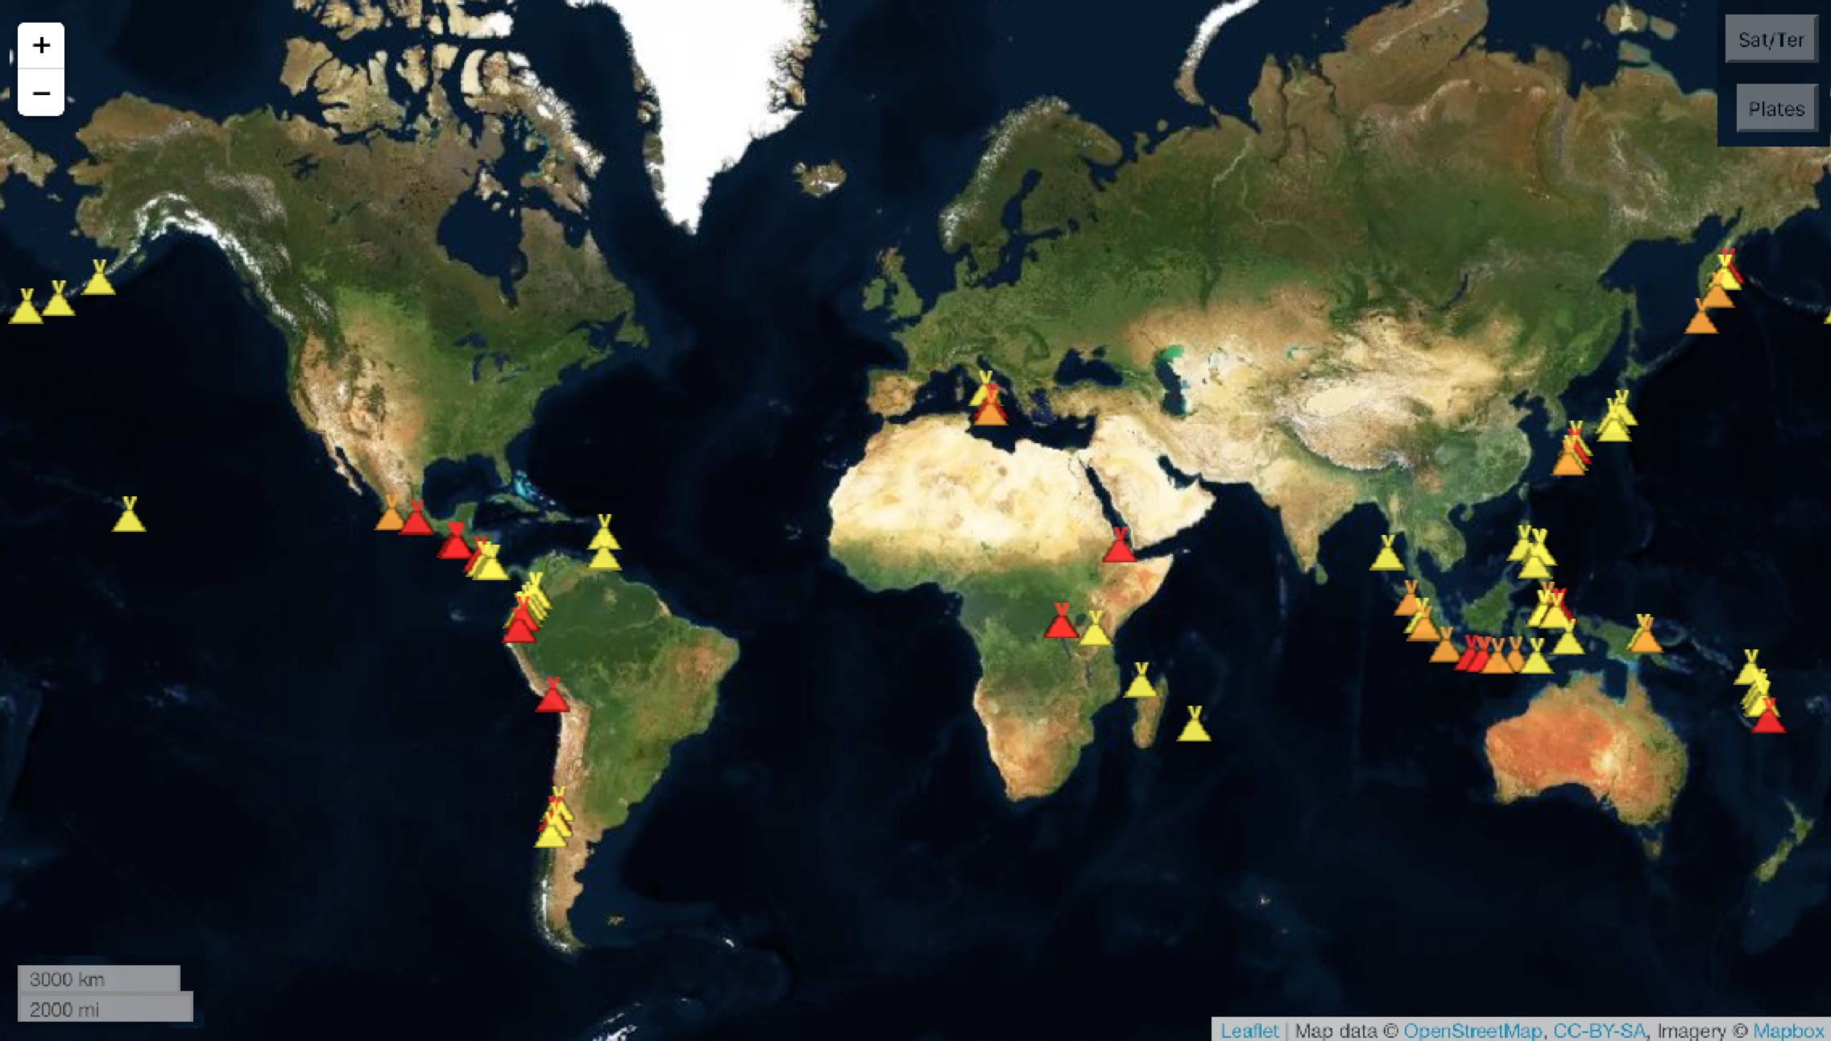
Figure 1. Active volcanoes as of 7 June 2019. Color coding: yellow = unrest, orange = minor activity, red = eruption.
https://www.volcanodiscovery.com/erupting_volcanoes.html
Instructions

Search online to find a volcano that is currently erupting. Discover as many facts about the volcano as you can, from the list below. Each correct fact about your volcano is worth 1 point, up to a total of 10 extra credit points possible. Points will be added directly to your total for the course.

- Go to the Volcano World website <http://volcano.oregonstate.edu/> and select a volcano to study.
- Using Volcano World (and any other informative website), determine the following facts and statistics about your volcano:
- Latitude and longitude
- Elevation
- Nation where located
- Type of volcano (shield volcano, stratovolcano, cinder cone)
- Plate tectonic setting (divergent, convergent, or transform boundary, or hotspot)
- Type of rock (basalt, andesite, rhyolite)
- Brief description of most recent activity (for example: lava flows, ashfalls, steam eruptions, ash-flows [or nuee ardentes], pyroclastic eruptions, lahars)
- Brief description of historical activity (i.e., activity observed and recorded during human history or length of current eruption)
- Brief description of the eruption’s effect(s) on people (evacuations, disruptions to air traffic, homes or towns destroyed, deaths)
- Record the information you found on the following page (page 3 of this file).
- Add a picture of your volcano to the file (instructions below).

Saving an Image with Windows

- Right-click on the image.
- In the Save Image window, select Save As.
- Navigate to the folder where you want to save the image, and click Save.

Saving an Image with Mac OSX

- Control-click on the image.
- In the Save Image window, select Save As.
- Navigate to the folder where you want to save the image, and click Save.

Save your document and print or upload it according to the instructor’s directions.

To view a sample of what your finished document will look like, open the example file that accompanies this exercise.

Physical Geology Name:

Volcano Search

Volcano Name:

Geographic Location Nation:

Latitude | Longitude | Elevation

Geologic Information

Volcano Type | Tectonic Setting | Main Rock Type

Description of Current Activity

Description of Historic Activity

Photograph:

[Insert here and adjust size to fit on one page.]

Caption:

Relative Dating in Geology

An extra credit exercise adapted by
Eileen Herrstrom
University of Illinois at Urbana-Champaign
herrstro@illinois.edu
2019

Context

- The audience for this activity is an undergraduate class on introductory physical geology or quantitative reasoning for non-majors.
- Students must know stratigraphic principles and be able to use them to interpret a geologic cross-section.
- This activity is an optional extra credit exercise that follows lectures and a laboratory exercise on geologic time and falls near the beginning of the course.

Goals

- The content and concept goals for this activity include applying stratigraphic principles such as superposition and cross-cutting relations to decipher the chronological order of geologic units.
- Higher order thinking skills goals for this activity involve constructing a sequence that includes faulting, tilting, and erosion and interpreting a second sequence with multiple episodes of faulting and erosion.

Reference

Harwood, R., 2011, Relative Dating #1 and #2: Online resource – accessed 21 June 2019
http://profharwood.x10host.com/GEOL101/Labs/Dating/index.htm
Relative Dating in Geology

Overview

In this activity, you use the relative dating website developed by Richard Harwood at Black Hawk College, Moline IL, to determine a sequence of geological units and structures.

Learning Objectives

- Apply stratigraphic principles such as superposition and cross-cutting relations to decipher the chronological order of geologic units
- Construct a sequence that includes faulting, tilting, and erosion
- Interpret a second sequence with multiple episodes of faulting and erosion

Stratigraphic Principles

Stratigraphy is the study of layered rocks, and geologists use several principles in this research. Superposition means that the oldest rock is at the bottom and the youngest rock is at the top. Original horizontality describes the most common deposition of sedimentary rocks in horizontal layers. Lateral continuity implies that rocks separated by a valley were once connected. Cross-cutting relations says that if A cuts across B, then A is younger than B. Other stratigraphic principles include fossil succession and the principle of inclusions.

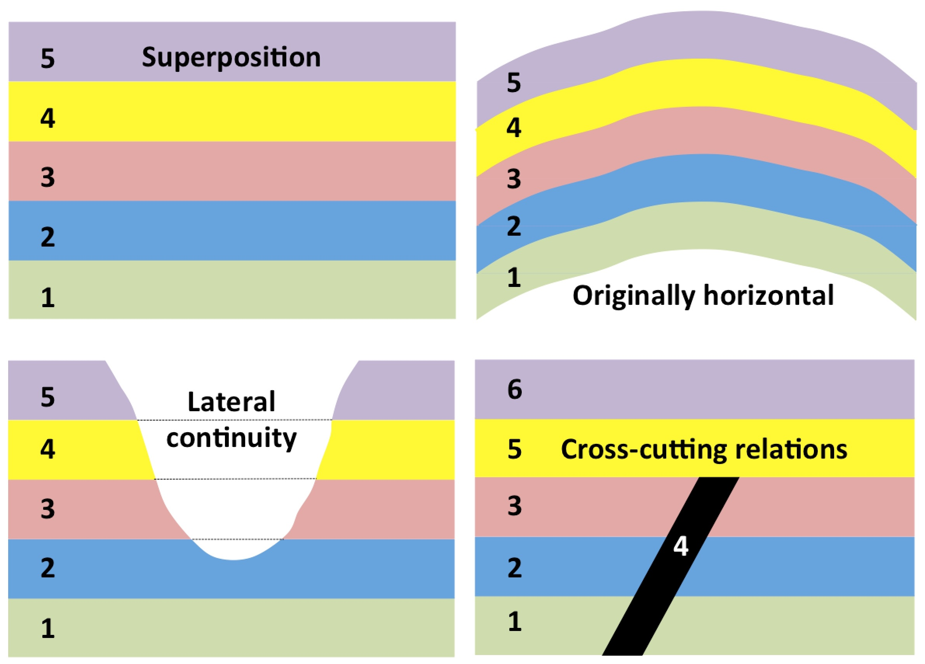
Figure 1. Illustrations of four stratigraphic principles. 1 = oldest unit.

Instructions

Go to the Earth Science Lab: Relative Dating #1 and #2 online tool at <http://profharwood.x10host.com/GEOL101/Labs/Dating/index.htm>.
- Follow the instructions listed at the top of the page.
- Enter each rock unit and structure in the proper chronological order with Event #1 = oldest and Event #20 = youngest.
- Check your answers by selecting the Grade Sequence button. Modify as necessary until you have correctly arranged the rocks and events in sequence.
- When you have EITHER correctly numbered all geologic events and seen the Congratulations box OR decided to submit your work for partial credit, take a screenshot of the worksheet by following the instructions below.

Windows Screenshot Instructions

- Press the Print Screen key on your keyboard. It is normally located in the upper-right corner of the keyboard. It may be labeled Prt Scn.
- The screenshot is now in the clipboard.
- Open a new document in Microsoft Word.
- Go to the Edit menu and choose Paste.

Mac OSX Screenshot Instructions

- Press the Command + Shift + 3 keys on your keyboard.
- The screenshot is now saved as a file on your desktop.
- Open a new document in Microsoft Word.
- Go to the Insert menu and choose Picture.
- Navigate to the Desktop and choose the screenshot file.

Additional Assistance

- Taking Screenshots in Windows
  - <http://graphicssoft.about.com/cs/general/ht/winscreenshot.htm>
- Taking Screenshots in Mac OSX
  - <http://guides.macrumors.com/Taking_Screenshots_in_Mac_OS_X>

Figure 2. Windows PrtScn (left) and Mac Screenshot on the desktop (right).

Example: Relative Dating #1

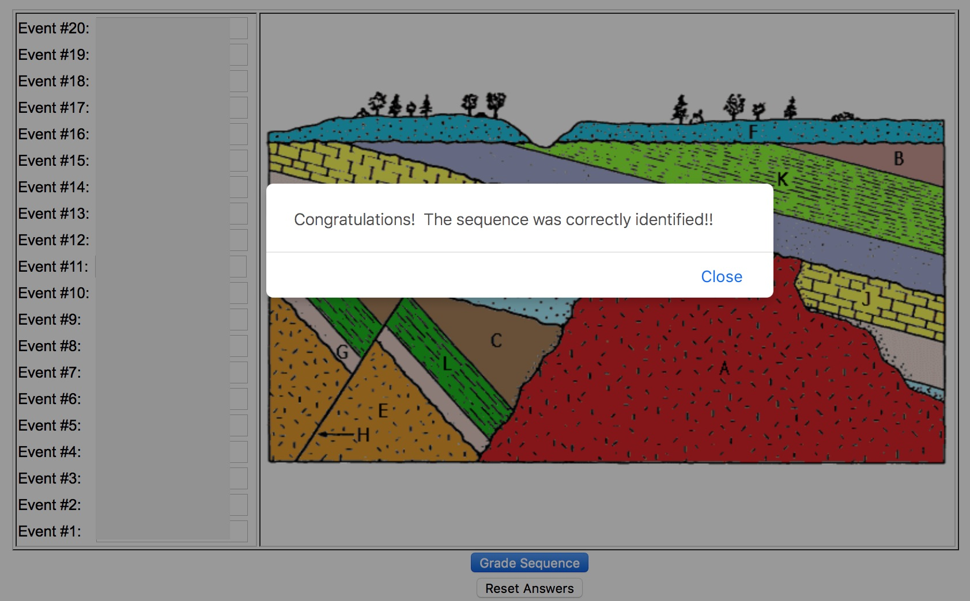
Figure 3. Screenshot showing successful arrangement of the first sequence.

If you choose to do the second sequence, click the link at the bottom to Relative Dating #2. Each correct sequence is worth 5 points, and partial credit will be given. Save and submit your Microsoft Word document according to the instructions.

Streamflow Data for Boneyard Creek, Urbana IL

An original extra credit exercise by
Eileen Herrstrom
University of Illinois at Urbana-Champaign
herrstro@illinois.edu
2019

Context

- The audience for this activity is an undergraduate class on introductory physical geology or quantitative reasoning for non-majors.
- Students must know definitions of discharge and drainage basins, have general knowledge about streams and floods and be able to manipulate data in an Excel spreadsheet.
- This activity is an optional extra credit exercise that follows lectures and a laboratory exercise on rivers and floods and falls in the last one-third of the course.
- Access to a computer is an essential part of the exercise.

Goals

- The content and concept goals for this activity include searching the USGS Water Data website for site information and for streamflow data from November 2009-February 2010 at the Boneyard Creek gaging station.
- Higher order thinking skills goals for this activity involve comparing the streamflow data with temperature and precipitation information to interpret discharge patterns at this gaging station.
- Other skills goals for this activity consist of practicing how to apply Excel to geological data.

Steamflow Data for Boneyard Creek, Urbana IL

Overview

In this activity, you obtain information from the U.S. Geological Survey (USGS) water data website for a small stream and drainage basin and examine discharge patterns for a 4-month period.

Learning Objectives

- Search the USGS National Water Information System for data about Boneyard Creek
- Determine basic facts about a specific gaging station
- Compare discharge patterns with weather data to explain changes in streamflow

About Boneyard Creek

There are several stories about the origin of the name “Boneyard.” One explanation is that the creek was full of human bones when the first European settlers arrived. According to a more recent legend, the name comes from the remains of poor students who could not manage the tough engineering curriculum.
The USGS monitors Boneyard Creek at a gaging station on the campus of the University of Illinois at Urbana-Champaign. Boneyard Creek headwaters lie in northern Champaign. The creek flows east through the university campus (Fig. 1) and then north through Urbana to its mouth. Boneyard Creek is a tributary of the Vermilion River, and its water eventually ends up in the Mississippi River. Land use in the drainage basin is virtually all urban: residential, commercial, and industrial.

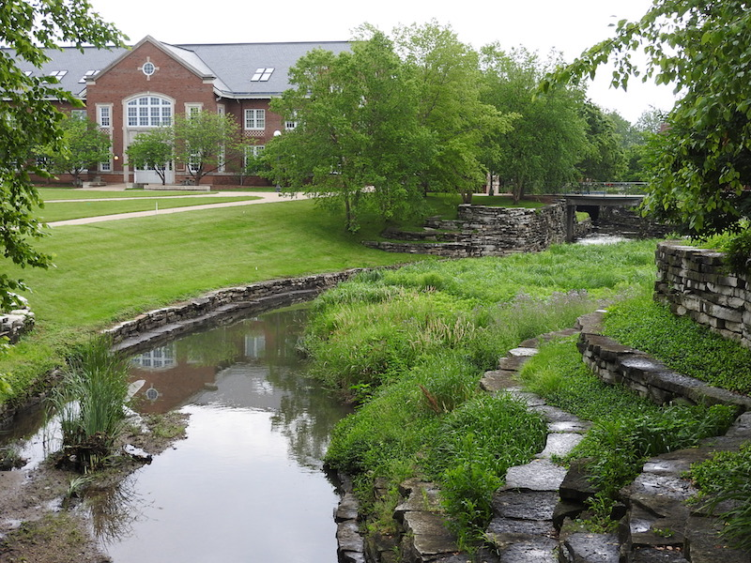
Figure 1. Boneyard Creek flowing through the University of Illinois campus.
Photograph by E. Herrstrom
A Bit of Boneyard History

Records for the campus gaging station go back to 1948. Since then, the entire watershed and channel have been greatly modified, and the natural floodplain is now highly developed. Prior to the environmental movement in the late 1960s, Boneyard Creek was practically an open sewer, with floating trash and a rotten smell. During the 1970s, many sources of pollution were removed; and water quality gradually improved.
In the late 1990s, the City of Champaign resolved to eliminate flooding near Fourth and Green Streets by building two storm detention basins upstream: one at Healey and Locust Streets and the other along Second Street between Springfield and University Avenues (Fig. 2). Since the basin was completed, the creek has experienced a dramatic increase in peak gage height, as more water remains in the channel during high flow times, instead of flooding into the streets.

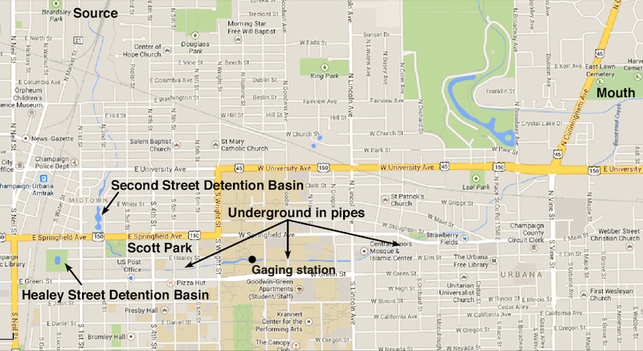
Figure 2. Boneyard Creek and city streets. The brown area is the University of Illinois campus.
Screenshot from Google Maps

1. If you are on the University of Illinois campus, find the stream gaging station on Boneyard Creek, where it flows through the Engineering Quad (east bridge). If you are not on campus, open the PDF that accompanies this activity and read all pages. What is the 8-digit number that identifies this station?

How To Find Data Corresponding to a Station Number

Go to http://waterdata.usgs.gov/il/nwis/sw/ to search for the official site description of the Boneyard Creek gaging station. Follow these steps:
- Click on the Daily Data button.
- For Site Selection Criteria, check the box for Site Number in the Site Identifier section and click Submit (Fig. 2).

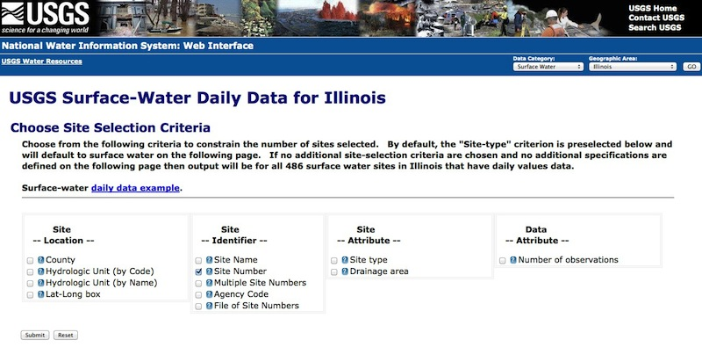
Figure 2. You should see this view at step B above.
Screenshot from the USGS Water Data website

- When the next page loads, enter the site number from question #1 in the text box (Fig. 3).
- Under Choose Output Format, go to the first section—Display Summary of Selected Sites.
- Select Site-description information.
- From the list of fields to include, scroll down and select Site name, Site type, Altitude of gage, and Drainage area.
- Scroll to the bottom of the page and click the Submit button.
- Use the information on the new page to answer the next four questions.

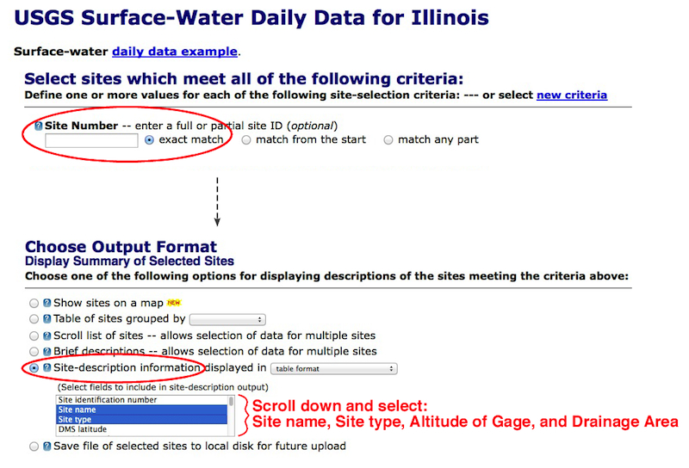
Figure 3. This view corresponds to steps C–G above.
Screenshot from the USGS Water Data website

2. What is the official name of the gaging station?

3. What is the site type for the gaging station?

4. What is the altitude (elevation) of the gage? Note that this website uses English measurement units, not the metric system, so that elevations are given in feet and areas in square miles.

5. What is the drainage area upstream of the gage?

How To Find Data for a Gaging Station

From the Site Description Information page, hit the "Back" button on your browser. This time, in the Choose Output Format section, scroll down to Retrieve USGS Surface-Water Daily Data. Select the following options:
- Retrieve data for the date range from November 1, 2009, to February 28, 2010.
- Under Output Options, check Table of data.
- Scroll to the bottom of the page and click the Submit button.
- Use the information on the new page to answer the next four questions.

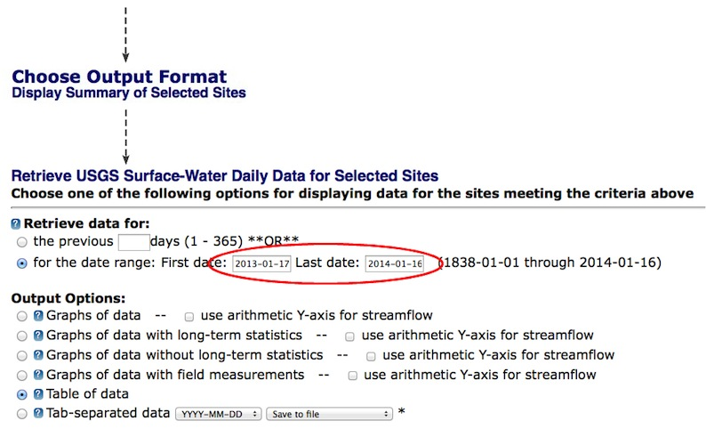
Figure 4. This page corresponds to steps I-K above.
Screenshot from the USGS Water Data website

6. Scan the data to find the dates of maximum discharge for all four months. Match each month to the day of that month when the maximum discharge occurred.

November 2009 A. 17

December 2009 B. 21

January 2010 C. 24

February 2010 D. 24-25

7. Scan the data to find the dates of minimum discharge for all four months. Match each month to the day of that month when the minimum discharge occurred.

November 2009 A. 3

December 2009 B. 6-7

January 2010 C. 10

February 2010 D. 14

8. For three of the date ranges below, discharge increased rapidly and then decreased abruptly. For which date range did discharge more than double in 24 hours and then more than double again in the next 48 hours?

November 14–19 December 23–28 January 22–27 February 20–25

9. Open the workbook file associated with this activity. For which month was heavy precipitation NOT the likely explanation for the maximum discharge?

November 2009 December 2009 January 2010 February 2010

10. What was probably the cause for the changes in streamflow during the period from January 22–27?

A. After a blizzard, snow was dumped in the creek and completely filled the channel.
B. Average temperatures above freezing quickly melted existing snow and ice cover.
C. Unusually low minimum temperatures froze the water so that it expanded and discharge increased.
D. Very heavy rainfall over a 48-hour period flowed directly into the creek from city streets.

