Stratovolcano and Shield Volcano Morphology, Eruptions, and Seismic Activity

Created by:
Mark W. Bowen
Department of Geography and Urban Planning
University of Wisconsin Oshkosh
Oshkosh, WI 54901
Phone: 920-424-7114
E-mail: bowenm@uwosh.edu

Purpose:
The purpose of this lab is for you to become familiar with differences in topography and seismic activity for stratovolcanoes and shield volcanoes.

Essential Learning Outcomes:
Calculate slope
Calculate mass and volume
Interpret topographic map data
Plot and interpret seismic data

Equipment required:
Ruler
Calculator
Computer with internet access and printer

Instructor’s Notes:
This exercise was developed for an online class and intended for students to work independently. Full-size versions of the maps used to complete Part 1 are available for free download at http://nationalmap.gov/ustopo/. Maps used for this exercise include Mount St. Helens, 1958 Washington 1:62,500 scale USGS topographic map and Hawaii, Hawaii 1975 1:250,000 scale USGS topographic map. Alternatively, students could complete most of the analyses using Google Earth and the historic topographic map layers.

Background:
The United States Geological Survey (USGS) is the primary agency in the United States for monitoring volcanoes and tectonic activity associated with them. The USGS has identified four primary volcano types: 1) cinder cones, 2) stratovolcanoes (AKA composite volcanoes), 3) shield volcanoes, and 4) lava domes. Cinder cones and lava domes are typically smaller features and are often associated with stratovolcanoes or shield volcanoes.

Stratovolcanoes are typically tall, steep-sided, and nearly symmetrical cones built from alternating layers of lava flows and ash. Most stratovolcanoes have a central crater at the summit that vents gases and lava. The lava is typically thick and resistant to flow, which prevents gases from escaping to release pressure. As a result, major eruptions of stratovolcanoes are often explosive and catastrophic, blasting away large portions of the volcano and burying several hundreds to thousands of square miles in lava and ash. Examples of stratovolcanoes include Mount Fuji in Japan, Mount Hood in Oregon, and Mount Saint Helens in Washington. In fact, most volcanoes in the United States (excluding Hawai’i) are stratovolcanoes.

Shield volcanoes are built almost entirely of lava flows because little to no ash is ejected during eruptions. Shield volcano eruptions often occur from several vents simultaneously, covering the landscape for many miles in a several-feet-thick layer of lava. The lava in shield volcanoes is less viscous and flows easily, preventing pressure from building inside the volcano. So eruptions rarely reach more than 100 m into the air, but may flow for several miles down the volcano’s flanks. The largest volcanoes in the world are shield volcanoes. The Hawaiian Islands are composed of numerous active and extinct shield volcanoes. Mauna Loa, in Hawai’i, is the largest volcano in the world.

Exercises:

Part 1 –Stratovolcano and Shield Volcano Morphology
Print Figure 1. Topographic map of Mount Saint Helens prior to the 1980 eruption to answer the following:

- What is the contour interval of the map?
(Tip: Count the number of lines between two index contours and determine the difference in elevation between the two index contours. Divide elevation difference by number of contour lines.)

Now measure a distance of two miles due north and two miles due south of the peak and plot an “A” to the north and plot a “B” to the south. (Tip: Each red square represents 1 mile.) Determine the elevation of the peak, at point A, and at point B.

- What is the percent slope of the north face of Mount St. Helens?
(Tip: Slope = elevation change / distance)

- What is the percent slope of the south face of Mount St. Helens?

Measure the width of the volcano north to south at an elevation of 4,400 feet going through the peak. Now calculate the volume of Mount St. Helens above 4,400 feet using the equation to calculate the volume of a cone. (Tip: The formula for calculating the volume of a cone is: volume = (1/3) x pi x r² x h, where pi = 3.14, r = radius of the cone, and h = height of the cone. To determine radius measure the length north to south from the 4,400 foot contour lines, going through the peak. Measure the north to south length of one red square to determine the length of one mile on the map. Divide the 4,400 foot N-S length by the red square length to get N-S distance in miles. Divide that by two to get the radius. To determine height take peak elevation minus 4,400 feet, then divide by 5,280 to convert to miles.)

- What is the volume of Mount St. Helens in cubic miles?

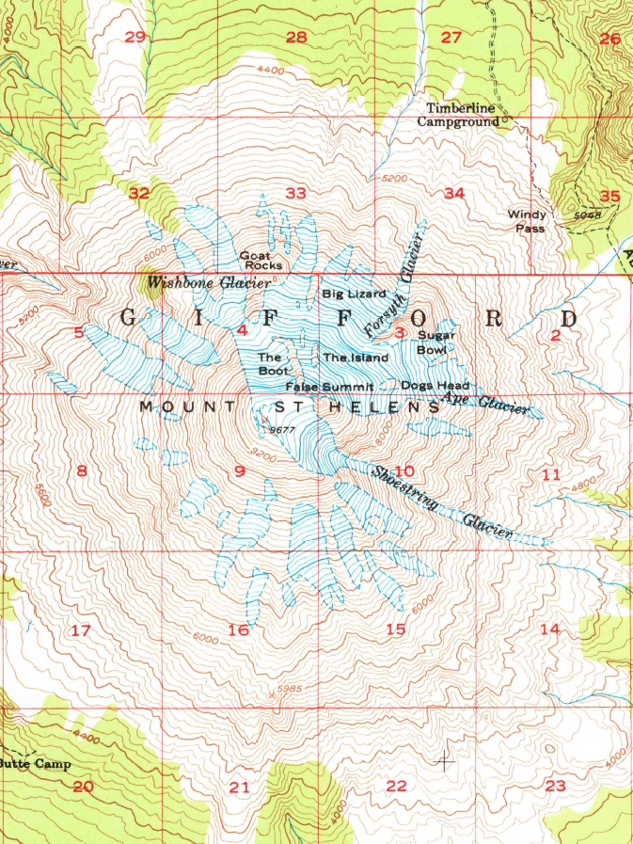
Figure 1. Topographic map of Mount St. Helens prior to the 1980 eruption
Print this map to complete measurements and calculations!
Print Figure 2. Topographic map of Mauna Loa to answer the following:

- What is the contour interval of this map?

Now measure a distance of 12.5 miles due north and south of the peak and plot an “A” to the north and plot a “B” to the south. (Tip: Each red square represents 6.25 miles.) Determine the elevation of the peak, at point A, and at point B.

- What is the percent slope of the north face of Mauna Loa?

- What is the percent slope of the south face of Mauna Loa?

Measure the width of the volcano north to south at an elevation of 7,000 feet going through the peak. Now calculate the volume of Mauna Loa above 7,000 feet using the equation to calculate the volume of a cone.

- What is the volume of Mauna Loa in cubic miles?

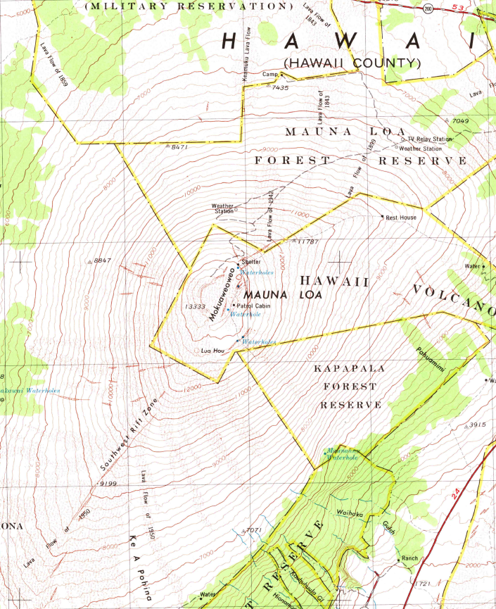
Figure 2. Topographic map of Mauna Loa, Hawai’i
Print this map to complete measurements and calculations!

Part 2. Volcanic Eruptions and Seismic Activity
Navigate to the following website to read U.S. Geological Survey Fact Sheet 036-00 Mount St. Helens – From the 1980 Eruption to 2000: http://pubs.usgs.gov/fs/2000/fs036-00/fs036-00.pdf

- Approximately how many days passed between the first seismic activity and the first explosion to blast a crater through the summit?

- What was the percent volume of the volcano removed by the May, 1980 eruption? (Tip: To calculate percent volume removed, determine volume removed from volcano in the reading, then divide that by your answer to number 4 above.)

- The lateral blast from the eruption produced a column of ash and gas that rose how far into the atmosphere?

- How fast did the avalanches of hot ash, pumice, and gas (i.e., pyroclastic flows) flow down the mountain?

Navigate to the following website to read Mauna Loa 1984 Eruption: March 25 – April 15 http://hvo.wr.usgs.gov/maunaloa/history/1984.html

- Approximately how much time passed between the first earthquakes and the first eruption?

- The summit of the volcano began inflating how many years before the eruption?

- Mauna Loa began erupting on March 25 as a curtain of fountains. How high in the air did these lava fountains reach in feet? (Tip: There are 3.28 feet in one meter)

- The fountains eventually coalesced to create four parallel lava flows down the mountain. How fast did these flows move down the mountain?

Use the earthquake data provided in Tables 1 and 2 to plot on the graph paper below the number of earthquakes for each listed day. X axis is Day #. Y axis is # Earthquakes / Day. Plot the data for both volcanoes on the same graph. Do not plot data for dates/days not included in the table.

Table 1. Number of earthquakes per day >3.2 magnitude, Mount St. Helens March to May, 1980.

Date | Day # | # Earthquakes / Day
20-Mar | 1 | 1
22-Mar | 3 | 1
25-Mar | 6 | 32
29-Mar | 10 | 139
31-Mar | 12 | 72
4-Apr | 16 | 82
10-Apr | 22 | 57
13-Apr | 25 | 61
20-Apr | 32 | 53
25-Apr | 37 | 32
27-Apr | 39 | 37
30-Apr | 42 | 24
6-May | 48 | 36
10-May | 52 | 20
12-May | 54 | 34
13-May | 55 | 19
14-May | 56 | 25
15-May | 57 | 18
17-May | 59 | 23
18-May | 60 | 12
19-May | 61 | 6
21-May | 63 | 3
24-May | 66 | 1
28-May | 70 | 2

Table 2. Number of earthquakes per day >2.0 magnitude, Mauna Loa, February to April, 1984. Only days with 3+ earthquakes greater than magnitude 2.0 are included.

Date | Day # | # Earthquakes / Day
21-Feb | 1 | 3
23-Feb | 3 | 3
25-Feb | 5 | 4
28-Feb | 8 | 4
1-Mar | 9 | 5
4-Mar | 12 | 3
7-Mar | 15 | 3
8-Mar | 16 | 4
9-Mar | 17 | 5
10-Mar | 18 | 5
11-Mar | 19 | 6
12-Mar | 20 | 4
14-Mar | 22 | 4
17-Mar | 25 | 3
18-Mar | 26 | 5
20-Mar | 28 | 4
21-Mar | 29 | 7
22-Mar | 30 | 3
25-Mar | 33 | 15
26-Mar | 34 | 3
28-Mar | 36 | 3
30-Mar | 38 | 3
1-Apr | 40 | 4
2-Apr | 41 | 4
5-Apr | 44 | 5
6-Apr | 45 | 3
9-Apr | 48 | 4
18-Apr | 57 | 5
19-Apr | 58 | 3
22-Apr | 61 | 4

1 10 20 30 40 50 60 70

180

160

140

120

100

80

60

40

20

0
- How did the number of earthquakes per day change over time for Mount Saint Helens after the large number of earthquakes on March 29?

- How did the number of earthquake per day change over time for Mauna Loa?

Prior to the 1980 eruption of Mount Saint Helens, most of our knowledge of volcanic eruptions was based on studies of Hawaiian volcanoes.

- Do you think seismicity data could have been used to reliably predict the eruption of Mount Saint Helens on May 18, 1980? Why or why not?

- Do you think seismicity data could have been used to reliably predict the eruption of Mauna Loa on March 25, 1984? Why or why not?

Something to consider…
How do stratovolcanoes and shield volcanoes compare in size, earthquake activity, and explosiveness of eruptions?

