Rivers and Floods in Tampa FL
on the Sulphur Springs Quadrangle
Part I: Drainage Basins
Part II: Floods
Part III: Discharge

An original laboratory exercise by
Eileen Herrstrom
University of Illinois at Urbana-Champaign
herrstro@illinois.edu
2018

Context

- The audience for this activity is an undergraduate class on introductory physical geology, natural disasters, or geology and society.
- Skills and concepts that students must have mastered include knowing how to read topographic maps and having basic skills with Microsoft Excel (entering formulas, filling down, and making charts).
- This activity is a laboratory exercise that follows lectures on rivers and floods. It is one of two exercises based on the Sulphur Springs quadrangle and falls near the end of the course.

Goals

- The content and concept goals for this activity include describing the general topography of the Sulphur Springs Fl quadrangle, identifying drainage divides on the map, and differentiating between tributary and trunk streams in terms of map view and flood potential.
- Higher order thinking skills goals for this activity involve calculating flood frequency and probability for two steams, creating a recurrence graph with Microsoft Excel, interpreting the results, and comparing recurrence curves for the trunk river and a tributary stream.
- Other skills goals for this activity consist of determining the reason for high discharges on particular dates, comparing responses of the trunk river and a tributary stream, and applying the knowledge gained to decide whether to purchase property in the floodplain.

Rivers and Floods in Tampa FL
on the Sulphur Springs Quadrangle
Part I: Drainage Basins

Overview

In this exercise, you work with a US Geological Survey (USGS) topographic quadrangle showing part of the metropolitan area of Tampa FL. The first part of the exercise defines basic terminology and introduces the map. Then, you study the topographic map and transfer specific information to a sketch map of the quadrangle.

Learning Objectives

- Identify several features on a topographic map
- Locate drainage divides on the topographic map
- Outline the drainage basins of small streams on a sketch of the quadrangle

Rivers and People

From ancient times, people have settled by rivers, using the flowing waters for drinking and bathing, irrigation, travel, power generation, and recreation. Many cities are located along rivers, including Tampa, FL, on the Hillsborough River. Although the rivers around the Tampa area are generally small, the dense urban population there has led to intense study of the local hydrology including both surface waters such as rivers and lakes and subterranean waters (groundwater). The Hillsborough River begins at Green Swamp (Fig. 1.1). Many smaller streams flow into the river along its 95-km (59-mile) length. Some of the these small streams lie completely within the city limits of Tampa and its suburbs, which is part of the reason scientists have been studying this area so thoroughly for decades.

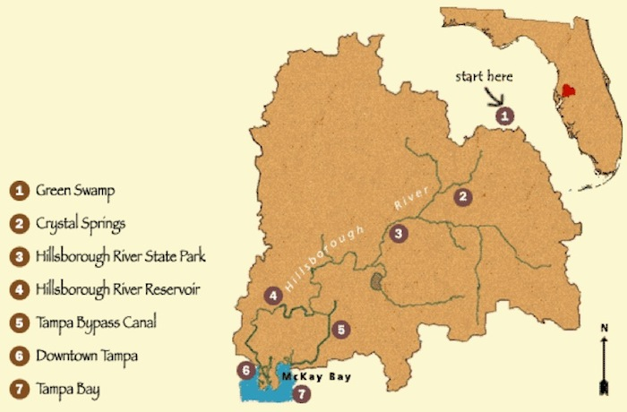
Figure 1.1. The Hillsborough River drainage basin. The Sulphur Springs quadrangle is near #4.
<https://www.swfwmd.state.fl.us/education/interactive/watershed/>
River Terminology

The trunk stream (main river) running through Tampa is the Hillsborough River, which begins at Green Swamp (the river's source, or headwaters; Fig. 1.2). Tributaries, or smaller streams flow into the trunk stream.
If you travel along the length of a river away from the source, you are going with the flow of the water. This is called the downstream direction. If you travel toward the source, you are moving against the flow, or in the upstream direction.
The mouth of a river is its end, where its water flows into a different body of water (ocean, lake, or another river). In downtown Tampa, the Hillsborough River flows into Hillsborough Bay, and from there, it eventually reaches the Gulf of Mexico.
A drainage basin (or watershed) is the entire land area that contributes water to a river. All rain that falls within the drainage basin either soaks into the ground or runs downhill toward the river. In urban areas, most rainfall enters a system of storm sewers that lead to the river.
The drainage basin of one river is separated from the drainage basins of neighboring streams by high ground called the drainage divide. The watershed of the Hillsborough River encompasses ~1900 km² (740 square miles).

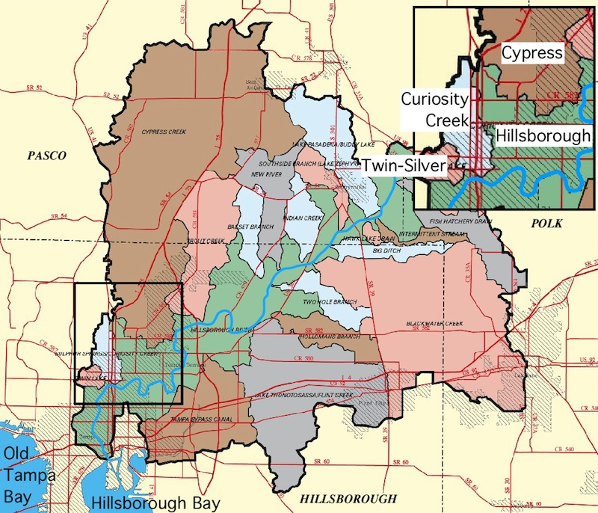

Figure 1.2. The drainage basin of the Hillsborough River and subbasins for its tributaries. The rectangle outlines the Sulphur Springs quadrangle, and the inset map provides an enlarged view of the quadrangle. Diagonal ruling indicates urban areas.
<http://fcit.usf.edu/florida/maps/pages/11600/f11657/f11657.htm>

Download and uncompress the .zip file for this exercise. Open the topographic map of the Sulphur Springs FL quadrangle. The map is provided in two formats (PDF and JPG) so that you can find the one that works better on your computer; i.e., you should be able to zoom in and read all the text.

1. Scroll around the topographic map of Sulphur Springs. The pattern of contour lines as a whole reveals the general character of the landscape. Is the terrain mostly flat, mostly steep, sloping gently overall from north to south, or sloping irregularly in many directions?

2. The highest point on this map is in the Temple Terrace area (southeast part of map), where the 75-ft contour line and several higher contours may be found. The lowest point is where the Hillsborough River flows off the southern edge of the map and the elevation is below the 25-ft contour line. What is the total relief for the entire quadrangle (i.e., the difference between the highest and lowest points)?

3. Most of the northeast part of the map is covered with symbols for marsh or swamps. Buck Hammock is not marked with these symbols, and parts of Rock Hammock are similarly free of marsh symbols. What do you think is the local definition of the term “hammock” as used here?

4. Lake Magdalene is one of the largest lakes on the Sulphur Springs quadrangle. In which part of the map is Lake Magdalene located?

5. Locate Curiosity Creek, approximately 1 mile east of Lake Magdalene. On the sketch map of the Sulphur Springs quadrangle (Fig. 1.3 - PDF), draw in the approximate path of Curiosity Creek.

6. How did Curiosity Creek get its name? In other words, what is “curious” about this creek? Hint: Find its source and its mouth on the map.

Drainage Divides on the Sulphur Springs Quadrangle

7. First, outline the divide that surrounds the drainage basin for Curiosity Creek. The divide on the north side of this basin runs from east of Platt Lake to north of Lake Gass and west of Long Lake (this lake is on the quadrangle but not on your map). For the eastern divide, draw a line along Interstate 275 to Fowler Avenue, then east of Nebraska Avenue. On the west side, the divide runs east of Platt Lake and Lake Magdalene, continues south between Lake Carroll and Lake Eckles, and then bends toward Sulphur Springs (near the bridge where Interstate 275 crosses the Hillsborough River). Refer back to the topographic map and Fig. 1.2 to help you finish drawing the complete drainage divide.

8. In the northeast quarter of the map, draw a line along the south and west edges of the marshy area to show the Cypress Creek drainage divide. Note: On the topographic map, the extreme northeastern part of the Sulphur Springs quadrangle includes part of another basin. Ignore this, and include it in the Cypress Creek basin.

9. In the southwest quarter of the map, Twin Lake and Lake Silver drain through an unnamed creek to the Hillsborough River. Draw a line starting at the west edge of the map about halfway between Twin and Silver Lakes. Curve around Twin Lake, staying south of White Trout and Boat Lakes. Continue your line southeastward until it reaches the Hillsborough River across from Riverview Terrace Playground (on the topographic map but not on your map). Notes: (1) In Fig. 1.2, the extreme southwestern part of the Sulphur Springs quadrangle includes part of another basin. Ignore this, and include it in the Twin–Silver basin. (2) There is a small area between the Twin–Silver watershed and the Curiosity watershed that drains directly to the river.

10. The northwest part of the Sulphur Springs quadrangle lies outside of the Hillsborough River watershed. Precipitation that falls in this area flows into Sweetwater Creek, which flows directly into Old Tampa Bay (northwest of Hillsborough Bay). Starting at the north end of the Curiosity basin, draw a line northeast to the edge of the Cypress Creek divide, staying south of Chapman Lake. The Sweetwater basin extends all the way south to the Twin–Silver divide.
The land north of the Hillsborough River and between the Curiosity Creek and Cypress Creek basins drains directly to the river. Label the drainage basin for each tributary and the trunk stream north of the Hillsborough River on your map.

Rivers and Floods in Tampa FL
on the Sulphur Springs Quadrangle
Part II: Floods

Overview

In this exercise, you work with streamflow data collected by the USGS in Tampa FL. The first part of the lab defines basic terminology about floods and how they are measured. In the second part of this lab, you determine the frequency of flooding for the trunk stream flowing through Tampa. Finally, you construct a recurrence curve for this river.

Learning Objectives

- Explain flooding in terms of discharge, recurrence, and probability
- Construct a recurrence curve using Microsoft Excel
- Use flood frequency graphs to analyze streamflow data

A Common Natural Hazard

Floods are ubiquitous geologic hazards, affecting more people than all other geologic hazards combined (earthquakes, volcanoes, landslides, etc.). In the United States, about 10% of the population lives in flood-prone areas (Fig. 2.1). Development of cities along rivers can intensify the effects of flooding, because pavement and buildings prevent rainwater from soaking into the ground. Instead, the water runs quickly into the river. Storm sewers also send rainwater directly from streets into the river. A large rainstorm along a stream such as the Hillsborough River produces worse floods today than a storm of the same size in 1900, before intensive urban development occurred. In spite of these potential problems, many people are unfamiliar with the basic ideas involved in flooding and flood control.

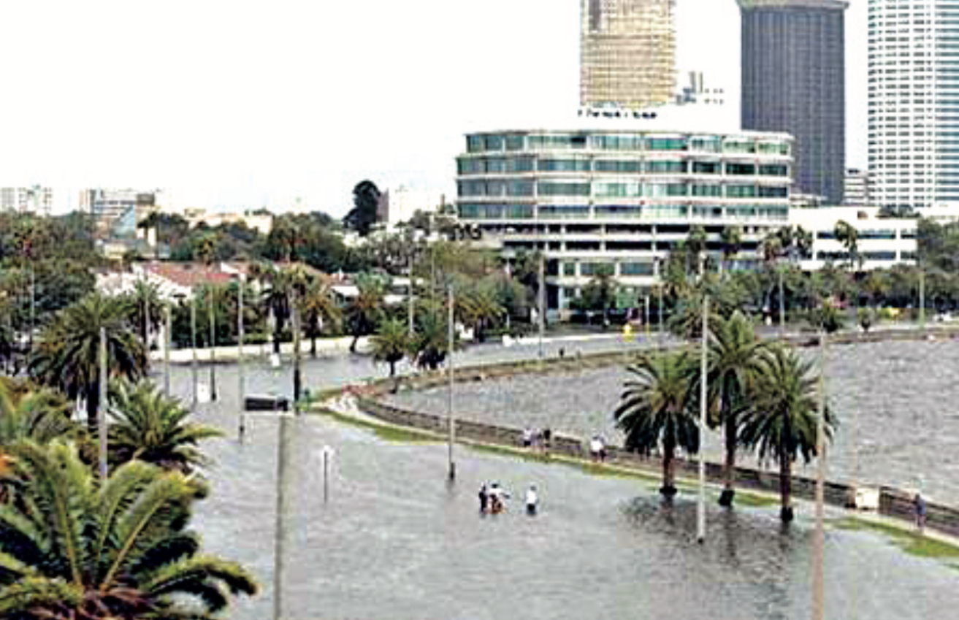
Figure 2.1. Flooding in downtown Tampa FL near the mouth of the Hillsborough River.
<https://pubs.usgs.gov/fs/2005/3028/> (Figure 5)
What is a 100-Year Flood?

You may have heard terms such as “10-year flood” or “100-year flood” in news reports. Floods are classified by applying flood frequency analysis. The method uses historical records of the size of floods, as measured by the maximum water depth or the maximum discharge. The discharge of a river is defined as the volume of water passing a given point along the channel within a given period of time. Discharge has dimensions of volume/time; in metric units it is expressed as m³/sec, and in English units, it is usually given in cubic feet per second (cfs). The historical records allow us to calculate, for a given flood, the recurrence interval (average number of years between occurrences of the same size flood) and probability (risk of a flood of this size in a given year).
Recurrence and probability differ from river to river, and from point to point along one river. Flash floods that occurred in the Rocky Mountains and eastern plains of Colorado in 2013 had estimated recurrence intervals ranging from 100 years up to 1,000 years! This event (precipitation plus flooding) was unprecedented in recorded history for the state.
Note that if a 50-year flood occurs along a stream such as the Hillsborough River, it is false that this area will not be flooded to the same level for another 49 years. It is possible to experience a 50-year flood in two consecutive years although the probability of such an event is very low.

Flood Frequency Analysis

How do we calculate recurrence and probability? Suppose that we have N years of data (gage height or discharge) for a stream. Arrange the floods in order from largest to smallest, and number them as follows: largest flood = 1, second-largest flood = 2, ... smallest flood = N. The number for each flood is called its rank R. The recurrence interval I of a flood of a particular size is defined by the formula:

I = (N + 1) / R (1)

The probability P of a flood of a particular size (given in terms of a percentage chance of flooding each year) is defined by the formula:

P = (100 / I) % (2)

Table 1 illustrates the general procedure of flood frequency analysis for Cypress Creek, one of the tributary streams of the Hillsborough River whose drainage basin you drew in Part I. This example shows only 7 years of data, but the full dataset covers 52 years from 1965 to 2016. In general, the longer the historical record is for a river's behavior, the more reliable the estimates are for recurrence interval and probability of flooding.

Table 1. Rank, recurrence interval, and probability of flooding along Cypress Creek FL.

Year | Discharge (cfs) | R | I (years) | P (%)
2004 | 1820 | 1 | 53 | 1.9
1965 | 1750 | 2 | 27 | 3.8
2015 | 1580 | 3 | 18 | 5.7
1982 | 1540 | 4 | 13 | 7.6
1987 | 1450 | 5 | 11 | 9.4
1997 | 1370 | 6 | 9 | 11.3
… | … | … | … | …
1999 | 59 | 52 | 1 | 98.1

Recurrence Curves

A graph of discharge vs. recurrence interval is known as a recurrence curve (Fig. 2.2). Such a chart shows recurrence interval on the X-axis and some measure of the size of the flood (e.g., discharge or water depth) on the Y-axis. Recurrence curves are different for each river and for various points along a single river.

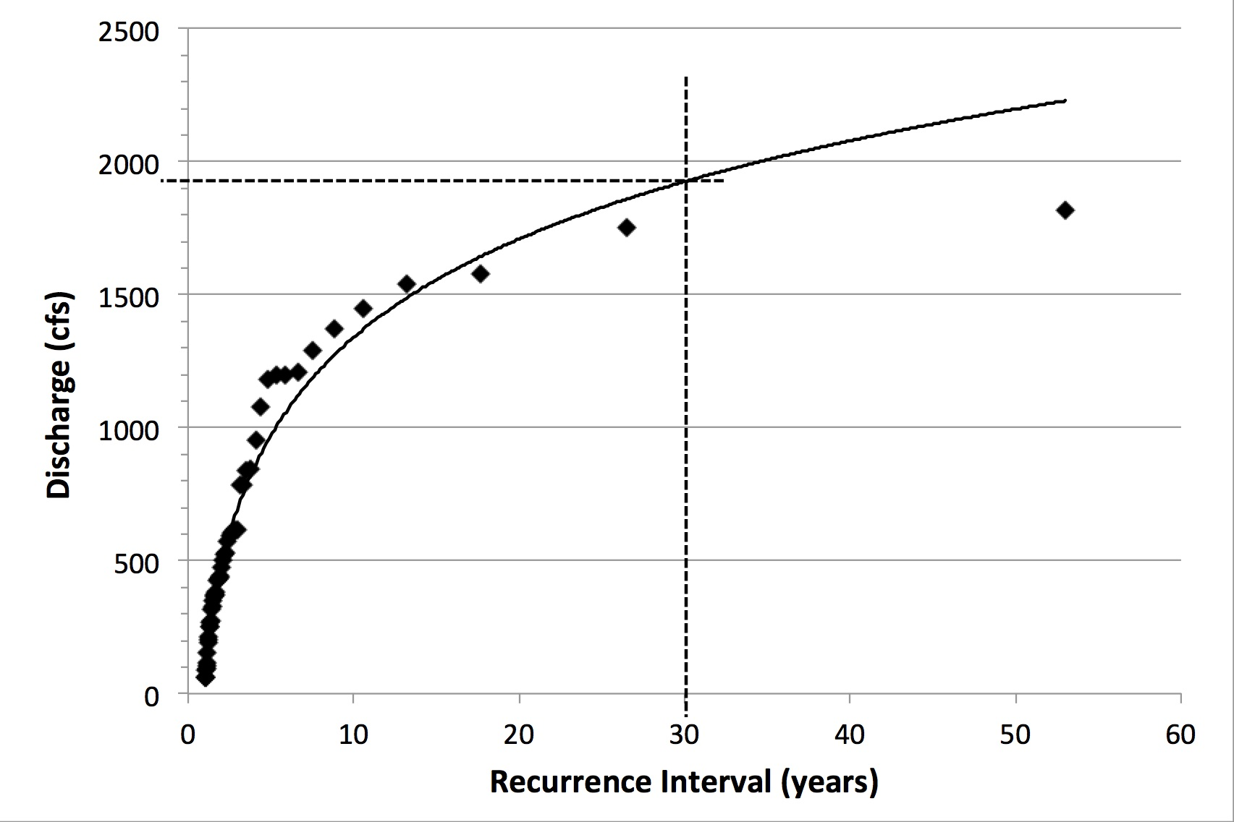

Figure 2.2. Recurrence curve for Cypress Creek. The graph may be used to estimate the recurrence interval for a particular size flood or to determine the size of flood that corresponds to a specific recurrence interval. For example, a 30-year flood has a discharge of 1920 cfs, as shown by the dashed lines.

1. Open the spreadsheet that accompanies this exercise, and select the “Hillsborough” worksheet. Columns A and B give the year and discharge data, respectively, for the Hillsborough River in Tampa, FL. What is the value of N (i.e., how many years of data are recorded)?

2. To determine rank, you first rearrange the data according to the size of the flood. Excel calls this process “sorting.” Highlight all of the cells that contain data in columns A and B (not the titles or headings). Click on the Data tab in the ribbon, then on the “Sort” icon. Go to “Custom Sort,” and sort on column B from largest to smallest. In what year did the largest flood occur?

3. In what year did the smallest flood occur?

4. To find the rank R of each flood, enter the value “1” in cell C4 and “2” in C5. Highlight C4:C5, and drag down to fill in column C with consecutive numbers. What is the rank of the largest flood?

5. What is the rank of the smallest flood? Note that this is also the value of N.

6. Calculate the recurrence interval I for the largest flood by entering formula (1) in cell D4. Then fill down column D. What is the recurrence interval for the flood with rank = 8?

7. What is the recurrence interval for the flood with rank = 16?

8. Calculate the probability of each flood by entering formula (2) in cell E4. Then fill down column E. What is the probability that a flood the size of the one with rank = 8 will occur in any given year?

9. What is the probability that a flood the size of the one with rank = 16 will occur in any year?

How To Make a Recurrence Curve with Excel

To finish, you must graph a recurrence curve (recurrence interval vs. discharge). The X-values for this graph are in column D, and the Y-values are in column B. Making the chart requires you to use two Excel techniques: selecting nonadjacent columns and switching X-values and Y-values.
Why is this second step necessary? When you select data for a scatter chart, whether or not the columns are adjacent, Excel always uses the left column for X-values and the right column for Y-values. Thus, if columns B and D are selected, Excel automatically uses column B for the X-values, which would not be correct for a recurrence curve.
The exact steps for making the chart differ depending on which version of Excel you use. Thus, general instructions are provided for Windows (PC) computers and Macintosh (Apple) computers.

On a Windows computer, make a chart using data in nonadjacent columns in this way:
- Highlight the data in column B as usual.
- Hold down the Control key while you highlight the data in column D.
- Insert a marked scatter chart.
To switch the X- and Y-values, follow these steps:
- Right-click on the chart, and choose “Select Data.”
- In the pop-up window, first put the cursor in the box labeled “X-values,” delete the letter “B” (two of them), and replace both with the letter “D”.
- Important: use the mouse to move the cursor. DO NOT use the arrow keys.
- Put the cursor in the box labeled “Y-values,” delete the letter “D” (two of them), and replace both with the letter “B”.

On a Mac computer, make a chart using data in nonadjacent columns in this way:
- Highlight the data in column B as usual.
- Hold down the Command key while you highlight the data in column D.
- Insert a marked scatter chart.
To switch the X- and Y-values, follow these steps:
- Control-click on the chart, and choose “Select Data” from the menu that appears.
- In the pop-up window, first put the cursor in the box labeled “X-values,” delete the letter "B” (two of them), and enter the letter “D” in both places.
- Then put the cursor in the box labeled “Y-values," delete the letter “D,” and replace with the letter “B”.

10. What is the maximum value shown on the Y-axis?

11. What is the maximum value shown on the X-axis?

12. Suppose that you are considering whether to buy a house next to the Hillsborough River. You learn that the house will be flooded if the river’s discharge exceeds 6000 cfs. Use your graph to determine how frequently you could expect floodwaters to reach this house.

13. What is the corresponding probability of flooding in any one year?

14. Based on this information, would you buy the house? Why or why not?

Rivers and Floods in Tampa FL
on the Sulphur Springs Quadrangle
Part III: Discharge

Overview

In this exercise, you work with streamflow data collected by the USGS in Tampa FL. The first part of the exercise involves analyzing flood data for Curiosity Creek and linking its discharge with weather events. In the second part of the exercise, you compare the responses of the Hillsborough River and the creek to extreme weather.

Learning Objectives

- Study the drainage basin of a tributary to the trunk stream in Tampa
- Determine the recurrence and probability of flooding along this small tributary
- Compare and explain the flood frequency graphs for the trunk and tributary streams

One Small Tributary

Curiosity Creek, located in northwest Tampa, is only 5.1 km (3.2 miles) long. A Tampa Tribune article stated that the creek was named for its strange relationship with a sinkhole: it came in one side and vanished in a low spot with no outlet (Fig. 3.1). A long-time neighbor of the creek recalled how it looked in the 1930s: clear water cascading over rocks, beautiful surroundings, and a wonderful place for sitting and contemplating. Although the area has changed with development, various groups have taken interest in the creek and have been working to improve or restore conditions along this waterway.

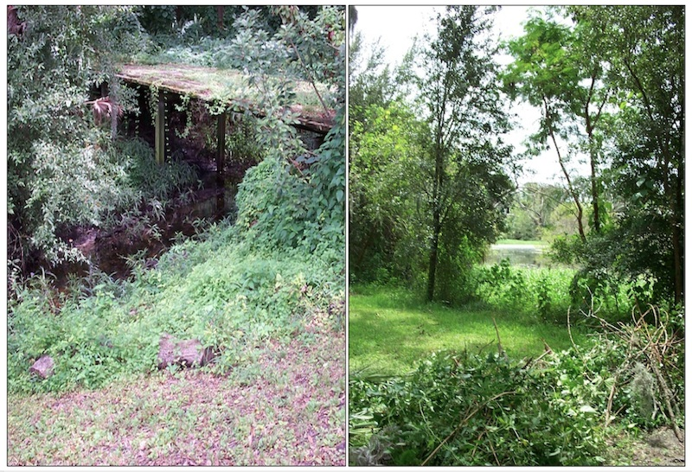
Figure 3.1. A footbridge crosses the creek (left), and the creek flows into a sinkhole (right).
< http://www.hillsborough.wateratlas.usf.edu/upload/documents/OH_Curiosity_Creek.pdf>
Curiosity Creek

Back in Part I, you pondered how Curiosity Creek came by its name: What is curious or unusual about this stream? Scanning the topographic map, you should have discovered that the creek simply ends; it does not flow into another body of water at its mouth as most rivers do. Curiosity Creek is not attached to any of the surrounding streams—this really is peculiar behavior for a river!
When you outlined the drainage basin for Curiosity Creek in Part I, you were instructed to extend the divide all the way to the Hillsborough River. This process is not quite correct; the creek and river are connected within this area but not via surface waters. Underground passageways connect these streams.
Thus, it would be more accurate to draw the drainage basin as shown in Fig. 3.2. The ground surface south of this map drains directly to the Hillsborough River and not into Curiosity Creek, as was implied in Part I.

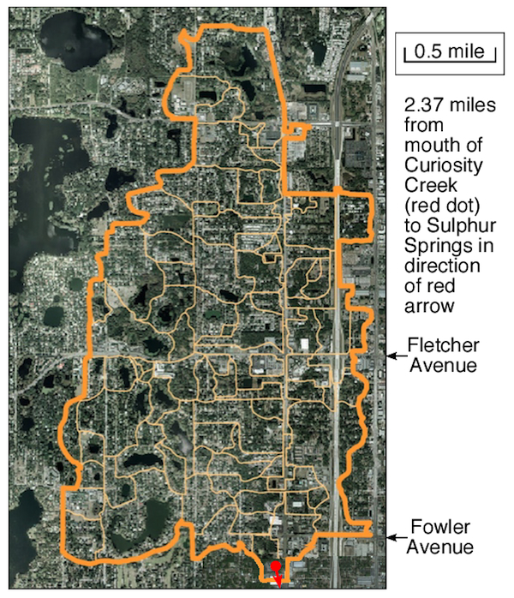

Figure 3.2. The heavy yellow line is the drainage divide for Curiosity Creek. The light yellow lines indicate subbasins of the Curiosity watershed.
<https://s3.amazonaws.com/wateratlasimages/679_CuriosityCreek20 05MgtPlan.pdf>

1. Open the “Curiosity” worksheet of the Sulphur Springs spreadsheet that accompanies this exercise, and highlight the data in A4:D17. Click on the Data tab in the ribbon, then on the “Sort” icon. Go to “Custom Sort,” and sort column D from largest to smallest. What was the date of the maximum peak streamflow?

2. Notice that the maximum peak streamflow is extremely high compared with most of the other data. Search the web for the date and Tampa FL. What weather event produced the unusually high discharge?

3. What weather event produced the second highest discharge along Curiosity Creek, and when did it occur?

4. Fill in the rank for each year in column E. What is the rank of the minimum peak streamflow?

5. What is the rank of the maximum peak streamflow?

6. What is the recurrence interval of the maximum peak streamflow?

7. Based on questions #1–5, is it reasonable to label the maximum discharge with the recurrence interval in question #6?

8. In general, are flood-frequency forecasts more reliable when they are based on a longer or shorter historical record? Hint: See the Flood Frequency Analysis section in Part II.

9. Go to the “Comparison” worksheet in the spreadsheet file, and study the recurrence graphs for Curiosity Creek and the Hillsborough River. Match the following statements that describe the behavior of discharge for the Hillsborough River before, during, and after the weather event in question #2.

River discharge began to increase

Peak discharge occurred

Discharge decreased gradually
as water from tributaries flowed into the Tampa area.
because of heavy rainfall east of Tampa.

because the city's sewers quickly delivered water to the river

10. Match the following statements that describe the behavior of discharge for Curiosity Creek before, during, and after the weather event in question #2.

Creek discharge began to rise slightly due to

Discharge quickly spiked to its maximum

After rainfall stopped, discharge dropped abruptly

because the small watershed had already drained all rain into the creek.
because water flowed immediately into the creek.

light precipitation before the storm reached Tampa.

