ASSIGNMENT

Constraints and Implications of Groundwater Temperature on the Formation of Mississippi Valley-type Zn-Pb Deposits

Martin Appold
Department of Geological Sciences
University of Missouri—Columbia
Columbia, MO 65211-1380

Phone: 573-882-0701
Fax: 573-882-5458
E-mail: appoldm@missouri.edu

Description:

This assignment is meant to illustrate how the advection of heat by groundwater leads to the elevated temperatures at shallow sedimentary basin margins at which Mississippi Valley-type Zn-Pb hydrothermal ore deposits are formed. The assignment is based on analytical solutions for groundwater flow and heat transport published by Domenico & Palciauskas (1973). Students use a spreadsheet to calculate and plot the flow field and temperature in a sedimentary basin, and to investigate the conditions needed to produce ore-forming temperatures. These results have further implications for the length of time available for ore formation and the concentration of metals and pH of the groundwater, which are also explored in the assignment. The assignment provides an example of how groundwater plays a fundamental role in an important geologic process in the Earth's crust. The activity also shows the linkages of hydrology to other disciplines such as heat transport, geochemistry, and economic geology.
ASSIGNMENT

Constraints and Implications of Groundwater Temperature on the Formation of Mississippi Valley-type Zn-Pb Deposits

Introduction: Groundwater is fundamentally involved in the formation of numerous types of economic mineral deposits in the Earth’s crust. One important example is the “Mississippi Valley-type” (MVT) class of Zn-Pb deposits, named after several prominent occurrences in the Mississippi River drainage basin in the central U.S. The principal economic commodities are typically the zinc and lead sulfide minerals, sphalerite and galena, and are typically also accompanied by significant amounts of calcite, dolomite, and quartz. Evidence from fluid inclusions, tiny samples of the ore fluid trapped in the mineral during precipitation, indicates that the deposits were formed from highly saline groundwater at temperatures around 100° C or more. These high formation temperatures presented a puzzle since MVT deposits appear to have formed at depths of no more than 1.5 km at or beyond the margins of sedimentary basins and not close to any local heating sources such as igneous intrusions. Contributions from groundwater hydrology (e.g. Domenico & Palciauskas, 1973; Garven & Freeze, 1984a,b) played an important role in ultimately solving the puzzle by showing that groundwater driven by regional gradients in the water table could have advected enough heat from deep parts of sedimentary basins to raise temperatures at shallow depths on or even well beyond the basin margin to the levels needed for MVT ore formation.

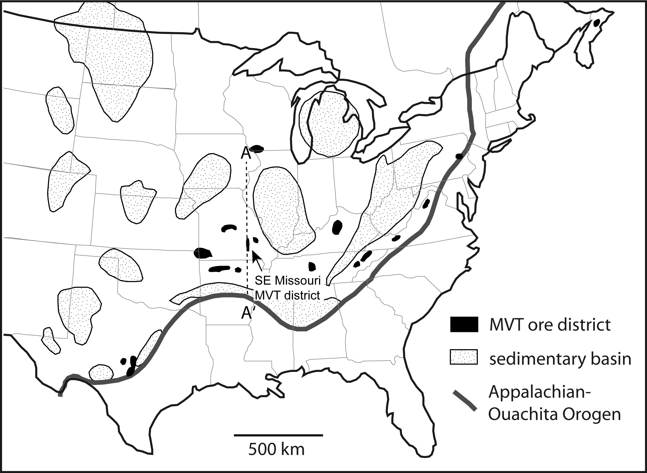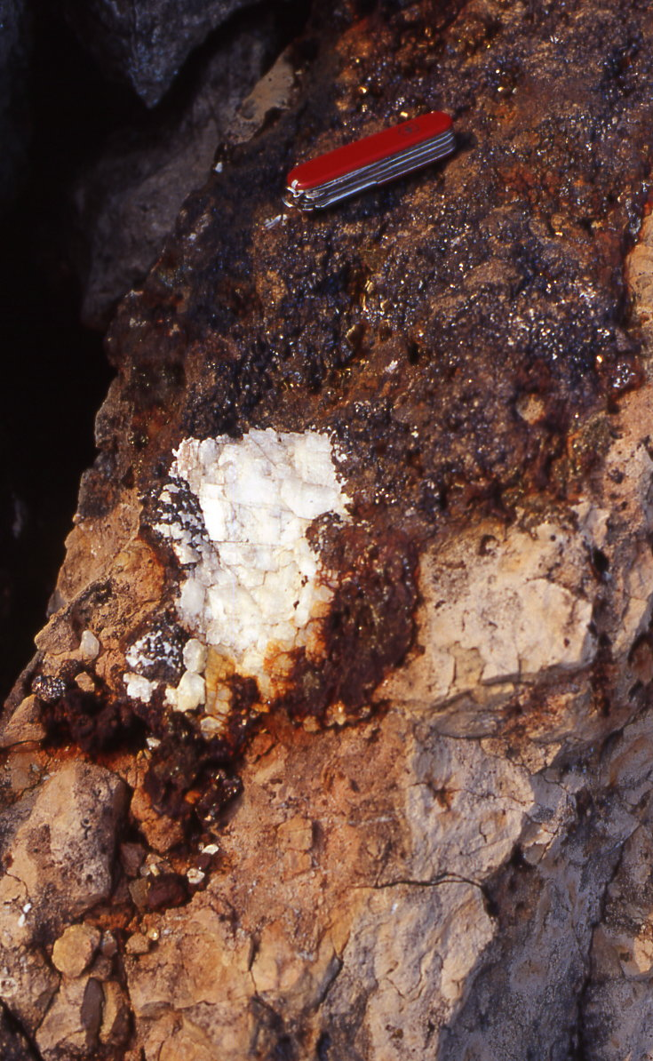
(a) (b)

Figure 1. (a) Map of major MVT ore districts in the eastern U.S. and their proximity to sedimentary basins. (b) MVT sphalerite (dark reddish brown mass around pocket knife) and calcite (white) hosted by Ordovician limestone from the Mulcahey mine in southwestern Wisconsin.

Objective: This exercise uses analytical solutions to the differential equations for groundwater flow and heat transport published by Domenico & Palciauskas (1973) to explore the conditions needed for MVT ore formation near the shallow margin of a sedimentary basin.

Question 1: Typical geothermal gradients in the Earth’s crust range from about 25-35° C per kilometer. Using these values and assuming an average surface temperature of 20° C, what range of temperatures would typically be expected at MVT ore forming depths of about 1.5 km?

Question 2: Figure 2 below shows the results of a numerical model of steady-state groundwater flow and temperature along a transect A-A′ (cf. Fig. 1a) extending from the Arkoma basin through the Southeast Missouri MVT district for the Late Pennsylvanian or Early Permian. Topographic relief was caused by uplift during the Appalachian-Ouachita orogeny and created the driving force for a regional-scale northward movement of groundwater. The heavy bold line in the interior of the cross section represents the top of the Precambrian basement, which was considered to have low permeability in the model and through which therefore very little fluid flow occurred. Above the bold line is a package of more permeable Paleozoic sedimentary rocks. The solid contour lines are isotherms in degrees Celsius and the dashed lines are flow lines. Describe the pattern of groundwater flow in the model. How does groundwater flow seem to affect the temperature distribution in the model?

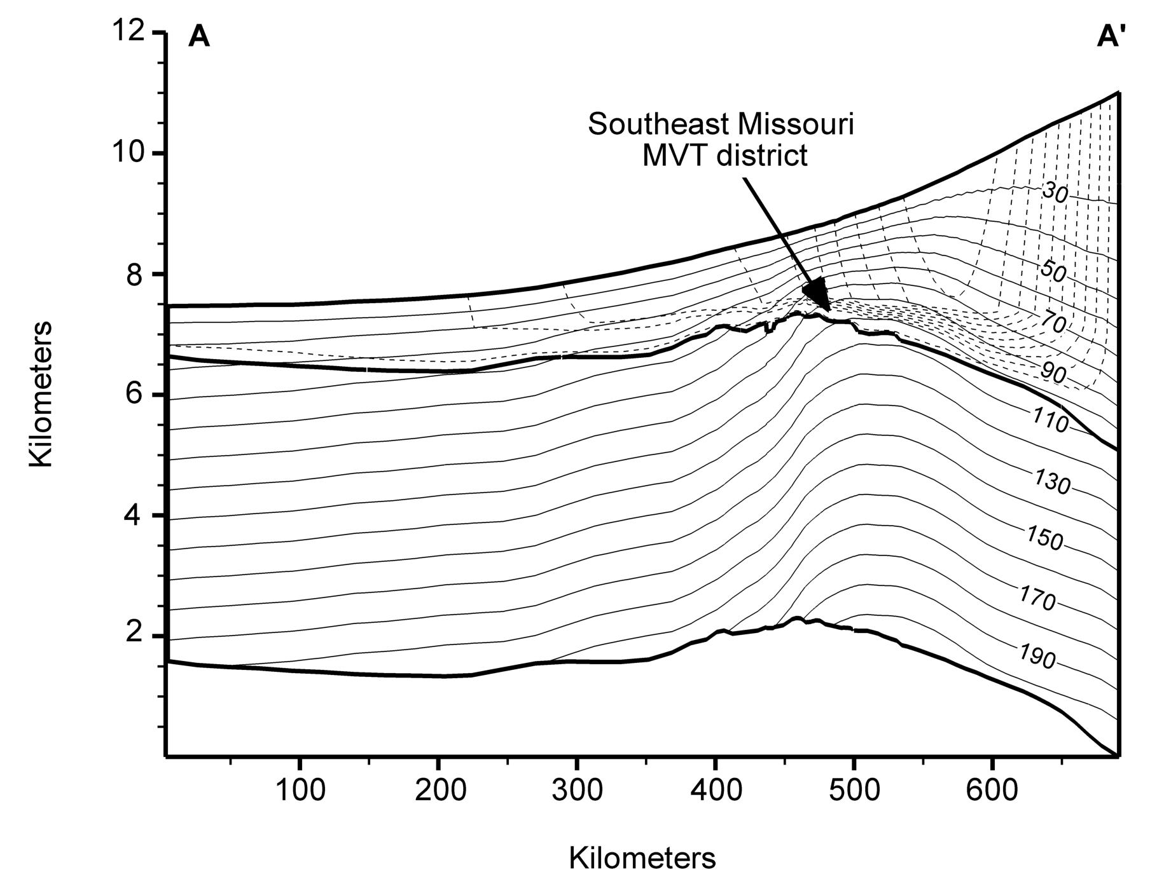
Figure 2: Steady-state groundwater flow and temperature field along a transect A-A′ shown in Figure 1a (cf. Appold & Garven, 1999).

Question 3: Domenico & Palciauskas (1973) published an analytical solution for steady-state groundwater flow over a two-dimensional rectangular domain that is given by the following equation:

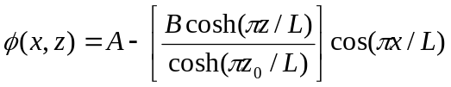 (1)

The equation assumes that the entire problem domain is homogeneous and isotropic, that there is no fluid flow across the lower or vertical boundaries, and that the fluid potential () across the top boundary varies as shown in Figure 3. This fluid potential curve also corresponds to the water table profile, where A represents the height of an inflection point in the slope of the water table and B represents the distance between the top of the rectangular domain over which flow is calculated and A. The remaining terms in the equation are as follows:

x = the horizontal coordinate
z = the vertical coordinate
z₀ = the height of the rectangular problem domain
L = the length of the rectangular problem domain
π = 3.14…

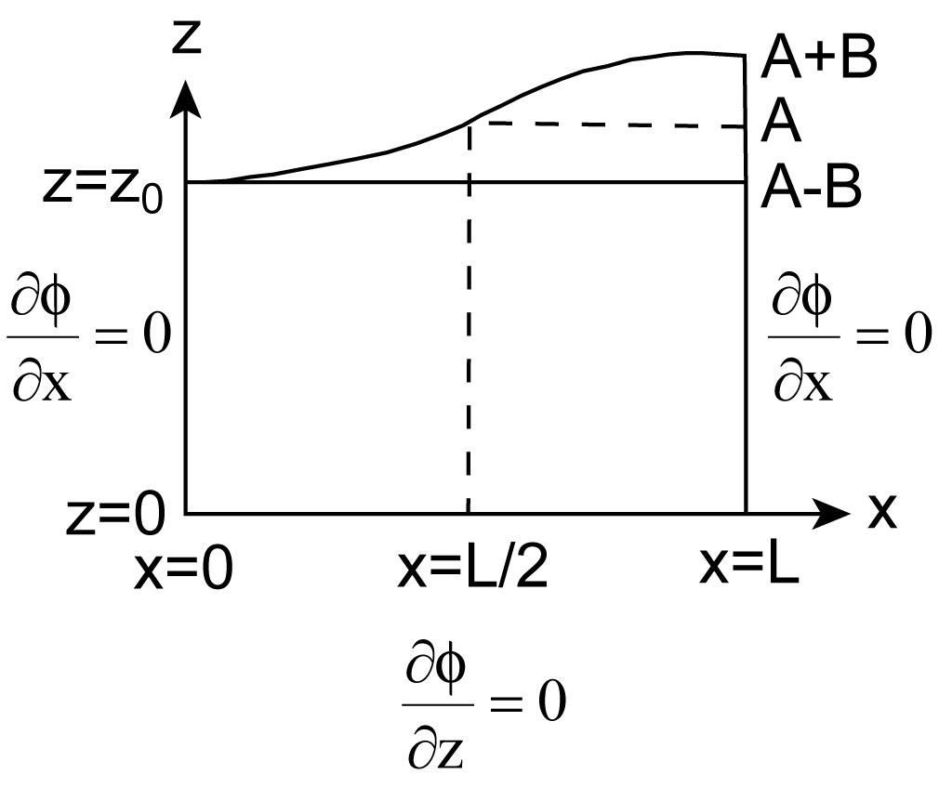

Fig. 3. Schematic of boundary conditions for equation 1 (after Domenico & Palciauskas, 1973).

Calculate and contour plot the fluid potential field in a hypothetical sedimentary basin for the following conditions:

z₀ = 10,000 m
L = 100,000 m
B = 500 m

The calculations and plotting can be conveniently carried out using a spreadsheet program like Microsoft Excel. A nodal spacing of 10-20 in each coordinate direction should provide sufficient detail to generate an accurate contour plot. Print out a copy of the fluid potential contour plot and draw in by hand the flowlines. What is the pattern of flow and how does it compare to Figure 2?

Question 4: Domenico & Palciauskas (1973) also published an analytical solution for steady-state heat transport over a two-dimensional rectangular domain that allows the prediction of temperature according to the following equation:

(2)

The solution assumes the existence of a groundwater flow field described by equation (1). Further assumptions are no heat flow through the vertical and lower boundaries, and a constant temperature along the top boundary of the rectangular problem domain. New variables introduced in this equation include:

T₁ = temperature along the top boundary of the rectangular problem domain
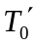= vertical temperature gradient due solely to conduction
K = hydraulic conductivity
α = thermal diffusivity of the bulk porous medium

(a) Calculate and contour plot the temperature field for the hypothetical sedimentary basin and conditions used in question 3, along with the additional conditions listed below:

T₁ = 20° C
= −0.030° C/m
K = 5 × 10⁻⁸ m/s
α = 1 × 10⁻⁶ m²/s

Describe the temperature pattern predicted by your calculation and the way in which it is influenced by the flow of groundwater in the basin.

(b) What is the temperature at the basin margin (x = 0) at a depth of 1.5 km? Does this temperature meet MVT ore-forming levels?

(c) How does the temperature gradient near the top of the problem domain at x = 0 and x = 100,000 m compare to the original background temperature gradient that was due solely to conduction? What implications might this have for the geologic exploration for MVT mineral deposits?

Question 5: Repeat the calculation in question 4 using a lower hydraulic conductivity value of K = 5 × 10⁻⁹ m/s keeping all other parameter values the same.

(a) How did lowering the hydraulic conductivity of the basin affect the temperature profile?

(b) Is the temperature at x = 0 at a depth of 1.5 km still sufficient for MVT ore formation?

(c) At approximately what rate must groundwater flow in the basin to allow MVT ore-forming temperatures to be reached?

Question 6: Highly saline fluids initially present in the sedimentary basin would gradually be displaced by fresh meteoric water unsuitable for MVT deposit formation that is entering the basin in the recharge zone. The advance of this fresh water plume is complicated by dispersion, but on average moves at the rate of the average linear velocity of the groundwater.

(a) Referring to your results from questions 3 and 4, estimate the distance that freshwater entering the recharge zone would travel before reaching a suitable site of MVT deposition at a depth of about 1.5 km near the margin of the basin.

(b) Approximately how long would it take for the fresh water plume to arrive at the site of MVT deposition, assuming that there are no additional sources of salinity (e.g. evaporites) in the basin? Assume an average basin porosity of 20%.

Question 7: Figure 4 shows the results of a mass balance calculation that indicates the length of time that would be needed to deposit all of the Southeast Missouri lead ore located on the transect A-A′ as a function of average linear velocity and dissolved lead concentration of the mineralizing groundwater. Based on your results above and Figure 4, estimate the concentration of lead that the groundwater would need to carry in order to deposit all of the lead located in the Southeast Missouri ores on A-A′ in the time available once meteoric recharge of the basin has begun, as calculated in question 6c.

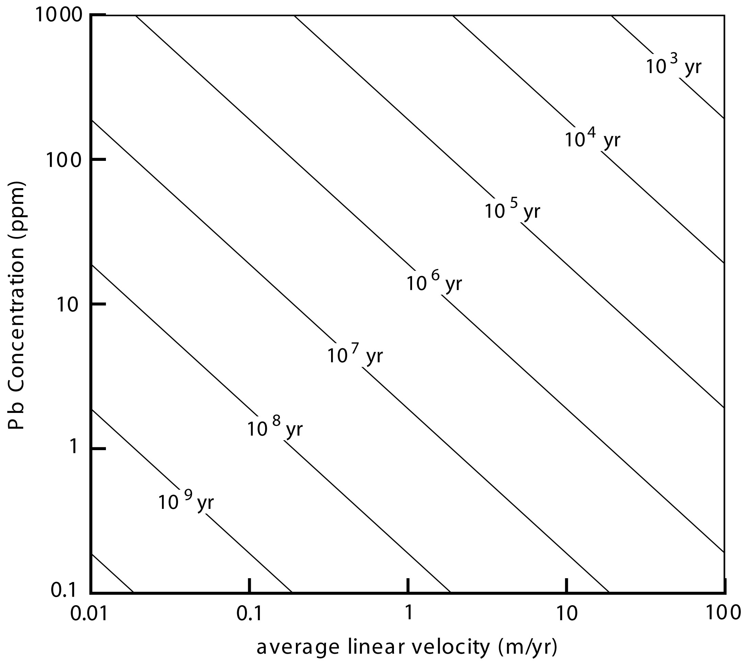

Figure 4. Contour plot showing the length of time needed to deposit all of the Pb ore in the part of the Southeast Missouri district lying on transect A-A′ as a function of average linear velocity and Pb concentration of groundwater (Appold & Garven, 1999).

Question 8: At the temperature and salinity of MVT ore forming groundwater, lead is transported primarily as the complex 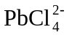 and may precipitate as galena according to the following reaction:

(3)

If the chloride concentration is 3 mol/kg and dissolved lead and sulfur are present in the same molar concentrations, compute the pH that the groundwater would need to be in order to transport the concentration of lead determined from question 7. The equilibrium constant for this reaction at a temperature of 100° C and a pressure of 16 MPa is K = 7603. Assume that the galena is composed purely of PbS. The activity coefficients for the aqueous species are as follows:

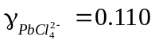
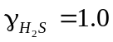
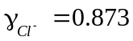
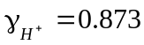

Compare your result to known ranges of typical pH values in natural groundwater and discuss the geologic implications.

References

Appold, M. S. and Garven, G., 1999, The hydrology of ore formation in the Southeast Missouri district: Numerical models of topography-driven fluid flow during the Ouachita orogeny: Economic Geology, v. 94, p. 913-936.

Domenico, P. A. and Palciauskas, V. V., 1973, Theoretical analysis of forced convective heat transfer in regional ground-water flow: Geological Society of America Bulletin, v. 84, p. 3803-3814.

Garven, G. and Freeze, R. A., 1984a, Theoretical analysis of the role of groundwater flow in the genesis of stratabound ore deposits 1. Mathematical and numerical model: American Journal of Science, v. 284, p. 1085-1124.

Garven, G. and Freeze, R. A., 1984b, Theoretical analysis of the role of groundwater flow in the genesis of stratabound ore deposits 2. Quantitative results: American Journal of Science, v. 284, p. 1125-1174.

Suggested Further Reading

Anderson, G. M., 1975, Precipitation of Mississippi Valley-type ores: Economic Geology, v. 70, p. 937-942.

Bethke, C. M. and Marshak, S., 1990, Brine migrations across North America—the plate tectonics of groundwater: Annual Reviews in Earth and Planetary Sciences, v. 18, p. 287-315.

Cathles, L. M., 1983, Thermal constraints on the formation of Mississippi Valley-type lead-zinc deposits and their implications for episodic basin dewatering and deposit genesis: Economic Geology, v. 78, p. 983-1002.

Leach, D. L., 1994, Genesis of the Ozark Mississippi Valley-type metallogenic province, Missouri, Arkansas, Kansas, and Oklahoma, USA, in, Fontboté, L. and Boni, M., eds., Sediment-Hosted Zn-Pb Ores: Berlin, Springer-Verlag, p. 104-138.

Leach, D. L. and Sangster, D. F., 1993, Mississippi Valley-type Lead-Zinc Deposits, in, Kirkham, R. V., Sinclair, W. D., Thorpe, R. I., and Duke, J. M., eds., Mineral Deposit Modeling: Geological Association of Canada Special Paper 40, p. 289-314.

