Notes from Meeting to Discuss Feasibility of Incorporating Deep-Time CZ Concept into Teaching: 08-08-2013, 7:00-8:00 PM, Northrup 105 (Earth Sciences Building) at UNM
Discussion led by Steve Driese and Jen Roberts, 11 people attended
The group discussed various issues around the potential for incorporating a newly emerging concept of interpreting the deep-time (pre-Quaternary) sedimentary record as a series of stacked paleo-Critical Zones (paleo-CZs). This concept was presented in a recent NSF publication Earth-Life Transitions (Transitions, 2012) and the accompanying graphic proposing the concept. Some recent advances in reconstructing colloidal properties of certain types of paleosols (paleo-Vertisols) using various paleoclimate proxies (something that can be measured in the rocks (e.g., bulk geochemistry, stable isotopes) that can be used to estimate paleoclimate conditions (e.g., Mean Annual Precipitation, Mean Annual Temperature, Precipitation Seasonality) and pedotransfer functions (something that can be measured in the rocks (e.g., bulk geochemistry) that can be used to estimate colloidal properties of paleosols (e.g., pH, Eh, CEC, etc.); both are developed from modern analog soil systems, e.g., Nordt et al. (2012, Geochimica et Cosmochimica Acta) suggest that it may be possible to reconstruct climate, energy and water balance, net primary productivity, biogeochemistry, etc., from deep-time paleosols that are exceptionally well-preserved. But soils are only part of the CZ system. Driese has already taught a combined field and lab exercise for his students in a graduate-level Paleopedology course at Baylor University using Pennsylvanian paleo-Vertisols (see accompanying figures). Sedimentary basins, and the fluvial stratigraphic successions contained within them, are also informative records of paleo-CZ systems, and they can be reconstructed with high degrees of confidence. Lacking are other important parts of the paleo-CZ system such as geomorphology, hydrology and geomicrobiology. How preservable these elements are will ultimately affect their use in paleo-CZ construction.
The consensus of the group seemed to be that the logical first step is the introduction and infusion of modern Critical Zones and CZ processes into undergraduate courses. Later as the science matures it may become feasible to try to introduce paleo-CZ systems into undergraduate courses. A promising start could be to try to incorporate the introduction of modern and paleo-CZs as part of Broader Impacts and Outreach plans in future NSF science proposals involving these topics. Broader expansion of the current NSF Critical Zone Observatory (CZO) program to include new CZO sites in lowland depositional settings with thick soil development may provide future Broader Impacts and Educational Outreach opportunities. These components of NSF proposals are becoming increasingly important as Principal Investigators (PIs) are required to show the relevance of their funded research to the broader community (especially non-scientists) as well as increasing effective communication of their findings.
Because several meeting attendees expressed lack of experience or never having seen deep-time paleosols, Driese has attached some figures appended to this document from a paper by Baylor M.S. graduate Amos Culbertson that is in review in the Journal of Sedimentary Research (Culbertson and Driese, in review).
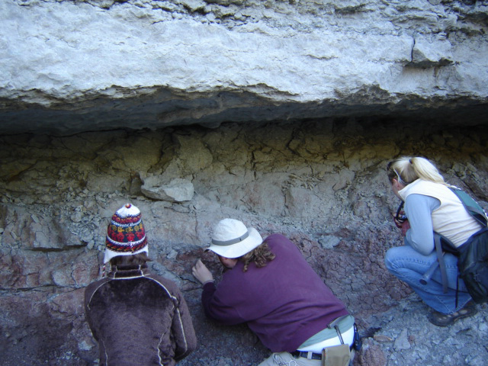
Figure 1 – Baylor Geology graduate students examining Pennsylvanian paleosols in Cedarton Formation at Lake Brownwood Spillway near Brownwood, Texas.
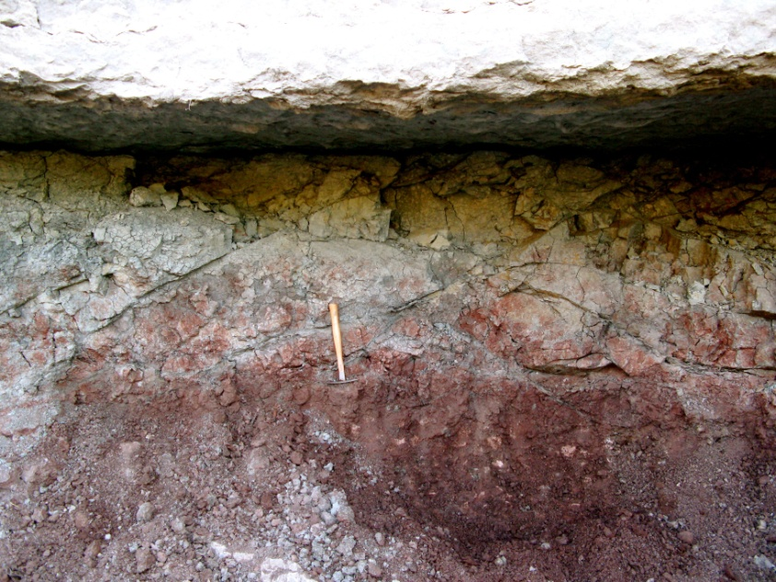
Figure 2 – Pennsylvanian paleo-Vertisol with gleyed (reduced) top, large pedogenic slickensides, wedge-shaped peds, root traces and pedogenic calcite nodules (white) in Cedarton Formation at Lake Brownwood Spillway near Brownwood, Texas. Small 25 cm pick for scale.
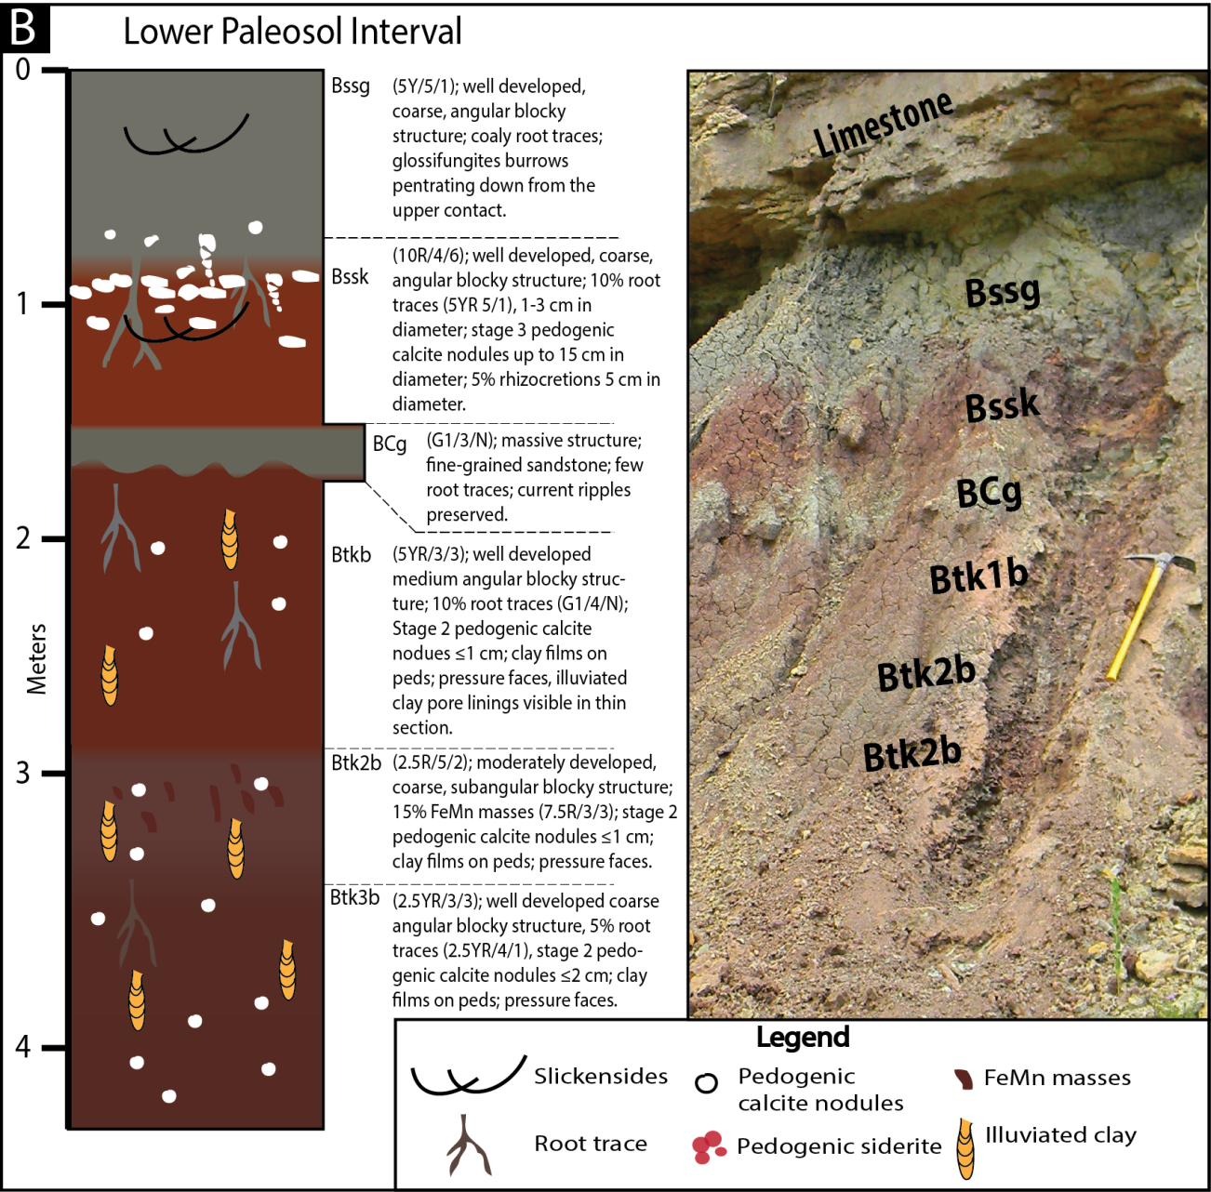
Figure 3 – Outcrop section of the Lower Paleosol Interval (LPI) at Lake Brownwood Spillway, Texas showing horizon designations and field descriptions along with corresponding field photographs (Culbertson and Driese, in review, Journal of Sedimentary Research).
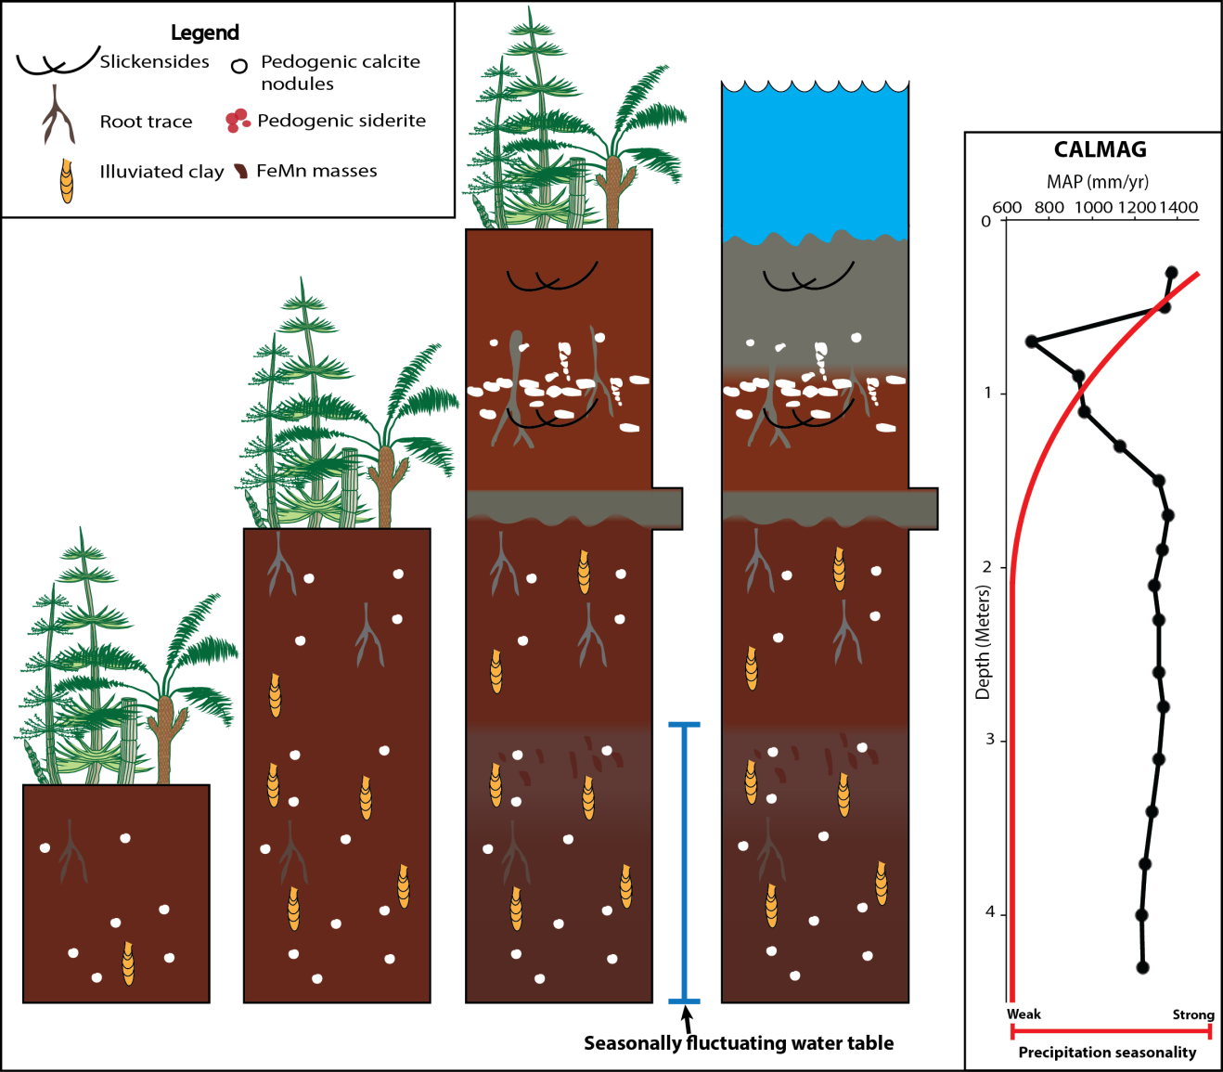
Figure 4 – Proposed paleohydrologic and precipitation history model for the LPI including CALMAG paleoprecipitation estimates. The soil was initially well-drained and precipitation seasonality is minimal with CALMAG paleoprecipitation estimates of ~1200mm/yr. The climate became drier (~700 mm/yr) and more seasonal, and the subsoil was saturated periodically during times of the year when the water table is high. Finally, precipitation rates increased to~1300 mm/yr prior to submergence and gleying during transgression. Pteridosperms and sphenopsids are depicted because they were the central plant groups in better-drained, tropical, mineral soils during the late Pennsylvanian (Culbertson and Driese, in review, JSR).

