**Groundwater Hydrogeology**

**Lab 2: Particle Size Analysis, Soil Texture, and Hydraulic Conductivity**

Due date: February 21, 2012 before lab begins (1 Week).

**Description**

Sediment texture has a large influence on water holding capacity (porosity) and water conducting ability (permeability). Sediment texture is characterized by its grain size and distribution. Grain size and its distribution can provide information on degree of sorting of sediments and subsurface water movement and infiltration. Data on grain size and distribution is also important in designing gravel pack. Gravel packs are used during installation of wells. We will discuss gravel pack further during the lecture topic titled well design and construction. Soil texture is important in determining soil water characteristics, water available for plants, water requirements for irrigation, and watershed hydrology modeling.

**Objectives**

1. In this lab you will sieve sediments with the goal to determine grain size and distribution of the sediments.
2. You will Plot your data on a semi-log graph paper and join the data points with a curve
3. You will also calculate the uniformity coefficient for sediments from your curve and compare their results in terms of sorting. Read about uniformity coefficient from Fetter.
4. Furthermore you will Classify soil data (to be provided) based on USDA Classification
5. Finally use the soil class that you have determined (4) to calculate infiltration rate of rain through the soil using the Green-Ampt Equation. The parameters of the Green-Ampt Equations are to be determined using table 2 in Rawls et al. (1983) or the table provided.

**PART 1:**

**Materials for Lab**

Stack of Sieves including pan

Weighing Balance

Pestle and Mortar (for crushing the soil if lumped or conglomerated)

Mechanical sieve shaker

**Procedure and Questions**

Sieve two types of sediments/soil which you have been provided. Prepare your sieves by stacking them together. Sieves having larger opening sizes (i.e lower numbers) are placed above the ones having smaller opening sizes (i.e higher numbers). The first sieve is #5 and the very last sieve is #120 and a pan is placed under it to collect the portion of soil passing #120 sieve.

Take a representative sample of the sediments provided and weigh about 400 g. If soil particles are lumped or conglomerated crush the lumped and not the particles using the pestle and mortar. Before you start, weigh all your sieves empty accurately. Also weigh your sieves with soil accurately and record the mass retained in the column of the table below. I will provide you with an excel sheet temperate

Determine the mass loss during sieve analysis as a percent of the original mass.



**Plot graph**

Plot your data on a semi-log graph paper and join the data points with a curve. Alternatively you can use excel to plot the data then print it out and manually join the points with a smooth curve.

**Uniformity coefficient**

Determine the uniformity coefficient for both soil samples based on your graph. Refer to Fetter for formula for calculating Uniformity coefficient.

**PART 2:**

**Soil Classification**

1. You are provided with a particle size analysis distribution curve (Figure 1) produced from a DigiSizer. What is DigiSizer? Determine the soil class for this data based on USDA classification diagram in figure 2 and figure 3.

The particle size analysis graph from DigiSizer is provided below:

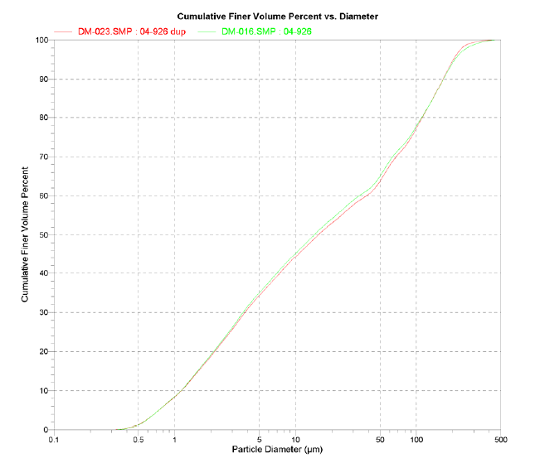

Figure 1: Particle size distribution curve of a soil sample (Dr. Michael Young’s UNLV soil physics course notes, 2007)

USDA Particle Classification and Soil Type:

Table 1. USDA particle size classification table

|  |  |
| --- | --- |
| Particle | Diameter |
| Clay | Less than 0.002 mm |
| Silt | 0.002 mm – 0.05 mm |
| Sand | 0.05 mm – 2.00 mm |
| Gravel | > 2 mm |

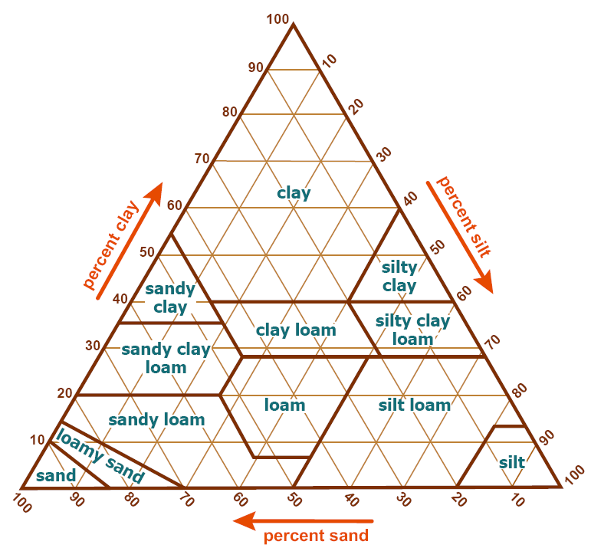

Figure 2. USDA Soil textural triangle

**Hydraulic conductivity estimate**

1. Estimate the hydraulic conductivity and infiltration rate for the soil class you determined. The hydraulic conductivity and other soil water retention parameters which are needed for infiltration rate calculation can be estimated from the table below (Rawl et al., 1983. Table 2):

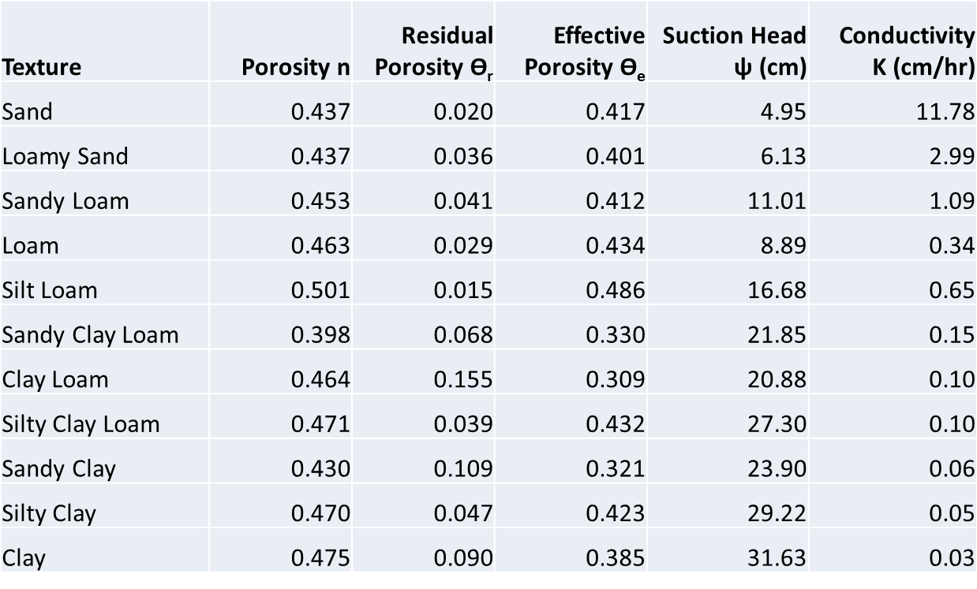

**Cumulative Infiltration and Infiltration rate**

Compute the Infiltration rate, **f** and the cumulative infiltration rate **F** after 1 hour of infiltration into the soil class which you have determined and assume that it had an initial effective saturation of 30 percent. Use the following equations. **F** is solved iteratively employing the method of successive substitution.

