## Due: 1 October 2012 Name _______________________

1. a. Using the soil taxonomy poster, surface map, and geologic maps, what can you hypothesize about the classification and diversity of Indiana soils?

b. What about the soils of your home state/region? (If your home state is IN, hypothesize about another location!)

1. Explain the soil order distribution of
   1. Texas
   2. Missouri

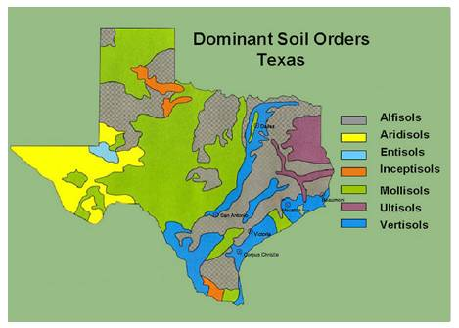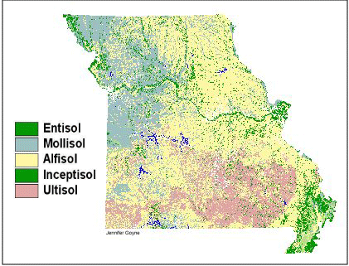

1. Use the guide and flow chart to determine the textural class and approximate sand, silt, and clay proportions of the following samples:
   1. unknown light material
   2. Planting Experiment Soil 1
   3. Planting Experiment Soil 2
   4. Planting Experiment Soil 3
2. Do you think you might get different answers if you performed the analysis again? Why or why not?
3. According to your own experience, and the definitions discussed in class and in your text, are these materials *soils*? Explain your answer.
4. Do you think testing the same soil by feel and by quantitative/mechanical analysis (e.g., sieve, hydrometer, laser diffraction, etc.) might yield different textural classes for any of these samples? Why or why not? If so, which assessment would you consider more v

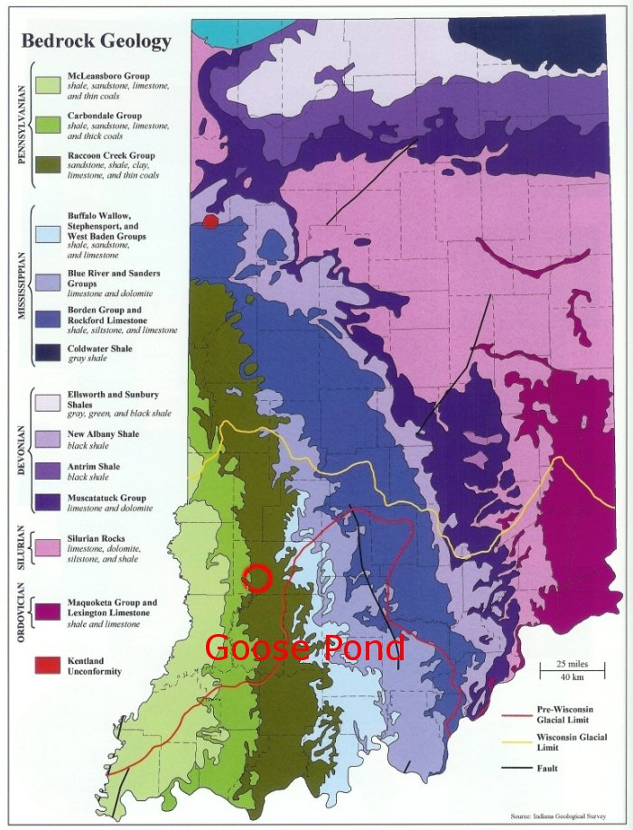

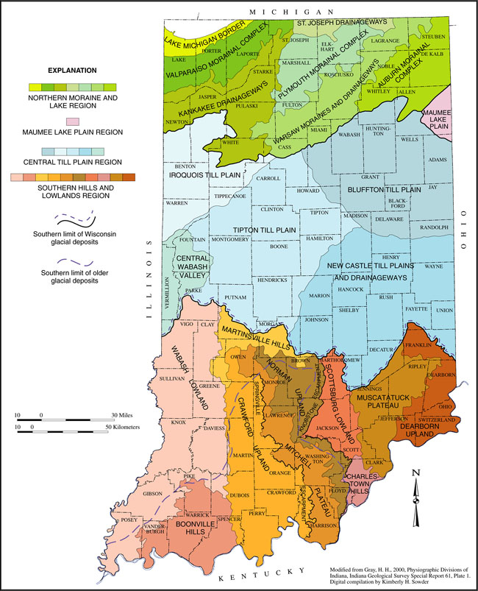

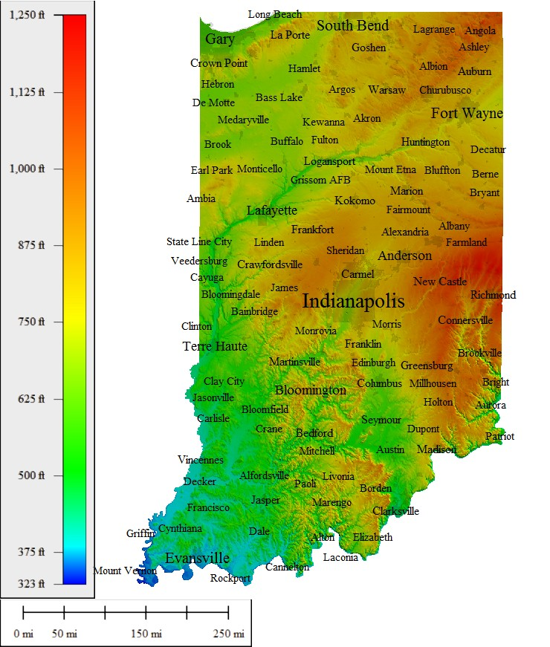

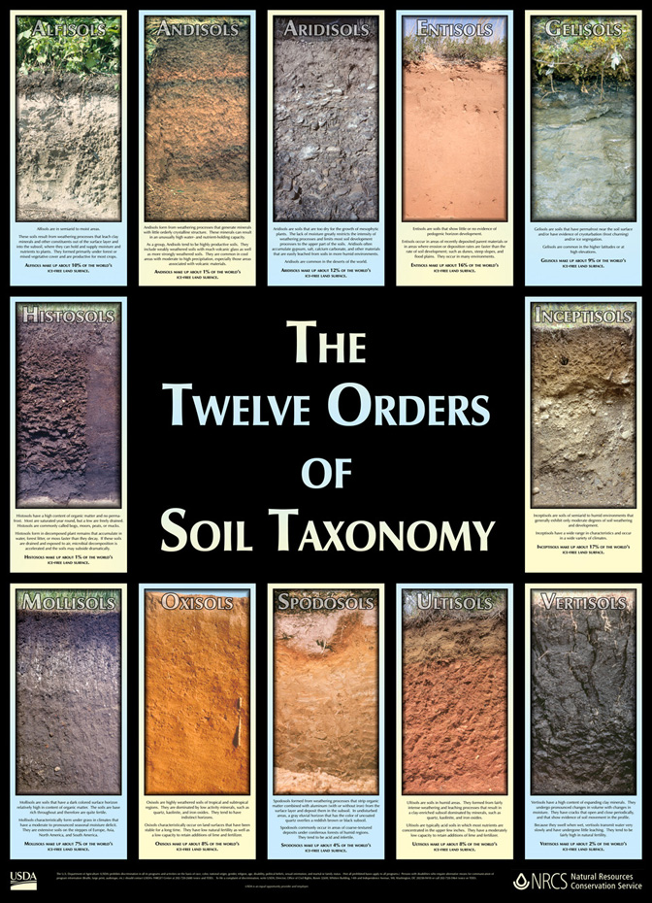



**Guide to Texture by Feel**

Modified from:

Thien, S.J. (1979). Aflow diagram for teaching texture by feel analysis*.* *Journal of Agronomic Education*. **8**:54-55.

Texture class is one of the first things determined when a soil is examined.  It is related to weathering and parent material.  The differences in horizons may be due to the differences in texture of their respective parent materials.

Texture class can be determined fairly well in the field by feeling the sand particles and estimating silt and clay content by flexibility and stickiness.  There is no field mechanical-analysis procedure that is as accurate as the fingers of an experienced scientist, especially if standard samples are available.  A person must be familiar with the composition of the local soils.  This is because certain characteristics of soils can create incorrect results if the person does not take these characteristics into account.

In some environments clay aggregates form that are so strongly cemented together that they feel like fine sand or silt.  In humid climates iron oxide is the cement.  In desert climates silica is the cement and in arid regions lime can be the cement.  It takes prolonged rubbing to show that they are clays and not silt loams.

Some soils derived from granite contain grains that resemble mica but are softer.  Rubbing breaks down these grains and reveals that they are clay.  These grains resist dispersion and field and laboratory determinations may disagree.

Many soil conditions and components mentions earlier cause inconsistencies between field texture estimates and standard laboratory data.  These are, but not limited to, the presence of cements, large clay crystals, and mineral grains.  If field and laboratory determinations are inconsistent, one or more of these conditions is suspected.

