**Debunking Climate Change Myths in the Classroom**

Daniel Bedford

Geography Department

Weber State University

Ogden

UT 84408-1210

[dbedford@weber.edu](mailto:dbedford@weber.edu)

**Solution Set**

The article presented for debunking contains numerous problems, most of which fall into two categories: mistaking short-term variability for a long-term trend, and citing non-authoritative sources (such as newspaper articles instead of the peer-reviewed literature). Although copyright restrictions preclude reproducing the entire article (which can be found online at <http://www.humanevents.com/article.php?id=263150>), a sample of representative passages is provided here, together with analysis highlighting why the passages are problematic.

**Sample passage 1:**

The article states:

NASA satellites found that last winter’s Arctic Sea ice covered 2 million square kilometers (772,000 square miles) more than the last three years’ average. It also was 10 to 20 centimeters (about 4 – 8 inches) thicker than in 2007. The ice between Canada and southwest Greenland also spread dramatically. “We have to go back 15 years to find ice expansion so far south,” Denmark’s Meteorological Institute stated.

Keeping in mind that the article was published in 2008, there are several difficulties here. It is helpful to compare the text above with the January 1953 to December 2011 Arctic sea ice extent from the National Snow and Ice Data Center is shown below (available via NSIDC’s State of the Cryosphere website, <http://nsidc.org/cryosphere/sotc/sea_ice.html>).

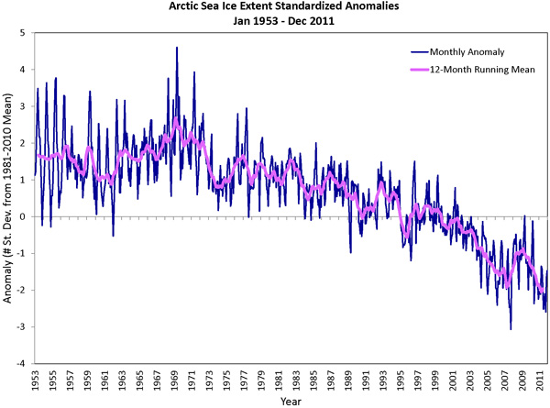

2008

The passage quoted above focuses on the short term without providing the long term context. It is clear from the above graph that 2008 (the year the article was written) represented only a relatively small uptick in a longer-term trend of declining sea ice. In the absence of information about this larger context, the article could easily mislead the reader into thinking that sea ice was increasing. Furthermore, 2007 represented the record lowest Arctic sea ice extent, so any increase on that record low (that is, from 2007 to the somewhat less dramatic, but still low sea ice extent of 2008) can be framed to appear much more significant than it really is. A small increase from a low number can be made to appear large, even when it isn’t.

**Sample passage 2:**

The article states:

“Snows Return to Mount Kilimanjaro,” cheered a January 21 International *Herald Tribune* headline, as Africa also defies the “warming” narrative.

While neither anecdotes nor one year’s statistics confirm global cooling, a decade of data contradict the “melting planet” rhetoric that heats Capitol Hill and America’s newsrooms.

“The University of Alabama, Huntsville’s analysis of data from satellites launched in 1979 showed a warming trend of 0.14 degrees Centigrade (0.25 Fahrenheit) per decade,” Joseph D’Aleo, the Weather Channel’s first Director of Meteorology, told me. “This warmth peaked in 1998, and the temperature trend the last decade has been flat, even as CO2 has increased 5.5 percent. Cooling began in 2002. Over the last six years, global temperatures from satellite and land-temperature gauges have cooled (-0.14 F and -0.22 F, respectively). Ocean buoys have echoed that slight cooling since the National Oceanic and Atmospheric Administration deployed them in 2003.”

This passage takes a somewhat similar tack to sample passage 1, by presenting the relatively short-term temperature trend of the last decade without the context of the preceding decades. Again, a graphic is helpful, this time showing the deviation of the global average temperature for each year relative to the average for 1961-1990, from the HadCRUT 3 temperature data set (developed as a collaboration between the UK’s Met Office Hadley Centre and the University of East Anglia’s Climatic Research Unit).



Temperature relative to 1961-1990 average (Celsius)

1998

Year

Source: Climatic Research Unit http://www.cru.uea.ac.uk/cru/data/temperature/#datter

Zooming in on the period 1980-2011, it becomes clear how the argument that the Earth has cooled since 1998 is derived: bars indicating temperatures for each year are indeed lower after 1998, suggesting a cooling.

2010

1980

2000

1990



0.0

0.5

Temperature relative to 1961-1990 average (Celsius)

1998

However, there are a number of problems with this line of reasoning. First, and most obviously, it depends on the years since 1998 being taken out of the context of the previous 150 years. Although the years since 1998 *were* cooler than 1998, hence suggesting cooling, this is cooling relative to a record warm year. The years since 1998 have still been among the warmest on record.

This is related to a second, and perhaps more pervasive, problem. The fact that years since 1998 were cooler does not invalidate the fact of human forcing on global climate. As with the sea ice example outlined earlier, a focus on the short term will reveal considerable interannual variability—lots of bouncing around in temperatures (or sea ice extent) from one year to the next. There are many reasons for this, notably that global climate experiences multiple forcings, and human emissions of greenhouse gases are just one of those forcings (albeit an increasingly dominant one). There are several excellent visualizations of the difference between long-term trend and short-term variability, including these two:

* The Escalator, available at SkepticalScience.com, <http://www.skepticalscience.com/graphics.php?g=47>
* Trend and variation as a dog going for a walk, from Norwegian TV show Siffer,

<http://www.youtube.com/watch?v=e0vj-0imOLw&feature=youtu.be>

* An excellent analysis of the “cooling-since-1998” myth (and most others) is available at SkepticalScience.com, <http://skepticalscience.com/global-cooling.htm>

Finally, this argument depends on the idea that 1998 was the warmest year on record, and that years since have all been cooler. Although 1998 was a very warm year, different research institutes, calculating global average temperature using slightly different statistical procedures, find other years to be the warmest on record. Notably, NASA’s Goddard Institute for Space Studies (GISS) finds 2005 to have been warmer than 1998 (and 2010 appears as the warmest year on record, but this occurred after the article was written). GISS gives more weight to Arctic temperatures than the HadCRUT data set, and since much evidence (such as melting sea ice) points to the Arctic warming much faster than the rest of the Earth, the GISS estimates of global temperature run a little warmer than HadCRUT. Thus, the idea that the Earth has cooled since 1998—which is a flawed argument against anthropogenic global warming anyway—is not supported in all global temperature data sets. For comparison, the GISS land-ocean temperature index data look like this (with temperatures compared to the 1951-1980 average, as opposed to 1961-1990 for HadCRUT 3):

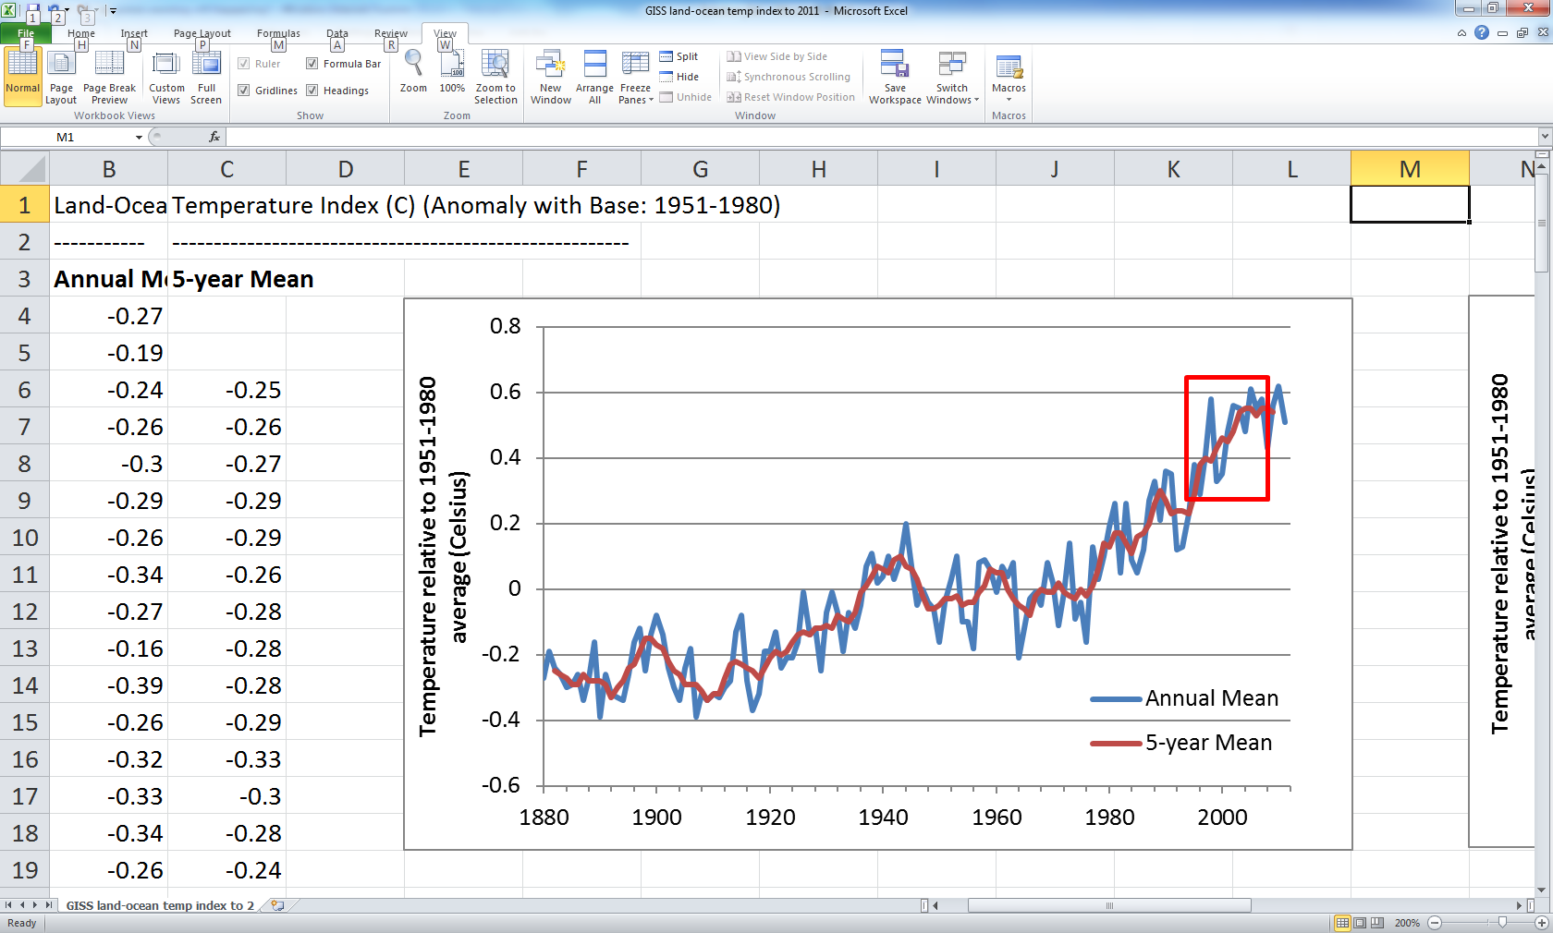

Source: drawn using data available from NASA GISS, http://data.giss.nasa.gov/gistemp/graphs_v3/

The red box highlights the period 1995-2008. Note that 1998 appears as a warm year—the warmest year on record up to that point—but is overtaken by 2005 (and later by 2010). Thus, the claim that the Earth has been cooling since 1998 is not supported by the NASA GISS data. This was the case even at the time the article was written, in 2008 (as 2005 was warmer than 1998 in the GISS analysis). The recently-released Berkeley Earth Surface Temperature (BEST) also finds warmer years after 1998, and provides a simple demolition of the “global-warming-has-stopped” argument here: <http://berkeleyearth.org/faq/#stopped>

**Sample passage 3:**

The article states:

“In stark contrast to the often repeated assertion that the science of climate change is ‘settled,’ significant new peer-reviewed research has cast even more doubt on the hypothesis of dangerous human-caused global warming,” 100 prestigious geologists, physicists, meteorologists, and other scientists wrote United Nations Secretary General Ban Ki-Moon last December. They also noted that “today’s computer models cannot predict climate. Consistent with this, and despite computer projections of temperature rises, there has been no net global warming since 1998.”

This passage attempts to convey an oft-repeated point of misinformation, that there is no consensus among scientists that the Earth is warming due to anthropogenic greenhouse gas emissions. It relies on a letter written to the United Nations Secretary General by “100 prestigious geologists, physicists, meteorologists, and other scientists”. However, these scientists are not named, so it is hard to know for certain whether they really are prestigious. Even assuming they are (which they could be—there are several quite prominent scientists who are deeply skeptical of the scientific consensus on global warming), the real problem with this passage is that it conflates peer review with opinion. Scientists are human beings, and subject to their own prejudices, biases, perceptions and opinions. As individuals, they are free to express their opinions just like anyone else. However, a letter is not a peer-reviewed piece of scientific research and should not be given the same weight. Several articles in the peer-reviewed literature have demonstrated the strength of the scientific consensus within the published literature, most notably Oreskes (2004) and Anderegg *et al*. (2010). News reporting on the subject of anthropogenic climate change has until recently emphasized a false balance where “both sides” were given equal prominence, even though one side has vastly more credibility and support within the scientific community than the other (Boykoff and Boykoff, 2004). This sample passage works in a similar way, reporting the views of a relatively small number of scientists writing outside the peer-reviewed scientific literature, and giving those views a prominence out of proportion to their real weight within the scientific community.

These three passages are indicative of the article as a whole and sufficient to demonstrate the misleading nature of the writing. Similar exercises could be undertaken with other sections of the article, or many other similar articles available in the popular press or on websites.

**References**

Anderegg, W.L., J.W. Prall, J. Harold, and S.H. Schneider. 2010. Expert credibility in climate change. *Proceedings of the National Academy of Sciences*, 107(27): 12107–12109.

Boykoff, M.T., and J.M. Boykoff. 2004. Balance as bias: global warming and the U.S. prestige press. *Global Environmental Change*, 14: 125-136.

Oreskes N. 2004. Beyond the ivory tower. The scientific consensus on climate change. *Science*, 306:1686.