Exercise 6: Choropleth maps – the Happiest States

Data set
- Shapefile of US States

Due: Monday, February 27 at the start of class.
Goal: To create your own data table that can be joined with a shapefile to create a choropleth map that illustrates the data in a paper published in December, 2009 in Science magazine by Stephen Wu (Hamilton Economics Department) and a British colleague. They analyzed data about which states in the US have the happiest people, but the original paper had no maps – only graphs. This little task isn’t geological, but it is a short, fun little job that will help you consolidate several ArcGIS techniques.
Turn in: a swell-looking choropleth map that provides a visual picture of which states in the US are the happiest. A choropleth map is a thematic map that is colored or shaded by classed values of a particular phenomenon. You will also make a second choropleth map with another variable of your choice. Here’s a choropleth map of US states by population from Wikipedia:

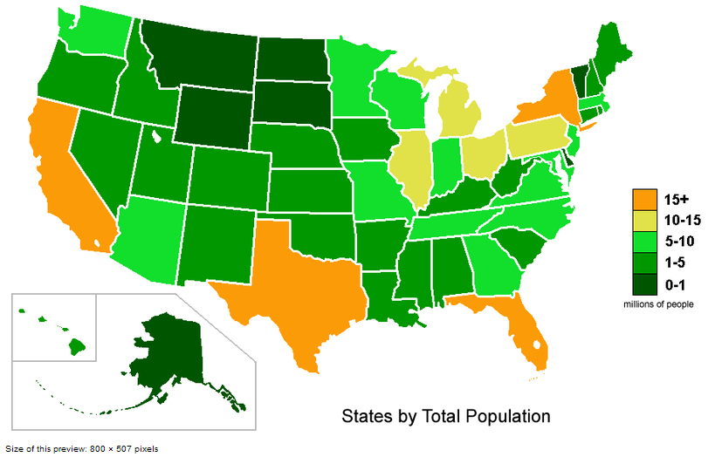

And note the spelling!!! It’s choropleth, not chloropleth. The Greek root choro means “area/region”. The Greek root chloro means “green”.

Part I. The Back Story
In December 2009, Professor Stephen Wu from Hamilton and a British colleague, Professor Andrew Oswald published an article in Science magazine that compared the self-reported happiness levels of about 1.3 million Americans with objectively determined indicators that could influence satisfaction with life (such as precipitation, violent crime, property taxes, etc.). Go to the following web site, and read about their work: http://www2.warwick.ac.uk/newsandevents/pressreleases/research_finds_the

At the bottom of the web page, you’ll see the list of states in rank order from happiest to least happy, and you’ll see a graph that is typical of the ones in the paper. But no map! No visual picture of the distribution of happy and unhappy states! You know enough GIS to easily fill this gap, and you only need one simple data set to do the job.
Part II: Data download
You don’t need much data for this task. All you need is a shapefile that contains the outlines of all 50 US states.

Getting a state outlines shapefile
- In ArcCatalog, do a search of ArcGIS Online for “US State Boundaries”. You’ll get lots of options. For this exercise, choose either USA States or USA Counties.
- Click on the file name in the list, and it will download to your C:\drive. Be patient – it may take a minute to download. ArcMap will open automatically.
- Save your ArcMap document.

Exploring layer files
- This is a Layer file and is composed of 2 layers, USA States (over 1:3m) and USA States (below 1:3m) The difference between the two layers is detail. The “over 1:3m” layer displays when the scale of the map is greater than 1:3,000,000. At scales less than 1:3,000,000, the “below 1:3m” displays. Using different layers with differing amounts of detail is a way to speed up data display based on scale.
- Let’s have a look at this. Zoom in on the state of Florida so that it fills the map window. With this view, the map scale is around 1:4,050,000 and the USA States (over 1:3m) is displaying. Take a look at the detail of the Florida coastline and the Keys. Pretty generalized, but at this scale, the detail is more than adequate to show the state outline. Notice that the “over 1:3m” is checked in the TOC.

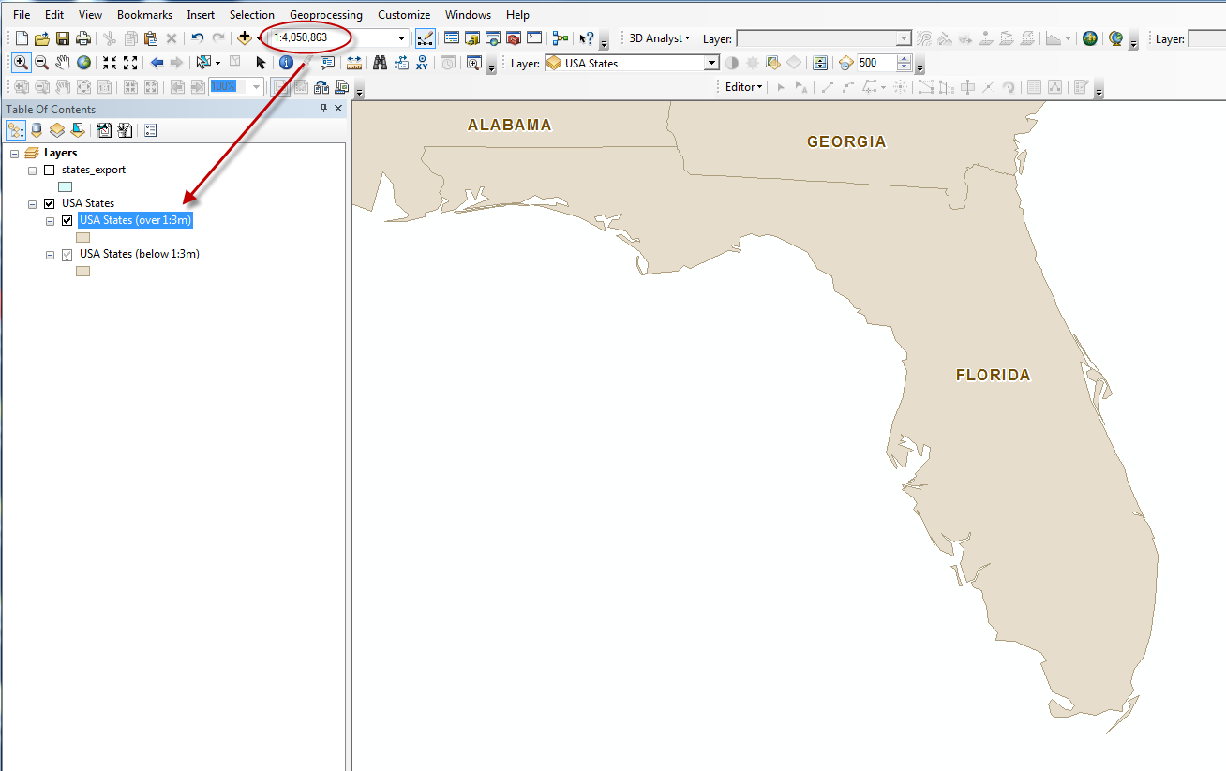
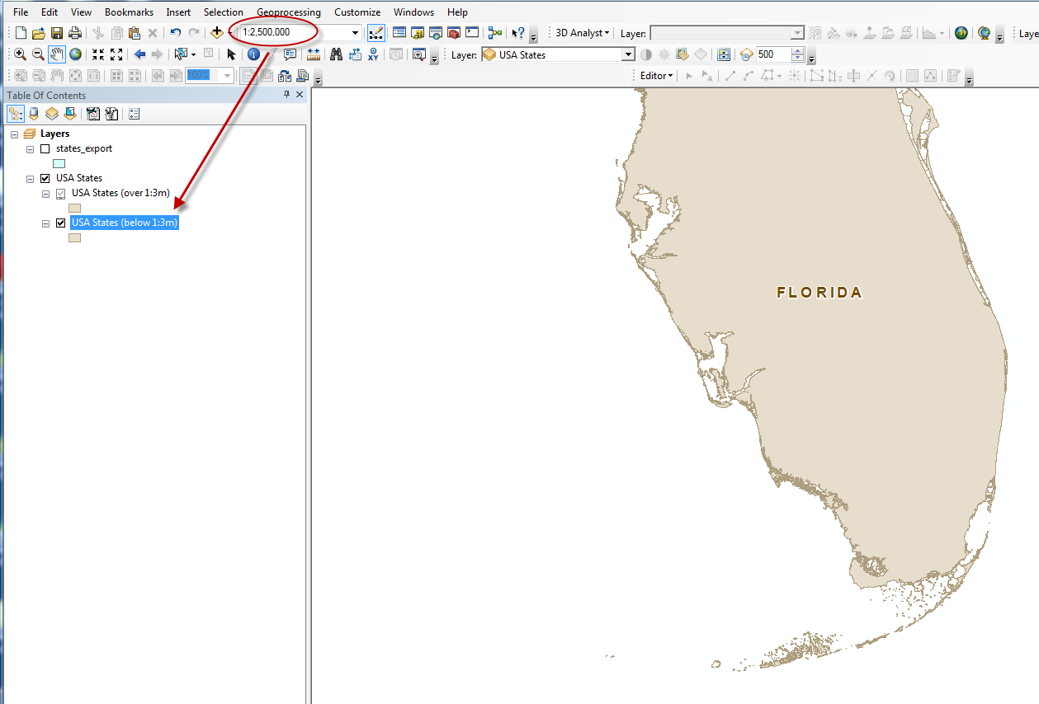
- Now change the scale to something less than 1:3,000,000 (either type it into the box circled in the pic above, or use the pulldown, or zoom) and see what happens to the map. Look at the detail displayed! And the “below 1:3m” layer is checked in the TOC.
- At what scale a given layer is displayed is governed by a setting in layer properties. Properties > General. Compare the scale range settings for your two USA States layers. What did you find?

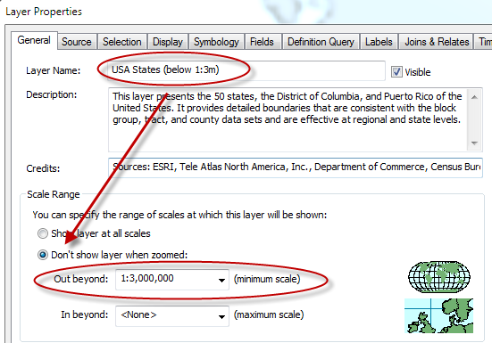

- What if 1:3,000,000 does not mean anything to you? Can you look a scale a different way? There are actually a number of options for the scale window.
  - In the pull down menu of the scale window, you can set the map to a specific scale, but if you scroll all the way to the bottom of the window you see <customize this list>. Select this.
  - The scale settings window opens with two tabs, Standard Scales and Scale Format.

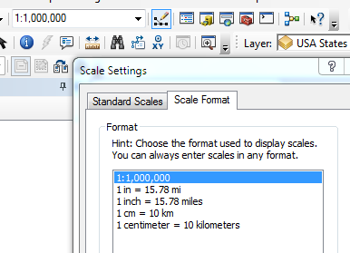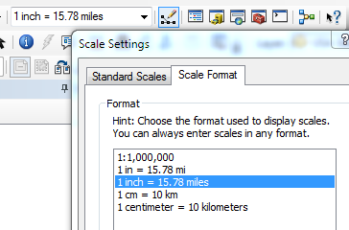

  - Under the Standard Scale tab, you can add a scale to the scales list if there is a particular one you need for a project. Under the Scale Format tab, you can change what is displayed in the scale window.
    - Select the 1 inch = format and click OK. Now the scale window on the main menu bar displays the scale in miles per inch. Pretty clear why centimeters and kilometers make for easy math as well.
    - Change the scale over to inch = or cm= and zoom in and out on your map and watch the scale change. These values can be far more intuitive than 1:3,000,000.

Work flow of what you’re going to do:

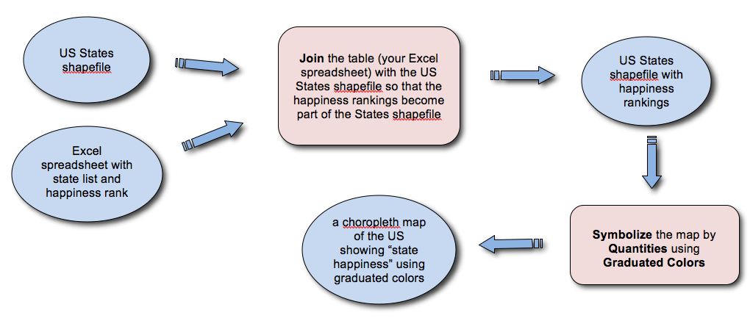

Part III: Making the map
- Getting the shapefile ready
  - Remember that your layers file was saved to your my Documents folder. Export the layer with the lower resolution outlines (you won’t need all the detail of the other one); save the shapefile to your own hard drive, and delete the original layers package. Check to make sure that the file has a defined coordinate system. What is it, and is it a GCS or a PCS?

  - Open the attribute table for your States shapefile, and check to see what the header name is for the state name field. You must use exactly the same name, same caps, same underscore when you create your Excel data table. Write it down so that you don’t forget.
- Creating your data table
Launch Excel, and start at new Excel file. Save the file as a .xlsx file. At the top of the first column, type the field name for the states field, exactly as it appeared in the attribute table for the shapefile. At the top of the second column, type a meaningful header for the happiness ranking field.
    - Enter the states into your spreadsheet in order of happiness ranking (the list from the web site) in the first column. Be very careful not to make spelling errors! If you do, your data won’t join properly with the states shapefile.
    - If you’ve entered the states in order of happiness ranking, you can just put numbers 1-51 into the rankings column (the data includes the District of Columbia, hence 51 instead of 50).
    - Save, and quit Excel.
Joining your data table to the States shapefile
- Joining a table allows you to attach data to a shapefile attribute table provided that there are matching columns in both the attribute table and the data set being attached. These columns must match exactly both in name and contents.
- Excel and ArcCatalog must be closed before you can do the next steps. If they are open, close them before proceeding.
- Right click on the states outline shapefile in the TOC, and scroll to Joins and Relates > Join.
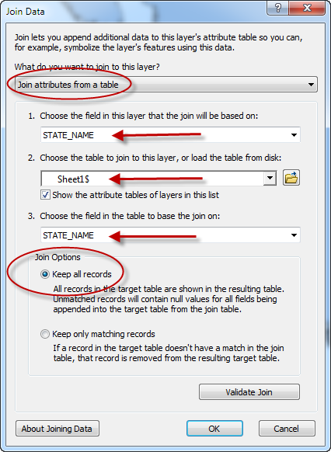
- In the Join Data window:
  - Choose Join attributes from a table.
  - Set Choose the field in this layer… to STATE_NAME
  - Browse to your Excel file, and choose Sheet1$ or whatever you named the sheet.
  - Set Choose the field in the table to base the join on to STATE_NAME
  - Under Join Options, select Keep All Records. You want to keep all records because if you have an error in your file, such as a typo of a state name, if you only keep matching records you will not see the issue because the records will not have matched and it will not be displayed. Click OK.

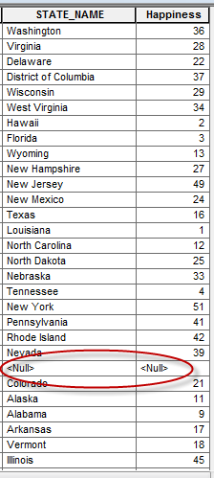
- To check your results:
  - Open the attribute table of the states shape layer, and scroll to the far right of the table.
  - The STATE_NAME and Happiness columns should be appended to the end of the attribute table. Scroll through the data and see if there are any <NULL> values in either of these two columns.
  - In the example shown at right, a <NULL> value appears between Nevada and Colorado. This could be the result of a typo or another reason. Click in the gray column on the far left side of the attribute table to select the row with the <NULL> values in it, then scroll all the way to the left side of the attribute table to see which state has the data problem.

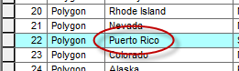

  - In this case, the issue is with Puerto Rico, which was not part of the happiest states survey, so there is no matching value in the Excel file. As long as you make your map layout so that PR doesn’t show, you can just ignore the <Null> value if it’s for Puerto Rico. Note: Puerto Rico may not be in the table, depending on which shapefile you downloaded.
  - If you have <NULL> values for other cells, though, you’ll need to fix the problem before proceeding. Remove the join (Joins and Relates > Remove Join). Reopen Excel, and see what the problem is (most likely a typo in the state name spelling). Correct it in the Excel file, resave the file, and redo the join.
- Note: a join is a temporary attachment of data to a shapefile. To make the expanded attribute table a permanent addition, you need to export the data and save it as a new shapefile. It’s a good idea to get into the habit of exporting the data and saving it as a new file so that, when you move files around, you are less likely to omit a critical component.
- Creating a choropleth map
- Your data are all ready to symbolize so that you can make a choropleth map.
- Colorize your map by Quantities > Graduated colors. Choose your happy ranking in Value. Type 51 into the Classes box, and try out various color ramps, clicking Apply until you find one that conveys the concept well.
- If you decide that you want to label the states by rank, you may discover a wrinkle in the way this shapefile is already set up (depending on how it’s set up). If you label features, and you are zoomed out to the full extent of the map, you won’t see any labels. If you zoom in, all of a sudden, the numbers appear. If you go to the Label dialog box, and choose Scale Range, you’ll see that you can choose not to show the labels when you are zoomed in or out to a certain distance. This prevents the labels from looking enormous when you zoom out. You also might not want, for example, state labels when you zoom in. But, in order to see the labels when the image is zoomed out, you need to check the first radio button (Use same scale range….), and size your text to look the way you want it for your final map layout.
- In terms of a nice-looking map, the current view looks pretty squished, and you’ll probably want to do a little projecting. Here’s a way to do this on-the-fly and try out a number of options.
  - Go to the Data Frame properties, and choose a projection for the data frame. Because you’re just trying to make a nice-looking map, you can OK the default choice that ArcMap makes for any transformations that might be necessary. Choose Apply, rather than OK, until you find one that looks good for the continental US.
  - Then, create two more data frames, and drag your new shapefile (the one with the added rankings) to each of the new data frames. Activate the second data frame, and choose a projection that will work well for Alaska.
  - Repeat for Hawaii.
  - Then you can switch to map layout view. All three data frames will show up, and you can drag them around and zoom in to the continental US for one dataframe, just Alaska for the second one, and just Hawaii for your final map.
- Make a swell-looking map that would be appropriate for USA Today, and save it as a pdf or a jpeg in your own folder on the server. Be very critical about whether the title, legend, and color scheme convey the message effectively to the reader and whether the elements you have chosen to include are appropriate for the intended venue. Do be sure, though, that you include a footnote with the source of the Happiest States data.
- A second choropleth map
- Do some internet sleuthing, and find another variable by state, make a new Excel spreadsheet, and join it to your existing attribute table. You must choose a variable other than one that is already included in the attribute data for your states file. This is a chance for you to do some sleuthing for data. Over the years, we have some humdinger maps with hilarious variables. Surprise us!
- Make a second map appropriate for USA Today and save it to your folder on the server.

On Monday, we will critique everyone’s maps, as we did with the Pleistocene land bridge maps. Here’s what we will be looking for:

Design
- Is the layout well-balanced, with items of appropriate size and spacing?
- Is labeling legible?
- Is the font choice attractive/appropriate?
- Do the chosen colors go well together?
- Is the legend clear and attractive with an appropriate amount of detail?

Message/communication
- Is the title informative and unlikely to be misinterpreted?
- Does the color ramp visually support the message?
- Do labels (if any) enhance the map, and are they unlikely to be misinterpreted?
- Does the legend visually support the message and is it unlikely to be misinterpreted?
- Does the map need additional information/components in order to effectively convey the message?

Cartographic aspects – remember that this is a map for the newspaper USA Today
- Do the projections chosen look good for continental US, Alaska, and Hawaii?
- Does the map contain any unnecessary cartographic elements?
- Are the data source, your name, and the date listed inconspicuously but legibly in an appropriate place on the map?

http://commons.wikimedia.org/wiki/File:USA_states_population_color_map.PNG

