Geology 310 – Geomorphology

Using a GIS to Assess Stream-Channel Migration

Instructors: Drs. Scott Linneman and Doug Clark
Western Washington Univ. Geology
http://geology.wwu.edu/dept/index.shtml

Background: Geomorphology at WWU is a 300-level course in the core of the Geology BS and BA sequence, but is generally the second or third class our majors take. The class also fulfills General Education requirements for several other majors, so there are many (up to 50% or more) non-geology students in the class as well.
We usually teach the lab in the first few weeks of the term, and for most students it is their first or second exposure to GIS, so we can only assume minimal experience with them. Our department recently introduced a new 200-level GIS class, so within a year or so, all students taking Geology 310 should have taken the class, but we haven’t quite achieved that goal yet.
The lab is generally part of a larger set of labs that investigate the local Nooksack River, including literature review, field trips, and traditional topomap assessment.

The Set-Up: For this lab, we use a single computer lab with ~20 computers, each with ArcGIS loaded on them. The computers have access to a Geology server with the necessary files on it, and the students can access the drive once they’re enrolled in the class. Because there are usually 25-30 students in the class, we have most students double up on a computer. This works well because most students benefit from having a partner to help work through the idiosyncrasies of ArcGIS.

The Goals:
- To gain exposure to and appreciation of the value of GIS in the Geosciences
- To become more familiar with working within the ArcGIS environment
- To improve their understanding of possible ways to use GIS to address a geomorphic problem
- To gain a sense of the rates and styles of channel migration in braided vs. meandering portions of a local river (the Nooksack)
The idea is to guide new geoscience students through a focused study of river channels with a heavily guided lab that allows them to qualitatively (and to a small extent quantitatively) determine the historic mobility of river channels.
What are GIS’s?

Geographic Information Systems (GIS) are digital management systems for large data sets that are widely used by geologists and other scientists in professional careers (i.e., city planning and natural resources/hazards assessment). Instead of using traditional stereo photos and topomaps to understand why rivers meander or braid, you will learn how to use ArcMap (an industry standard GIS) to retrieve valuable information that will supplement your findings from other sections of the research project.

Question: How do river channels migrate?
For this lab, you will create a GIS using digitized historic aerial photography of our local Nooksack River to assess how rivers migrate through time. In order to complete this task, you will need to navigate to the H-drive (the “Geologist” server) to the >Classes>Geology 310 folder (the TA or I will show you how to do this if you have trouble). In the Geology 310 folder, there is a folder titled “River lab Data.” Open this folder by double-clicking the folder icon and you will see the folders listed below:

DRGs
Digitized Nooksack Photos

A DRG file, simply put, is a digitized version of a USGS 7.5 minute topographic map that has been referenced to a geographic projection (a coordinate system) of the Earth. The folder titled “Digitized Nooksack Photos” contains multiple images of the Nooksack River of Bertrand Creek SE and Deming NE quadrangles from the years of 1933, 1938, 1950, 1966, and 1976 (Bertrand Creek SE also has photos from 1993, while Deming NE does not). Notice that all images have other associated files with them called metadata files. These files are used by the GIS to define the image’s coordinate system and it is important that you download each accompanying metadata file with its image if you move the files; otherwise the GIS will not be able to locate the position of your image. The benefits of a GIS will be apparent as you start to use it, because you will not have to re-locate or re-size each image; also, the images will automatically overlay atop of one another, allowing rapid observation of stream channel changes.
The process is relatively easy to follow and has been outlined below. First, click on the Windows start menu and highlight programs. The programs window should expand and you need to navigate to the ArcGIS menu. The ArcGIS menu will expand and you need to select ArcMap from the dropdown window. Once ArcMap is open, select a new project and click ok. Now we can begin to populate our GIS with images from the Geology 310 folder. Before adding each image to the GIS, first download all files to a temporary folder in the temp files (I can show you how to do this if you do not know how). To add each image, click on the plus icon on the toolbar menu and navigate to the folder in which your image is located. You may have some problems finding your folders at first and you may have to map (add) your drive in ArcGIS, which I can show you how to do. Listed below are the steps needed to create shape files for each image year. The examples below are from a previous study that one of my students conducted on the Nooksack Delta, but the process is identical to what you will do.

Step 1: Load a referenced digital photograph of the Nooksack Delta into ArcGIS and open ArcCatalog.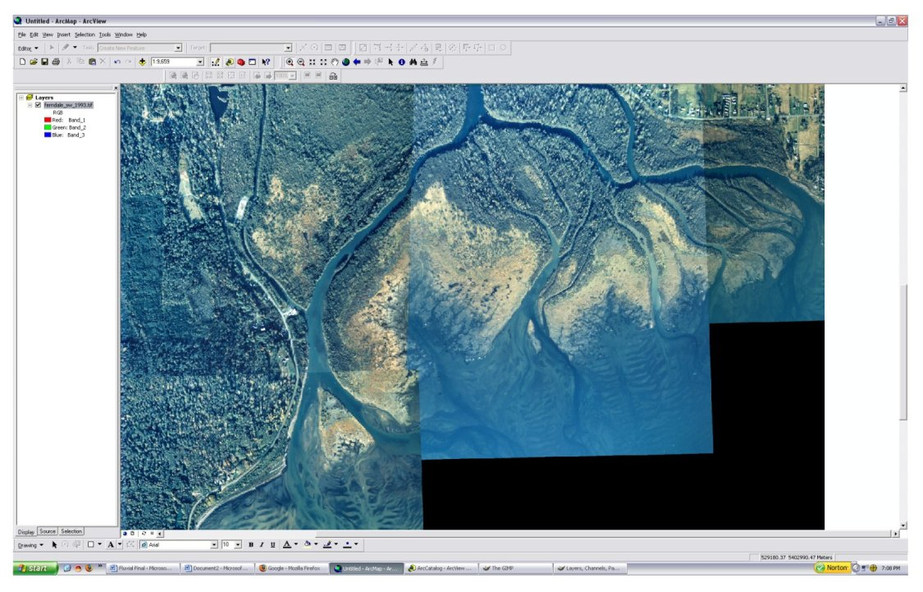
To open ArcCatalog,, click on the yellow file cabinet in the menu bar.

Step 2: Locate the storage location of the image on the hard drive, right click on the contents tab within ArcCatalog, and select New Shapefile. Make sure to save your shapefile in the folder you’re working out of, and not in the H drive.
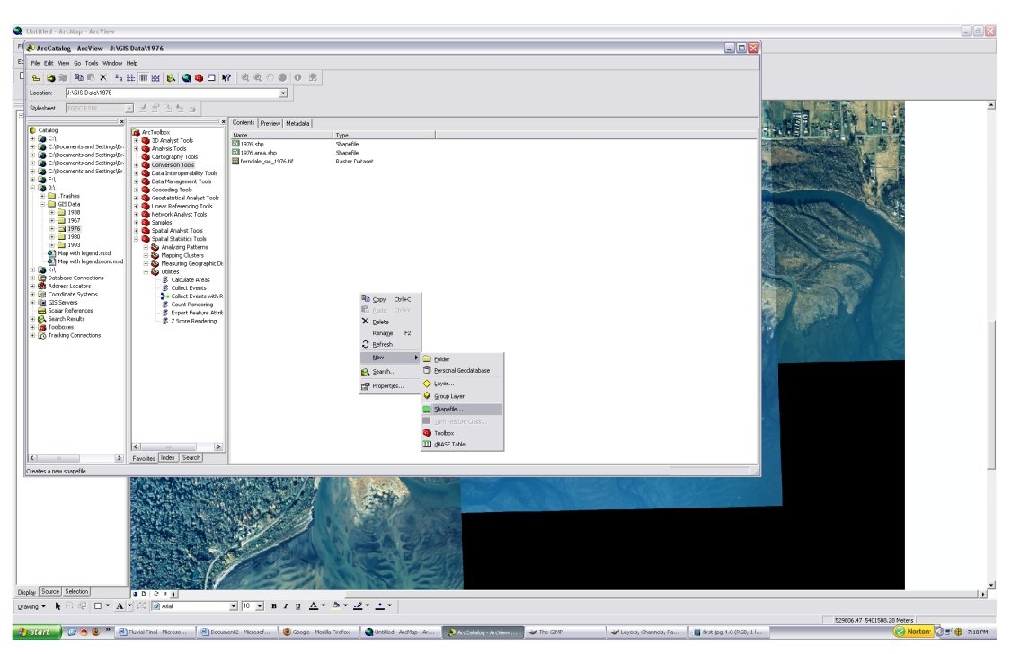

Step 3: Choose a name for the shapefile (best to use the location and year), change the Feature Type setting to Polygon, and select Edit underneath description. From the new box labeled Coordinate System, click on Import and navigate to and click on the specific arial photo you are creating the shape file for. This will overlay the shapefile onto the arial photograph and the shapefile will be referenced to the same coordinate system as the image. Then click OK.
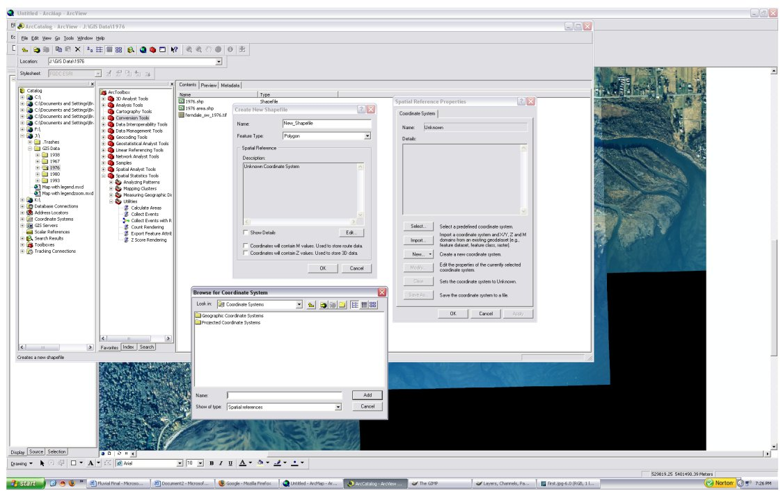

Step 4: Load the shapefile into ArcMap as a feature by clicking on the plus icon. To edit the blank shape file, you may need to activate your editor tool bar by selecting tools on the main menu bar, and clicking on editor tool bar. With the editor tool bar open, make sure that your active layer (i.e. the shapefile) is highlighted in the left-hand box. To begin editing, click on the editor toolbar (where it says editor and has a down triangle) and select start editing. Make sure that you select the correct layer to edit. Make sure that the symbol to the right of the editor drop down box is a pencil. If not, click on the down drop arrow and select the pencil. Now you’re ready to create your shapefile.
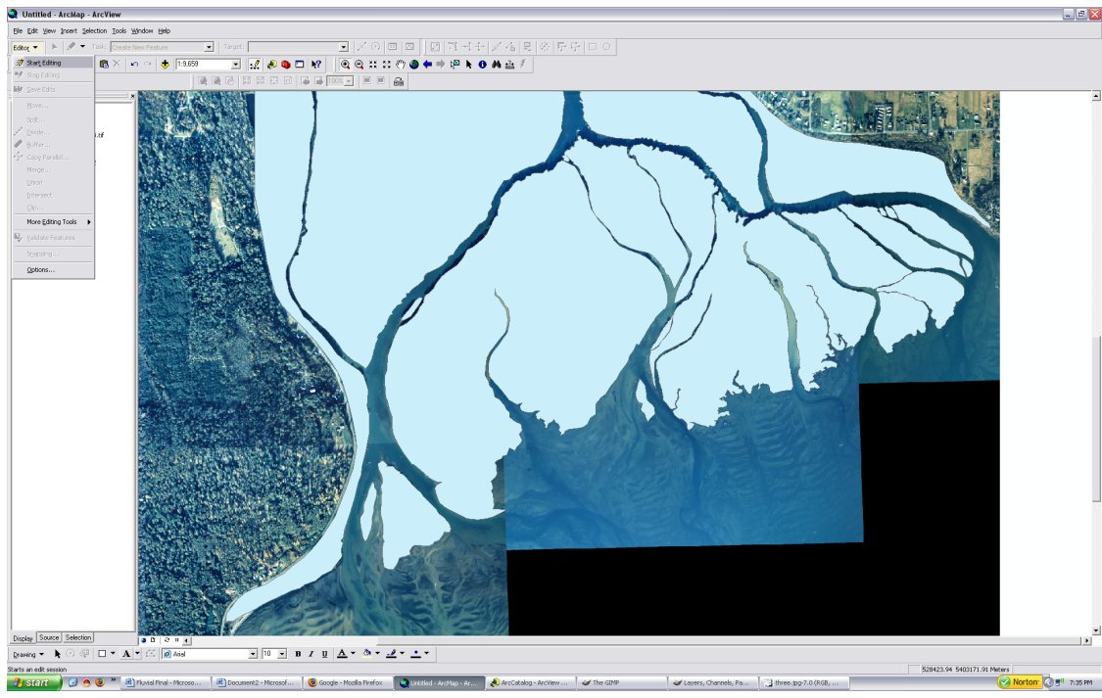

Step 5: Begin marking along the channel by clicking along the channel margins to define your line. When you have completed one segment or side of the channel, double click on your last point. This will effectively end your editing for that segment, in which you can create another line on the opposite side of the channel by following the same process in step 4.
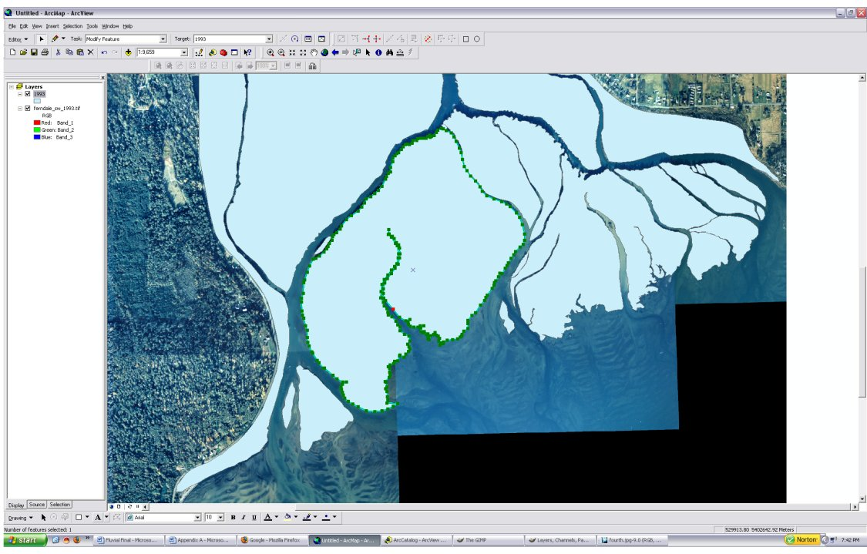

Step 6: When the entire image is covered in polygons, click on the Editor Toolbar and select Save Edits. After all edits have been saved, select the Editor Tool bar again and click on Stop Editing. Creation of the shapefile is complete and other shapefiles for other years can be created in a similar manner. For each set of photos, compare the number and width of channels for that year, and record those values. Then compare how the values change for the different years. This measure will give you a sense of how mobile the channels are in various reaches of the river. Also, measure the total channel area for each (see below).
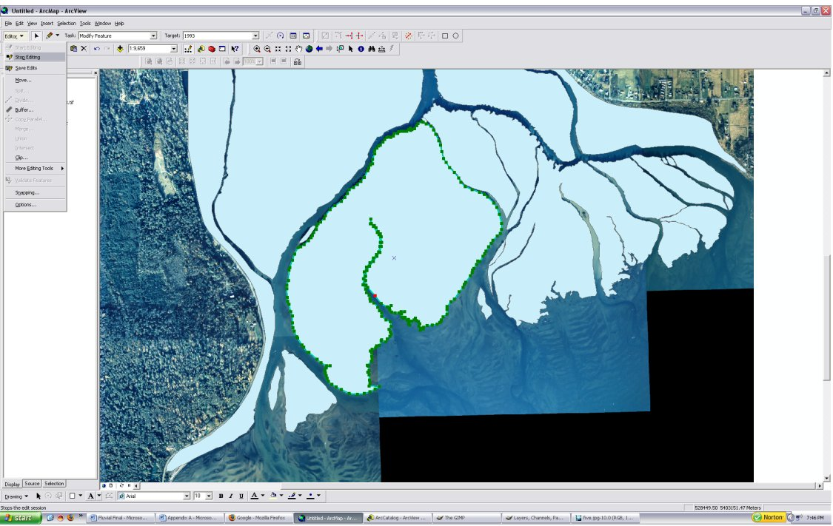

(If time permits and you’re interested)
Appendix A: Calculation of Channel Areas using Shapefiles

Step 1: Open ArcToolbox by selecting the red tool box icon within ArcMap. From the window next to layers window, select Spatial Statistics Tools. After selecting spatial tools a drop down box will appear. Click on Utilities and then double click on Calculate Areas.
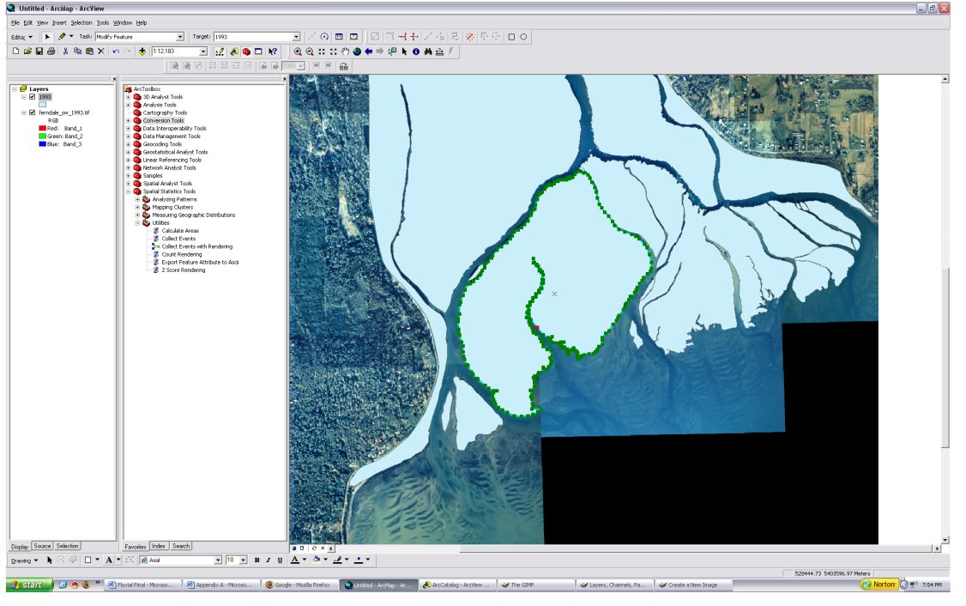

Step 2: On the separate pop up window, click on Input Feature Class and select the shapefile in which you would like to calculate area. Click ok. Then select the Output Feature Class icon and name the output file and select save. In this output file, ArcMap will calculate each individual polygons area.
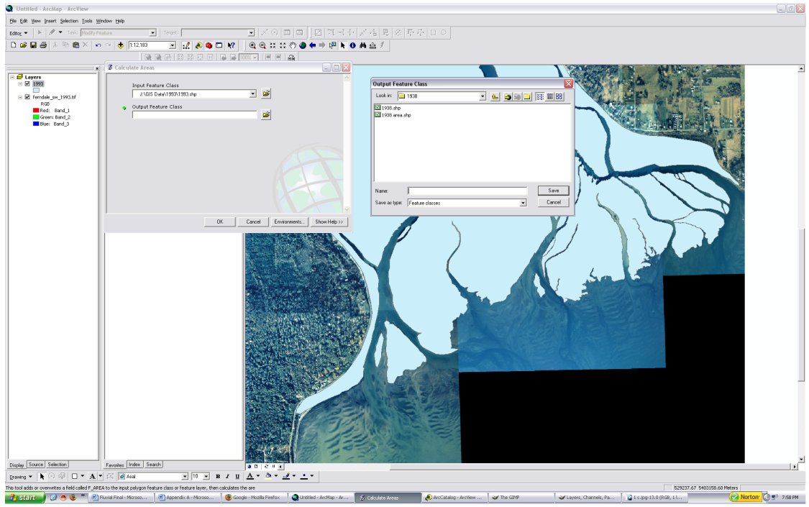

Step 3: Load the newly created area shapefile into ArcMap, by clicking on the Plus Icon and selecting Add. Highlight the shapefile and right click on the name. From the drop down menu select Open Attributes Table. The table will open and you need to select the Options button. From the drop down box click on Select all (this will highlight all values). Click on Options again and select Export. A new box will appear titled Export Data. From this menu, click on the folder button and name the file. Select ok. This export function will create a .dbf file, a database file that Microsoft Excel can open. 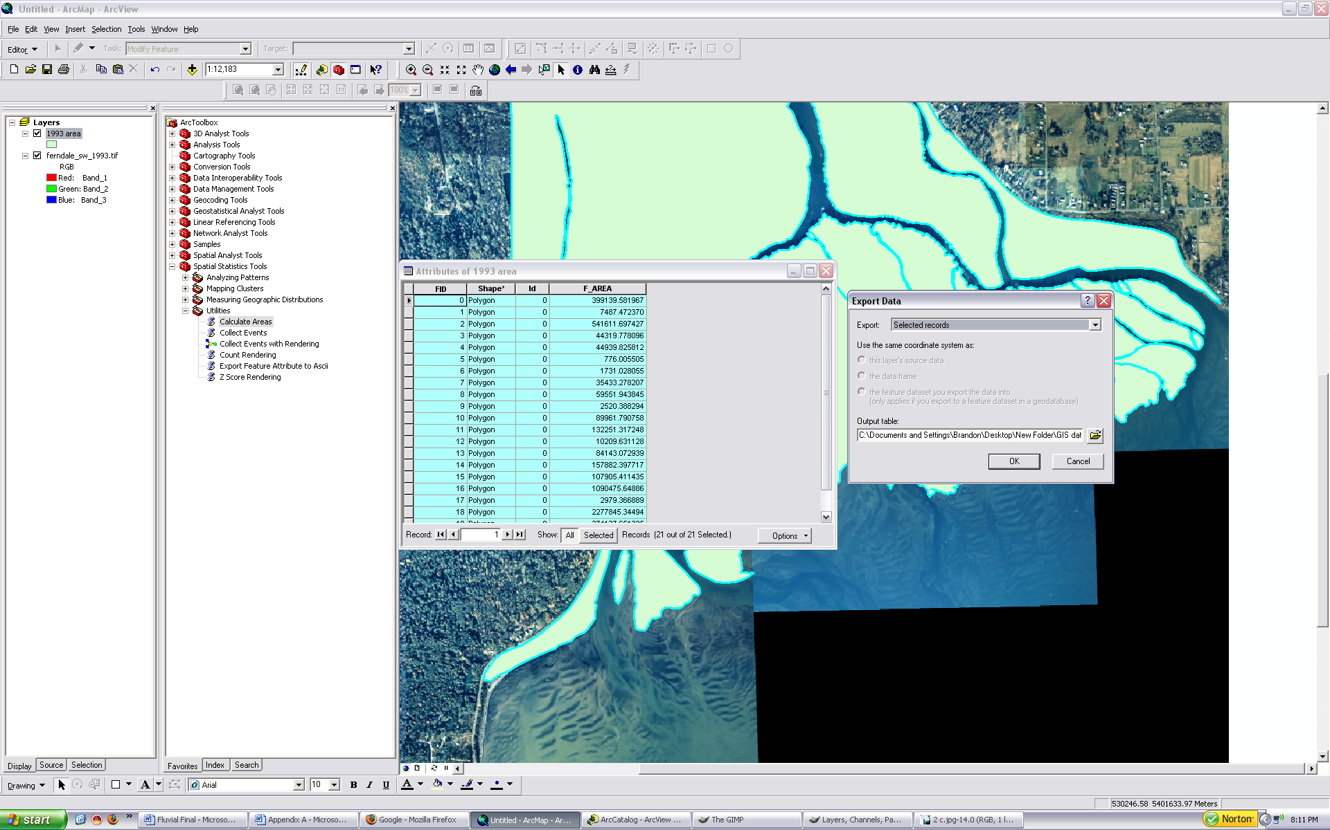

Step 4: Open Microsoft Excel and open the newly created .dbf file. Sum all polygon areas together to obtain the total area of the delta for the specified year. Repeat the cycle for all other years desired.


