Georeferencing

Authors: Davis, A.¹, W. L. Mills²
¹ Furman University, Greenville SC, davis.amelie AT gmail.com
² Purdue University, West Lafayette IN, wmills AT purdue.edu

Goal:

As a result of this lab you should be able to understand the process of georeferencing and be able to carry it out.

Learning objectives/outcomes:
- Understand what the rectifying process does
- Know how to georeference any scanned map or aerial photo
- Perform a basic historical Land Use change analysis

Statement of problem

Premise for exercise
You learned in earlier labs the importance of projections. Sometimes however data will come in a format with unknown projection and no way of knowing what it is. This data is most often aerial photos or paper based maps. In order to use the information in these maps you will need to match it up spatially with your GIS data which already has spatial information associated with it. This process is known as georeferencing. You will practice georeferencing on scanned aerial photos of the Muskegon watershed in Michigan.

We recommend you read quickly through the entire lab exercise before beginning.

Data
You need to download data from http://eweb.furman.edu/~adavis2218/Mecosta_MI_data.zip to download the data. Save it to the C:\temp\ folder and unzip it. Open the georectify.mxd document and look at the properties of the following files to fill in the blanks below.
File name:  - Description:  - Data model:  - Data type:  - Units:  - Coordinate system:  - Any previous coordinate system: | allroads_miv2a  - roads data for Michigan  - vector  - line shapefile  - meter  - NAD_1983 Hotline Oblique Mercator Azimuth  - GCS_North_American_1983
File name(s):  - Description:  - Data model:  - Data type:  - Units:  - Coordinate system:  - Any previous coordinate system: | 271_1938.tif, 271_1972.tif,  - Scanned aerial photography of Mecosta County, MI in 38, and 72.

Processes
- Add control points (Georeferencing toolbar)
- Rectify (Georeferencing toolbar)

Lab exercise

Part A
Georeferencing allows you to use photos and maps that would not have been available to you in ArcGIS. Let’s say that you were hired to create a timeline of how the landscape has changed in and around the town you live in. You enlist the help of a historian who finds old paper maps of the area as historical aerial photos printed on photo paper. These maps and photos are invaluable because they give you information on where the roads were, if they were paved or not, how much forest there was, where houses were concentrated, etc. You then need to scan the maps and photos (as .jpg for example) and import them into ArcMap. However ArcMap does not know where to locate them in space relative to the data you already have in GIS-ready format such as roads and current orthophotos. You will need to reference this data that is ‘floating’ in space to the data you know is correctly located in space.
In this section you will learn how to georeference an aerial photo. This process also applies to scanned maps.

- Open the Georectify_Thu.mxd ArcMap document. Select View > bookmarks > Region_zoom. Examine the features.

- Right click on the 1938 aerial photo called ‘271_1938.tif’, and select ‘zoom to layer’.
As you can see it is not lining up with the Michigan roads data even though it is of the same geographical area. Georeferencing will ensure that they overlap

- Turn on and off the various .tif images for the 2 different time periods: 1938 and 1972.
Do they all depict the same geographical area? Explain your answer in 2-3 sentences.

Do they all have the same spatial extent? Explain your answer in 2-3 sentences.

- Go to the View menu > Toolbars > Georeferencing.

- In the Georeferencing toolbar make sure your target is Layer: ‘271_1938.tif’. This means you are going to rectify that image so that it matches your spatially referenced layer which in this case is your roads layer: allroads_miv2a.shp.

- You must now identify locations on the image and “connect” them with the same location on allroads_miv2a.shp. One of these connections, or pair of control points, has been identified for you and is shown in Figure 1 with the red circles. You will identify more control points.
Compare the aerial photo and the roads shapefile (the streams and ponds are provided to help you visually) and find 4 other ‘good’ control points. A good control point is generally a road intersection which you can easily find in both the spatially defined layers and the layer that is being georeferenced. The control points should be scattered through the image you are trying to georeference (here the aerial photo), i.e they never should be clustered in one side of the photo or along a same line. Using rivers or lakes is generally avoided because a particular aerial photo may have been taken during flood or drought conditions, both of which could change the location and shape of the feature. Then use and the print out which was provided to you and draw circles around the 4 control points you picked in the top and bottom images in the images. Each match should be labeled with the same number (2 through 5).
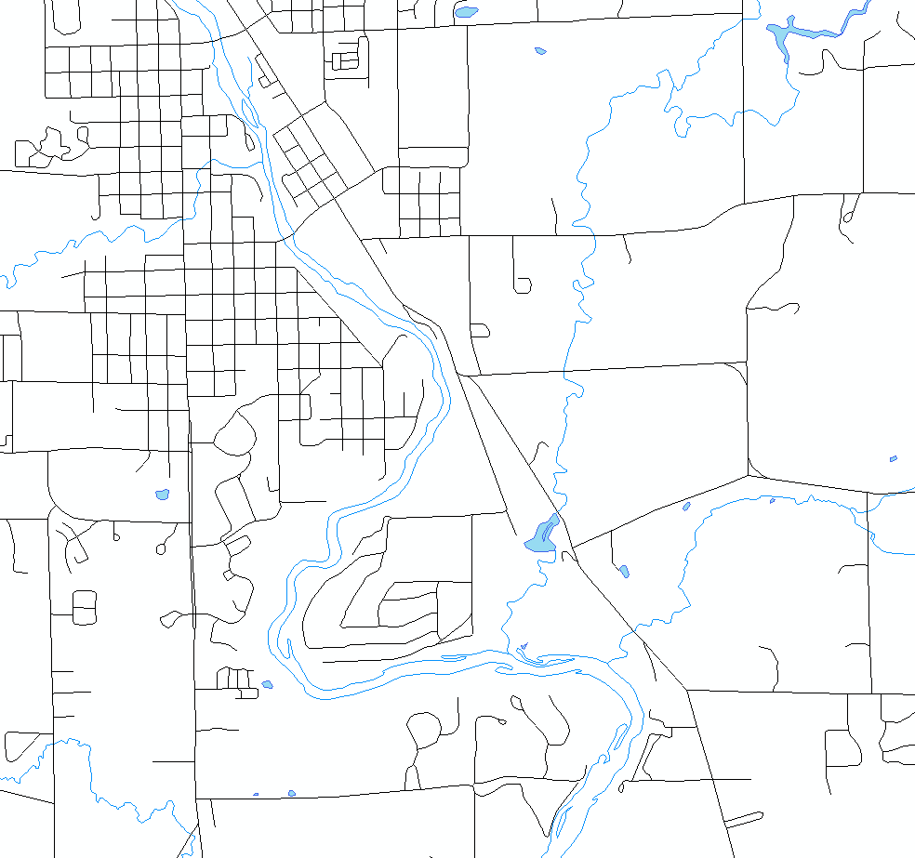
1`
1
Fig 1. 1938 Aerial photo of Mecosta County, MI (below) and corresponding roads (top)

- Go back to the ArcMap document. You are now going to add your first pair of control points. The first point should be the intersection of two roads outlined by the red circles in Figure 1.
Go to view > bookmarks > region_zoom and from the dropdown menu of the Georeferencing Toolbar, select Fit to Display. This will move the 271_1938 image to roughly coincide with the roads layer.
- Select the Add Control Points tool from the Georeferencing toolbar ( ). With the ‘cross’ cursor, click FIRST on the intersection on the image, i.e. the aerial photo then on the road location.

- Select the Zoom tool and zoom and use the Pan tool to locate the other pre-selected points. Select the Control Points tool to add the next set of control points.

- Add the other 3 control points you identified earlier. You will probably need to zoom in and out on the image and move to various parts of the image as you select the points. If you make an error, open the View Link Table on the Georeferencing toolbar () to see a list of control points, click on the last point to select it and push to the Delete key. The point will be deleted and you can select another point. Remember that you always add control points by first clicking on the image that needs to be georeferenced (in this case the aerial photo) to the layer which is already correctly located in space (in this case the roads layer).

- Exam the View Link Table ()after the fifth point and check the RMS value. You should get a value less than 10 (I got a 4.9 RMS). You only need 4 points to calculate an RMS value so you can delete the point which gives you the largest residual. This should improve your RMS.

- If you find you have to redo a lot of your control points, once you’ve deleted the ones that gave you the largest residuals, go to the georeferencing toolbar and select ‘Reset Transformation’. This will move the image back to where it would be if those points had not been added, so that you can add new points more easily.

- When you are satisfied with your control points, write down your RMS for the 271_1938.tif rectification. What does your RMS value mean?

RMS
Meaning (2-3 sentences):

- Select Rectify from the Georeferencing Toolbar and save the rectified image to the C:/temp/ directory. Select ‘TIFF’ as the format. Name the file 271_1952_rect.tif. Keep the defaults for the other choices.

- Once the rectification process is ended add your newly created .tif file to your ArcMap document and uncheck 271_1952.tif in the TOC. Create a screengrab showing the rectified image with the road network overlaying it. You can choose to keep the rivers and lakes layers if you wish. Did you have any distortions in your final map? How could you make sure you had less distortion if you were to redo this process?
Paste map here
Distortions and Improvements?

- Rectify the 271_1972.tif file. Remember to change the target Layer in the georeferencing toolbar to the aerial photo you intend to rectify.

Date | RMS = | Map (Screengrab is OK)
1972

Note:
_ Sometimes scanned images will not be scanned in the orientation which matches your reference data i.e. the data which is correctly located spatially (here the roads data), you would then have to use the tools of the Georeferencing toolbar under the ‘Flip or Rotate’ menu.
_ Additionally you can save your control points when you are in the ‘View Link Table’ menu and load them later to either add more or have a record of what you used.
_ In the data folder you downloaded there are aerial photos for 1952, 1965 and 1981as well. Those can be georectified for added practice or if interested in having more information for the land use change analysis that follows.

Part B
Georeferencing is necessary so that you have access to spatial information you otherwise could not use. In the example above you now have a time series of what the landscape looked like, i.e. the photos that you georeferenced can be used along with current orthophotos and other data so study the changes that have occurred in the landscape over the year. Georeferencing allows you to be able to compare an exact location (with an error margin) on multiple photos and maps. This is not always done for different years but can be done just comparing maps to see the differences between them: what got left out, what was better represented in one versus the other, which representations or roads follow the aerial photo better, etc…
In this section you will use the aerial photos you just rectified to perform a quick spatial analysis of land use change in a portion of Mecosta County

- Activate the data frame called ‘Grid’. You may have to ‘repair the broken links’ by linking back to the folder you just unzipped.
Add the 2 aerial photos you just rectified to this dataframe.
- You will now estimate the percentage of the image which is in the different classes for the region of the aerial photo which is delimited by the polygon shapefile named 271. The land use classes we are interested in are:
_ water
_ forest
_ agriculture
_ shrub
_ wetland
_ barren land
_ urban (roads are not considered urban, they should be classified as other)
_ other.
Some portions of the images will be missing or will have pen marks on them, ignore those.
Open the box271.xlsx document. Click on the worksheet labeled ‘wholeimage’ and fill in the tables. You must also assess how certain you are of the percentage you assigned to each class by attributing it a 1 through 4, one being the least certain and four the most certain. This should be individual work. We ask that you not confer with other lab mates. If you are having trouble with this please ask the instructor.

Do this for the 1938 and 1972 aerial photos that are located under the Grid data frame.

- Turn off 271.shp and turn on grid2_2 in the ArcMap document. Next click on the worksheet labeled ‘4_boxes’. For each of the 4 grid boxes estimate the percentage of the 4 different land use classes for the different aerial photos and fill the table in the excel document. Check that the sum of your rows is equal to 100%.

Based on your estimations, which quadrant experienced the most land use change between 1938 and 1972 (considering all land use classes as a whole, i.e. which quadrant had most of its land modified between 1938 and 1972)?

Considering all four quadrants, which land use class gained the most and which lost the most area (use the totals)?

Part C
One way to use the information in raster images is classification. You will be introduced to a simpler version of classification in this exercise. Classification of rasters allow you to do spatial analyses of land use change for example. Using this technique you could summarily document which areas went from forest to agriculture to urban and at what time periods those changes occurred.
In this section you will use a different method to rapidly classify the aerial photos you just rectified.

- In the ArcMap document, turn off the grid2_2 layer and turn on the pts_217 layer. In the excel document, click on the worksheet named ‘rdm_pts’. Assign classes for each of the points which are labeled on your aerial photo for the different years. You may wish to zoom in. Also indicate your level of certainty with the class assignment. Classes are Forest (F), Urban (U), Water (W), Agriculture (A), Wetland (E), Barren (B), Shrub (S), and Other (O). The level of certainty still ranges from 1 (extremely uncertain) to 4 (extremely certain).
- Identify 2 points (by their ID number) which went from Agriculture to Urban sometime over the 20 year time period the images were taken.

- Are there any land use change successions that you find surprising (Urban to Forest for example?) If yes identify them below and discuss whether you think it is an error in classification or in registration (the georeferencing) or if you think it is correct.

- Compare your results with your neighbor or another student that is at the same point as you are in the lab. Were there any discrepancies in your results? If yes, were you able to resolve the discrepancies through discussion or not?

PLEASE EMAIL YOUR WORSHEETS TO davis.amelie AT gmail.com AT THIS TIME.

Assessment
Why do you first select a control point on the aerial photo and then select one on the roads layer and not vice versa?

Define an aerial photo. Cite your sources.

Using the internet i.e. most likely Google earth and/or Google maps find the name of the city which is depicted in northwestern portion of the 1972 aerial photo for box 271.
City?
How did you find the information?

Why is the process of georeferencing necessary and what exactly does it do? Explain in 1 - 2 paragraphs.

