Solution Set:
Seismic Refraction Exercise for a Hydrogeology Course

Purpose:
The following pages provide the solution set to “Seismic Refraction Exercise for a Hydrogeology Course.”

Contents:

1) Step 1: Results of seismic refraction survey with P-wave arrival times circled.

2) Step 2: Table showing geophone number and P-wave arrival times.

3) Step 3: Plot of arrival times versus distance.

4) Step 4: Plot of lines showing the velocity in each layer.

5) Step 5: P-wave velocity calculations for each layer.

6) Step 6: Plot showing X_{c1} and X_{c2} distances.

7) Step 7: Calculations for the depth of z₁.

8) Step 8: Calculations for the depth of z₂.

9) Step 9: Data interpretation.

10) Step 10: Stratigraphic column.

For questions about this exercise, feel free to contact:

Dr. Devin Castendyk
Assistant Professor and Water Resources Program Director
State University of New York, College at Oneonta
Oneonta, New York
Email: castendn@oneonta.edu
Phone: 607-436-3064
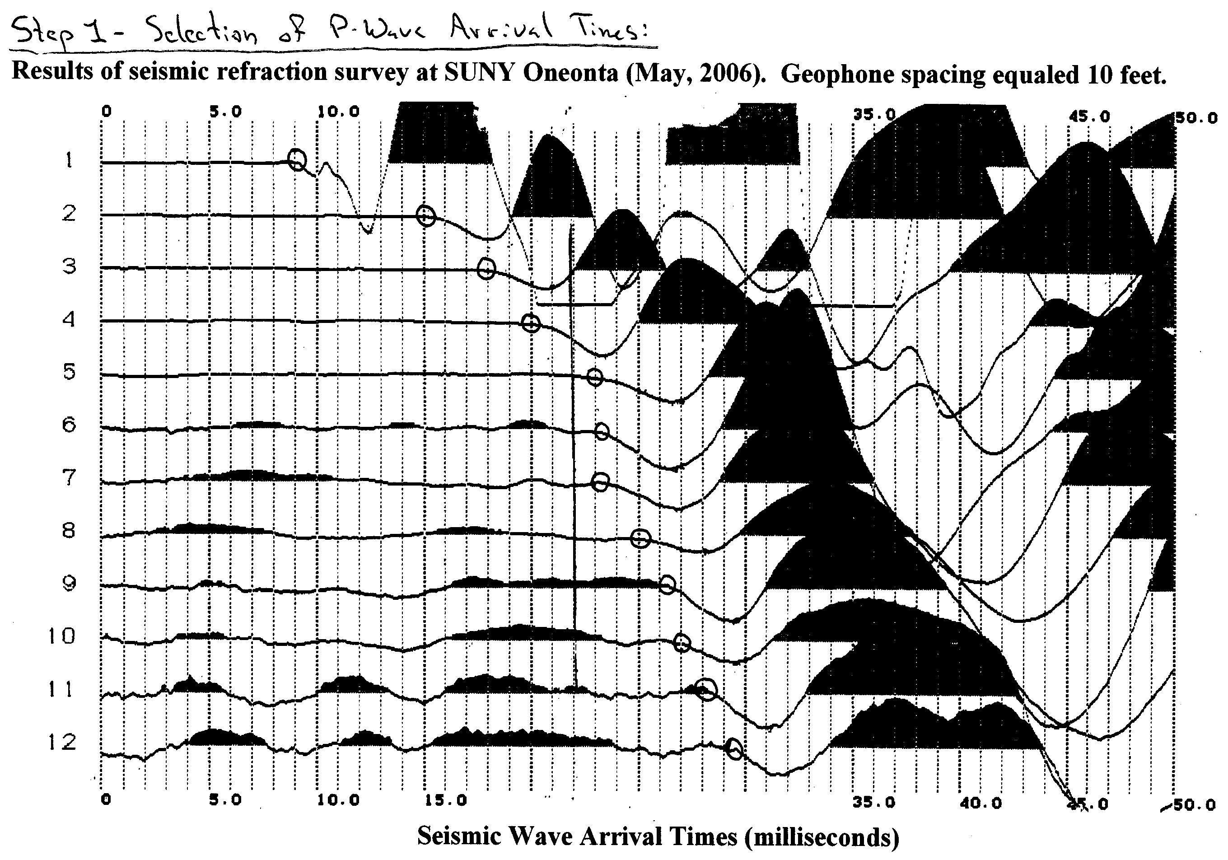
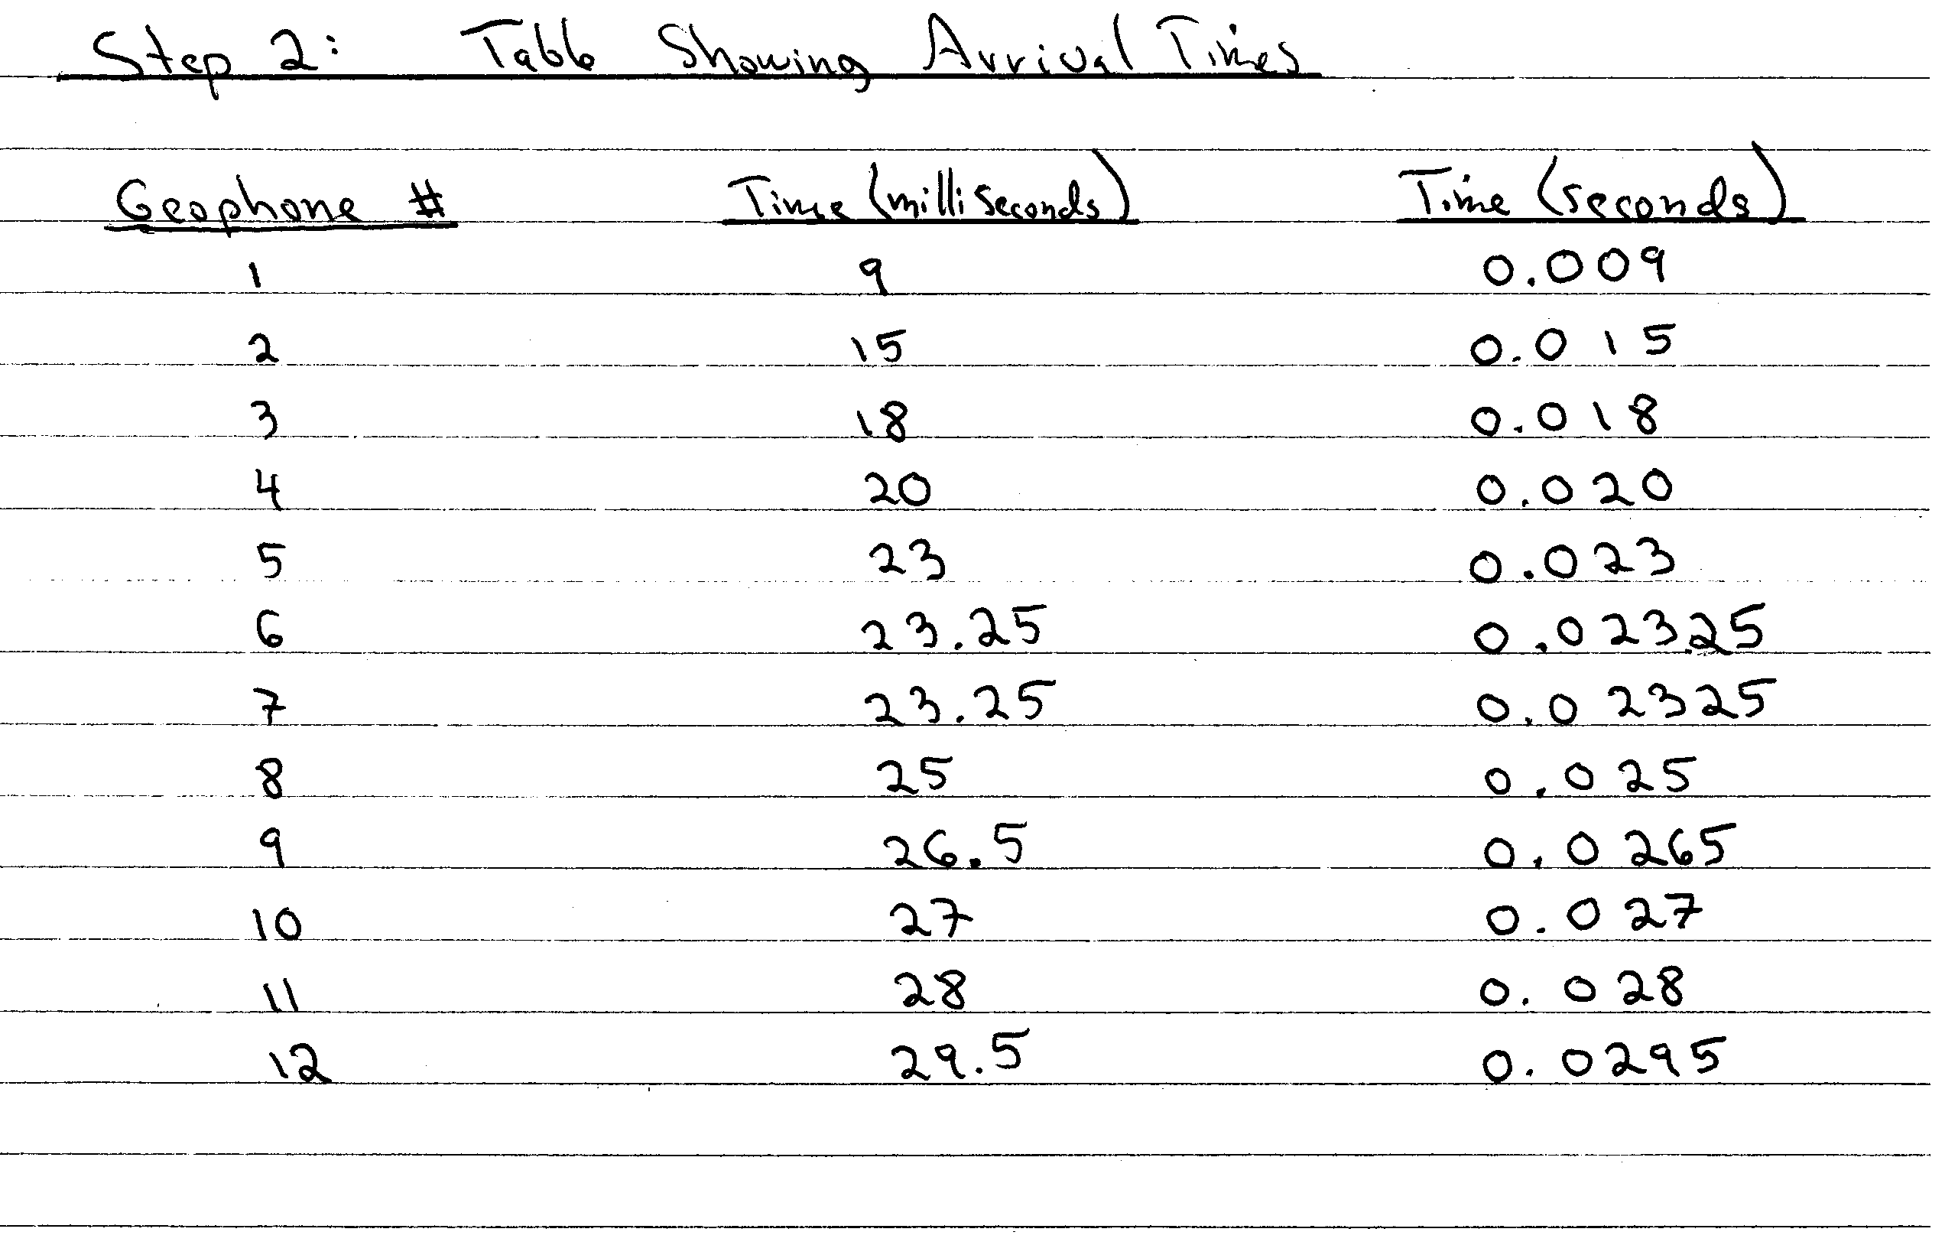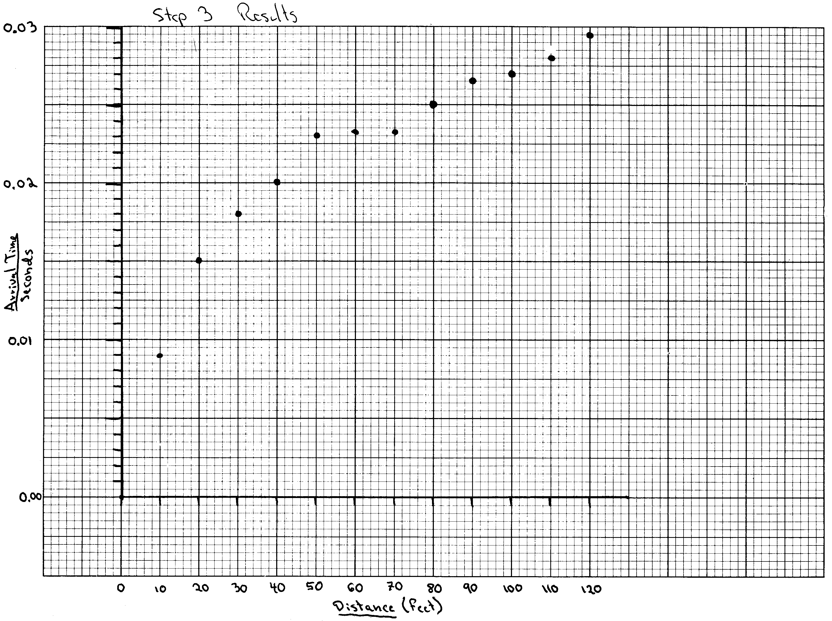
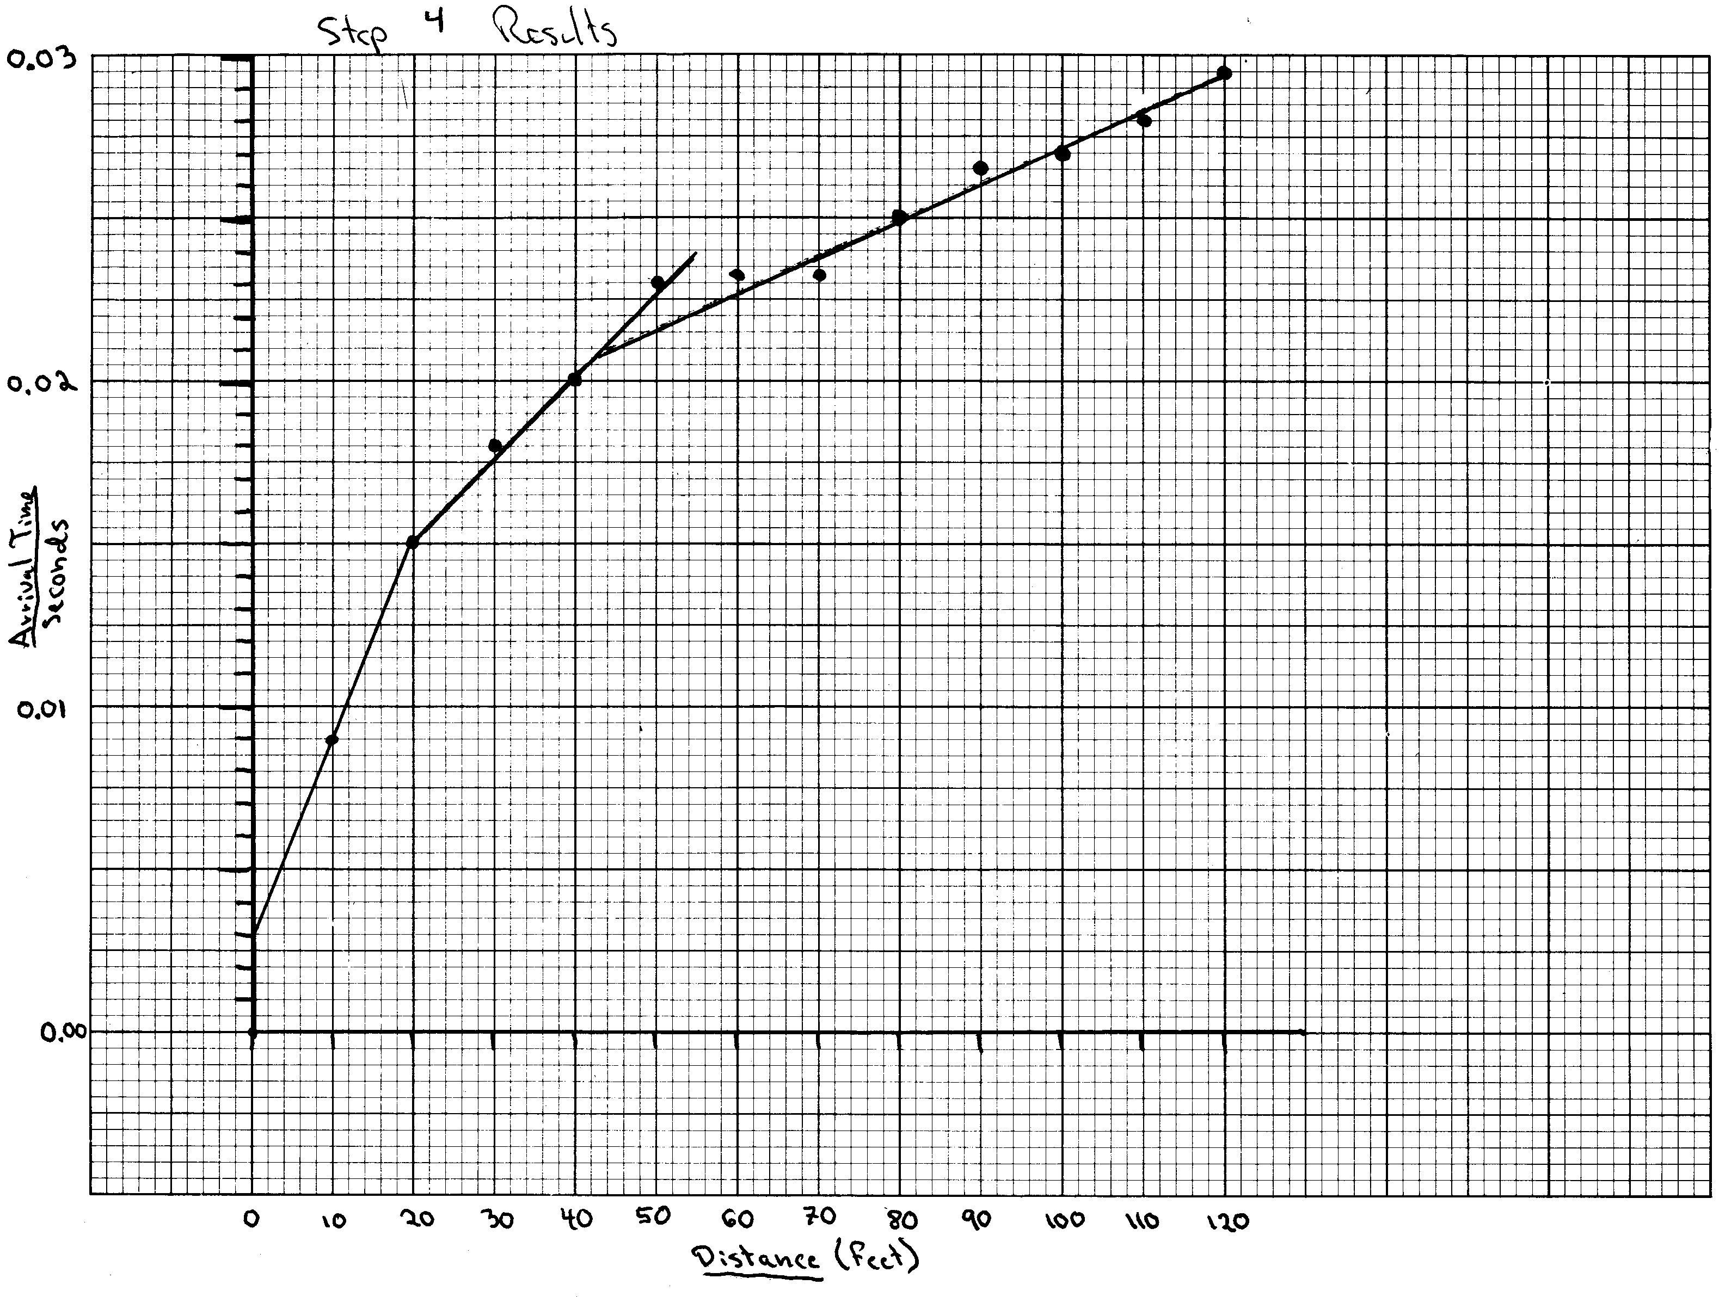
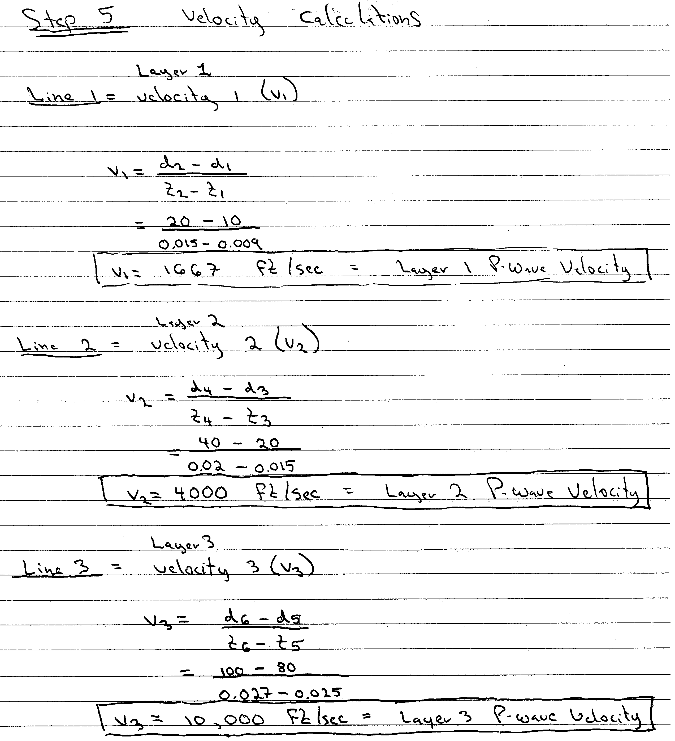

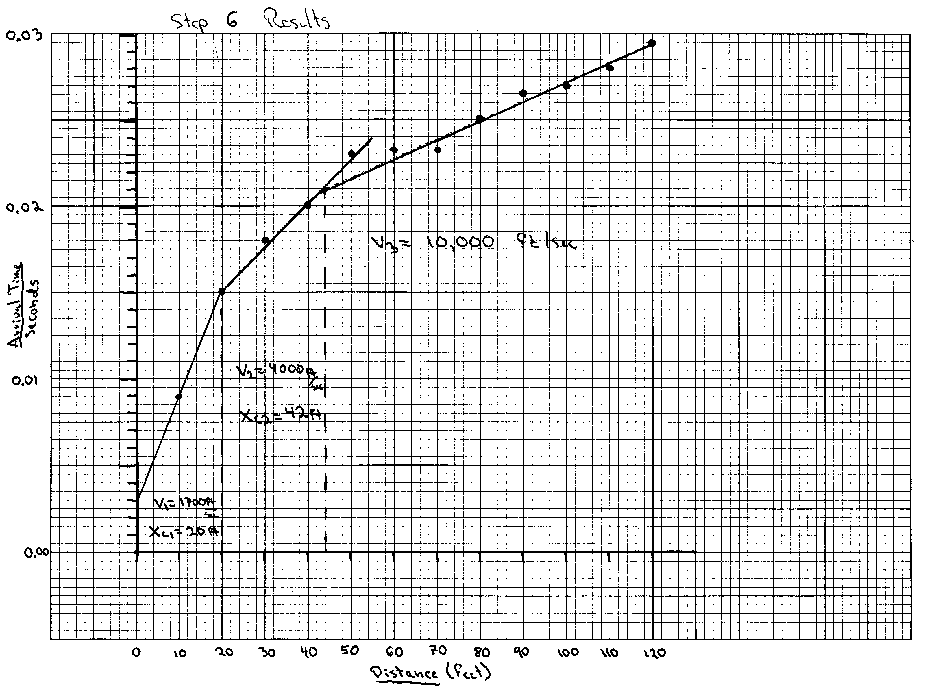
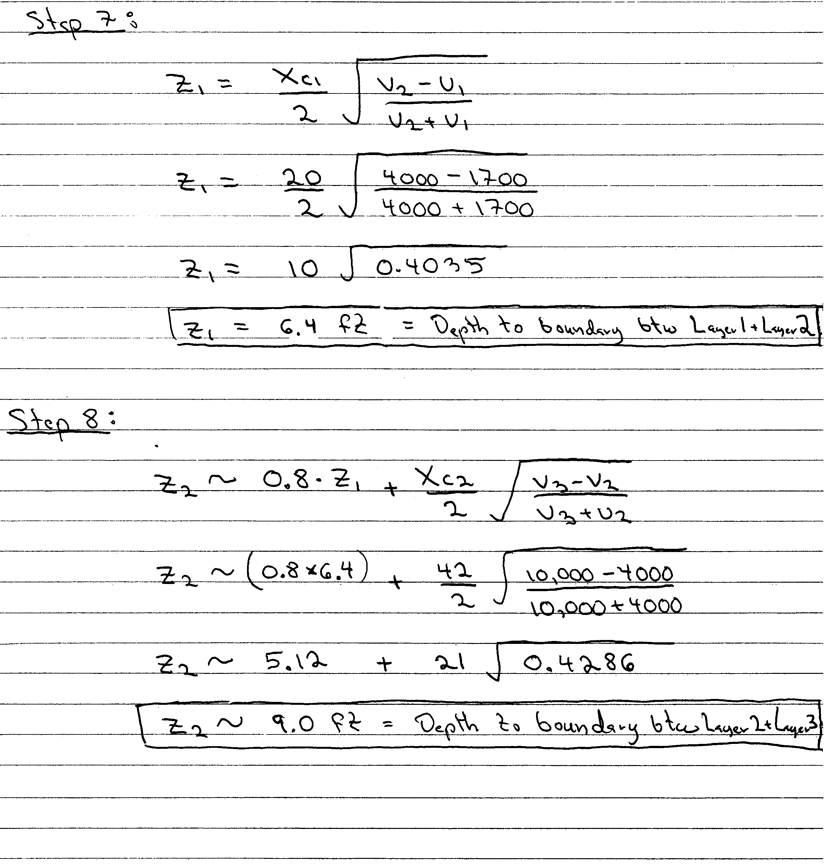

Step 9: Data interpretation

Layer # | Depth  (feet) | Velocity (ft/sec) | Interpretation
Layer 1 | 0 to 6.4 feet | 1700 | Slightly moist, unsaturated soil
Layer 2 | 6.4 to 9.0 feet | 4000 | Saturated soil
Layer 3 | > 9.0 feet | 10,000 | Sandstone



