Greys River Field Trip, Wyoming
Goals:
- To have a fine time in a beautiful field area with a group of positive, enthusiastic and motivated students. To get to know each other better.
- To recognize the interplay between multiple geomorphic processes in the same environment (Fluvial, Hillslope, Glacial, Land-Use).
- To keep an organized and active field book that contains observations and interpretations as well as your own musing on the experience.
- To become proficient at measuring river discharge and channel geometry using velocimeters, tapes, laser rangefinders.
- To use measurements of river discharge and channel geometry to evaluate the applicability of scaling relationships in this fluvial system.
- To begin thinking about the impacts of land-use (roads, timber, agriculture, grazing) on geomorphic and ecological systems.
- To recognize the record and impact of active tectonics on the geomorphic system.

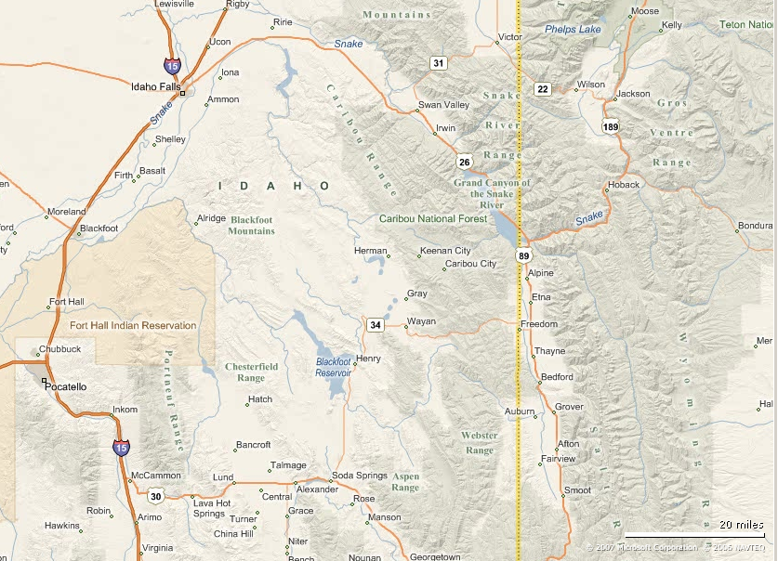
Greys River
Gaging Stn.

Why is this watershed so special?
- Large (1160 km²) watershed with no major water withdraws or development
- Basin form influenced by lithologic and active tectonics structures. Landslides!
- Headwaters contain the triple divide for the Colorado, Columbia and Great Basin
- A road runs the entire length of the channel and the waters can be waded.

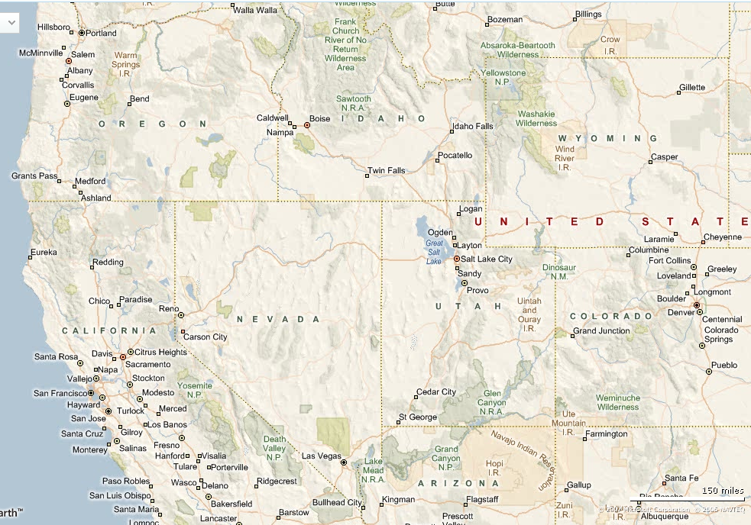

The triple divide is the headwaters for the Columbia, Colorado and Great Basin Systems.

Tasks at hand:
- At 5-10 locations along the Greys River and its tributaries we will measure water discharge (two methods), channel width, slope and depth, and sediment grainsize.
- At 2-3 locations we will observe recent landslides and discuss their impact on the fluvial and hillslope systems. Why do they occur? How extensive are they?
- At 2-3 locations we will try to find evidence of recent deformation along the normal fault that runs along the East side of the valley.
- At each location and during transit we will stay aware of the land-use practices that are ongoing in this watershed.
- As we will cover a lot of ground, try to pay attention to our location as we go
- This data will be transferred to excel spreadsheets and used in the upcoming large assignment. Do take good notes and be attentive.

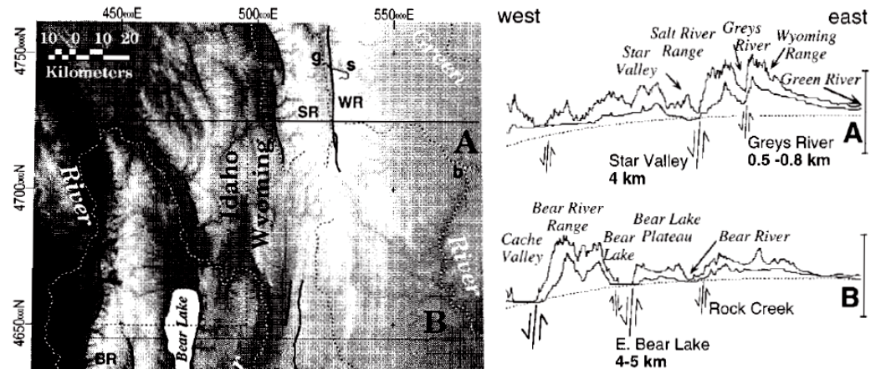
(Harbor, 1997)
Suggested Measurement Stations
-dots locate discharge and chan morphology msmt locations
-plus’ mark fault scarp locations
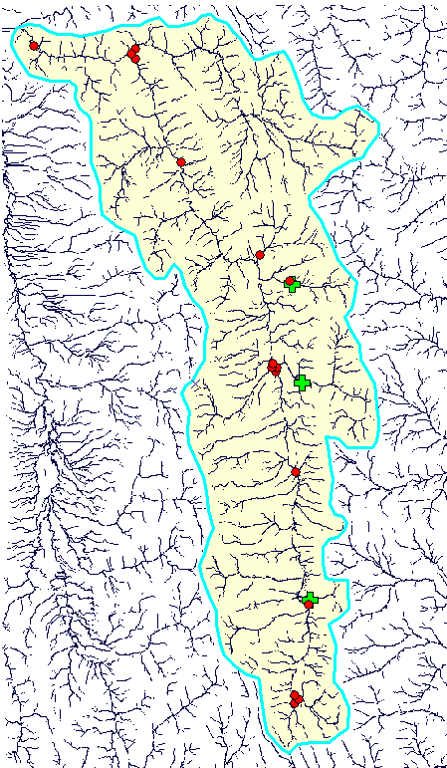

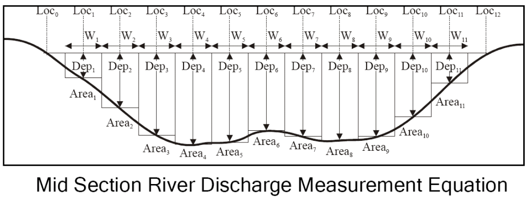

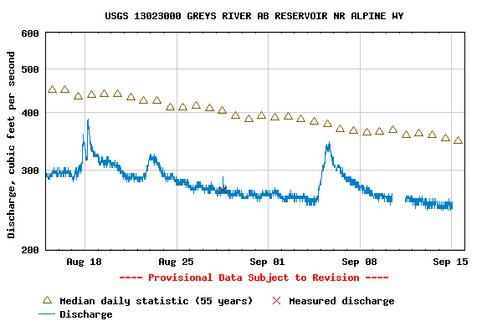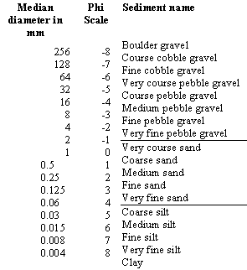

Daily discharge statistics, in cfs, for Sep 15 based on 55 years of record more
Min  (1977) | Most Recent  Instantaneous  Value | 20th  percen-  tile | Median | Mean | 80th  percen-  tile | Max  (1997)
193 | 247 | 268 | 347 | 365 | 444 | 603

Resources:
Harbor, David J., 1997, Landscape evolution at the margin of the Basin and Range, Geology, v. 25, no. 12, p. 1111-1114.

Jones, L C Allen, 1995, The Quaternary geology of the eastern side of the Greys River valley and the neotectonics of the Greys River Fault in western Wyoming, M.S. Thesis, Utah State University, Logan, UT
The Greys River fault is the easternmost active normal fault associated with Basin and Range extension in the Intermountain seismic belt. It is a north-south trending normal fault, located in the Sevier-age fold and thrust belt of western Wyoming, and bounds the west side of the Wyoming Range. The fault is at least 54 km long, and juxtaposes Permo-Pennsylvanian Wells Formation against various Triassic formations. Throw ranges from 100-1000 m. Seismic reflection data suggest that the Greys River fault is a listric normal fault that soles into the Darby thrust at depth. The fault offsets late Quaternary deposits on the west flank of the Wyoming Range. These deposits were mapped and differentiated on the basis of provenance and weathering characteristics. Four sets of moraines were identified in the study area. The moraines segregated into a local four-fold relative age sequence based on topographic position and relative dating parameters. The four-fold relative age sequence was correlated to Blackwelder's original Rocky Mountain glacial chronology. The most extensive glacial deposits were correlated to the late Pinedale glacial advance. Alluvial deposits associated with the Pinedale glacial cycle also contain evidence for late Quaternary faulting on the Greys River fault. Maximum vertical surface displacements of late Quaternary deposits range from 8.6 m in Blind Bull Creek to 8.3 m in Box Canyon, 25 kilometers to the south. Between these points, vertical surface offset ranges from 3 to 8.2 meters. Three trenches were excavated in a late Pinedale alluvial terrace complex in Sheep Creek across a 7.5-meter scarp, a 3.1-meter scarp, and a 7.5-meter scarp-graben. The trenches revealed evidence for two paleoseismic displacements, the ages of which were constrained by eight radiocarbon dates. The most recent event involved a maximum displacement of 4.5 meters and occurred between 2110+ or -60 and 2910+ or -60 (super 14) C years BP. The earlier event was associated with a maximum observed displacement of 3.2 meters and occurred between 5080 + or -60 and 5310 + or -60 (super 14) C years BP. The moment magnitudes for these events, calculated from displacement and surface rupture length, range from M (sub w) = 6.9 to 7.4 for both events. Scarp heights indicate an uplift rate of 1.11 mm/year. If the late Pinedale alluvium is 44,000 years old, then it appears no events occurred between 44,000 yr BP and 5310 (super 14) C yr BP, and two events have occurred between 5310 (super 14) C yr BP and 2110 (super 14) C yr BP. Such irregular recurrence interval is typical for normal faults in the Basin and Range and makes long-term prediction difficult.

Love and Christiansen, 1985, Geologic Map of Wyoming

McKissock, Richard P; Stephens, George C, 2003, Geologic mapping for recognition and classification of slope movements in the lower Greys River valley, Lincoln County, Wyoming, Abstracts with Programs - Geological Society of America, vol.35, no.6, pp.70

Greys River Realtime USGS Gaging Station:
http://waterdata.usgs.gov/nwis/uv?cb_00060=on&cb_00065=on&format=gif_default&period=31&site_no=13023000

Wyoming Geographic Information Science Center WyGISC: Good Data!
http://www.wygisc.uwyo.edu/clearinghouse/datalist.html

