GEOMORPHIC LANDSCAPE GEOL 3044: GEOMORPHOLOGY
ANALYSIS PROJECT

ANALYSIS PROJECT OUTLINE

- Nature of Project
- Nature of Evaluation
- Project Directions
- Mount Nebo Example of Site Geomorphic Assessment
- Suggested References

- NATURE OF PROJECT

As part of Geol 3044: Geomorphology, you will choose or be assigned an area to assess in terms of geomorphic processes acting within that area. For example, you may wish to evaluate a portion of Cardon Bottoms in Yell County where the Petit Jean rivers joins the Arkansas River, OR you might be assigned to evaluate the area that surrounds Spring Lake in Yell County, OR you might wish to assess the area around Kings Bluff Falls at Pedestal Rocks National Forest Area. Evaluation will involve review of the geological location (geological province), documentation of bedrock and soils of the area, landform identification and description, identification and discussion of geomorphic processes, and evaluation of land-use impact of geomorphic processes observed. Results of the assessment will be summarized in a written report.

- NATURE OF EVALUATION

Aspects of the assessment and evaluation of the site will include:

- Identification of a Site for Geomorphic Analysis

Choose a roughly one-half to one square mile area. If the area is quite varied in terms of landforms, limit the size of the area to be assessed to about one-half a square mile (For example, Mount Nebo, which is being used as an example of geomorphic analysis later in this set of directions, is quite varied on the east slope of the mountain in terms of rock type, tectonic features, weather features, mass wasting features, erosion features, and soil-forming processes. Only about one-quarter of a square mile was chosen for example of assessment from Mount Nebo.). Discuss your selection with the course instructor to verify that enough information is available both from field reconnaissance and other published information to allow for completion of the project.

- Geologic Information to be Considered

Aspects of the geology that should be investigated include:

- geological province
- tectonic expression
- bedrock geology
- weathering: physical and chemical weathering styles and small-scale and large-scale landform features
- soils: types, horizons, and structures
- mass wasting: types, causes of destabilization, and landform features
- soil erosion processes and features
- stream erosion processes and landform features

- Land-Use Issues Related to Geomorphic Processes Identified and Discussed

Issues related to land-use should be considered, identified, and discussed. Land-use issues range in terms of stability, natural resource availability and protection, environmental impact, farming practices, etc. Issues could include but are not limited to the following examples:

- issues related to geological province and tectonic expression – In areas of highly deformed bedrock, high relief is often present that can promote slope failure and serious soil and stream erosion. Dipping strata can conduct contaminants deep into the subsurface.
- issues related to weathering – Highly weathered rock is more susceptible to erosion and mass wasting than rock that is slightly weathered.
- issues related to soils – Very sandy soils are highly porous and permeable and can be easily eroded and can readily conduct fluids including fluid contaminants.
- issues related to stream systems – Meandering fluvial systems are associated with flooding and with cut-bank erosion issues.

- PROJECT DIRECTIONS

The project will involve collection of information on the geomorphic processes that are currently active or have been recently active in creating the landscape of the site selected for analysis and the compilation of geomorphic findings in a written report.

- Field Component of the Project

The following steps are recommended for completing the field component of the project:

- Select a site and obtain approval for study of that site with course instructor.
- Complete a background review of the general geology of the site: general geographic site location, significance, geological province, and general geologic setting. Background information can be obtained from state geologic surveys, textbooks, geologic maps, etc. The background information will serve as the introductory statement to the project.
- Determine the geographic location of the site and describe in terms of local landmarks, Latitude & Longitude, and General Land Office (GLO) Survey.
- Obtain available maps, images, and reports (for example: aerial photographs and other aerial imagery, satellite imagery, geologic maps, topographic maps, county soil surveys, and other specialty maps and reports). Use available imagery to aid in the identification and interpretation of geomorphic features and processes.
- Plan a strategy for field reconnaissance of the site – examine maps for trails and access to the site.
- Conduct the field reconnaissance of the site. Compile information on the geomorphic processes and landscape large-scale and small-scale features that indicate interpretations made. Tables of information are a good way to compile information and insert into the final written report. Geomorphic processes that are most likely present and will most likely be encountered include:

- tectonic structures and expression of those structures
- bedrock geology – rock types, structures,
- weathering –
chemical weathering styles and evidence of chemical weathering
including both small- and large-scale features
physical weathering styles and evidence of physical weathering
including both small- and large-scale features
- soils – types, horizons, structures, and soil taxonomic assignment
- mass wasting – types, causes of destabilization, and landform features
- soil erosion processes and features
- stream erosion processes and resulting landform features

- Project Report

- The report should consist of the following sections:

- Body of the Report
- purpose of the study
- identification of the site
- location in terms of well-known landmarks
- location in terms of geological setting/geological province
- location in specific terms: Latitude & Longitude and General
Land Office (GLO) Survey
- discussion of geomorphic processes and supporting data
- discussion of issues related to geomorphic processes and land use
- body of paper should be a minimum of seven complete pages
and not more than 11 pages
- paper must be typed, double space, and use 12 point font

- Graphs/charts
The paper must have at least 4 diagram/figures in addition to the seven
pages of text AND the diagrams should be clearly identified
and labeled

- Bibliography
The paper must include a bibliography in addition to the seven pages
of text. The bibliography must include a minimum of five references correctly sited (use references in recent Geological Society of America publications as examples of acceptable citations). Only three of the references cited can be web sites.
- Grading:
The written report will be graded on the following criteria (125 points total):

- 6 points length requirement met: seven to eleven pages
- 7 points formatting requirements met
- 7 points diagram requirements met
- 8 points bibliography requirements met
- 72 points content: Content will be judged on clarity of writing,
understanding of geological principles, correct
and complete identification of geomorphic processes and
features encountered, reasonable interpretation of land use
issues, and quality of data collected.
- 25 points writing competency: Writing competency will be based
on:
      - focus: The text has a clear central idea that unifies the parts
      - organization: Organization is clear and sensible with helpful transitions.
      - style: The sentence structure is clear and coherent with appropriate word choices for the topic and the audience.
      - mechanics: Spelling, punctuation, and grammar conform to Standard American English.

- MOUNT NEBO EXAMPLE OF GEOMORPHIC SITE ASSESSMENT

Mount Nebo is a mountain in West Central Arkansas with which geology students from Arkansas Tech University are well acquainted. The mountain has been visited on numerous field trips. Mount Nebo serves as a good model for illustrating the approach to geomorphic analysis of a landscape site and compilation of geomorphic information into a written report. Following is an excerpt of a portion of a geomorphic analysis of Mount Nebo.

Introduction

The purpose of the study is to produce a written geomorphic analysis of a portion of Mount Nebo, a nearly flat-topped mountain located in Yell County in West Central Arkansas approximately seven miles west of Dardanelle (Figure 1). Much of the mountain top and surrounding slopes comprise Mount Nebo State Park, one of Arkansas’s 52 state parks.

Mount Nebo State Park is located in the Arkansas River Valley Province of Western Arkansas, an east-west trending region of slightly to moderately deformed Paleozoic strata that lies between the Ouachita Mountains (south) and Boston Mountains and southern flank of the Ozark Dome (north). The portion of the mountain chosen for detailed analysis is a one-quarter square mile area comprising the east-southeast portion of the mountain (Figure 2). The one-quarter square mile section was chosen because of accessibility, variety in geomorphic processes active at the site, and availability of supplementary material (topographic maps, county soil surveys, aerial imagery, etc.).

Location coordinates for the site are:
General Land Office (GLO) Survey coordinates are:
East ½, SW ¼, Sec. 32, T7N, R21W and
West ½, SE ¼, Sec. 32, T7N, R21W

Latitude and Longitude location for the radio tower near “Sunrise Point”, the highest point in the assessment area is:
35º 12.9’ North Latitude
93º 15.1” West Longitude

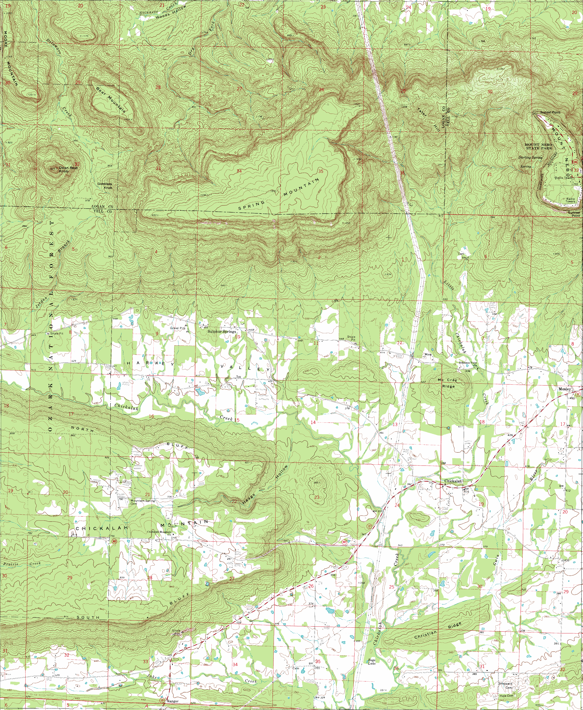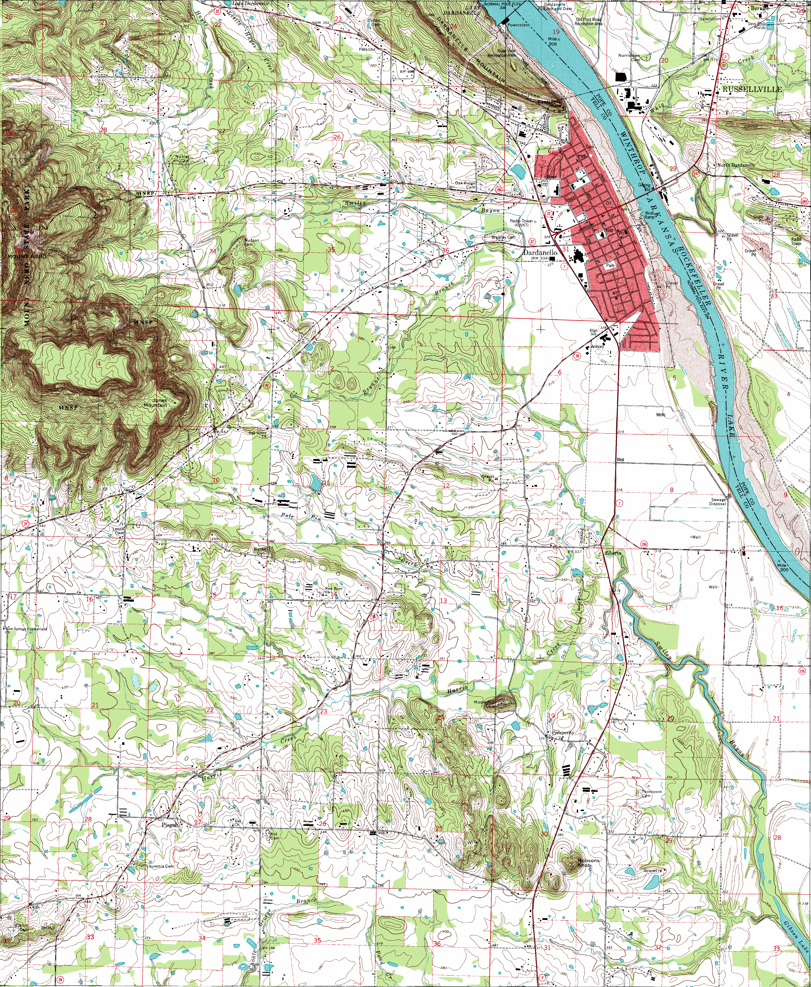
One mile

Figure 1: Mount Nebo location: approximately 7 miles west of
Dardanelle, Arkansas, on Arkansas Highway 155
(United States Department of Interior, United States
Geological Survey 7 ½ Minute Topographic Quadrangle Series
Dardanelle, Arkansas, and Chickalah East, Arkansas
Quadrangle maps)

One mile

Figure 2: Geomorphic Analysis area on the east-southeast portion of
Mount Nebo (United States Department of Interior, United States
Geological Survey 7 ½ Minute Topographic Quadrangle Series
Dardanelle, Arkansas, and Chickalah East, Arkansas
Quadrangle maps. Red line outlines study area. Blue arrow represents axial trace of a plunging syncline.)

Mount Nebo comprises the trough of a broad shallow syncline whose plunge is to the west (see axial trace in Figure 2). The mountain bedrock is composed of two Pennsylvanian formations, the Atoka Formation which forms the moderate to steeply sloping base of the mountain, and the Hartshorne Sandstone which forms the cliff-rimming summit of the mountain. The Atoka formation is comprised of alternating thin to medium bedded fine grained micaceous sandstones , siltstones, and fissile shales. The “bench” that rings the mountain below the summit is comprised of a more thickly bedded member of the Atoka. The lower slopes of the mountain are comprised primarily of the shaley facies of the Atoka. The resistant Hartshorne sandstone comprises approximately the upper 30+ meters of the mountain forming the mountain’s cap rock. The Hartshorne Sandstone is a fine to medium grained massive quartz sandstone. The Hartshorne Sandstone exhibits well preserved large-scale tangential cross bedding in less massive facies. It is the massive facies of the Hartshorne that create the cliffs and the wide vistas for which the mountain is known locally.

Geomorphic Processes

Geomorphic processes identified during the course of the investigation included:

chemical and physical weathering
soil forming processes
mass wasting
soil erosion
stream erosion

Weathering has involved both chemical and physical aspects. In terms of chemical weathering, solution, oxidation, and hydrolysis have been identified. Solution was most widely observed in the quartz sandstones of the Hartshorne Sandstone. Solution and re-precipitation of silica and have produced case-hardening on the cliff faces of some of the most massive sandstone layers. Solution, oxidation, and re-precipitation of iron oxides (primarily limonite) have produced common leisengang structures. Hydrolysis is most common in the shaley facies of the Atoka Formation. Chemical hydration of shales of the Atoka have produced illitic clays. Illitic clays were inferred by the lack of significant shrink/swell features in soils.

Physical weathering has had significant impact on the landforms developed on Mount Nebo. Table #1 summarizes the styles of physical weathering and large- and small-scale features that are suggestive of styles of physical weathering active on the eastern-southeastern slopes and southern summit of Mount Nebo. Weathering along tectonic joints has produced columns in the Hartshorne Sandstone towering over 30 meters in height (Figure 3). Failure of these columns has produced enormous rock topples which will be discussed in the section on mass movement.
tectonic jointing | Two joint sets were observed, one trending nearly N-S and a second set trending nearly E-W which had experienced widening and separation; joint bounded rock “columns”.
exfoliation | exfoliation arches in massive sandstone sequences
pressure release | fragmentation at granular level of quartz cemented sandstone and separation of bedding planes of fissile shales
ice wedging | blocks and clearly corresponding “depressions” in medium to thickly bedded sandstone strata
biologic activity/root prizing | offset strata associated with roots, offset trail flagstone related to root presence, and moss and lichen growth on grannularized sands and sandstones
Table 1. Types of physical weathering and associated landforms

Tectonic joining, ice wedging, exfoliation, pressure release, and biologic activity have produced numerous small- to large-scale talus accumulations. Pressure release and fragmentation have probably been partially responsible for promoting the grannularization of sandstones and bedding plane weathering of fissile shales.

Mass movement has been significant in shaping the landscapes of Mount Nebo. Table #2 summarizes the styles of mass movement identified and landform features indicative of those styles of movement.

Rock topples and rock falls are mainly developed in the Hartshorne Sandstone that forms the cap rock of the mountain. Abundant rock columns demonstrating current instability and long lichen-covered rock talus “streams” are indicative that rock topple is the pervasive mass movement responsible for the creation of the Mount Nebo cliffs (Figure 4).

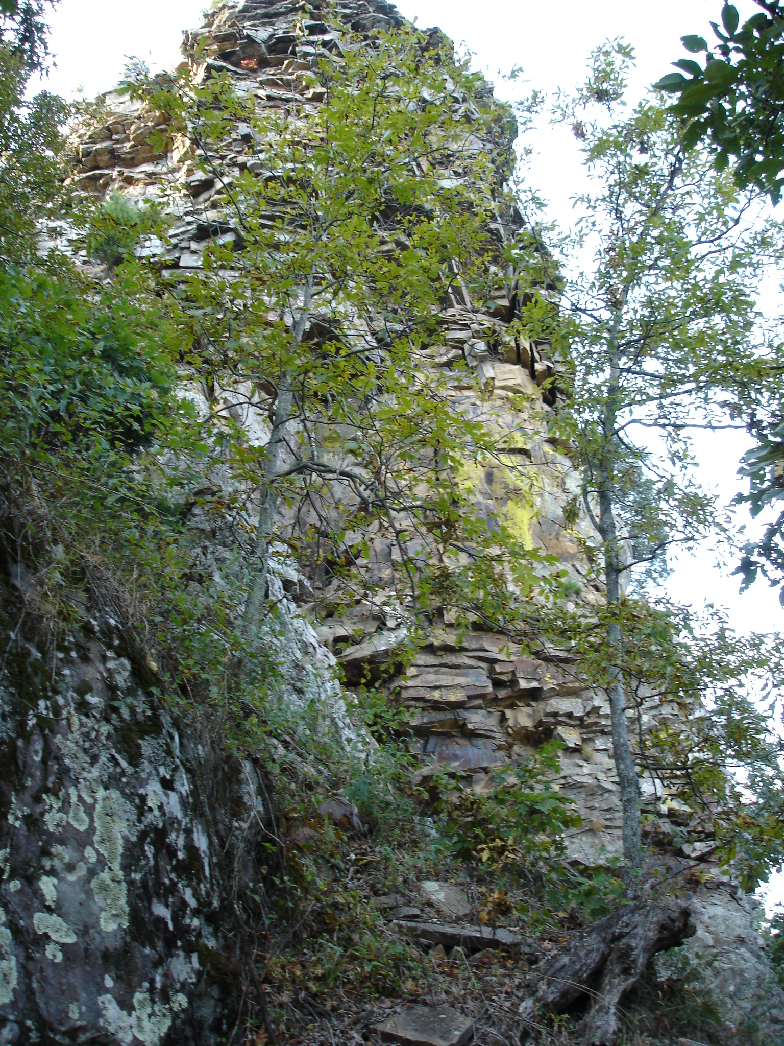

Figure 3. Columns developed by intersection of tectonic joints in the Hartshore
Sandstone along the eastern slope of Mount Nebo (column approximately 30 meters in height).

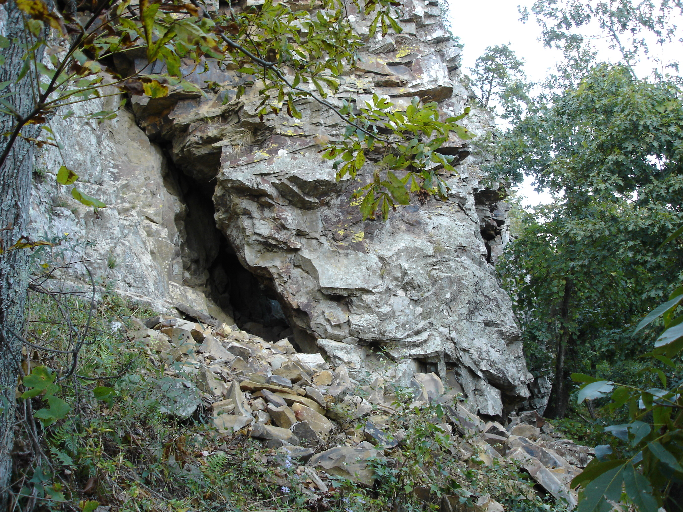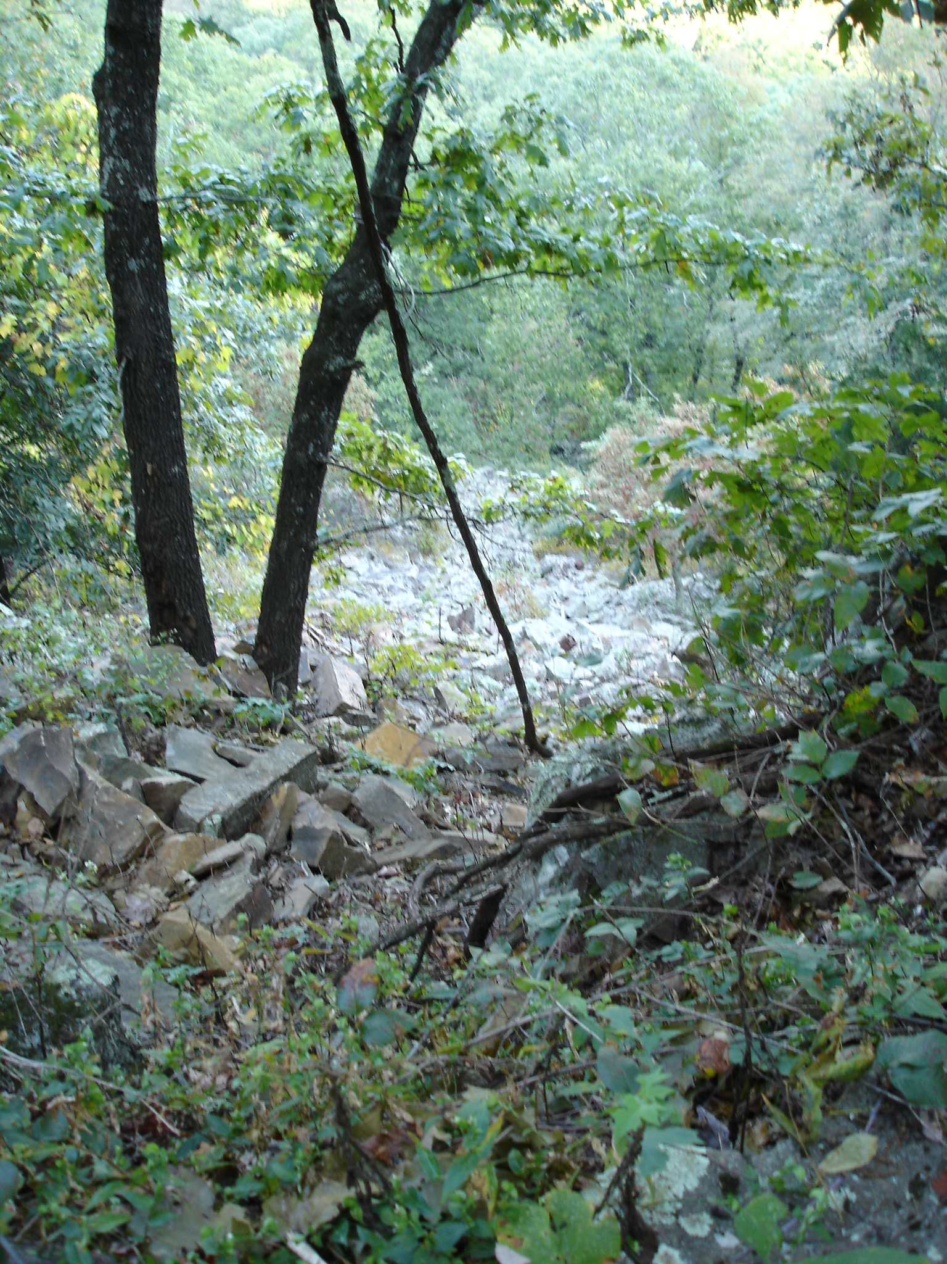
  - b.

Figure 4. Rock Topple features: a). destabilized base of rock column on
east slope of Mount Nebo. b). rock talus “stream” believed to be
Associated with previous rock topple on the east lope of Mount Nebo.

rock falls | isolated talus, talus slopes
rock topples | jointed rock columns, elongated talus “streams”
debris slides | recent slides with scarps and deposits with mixed  soil, organic, and rock debris; soil, organic, and rock debris exposed along vegetated slopes by road construction, soil erosion, and stream erosion
slump | steep rotational scars; slopes with “convex” bases and hummocky terrain; trees tilted both “into” and “out of” slope
earth flow | shallow concave scars lacking evidence of rotation; slopes with shallow “convex” bases and hummock terrain
creep | Rock trails with flagstone shifted “downslope”;
Table 2. Types of mass movement and associated landforms

The previous section is a short excerpt from a geomorphic analysis and illustrates the level of treatment expected in the geomorphic assessments for Geol 3004: Geomorphology. You would be expected to finish discussing types of mass movement and address soils and soil-forming processes, soil erosion processes, and stream erosion processes.

- SUGGESTED REFERENCES

References suggested to help you in preparing for your field reconnaissance include:
Surface Processes and Landforms. Don. J. Easterbrook. 1999. 2nd Edition.
Prentice-Hall Inc.

Cathy Baker website for Geology 3044: Geomorphology – Arkansas Tech University:
http://pls.atu.edu/physci/geology/people/baker/geol3044/

