Mt. St. Helens Topographic Profiles
May 18, 1980
Overview

On May 18, 1980, Mt. St. Helens in the state of Washington exploded in a cloud of ash, plus lava and mud flows. What had been a beautiful symmetrical snow-covered mountain with heavily forested slopes became a startling landscape of ash, mud, and downed trees surrounding a broken, irregular peak. The power of the initial blast was directed upward and laterally, snapping off trees for miles in the blast zone. In the years since 1980, many people – geologists, biologists, environmentalists – have been observing and studying how the landscape recovers after a major volcanic eruption.

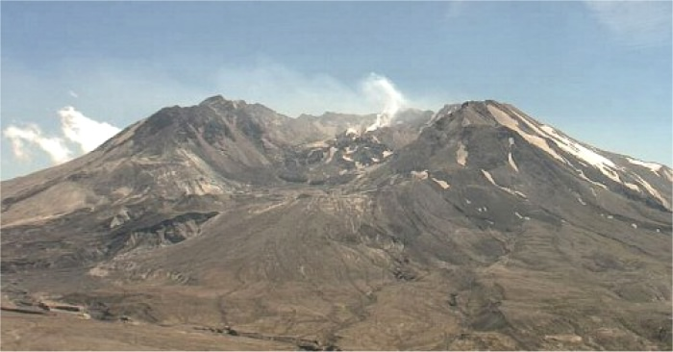
Screen shot from the Mt. St. Helens VolcanoCam on March 22, 2011, showing a small plume of steam emerging from a lava dome inside the crater.

Learning objectives

- Describe the shape of Mt. St. Helens before and after the eruption.
- Draw two topographic profiles across the volcano and determine their vertical exaggeration.
- Use your profile to estimate the dimensions of the material removed by the eruption and calculate the volume.
- Compare your result with published values and identify sources of error in your work.

A Brief Chronology of the Eruption

In the month of March 1980, gas-rich magma rose beneath the volcano, causing the ground to rise ~300 feet (like blowing up a balloon). Small earthquakes were detected beneath the mountain, as magma began moving toward the surface. Older eruptions here had produced silicic lavas, so geologists warned that there was a high likelihood of an explosive eruption. At 8:30 AM, on May 18, two strong earthquakes caused by movement of magma triggered a large landslide. This in turn released the pressure on the magma and set off the eruption. The side of the mountain burst horizontally in a lateral blast of volcanic ash, and almost simultaneously, the top blew up. There was an enormous force to the blast (~25 megaton H bomb). The mountain's symmetry was destroyed, with a large crater forming at the top, and trees were knocked over for large distances. The ash reached 16 km up into the atmosphere and darkened skies as far away as western Montana. Ash was carried by the jet stream all the way to the eastern part of the United States. Hot ash melted the snow on the mountain, and the mixture of ash and water produced destructive mudflows that extended miles from the mountain.
In the subsequent years, Mt. St. Helens has occasionally produced small earthquakes and ash eruptions, but nothing comparable to 1980. Within the crater, a small bulge has developed, called a lava dome, which indicates the mountain is still active, only biding its time.

Instructions

1. Open the Mt. St. Helens (MSH) topographic maps file (PDF) that accompanies this exercise. The first map shows the arrangement of contour lines around MSH before the eruption, while the second map shows contours after the eruption. Print these maps.

2. Study the first map of MSH (before the eruption), and examine the contour lines closely. Describe the shape of the volcano before it erupted, including its outline, general topography, symmetry, and the slopes of its sides.

3. Study the second map of MSH (after the eruption), and examine the contour lines closely. Describe the shape of the volcano after it erupted, including its outline, general topography, symmetry, and the slopes of its sides.

4. These maps show many glaciers surrounding the peak, some of which are labeled with their names. Which of these named glaciers were totally destroyed by the eruption, as shown by comparing the before and after maps? Which glaciers survived the eruption but were cut off from their source at the top of the mountain?

5. Open the MSH graph file (PDF) that accompanies this exercise. Use the graph to draw a topographic profile along line A-A’ on the first topographic map (MSH before the eruption).

6. Draw another topographic profile along line B-B’ on the second map (MSH after the eruption), using the same graph. A and B are the same point, so when you graph the second profile, start from the south end (at B’). This profile should match the first one up to the 2500-meter contour.
7. If 1 cm = 150 m on the Y-axis of the profile graph, what is the fractional vertical scale of your profiles? Hint: change 150 meters to centimeters.

8. If 3.5 cm = 1 km on the map, what is the fractional horizontal scale of the profiles?
Hint: change 1 km to centimeters, then divide both sides of the equation by 3.5. Round your answer to the nearest 1000.

9. What is the vertical exaggeration? Hint: divide the vertical scale by the horizontal scale. Round your answer to the nearest whole number.

Compare Topographic Profiles

Look again at your two topographic profiles. In this section, you will estimate how much material was removed from the top of the mountain by the explosion and eruption. Assume that the upper part of the volcano (the part that was blown away) was a perfect cone. You will draw a horizontal line across the profile to represent the base of the cone. Of course, the part of the mountain removed by the eruption was not a perfect cone, so you will have to choose the best position for the base line.
In the sketch below, the black line represents the original profile of Mt. St. Helens, and the red line shows its profile after the eruption.

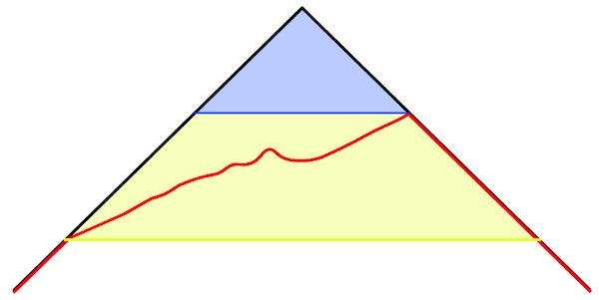
Representative sketch of the topographic profiles and possible choices for the base of the conical section removed by the eruption.

If you use the highest point of the after profile as the base of the cone (blue line), this would correctly account for the area colored blue, which was removed by the eruptions. However, it would omit rock below the blue line and above the red line, so that the calculated volume would be too small.
But if you use the lowest point of the after profile as the base of the cone (yellow line), this would imply that everything shaded blue and yellow was removed, including all rock between the red and yellow lines. Because these lower rocks were not removed, the calculated volume would be too large.
You must choose a location for the base of the cone such that the amount that is included but should not be is approximately the same as the amount that is not included but should be!

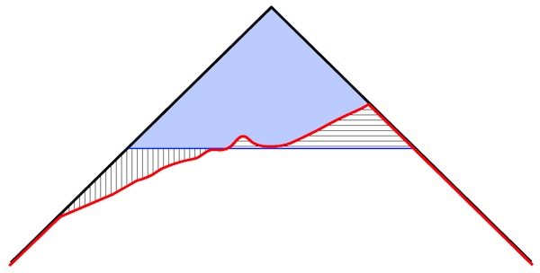
d
h
Representative sketch of the topographic profiles and one possible choice for the base of the cone.
Vertically ruled area ≈ horizontally ruled area. Measure h using the scale on the Y-axis and d using the scale on the X-axis.

10. Draw a horizontal line across your topographic profile to represent the base of the cone-shaped mass of rock removed by the eruption. Measure the diameter d from side to side on the "before" profile, using the scale printed at the bottom of the graph. What is the approximate value of d for the cone on your profile?

11. Given the diameter d you found in the previous question, what is the radius of the cone? Hint: d = 2r.

12. What is the approximate height h of the cone? Measure the height from the highest point of the mountaintop on the "before" profile to the base line that you drew for the cone.

13. Make sure that r and h are expressed in the same units (both meters or both km). Use the formula for the volume of a cone: V = 1/3 (π r² h). What is your calculated volume for the cone that represents material removed by the eruption?

14. Open the fact sheet on Mt. St. Helens http://pubs.usgs.gov/fs/2000/fs036-00/, which summarizes the 1980 eruption. Compare numbers on the fact sheet for the volume of mountain removed with the value you found in the previous question. You will have to convert between metric and English units. Is your calculated volume greater than, less than, or about the same as the number given?

15. What are some possible sources of error in your calculation?

