Structural Geology Field Trip #2: Hudson Valley Fold and Thrust Belt geometries

Contact and copyright:
Dr. Martha Growdon
SUNY Oneonta
growdoml@oneonta.edu
607-436-3067
Spring 2011

Background:
This field trip occurs about mid-way, or slightly post-mid-way through the semester, after students have learned to measure strikes and dips and during the discussions of thin-skinned tectonics and fold-and-thrust belts. This field trip can incorporate much more than just structural geology; for example, the vein mineralogy and timing is interesting too. The outcrops are on both sides of the road and are large. They are the paired roadcuts on the immediate eastern side of the bridge over Catskill Creek. I suggest parking on the northern side of the road because then students get a really good view of the structural relationships in the southern wall.

Student Goals:
Students will:
- make observation in the field
- derive interpretations from observations of folded/faulted rocks
- measure strike and dip of folded rocks
- measure rakes of slickenlines on bedding
- identify folds in map patterns
- begin to synthesize the interrelated concepts of burial, deformation, and metamorphism
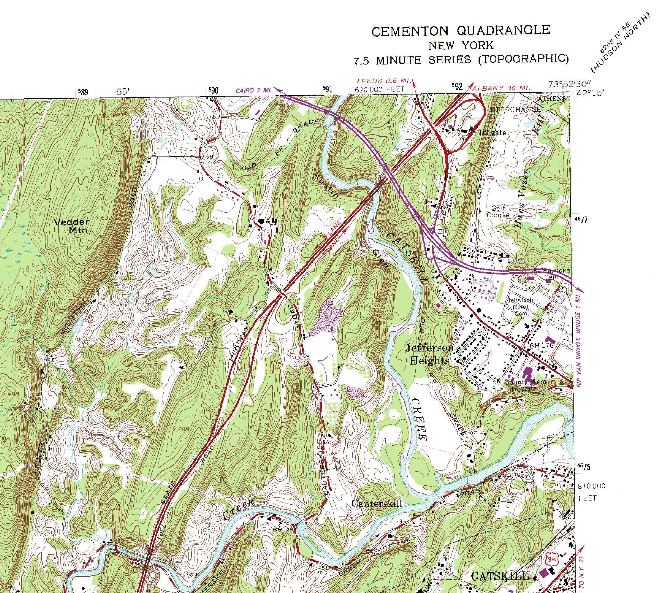
Our destination is a set of outcrops along NY route 23 in the Hudson Valley Fold and Thrust Belt that shows a cross section through some
large-scale structures. Please complete the first part of
this assignment on the van ride to the outcrops.

The location
of the outcrops
we will visit
approximately
coincides with
the place along
rte 23 where
the 200’
contour
interval
intersects the
road (map
below). Plot
this point on
the map to the
right and label
it “S2.”

Color the
geologic map
of this area on
the following
page; give each
unit in the key
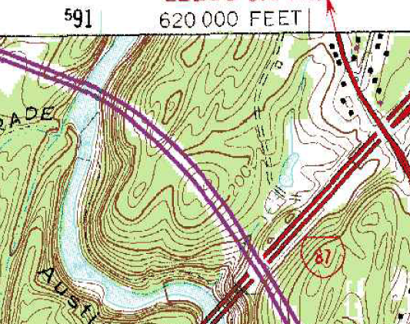
its own color. Identify all major folds on this map by writing the type of fold approximately over the hinge line.
Identify and mark with an “S2” the location of the field trip stop on this bedrock geologic map.
Do you expect to find cleavage in these rocks? (Discuss in your field notebook)
List the major geologic units we will see at these outcrops in order of oldest to youngest.
Oldest Youngest:

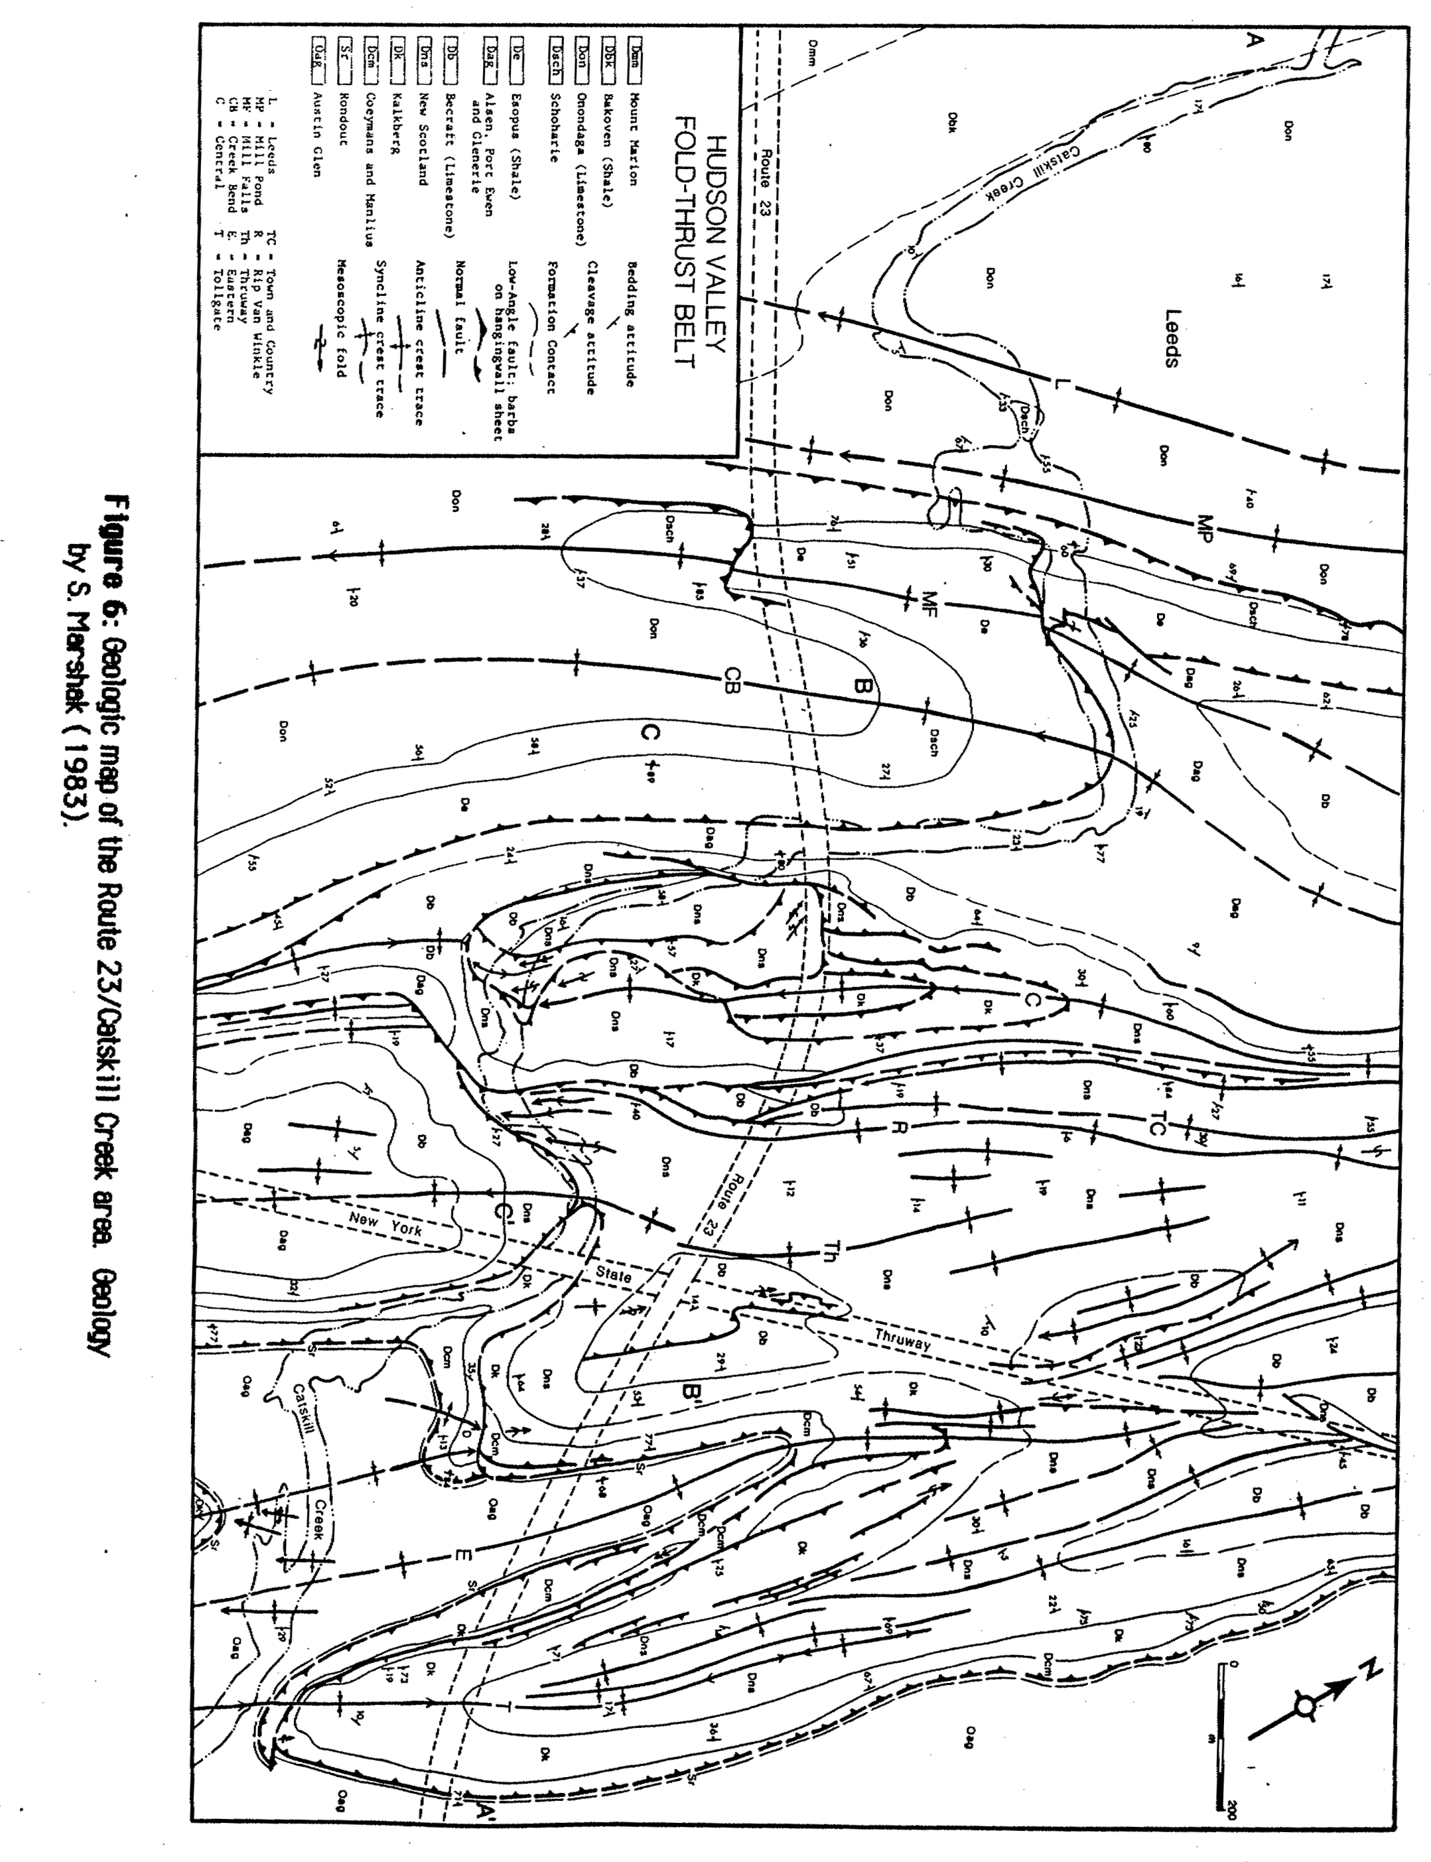
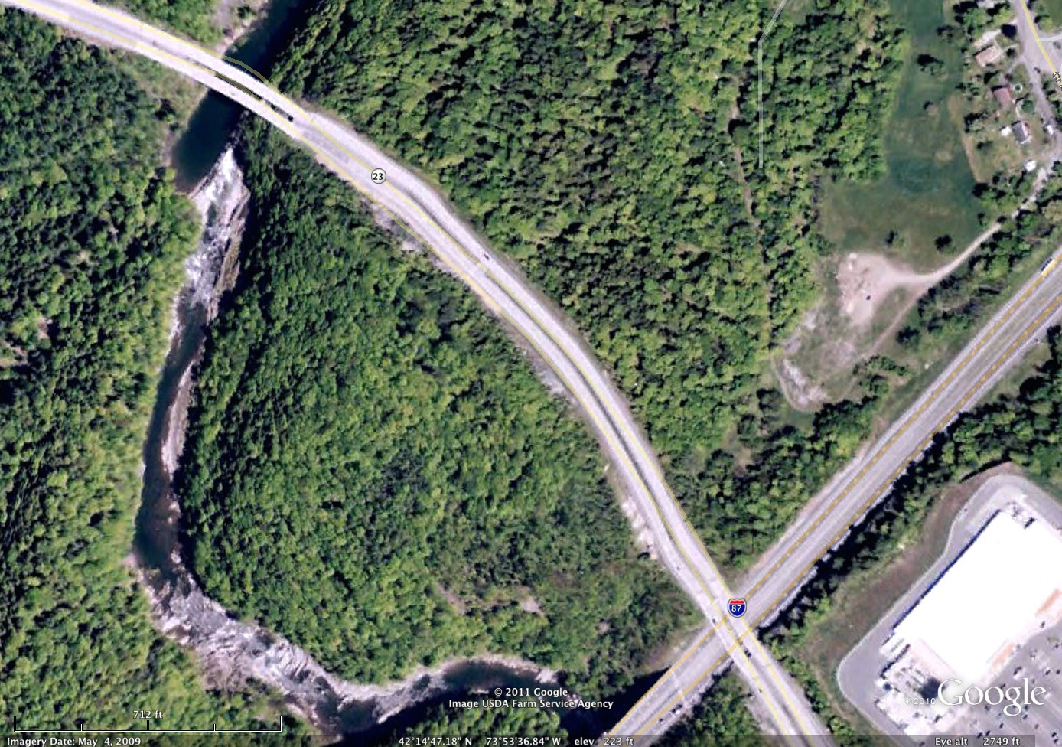
Once in the field orient yourself with the help of the maps and the Google Earth image. Plot your location with respect to topography on the Google Earth and topographic map selections below:
Draw a sketch, in your field notebook, of the outcrop on the other side of the road: DO NOT CROSS THE ROAD!! STAY AWAY FROM THE ROAD BED!! STAY IN THE DITCH!
Make sure to note any place where the beds appear to change orientation or where they pinch out. Draw these areas carefully.
Work in teams of two, spread out along the southern outcrop and measure bedding attitudes (i.e. strikes and dips). Record these in neat columns in one location in your field notebook.
Now locate a fault. Draw a sketch of the fault and label all important/interesting features.
What is the direction of slip on this fault?
Is the fault cutting bedding or parallel to bedding?
Is there mineralization along the fault?
Measure the orientation of the fault and any slickenlines or slickensides you find using the strike, dip, rake notation.
Review your notes in the van on the way home and answer the following questions:
What was the basic geometry of the large-scale faults?

Was there a correlation between the folds and these faults?

What is your evidence?

Explain any evidence you found for the mechanism by which layers folded (i.e. buckling, flexural slip, passive folding, etc.).

Was there any evidence for metamorphism at this location?

What was the approximate grade of metamorphism?

Approximately how deep were these rocks when this deformation occurred?

What is the age of the deformation?

What was the likely cause of this deformation?

Turn in your field notebook at the end of the field trip along with the answers to these questions.

