GEO 1060 Does Fracking cause earthquakes? Name____________________________

1. Go to: <http://ds.iris.edu/ieb>

2. Zoom in to the United States and then to Arkansas. Zoom until your window looks similar to this: (note lat/long ranges in the bottom right).

3. Next, click on the time range:





4. For Time Range, uncheck latest available and choose the date shown. Before you do, scroll backward to the earliest date. Don’t forget to press Apply.

a. What is the earliest available date for data here? _______________

b. What is the earthquake count?_____________

c. What is the time range?______________ years

d. This is an average of how many quakes per year:__________

5. Next, choose the following dates: 2009-01-01 to 2011-09-01

Don’t forget to press Apply.

a. What is the earthquake count?_____________

b. What is the time range?______________ years ______________ months

c. This is an average of how many quakes per year:__________per month______________

6. Compare the average rate of earthquakes for question 4 to that of question 5. What is the rate of increase:? ____________

7. Do you notice any other changes in the earthquakes between the two time frames listed?? (location, magnitude, depth?). (It will help to look at both the 3D viewer and the Table View (bottom right)

Discuss:

8. Fracking for oil and gas in this area began in around 2005. According to the Arkansas Geologic Survey: “*The Fayetteville Shale Formation (Upper Mississippi) is the current focus of a regional shale-gas exploration and development program within the eastern Arkoma Basin of Arkansas. Approximately 2.5 million acres have been leased in the Fayetteville Shale gas play with a cumulative production of 5,150 Bcf since drilling began in 2004.”*

Maps of the areas of this country and specifically Arkansas where fracking has been taking place are shown at the end of this exercise. Compare these maps to your map area in this exercise.

Could these earthquakes be associated with fracking?__________

9. List below what further information one would need or further questions one should ask or further research one would need to do to determine the answer to this question.

10. The state of Arkansas banned wastewater injection in the area of the earthquake swarm in 2011. Does this seem to have made a difference? Go back to the IRIS earthquake viewer and change the dates again. Start in 9/1/2011 and go until today. Don’t forget to press Apply.

a. What is the earthquake count?_____________

b. What is the time range?______________ years ______________ months

c. This is an average of how many quakes per year:__________per month______________

d. Was there a change in the number or pattern of earthquakes after wastewater injection was stopped?_______ Discuss:

11. Go back to the IRIS earthquake viewer. Look elsewhere in the United States. Are there other areas where there appears to be an increase in earthquakes in areas of fracking? (Use the maps provided with this exercise as your guide) ____________ If so where?____________________________

For this area, use the IRIS earthquake browser to begin to test if this is true by changing the time parameters to before and after fracking began in the area. Describe what you found:

12. For next time:

a. Find information that supports that fracking or fracking related activities can cause earthquakes. List at least two web addresses/references here, briefly explain each says and include why you feel this source is credible.

b. Find information that supports that fracking or fracking related activities does not cause earthquakes. List at least two web addresses/references here, briefly explain what each says and include why you feel this source is credible.

13. Assume you work for the Arkansas Geological Survey and the public wants to know if these earthquakes are human induced. Write a statement to release to the public about your findings:

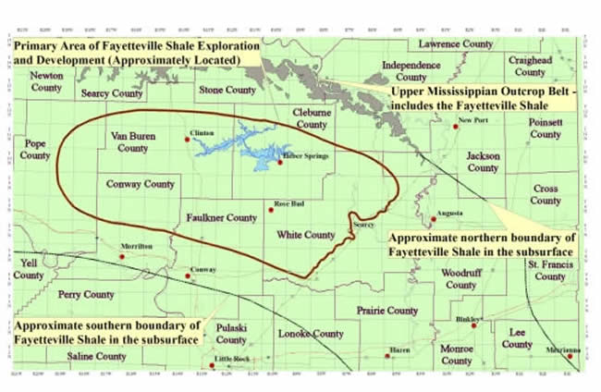

From: <http://ar.water.usgs.gov/Fayetteville_Shale/>

