Geology 463/563: Introduction to seismology Name: ________________________

POWER SPECTRA AND FILTERING:

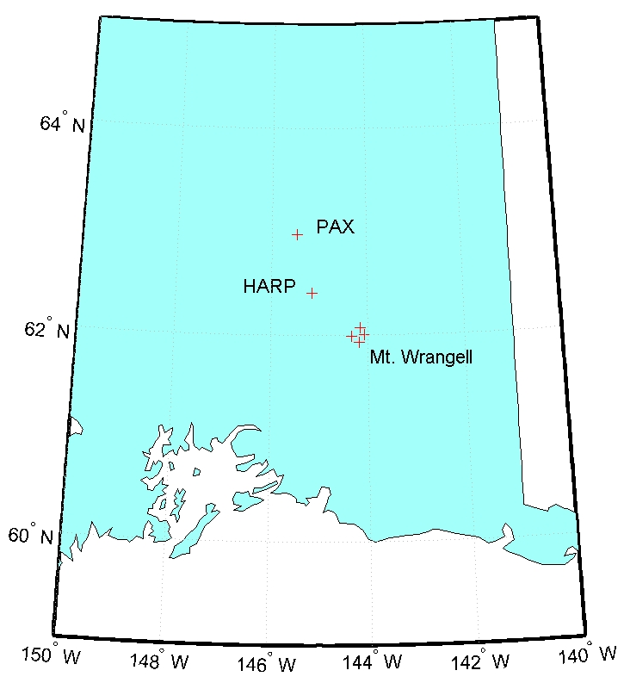
For this project you will need to download “Data_files.zip”, which contains several seismic data files in SAC (Seismic Analysis Code) format. These data were recorded at stations called HARP, PAX, and WANC (see map below); the station names are part of each file name. Stations HARP and PAX are part of the Alaska Earthquake Information Center’s regional broadband seismic network while station WANC is part of the Alaska Volcano Observatory’s short period seismic network on Mt. Wrangell volcano. You will also need the MATLAB scripts contained in the zip file “MATLAB_files.zip”: pspec.m, readsac.m, and datafilt.m.

Your mission is to investigate seismograms recorded at stations HARP, PAX and WANC. Each data file is for the same time period and shows the 12/26/04 Sumatra M9.0 earthquake as recorded by each of the stations. Note that the stations are within 100 km of one another and all are >11,000 km from the epicenter of the earthquake.

Your task is to investigate these data by doing the following:

- Read SAC files for each station into MATLAB. Seismic Analysis Code is a binary data format commonly used in seismology. To read these files into MATLAB, you can use the the “readsac.m” function. The syntax is [x, hdr] = readsac(filename). In this syntax x will be your data vector and hdr will be a structure array that has all of the header information. To get information from the structure use one of the following syntaxes:

>>dt = h.DELTA;
>> station_lat= h.STLA;

Or

>> dt = getfield(h, ‘DELTA’);
>> station_lat = getfield(h, ‘STLA’);

  - Plot seismograms for all three stations as a function of absolute time. To do this you will need to find the file start time in the header and you will create separate time vectors for each station. Using the “subplot” function, put all three figures on the same page. Include axis labels and titles so that it is clear which station is which.

  - Calculate power spectra for each of the three files and plot them on a single graph. To do this, use the script “pspec.m”. Where the syntax is

>>[f, amp] = pspec(x, length(x), Fs, flag);

This function outputs “f” and “amp” where f is a vector of frequencies and “amp” is the amplitude of the power spectrum. x is a vector of data for which you want to calculate the power spectrum, and Fs is the sample rate of those data. As usual, you can give these any name that you want. Note that if the flag is set to 1 you will get your amplitude in dB units (a log scale). If the flag is set to 0 you’ll get linear amplitudes. To plot your x axis in log space use the “semilogx(f, amp)” plot function (if you want both scales in log space use “loglog(f, amp)” or output your amplitudes in dB and use semilogx).

  - Describe (in words) how the waveforms and power spectra differ for these three files. What frequencies are the strongest in each file? How does the strength of the strongest frequencies compare to the strength of other frequencies?

  - Identify the surface waves (either Love or Rayleigh) on stations HARP and PAX. Does station WANC show these same waves?

  - Why do you think WANC looks so different from HARP and PAX? What could explain this? Remember that all 3 stations are >11,000 km from the source and all three are working properly.

  - You will now experiment with filtering the data to investigate the differences between the waveforms recorded at these three stations. To do this, use the script “datafilt.m”, which takes input data and filters it. The syntax for datafilt.m is:

>> df =datafilt(data, type, cutoff, Fs);

Where:
- “df” is the name of the variable that will hold the filtered data (call it whatever you want)
- “data” is the name of the data vector you wish to filter
- “type” is the type of filter. Use ‘h’ for a highpass filter, ‘l’ for a lowpass filter and ‘b’ for a bandpass filter (and make sure the letters are in single quotes.)
- “cutoff” is the frequency at which you want to start filtering. For a bandpass filter, this should be input as [f1 f2] where f1 and f2 are the two cutoff frequencies.
- “Fs” is the sample rate.
- So let’s say you want to bandpass filter a vector x between 0.1 and 3 Hz, and you know that x was sampled at 100 Hz. You would type
>> y = datafilt(x, ‘b’, [0.01 3], 100);

- Using datafilt.m, lowpass filter the WANC data at 0.1 Hz and plot the filtered waveform. How do the data compare with HARP and PAX now?

- Using datafilt.m, bandpass filter the WANC data between 0.5 and 5 Hz and plot the filtered waveform. How do the data compare with HARP and PAX now?

- What do your answers to 2 and 3 above tell you about how station WANC recorded these two frequency bands?

- Plot the bandpass and lowpass filtered data for WANC on the same plot. If scaling is a problem, you can either normalize the data to 1 (divide the data by the maximum amplitude in the vector), or use the “plotyy” function. “plotyy” allows you to plot two signals and show two different y-axes (type “plotyy(x1, y1, x2, y2)). As usual, label axes and include a legend.

- Zoom in on the surface waves (as closely as you can!). What do you notice about the timing of the high frequency signals late in the waveform relative to the surface waves? Be as specific as possible.

- Please read the article at http://www.sciencemag.org/cgi/reprint/308/5725/1144.pdf and answer the following questions. In all cases be sure to express your answers in YOUR words, not those of West et al. I suggest that you read the paper and take notes on it, and then answer these questions based on your notes so that you do not accidentally use the same words or order if ideas as the authors.
  - What are the high frequency signals recorded on WANC? Why did they occur?
  - Describe the relationship between stress changes induced by the Sumatra earthquake and the high frequency events recorded on WANC.
  - How might hydrothermal fluids play into the story of earthquake triggering at Wrangell?

