SEISMIC REFRACTION IN MATLAB

The following activity is designed to help you interpret the results of active source refraction surveys for simple systems (2-3 horizontal subsurface layers). In this activity you will investigate the effects on seismic arrival times of changing layer thicknesses and velocities. Your objective is to see how much you can infer about a subsurface system simply by looking at refracted arrival times. You will also investigate which parameters cannot be determined from this type of survey.

This activity uses two MATLAB functions, provided for you: “refraction_2layers.m” and “refraction_3layers.m”. Download these files and put them in your working directory.

TWO LAYER SYSTEMS:

You will begin by investigating a two layer system, using the MATLAB function “refraction_2layers”. To run this function, in the MATLAB command window you will type:

>> refraction_2layers(v1, v2, z, FIRST_ARRIVALS_ONLY)

where v1, v2 are the layer velocities (in m/s) and z is the thickness of layer 1 (in m). The parameter “FIRST_ARRIVALS_ONLY” allows you to plot only those phases that would be the first to arrive at a given geophone. If you set the value of FIRST_ARRIVALS_ONLY to 1, MATLAB will plot only those arrivals. The default is to plot all arrivals, which you can do either by leaving that parameter blank or setting it equal to 0.

As an example, if you have a layer 1 velocity of 500 m/s, a layer 2 velocity of 1500 (m/s) and a thickness of 20 m you would type:

>> refraction_2layers(500,1500,20);

This will plot all direct and head wave arrivals as shown below:
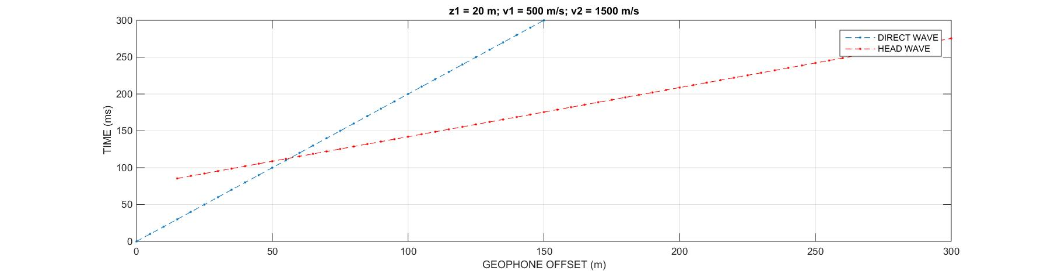

If you instead type

>> refraction_2layers(500,1500,20, 1);

Only the first arrivals will be shown (see below):

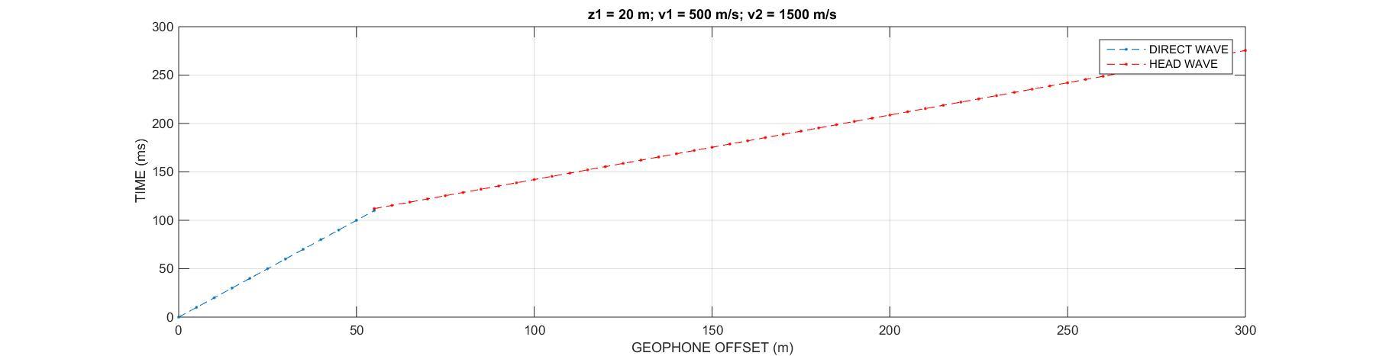

You can enter any combination of values that you want. Try starting with the values above.

Next, edit the input values and run the script again. Test as many values as you want until you feel confident answering the following questions:

- How do the slopes, travel times, and crossover distance change as you increase layer thickness? Can you explain why?

- How do the slopes, travel times, and crossover distance change as you increase the velocity of layer 1? Can you explain why?

- How do the slopes, travel times, and crossover distance change as you increase the velocity of layer 2? Can you explain why?

- Why is crossover distance important when planning a refraction survey?

THREE LAYER SYSTEM:

The function “refraction_3layers” is similar to the 2 layer version and may be run with:

>> refraction_3layers(v1, v2, v3, z1, z2, FIRST_ARRIVALS_ONLY)

Begin with v1 = 500, v2 = 1500, v3 = 3000, z1 = 20, z2 = 40.

Again, velocities are in m/s and thicknesses are in m. Edit the input values to answer the following questions, keeping in mind that when analyzing refraction data you can only see the first arriving waves (you may wish to set the FIRST_ARRIVALS_ONLY flag to 1 to see how this affects your results).

- What happens to the order of first arriving waves if you make layer 2 slower than layer 1? Why does this happen?

- What happens to the order of first arriving waves if you make layer 2 very thin? Why does this happen?

- What does this tell you about the limits of refraction geophysics for investigating the subsurface?

