A Nuclear Power Survey

Please answer the following questions to the best of your ability.

- An isotope is a/an:
  - positively charged ion
  - negatively charged ion
  - electrically neutral atom
  - atoms of the same element with different number of protons
  - atoms of the same element with different number of neutrons
  - atoms of the same element with different number of electrons
  - don’t know
- What are the potential consequences of a nuclear reactor accident? (select all that apply)
  - release of radioactive material to the environment
  - chemical explosion
  - run away nuclear chain reaction
  - nuclear explosion
  - release of fission products to the environment
  - don’t know
- Which consequence cannot result from a nuclear reactor accident? (select all that apply)
  - release of radioactive material to the environment
  - chemical explosion
  - run away nuclear chain reaction
  - nuclear explosion
  - release of fission products to the environment
  - don’t know
- Which was the worst industrial accident in human history?
  - Three Mile Island nuclear accident, 1979 (0 fatalities, 0 injured)
  - Texas City explosion and fires, 1947 (> 578 fatalities, 3,500 injured)
  - Bhopal methyl isocyanate release, 1984 (20,000 dead, 570,000 injured)
  - Chernobyl nuclear power plant disaster, 1986 (50 fatalities)
  - Benxihu Colliery mine disaster, 1943 (1,549 fatalities)
  - don’t know
- Where would you receive a larger dose of radiation?
  - control room of a commercial nuclear power plant
  - surface uranium mine
  - transcontinental jetliner
  - Waste Isolation Pilot Plant (repository for U.S. defense related transuranic waste)
  - hospital diagnostic facility
  - don’t know

- Which type of radiation is more penetrating?
  - alpha
  - beta
  - gamma
  - x-ray
  - don’t know
- Which type of radiation is least penetrating?
  - alpha
  - beta
  - gamma
  - x-ray
  - don’t know
- What is transuranic waste?
  - radioactive elements produced in a nuclear reactor with atomic numbers near iron
  - radioactive elements with atomic numbers greater than uranium
  - stable elements produced by fusion with atomic numbers near hydrogen
  - radioactive elements in metals of reactor components produced by neutron bombardment
  - don’t know
- Which type of product from the nuclear power industry must be isolated from the longest time?
  - fission products
  - radioactive elements with atomic numbers greater than uranium
  - fusion products
  - radioactive elements that decay by gamma radiation
  - don’t know
- Which industrial facility emits more radiation?
  - nuclear power plant
  - coal-fired electrical power plant
  - natural gas electrical power plant
  - nuclear fuel fabrication plant
  - oil refinery
  - don’t know
- In addition to being radioactive, plutonium (Z = 94) is also toxic. In fact, it is often described as the most toxic substance known to humans. Please choose the statement below that best describes your understanding of what is meant by Pu’s toxicity. Check all that apply. If none of these statements capture the essence of your understanding, please explain it in your own words in the space below.
  - within hours of ingestion, death results
  - exposure to plutonium always results in death
  - death results within days of ingestion
  - biological harm results only from ingestion
  - biological harm results from contact as well as ingestion
  - don’t know

- Which uranium enrichment process is relatively new and the one Iran is using to enrich its uranium?
  - gaseous diffusion
  - high-speed centrifuges
  - laser enrichment
  - dynamic separation
  - don’t know
- What would the result of the chain reaction depicted in the diagram below?

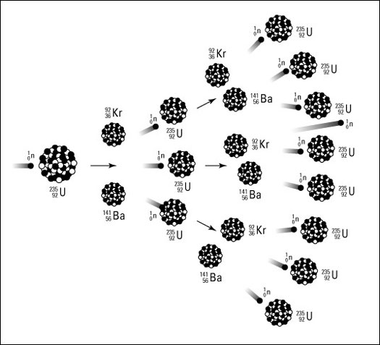

- An isotope that can be induced to fission by capturing a thermal neutron is:
  - stable
  - unstable
  - fissile
  - fertile
  - don’t know
- What is the purpose of a moderator in a nuclear reactor?
  - absorb neutrons
  - reflect neutrons
  - slow neutrons
  - speed neutrons up
  - don’t know
- Explain how nuclear reactions differ from chemical reactions.

- What characteristic defines an element?
  - number of protons
  - number of electrons
  - number of neutrons
  - sum of protons and neutrons
  - atomic weight
- The disintegration of certain isotopes by the emission of subatomic particles is:
  - radioactive decay
  - fusion
  - daughter production
  - fission
  - carbon dating
- Alpha decay involves the:
  - loss of 2 protons and 2 neutrons
  - conversion of a neutron to proton
  - combining of a proton and an electron to form a neutron
  - loss of a proton and gain of a neutron
  - capture of a neutron
- Fission produces heavier elements than the starting ones. True/False
- Gamma rays are a form of:
  - neutron radiation
  - particle radiation
  - electromagnetic radiation
  - beta radiation
  - alpha radiation
- Alpha radiation is extremely dangerous because it is a highly penetrating form of radiation. True/False
- To maintain a controlled, sustainable chain reaction, how many subsequent fission events must each fission initiate?
  - 0.5
  - 1
  - 1.5
  - 1.75
  - 2
  - don’t know
- What is the purpose of the coolant in a nuclear reactor?
  - remove heat from the core to produce steam
  - slow neutrons
  - remove fission products from the core
  - produce electricity from the core’s heat
  - don’t know

- On the diagram below illustrating a nuclear chain reaction, identify the major conceptual error.

