Arctic Climate Connections

Using authentic Arctic research data to learn about climate

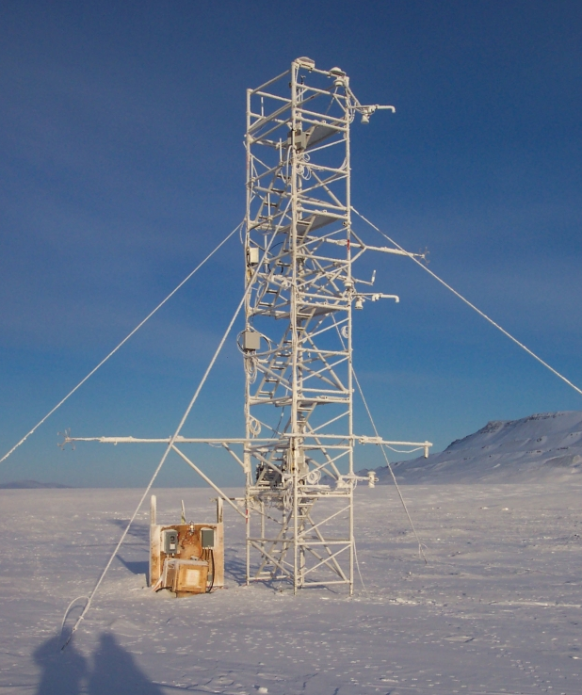
Photo by A. Grachev/O. Persson – Meteorological Tower in Eureka, Canada

ACC Curriculum prepared by Anne Gold and Karin Kirk.
Cooperative Institute for Research in Environmental Sciences (CIRES)
University of Colorado

TEACHER GUIDE WITHOUT ANSWER KEY

Table of Contents
Acknowledgements and Funding 3
Overview 4
Organization of Curriculum 5
Materials Available for ACC Curriculum 7
Arctic Climate Connections Resources 8
Standard Alignment 11
Arctic Climate Connections Activity 1 Exploring the Arctic 13
Part A - What’s the big deal about the Arctic anyway? Why are so many scientists studying the Arctic? 13
Part B - A Virtual Trip to the Arctic 18
Part C — Collecting Your Own Meteorological Data 25
Extension Activity - Using Image-Processing Software ImageJ to Measure Albedo 33
Arctic Climate Connections Activity 2 Do you really want to visit the Arctic? 34
Part A – Research Groups 36
Part B – Research Teams 45
Part C – Individual Reflection 47
Extension Activity - Create an Infographic 48
Arctic Climate Connections Activity 3 Exploring Arctic Climate Data 49
Part A - Understanding Albedo 49
Part B - Analysis of Albedo, Snow Depth and Temperature 51
Extension Activities - I) Greenland Albedo, II) Dust on Snow 58

Acknowledgements and Funding

The authors would like to acknowledge the contributions of Emily Kellagher to this curriculum and the support and contributions of Dr. Andrey Grachev (CIRES/NOAA ESRL Physical Division) and Dr. Ola Persson (CIRES/NOAA ESRL Physical Division). We thank Dr. Susan Buhr Sullivan (CIRES) for discussions, Milena Van der Veen (CIRES) for testing the hands-on activities, Amanda Morten (CIRES) for administrative support, and Kim Merryman for proofreading. Our curriculum was reviewed by the following educators: Deb Morrison (PhD candidate, School of Education, middle school science teacher), Jennifer Taylor (middle school teacher, curriculum developer), Cheryl Manning (high school science teacher, curriculum developer), and Betsy Youngman (high school science teacher, curriculum developer). The materials were used by 26 educators (elementary school through undergraduate) during a professional development workshop, three teachers implemented the curriculum. Feedback from the workshop participants and implementing teachers improved the curriculum

The authors wish to express their appreciation to the National Science Foundation (NSF). NSF support made this work possible.
This grant is associated with the following Parent Science Research Award:
Surface Energy Budgets at Arctic Terrestrial Sites: Quantifying Energy and Momentum Fluxes and their Associated Physical Processes. NFS Award Number 1107428, by Dr. Andrey Grachev (co-PI: Dr. Ola Persson, Dr. R. Stone). This award was under the following program: Arctic Sciences Division

Teaching Notes – Critical Literacy

Students can use this acknowledgements section to understand the provenance of this information and the intent of this work.

Optional pre-activity questions could include:
- Who constructed this material?
- Why should we believe what they have to say?
- Who funded this work?
- What is their intent in funding this type of work?
- What other work do the authors or funders do in the Arctic? Elsewhere?
- What expertise do the authors have in the topic of climate science?

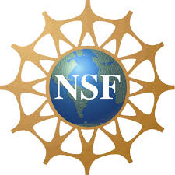
For further information on this program please contact:
Dr. Anne Gold
Cooperative Institute for Research in Environmental Sciences (CIRES)
Education and Outreach, Campus Box 449
Boulder, CO, 80309
anne.u.gold@colorado.edu

Overview

Abstract of Curriculum:
This suite of activities is designed to engage learners in climate science through working with data from an ongoing Arctic research project. Educators can use the entire curriculum or select the components best suited to their audiences. Each activity contains multiple parts; educators can implement all or just parts of the activities. All activities include a teacher’s guide along with possibilities for additional exploration, a teacher’s guide with an answer key, a student guide, student worksheets and supporting data and image files.

Activity 1 introduces students to the Arctic and allows them to explore the geography of the Arctic using Google Earth. Students go on to learn about meteorological parameters that are measured by research teams and practice the measurements in hands-on activities.
In Activity 2, students work in a jigsaw format to examine data collected by CIRES researchers in the Arctic and draw connections to the weather and climate in their hometown.
Activity 3 puts students in the researcher position, and they work through real data using Excel. Students then explore the significance of albedo for global climates.

Driving Questions:
- What is the Arctic? What is the geographic extent of the Arctic?
- Why should we study the Arctic?
- How do scientists study Arctic weather and climate?
- How do scientists interpret and use their data?
- How are the findings from Arctic research related to global climate?
- How do feedback mechanisms operate, specifically the effect of albedo?

Grade Level
- This curriculum was primarily designed for a high school audience – grades 9-12
- Activities 1 and 2 can be adapted for middle school students with teacher support.
- Activity 3 and the extension activities from Activities 1-3 can be adapted for use at the introductory college level.

Organization of Curriculum

Activity 1 – Exploring the Arctic
Part A: What is the Arctic? (time in classroom required: two 45-minute class periods)
In this activity students brainstorm their knowledge about the Arctic and build a concept map of different aspects of the Arctic environment. Students try to define the Arctic and create a whole-class definition. Students further explore the Arctic environment by looking at vegetation and indigenous people.
Assessments: Concept Maps, Whole-Class concept map of Definition of Arctic, Worksheet questions
Part B: A Virtual Trip to the Arctic (time in classroom required: two 45-minute class periods)
Students take a virtual tour of the Arctic and Arctic research sites using Google Earth.
Assessments: Google Earth kmz files, worksheet questions, Thinking Further questions
Part C: Collecting Your Own Meteorological Data (time in classroom required: two to three 45-minute class periods)
Students conduct hands-on experiments measuring albedo, relative humidity, and soil temperature using simple classroom methods. In this jigsaw activity, they regroup and analyze the data in teams and discuss questions that have them think further. Then they research and identify scientific instruments at the Eureka Arctic meteorological tower.
Assessments: Data collection sheets, responses to discussion questions
Extension Activity I: Using ImageJ for Albedo Measurements (time required: one 45-minute class period)
Students use ImageJ, a free image processing software, to measure albedo digitally on images of their own choice.
Assessment: Estimated and measured albedo values

Activity 2 – Do you Really Want to Visit the Arctic?
Warm-up Activity (time in classroom required: 20-30 minutes)
The warm-up activity allows students to learn a little about the Arctic and the climate system and ask research questions like scientists do.
Assessment: Three research questions
Part A: Research Groups: Analysis of an Arctic Meteorological Dataset (time in classroom required: one 45-minute class period
Student groups examine and describe one of four guided datasets of the annual record of 2010 at Eureka Arctic meteorological tower for air temperature, wind speed, snow depth, and incoming solar radiation.
Assessment: Worksheet questions
Part B: Research Teams: Synthesis of Data to Determine Arctic Meteorological Dataset (time in classroom required: 30 minutes)
Students rearrange into Research Teams (each team will contain one member from each of the research groups). The research teams describe their parameter and then synthesize the data to determine the best time of year to visit the Arctic.
Assessment: Completed discussion questions
Part C: Individual Reflection (time in classroom required: 20 minutes to one 45-minute class period, depending on the level of detail in comparing Eureka weather to hometown weather)
Students work individually to create a measureable definition for winter, taking into account what they learned about the Arctic climate, and then transfering this information to their hometown by finding weather and climate data for their hometown.
Assessment: Definition for winter, completed worksheet questions
Extension Activity: Infographics (time in classroom required: one 45-minute class period)
Students work in groups to create an infographic about the weather in Eureka, Canada. An infographic is a fun and creative way to organize and express data.
Assessment: Infographic

Activity 3 – Exploring Arctic Climate Data
Part A: Understanding Albedo (time in classroom required: 30 minutes)
Students practice calculating albedo as a simple ratio of incoming to outgoing short-wave radiation.
Assessment: Completed student guide
Part B: Analysis of Albedo, Snow Depth, and Temperature (time required: two 45-minute class periods, possibly more depending on existing familiarity with Excel)
Students dig into the Arctic data using Excel to unravel some causes and effects of the melting of the snowpack. Students develop concept sketches of albedo.
Assessments: Completed student guide, Excel graphs, concept sketch of albedo
Part C: Think Globally (time in classroom required: 15 minutes)
Students analyze glacier image pairs from a time series and think about the implications of albedo on the rate of glacial melt. Students then discuss global implications of their findings.
Assessment: Discussion questions
Extension Activity I: Greenland Albedo (time in classroom required: one to two 45-minute class periods, depending on depth. Could also be assigned as homework.)
Students use a variety of data sources to understand several causes of decreasing albedo in Greenland.
Assessment: Discussion questions
Extension Activity II: Dust on Snow (time in classroom required: one 45-minute class period, depending on depth. Could also be assigned as homework.)
Students learn about the relationship between dust storms, albedo, and water supplies in the Colorado River. Higher-order thinking questions address the challenges of establishing climate policy.
Assessment: Discussion questions

Materials Available for ACC Curriculum
- Teacher Guide with answer key [Word document]
- Teacher Guide without answer key (this document) [Word document]
- Student Guide [Word document]
- Student Worksheets [Word documents and PowerPoint slides]
- Companion Images [PowerPoint slides]

If you would like to obtain the Teacher Guide WITH answer key please send an email from your official school email address, providing a contact phone number for us to verify that you are a teacher/educator.

Activity 1:
- Background information – has to be printed double sided and then folded in half to make a little booklet [PowerPoint file, to be printed]
- Instructions for hands-on experiments [PowerPoint slides]
- Student guide [Word document]
- Student worksheet [Word document]

Activity 2:
- Guidelines for jigsaw/data description activity [PowerPoint slides]
- Graphs for jigsaw activity [Excel]
- Student guide [Word document]
- Student worksheet [Word document]

Activity 3:
- Instructor dataset and graphs [Excel]
- Student dataset [Excel]
- Paired glacier photographs [PowerPoint slides]
- Student guide [Word document]
- Student worksheet [Word document]

Arctic Climate Connections Resources

The Arctic climate connections curriculum consists of a classroom set of student materials and a teacher’s guide for each lesson.

All materials are also available to use online or download from our website:

http://cires.colorado.edu/education/outreach/ICEE/arcticclimate/index.html

All materials and worksheets are available as downloadable Adobe PDF files as well as Microsoft Word, PowerPoint, and Excel files – allowing for edits of the original version.

The website also includes the recording of a presentation by Dr. Ola Persson that was held during a teacher professional development workshop around this curriculum

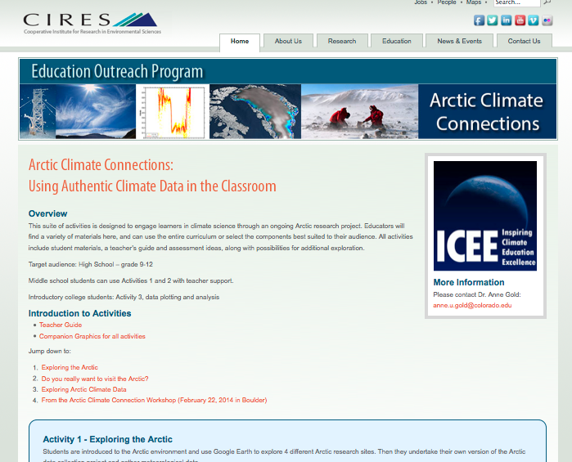

Presentation by Research Scientists

The ACC curriculum was presented by educators during a teacher professional development workshop. Dr. Ola Persson gave a presentation tailored to this curriculum. The presentation is recorded and can be viewed at the link below.

http://cires.colorado.edu/education/outreach/ICEE/arcticclimate/index.html#workshop

The talk was structured into four sections. See below the time stamps where to start the presentation for each of the sections:

Question 1: Timestamp 3:03 min –13:34 min
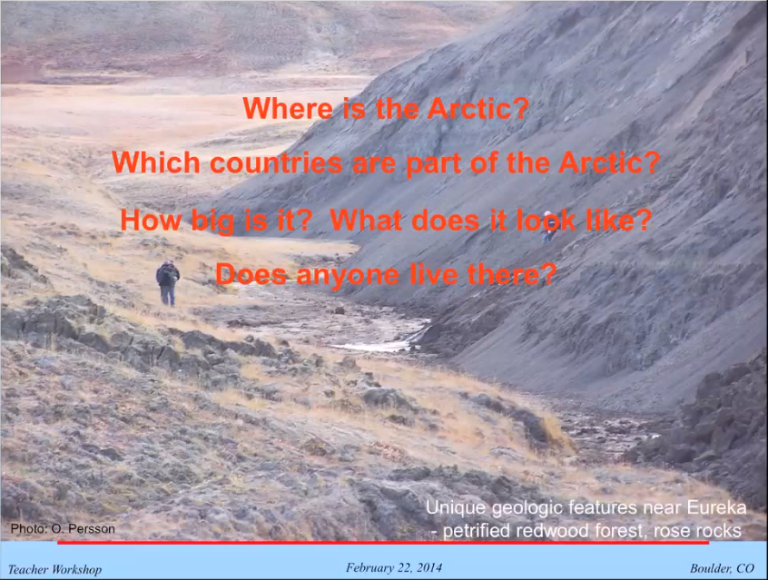

Question 2: Timestamp 13: 36 min – 30.48 min
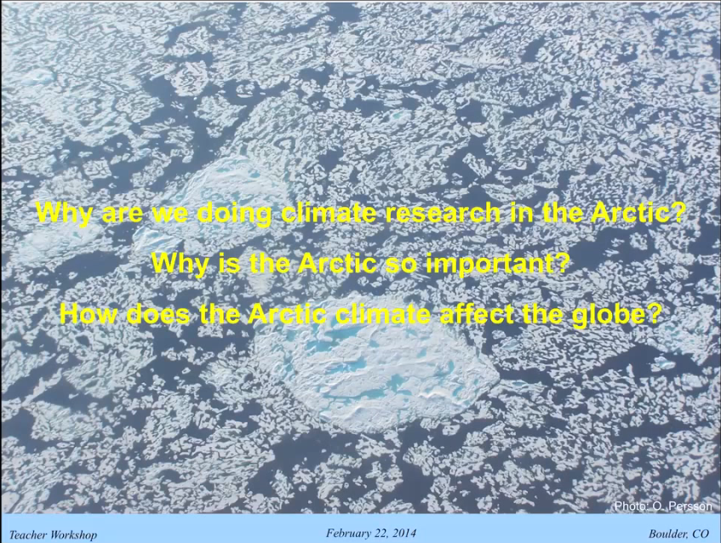

Question 3: Timestamp 30:48 min-1:00:00 min
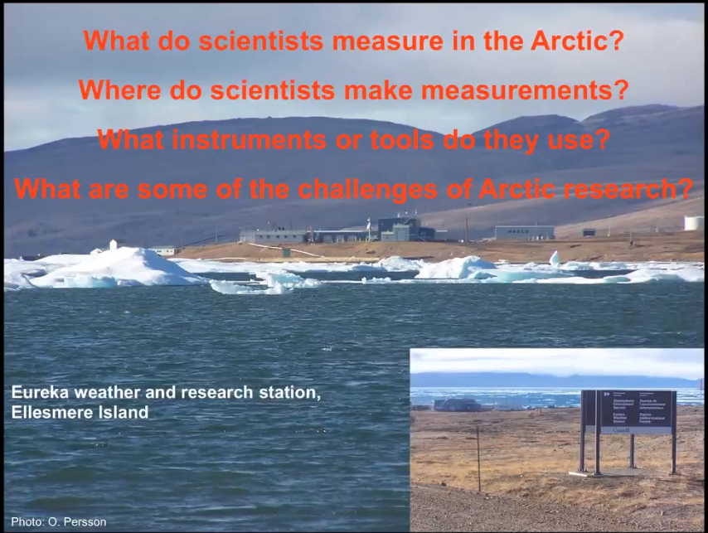

Question – Energy Budget: Timestamp 48:51 min-52:13 min
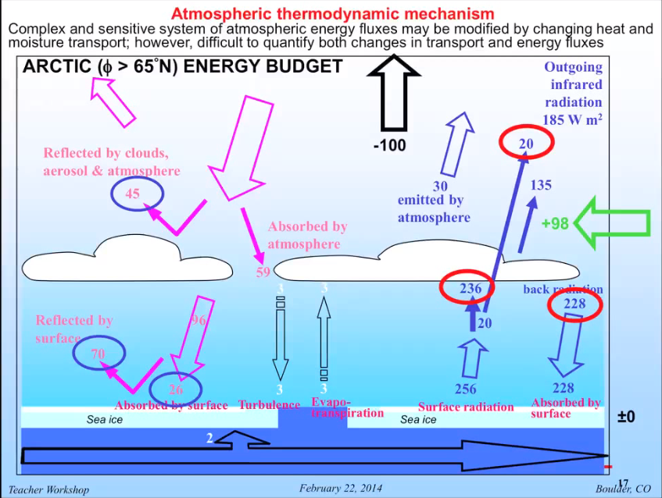

Question 4: Timestamp 1:00:00 min
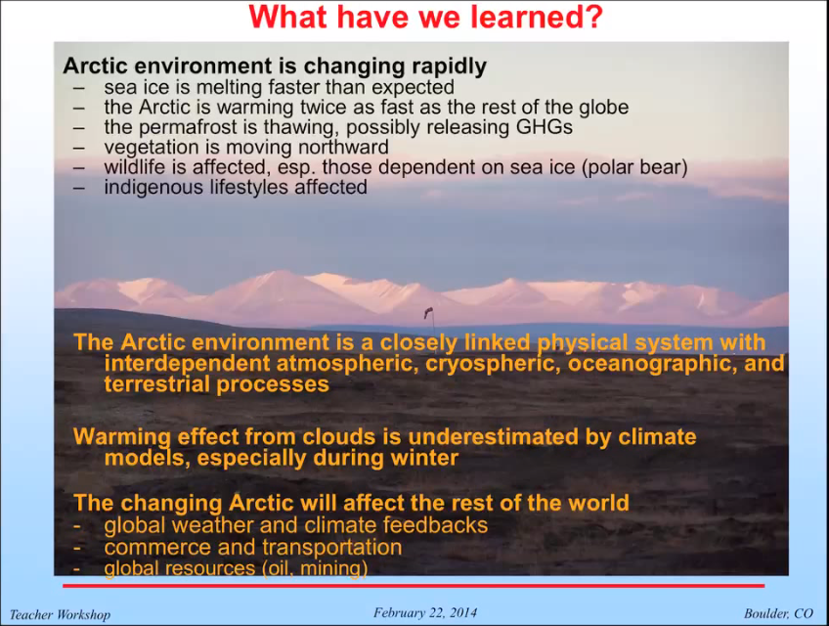

Standard Alignment

Colorado Science Standards

Standard | Activity 1 | Activity 2 | Activity 3
1. Physical Science | Part B, C | Part A | Part A, B, C
2. Life Science | Part A
3. Earth System Science | Part A, B, C | Part A | Part A, B, C

Next Generation Science Standards

Science and Engineering Practices | Activity 1 | Activity 2 | Activity 3
#1 Asking and Defining Problems | Part A | Warm Up
#2 Developing and Using Models
#3 Planning and Carrying Out Investigations | Part B, C
#4 Analyzing and Interpreting Data | Part C | Part A, B | Part A, B, C
#5 Using Mathematics and Computational Thinking | Part C | Part A | Part A, B
#6 Constructing Explanations and Designing Solutions |  | Part B | Part B
#7 Engaging in Argument From Evidence | Part C | Part B, C | Part B, C; Extensions
#8 Obtaining, Evaluating, and Communicating Information | Part A | Part B, C; Extension
CH11 Youth Discourses to Scientific Discourses | Part A | Warm Up; Part C; Extension
Crosscutting Concepts: | Activity 1 | Activity 2 | Activity 3
#1 Patterns | Part A  Part C | Part A | Part C
#2 Cause and Effect | Part A |  | Part B, C; Extension 1, 2
#3 Scale, Proportion, and Quantity | Part B |  | Part B, C
#4 Systems and System Models |  | Part B | Part B, C
#5 Energy and Matter: Flows Cycles & Conservation | Part B, C |  | Part B, C; Extensions
#6 Structure and Function
# 7 Stability and Change |  | Part B | Part C
Disciplinary Core Ideas: | Activity 1 | Activity 2 | Activity 3
ESS1: Earth’s Place in the Universe | Part B
ESS2: Earth’s Systems | Part A, B, C | Part A | Part A
ESS3: Earth and Human Activity | Part A | Part B | Part C; Extensions

Essential Principles of Climate Literacy

Climate Literacy Principle 1A. Sunlight reaching the Earth can heat the land, ocean, and atmosphere. Some of that sunlight is reflected back to space by the surface, clouds, or ice. Much of the sunlight that reaches Earth is absorbed and warms the planet.

Climate Literacy Principle 2F. The interconnectedness of Earth’s systems means that a significant change in any one component of the climate system can influence the equilibrium of the entire Earth system. Positive feedback loops can amplify these effects and trigger abrupt changes in the climate system. These complex interactions may result in climate change that is more rapid and on a larger scale than projected by current climate models.

Climate Literacy Principle 4A. Climate is determined by the long-term pattern of temperature and precipitation averages and extremes at a location. Climate descriptions can refer to areas that are local, regional, or global in extent. Climate can be described for different time intervals, such as decades, years, seasons, months, or specific dates of the year.

Climate Literacy Principle 4B. Climate is not the same thing as weather. Weather is the minute-by-minute variable condition of the atmosphere on a local scale. Climate is a conceptual description of an area’s average weather conditions and the extent to which those conditions vary over long time intervals.

Climate Literacy Principle 5B. Environmental observations are the foundation for understanding the climate system. From the bottom of the ocean to the surface of the Sun, instruments on weather stations, buoys, satellites, and other platforms collect climate data. To learn about past climates, scientists use natural records, such as tree rings, ice cores, and sedimentary layers. Historical observations, such as native knowledge and personal journals also document past climate change.

Climate Literacy Principle 7B. Climate plays an important role in the global distribution of freshwater resources. Changing precipitation patterns and temperature conditions will alter the distribution and availability of freshwater resources, reducing reliable access to water for many people and their crops. Winter snowpack and mountain glaciers that provide water for human use are declining as a result of global warming.

