Jigsaw Assignments and Templates
Barbara Tewksbury
Hamilton College
btewksbu@hamilton.edu

Template #1 for using the jigsaw technique

This is a very simple jigsaw assignment (actual assignment starts on page 2) with only two teams and with little guidance on pre-class preparation other than to answer a few simple questions and prepare a summary (see template #2 for contrast). Here are a few things to note:

• I collect written preparations at the start of class (students bring two copies to class, one to turn in and one to work with during class).
• At the start of class, I divide the class into their respective teams to share ideas about how they will convey what they know to a member from the other team and to clear up any confusions. Because this is a two-team assignment, each team consists of nearly a dozen people. During the team meetings, I divide each team up into smaller subteams of 3-5 so that they can work effectively. At the beginning of class, then, the class is divided into teams of 3-5, with several team #1’s and several team #2’s. My TA’s and I circulate to make sure that each team is on the right track before forming mixed groups.
• After all teams are ready, students pair up with a member from the other team. If there are an odd number of people in the class, one group will have three instead of two.
• The group task (what the pairs of people must tackle together) cannot be done without an analytical comparison of what each person has learned. This is a nice example of how a jigsaw is more than just listening to other teams present what they know. Having an inidividual written follow-up insures that students are diligent about the group task and learn something from it.

Smelting in Pre-colonial Africa

When thinking about minerals in Africa, we tend to link African mineral exploitation to the Europeans. People commonly believe that civilization and technology on the African continent were practically nonexistent until Europeans began to explore the region. In reality, pre-colonial African societies flourished south of the Sahara, and Africans were both culturally and technologically active long before European nations invaded the African continent. Some very recent archaeological evidence even suggests that smelting of metallic ores may have originated in Africa, not in Eurasia as everyone has assumed for years.

Everyone reads: Herbert, Eugenia, 1984, Red gold of Africa: Madison, WI, Univ. of Wisconsin Press, p. 3-11.

Write short answers to the following: What are metallic ores? What is smelting, and why is it necessary? How did smelting likely originate? Are all metallic ores equally easy/difficult to smelt? Bring two copies of your answers.

Team 1: the metallurgists
Write a summary outlining the smelting process described in the article listed below and indicate what happens chemically during the various steps of preparing and smelting iron ore in traditional fashion. Bring two copies of your summary to class.

Van Noten, Francis and Raymaekers, Jan, 1988, Early iron smelting in Central Africa: Scientific American June 1988, p. 104-111.

Team 2: the ritualists
Write a summary outlining the smelting process described in the articles listed below and indicate what the ritualistic significance is of the various steps in preparing and smelting iron ore in traditional fashion. Bring two copies of your summary to class.

Rowlands, Michael and Warnier, Jean-Pierre, 1993, The magical production of iron in the Cameroon Grassfields, in, Shaw, T., Sinclair, P., Andah, B., and Okpoko, A., eds., The archaeology of Africa: London, Routledge, p. 520-530.
Collett, D.P., 1993, Metaphors and representations associated with precolonial iron-smelting in eastern and southern Africa, in, Shaw, T., Sinclair, P., Andah, B., and Okpoko, A., eds., The archaeology of Africa: London, Routledge, p. 502-504.

In class: In class, you will be paired with a person from the other team. Compare what you learned about the ritualistic and metallurgical aspects of smelting. What does “ritual” mean? Which ritualistic aspects have a basis in metallurgy? What does each of those steps accomplish? Which steps are purely ritual?

Follow-up written assignment: After class, write a short paper answering the questions listed under “in class”; turn it in on Friday.

Template #2 for the jigsaw assignment

This jigsaw assignment provides more guidance to prepare students for peer teaching than does template #1. The actual assignment begins on page 4.

Purpose of the jigsaw:

• To have students construct an approximate temperature curve (average temperatures higher than, lower than, or similar to today) for Iceland for the past 1000 years based on a variety of climate proxies.
• Each student studies a different proxy, and the group puts the data together to construct the curve. No one student would have time to study all of the proxies, so this is an ideal assignment for the jigsaw technique. This is a nice example of the fact that good jigsaw team assignments are related to one another.

Part I: preparation before class

• Questions to guide reading: If you want to students to come well-prepared for peer-teaching, you should provide them with specific questions to answer as they do the reading. If you don’t, they will likely not prepare in the manner you would if you were reading the article and will not be adequately prepared to teach the topic to someone else. The questions in this assignment provide that kind of preparation.
• Preparation of a handout: For a topic involving graphs, photos, maps, etc., a handout is a valuable addition to help a student in peer teaching. This assignment requires students to prepare an appropriate handout and bring enough copies for his/her mixed group.
• Preparation of a teaching sheet (page 8): When asked to peer teach in the mixed group, many students will simply say, “The answer to question #1 is .....; the answer to question #2 is....”. This is not what you would do if you were teaching. You would step back from a topic and ask what the most important message was and then decide how to convey it. Asking students specifically to do this improves the quality of peer teaching. This template has a “teaching sheet” that asks for a summary statement plus the ideas that help support that statement. This can be completed ahead of time, or teams can be asked to discuss it and complete it during the team meetings at the start of class. The rule for students, then, is to use the teaching sheet, rather than the list of preparation questions, to make the points during peer teaching.

Part II: in class

• This assignment is the same as template #1 for both beginning-of-class team meetings and mixed groups. It is useful during peer teaching to have students play the role of the researchers and say “I/we discovered blah blah blah…” Surprisingly, it changes the whole tone of the class!

Part III: group assignment

• The group puts the temperature curve together on a large sheet of shelf paper on the basis of shared information and discusses several questions listed on the last page of the template.
• The group receives a group grade on the basis of their temperature curve and answers to discussion questions. Individuals receive an additional grade on their preparation and handout.

Climate in Iceland over the past 1000 years

For the next several weeks, we will be looking at climate changes, glaciers, and the spectacular intersection between glaciers and volcanoes in Iceland.

Iceland has what can be termed a “threshold climate” – minor changes in temperature can mean major effects on the population that include crop failure and expansion of glaciers. Reconstructing climate and changes in climate can be done in a number of ways. We’ll investigate 4 ways of reconstructing climate change in Iceland over various portions of the last 1000 years, and we’ll consider the limitations of using glacial fluctuations as a proxy for climate change.

Team #1: using historical records to reconstruct climate

Read the following article:

Thorarinsson, Sigurdur, 1956, The thousand years struggle against ice and fire: Reykjavík, Bókaútgáfa Menningarsjód s, p. 5-20, 35-40.

Prepare a handout that shows periods of warmer and cooler climate in Iceland over the past 1000 years, along with what evidence ﬁórarinsson used to draw those conclusions.

Come prepared to teach the rest of the class about the following issues:

a) What is drift ice, and where does it come from? How do the marine currents around Iceland control both the climate of Iceland (which is considerably warmer than one would expect for its latitude – modern Reykjavík has a winter climate not all that different from New York City) and the distribution of drift ice in a typical year in Iceland?
b) In terms of a climate threshold, why are severe ice years particularly devastating for Iceland?
c) ﬁórarinsson attempts to put together a historical picture of drift ice since the Time of Settlements. What are the limitations of this type of reconstruction, which is based on written historical documents? What overall conclusion does ﬁórarinsson draw about drift ice over the last 1100 years in Iceland?
d) How have people used changes in cereal cultivation as a proxy for changes in climate? What are the potential problems in drawing correlations between changing crops and changes in climate? What does ﬁórarinsson conclude?
e) What do historical records suggest about the positions of the margins of outlet glaciers of the Vatnajökull since the Time of Settlements?

Team #2: using historical records to reconstruct climate

Read the following article:

Ogilvie, A.E.J., 1992, Documentary evidence for changes in the climate of Iceland, A.D. 1500 to 1800, in, Bradley, Raymond S. and Jones, Philip D., eds., Climate since AD1500: New York, Routledge, p. 92-117.

Prepare a handout that illustrates what the documentary evidence suggests about climate in Iceland between AD1500 and 1800 and what evidence is used to draw the conclusions.

Come prepared to teach the rest of the class about the following issues:

a) The article states that the place in Iceland with the highest precipitation between 1931 and 1960 was as Kvisker, in south Iceland, with an annual average of 3300 mm. By contrast, Myvatn in north Iceland annual average was 394 mm. How much is that in inches per year, and how do these values compare to annual precipitation in Clinton? Why does less rain fall in the north and northeast of Iceland than in the south?
b) What is sea ice or drift ice, and where does it come from? Why is the extent of sea ice near Iceland used as a proxy for direct climate records?
c) What kinds of written sources exist that give information useful to reconstructing climate, and what types of information are available? How does one go about reconstructing climate from the types of information discussed in the article?
d) What does the documentary evidence suggest about temperature and sea-ice variations between AD1500 and 1800 in Iceland, and what does that suggest about the climate overall in Iceland in this time period?
e) What are the limitations in using documentary evidence as a proxy for determining climate?

Team #3: dating moraines using lichenometry

Read the following articles (read them in the following order):

Kugelmann, Ottmar, 1991, Dating recent glacier advances in the Svarfa› ardalur-Skí› adalur area of northern Iceland by means of a new lichen curve, in, Maizels, J.K. and Caseldine, C., eds., Environmental change in Iceland: Past and Present: Amsterdam, Kluwer Academic Publishers, p. 203-217.
Caseldine, Chris, 1985, The extent of some glaciers in northern Iceland during the Little Ice Age and the nature of recent deglaciation: The Geographical Journal,.v. 151, p. 215-227.

Prepare a handout showing what lichenometry indicates about time periods of glacial advance and recession in northern Iceland over the past 150 years or so. Be sure you also have maps to illustrate your points.

Come prepared to teach the rest of the class about the following issues:

a) What is lichenometry, and how does it work? How did Kugelman develop a lichen growth curve for northern Iceland?
b) Why do moraines lend themselves so well to being dated using lichenometry? What magnitude error (± how many years) does Kugelman suggest for morainal dates where he tested his lichen curve in ﬁveradalur? How does this compare to Caseldine’s error bars?
c) How do moraines form, and what do they tell us about the behavior of a glacier at a particular time?
d) What do the ages of moraines in Tröllskagi indicate about glacier positions over the past 150 years or so? Why can’t the studies be extended farther into the past?
e) How might temperature changes influence the a glacier? To what extent do you think morainal positions and the behavior of a glacier margin can serve as a proxy for climate changes?

Team #4 using remote sensing:

Read the following articles:

Williams, Richard S., Hall, Dorothy K., Sigurdsson, Oddur, and Chien, Janet Y.L., in press, 1997, Comparison of satellite-derived with ground-based measurements of the fluctuations of the margins of the Vatnajökull, Iceland: 1973-1992: Annals of Glaciology, v. 24.
Williams, Richard S., Jr., 1987, Satellite remote sending of Vatnajökull, Iceland: Annals of Glaciology, v. 9, p. 127-135.

Prepare a handout showing what remote sensing of the Vatnajökull indicates about the positions of the various outlet glacier margins between 1973 and 1992. A map would be a really good base to use for such a handout – make sure it has the names of all of the outlet glaciers on it (Williams et al. have a nice one in their 1997 paper).

Come prepared to teach the rest of the class about the following issues:

a) What kinds of interesting things did the satellite images reveal about the Vatnajökull that are difficult to study on the ground?
b) How is remote sensing used to compare positions of glacial margins over time? What are the difficulties and limitations?
c) What happened to the margins of the various outlet glaciers of the Vatnajökull over the 20-year time period covered by the study?
d) What do you think the limitations are of using glacier margin positions as a proxy for climate?

Team #5: the problem of glacial surges

Read the following article:

Thorarinsson, Sigurdur, 1964, Sudden advance of Vatnajökull outlet glaciers 1930-1964: Jökull, v. 14, p. 76-89.
Thorarinsson, Sigurdur, 1969, Glacier surges in Iceland, with special reference to the surges of Brúarjökull: Canadian Journal of Earth Sciences, v. 6, no. 4, p. 875-882.

Come prepared to teach the rest of the class about the following issues:

a) What is a glacial surge, how fast does a glacier move during a surge, how long do surges typically last, and what does a glacier look and sound like during a surge?
b) Which glaciers of the Vatnajökull have exhibited surge-type behavior in the 20th century?
c) What might cause a glacier to surge?
d) What do you think the limitations are of using glacier margin positions as a proxy for climate information?

Please bring the following to class on Wednesday:

– detailed written answers to the questions for the reading assigned to you, plus the handout we asked you to prepare. This must be an individual effort – each person must turn in his/her own work.These questions are designed to help you to be sure that you understand the reading and don’t miss any important points. If you do not understand anything in your article(s), please come see one of us early (not Wednesday noon).
– In class on Wednesday, you will have 5-10 minutes to explain the important aspects of the topic you have prepared to a group of people who have prepared other topics. In order to prepare to teach them, do the following after you have prepared your handout and answers to your questions. Use the form on the next page. Again, this must be an individual effort.

– Step back, and look at the article(s) and the answers to your questions. Write three to four sentences that summarize the most important message(s) you want to convey about your topic. You will start with this summary when you teach your group.

– Decide what information you will present to your group in order to support your main points and to explain the topic clearly. Make a list or outline of those topics, as well as specific data/information not on your chart that you will need when you elaborate on what appears in those topics. Remember that you must not simply recite your summary page – you must sort out what picture you want to paint and muster the evidence that your summary statements are correct.

Preparation for teaching – remember that you will have only 5 minutes to talk!!

Name Team # & topic

Summary statement (three to four sentences summarizing the most important messages you want to convey about the article(s) you read.

Outline of topics plus additional facts/data (this outline must contain the topics that you need to cover in order to elaborate on your summary statements and to provide evidence that your summary statements are reasonable; include any additional facts, data, or tidbits that are not on the handout you prepared)

Template #3 for using the jigsaw technique
(analysis of this template appears on page 27.

Analysis of template #3 for the jigsaw assignment

This jigsaw assignment is a good example of 1) a jigsaw that does not require out-of-class preparation of a team assignment and 2) a jigsaw in which students gain the benefits of close examination of one set of data and exposure to similar but not identical data sets. The actual assignment begins on page 10.

Purpose of the jigsaw
• The purpose is two-fold: 1) to gain experience in reconstructing paleoclimates using the rock record and 2) to determine the timing of rainfall changes in the Sahara between 10,000 and 4,000 ybp and to subsequently correlate those changes with the development of Egyptian civilization. Both could be done via lecture, but students can “think like geologists”, analyze the data themselves, and come to the conclusions themselves in approximately the same length of time that it would take to do a complete lecture on the subject.

Pre-class prep
- Although the jigsaw activity is conducted entirely in class, students complete a pre-class assignment that sets the stage and helps them visualize the modern Sahara better. The pre-class prep assignment begins on page 20.

Part I: in-class preparation (team assignment)
• The class is divided into teams, and each team analyzes its own strat column, drawing conclusions about rainfall changes and marshalling evidence. I circulate and talk to teams, answer questions, and make sure that no one is wrong-headed.

Part II: in-class peer teaching (mixed groups)
• During peer teaching in mixed groups, students discover that the evidence is different for different strat columns (faunal in some, floral in others, sedimentologic in others) and that difference columns show different rainfall patterns. These kinds of differences make for a good jigsaw – each student doesn’t need to do a detailed analysis of all four columns in order to get the point, but each would be missing the variations unless he/she learned something about each column.

Part III: group assignment (mixed groups
• The group then puts together evidence form all four columns and evaluates the timing and pattern of climate change in the Sahara. Because there is not a clear “right answer”, different groups arrive at somewhat different conclusions (having placed more weight on certain differences and similarities than others), and all-class discussion at the end is a way to bring out the various possible conclusions.

Individual follow-up assignment
- An individual follow-up assignment appears on page 29. This assignment does not require that all students know each of the strat column analyses equally well, but they do have to know what their group concluded and why, use that to evaluate a new set of information, and incorporate several example of evidence and timing into their arguments.

Name Saharan paleolakes
Class Wednesday, November 15

Over the past few weeks, we’ve seen some tantalizing clues that the Sahara has not always been as dry as it is today. Wouldn’t it be neat to know how long ago it was wetter? And how much wetter it was? Were humans around then? Could they have made a living in what is now a hyperarid desert? Were rainfall changes in any way connected with the rise of Ancient Egyptian civilization? Was it warmer or colder when it was wetter in the Sahara, and can we make any predictions about what global warming will do to the Sahara? Fortunately, we have the geological and archaeological record to help us out!

Let’s start by thinking about what you already know about when it was wetter in the Sahara in the recent past:

- When we studied groundwater in the Sahara, what did you learn from the ages of Saharan groundwater about periods of higher rainfall in the Sahara?

- When we studied the Libyans Great Man-Made River Project, you learned about the sources of aggregate that the Libyans used to make the concrete pipes. What evidence is there in the aggregate sources for higher rainfall in the recent past in the Libyan Sahara?

- What additional things did you learn about in the homework that suggest higher rainfall in the past in the Sahara?

Taoudenni
For homework, you read about the salt mines at Taoudenni. Below, you'll find a stratigraphic column from the Taoudenni area, and you'll find a map of the area at your table. The stratigraphic column shows a representative sequence of sediments in a particular place, with the oldest sediments at the bottom of the column and the youngest at the top (kind of like a core sample). These sediments have been interpreted to represent sediments deposited in a lake that periodically became hypersaline and occasionally dried out altogether. What features of the sedimentary record support that interpretation?

What information might we like to know about these sediments that isn't included in the stratigraphic column and key?
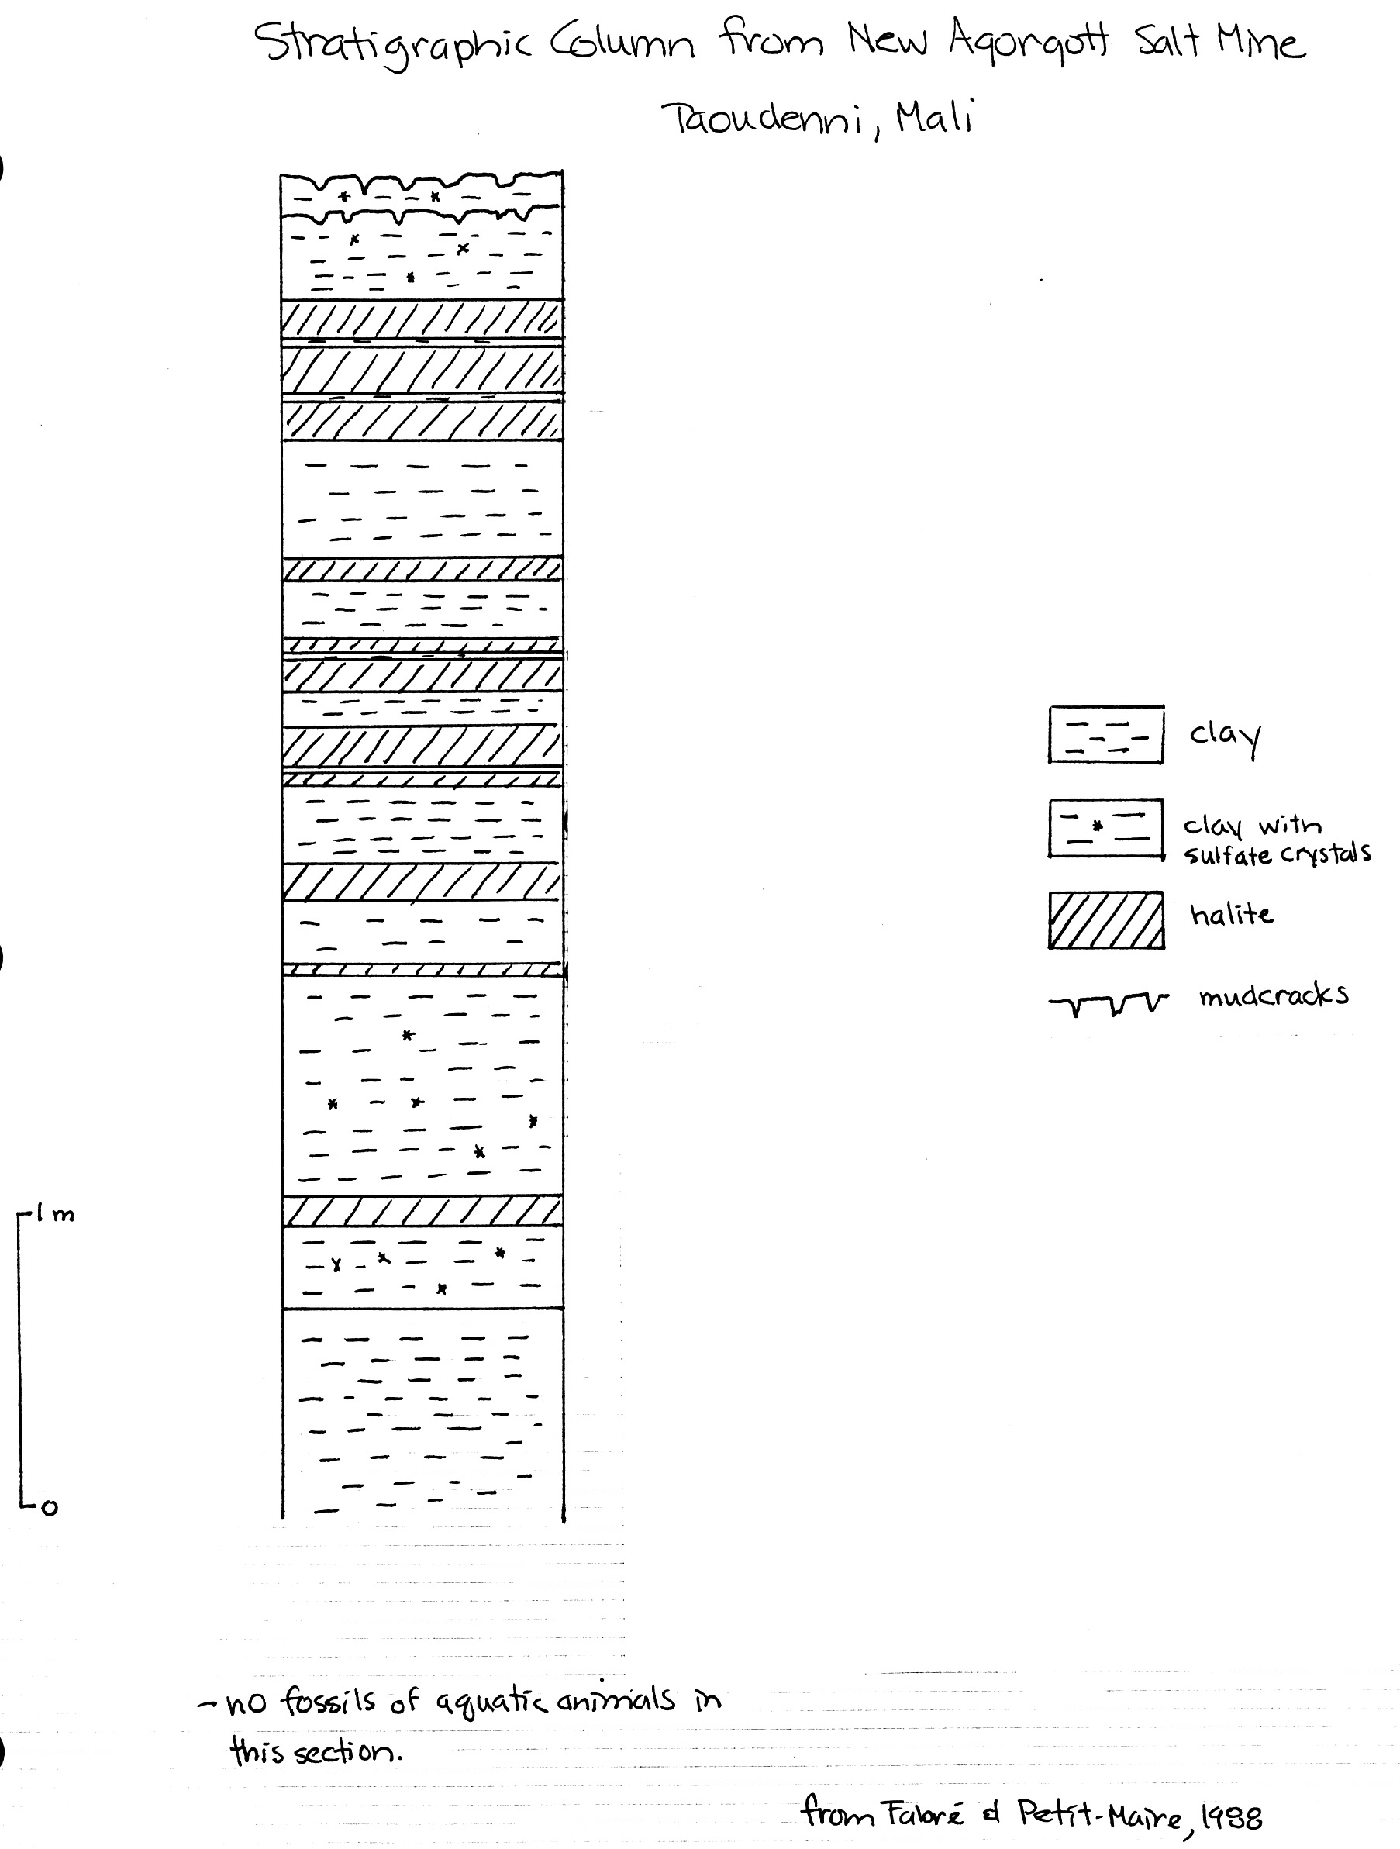
Your job:

- To study the sediment record at four other sites scattered across the Sahara.
- Develop a picture of what the Sahara was like when rainfall was higher.
- Draw conclusions from the features in the sediments about when rainfall was higher than it is today and when it was lower.
- Compare the four sites to develop a more complete picture in time and space across the Sahara.
- Use the geological record to make predictions about the impact of global warming on the Sahara.
- Look for correlations between climate events in the Sahara and historical events in Ancient Egypt.

The data:
Starting on page 6, you will find data from four other sites scattered across the central Sahara. These data include the following:

– a stratigraphic column showing sediment types
– radiocarbon dates, including what the dates were obtained on and where the samples were located in the section
– fossils, including microfossils, found in sediments in the section
– information on large animal populations and human activities, evidence for which may come from the immediately surrounding area rather than the section itself.
– information on floral remains, which may come either from vegetal remains (either in situ or having floated out onto a lake and sunk) or from pollen preserved in the section. Shape and size of pollen vary from species to species, and pollen analysis (palynology) of sediments can provide valuable information about what species were in the vicinity of the sample site. How representative a sample is of the actual vegetation depends upon 1) how far the wind carried pollen from various species and 2) whether conditions were right for preservation of pollen in the sediments.
– a map on page 5 showing modern vegetation (floristic) zones in North Africa, with lists of important plant species from each zone.

Your team assignment:
– locate your site on the map of the Sahara that I’ve given you.
– examine the data from your site. You will find reference information on various rock and sediment types at the end of this handout.
– develop a picture of what your site must have looked like at various times.
– establish the major changes in the environments of deposition (e.g., change from beach to dune to lake bottom to whatever), with evidence for those changes, and the timing of those changes.
– assess what your section suggests about rainfall changes in the area and why, and what the timing of changes appears to have been.

Once your group has worked through your column, have me check over your conclusions. Then, decide how to go about conveying all of the points listed above, starting with a descriptive picture of what the area must have looked like at various times. Remember that you are a geologist charged with conveying a detailed and convincing argument clearly supported by specific pieces of data (e.g., pollen, radiocarbon dates, sediment type, etc.). Be sure that everyone on your team is prepared to convey the following to a mixed group:
– the overall evolution of your paleolake, with evidence for your conclusions, including what the lake area looked like at various times (e.g., vegetation, animals, lake, mudflat, dunes, and so on). Be sure to be prepared to describe the rock types contained in your column.
– a summary of the timing of the major changes in rainfall, including any evidence that you did not cover in the first part.

In your mixed group:

Each person will teach the rest of the group about the two items listed above. Then, as a group, compare the four sites, and discuss the following:

- What do the four sites suggest about changes in rainfall over time across North Africa? Be specific about the timing of changes. Make a list of points below, and we will list them on the board.

- The current Sahara-Sahel boundary lies at approximately 17°N latitude (roughly through Timbuktu). Where would you place the Sahara/Sahel boundary in Early Holocene time, between 7500 and 8000 ybp? Explain the reasoning behind your answer.

- Are the conclusions you have drawn using the information from the paleolakes consistent with what you knew earlier (and listed on page #1) about wetter and drier times in the Sahara?

- Here are two more geological observations for you to consider:

  - At about 18,000 ybp (Late Pleistocene, at the height of the last major glacial advance), the Sahara/Sahel boundary lay at about 10°N latitude. Worldwide temperatures were significantly colder then than they are today.
  - The Early Holocene, by contrast, was a time of warmer temperatures worldwide than either the Late Pleistocene or the modern era. The Early Holocene is commonly referred to as the "Early Holocene Climatic Optimum".

Based on the geological record preserved in the Sahara from the Late Pleistocene, Early Holocene, and present, what might you predict for rainfall conditions in the Saharan region if global warming results in long-term worldwide temperature rise? Explain your answer, and provide evidence.

Major Floristic Regions Of North Africa With Characteristic Pollen Taxa

III – Saharan: desert with very limited pollen flora. Wadis typically contain Tamarix, Cornulaca, Calligonium, Fagonia, Salvadora, Maerua.

IV – Sahelian: sparsely wooded desert grassland and thorny shrubland; grades into Saharan type in the north and to Sudanian type in the south.

Acacias of various species are ubiquitous (these are the thorny trees of the Sahel); also Commiphora, Blepharis, Balanites, and the shrub Tribulus.

Rainfall determines which annual and perennial herbaceous plants and shrubs form the ground cover in a particular place. In the wetter parts of the Sahel, Graminae (grasses) and Cyperaceae (plants that grow on and stabilize inactive sand dunes) dominate. In drier (notice that I spelled this correctly this time, and didn’t use “dryer”, as in washer and dryer, like I did last time...) parts, Chenopodiaceae and Amaranthaceae dominate.

V – Sudanian: wooded savanna and dry forest. The most common tree taxa are Grewia and Piliostigma. Other species of plants include Celtis integrifolia, Combretaceae, and Lannea.

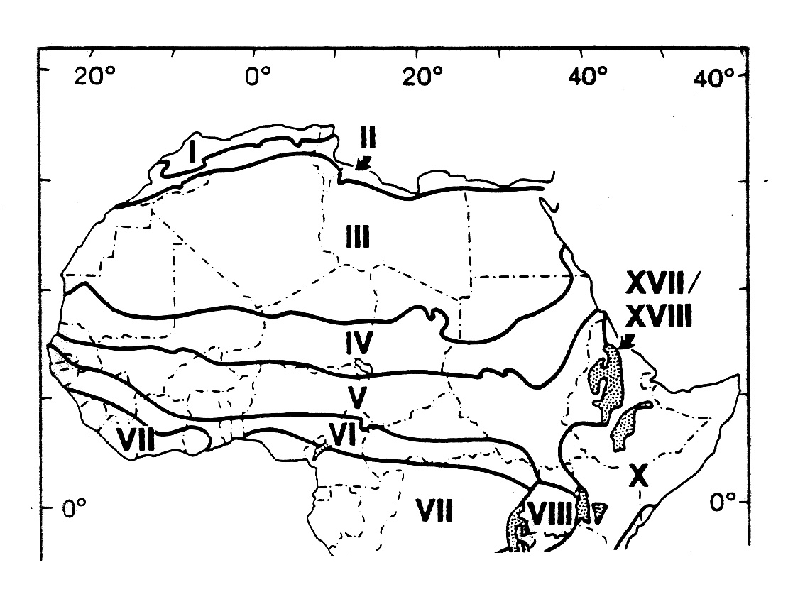
Team #1 Haijad, in the Taoudenni Depression

Taoudenni Depression is a internally-draining basin that currently contains no surface water, seeps, or springs. During the Holocene, however, many lakes and marshes developed in the area. The Taoudenni paleolake that we looked at earlier today is the most well-known of all of these lakes, because it was hypersaline and left behind salt deposits that have been exploited for centuries. The other lakes in the Depression do not have associated salt deposits.

Haijad paleolake lies about 20 km southeast of Taoudenni paleolake (see the map at your table and at a slightly higher elevation. Modern rainfall in the Haijad area averages less than 5 mm per year, and vegetation is virtually non-existent.
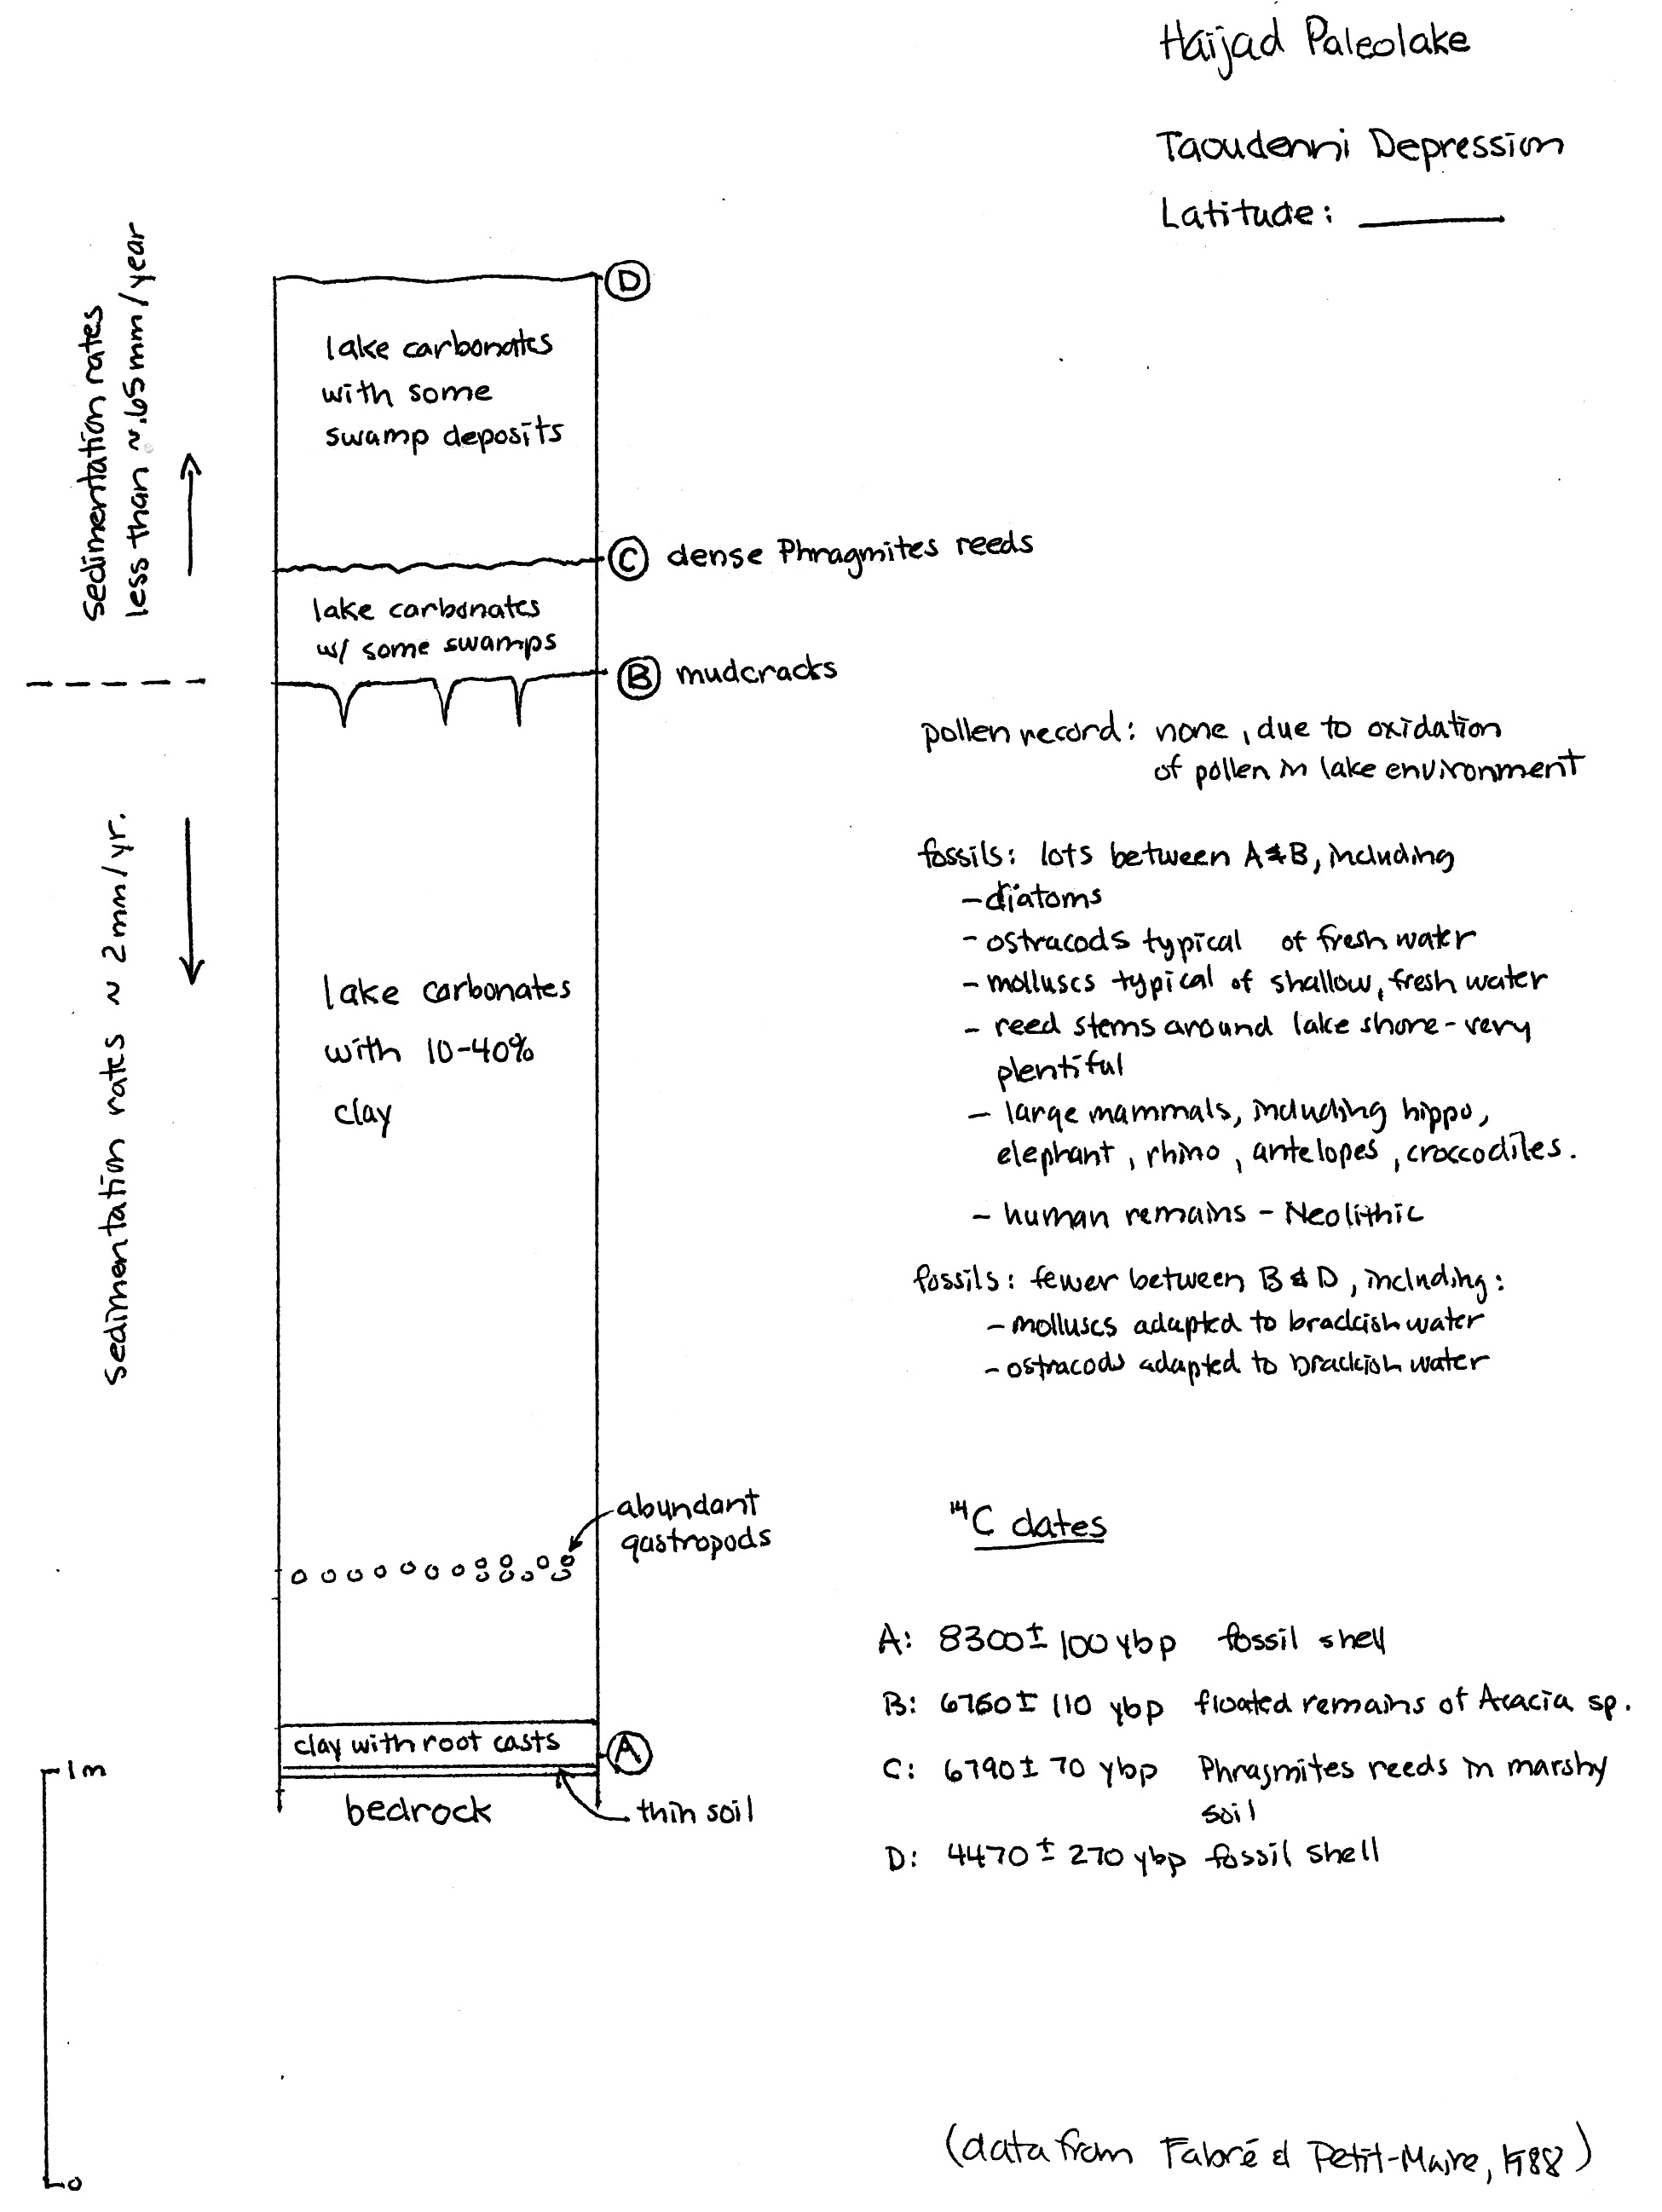

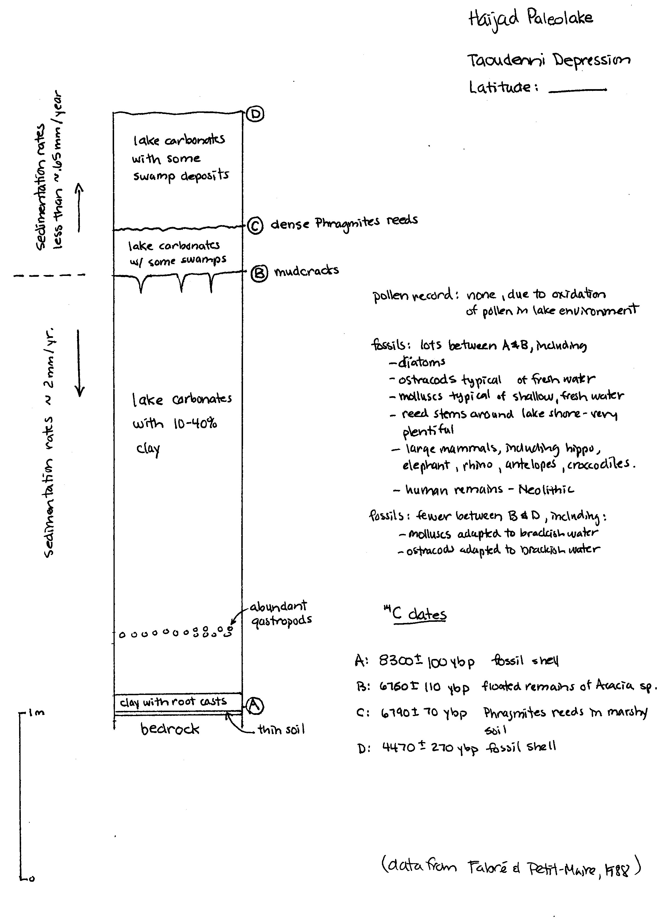Team #2 Adrar Bous, in the Ténéré Desert

Adrar Bous is large area of exposed bedrock located in the drifting sands of the Ténéré Desert about 65 km east of the Aïr Mountains of northern Niger. Locate Adrar Bous on your large map. Agorass N’Essoui paleolake that formed in a small depression on the south side of Adrar Bous.

Modern rainfall in the Adrar Bous area averages well less than 50 mm per year, and vegetation is virtually non-existent.
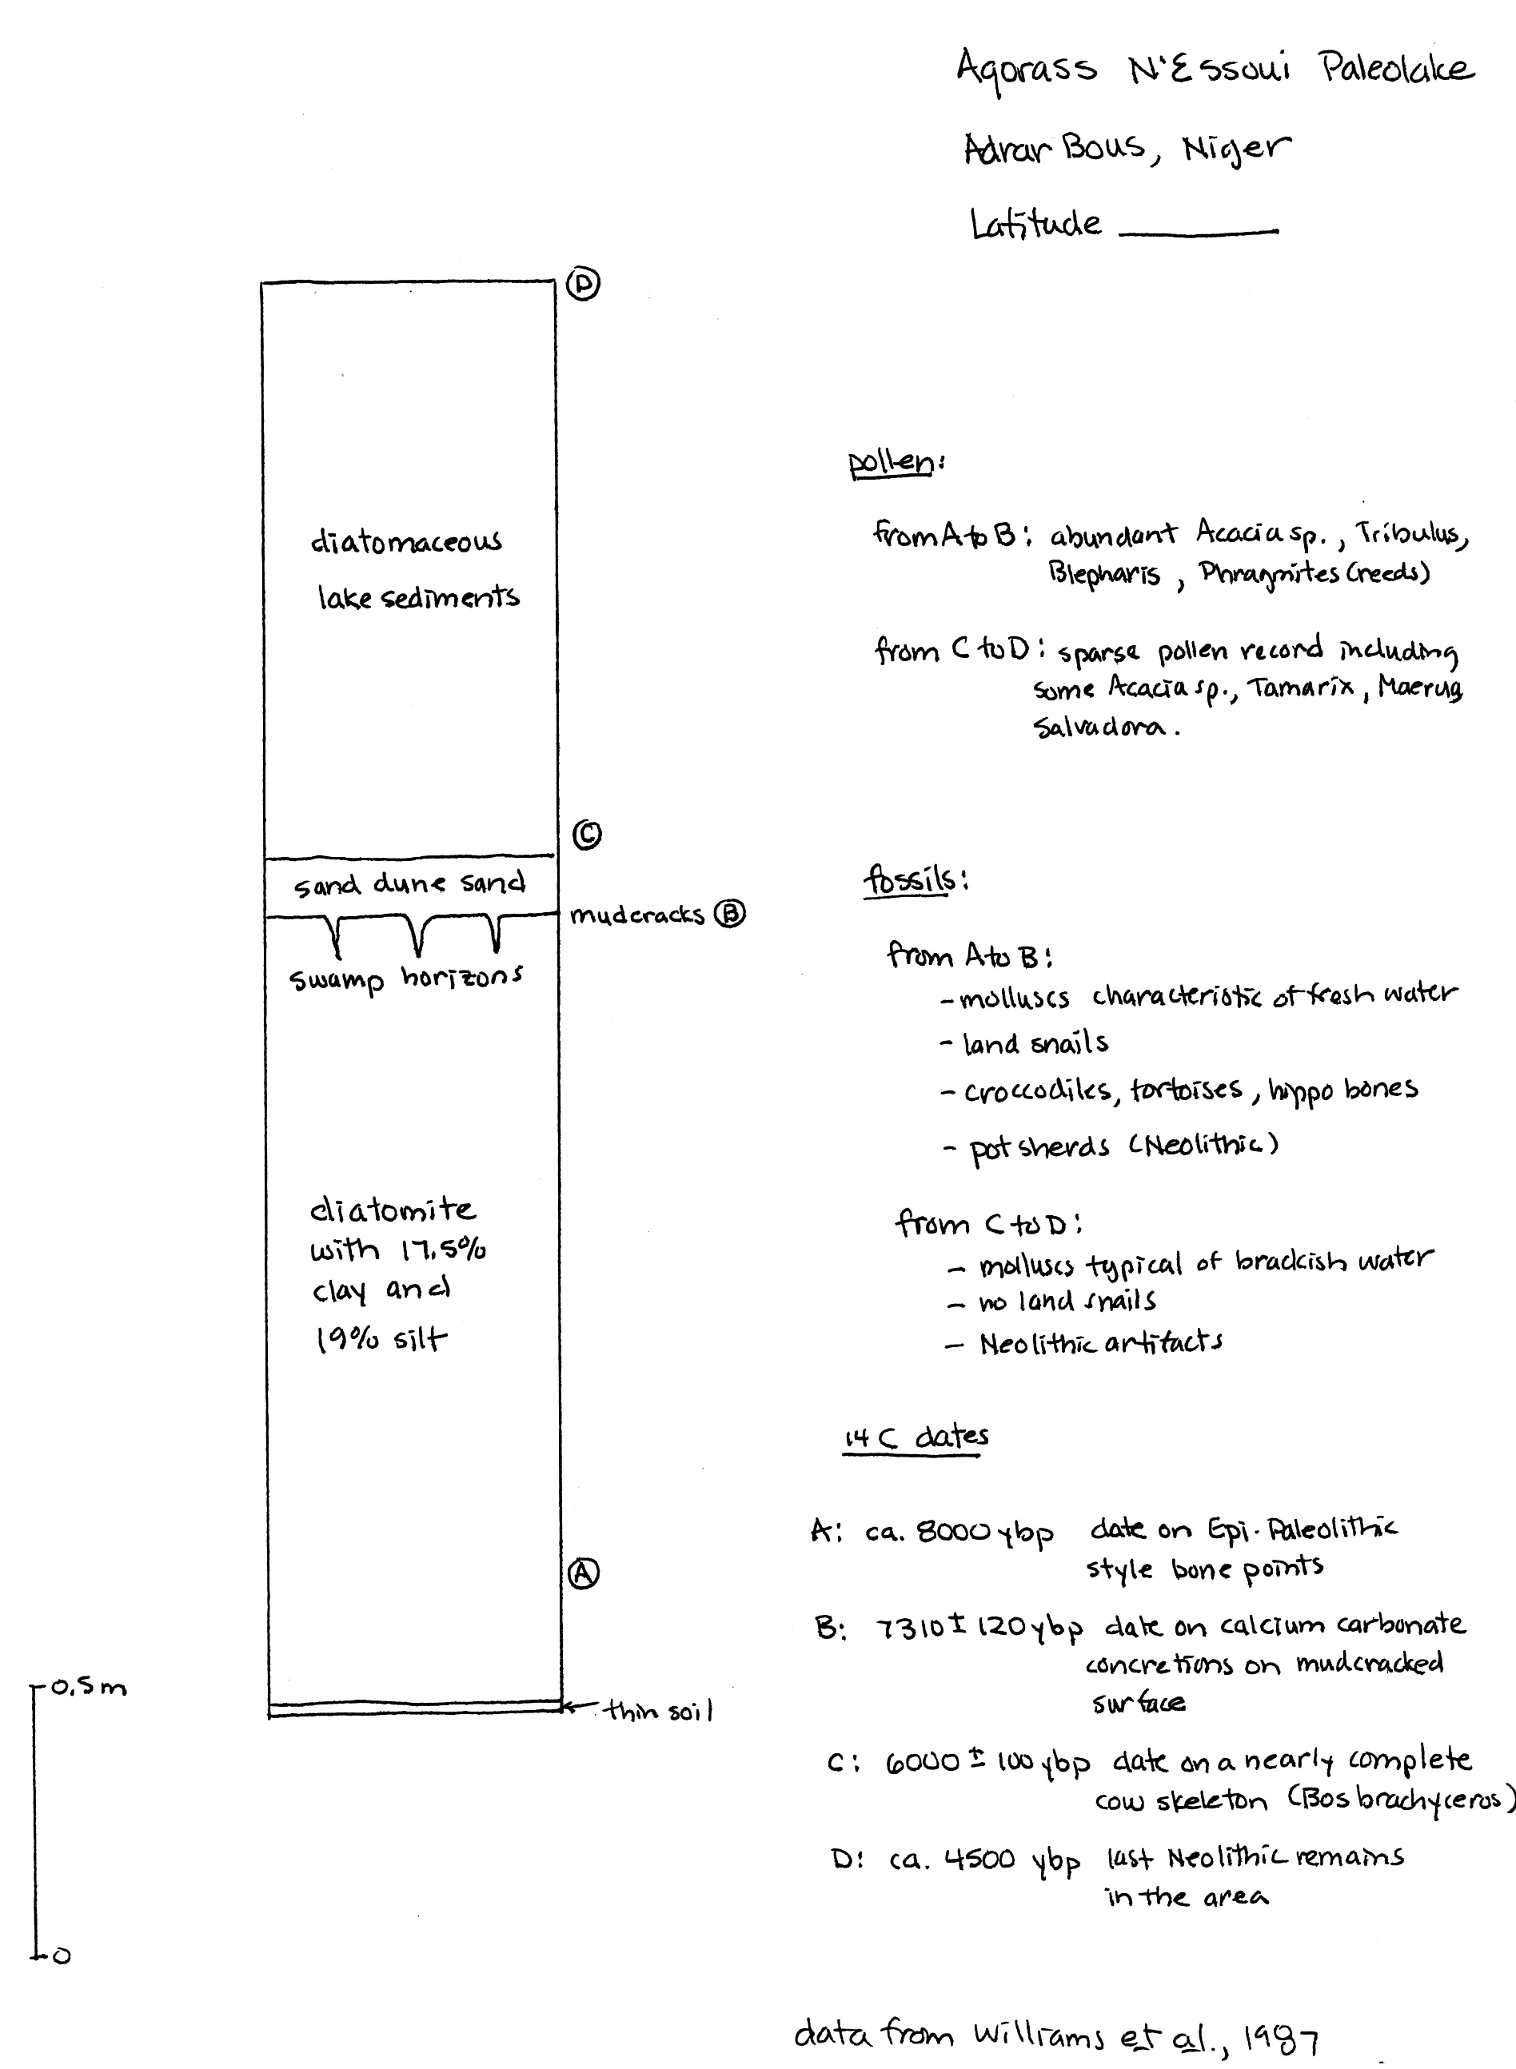

Team #3 Selima, in northern Sudan

Selima paleolake is on the margins of what is now an uninhabited oasis in northern Sudan near the Egyptian border. Selima paleolake lies just south of the “radar rivers” we talked about in class. Locate Selima on your large map of the Sahara.

Before the end of the slave trade in 1898, Selima was a major watering place on the trade route from Darfur, Sudan to Assyut on the Nile. The oasis depression does not contain a modern lake.

Selima is located within the Darb el Arba’in Desert (remember the "route of the 40 days" that goes from Assiut, Egypt through El Kharga and Baris Oases and west of the Toshka Depression into the Sudan). The area now averages less than 10 mm of rainfall per year.
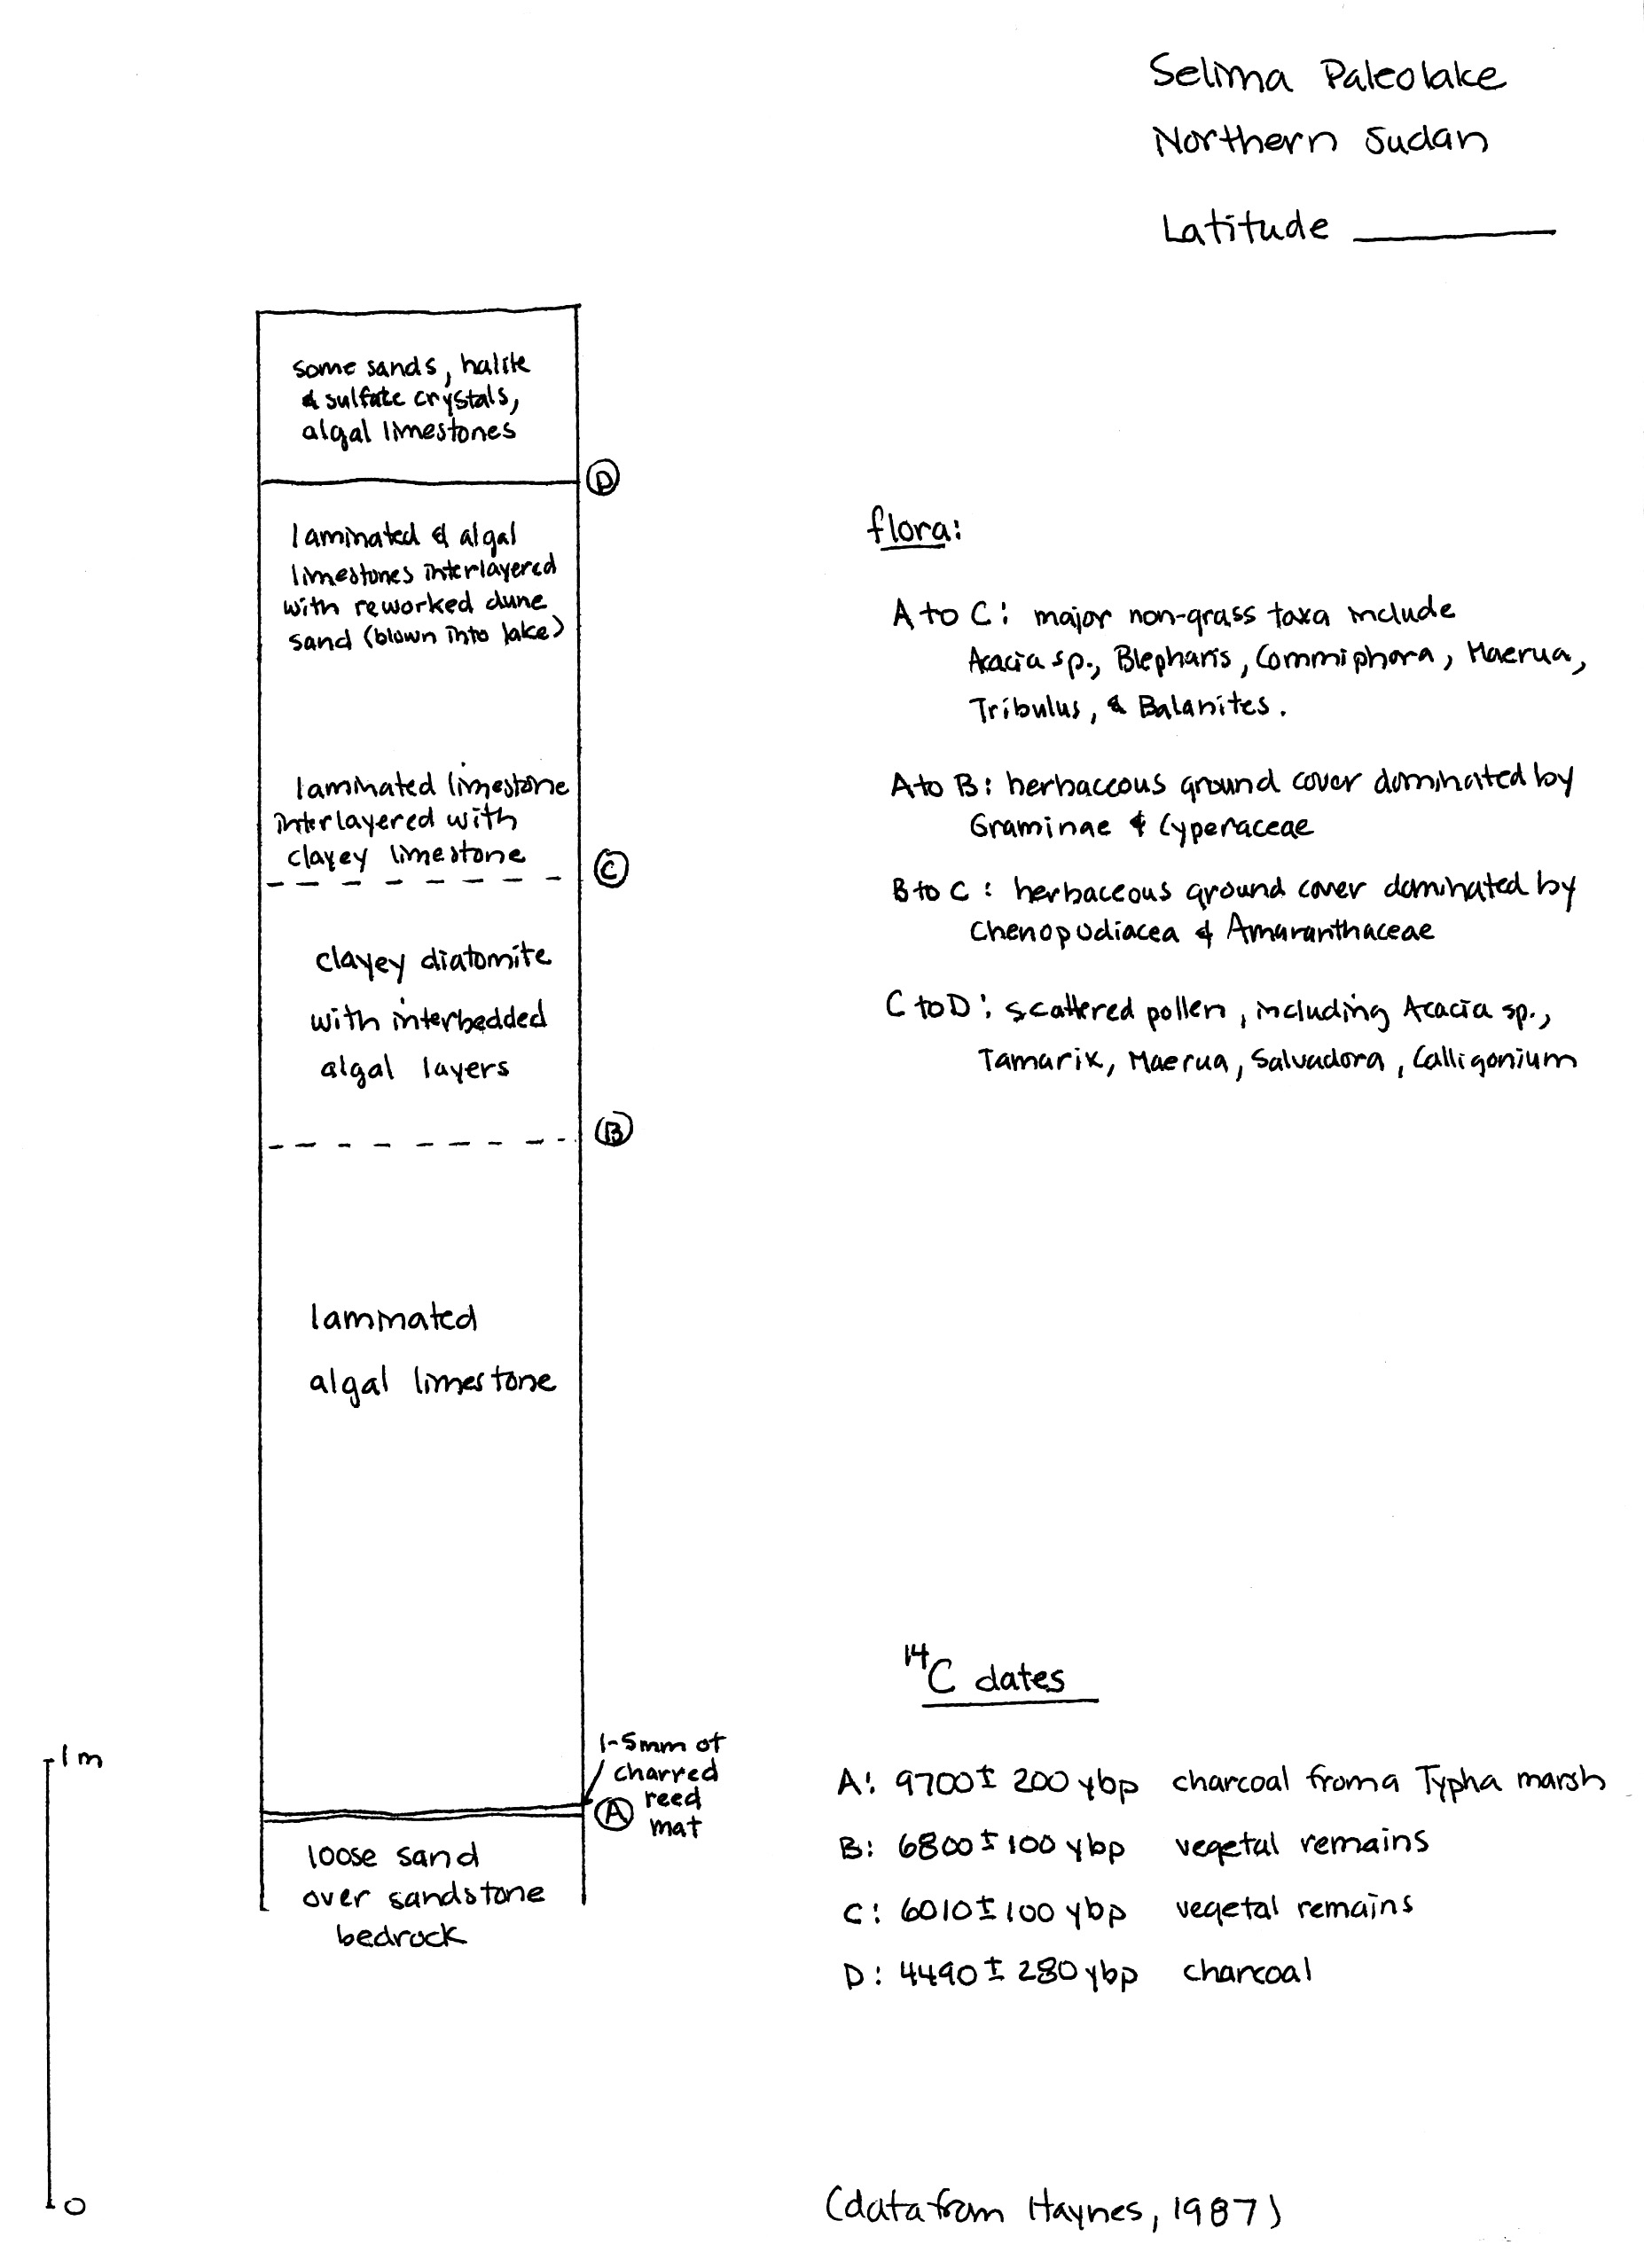
Team 4 Oyo, in northern Sudan

Oyo paleolake lies in an area of northern Sudan that contains evidence of many paleolakes, as well as a paleoriver, Wadi Howar. Locate Oyo on your big map of the Sahara.

At your table, you’ll find a wonderful map summarizing many of the features of the region at the time the paleolake was present at Oyo and shows clearly that Oyo is not unique. This area is now an arid to semi-arid desert averaging less than 20 mm of rainfall per year.
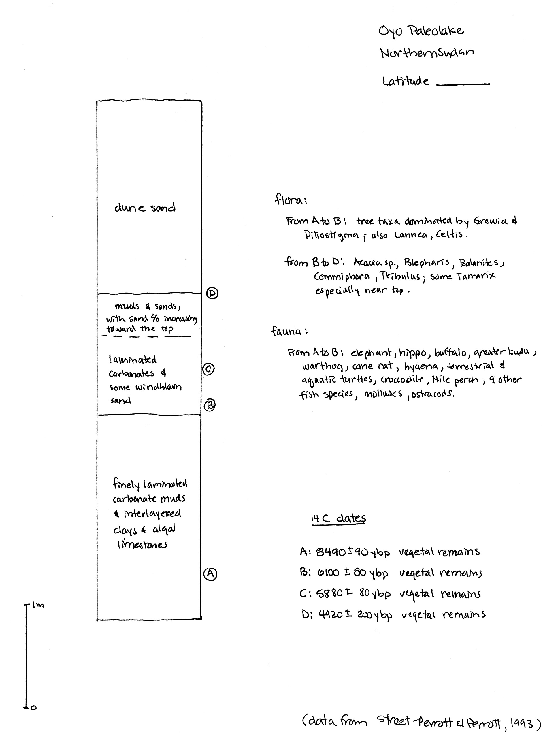
Reference information:

laminated clay or silt and clay: fine particles of quartz and clay minerals weathered from pre-existing rock enter the lake via permanent or intermittent streams and settle slowly out of the quiet lake waters, forming fine layers of clay or silt and clay. Sedimentation rates give a clue to rainfall – the higher the rainfall, the greater the amount of clay washing into the lake. Look at the sample.

limestones: limestones are rocks made up of the mineral calcite (CaCO₃ – a carbonate mineral); they don’t form by the accumulation of particles weathered from pre-existing rock and transported to the site of deposition. Rather, carbonate sediments that become limestones are formed at or near the site of deposition by biologic or chemical processes. Lacustrine limestones typically form from either biogenic precipitation of calcite or biogenically-induced precipitation of calcite. In the first case, organisms extract calcite directly from lake water to build their skeletons, which accumulate as carbonate sediments when the organisms die. In the second case, photosynthesis changes the chemistry of the lake water by removing CO₂. Calcite becomes less soluble and precipitates out. If precipitation results in finely layered sheets of carbonate, the sediment is called a laminated carbonate mud. If the carbonate sediment occurs in lumpy mats cementing algae together, such a sediment is called an algal carbonate sediment. Carbonate sediments eventually harden into limestones. Look at the sample.

diatomaceous sediments: Single-celled microorganisms called diatoms extract silica (SiO₂) from lake water to form tests in which they live. Come up to the front of the room, and have a gander through the microscope at some of these little beauties. While the diatoms are alive, they float around in the water. When they die, their tests sink to the bottom of the lake and accumulate as sediment. If very little other sediment is accumulating along with the diatoms, layers of pure diatomaceous sediment may form. If clay or carbonate is accumulating too, the sediment will be mixed. If you have a swimming pool at home, your swimming pool filter likely is filled with diatomaceous earth – the stuff makes a nice, fine-grained, inert material for filtering your pool water. Diatomaceous sediment hardens into a rock known as a diatomite. Look at the sample.

evaporites: If a lake lies in an isolated basin where significant evaporation is taking place, the concentration of dissolved salts can increase, making the lake brackish (slightly salty) or saline (very salty). As the lake becomes saltier, minerals will begin to precipitate out and accumulate in the sediments. Sediments consisting largely of minerals precipitated by evaporation are called evaporites. Minerals that are less soluble will precipitate first. Sulfate minerals (containing sulfur and oxygen) are common early precipitates. Salt (NaCl – sodium chloride, or table salt), on the other hand, is so soluble that huge quantities of water must evaporate away before the lake water is concentrated enough that salt begins to precipitate out and accumulate on the lake bottom as layers of salt. Animals and plants are pretty unhappy about living in this kind of a lake. Look at the sample.

halite and sulfate crystals in sediments: Sediments deposited in salty lakes undergoing evaporation can have halite (NaCl) crystals or sulfate (gypsum) crystals (CaSO₄.2H₂O) that have crystallized from the salty pore waters in the sediment.

Name Saharan playa lakes and sabkhas
due Friday, Nov. 9

Water quickly evaporates in a desert environment. Depending upon the balance between evaporation and inflow (via either surface runoff from rainfall or groundwater springs or both), water may exist at the ground surface, at least temporarily. Evaporation concentrates salt, and salts in the desert provide clues about water. The list below shows the kinds of features that can develop, in order of decreasing ratio between influx and evaporation.
- lakes
- brackish lakes: slightly salty water
- saline lakes: if a lake is saturated with respect to dissolved salt, additional influx and evaporation will be matched by precipitation of rock salt at the bottom of the lake.
- playa lakes/sabkha lakes: lakes in dry environments that wax and wane with water availability. They are typically surrounded by salt flats.
- salt marshes/salt bogs/salt quicksand: areas without enough water to make a salt lake. They are typically covered with a solid crust of evaporite salts that give the illusion of a solid surface. Stepping out or driving out can be catastrophic. If the crust holds, it's like driving on jello – a quaking bog. If the crust breaks, there's nothing to protect you from the underlying salt quicksand.
- playas/sabkhas: salt flats formed by complete evaporation of lakes and/or groundwater.

***I will expect you to know these terms on Friday.

Let's look at a couple of examples of lakes, salt bogs, and salt deposits in the Sahara.

The Chott El Djerid in Tunisia
Go to the collection of maps at the end of this assignment, and find the map of Tunisia and western Libya. The Chott El Djerid is a large playa lake in the northern Sahara. "Chott" means a depression with a salty lake or a dry salt lake bed. Find the Chott El Djerid on the map. Do a Google Image search for Chott El Djerid (also spelled Jerid). Explore some of the links. What have you learned about this particular Chott?

The Qattara Depression of Egypt
Go to the collection of maps at the end of this assignment, and find the map of Egypt and eastern Libya. Locate the Qattara Depression. The Qattara Depression is a spectacular geographic area that lies as much as 134 m below sea level. It is bounded on the northern side by an escarpment several hundred meters high, and the only routes into the Qattara Depression are from the southwest, via Siwa Oasis and the Qara spring, or from the northeast.

Huge tracts of the Qattara Depression floor are underlain by salt bog and salt quicksand, created by slow seepage of groundwater into the Depression. As is typical for salt bogs in desert climates, the salt bogs of the Qattara Depression have a solid crust of evaporite salts underlain by salt quicksand. The Qattara Depression is a peculiar area – go to Google Earth, and browse around the Depression a bit. I've also posted a couple of huge satellite images of the Qattara Depression on the bulletin board in the classroom. What struck you about the Google Earth images?

As you should remember (hopefully!!), the German Afrika Korps during WWII under the command of General Rommel wanted to push east, take over Egypt, the Suez Canal, and eventually Middle East oil supplies. The Allies, of course, wanted to prevent that. The Afrika Corps took Tobruk (in Libya – see the map) and pushed east toward El Alamein (also on the map). The British Long Range Desert Group (LRDG) and special forces waged campaigns behind the German lines. At one point just before the Battle of El Alamein, one of these special forces units was essentially trapped as the Germans pressed eastward, and the only route to Cairo lay directly through the Qattara Depression, a route that was widely considered impassable except on foot or camel, because heavy wheeled or tracked vehicles were too likely to break through the salt crust and bog down in the salt slush beneath.

Read the 1944 document "A Journey Through the Qattara Depression" (Mather, D.C.M., 1944, A journey through the Qattara Depression: The Geographical Journal, v. 103, no. 4, p. 152-160; pdf on Blackboard), which describes the mission of the group of British soldiers described above and their escape from the Germans through the Qattara Depression to Cairo. Pay particular attention to the map on the second page of the article, and use it as you read the text.

What did you learn about conditions in the bottom of the Qattara Depression?

What other things struck you?

The Taoudenni Salt Mines of Northern Mali
Long term evaporation from a salt lake can produce deposits of rock salt. In northern Mali at Taoudenni (see map on the map pages), salt has been mined for well over 1000 years. In Medieval and Renaissance times, trade of Saharan salt south across the desert to West Africa and West African gold north across the Sahara was an important part of the economic picture of North Africa and the Mediterranean. Even today, the salt trade continues, and (believe it or not) camel caravans still make the 700 km (!) trek from the salt mines south to the markets of Timbuktu to sell salt.

The Taoudenni area lies in the middle of the hyperarid Sahara, and a lake no longer exists at Taoudenni, just the salt left behind to tell us that a lake was once there. Start by doing a Google Image search to find pictures of what the Taoudenni salt mines look like, and explore a few of the sites connected with the images. What did you learn?

Then, go to the following site, and read the description of a recent journey taken by the British writer and reporter John Pilkington:

http://www.pilk.net/update5.sahara.html
http://www.pilk.net/info.sahara.html

[Pilkington is a rather interesting guy – you can read about him on his web site at
http://www.pilk.net/biography.html]

What did you learn from his recounting?

What struck you?

The Stunning Rock Carvings in the Ténéré Desert in Niger
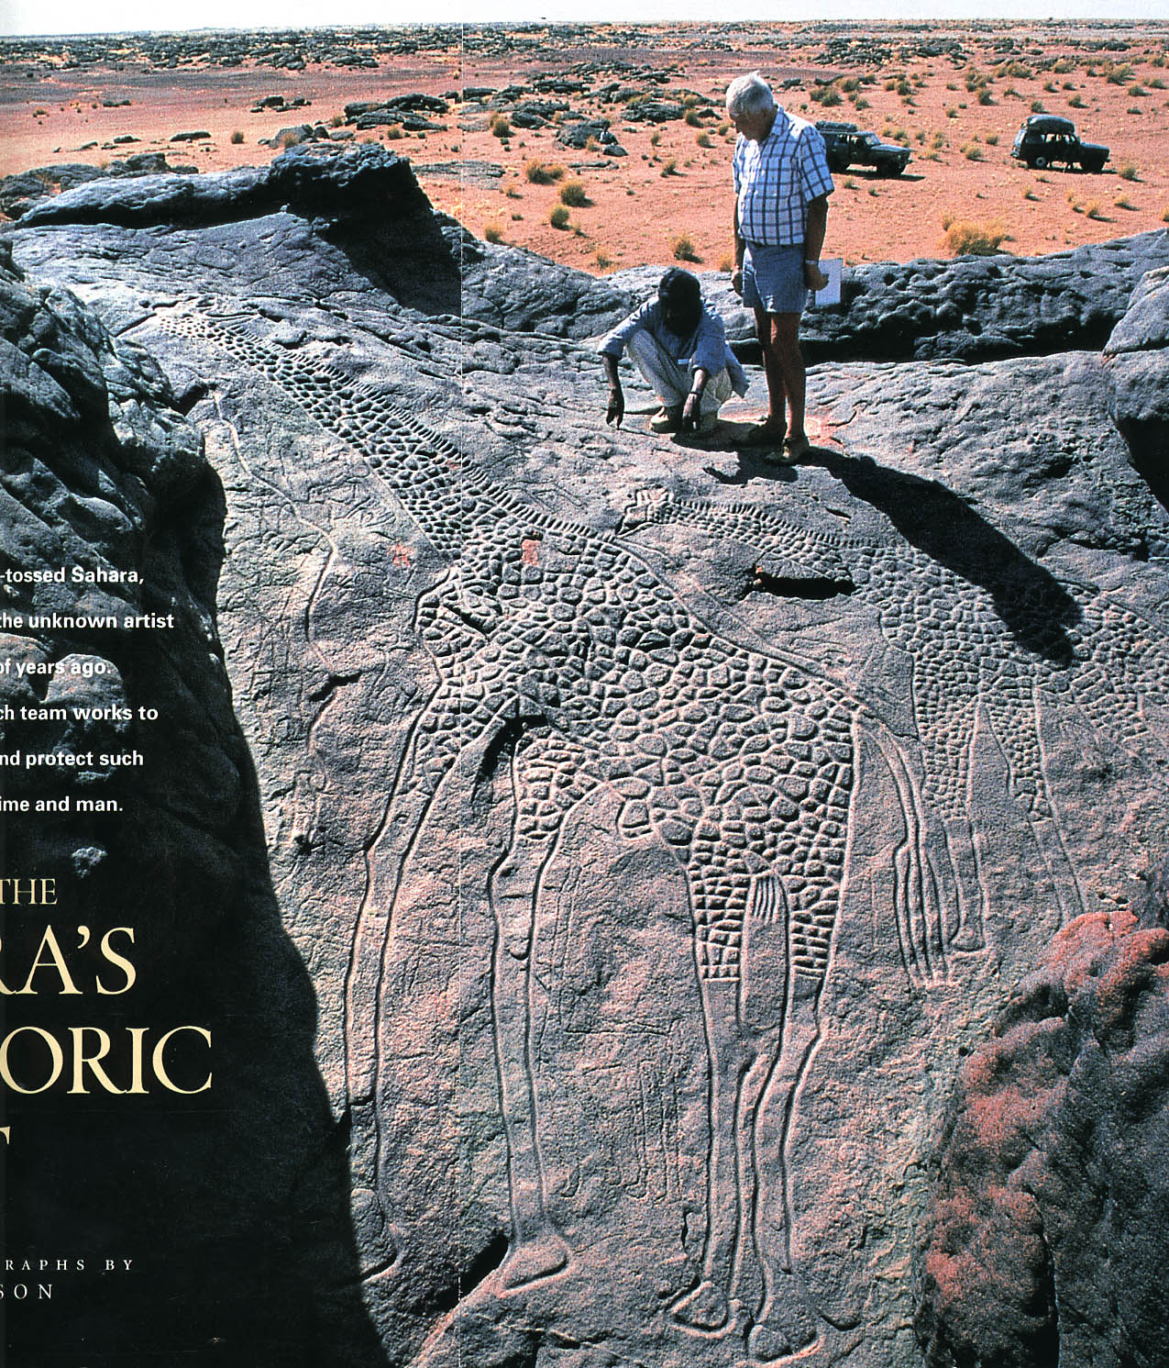
Scattered throughout the Sahara, one can find prehistoric rock carvings (petroglyphs) made by human inhabitants long before the rise of Egyptian civilization along the Nile. These carvings commonly depict animals (e.g., giraffes, ostrich, elephants) that are no longer seen in the hyperarid Sahara and depict human activity (herding cattle, for example) that is not possible in the modern Sahara. One of the most spectacular occurrences of petroglyphs anywhere in the world occurs in the northern part of the Ténéré Desert in Niger. These petroglyphs include literally hundreds of carvings of animals not currently found in this part of Africa and include the now-famous giraffe carvings shown at right.

The sand in this part of the desert is quite red, and, if you look closely at the image, you'll see that the rocks are, in reality, red. They are red sandstones, quite easily carved. The giraffe carving itself is dark gray because it has been around long enough for desert varnish to accumulate on the rock surface. So, we know these are quite old carvings.

Browse the Bradshaw Foundation web site (URL below), read the National Geographic News article (URL also below), and the article listed below. None of the three has much scientific detail, but they have nice pictures and quite a lot of general information about the site. You'll also see pictures of the Tuareg people (whom I have mentioned several times in class as being the nomadic camel-riding people who once traveled and traded between oases in the Sahara).

http://www.bradshawfoundation.com/giraffe/
http://news.nationalgeographic.com/news/2001/10/1003_africarocks.html
Miller, Richie, 2000, Saving rock art in Niger: State Magazine, September 2000 issue, p. 18-21 (www.state.gov/documents/organization/83354.pdf posted as pdf on Blackboard)

What did you learn about the modern character of the area where the carvings are found?

What did you learn about the carvings themselves?

What do the carvings suggest about Saharan rainfall in the past?

If you are fond of these wonderful carvings, the Trust for Africa Rock Art has a gift shop where they sell kangas and kikois with the big giraffe carving on them at:

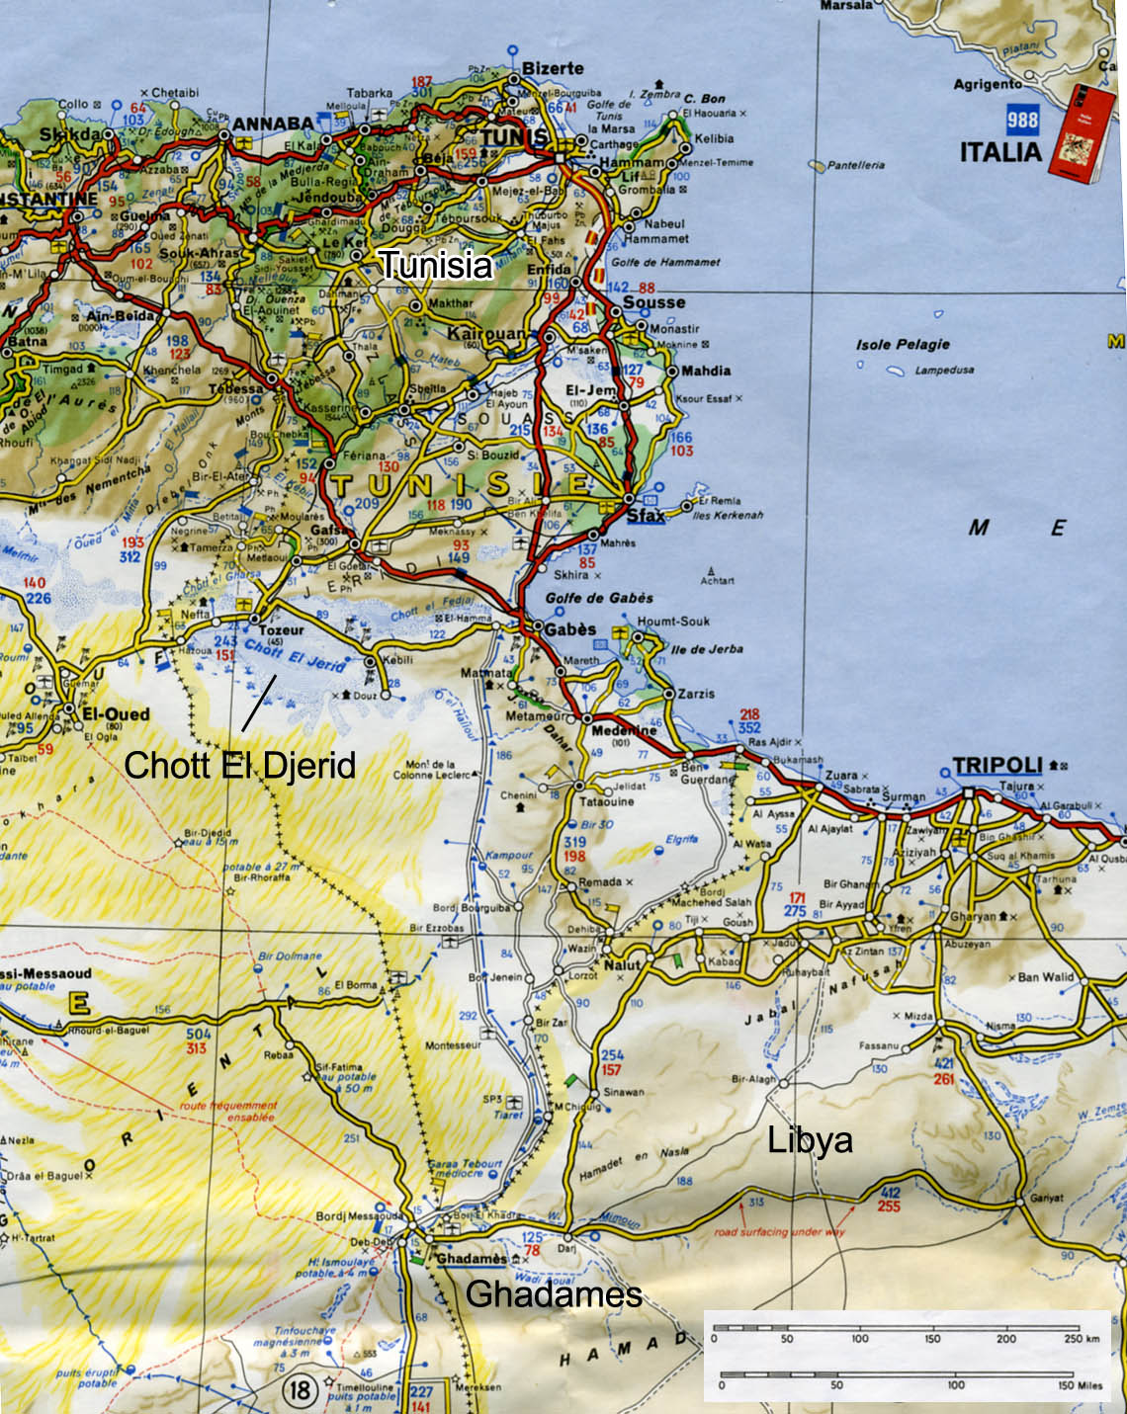
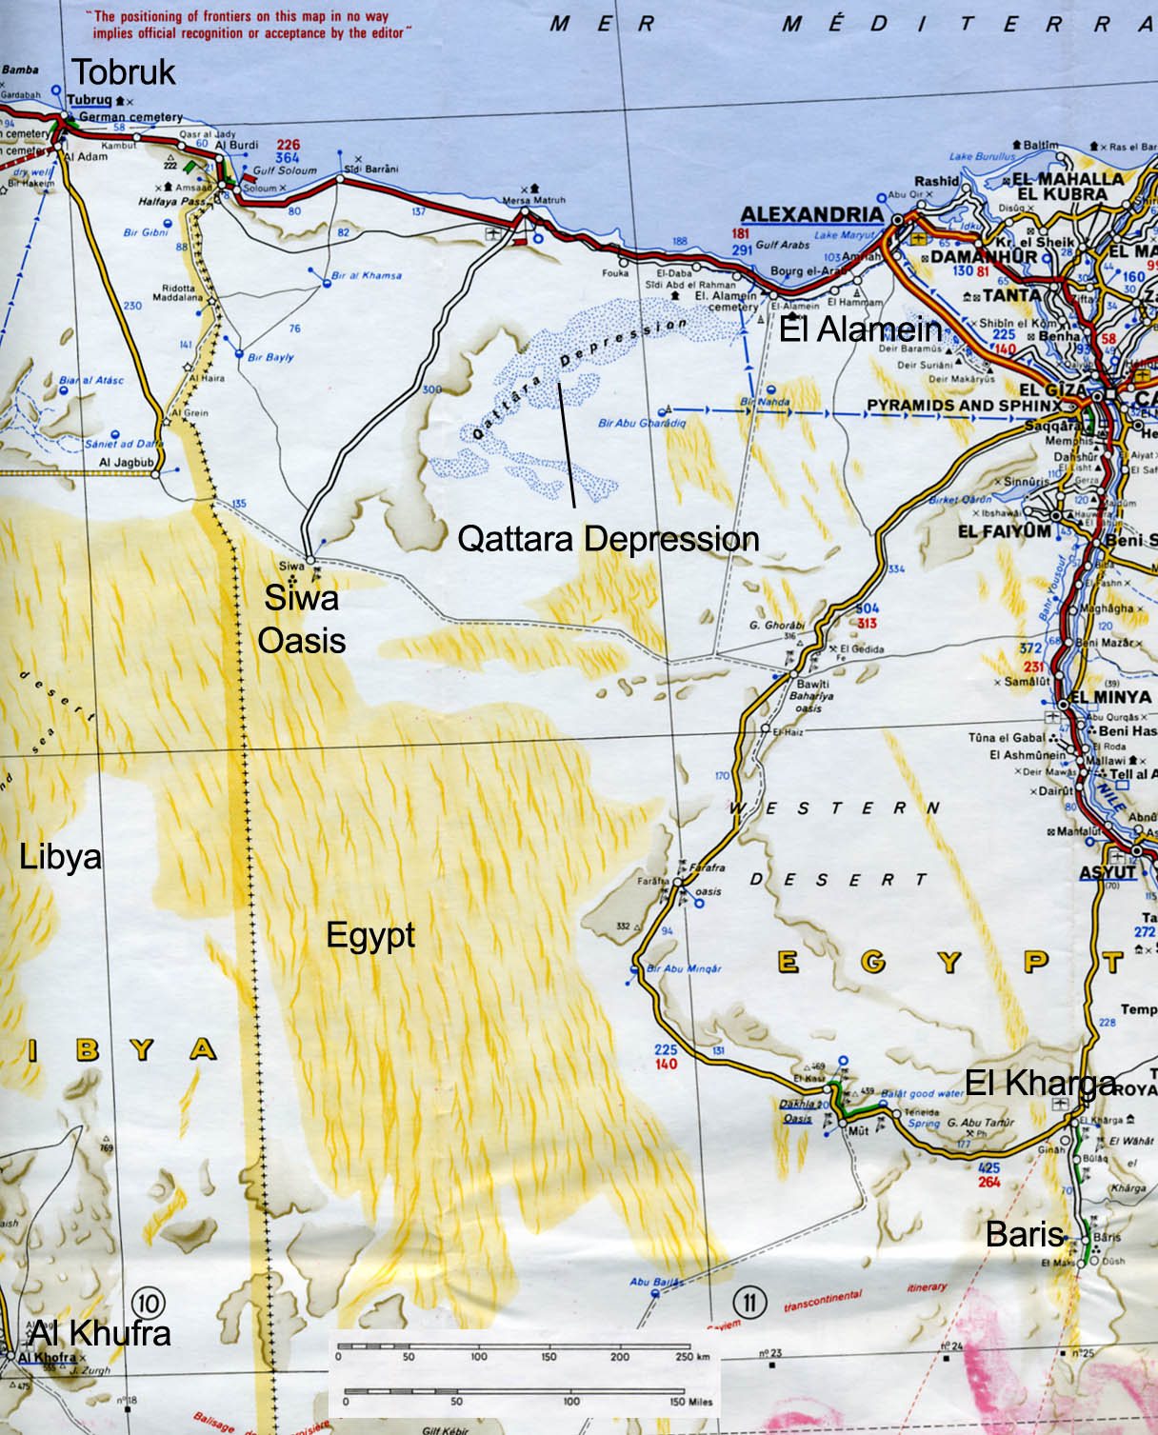
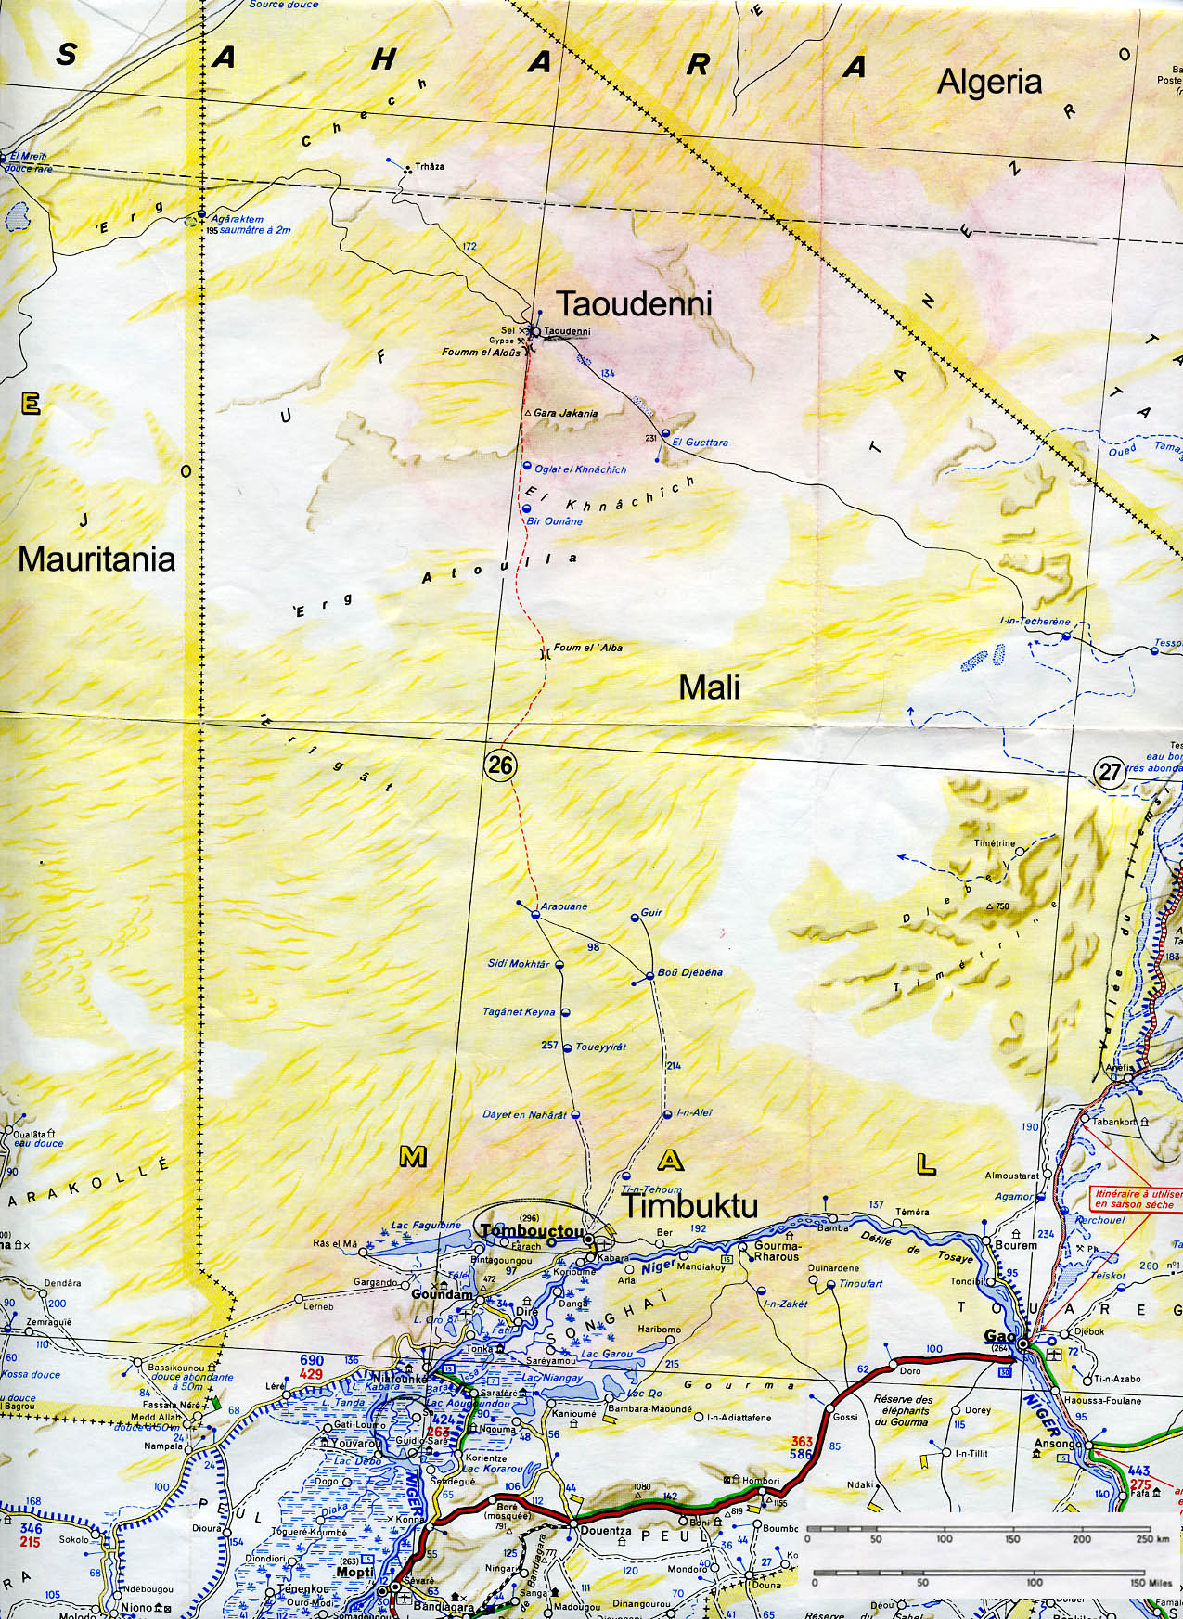
http://www.africanrockart.org/shop/

Follow-up for Paleolakes Jigsaw

Name Climate change in Dakhleh Oasis
due Wednesday, November 29

Go to the Saudi Aramco World web site (http://www.saudiaramcoworld.com/issue/200606/ ), click on Indexes, navigate to the September/October 2006 issue, and read the article Before the Mummies: The Desert Origins of the Pharaohs.

Where is Dakhleh Oasis relative to the Toshka Lakes, to El Kharga Oasis, and to the Qattara Depression?

Until fairly recently, what was considered to have been the origin of Egyptian civilization, and where were the people thought to have come from?

What has archaeological research in Dakhleh Oasis over the past 25 years revealed about this traditional interpretation, and what alternative explanation is more consistent with the archaeological evidence? What are the crucial pieces of evidence?

On a separate sheet, write a short essay that addresses the question of the correlation between the geological evidence for climate change (that we looked at in class) and the archeological evidence for who lived where and when in North Africa. Make an argument for whether or not climate change might have been a factor in the timing of development of Ancient Egyptian civilization. Be specific about the geological evidence from the paleolake strat columns.

