Name: _______________________

- True or False: The asthenosphere is gooey like a melted chocolate bar.
- True or False: The lithosphere is thicker than the asthenosphere.
- True or False: The lithosphere rides on top of the asthenosphere.

Match the boundary types with the correct picture and write what happens at each boundary type:

- Transform Boundaries: ___________________
- Convergent Boundaries:__________________
- Divergent Boundaries:____________________
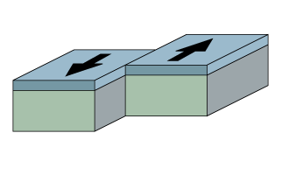
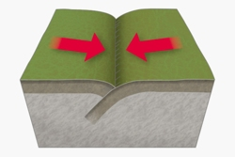
Letter: ____________
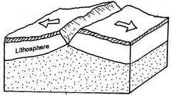
Letter: _____________

Letter: _____________

