Name: _____________________
Boundary Movement Identification Worksheet: Color if you wish

Transform Boundary: “rub against”
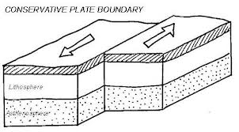

Convergent Boundary: “come together”
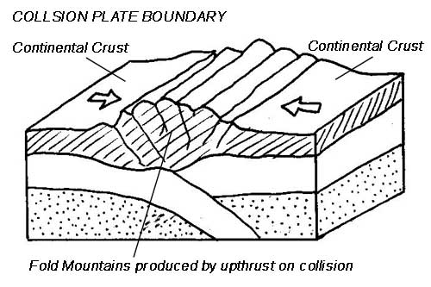

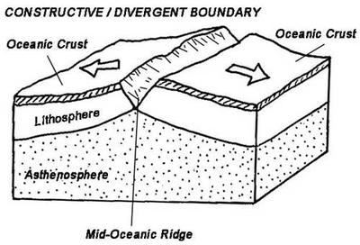
Divergent Boundary: “break away”

