Aly and Marissa
Lesson #1 , Introduction to Global Climate Change

Instructional Context
What do I know about my students that will inform this lesson?
Nothing
How does this lesson connect with and build on the previous lesson(s)?
The first lesson will introduce the topic of global warming/global climate change.
How do you expect to build on this lesson in subsequent lessons?
The introduction activity will be used in the subsequent lessons because it introduces vocabulary and important ideas to be used during the remainder of the unit.
Standards Addressed (Common Core State Standards/Local Standards)
-Ask questions to clarify evidence of the factors that have caused the rise in global temperatures over the past century. MS-ESS3-5
-Draw evidence from informational texts to support analysis, reflection, and research. (WHST.6-8.9)

Learning Objectives

Objective | Assessment
Students will apply their ability to navigate a website to research the topic of global climate change. | Effective use of the scavenger hunt worksheet.
Students will communicate their findings on global climate change to show their understanding of new vocabulary. | Class review of worksheet, and discussion. (2nd day of lesson)

Academic Language/Language Function Objectives
Global climate change: a long-term change in the Earth’s climate, or of a region on Earth
Global warming: the average global surface temperature increase from human emissions of greenhouse gases.
Greenhouse gases: Certain gases in the atmosphere that trap energy from the sun.
Weather: the state of the atmosphere at any given time.
Climate - the average weather conditions in a certain place over many years.
environment
Assessments
Scavenger Hunt Worksheet (see below)
Instructional Strategies and Learning Tasks

Time | Instructional Strategies/Learning Tasks | Purpose
10-15 minutes | Set up the class in a computer lab, or with ipads, making sure all the students find the correct website of your choice. A good resource to use, that we based our worksheet on is: (http://epa.gov/climatechange/kids/index.html). Go through the worksheet with the students, pointing out where each of the large tabs and subcategories are on the website, and their corresponding section on the worksheet. | This time is to make sure the students understand their task, and can make their way through the website without problems.
25-30 minutes | Students will complete the worksheet. Depending on the students and the atmosphere of the classroom, students could work as a pair, or if students are more independent/distracted easily it may be a better choice to have students work separately. | The worksheet is meant to introduce students to the topic of global climate change. The worksheet also aims to build up technology literacy, so that they can navigate a website to find information.

Materials and Resources
-Computers or ipads

Handouts & PowerPoints
-Scavenger hunt worksheet (located below)

*This worksheet can be adjusted to different websites that the teacher wishes to use. The aim of having a scavenger hunt worksheet is to introduce students to the content, as well as have a way to engage and tie in technology.

A Student’s Guide to
Global Climate Change
Website Scavenger Hunt

Name: Date:

Instructions: Go to http://epa.gov/climatechange/kids/basics/index.html. On the homepage you will see four categories: Learn the Basics, See the Impacts, Think Like a Scientist, and Be Part of the Solution. Click on each of the sections, and fill in the guided notes with the information you find on the website.

Learn the Basics
Overview
-The Earth is getting warmer because ______________________________________________________________________
mainly by ______________________________________________________.
-The three things linked to climate are: ________________________, ______________________ and ___________________.
Climate Concepts
Climate is:
Global climate change is:

See the Impacts
Overview
Signs the earth is getting warmer are:
1)
2)
3)
The Signs of Climate Change
Signs of climate change listed on this page:
1) 4)
2) 5)
3) 6)
Effects on People and the Environment
Signs of effects on people & the environment listed on this page:
1) 4)
2) 5)
3) 6)

Think Like a Scientist
Clues of Climate Change
Use the microscope to click and reveal different possible effects of global climate change. List 4 that you find below:
1) 3)
2) 4)

Lesson #2, Explanation of Concepts
Instructional Context
How does this lesson connect with and build on the previous lesson(s)?
Explanation of vocabulary and concepts that were presented in the previous lesson’s worksheet.
How do you expect to build on this lesson in subsequent lessons?
This information will be carried forth into an activity in which students use this new information, to prove they understand the new concepts.
Standards Addressed (Common Core State Standards/Local Standards)
Ask questions to clarify evidence of the factors that have caused the rise in global temperatures over the past century. MS-ESS3-5
Write informative/explanatory texts to examine a topic and convey ideas, concepts, and information through the selection, organization, and analysis of relevant content.WHST.6-8.2

Learning Objectives
Objective | Assessment
Students are able to define and explain global climate change, greenhouse gases, weather, climate and the environment through an in class discussion. | Hand in scavenger hunt worksheet with all correct answers after making corrections during the class period. The class will go through the worksheet for the first half of the class time. It is handed in to assess students’ understanding and participation.
Students will use their new knowledge of the vocabulary terms and existing technology skills to independently research information on global climate change. They will communicate the ideas through writing down facts. | Students will communicate their content knowledge by writing and citing facts related to global climate change. This will be used the following day in the unit.

Academic Language/Language Function Objectives
Global climate change, global warming, greenhouse gases, weather vs. climate, environment.

Assessments
Hand in the scavenger hunt worksheet after the class is complete.
Take home assignment - Students will be reviewing 2 websites provided by the teacher, and coming back to class with 5-10 facts that they found about global climate change.

Instructional Strategies and Learning Tasks (Procedures & Timelines)
Time | Instructional Strategies/Learning Tasks | Purpose
35-40 minutes | Review of the scavenger hunt worksheet. The teacher should go one blank at a time, asking students what they think the correct answer is. Leading a discussion throughout the class, students should at the minimum have a decent exposure to each of the vocabulary terms, if not a good understanding of the overall content. | Through discussion, students will be able to communicate their findings, in a way that shows their understanding. The teacher will also have the opportunity to clarify wrong answers, and deepen students’ levels of comprehension by repetition. The teacher should write the answers on a board in order to give visual learners the opportunity take in information.
10-15 minutes | Introduce homework. Students are to explore 2 websites from a list of websites provided by the teacher. On these websites they are to read and collect 5-10 facts (depending on the classroom) about global climate change that relates to the scavenger hunt worksheet vocabulary and content from the first day. Students are to record these facts in their science notebooks and come to class ready to use them in a carbon footprint activity.  Teacher must review what a fact is. This is not to be a definition or opinion, but rather a piece of information relating to the topic, that further talks about global climate change, or one of the subcategories such as climate, the atmosphere, water/ocean, etc. Also, the teacher should review how to cite information found on the internet. This includes writing the webpage name on the top of their paper, with an author or other pertinent pieces of information if provided.  Website Ideas: http://www.eschooltoday.com/climate-change/climate-change-fact-sheet-for-kids.html  http://climatekids.nasa.gov/climate-change-meaning/ | Having students take the information they learned in class about global climate change, they will apply this by finding relevant information online. This incorporates technological literacy, science standards, and literature standards.

Student Supports (List what you are using to support student learning/organization)
Scavenger hunt worksheet
Citation Review on the board (write out how to cite a webpage: eSchoolToday: Interesting Facts on Climate Change)
Fact examples - How to construct a sentence that is a fact, not an opinion. Possible examples:
- The climate in Arizona is dry, which means they get little rain during the year.
- The levels of CO2 in the atmosphere has increased because of humans and our fossil fuels.
Materials and Resources
Scavenger hunt worksheet
2-3 websites that have information students will be able to pull facts from for their assignment.
Materials needed in class
Notebooks, computers

Lesson #3 , Correlation, Causation and Data
Instructional Context
How does this lesson connect with and build on the previous lesson(s)?
This lesson will build upon the previous, by using vocabulary terms and applying them to data found in the real world.
How do you expect to build on this lesson in subsequent lessons?
This information will be used in creation of carbon footprints on the subsequent day.

Standards Addressed (Common Core State Standards/Local Standards)
Apply scientific principles to design a method for monitoring and minimizing a human impact on the environment. MS-ESS3-3
Learning Objectives

Objective | Assessment
Students will use facts they collected, to draw conclusions between all of their facts by sorting their facts in class. | The intro. activity for the day is to have students organize their notecard facts into different categories on whiteboards in the room. Categories can include:  -Climate  -Weather  -Humans and the Environment
Students will be able to communicate the pros and cons of global warming, by drawing conclusions from the facts they post throughout the room. | A pro/con worksheet will guide small group discussions, and keep students on task. Split class into small groups of about 4-5 students, and have them discuss and come up with pros and cons of global warming using the facts posted that their classmates came up with.

Academic Language/Language Function Objectives
-Drawing conclusions
-Fact vs. opinion
-Global climate change
Assessments
-Intro. activity - notecards posted on whiteboards
-Pro/con activity worksheet and small group discussion

Pros and Cons Worksheet

Name: Date:

Instructions: In your small group, sort the facts that your class came up with about global climate change. Under Pros, decide which facts can be considered positive, or beneficial for the earth, related to global climate change. Under Cons, decide which facts are considered negative, or harmful for the earth, related to global climate change. Write a list of 3-4 facts for each category.

Pros: | Cons:

Instructional Strategies and Learning Tasks (Procedures & Timelines)

Time | Instructional Strategies/Learning Tasks | Purpose
15 minutes | Students should take out their 5 notecard facts they had to write for homework the following evening. They will organize their note cards into three categories posted on the whiteboards:  -Climate  -Weather  -Humans and the Environment  *These categories can be manipulated to fit certain classrooms. (if you want it to be more in depth, add categories: global climate change, etc.) | Students will have an opportunity to read one fact to the class, and then they have time to work together to categorize the facts they found.  Students will stick their own facts into different categories. Once students have this completed, the class should discuss if they agree with the placements everyone decided on.

Student Supports (List what you are using to support student learning/organization)
-Drawing conclusions: Determining the main idea from a set of facts or from a reading.
-Fact vs. opinion:
- Fact: something that can be proven to be true.
- Opinion: someone’s feelings about a particular topic
-Global climate change: a long-term change in the Earth’s climate, or of a region on Earth

Materials and Resources
-Pros & Cons Worksheet

Materials needed in class
-Tape (to tape facts to the board)
-Category labels: (print and tape to sections of the board - seen below)
Climate Weather
Humans & the Environment

Lesson # 4, Carbon Footprint
Instructional Context
Standards Addressed (Common Core State Standards/Local Standards)
Reducing the level of climate change and reducing human vulnerability to whatever climate changes do occur depend on the understanding of climate science, engineering capabilities, and other kinds of knowledge, such as understanding of human behavior and on applying that knowledge wisely in decisions and activities. (MS-ESS3-5)

Learning Objectives
Objective | Assessment
Students will be able to communicate the importance of reducing our carbon footprint. | Carbon footprint activity - discussed below.
Students will make connections between vocabulary we have learned, to the ways in which we live that affect our carbon footprint. | Students will include personal examples of what they are doing, that affects their carbon footprint, shown on their footprint during the activity.

Academic Language/Language Function Objectives
-Global climate change
-Carbon footprint: the amount of carbon produced by everything you are doing
Assessments
-Students will hand in their completed carbon footprint
-Participation in class discussion, about their results after taking the quiz.
Instructional Strategies and Learning Tasks (Procedures & Timelines)

Time | Instructional Strategies/Learning Tasks | Purpose
10 minutes | Begin by discussing what was done the day prior as a refresher for the students.  Discussion prompts:  -What did we talk about yesterday?  -What did you learn that surprised you about the environment?  -Was it hard to find pros and cons with your facts? | It will be a short discussion, in order to answer any last standing questions. It will also work as a time for any students that were absent to catch up.
25min | After everyone is caught up, students will be shown an example of a carbon footprint (Teacher should have an example of one made prior to the day of the lesson). Explain to students that they are going to be using the data they collected and wrote down yesterday to create a personal carbon footprint.  What is a carbon footprint?  -It measures the amount of carbon produced by everything you are doing.  - Carbon is a gas in the atmosphere, and if there is too much of it, the atmosphere is not balanced, and is then harmful.  - Take the carbon footprint quiz (see below)  - Tally a number of what the student’s footprint # is, using the quiz.  - Hand out materials for carbon footprint  - Trace & cut out one foot on a piece of recycled cardboard (cereal boxes, granola bar boxes, etc.)  - Write the # of their carbon footprint in the center. Write 3-4 facts that the students collected the previous day, on their footprint.  - Students should decorate the footprint with any pictures related to their facts, to make the footprint look neat and organized. | Students will receive all the necessary materials to create their carbon footprint. By making a carbon footprint, students are connecting the facts and ideas we previously discussed, with themselves. As conscientious citizens, we should be aware of our effects on the Earth, which the carbon footprint quiz incorporates.  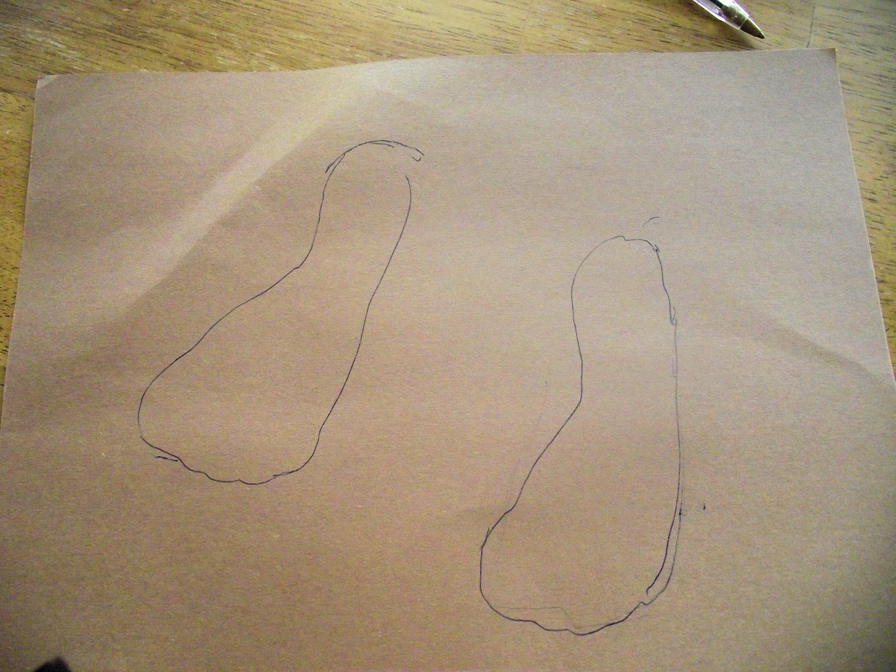
30+min (next day too) | Students will have time in class to work on their carbon footprints. After completing them, they can be given the opportunity to share what their carbon footprint tells about them. | While sharing the carbon footprints, students in class can work together in class to come up with different strategies to improve our carbon footprints. This should be done by holding a conversation with the class as they go through their projects.  Discussion Questions:  - How do humans affect the balance of CO2 and Oxygen in the atmosphere?  - Can you think of anything bad that could happen if this balance in the atmosphere is disrupted?  - Have you ever heard anyone say “go green”? What does this mean?  - What are some ways we can make better choices about our daily habits, that would better the environment?

Student Supports (List what you are using to support student learning/organization)

Materials and Resources

Finding My Carbon Footprint

1. How do you get to school?
Walk – 0 points
Car with your parents/siblings – 5 points
School Bus – 3 points
Bike – 1 point
Carpool – 4 points

2. Do I use a reusable water bottle/other bottles, or do I buy and use plastic (water) bottles?
Reusable – 2 points
Plastic – 4 points
None – (probably not true!) 0 points

3. How many lights are there in my living room?
1 light – 2 points
2 lights – 3 points
3 lights – 4 points
4 lights or more – 5 points

4. Does my family purchase and eat local fruits and vegetables?
Yes – 1 point
No – 4 points
Sometimes – 3 points

5. How many minutes do I take in the shower?
3-5 minutes – 2 points
6-8 minutes – 3 points
9-12 minutes – 4 points
13 or more – 5 points

6. Do I bring a brown bag lunch, a reusable lunch box, or do I eat from the school cafeteria?
Brown bag – 4 points
Reusable lunch box – 2 points
School cafeteria – 3 points

7. What do I do with old clothes that no longer fit me, or that I do not wear?
Donate to Goodwill/St. Vincent De Paul – 1 point
Give as hand-me-downs to other siblings, neighbors or friends -1 point
Throw away – 5 points
Keep in my closet for awhile – 3 points

8. How often do I use a trashcan when disposing of my garbage?
Always – 1 point
Never – 5 points
Most of the time – 3 point

9. Do I turn off electronics when I am not using them? (not leaving them on, or asleep, or plugged in)
Yes – 1 point
No – 4 points
Most of the time – 3 points

10. For fun, my favorite activity is:
Going outside to play – 0 points
Going shopping (clothes, furniture, household items) – 4 points
Playing on a sports team – 2 points
Being a part of the band, orchestra, choir – 2 points
Go on a vacation (via airplane or car) – 4 points

Total Points: _____________________________

What does my score tell me?

10-14 points
- Very good! Your carbon footprint is fairly low, be proud! To keep it low, always be mindful of the following categories: Car emissions, Public transportation, Electricity, Heating, Cooling, Eating & drinking, Clothes & personal items, and Recreational activities. All of these activities produce carbon dioxide, the most harmful of the greenhouse gases. The harmful effect of too much carbon dioxide on the environment will make life on Earth in the future, not so great. Keep up the good work, and remember to go green as much as possible!

15-20 points
- Not too bad! Your carbon footprint is in the medium range, try to think of ways you can start to lower it even more. Each of our daily activities has some effect on our carbon footprint, the lower the better. Recall, our carbon footprint is made up of the following categories: Car emissions, Public transportation, Electricity, Heating, Cooling, Eating & drinking, Clothes & personal items, and Recreational activities. To be more environmentally conscious, always think ahead with the products you buy, the activities you participate in, and the transportation you use, as to be the friendliest to the environment.

21 or more points
- Oh no! Your carbon footprint is getting to be a little too high. Thank you for being honest, let’s try and find ways to change our habits, and help the environment a little more each day. Remember, our carbon footprint is mostly formed by these categories: Car emissions, Public transportation, Electricity, Heating, Cooling, Eating & drinking, Clothes & personal items, and Recreational activities. To lower your carbon footprint, look at each category and think about habits you and your family have that are good, and those that could be improved, to help the environment more.

Materials needed in class
-Recycled cereal boxes (or granola boxes)
-Scissors
-Glue
-Facts about global climate change
- Markers, crayons or colored pencils

Lesson # 5, Explanation of Final Project

Instructional Context
How does this lesson connect with and build on the previous lesson(s)?
- It connects and builds previous lessons because it is using the knowledge they have gained
How do you expect to build on this lesson in subsequent lessons?

Standards Addressed (Common Core State Standards/Local Standards)
WHST.6-8.2 Write informative/explanatory texts to examine a topic and convey ideas, concepts, and information through the selection, organization, and analysis of relevant content (MS-ESS2-2)

Learning Objectives

Objective | Assessment
Students will be able to explain knowledge through written articles based on an assigned topic. | Students will be put into small groups (2-3 students) and write an article based on an assigned topic which will put into a class newspaper.

Academic Language/Language Function Objectives
-article: a written piece of nonfiction information, about 4-5 paragraphs in length
Assessments
Finished news article that will be placed with other articles to form a classroom newspaper.

Instructional Strategies and Learning Tasks (Procedures & Timelines)

Time | Instructional Strategies/Learning Tasks | Purpose
15min | Each student in the class will be assigned a topic relating to Global Warming and climate change to write about. Some topics will be repeated. | We are assigning topics to students so there is a variety of topics discussed rather than everyone picking the same topic.
20min | They will have time to look back at the information gathered on their topic and put together a draft of the various things they will be including in their articles. | This will teach them how to prewrite and formulate their ideas before submitting a final draft right away.
20min | Once they have found enough information and a format for writing their articles, they will write their articles out. When they are finished with the article they will take turns peer editing. | They will be able to bounce ideas off others in class by reading other articles. Students will also learn the basics of editing.
(Next day) | After articles have been completed, the class will work together to complete the full newspaper/magazine. They will put the articles together based on topic discussed. | Putting the articles all together in a newspaper/magazine format will make it so the students can share the various knowledge gained with others outside of class in a fun way.

Student Supports (List what you are using to support student learning/organization)
Topics for Articles:
-Climate
-Weather
-Global Warming
-Global Climate Change
-Humans & the environment
-Carbon footprints

Materials and Resources
- students will need computer time to type up their articles.
Handouts & PowerPoints
- handout showing expectations for articles.
Materials needed in class

Rubric for Newspaper Article:

Ideas and Content | Organization | Style (voice, word choice, fluency) | Points:
Stays on topic (does not ramble or repeat)  Includes main ideas with 3 or more well developed supporting details  creates clear images or explanations for reader. | Shows understanding of multi paragraph form  Has engaging introduction with topic sentence and satisfying conclusion  uses effective, varied and thoughtful transitions between sentences and paragraphs | Includes dynamic, vivid or challenging words, enhancing meaning and clarifying understanding  uses original, unique, authoritative and/or interesting voice  uses purposeful and varied sentence beginnings which add variety and energy
Stays on topic  Includes main ideas with 2 supporting detail  creates somewhat clear images or explanations for reader | shows understanding of multi paragraph form  Has inviting introduction with topic sentence and conclusion  Uses varied transitions in sentences and paragraphs | Includes dynamic, vivid or challenging words. (no meanings)  uses original, unique voice  Has complex sentences  Uses literary devices effectively, has fluent writing
Stays mostly on topic  Includes main idea with 1 piece of supporting detail | Shows understanding of multiple paragraph form  Has effective intro with topic sentence  Clear sequence of beginning, middle and end | Includes some interesting words  attempts uses of literary devices  uses interesting voice  attempts complete, complex sentences
Does not stay on topic.  No supporting evidence | Does not attempt paragraph form  lacks intro or conclusion  has limited sequence of events | Uses basic vocabulary  Demonstrates little awareness of audience  attempts simple sentences

