Formation of the Earth
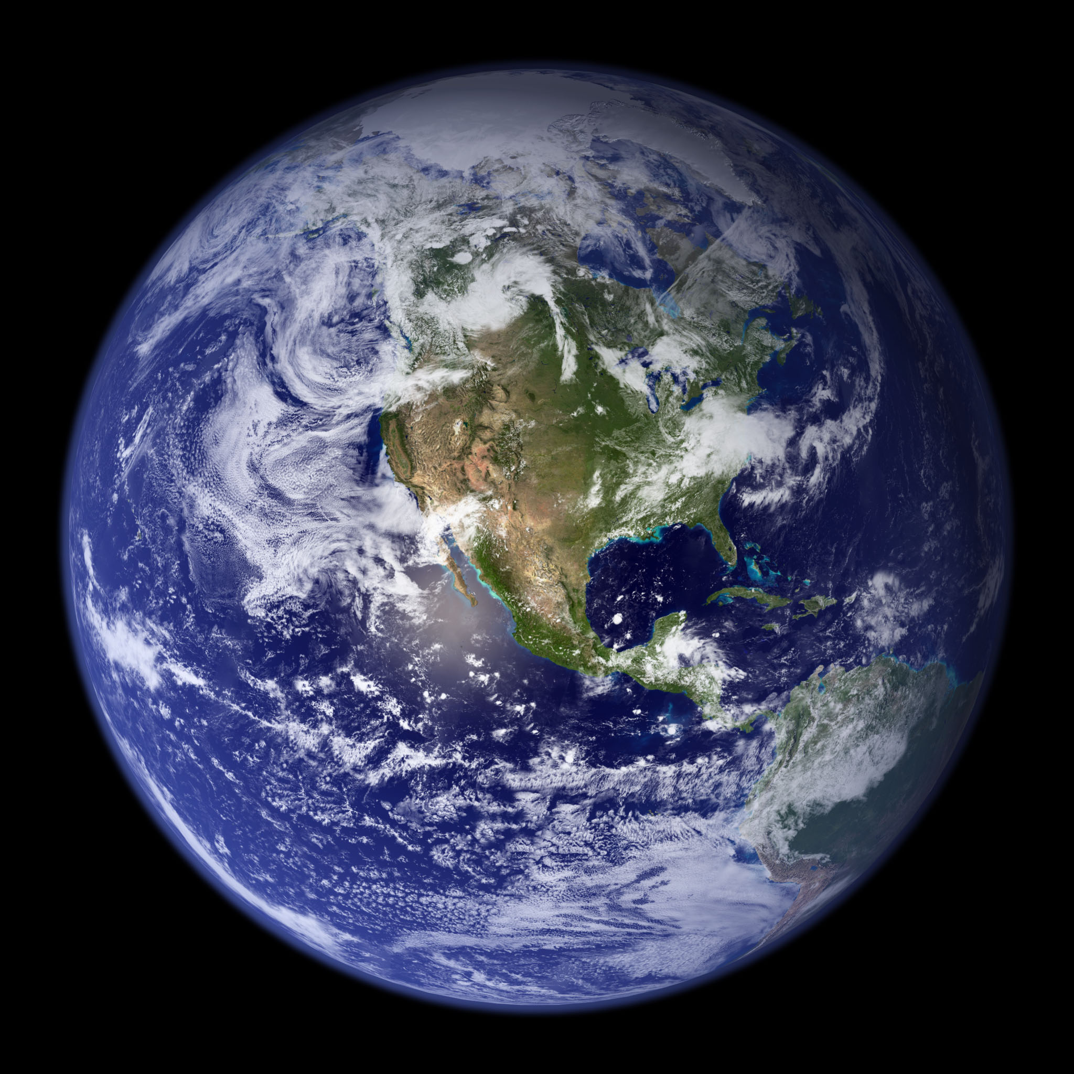

By Melissa Ballestad, Kaitlyn Hintz, and Peter Schnell

About this Unit

This unit plan focuses on the formation of the Earth and how it’s features continue to change today. The first and second lessons in this unit plan discuss the formation of the Earth (Pangea, Plate Tectonics). The third lesson discusses rocks and the rock cycle. The fourth and fifth lessons discuss natural disasters (Earthquakes and Volcanoes). All of our lessons are structured in a similar manner, each lesson begins with a short lecture style direct instruction, and is then followed by a hands-on activity to ensure understanding of the concepts and material.

Lesson 1, Formation of the Earth Part 1 (History)

Standards Addressed (Common Core State Standards/National Standards)
NGIS.4-ESS1-1: Identify evidence from patterns in rock formations and fossils in rock layers to support an explanation for changes in a landscape over time.
CCSS.4.MD.A.1:Know relative sizes of measurement units within one system of units including km, m, cm; kg, g; lb, oz.; l, ml; hr, min, sec. Within a single system of measurement, express measurements in a larger unit in terms of a smaller unit. Record measurement equivalents in a two-column table. For example, know that 1 ft is 12 times as long as 1 in. Express the length of a 4 ft snake as 48 in. Generate a conversion table for feet and inches listing the number pairs (1, 12), (2, 24), (3, 36),...
Wisconsin Social Studies.A.4.2: Locate on a map or globe physical features such as continents, oceans, mountain ranges, and landforms, natural features such as resources, flora, and fauna; and human features such as cities, states, and national borders

Learning Objectives
Objective | Assessment
Students will be able to demonstrate thorough knowledge of the earth’s formation. | Jeopardy Game
Students will be able to use maps to identify the layers of the earth. | Label diagram that illustrates the layers of the earth (Exit Slip)
Students will know how the earth was formed | Answer questions based on how the earth was formed (Exit Slip)

Assessments
- Jeopardy Game
- Exit Slip

Instructional Strategies and Learning Tasks (Procedures & Timelines)
Time | Instructional Strategies/Learning Tasks | Purpose
15 min | Powerpoint Presentation | Go over key information on the topic of the formation of the earth
20 min | Jeopardy  - Click on Get Link Here tab on the both of the spreadsheet  - Click on the click here to go to your Flippity Quiz Show link | Ensure that students retained the information presented in the powerpoint.
5 min | Exit Slip  - Label diagram that illustrates the layers of the earth  - Answer questions based on how the earth was formed | Provides a tangible assessment for the retention of knowledge.

Academic Language/Language Function Objectives
- Big Bang Theory: the theory of how our universe was formed
- Nebula Theory: the theory of how our solar system was formed
- Iron Catastrophe:the melting and reconstruction of the earth about 500 million years after the earth was formed
- Inner core: the innermost layer of the Earth; made of iron and nickel
- Outer core: the 2nd innermost layer of the Earth; made of iron and nickel; liquid
- Mantle: the 3rd innermost layer of the Earth; composes 80% of the Earth’s volume
- Crust: the outermost layer of the Earth
- Moon: the object made of basalt that orbits the earth
- Earth: the planet we live on
- Pangea: super continent proposed by Alfred Wegener; means “all of Earth”

Materials and Resources
- Jeopardy Game
- PowerPoint
- Exit Slip
- Guided Notes

Lesson 2, Formation of Earth Part: 2 (Plates)

Standards Addressed (Common Core State Standards/National Standards)
NGIS.4-ESS1-1: Identify evidence from patterns in rock formations and fossils in rock layers to support an explanation for changes in a landscape over time.
CCSS.ELA-LITERACY.W.4.9: Draw evidence from literary or informational texts to support analysis, reflection, and research.

Learning Objectives
Objective | Assessment
Students will understand cause and effect relationships and how they deal with the formation of earth. | Relationship Flow Chart
Students will know how plates work. | Reflection on Oreo Activity
Students will be able to use evidence from informational texts to support their writing. | Reflection on Oreo Activity

Assessments
- Reflection (on Oreo Activity)
- Flow Chart (Cause and Effect)

Instructional Strategies and Learning Tasks (Procedures & Timelines)
Time | Instructional Strategies/Learning Tasks | Purpose
15 min | Relationship Flow Chart | Students will receive guided notes in the form of a flow chart that we will go over as large group in lieu of a lecture.
15 min | Oreo Activity | This activity is a visual demonstration of how plates work using oreos.
10 min | Activity Reflection | Students will write a reflection based on the activity they just completed.

Academic Language/Language Function Objectives
- Plate: the lithosphere of the earth is divided into a small number of plates which float on and travel independently over the mantle and much of the earth's seismic activity occurs at the boundaries of these plates.
- Boundaries: the point at which plates are coming together, moving apart or sliding past each other.
- Subduction: when plate is forced underneath another plate.
- Convergent: when two plates are coming together.
- Divergent: when two plates are moving away from one another.

Materials and Resources
- Oreo’s
- Oreo Activity Instructions
- Reflection Instructions
- Flow Chart
- Writing Notebook

Lesson 3, Rock Cycle

Standards Addressed (Common Core State Standards/National Standards)
NGIS.4-ESS2-1: Make observations and/or measurements to provide evidence of the effects of weathering or the rate of erosion by water, ice, wind, or vegetation.
NGIS.4-ESS1-1: Identify evidence from patterns in rock formations and fossils in rock layers to support an explanation for changes in a landscape over time.

Learning Objectives
Objective | Assessment
Students will be able to identify evidence that supports explanation. | Exit Slip - Rock Cycle Chart
Students will understand patterns that will be used as evidence. | Exit Slip - Rock Cycle Chart

Assessments
- Exit Slip (Rock Cycle Chart)

Instructional Strategies and Learning Tasks (Procedures & Timelines)
Time | Instructional Strategies/Learning Tasks | Purpose
20 min | PowerPoint/Prezi and Rock Exploration | To ensure that students understand the different cycles in a rocks life.
15 min | Playdoh Activity | A tactile demonstration of how rocks go through many different stages.
5 min | Exit Slip | Fill in cycle chart that demonstrates gained knowledge from the activity and presentation.

Academic Language/Language Function Objectives
- Rock: solid material made up of one or more minerals
- Mineral: solid element or compound found in the Earth’s crust, that has the same definite crystal shape and chemical formula
- Igneous Rock: rocks formed when magma or lava cool
- Magma: molten rock below Earth’s surface
- Lava: molten rock above Earth’s surface
- Sedimentary Rock: rocks formed from sediments being squished together
- Sediments: tiny particles of rocks, minerals, plants, bones, or shells
- Metamorphic Rock: rocks formed from igneous or sedimentary rock is changed by pressure or heat

Materials and Resources
- Powerpoint or Prezi http://prezi.com/avxm66nydaov/?utm_campaign=share&utm_medium=copy&rc=ex0share
- Guided Notes
- Rocks (contact high school teachers, local college, museum, or geologist for samples)
- Playdoh
- Playdoh Activity Instructions
- Exit Slip

Lesson Plan 4, Natural Disasters (Earthquakes)

Standards Addressed (Common Core State Standards/National Standards)
NGIS.4-ESS1-1: Identify evidence from patterns in rock formations and fossils in rock layers to support an explanation for changes in a landscape over time.
CCSS.ELA-LITERACY.W.4.7: Conduct short research projects that build knowledge through investigation of different aspects of a topic.
CCSS.ELA-LITERACY.W.4.9: Draw evidence from literary or informational texts to support analysis, reflection, and research.

Learning Objectives
Objective | Assessment
Students will know the effects behind earthquakes. | Jell-O Experiment
Students will be able to reflect on Jell-O demonstration and its relation to actual earthquakes | Exit Slip Worksheet

Assessments
- Exit Slip (Reflection on Experiment)

Instructional Strategies and Learning Tasks (Procedures & Timelines)
Time | Instructional Strategies/Learning Tasks | Purpose
15 mins | Direct Instruction  - Prezi | To acquire basic knowledge and vocabulary about earthquakes
10 mins | Experiment  - Jell-O and marshmallow structure demo | To demonstrate the effects of earthquakes through a visual representation
15 mins | Exit Slip  - Reflect on experiment | To assess student knowledge of earthquakes

Academic Language/Language Function Objectives
- Earthquake: a natural hazard caused by the sudden and rapid movement of a large volume of rock
- Fault: slippage along fractures in the earth’s crust causing shaking and destruction
- Focus: the location where the earthquake begins
- Hypocenter: the point within the earth where the earthquake rupture starts
- Epicenter: the point at the surface directly above the focus
- Seismic waves: waves of energy that travel through the earth’s layers as the result of an earthquake
- Surface waves: waves that travel along the earth’s surface
- Body waves: waves that travel through the interior of the earth
- P-waves: compressed longitudinal waves
- S-waves: transverse waves

Materials and Resources
- Earthquake Powerpoint
- Jell-O Activity Worksheet
- Earthquake Guided Notes
- Materials for Jell-O Activity (Jell-O, toothpicks, marshmallows, tins)
Instructions for Jell-O Activity

Lesson 5, Natural Disasters (Volcanoes)

Standards Addressed (Common Core State Standards/National Standards)
NGIS.4-ESS1-1: Identify evidence from patterns in rock formations and fossils in rock layers to support an explanation for changes in a landscape over time.
NGIS.4-ESS2-1: Make observations and/or measurements to provide evidence of the effects of weathering or the rate of erosion by water, ice, wind, or vegetation.
NGIS.4-ESS2-2: Analyze and interpret data from maps to describe patterns of Earth’s features.
Learning Objectives
Objective | Assessment
Students will know the mechanisms behind volcanoes. | Participation - questions/review after volcanic eruption demonstration
Students will be able to identify and label the parts of a volcano. | Exit Slip Worksheet - diagram

Assessments
- Exit Slip (Parts of a Volcano)

Instructional Strategies and Learning Tasks (Procedures & Timelines)
Time | Instructional Strategies/Learning Tasks | Purpose
15 mins | Direct Instruction  - Prezi and Fun Stuff | To acquire basic knowledge and vocabulary about volcanoes
10 mins | Experiment  - Make a Volcano | To learn hands - on how volcanoes explode
15 mins | Exit Slip  - Label Your Volcano Worksheet | To assess student knowledge of volcanoes and their parts

Academic Language/Language Function Objectives
- Volcano: a mountain that produces magma, lava, and ash and is formed by cracks in the Earth's surface.
- Magma: melted rock under the surface of the Earth
- Magma chamber: an enclosed space where magma collects below the surface of the Earth
- Lava: magma is called lava when it reaches the Earth's surface
- Earthquake: the result of a sudden release of energy in the Earth's crust that creates seismic waves (violent vibrations)
- Pressure: the force under the Earth (in the volcano) that causes a volcanic eruption to be so violent
- Ash/ash clouds: burnt material that shoots out of the top of a volcano and forms a cloud
- Central vent: the main pathway in the center of a volcano from which lava flows upward
- Crater: a bowl-shaped geological formation at the top of a volcano
- Side vent: a small pathway to the side of a volcano through which lava flows
- Active volcano: volcano that is currently erupting
- Dormant volcano: volcano likely to become active again (awaken) in the future but is not currently active
- Extinct volcano: unlikely to ever erupt again
- Shield volcano: layers of lava pouring out of the vent create this type of volcano
- Cinder volcano: a volcano created by layers of ash, cinders, and bombs
- Composite volcano: tall, cone-shaped mountains that alternate with layers of lava and ash

Materials and Resources
- Prezi http://prezi.com/2wqv0iaywbik/?utm_campaign=share&utm_medium=copy&rc=ex0share
- Volcano Stuff http://worldforlearning.com/look-out-for-the-lava/ (dish soap, food coloring, baking soda, vinegar, container)
- Soda
- Guided Notes
- Exit Slip

Lesson 6, Assessment

Standards Addressed (Common Core State Standards/National Standards)
NGIS.4-ESS1-1: Identify evidence from patterns in rock formations and fossils in rock layers to support an explanation for changes in a landscape over time.
NGIS.4-ESS2-1: Make observations and/or measurements to provide evidence of the effects of weathering or the rate of erosion by water, ice, wind, or vegetation.
NGIS.4-ESS2-2: Analyze and interpret data from maps to describe patterns of Earth’s features.
CCSS.MATH.4.MD.A.1:Know relative sizes of measurement units within one system of units including km, m, cm; kg, g; lb, oz.; l, ml; hr, min, sec. Within a single system of measurement, express measurements in a larger unit in terms of a smaller unit. Record measurement equivalents in a two-column table. For example, know that 1 ft is 12 times as long as 1 in. Express the length of a 4 ft snake as 48 in. Generate a conversion table for feet and inches listing the number pairs (1, 12), (2, 24), (3, 36),...
Wisconsin Social Studies A.4.2: Locate on a map or globe physical features such as continents, oceans, mountain ranges, and landforms, natural features such as resources, flora, and fauna; and human features such as cities, states, and national borders
CCSS.ELA-LITERACY.W.4.7: Conduct short research projects that build knowledge through investigation of different aspects of a topic.
CCSS.ELA-LITERACY.W.4.9: Draw evidence from literary or informational texts to support analysis, reflection, and research.

Learning Objectives
Objective | Assessment
Students will be able to demonstrate knowledge on the formation of the Earth, rocks, and natural disasters | Final Assessment Writing Responses

Assessments
- Final Assessment Writing Responses

Instructional Strategies and Learning Tasks (Procedures & Timelines)
Time | Instructional Strategies/Learning Tasks | Purpose
3 mins | Explain Assessment  - Tell the students what they need to do and how they will be graded  - These can be changed based on the class | To explain the assessment
30-45 mins | Final Assessment  - Students complete the final assessment prompts | To assess student knowledge on the formation of the Earth, rocks, and natural disasters

Academic Language/Language Function Objectives
- See vocabulary throughout the unit

Materials and Resources
- Paper and Pencil
- Writing Prompts

Resources and References
Dr. Tim Flood, St. Norbert College
Dr. Scott Kirst, St. Norbert College
https://s-media-cache-ak0.pinimg.com/originals/78/c4/b1/78c4b1cc8e8457f4c8f77e23c2ff072a.jpg
http://www.layers-of-learning.com/tag/rock-cycle-worksheet/
http://iijuan12.hubpages.com/hub/earthquake-lesson-for-homeschool
http://www.redcross.ca/blog/2010/4/understanding-earthquakes-and-volcanoes-with-snack
http://eisforexplore.blogspot.com/2012/12/play-doh-rock-cycle.html
http://www.freetech4teachers.com/2014/11/how-to-create-jeopardy-style-game-in.html#.VHjalktte2y

