GEOLOGY UNIT PLAN: SYSTEMS OF THE EARTH & ITS CHANGE OVER TIME
Lauren Adams, Meghan McGorey, Rachel Pischke
St. Norbert College

TABLE OF CONTENTS

Lesson 1: Plate Tectonics - Convergent Boundaries………………………………..Page 3

Lesson 2: Plate Tectonics - Divergent Boundaries………………………………….Page 11

Lesson 3: Where Water is Found……………………………………………………..Page 16

Lesson 4: The Water Cycle…………………………………………………………....Page 21

Lesson 5: Erosion………………………………………………………………………Page 27

References……………………………………………………………………………...Page 32

The Earth is always changing - even if we can’t always see it. Some changes occur slowly, while others are changing on a daily basis. This unit on the systems of the Earth, including Plate Tectonics, the Water Cycle, and Erosion will give your students a better understanding of these changes that take place on our planet through the use of fun, hands-on experiments and technology.

Lesson 1
Theme: Plate Tectonics - Convergent Boundaries
Content Area: Science (Geology)
Grade Level: 2nd
Time: 50 minutes

Disciplinary Core Ideas:
- ESS2.B: Plate Tectonics and Large-Scale System Interactions
  - Maps show where things are located. One can map the shapes and kinds of land and water in any area.

Cross-Cutting Concepts:
- Stability and Change: Things may change slowly or rapidly. (2-ESS2-1)

Learning Objectives:
- The students will know what a convergent boundary is and what each of the three types of convergent boundaries are.
- The students will describe how volcanoes and mountains were formed according to Plate Tectonics.
- The students will be able to identify various volcanoes and mountain ranges on a map of Earth.
- The students will recognize that plate tectonics is a very slowly-moving system of the Earth.

Academic Language:
Convergent Boundary, Oceanic-Oceanic Convergent Boundary, Oceanic-Continental Convergent Boundary, Continental-Continental Convergent Boundary, tectonic plate, collision, volcano, island, mountain

Activities:
- PowerPoint with Total Physical Response (TPR) Actions and Map Activity - 30 minutes
- Boundary Demonstration - Convergent Boundaries - 15 minutes
- Exit Slip - 5 minutes

Materials Needed:
- PowerPoint
  - Computer
  - Projector
  - Convergent Boundary PowerPoint Presentation
  - Map of Earth (whole-class size)
  - Printed 8.5 x 11” maps of Earth (1/student)
  - Colored Pencils or Markers (1/student)
- Boundary Demonstration
  - Graham Crackers (1 full cracker/student)
    - Split in half
  - Fruit Roll-Ups (1/student)
    - Cut in half
  - Vanilla Frosting (¾ cup/student)
  - Wax Paper (1 medium-sized sheet/student)
  - Plastic Spoon (1/student)
  - Cup of Water (1/student)
  - Document Camera/ELMO (optional)
  - Science Journal
    - Pieces of paper stapled together (1 packet/student)
  - Pencil (1/student)
- Exit Slip
  - Notecards (1/student)

Prior Knowledge:
- Familiarity with the 7 continents of the Earth
  - Africa
  - Antarctica
  - Asia
  - Australia
  - Europe
  - North America
  - South America
- Knowledge of Tectonic Plates
  - The Earth is divided into many different plates/sections that move in various ways

Procedure:
- Have the students sit in their desks and hand each of them a printed 8.5 x 11” map of Earth. Ask them to put their names at the top of their maps.
- Begin presenting the PowerPoint on convergent boundaries.
  - Slide 1: Convergent Boundaries
    - Teach students the action for the academic term convergent boundaries. This action should be used every time the term convergent boundary/boundaries appears throughout the unit.
      - Start with hands out in front of your torso. Your fingers should be facing the ceiling and your palms should be facing each other with some space in between. Move your palms toward each other to model a convergent boundary.

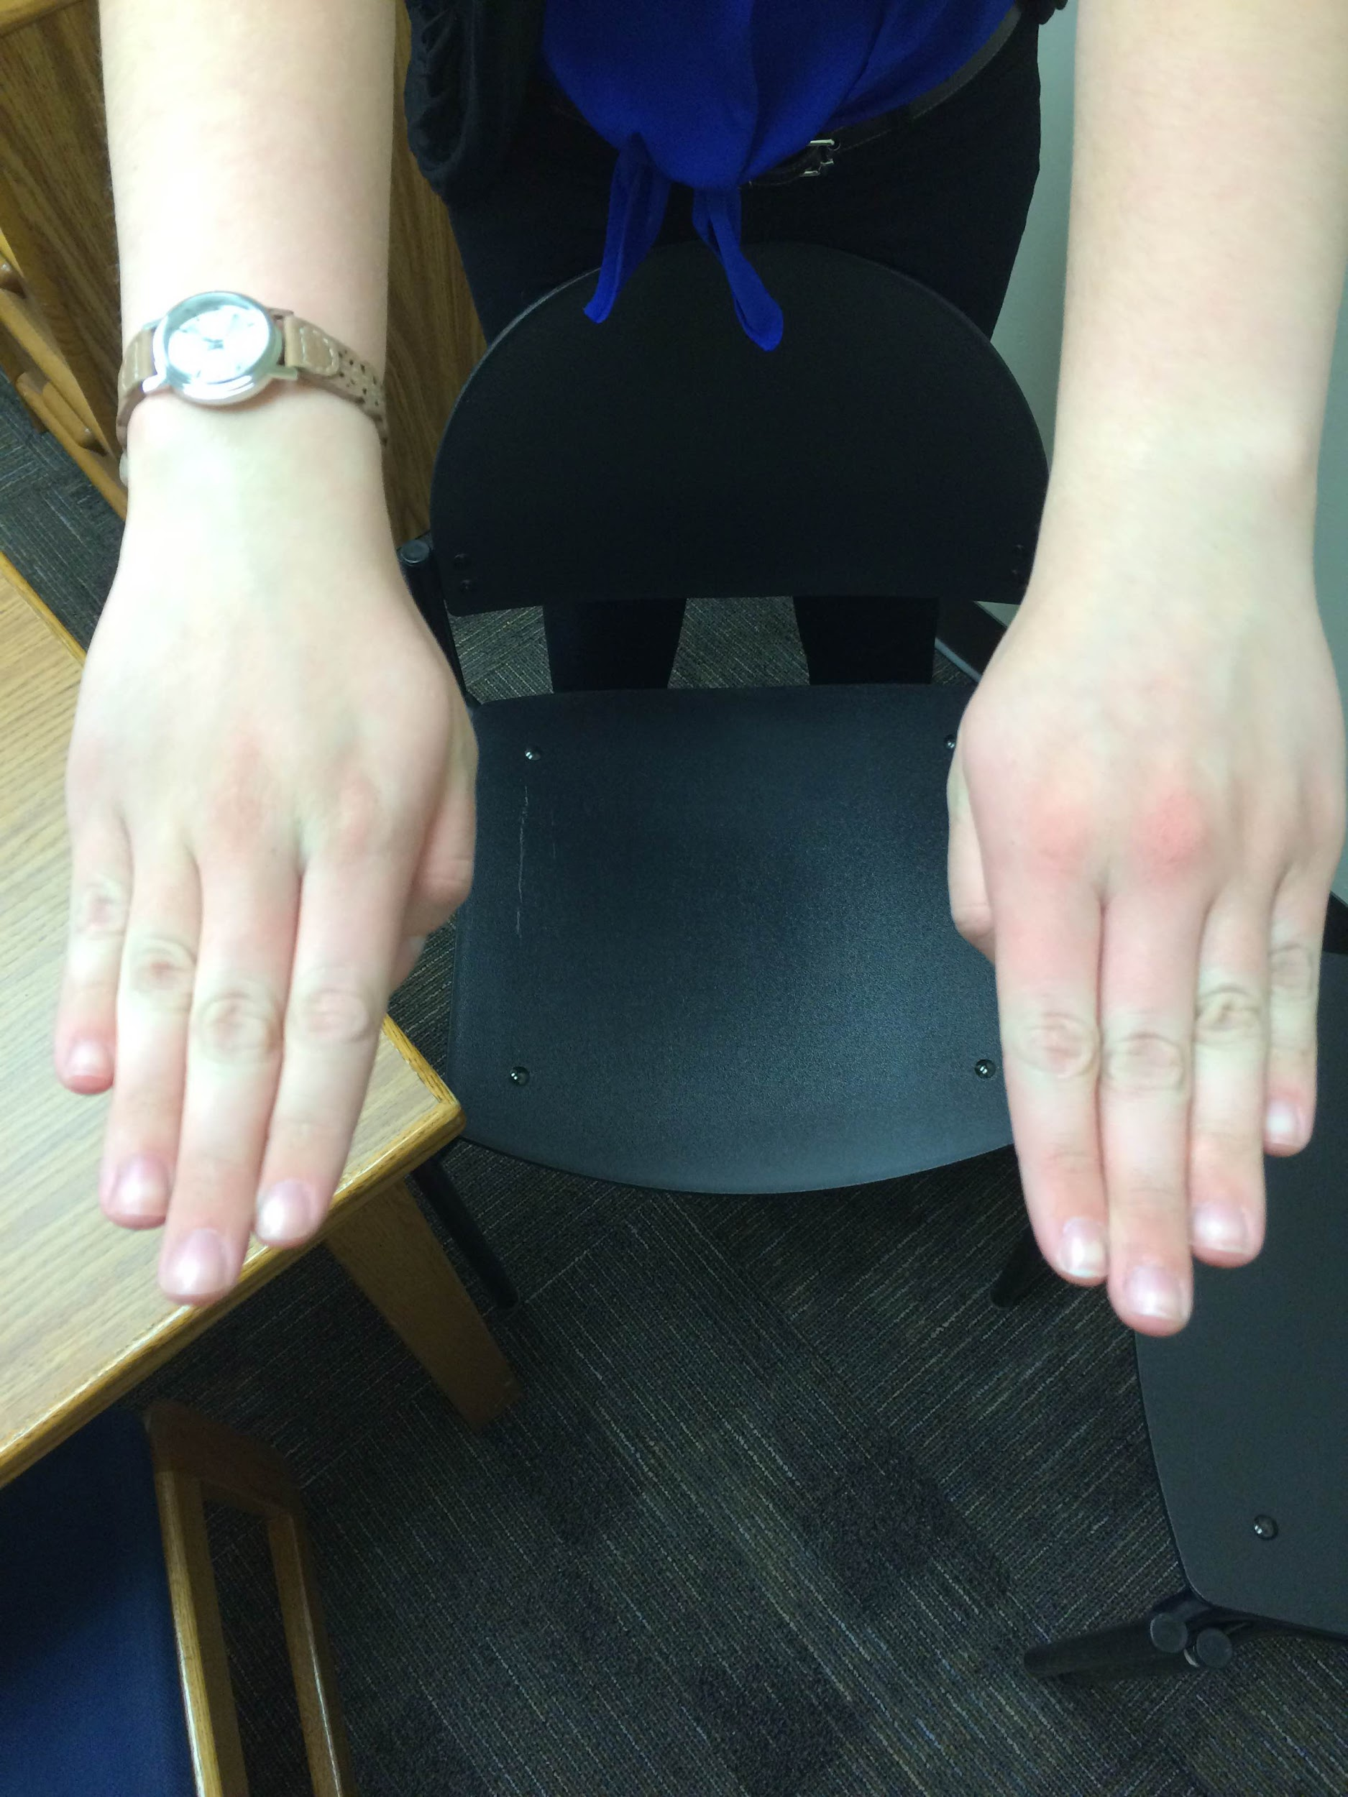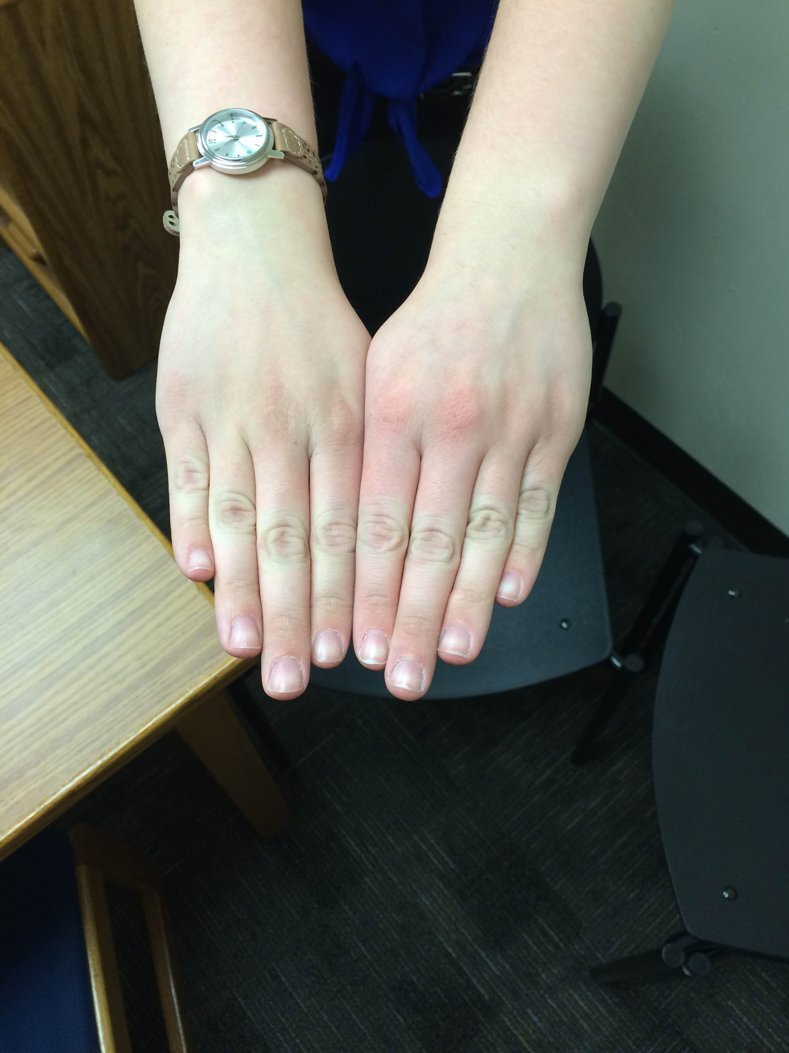

    - Explain that convergent boundaries occur when two tectonic plates on the surface of the Earth slide toward each other and collide.
    - Explain that there are three types of convergent boundaries and list them (they will be described in greater detail later in the PowerPoint).
      - Oceanic-Oceanic Convergent Boundaries
      - Oceanic-Continental Convergent Boundaries
      - Continental-Continental Convergent Boundaries
  - Slide 2: Oceanic-Oceanic Boundary
    - Teach students the action for the academic term oceanic-oceanic boundary. This action should be used every time the term oceanic-oceanic boundary/boundaries appears throughout the unit.
      - Start with both hands in front of you with your palms facing down. Bring your hands together with your palms still facing down. Then slide your right hand underneath your left hand. Pictures of the described action are included below if needed.

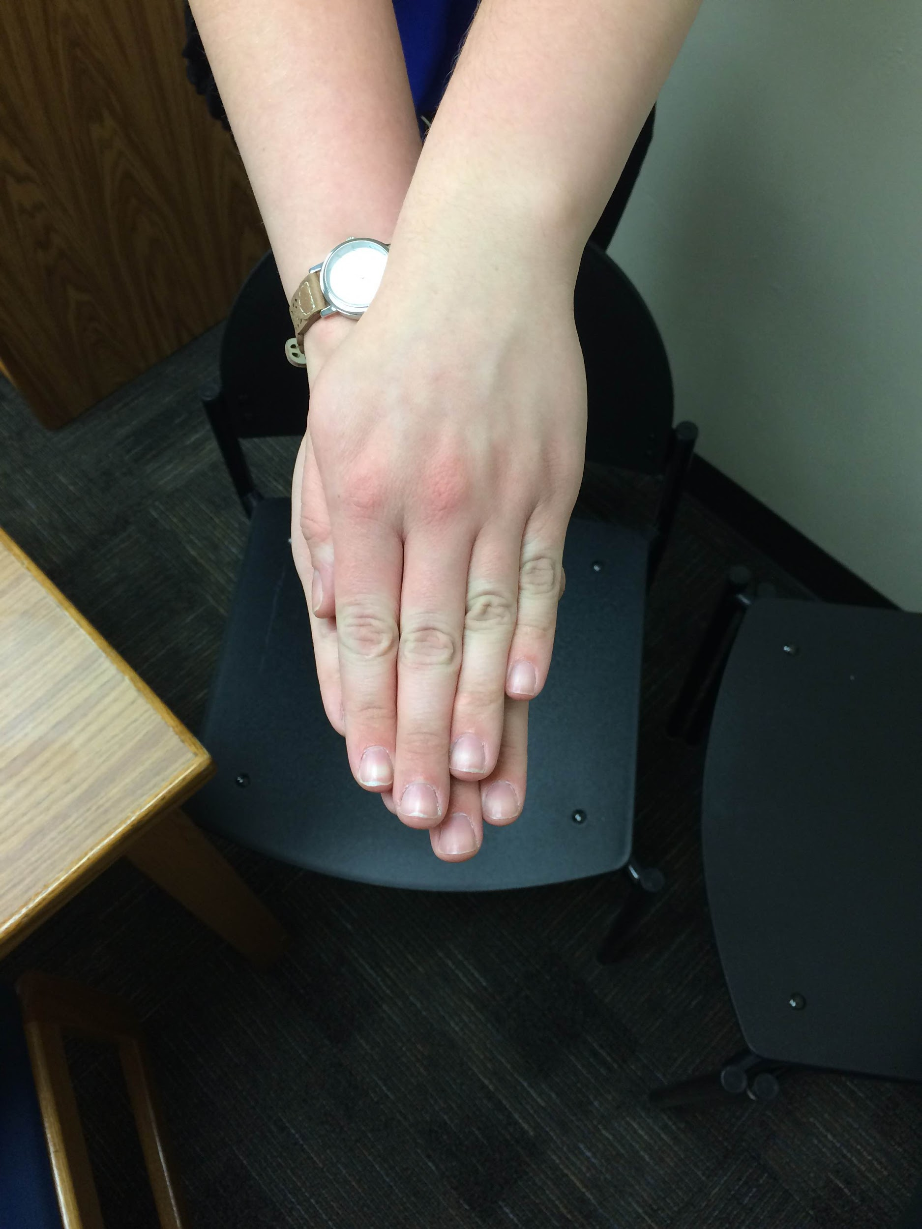

    - Explain that oceanic-oceanic boundaries occur when two oceanic (water) plates slide toward each other and collide.
    - One of these oceanic plates slides underneath the other (Plate B slides underneath Plate A), which causes heat to build up underneath Plate A.
    - The heat that builds up underneath Plate A rises up and causes a volcano/island arc to form on the surface of Plate A.
    - Because both plates are oceanic (water), these volcanoes appear as islands surrounded by water.

  - Slide 3: Example of an Oceanic-Oceanic Boundary
    - Aleutian Islands of Alaska
    - Move over to the map and demonstrate where these are found in relation to where the students live.
      - Explain to the students that they should follow along and circle the Aleutian Islands on their personal maps of Earth.
    - Explain to students (if they live in the landlocked United States) that there are not any boundaries really close to where we they because the all of North America is on the same plate.
  - Slide 4: Oceanic-Continental Convergent Boundaries
    - Teach the students the action for the academic term oceanic-continental boundary. This action should be used every time the term oceanic-continental boundary/boundaries appears throughout the unit.
      - Start with both hands in front of you. Your left hand will be out with the palm facing down while your right hand will be in a fist. You will bring your hands together so the palm facing down is touching the fist. Next, your left hand (the one with the palm facing down) will slide under the fisted hand. Pictures of the described action are below if needed.

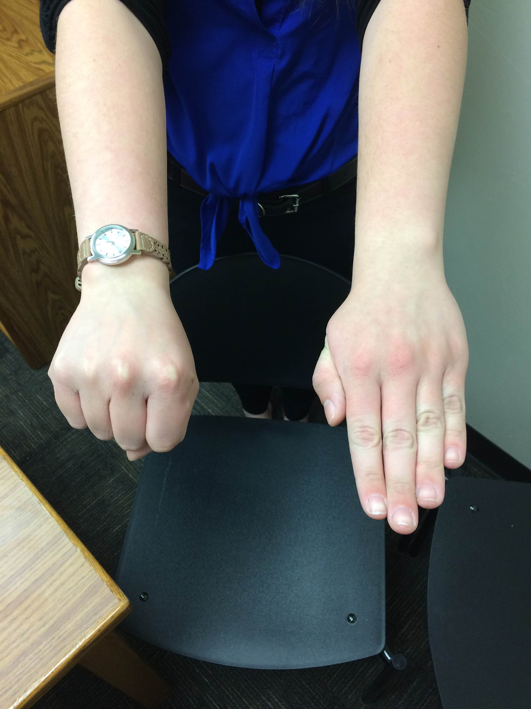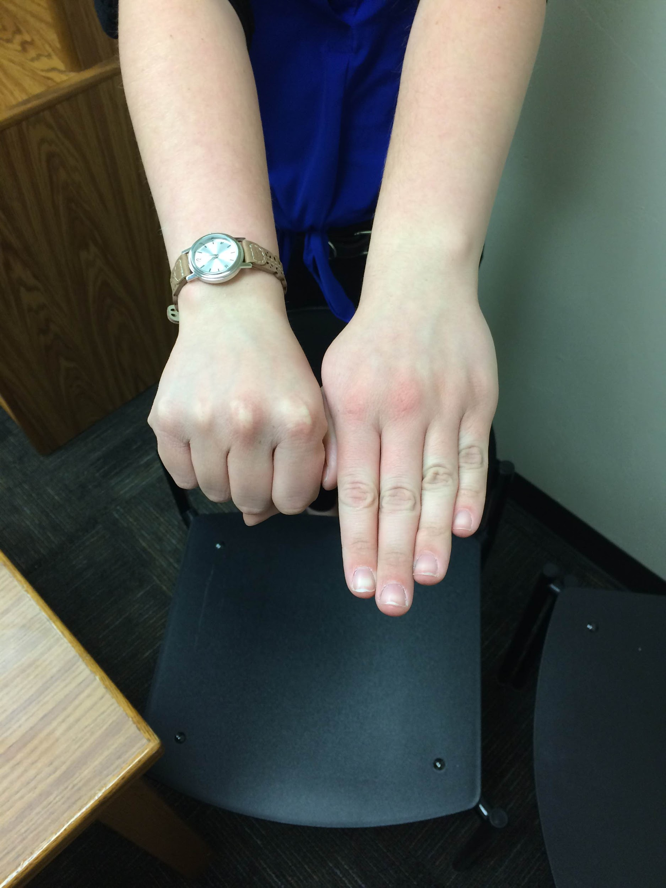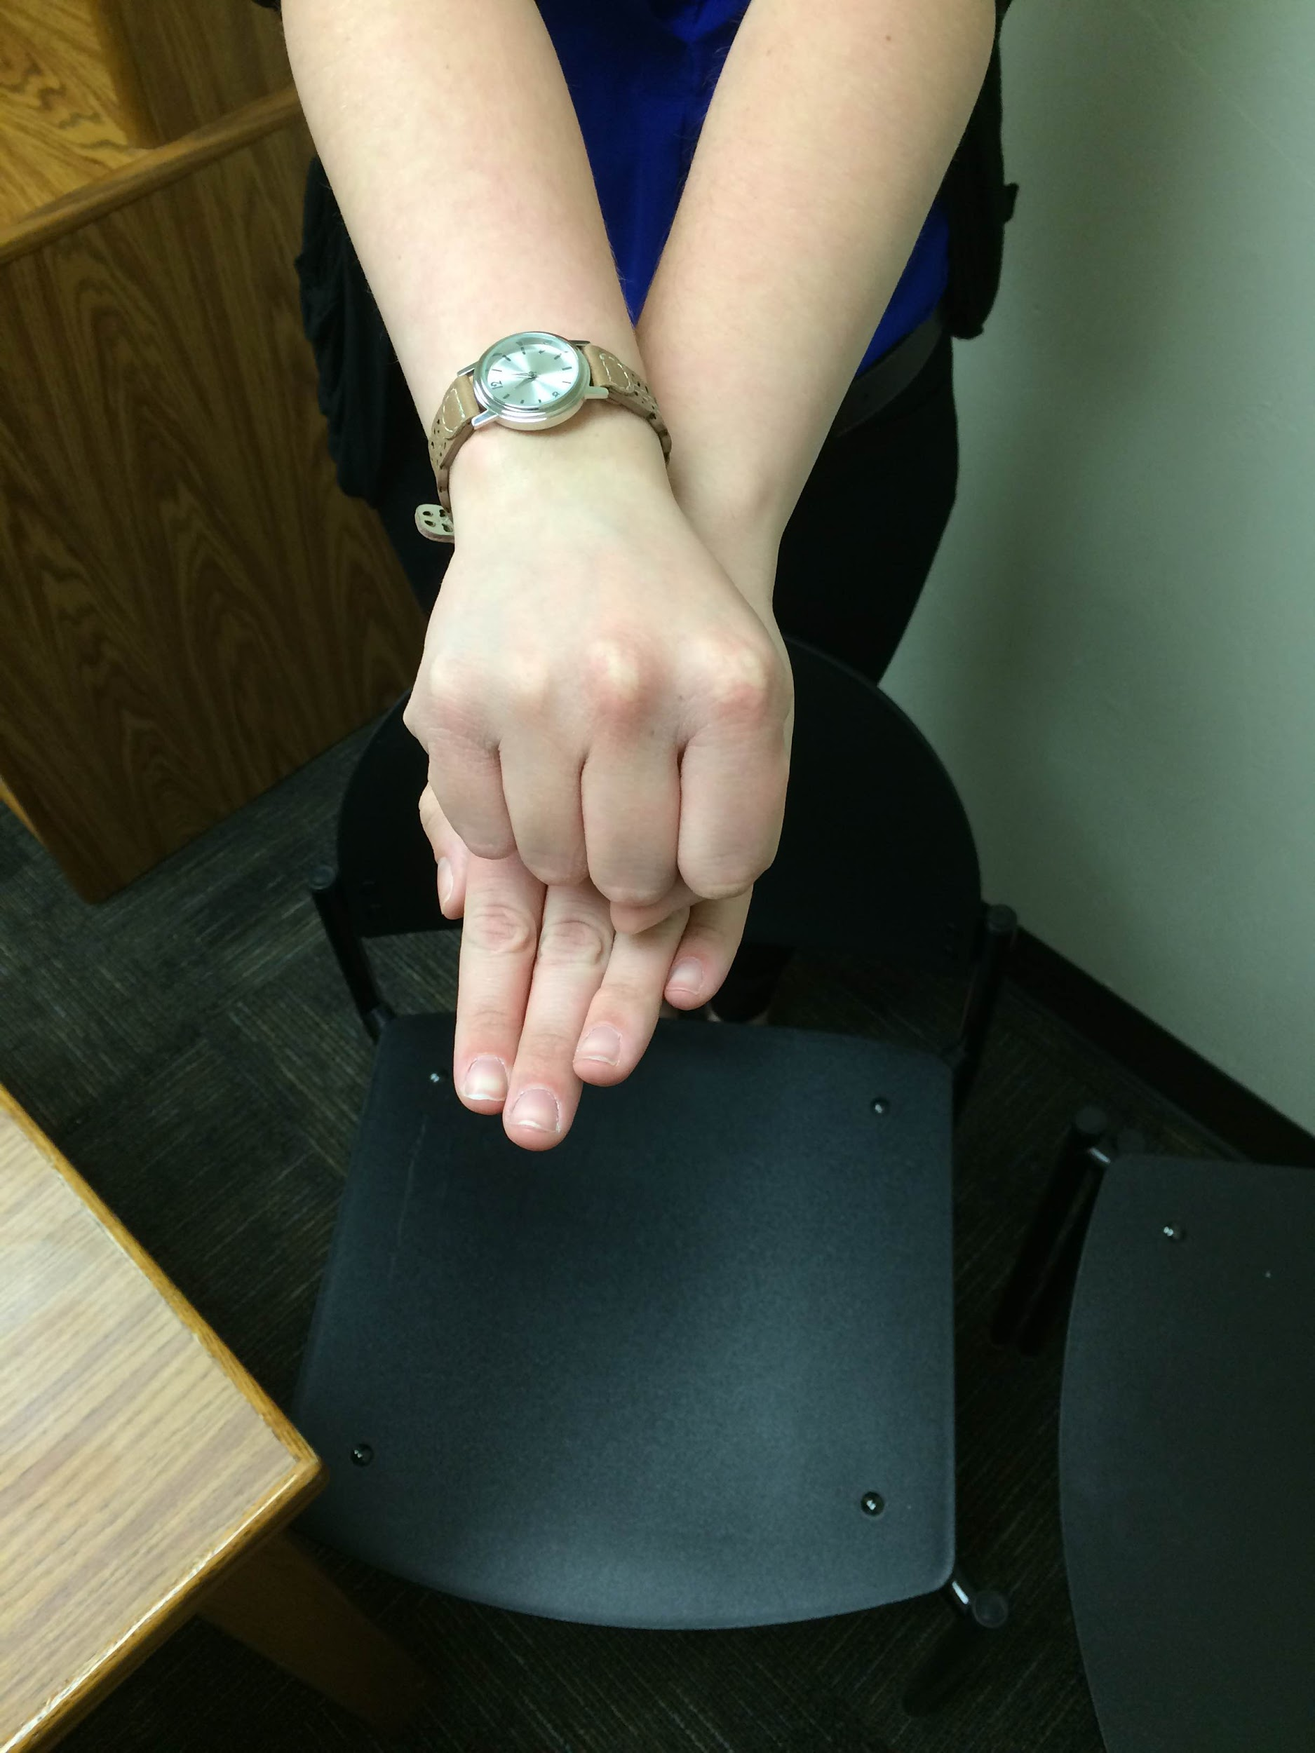
    - Explain that oceanic-continental boundaries occur when an oceanic (water) plate and a continental (land) plate slide toward each other and collide.
    - The oceanic (water) plate slides underneath the continental (land) plate, which causes heat to build up underneath the continental (land) plate.
    - The heat that builds up underneath the continental (land) plate rises up and forms a volcano on the surface of the continental (land) plate.
    - Oceanic-continental boundaries create the types of volcanoes we are most familiar with.

  - Slide 5: Example of Oceanic - Continental Convergent Boundaries
    - Andes Mountains in South America
    - Move over the to the map and demonstrate where these are found in relation to where the students live.
      - Students should follow along and circle the Andes Mountains on their personal maps of Earth.
    - Explain to students (if they live in the landlocked United States) that there are not any boundaries really close to where we they because the all of North America is on the same plate.
  - Slide 6: Continental-Continental Boundaries
    - Teach the students the action for the academic term continental-continental boundary. This action should be used every time the term continental-continental boundary/boundaries appears throughout the unit.
      - Hold your two hands out in front of you as fists. Bring them together so they are touching. Pictures of the described action are attached below if needed.
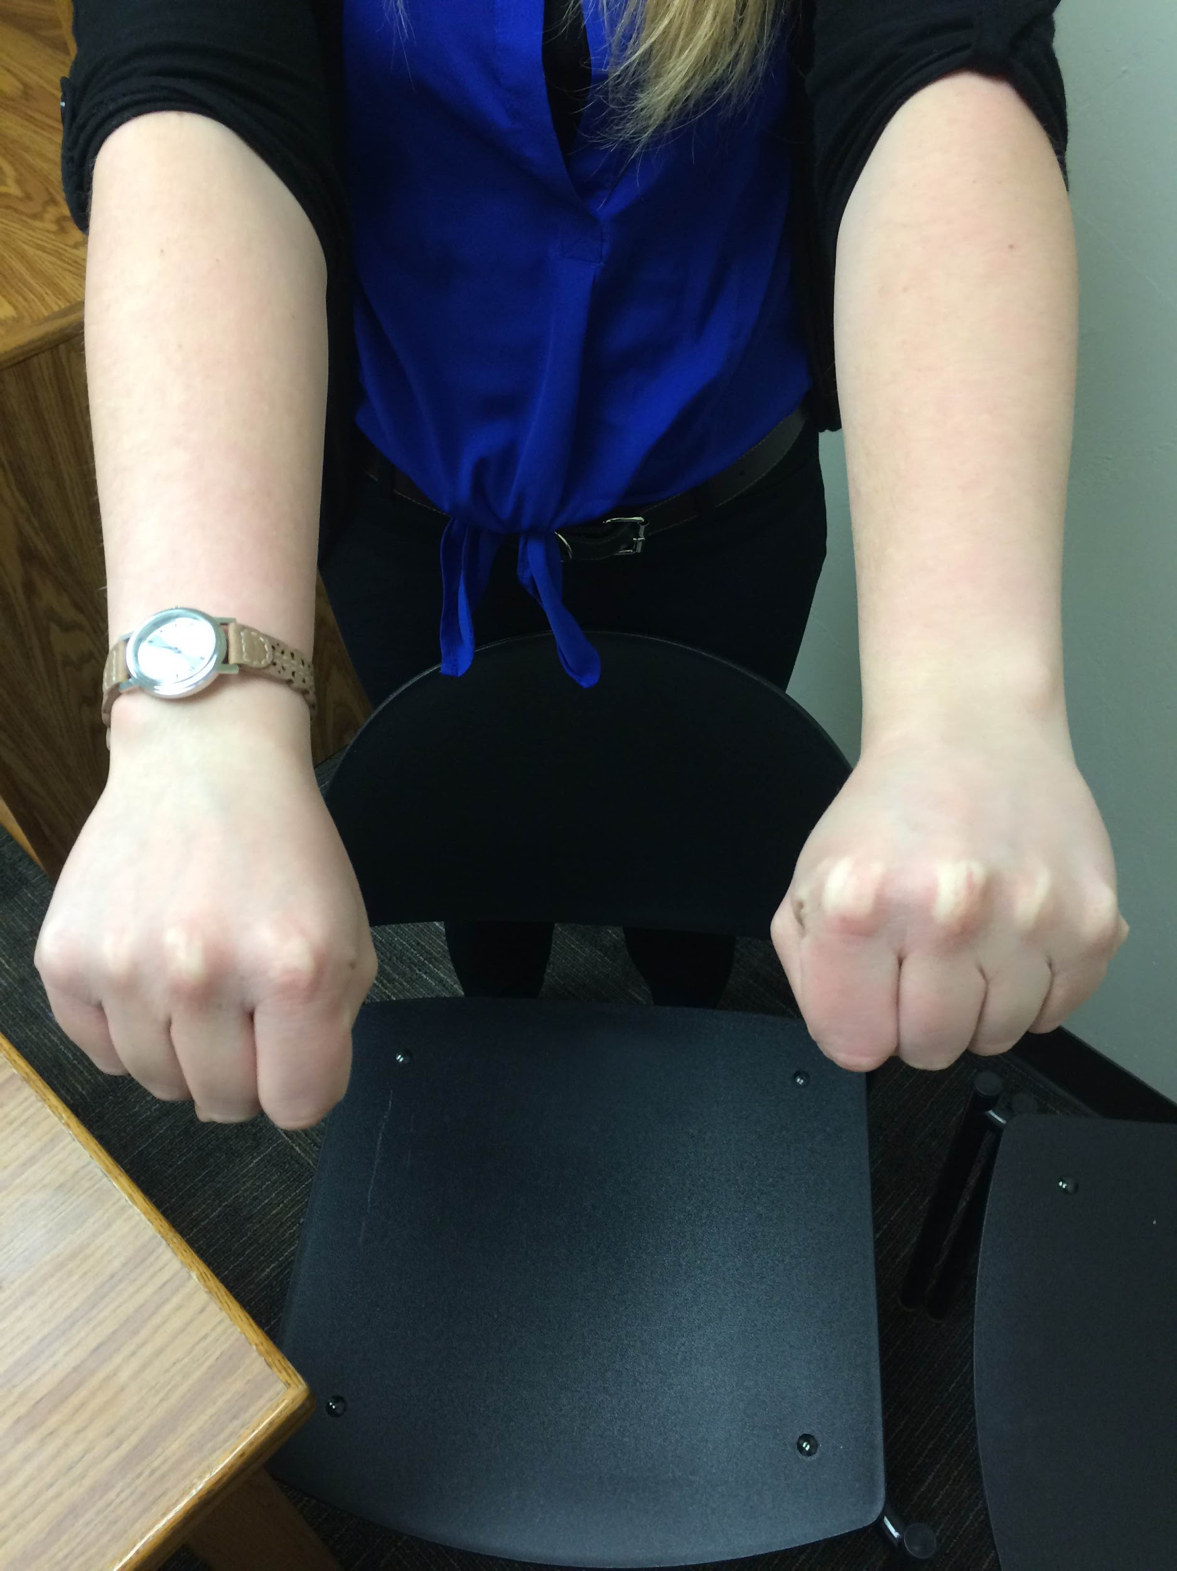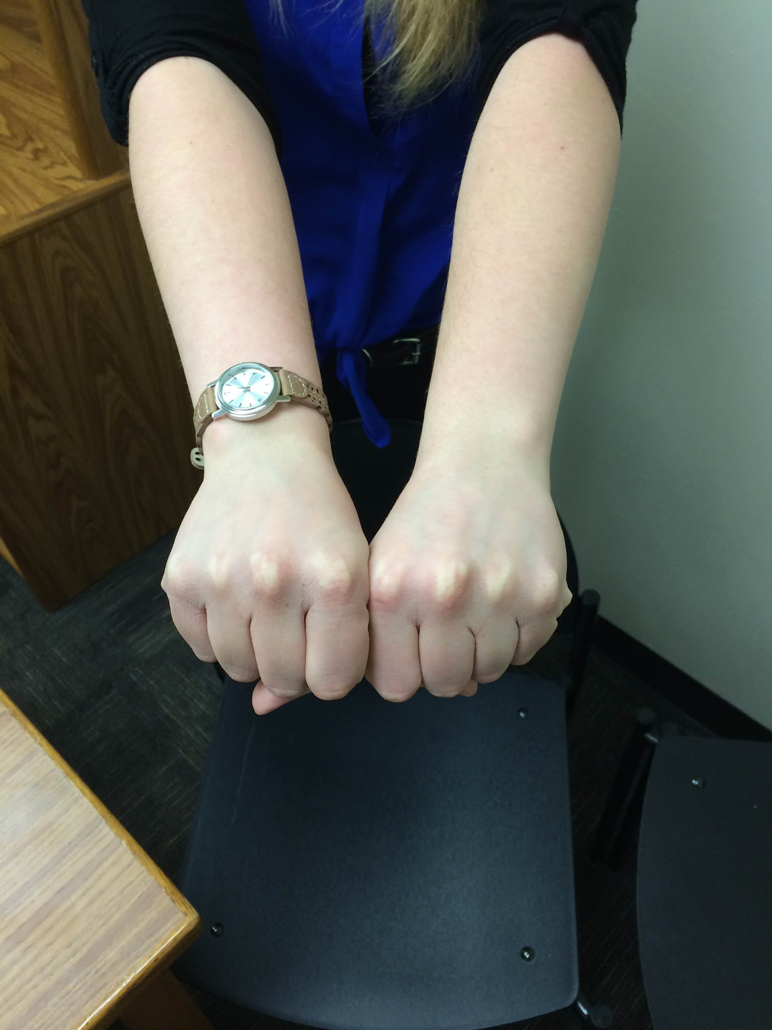

    - Explain that continental-continental boundaries occur when two continental (land) plates slide together and collide.
    - Neither plate slides underneath the other.
    - This causes mountain ranges to form.
      - There are no volcanoes formed by this process because neither plate slides underneath the other so there is no heat built up.
  - Slide 7: Example of Continental - Continental Boundaries
    - Himalaya Mountain Range on the border of India in Asia
    - Move over to the map and demonstrate where these are found in relation to where the students live.
      - Students should follow along and circle the Himalaya Mountain Range on their personal maps of Earth.
    - Explain to students (if they live in the landlocked United States) that there are not any boundaries really close to where we they because the all of North America is on the same plate.
- Collect the maps from the students.
- Begin the Convergent Boundary Activity.
  - Give each student a piece of wax paper and a plastic spoon.
  - Go around to each student and give him/her a large spoonful of vanilla frosting.
  - Have the students spread their frosting out (as if they were frosting a cake) in the center of the sheet of wax paper.
  - Give each student 2 halves of a graham cracker, 2 halves of a fruit roll-up, and a cup of room-temperature water about ⅓ of the way full.
  - Have the students model an oceanic-oceanic boundary. *If there is access to a document camera, the teacher can model each stage of this activity using this available technology.
    - Take both halves of the fruit roll-up and place them on top of the frosting with space in between.
      - Explain that the fruit roll-up halves each symbolize an oceanic (water) plate.
    - Apply a little bit of pressure to the fruit roll-ups to get them to slide towards each other.
      - One of the halves should go underneath the other.
    - Ask the students to write the name of the type of boundary that is being modeled and one sentence about what they observe in their science journals.
    - Ask the class what they think happens during this type of collision (what is formed?). They will have learned it from the PowerPoint, but may need a reminder.
      - If needed, remind them that this type of collision forms volcanoes that are surrounded by water (islands).
      - Ask them what causes the volcanoes to form.
        - Heat builds up underneath the top oceanic (water) plate.
  - Have the students model an oceanic-continental boundary.
    - Take one of the graham cracker halves and one of the fruit roll-up halves and place them on top of the frosting with space in between.
      - Explain that the graham cracker symbolizes the continental (land) plate and the fruit roll-up symbolizes an oceanic (water) plate.
    - Apply a little bit of pressure to the fruit roll-up and graham cracker to get them to slide towards each other.
      - The fruit roll-up should slide underneath the graham cracker
    - Ask the students to write the name of the type of boundary that is being modeled and one sentence about what they observe in their science journals.
    - Ask the class what they think happens during this type of collision (what is formed?). They will have learned it from the PowerPoint, but may need a reminder.
      - If needed, remind them that this type of collision forms volcanoes on land, like the volcanoes we are familiar with.
      - Ask them what causes the volcanoes to form.
        - Heat builds up underneath the continental (land) plate.
  - Have the students model a continental-continental boundary.
    - Take two halves of a graham cracker and soak one side of each cracker in water for 20 seconds. Then, place them on top of the frosting with space in between. The wet ends of the graham cracker halves should face each other.
      - Explain that the graham cracker halves each symbolize a continental (land) plate.
    - Apply a little bit of pressure to the graham crackers to get them to slide towards each other.
      - The wet ends should fold into each other creating a mountain-type effect.
    - Ask the students to write the name of the type of boundary that is being modeled and one sentence about what they observe in their science journals.
    - Ask the class what they think happens during this type of collision (what is formed?). They will have learned it from the PowerPoint, but may need a reminder.
      - If needed, remind them that this type of collision forms mountain ranges.
  - Briefly discuss what they learned from the Boundary Activity model and ask students to share some of their observations from their science journals with the class.
  - Introduce the idea that Plate Tectonics is a system of the Earth that causes the Earth to change slowly over time. We cannot see this change happening in our lifetime, but there is scientific evidence that it is happening. The Earth is changing bit by bit each and every day.
- Give each student a notecard and ask the students to write down one thing they learned and one question they still have about convergent boundaries.

Adaptations:
- Students may draw a picture of what they observe during the boundary activity or of what they have learned on their exit slip notecard if they struggle with spelling/writing. If some students are not able to draw/write, they may orally tell the teacher something that they have learned.
- If any students are allergic to the materials used in the boundary activity they can partner up with another student and watch what is happening at each stage. If available, these students may use different colored blocks to represent the oceanic and continental plates. The frosting can be omitted at this level if an allergy is present.

Assessments:
- Teacher Observation: The teacher will observe that the students are participating correctly in the activities (Powerpoint and Boundary Activity). The students must be listening and doing the TPR actions along with the PowerPoint.
- Map Worksheet: The students will follow along while the teacher points out various mountain ranges and volcanoes on a map of Earth. They will each have a map of the Earth and will circle where these mountain ranges and volcanoes are found using colored pencils or markers.
- Science Journals: The students will record their observations of the convergent boundary activity in their science journals. Some students will share their observations with the class at the end of the activity and the teacher will collect the science journals when they lesson is over.
  - Grading Criteria: The students must have the name of each type of collision (oceanic-oceanic, oceanic-continental, and continental-continental) and at least one complete sentence about something they observe for each collision.
- Exit Slip: Students will be given a notecard on which they will write one thing they learned during the activity and one question they still have about plate tectonics.

Lesson 2
Theme: Plate Tectonics - Divergent Boundaries
Content Area: Science (Geology)
Grade Level: 2nd
Time: 45-55 minutes

Next Generation Science Standards:
- 2- ESS2-2 Develop a model to represent the shapes and kinds of land and bodies of water in an area.

Disciplinary Core Ideas:
- ESS2.B: Plate Tectonics and Large-Scale System Interactions
  - Maps show where things are located. One can map the shapes and kinds of land and water in any area.

Crosscutting Concepts
- Stability and Change: Things may change slowly or rapidly. (2-ESS2-1)

Learning Objectives:
- The students will be able to define what a divergent boundary is.
- The students will be able to identify where these divergent boundaries are located on a map of the Earth.

Academic Language:
Divergent Boundary, Crust, Convergent Boundary, Oceanic-Oceanic Boundary, Oceanic-Continental Boundary, Continental-Continental Boundary

Activities:
- Answer Questions from Previous Lesson - time depends on number of questions
  - The teacher should read the exit slips from Lesson 1 prior to starting this lesson so he/she can pick the most important questions to address. Try to limit this time to 10 minutes if possible.
- PowerPoint with TPR Actions and Map Activity - 5 minutes
- Divergent Boundary Activity - 10 minutes
- Develop a Model of a Boundary Type - 30 minutes

Materials Needed:
- Answering Questions
  - Exit Slips from Lesson 1
  - Materials will depend on concepts being re-taught (see lesson 1)
- PowerPoint with TPR Actions
  - Computer
  - Projector
  - Divergent Boundary PowerPoint Presentation
  - Map of Earth
- Boundary Activity - Divergent Boundaries
  - Graham Crackers (1 full cracker/student)
    - Split in half
  - Vanilla Frosting (¾ cup/student)
  - Wax Paper (1 medium-sized sheet/student)
  - Plastic Spoon (1/student)
  - Document Camera/ELMO (optional)
  - Science Journal
    - Same science journal each students uses throughout the unit
  - Pencil (1/student)
- Develop a Model of a Boundary Type
  - 4 individual tubs of Play-Doh
    - At least two different colors
  - 1 Loaf of Bread
  - 1 Pack of Oreos
  - 1 Pack of Construction Paper
  - 1 Pack of Colored Pencils
  - ***The list of items above are just suggestions to give students a variety of options for their models. The materials can be eliminated as needed depending on the allowed budget. In addition, if the teacher has any other ideas for materials that could be used to develop models of boundaries, he/she is welcome to include them in the lesson.***

Prior Knowledge:
- Knowledge of the different types of Convergent Boundaries
  - Oceanic - Oceanic
  - Oceanic - Continental
  - Continental - Continental

Procedure:
- Have the students sit in their desks.
- Answer any questions students have about convergent boundaries from their notecards they completed at the end of Lesson 1.
- Hand each student a printed 8.5 x 11” map of Earth. Ask them to put their names on the top of their maps and to copy the title “Divergent Boundaries” at the top of the map.
  - The teacher should write “Divergent Boundaries” on the board either before or during this step.

- Begin presenting the PowerPoint Presentation on divergent boundaries.
  - Slide 1: Divergent Boundaries
    - Teach the students the action for the academic term divergent boundaries. This action should be used every time the term divergent boundaries appears throughout the unit.
      - Start with your palms touching and your fingers pointing toward the ceiling. Slowly move your hands apart to model a divergent boundary. Pictures of the described action are included below if needed.

    - Explain that divergent boundaries occur when two plates slide away from each other.
    - Explain that new crust (either on land or under water) is formed at a divergent boundary.
  - Slide 2: Example of Divergent Boundary
    - East African Rift in Northeast Africa
    - Move over to the map and point to this location to show students where it is in relation to where they live.
      - Explain to the students that they should follow along and circle the East African Rift on their personal maps of Earth.
    - Explain to students (if they live in the landlocked United States) that there are not any boundaries really close to where they live because all of North America is on the same plate.
  - Slide 3: Example of Failed Divergent Boundary
    - The Five Great Lakes in the Midwest Region of the United States
    - They were part of a divergent boundary but then the plates at the boundary stopped moving apart from each other and water was left landlocked in the middle of North America.
- Have students return to their seats.
- Begin the Divergent Boundary Activity.
  - Give each student a piece of wax paper and a plastic spoon.
  - Go around to each student and give him/her a large spoonful of vanilla frosting.
  - Have the students spread their frosting out (as if they were frosting a cake) in the center of the sheet of wax paper.
  - Give each student 2 halves of a graham cracker.
  - Have the students model a divergent boundary. If there is access to a document camera, the teacher can model each stage of this activity using this available technology.
    - Take both halves of the graham cracker and place them on top of the frosting. The two graham cracker halves should be touching each other (no space in between).
      - Explain that the graham cracker halves each symbolize a tectonic plate.
    - Apply a little bit of pressure to the graham cracker halves and move them apart from each other.
    - Ask the students to write the name of the type of boundary that is being modeled and one sentence about what they observe in their science journals.
    - Ask the class what they think happens during this type of collision (what is formed?). They will have learned it from the PowerPoint, but may need a reminder.
      - If needed, remind the students that new crust is formed either on land or under water.
- Remind the students that plate tectonics is a very slow process and that divergent boundaries are included in this slow process.
- Begin the Develop a Model of a Boundary Type Activity.
  - Place the materials for this activity out on a table/counter. Tell the students not to touch them until directed to do so. *If preferred, these materials can be set up before the lesson begins.
  - Review the four types of boundaries that the students learned.
    - Oceanic-oceanic convergent boundary
    - Oceanic-continental convergent boundary
    - Continental-continental convergent boundary
    - Divergent boundary
  - Explain to the students that they will be creating their own model/representation for one of the boundary types above. Briefly remind them of the models they used in Lesson 1 and Lesson 2.
  - Put the students into pairs. Ask each pair to choose one of the four boundary types that they would like to model.
  - Ask the students to choose the materials they would like to use to represent their model and allow them a few minutes to think about the materials that would best model the boundary type they chose.
  - Give the students a few minutes to pick out their materials from the table and return to their seats with their partner.
    - The pairs of students should only take the amount of materials necessary to create one model.
  - Give the students time to create their models of their chosen boundary types.
    - The teacher should walk around and observe the students’ models. The teacher should also ask each pair to explain their model.
  - Once every pair of students has had a chance to create a model, they should form a group of four with another pair of students. Each pair will take turns teaching the other pair about their chosen boundary type using their model.
  - If time allows, have a few of the pairs share their models with the whole class. Utilize a document camera if the technology is available.

Adaptations:
- Students can draw pictures of their observations or share their observations orally during the divergent boundary activity if they are unable to write.
- Students can work alone to develop a model of a boundary type if they so choose. If needed, groups of three students can be utilized.

Assessments:
- Teacher Observation: The teacher will observe to see if students are participating by doing the TPR actions along with the PowerPoint.
- Map Worksheet: The students will follow along while the teacher points out various divergent boundaries. They will each have a map of the Earth and will circle where these divergent boundaries are found using colored pencils or markers.
- Science Journals: The students will record their observations of the divergent boundary activity in their science journals. The teacher will collect the science journals when they lesson is over.
  - Grading Criteria: The students must have the name, divergent boundary, and at least one complete sentence about something they observe about this type of boundary.
- Explanation of Model: The students will describe their models to the teacher.
  - Grading Criteria: The students must explain what their chosen materials represent. They must also correctly show what happens at their chosen boundary type. If a type of land formation (Island, Volcano, Mountain) results from their boundary type, they must explain what forms and how it forms.

Lesson 3
Theme: Where Water is Found
Content Area: Science (Geology)
Grade Level: 2nd
Time: 60 minutes

Next Generation Science Standards:
2-ESS2-3 - Obtain information to identify where water is found on Earth and that it can be solid or liquid

Disciplinary Core Ideas:
ESS2.C - The Roles of Water in Earth’s Surface Processes
- Water is found in the ocean, rivers, lakes, and ponds
- Water exists as solid ice and in liquid form
ESS2.B: Plate Tectonics and Large-Scale System Interactions
- Maps show where things are located. One can map the shapes and kinds of land and water in any area.

Learning Objectives:
- The students will be able to name places in which water is found on Earth.
- The students will be able to tell the difference between water as a solid or liquid.

Academic Language:
- Lake, river, ocean, current, landlocked, solid, liquid, temperature

Activities:
- Connect Plate Tectonics to Where Water is Found - 5 minutes
- Find Water on Map of Earth - 10 minutes
- Video - 5 minutes
- Anchor Chart - 15 minutes
- Observation of States of Water - 20 minutes
- Identify Water on a Globe - 5 minutes

Materials Needed:
- Connect Plate Tectonics to Where Water is Found
  - No materials needed
- Find Water on Map of Earth
  - Map of Earth
  - Wikki Stix (1 package)
- Video
  - Computer
  - Projector/Screen
  - Video
- Anchor Chart
  - Chart Paper
  - Markers
  - Tape
- Observation of States of Water
  - Clear Plastic Cups (2/student)
  - Ice Cubes (3/student)
  - Room-temperature Water (⅓ cup/student)
  - Science Journals
    - Same science journal used throughout the unit
  - Pencils (1/student)
- Identify Water’s Location on Globe
  - Mini Globe Beachballs (1/student)
  - 2 Sharpies
  - Colored Star Stickers
    - 2 blue stickers/student
    - 2 red stickers/student
    - 2 green stickers/student
      - *These colors can be changed as long as there are three different colors*
Prior Knowledge:
- The students should have knowledge of the seven continents.

Procedure:
- Have the students sit on a carpet or in a group on the floor.
- Explain the connection between plate tectonics and where water is found.
  - Recall when the students learned about oceanic-oceanic convergent boundaries and oceanic-continental convergent boundaries. These boundaries had to happen where there is water on the Earth. So, where can we find water? Let’s find out!
- Get out a map of Earth.
- Ask the students to turn and talk to a partner about bodies of water they know and can identify on a map of Earth.
  - Call on various students to come up to the map and circle a body of water with Wikki Stix.
    - Make sure at least 3 oceans, 3 rivers, and 3 lakes have been identified on the map before moving on to the next activity.
    - *The teacher can add some examples to the map using Wikki Stix if the students are unable to identify enough types of bodies of water.
  - Some bodies of water the students may identify are:
    - The Mississippi River
    - The Atlantic Ocean
    - Lake Michigan (or other Great Lakes)
  - Draw attention to the fact that there is a difference between rivers, oceans, lakes, and seas. Ask students if they know what the differences are.
- Show the video that describes the differences between various types of bodies of water.
  - Oceans - largest body of water
  - Rivers - have a current
  - Lakes - landlocked bodies of water that sit still
- Create an anchor chart to review the differences between the types of bodies of water.
  - Get out a large piece of chart paper and tape it to the whiteboard/chalkboard.
  - Write “Bodies of Water” at the top of the chart paper.
  - Separate the piece of paper into three columns.
  - Label the 3 types of bodies of water (1 in each column) at the top of the chart.
  - Ask the students to identify characteristics of each type of body of water and record their responses underneath the corresponding type of body of water.
    - Students may also put examples of the various types of bodies of water in the appropriate columns.
    - You can see an example of an anchor chart of this type here.
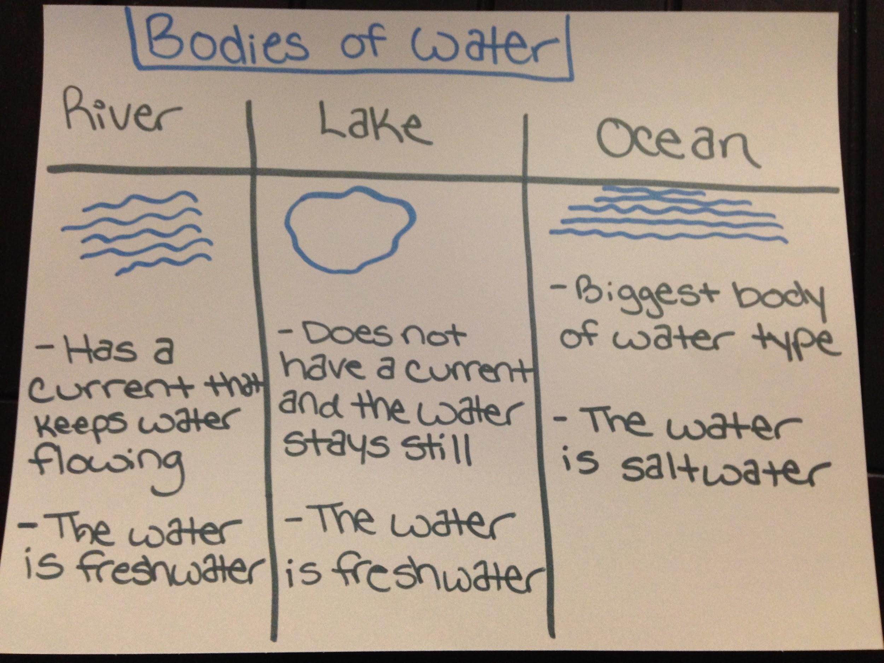

- Have students move to their desks to begin observation of the states of water activity.
- Give each student 3 ice cubes (in one of their clear plastic cups), ⅓ cup of room-temperature water (in the other clear plastic cup), and a science journal.
- Ask the students to write down and illustrate their observations of the water and of the ice cubes in their science journals.
  - Encourage the students to write about texture, color, relative temperature, and shape observations.
- Discuss their observations as a full class.
  - What did they see? Color? Shape? Texture?
  - What did they observe about the temperatures? Which was colder, warmer?
- Explain that water exists in liquid and solid forms on Earth.
  - Explain that liquid means the water can flow and that it takes the shape of whatever is holding it (container, land around it, etc.). Water in the liquid state can also be scooped up with a bucket and poured out.
    - If desired, have a couple students demonstrate scooping up water out of a bowl with a plastic cup and pouring it out into another cup.
    - Relate the liquid form of water to the room-temperature water used in the observation activity.
  - Give examples of water in liquid form.
    - The Atlantic Ocean is always in liquid form because its temperature never gets cold enough to freeze.
    - The Mississippi River is in liquid form when it is summer in North America because the temperature is too high to freeze the water.
  - Explain that solid means the water cannot flow and that it has a certain shape that does not change. It cannot be poured. Students may be familiar with the term frozen.
    - Relate the solid form of water to the ice cubes used in the observation activity.
  - Give examples of water in solid form.
    - Antarctica has a lot of solid water on it because of its very cold temperatures.
    - The lakes in Wisconsin are in the solid state when it is winter in North America because the temperatures are cold enough to freeze the water.
- Have the students identify 2 oceans, 2 lakes, and 2 rivers on a mini globe beachball.
  - Give each student a globe beachball, 2 blue stickers, 2 red stickers, and 2 green stickers.
  - Have the students write their names on the top of their globe beachballs with a Sharpie marker. There should be two Sharpie Markers that can be passed around the room so each student may write his/her name.
  - Ask the students to put their blue stickers on the 2 oceans they identify, their red stickers on the 2 lakes they identify, and their green stickers on the 2 rivers they identify.
    - The teacher should walk around and observe the students doing this activity. Collect the globes when they are finished to be evaluated.
Adaptations:
- If you are unable to show the video on the differences between the different types of bodies of water, you can omit this step. Instead, complete the anchor chart with the students and assist them with their explanations as needed.
  - Feel free to find other videos that describe the same concepts if you are not satisfied with the one provided.
- Students can draw pictures or explain observations orally if they are unable to write in their science journals.
- If globe beachballs are not available, print out a map of Earth for each student. Do the same activity using the print-out instead of the globe beachball.
Assessments:
- Teacher Observation: The teacher should observe to make sure students are paying attention to the video and participating in the creation of the anchor chart. The teacher should observe and listen to the turn and talk in which students discuss bodies of water they are able to identify on a map.
- Science Journals: The students will write about their observations of water in both liquid and solid form.
  - Grading Criteria: The students should have at least two sentences describing their observation of the water. The students should have at least two sentences describing their observations of the ice cubes. The students should discuss at least two of the following topics: color, texture, shape, and relative temperature.
- Globe Beachball Activity: The students will identify oceans, lakes, and rivers using stickers on a globe beachball.
  - Grading Criteria: The students should correctly identify 2 oceans, 2 lakes, and 2 rivers on their globes.

Lesson 4
Theme: The Water Cycle
Content Area: Science (Geology)
Grade Level: 2nd
Time: 50 minutes

Next Generation Science Standards:
2-ESS2-3 - Obtain information to identify where water is found on Earth and that it can be solid or liquid

Disciplinary Core Ideas:
ESS2.C - The Roles of Water in Earth’s Surface Processes
- Water is found in the ocean, rivers, lakes, and ponds
- Water exists as solid ice and in liquid form

Crosscutting Concepts
- Stability and Change: Things may change slowly or rapidly. (2-ESS2-1)

Learning Objectives:
- The students will be able to describe the steps of the Water Cycle.
- The students will recognize that the Water Cycle is a faster process than Plate Tectonics.

Academic Language:
Precipitation, Condensation, Evaporation, Water Vapor, Rain, Snow, Hail, Cloud

Activities:
- Review Where Water is Found
- Read a Book about the Water Cycle
- Water Cycle Anchor Chart
- Water Cycle Cloud Model (optional)
- Exit Slip

Materials Needed:
- Review Where Water is Found
  - No materials needed
- Read a Book about the Water Cycle
  - The Snowflake: a Water Cycle Story By: Waldman, Neil
  - *You are welcome to use any book that explains the Water Cycle. This book is just a suggestion.
- Water Cycle Anchor Chart
  - Chart Paper
  - Markers
  - Tape
- Water Cycle Cloud Model (optional)
  - Clear Plastic Cups (1/student)
  - Room Temperature Water (½ cup/student)
  - Shaving Cream
    - Each student will need enough to fill the area of the plastic cup’s opening
  - Blue Food Coloring (1 bottle/every 4 students)
  - Science Journal
    - Same science journals used throughout the unit
    - Pencil (1/student)
  - Paper Towels (1/student)
- Exit Slip
  - Here (1/student)

Prior Knowledge:
- The students need to have knowledge of where water is found and that it can exist in a liquid state.

Procedure:
- Before the students arrive, set out one clear plastic cup for each student. Fill each cup with ½ cup of room-temperature water. Spray shaving cream on top of the water in each cup until it fills up the whole area of the opening of the cup. These materials will be used later on in the lesson, so put them somewhere that is out of reach of the students and can be accessed easily.
- The students should sit on the carpet/in a group on the floor.
- Briefly review the places where water is found.
  - Oceans, Rivers, and Lakes
- The teacher should begin reading The Snowflake: A Water Cycle Story
  - As important academic terms come up in the book, stop and explain to the students what each word means. In addition, teach them the action for the academic terms and have them do this action every time the word appears throughout the book.
    - Evaporation: Water gets warmer and changes from a liquid to a gas. It then floats up into the sky.
      - Action: Start with your hands out in front of you. While wiggling your fingers, raise your hands towards the ceiling.
    - Condensation: Water vapor in the air gets colder and turns into clouds.
      - Action: Start with your hands above your head. Move your hands left and right while wiggling your fingers.
    - Cloud: Drops of liquid water that float in the sky.
      - Action: Start with your hands above your head. Use just your pointer fingers and pretend as if you are pressing buttons with them.
    - Precipitation: Too much water has condensed in the clouds and it gets too heavy for the air to hold it. It falls back down to Earth.
      - Action: Start with hands above your head with your palms facing down. Lower your hands toward the ground.
    - Rain: A type of precipitation in which water is in liquid form.
      - Action: Start with your hands above your head with your palms facing down. Wiggled your fingers as you lower your hands to the ground.
    - Snow: A type of precipitation in which water is in solid form as snowflakes.
      - Action: Start with your hands above your head. While wiggling your fingers, move your hands toward the ground in a zig-zag pattern.
    - Hail: A type of precipitation in which water is in solid form as small balls of ice.
      - Start with your hands in fists above your head. Punch in front of you in a downward motion.
- The teacher should begin making an anchor chart on the Water Cycle.
  - Get out a large piece of chart paper and tape it to the whiteboard/chalkboard.
  - Write “The Water Cycle” at the top of the chart paper.
  - Ask the students to recall and describe what happens during the first step of the Water Cycle from the book they read. They may turn and talk to a partner about this step.
    - Evaporation: Water from an ocean, lake, or river heats up and turns into a gas (water vapor). It rises up into the air.
  - Draw a lake/river/ocean at the bottom of your chart paper and a sun in the top right corner of your chart paper. Draw an arrow pointing up and label it evaporation. You may want to draw tiny polka dots around the arrow to symbolize water vapor rising. Draw attention to the fact that the sun is heating the water up causing it to become water vapor and rise.
  - Ask the students to recall and describe what happens during the second step of the Water Cycle from the book they read. They may turn and talk to a partner about this step.
    - Condensation: Water vapor gets colder and turns back into liquid form to form clouds in the sky.
  - Draw a cloud at the top of your chart paper. Connect the first step (evaporation) to the second step (condensation) with an arrow going from the sun to the cloud. Draw attention to the fact that the water vapor is getting colder as it becomes a cloud.
  - Ask the students to recall and describe what happens during the third step of the Water Cycle from the book they read. They may turn and talk to a partner about this step.
    - Precipitation: The drops of water in the cloud get too heavy for the air to hold, so they fall back down to Earth as raindrops, snowflakes, or hail. Do the actions for rain, snow, and hail as you talk about these words.
  - Draw raindrops, snowflakes, and hail coming down from the cloud with an arrow pointing back toward the lake/river/ocean at the bottom of your chart paper. Draw attention to the fact that the precipitation ends up in the lake/river/ocean when it falls from the sky.
  - Your anchor chart should look similar to the one below:
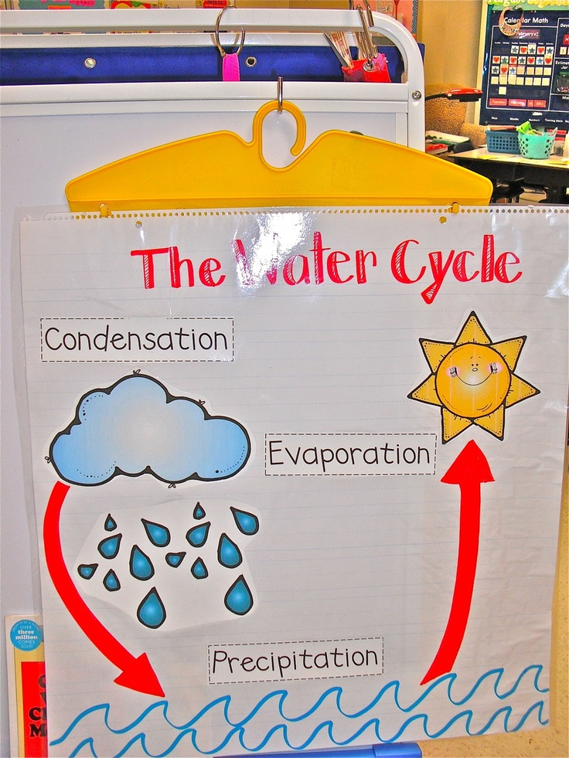
Image found here.

  - Explain that this process repeats itself over and over again and that water changes position faster than the plates on Earth move apart and collide. We can see the changes that water makes in our day-to-day lives.
  - Use this website for more information about the steps of the water cycle!
- Ask if the students have any questions about the Water Cycle.
- Have the students return to their seats to begin the Water Cycle Cloud Model.
  - Give each student a paper towel and have him/her place it on his/her desk. Give each student a clear plastic cup of water and shaving cream (the ones you set up before the students arrived) and have him/her place it on top of the paper towel.
  - Pass out a bottle of blue food coloring to every fourth student. Make sure they know that they should wait for instructions before using the food coloring and that they will need to share with the three other students sitting next to them.
  - Pass out a science journal and pencil to each student.
  - Ask the students what they think the shaving cream and water in their cups represents.
    - The shaving cream represents a cloud.
    - The water represents a lake/river/ocean.
  - Have the students squirt ten drops of blue food coloring on top of the shaving cream.
  - Ask the students to write down what they observe in their science journals. Also have them answer the question “Which step of the Water Cycle are you observing?”
  - Ask the students what they think the blue food coloring represents in their model.
    - The food coloring represents drops of water. When the drops of food coloring are in the cloud they are in the condensation step of the Water Cycle. When the drops of food coloring begin to fall from the shaving cream they are in the precipitation step of the Water Cycle.
  - Have the students discuss their observations with a partner and then call on a few of them to share with the whole class.
- Clean up the Water Cycle Cloud Model supplies.
- Hand out an exit slip to each student.
  - The students will be given a diagram of the Water Cycle with blank lines labeling each step and other related parts. They will have to write the three main steps and the word “river” on their correct lines on the diagram. They will be given a word bank with the following words: precipitation, river, evaporation, condensation.
  - Have the students hand in their exit slips before they leave.

Adaptations:
- Students can draw or explain their observations orally if they are unable to write in their science journals.
- The book used in this lesson is just a suggestion. The teacher may substitute this book with any other book that discusses the Water Cycle. Keep in mind that you may need to adjust the procedure depending on the details of the book you choose.
- If students are allergic to materials used in the cloud model, they may pair up with a student and watch/make observations while their partner does the experiment.

Assessments:
- Teacher Observation: Observe to make sure the students are participating in the read-aloud and the creation of the anchor chart. They should be doing the TPR actions and turning to talk to their partners when asked to do so.
- Science Journals: The students should record their observations of the Water Cycle Cloud Model in their science journals.
  - Grading Criteria: The students should write at least one sentence about something they observe and one sentence answering the question “What step of the Water Cycle are you observing?”
- Exit Slip: The students should label the parts of the Water Cycle on their exit slip before leaving class.
  - Grading Criteria: The students should have all four of the parts of the Water Cycle labeled correctly. There will be four total parts that they will need to label. If they get all 4 of the labels correct, they understood the material taught in class. If a students gets 3 or less of the labels correct, the teacher may need to review the Water Cycle.
  - The answers from left to right are: evaporation, condensation, precipitation, river

Lesson 5
Theme: Erosion
Content Area: Science (Geology)
Grade Level: 2nd
Time: 60 minutes

Next Generation Science Standards:
2-ESS2-1 - Compare multiple solutions designed to slow or prevent wind or water from changing the shape of the land.

Literacy Standard:
CCSS.ELA-Literacy.W.2.8 - Recall information from experiences or gather information from provided sources to answer a question.

Disciplinary Core Ideas:
ESS2.A - Earth Materials and Systems
- Wind and water can change the shape of land
ETS1.C: Optimizing the Design Solution
- 􏰀 Because there is always more than one possible solution to a problem, it is useful to compare and test designs.

Crosscutting Concepts:
- Stability and Change: Things may change slowly or rapidly. (2-ESS2-1)

Learning Objectives:
- The students will be able to define erosion and factors that cause it.
- The students will be able to develop a solution to prevent wind and water from changing the shape of the land.

Academic Language:
- Erosion, wind, water, prevention, vegetation, matting

Activities:
- Review
- Erosion Video
- Debrief the Video
- Erosion Experiment

Materials Needed:
- Review
  - Convergent Boundaries PowerPoint
- Erosion Video
  - Computer
  - Projector/Screen
  - Video
- Debrief the Video
  - No materials needed
- Erosion Experiment
  - Plastic Straws (1/student)
  - Medium-Sized Spray Bottle (1)
  - Water to Fill Spray Bottle
  - Medium-Sized Plastic Bin
  - Sand
    - Enough to fill up one half of the plastic bin
  - Science Journals
    - Same science journal used throughout the unit
    - Pencil (1/student)
  - Assortment of Classroom Objects
    - Things that could be used to slow the process of erosion in your model of the land
- How Erosion is slowed today
  - Computer
  - Projector/Screen
  - PowerPoint Presentation
- Exit Slip on Change over Time
  - Worksheets (1/student)

Prior Knowledge:
- The students should have knowledge of Plate Tectonics and should understand that it is a very slow process.

Procedure:
- Before the students arrive, fill the spray bottle with water.
- Have the students sit on the carpet/in a group on the floor.
- Review how mountains were created using Slide 6 on the Convergent Boundaries PowerPoint used in Lesson 1.
  - Continental-continental convergent boundary: Two continental (land) plates collided causing mountains to form.
- Connect knowledge of mountains to the concept of erosion.
  - We know how mountains were created and now we are going to learn about how they change over time.
  - Teach students the academic term erosion and have them do the action along with you.
    - Erosion: When wind and water change the shape of land over time.
      - Action: Start with hands out in front of you with one hand on top of the other. While keeping the bottom hand in place, move your top hand back and forth to symbolize erosion. The students should do this action every time the academic term erosion appears throughout the lesson.
- Play the video about erosion and have the students watch it.
- When the video is over, ask the students to turn and talk to a partner about one thing they learned from the video. Encourage the students to use their TPR actions when academic terms come up in conversation.
- Explain to students that the process of erosion can fast or slow depending on how big the land is and what makes up the land which is eroding. Explain to the students that it is possible to slow the process of erosion in various ways. Encourage them to think about how they might slow this process. They may want to turn and talk with a partner. Have the students find materials around the room that they think could aid them in slowing the process of erosion in a model of the land. Each student should find 1-2 different materials. Make sure these materials are waterproof or do not need to be re-used.
- Ask the students to sit back down at their desks with their chosen materials.
- Hand out one science journal and a pencil to each student.
- Take the students outside on the blacktop or in an open area of grass. Make sure the students bring their materials for slowing down erosion and their science journals outside with them.
- The teacher will need to bring the clear plastic bin, the sand, the full spray bottle, and the straws outside.
  - Fill one half of the plastic bin (see picture below) with sand. Tell the students that the sand symbolizes land.
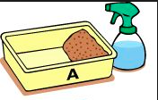
Image found Here

  - Give a straw to each student.
  - Ask for 3-5 volunteers to spray water on the sand using the spray bottle. The students should each spray the sand 5 times.
  - Have the students record their observations in their science journals.
  - Have each student come up to the bin with a straw and use the straw to blow the sand five times. Ask the students what they think blowing through the straw symbolizes.
    - Blowing through the straw symbolizes wind.
  - Have the students record their observations in their science journals.
- Ask the students to find a partner.
- Each pair will need to come up with a solution to slow the process of erosion using the materials they collected from around the room.
  - The students should choose to prevent either wind or water erosion.
  - They will need to discuss which of their materials they think will work best to slow the process of erosion that they chose.
  - Have each pair of students present their solution using the sand model. They should present their solution in front of the whole class and their classmates should record their observations in their science journals.
    - They should write what type of erosion is being prevented, what materials they used to prevent it, and how well it worked to prevent the type of erosion.
  - Repeat the above step for each pair of students.
  - The students should decide which of the solutions seemed to work the best for preventing each type of erosion (wind and water). They should report their conclusion in their science journals.
- Clean up the materials used outside and return to the classroom.
- Have the students sit in their desks.
- Let the students know that they did a good job trying to find solutions to prevent wind and water erosion using their model.
- Teach the students real-life examples of how humans try to prevent wind and water erosion from eroding soil using this PowerPoint.
  - Explain that humans care about preventing soil erosion because we need soil to plant food.
  - Examples of prevention solutions include:
    - Planting Vegetation (trees and other plants) to contain soil.
    - Using mulch or fertilizer
    - Matting
- Have the students return to their desks.
- Pass out an exit slip to each student.
  - The exit slip with include the three systems of the Earth that change over time. They will need to circle whether the system is a slow process or a fast process. The students will also need to write down one thing they learned from the whole unit and any questions they still have.
  - Collect the exit slips from the students.

Adaptations:
- If necessary, students can work in groups of three or alone for the Erosion Experiment.
- Students can draw or share their observations orally if they are unable to write.
- The materials used to prevent erosion in the Erosion Experiment will vary depending on the classroom.

Assessments:
- Teacher Observation: The teacher should observe the students to make sure they are participating in the TPR actions, watching the erosion video, participating in the Erosion Experiment and listening attentively to the PowerPoint presentation on how erosion is prevented today.
- Science Journals: The students should record their observations in their science journals during the Erosion Experiment.
  - Grading Criteria: The students need to write at least one sentence about their observations of water (spray bottle) erosion and at least one sentence about their observations of wind (straw) erosion. They will also need to record their observations of their classmates’ solutions to slow the process of erosion. The type of erosion being slowed/prevented, the materials being used, and how well the materials worked should be included. The students will also need to include their conclusions as to which model they they think worked the best to slow/prevent each type (wind and water) of erosion.
- Exit Slip: The students will fill out an exit slip pertaining to the systems of Earth and how they change over time.
  - Grading Criteria: The students must circle the correct response for each system of Earth and each academic language question. They must also write at least one sentence about something they learned in the unit as a whole. If they have any questions about the unit, they should include them on this exit slip.
    - The answers are:
      - 1) b
      - 2) a
      - 3) c
      - 4) a
      - 5) c
      - 6) b
      - 7) c
      - 8) a
    - Be sure to answer any of their questions the next time you hold class.

REFERENCES

Envirothon (n.d.). Retrieved March 19, 2015, from
http://www.envirothon.org/pdf/CG/Why_Soil_is_Important.pdf

Flood, T. (Professor) (2014, September 29 and October 6). Plate Tectonics. Lectures conducted
from St. Norbert College, De Pere, WI.

KidZone Science The Water Cycle. (n.d.). Retrieved March 19, 2015, from
http://www.kidzone.ws/water/

Landscape Maintenance - Soil Erosion Prevention. (n.d.). Retrieved March 19, 2015, from
http://www.landscapeplanet.com/maintenance-1-soil-erosion-prevention.htm

