EarthScope Alaska Native Geoscience Learning Experience

Field Trip Guide

The 1964 Great Alaska Earthquake and Tsunami: Consequences of Living on the Leading Edge in Alaska

October 1, 2022

Field trip leaders: Beth Pratt-Sitaula, Jennifer Pickering, Bob DeGroot

Guide modified from the original written by Rob Witter, USGS

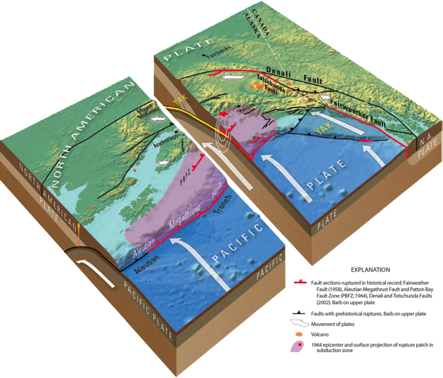
Perspective view of the Pacific Plate being subducted beneath the North American plate at the Alaska-Aleutian Subduction zone. The pink highlighted region shows the part of the megathrust fault (plate boundary) that slipped in 1964 during the Great Alaskan Earthquake. White arrows show relative plate motion. Red and black bold lines show important faults of the South Central Alaska region. (Source: USGS, https://pubs.usgs.gov/fs/2014/3018/)

Field trip stops and driving times
Stop | Location | Arrive | Depart | Duration | Topic
0 | UAA Gorsuch Commons | 7:30 am | 8 am | 30 min | Start field trip
Drive time: 16 min (8.5 mi)
1 | Sunset Park | 8:20 am | 9:00 am | 40 min | 1964 earthquake landslides
Drive time: 41 min (32 mi)
2 | Bird Point | 9:45 am | 10:45 am | 60 min | UNAVCO GPS instrument
Drive time: 31 min (26 mi)
 | Whittier Tunnel | 11:15 am | 11:30 am | 15 min | Tunnel to Whittier
Drive time: 8 min (3 mi)
3 | Whittier | 11:40 am | 1:40 pm | 2 hrs | Tsunami / LUNCH
Drive time: 5 min (2 mi)
 | Whittier Tunnel | 1:45 pm | 2 pm | 15 min | Tunnel to Girdwood
Drive time: 29 min (21 mi)
4 | Girdwood Ghost Forest* | 2:30 pm | 4:15 pm | 1 hr 45 m | Earthquake evidence
Drive time: 43 min (38 mi)
5 | UAA Gorsuch Commons | 5ish pm |  |  | End of field trip
*Low tide at Girdwood is around 5:36 pm on October 1, 2022.
Note: If a pit stop on the return to Anchorage is necessary, the bus could stop at Bird Point, which would add ~30 min.

Field trip map
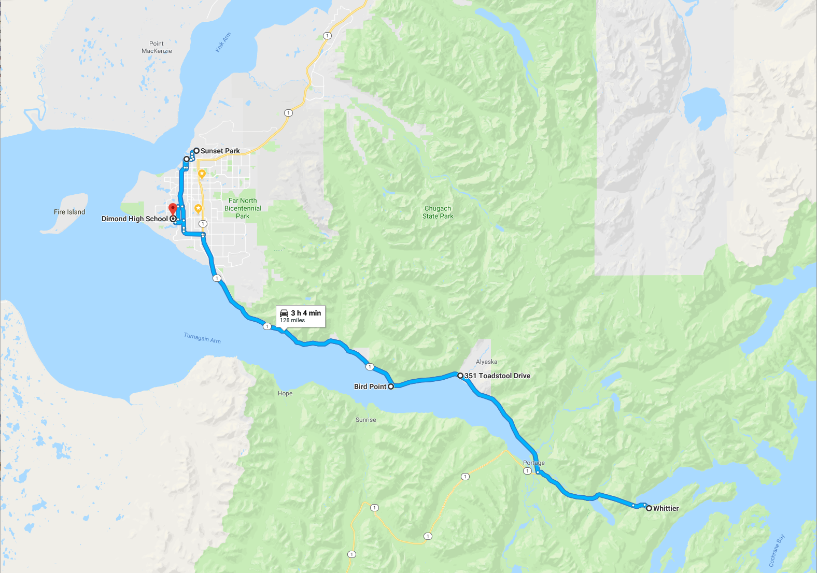

Stop 0. Introductions and start of the field trip (7:30–8:00 am)

This 8-hour field trip, part of the EarthScope Alaska Native Geoscience Learning Experience Workshop, will review the impacts of the 1964 great Alaska earthquake and offer glimpses of the geology of south-central Alaska between Anchorage and Whittier.

The Anchorage area is poised on the edge of a very active plate boundary between the North American and Pacific plates (cover illustration). These two plates are converging (crashing into one another!) at a rate of about 2.3 inches/year (~5.8 cm/year), and this convergence directly or indirectly causes many of the most prominent geological features in this region. The Alaska-Aleutian subduction zone, at the plate boundary, is responsible for most of the earthquake activity in south-central Alaska—including the 1964 Earthquake. Because of its higher relative density, as it collides into North America, the Pacific plate descends (subducts) beneath the North American plate. The broad interface where the two plates come into contact (pink area on cover illustration) is a giant thrust fault called a megathrust. The megathrust projects to the seafloor at the Aleutian trench, which is greater than 3 miles (>5000 meters) deep in the Gulf of Alaska. As the two plates converge, the megathrust undergoes “stick-slip” motion: Friction causes the plates to stick together and accumulate elastic strain, which slowly bends and buckles the plates as they continue to move. An earthquake happens when the megathrust fault slips, causing the plates to rebound elastically like springs, relieving the stress and resulting in widespread vertical and horizontal changes of the surface topography. The 1964 great Alaska earthquake was an example of slip on the eastern Aleutian megathrust over an area ~580 miles long by ~150 miles wide.

Four field stops (see schedule of stops above) will focus on some of the most costly, and lasting effects of the 1964 earthquake between Anchorage and Whittier. Among the many damaging effects of the earthquake, translational landslides triggered by earthquake ground motions caused the greatest devastation (Hansen, 1966). The first stop will visit Sunset Park, the site of the Government Hill landslide that caused the collapse of the Government Hill Grade School, destroyed two houses and damaged a third, and wrecked railroad property along Ship Creek.

Enroute to the second stop at Bird Point to visit UNAVCO GPS station AC20, we will drive along Turnagain Arm, a shallow fjord that extends east from Cook Inlet. Turnagain Arm is the scenic gateway to Whittier, Seward and other points of interest on the Kenai Peninsula. James Cook’s 1778 expedition originally named the waterway Turn Again River out of frustration in their failed search for a Northwest Passage. Tides in Turnagain Arm range between 25 to 30 feet and produce currents in excess of 6 miles per hour. Turnagain Arm is also one of only about 60 bodies in the world to host a tidal bore. A tidal bore is a wave that forms at the leading edge of the incoming tide, and on a high spring tide, the Turnagain bore may travel at speeds up to 15 miles per hour and reach a height of 6 feet. As we drive east along the Seward Highway, look for Dall sheep foraging or sunning themselves on the steep south-facing slopes of the Chugach Range.

The third stop of the day will take us to the port of Whittier at the western end of Passage Canal. The drive to Whittier passes through the second longest (2.5 miles) highway tunnel in North America, the Anton Anderson Memorial Tunnel. The Army Corps of Engineers built Whittier in 1942-43 to provide an all-weather port connected by railroad to Anchorage and Fairbanks for military purposes. Our visit to Whittier will focus on the devastating effects of tsunami waves generated by underwater landslides triggered by earthquake shaking in 1964 (Kachadoorian, 1965).

The fourth stop near Girdwood will reveal the lasting effects of earthquake subsidence in 1964 that dropped Turnagain Arm by as much as 8 feet. Along the way, look for evidence of earthquake subsidence that led to the relocation of Girdwood and the abandonment of Portage. Vertical deformation during the 1964 earthquake dropped much of the railway and Seward Highway below high tide level, and killed swaths of spruce trees whose remains haunt the shoreline as forests of bleached snags.

8:00 AM — UAA Gorsuch Commons, drive 5.8 mi (15 min) to Sunset Park, Government Hill
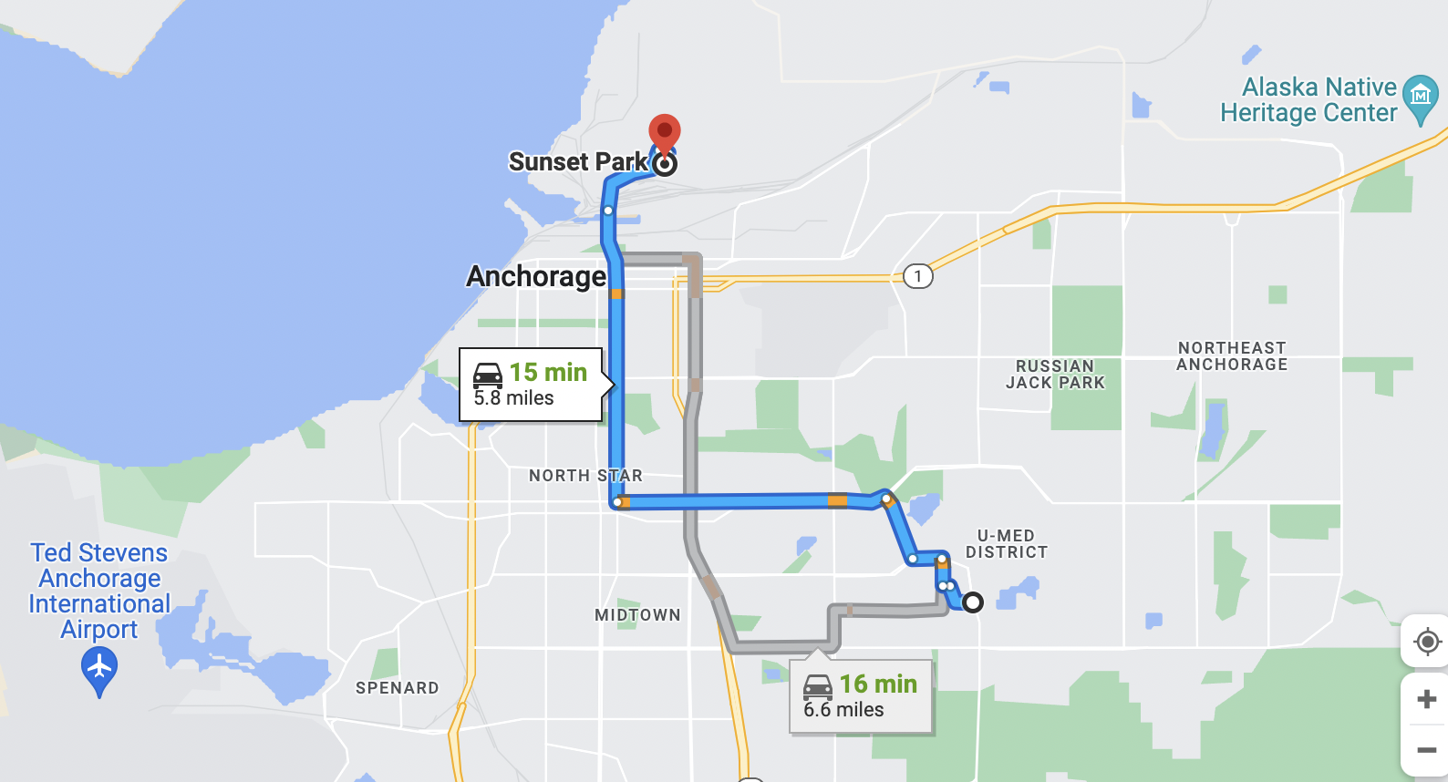

Along the way to our first stop, browse historical photographs, maps, and documents that show the damaging effects of the 1964 earthquake via an interactive web map available here: https://alaska.usgs.gov/news/1964Earthquake/ (note: if you get a prompt to log in to arcgis.com, just hit cancel).

The 1964 Great Alaska Earthquake Photo Tour of Anchorage was created as part of the commemoration events for the 50th anniversary of the 1964 Great Alaska Earthquake. The photo tour shows buildings in Anchorage that were severely damaged, sites of major landslides, and locations of post-earthquake engineering responses. Full documentation by Thoms et al. (2014) that supports the photo tour can be found here: https://pubs.er.usgs.gov/publication/ofr20141086

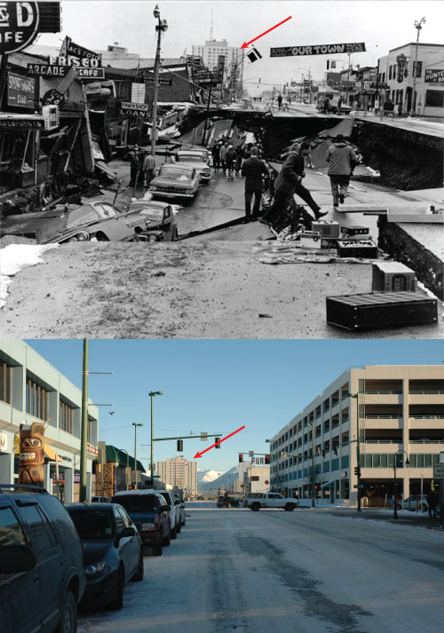
Figure 1 Top: View to the east in downtown Anchorage, Alaska showing buildings damaged at the head of the Fourth Avenue landslide in 1964 (photo: USGS). Bottom: The same view in 2013 (photo: Game McGimsey). Red arrows point to the McKinley Tower in both photos.

The 1964 great Alaska earthquake
On Friday, March 27, 1964 the largest earthquake in U.S. history and the second largest recorded instrumentally worldwide struck south-central Alaska with a magnitude of 9.2. Shaking in the Anchorage area lasted for 4 to 5 minutes and was felt 480 mile west as Dutch Harbor in the Aleutian Islands, and more than 1,200 miles southeast at Seattle, Washington, where the Space Needle swayed perceptibly (USGS Fact Sheet 2014–3018). The 1964 great Alaska earthquake caused regional ground displacements, rockfalls and avalanches, damaging landslides, submarine slumps, liquefaction-related ground failures, and tsunamis. Seafloor displacement caused by slip on the megathrust fault generated a tsunami that propagated across the Pacific Ocean, which resulted in fatalities in Oregon and northern California. Underwater landslides in Alaskan fjords generated local tsunamis that devastated coastal ports and communities in Prince William Sound. All told, the earthquake and tsunamis caused over 120 fatalities and an estimated $2.3 billion in property losses (in 2013 dollars).

On our way to Stop 1 we will drive along Fourth Avenue and pass the head scarp of the Fourth Avenue landslide (Figure 1), now repaired. The slide involved 14 city blocks in the northern part of downtown Anchorage, impacting an area about 36 acres between Fourth and First Avenues and E Street and Barrow Street. The landslide was attributed to translational sliding on a failure plane at a depth of 60 feet due to the loss of strength of sandy layers in the Bootlegger Cove Clay attributed to liquefaction. The process of liquefaction causes saturated sandy sediment to lose strength during strong seismic shaking, which often leads to landsliding and other ground deformations. Buttress Park, located between First and Fourth Avenues, has been re-graded and reinforced with a buried gravel buttress to stabilize the slope. The Port Access Bridge (Figure 2), over which we will drive on A Street, was constructed in 1975, seismically retrofitted in later years, and has been instrumented with seismometers to monitor bridge response to earthquakes and railroad vibrations.

Figure 2. The Port Access Bridge, constructed in 1975 after the 1964 great Alaska earthquake, has been retrofitted over its lifespan to resist earthquake ground motions. The bridge is instrumented with seismometers that measure vibrations generated by earthquakes and trains. In all, 39 sensors have been installed on the bridge to collect data that help formulate ground motion estimates for future earthquakes.

Stop 1. Sunset Park, 1964 Government Hill Landslide (8:20–9:00 am)

At Sunset Park (Stop 1; Figure 3) we will discuss the geomorphology of the Government Hill landslide and its effects as documented by Hansen (1966). The 11-acre Government Hill landslide displaced 900,000 cubic yards of earth along a south-facing bluff on the north side of Ship Creek (Figure 4). The width of the slide extended 1,180 feet from west to east flank. The slide measured 600 feet from head to toe at its greatest length. The south wing of Government Hill school
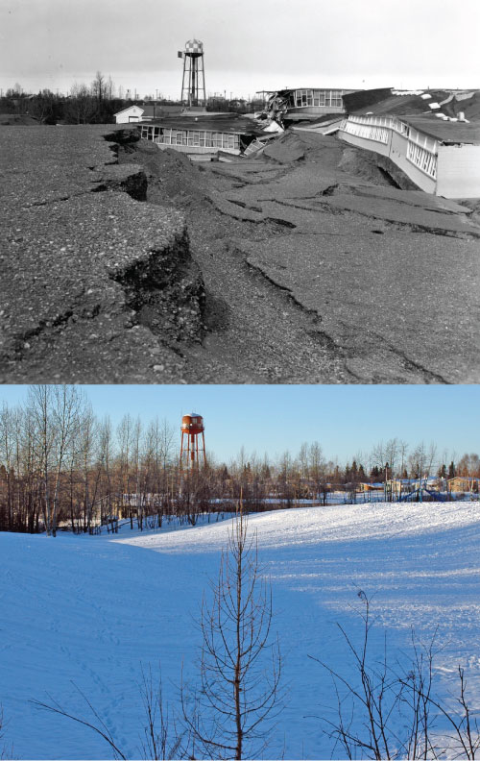

Figure 3. Top: View to the west showing the Government Hill School collapsed into a graben, or linear trough, formed by the Government Hill landslide in 1964 (Hansen et al., 1966). Bottom: Same view in 2013 (photo: Game McGimsey). The graben formed by the landslide is still expressed in the landscape in the lower photo.
dropped 20-feet into a broad graben that formed 400 feet back from the original bluff edge, which sheared the building vertically and stopped electric clocks at 5:36 pm. Lateral displacements varied. Although the south wing of the school shifted 6–7 feet to the southwest, playground equipment and a house at the end of Birch Street moved as much as 35 feet. Sites involved in a lateral earthflow at the toe of the slide were displaced 150 feet causing damage to equipment in The Alaska Railroad yard. Geotechnical investigations determined the failure plane was located in a zone of low shear strength, high water content, and high sensitivity in the Bootlegger Cove Clay at a depth of 70–90 feet below the pre-earthquake bluff elevation (Figure 5).

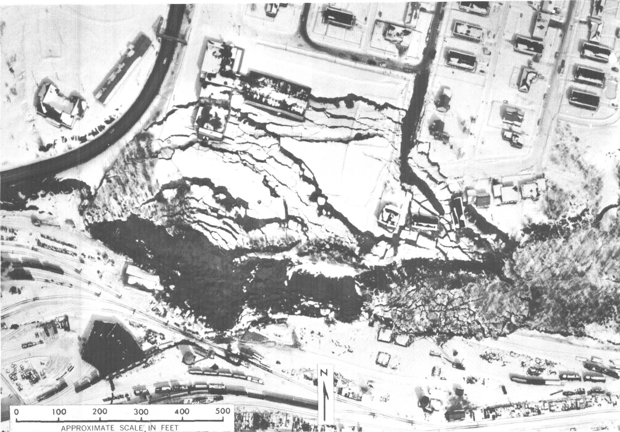

Figure 4. Aerial view of Government Hill landslide (from Hansen, 1966). View direction in Fig. 3 is westward, along the arrow shown in Fig 4 above.

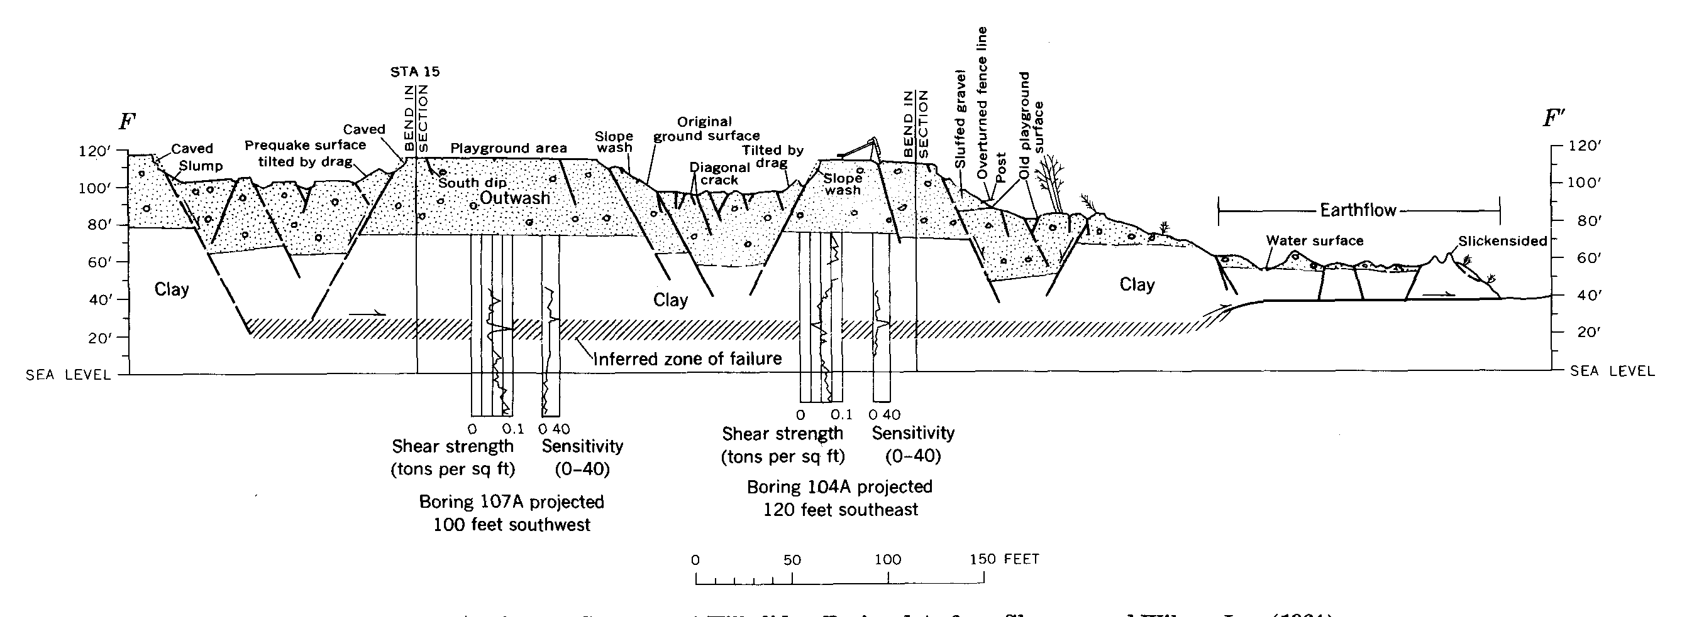
Figure 5. Geologic cross section through Government Hill landslide (from Hansen, 1966).

Translational landslides in Anchorage

The most devastating effects of the 1964 great Alaska earthquake in Anchorage were large translational landslides that caused extensive property losses (Hansen, 1966). Translational landslides involve mass movements that occur along planar failure surfaces with little rotation or backward tilting (Figure 6) (USGS Fact Sheet 2004-3072). Bootlegger Cove Clay that underlies much of Anchorage was deposited in a glacial-marine setting and consists of discontinuous layers of silty clay, sand and gravel. Post-earthquake geotechnical studies of the Bootlegger Cove Clay identified zones of low shear strength, high water content, and high sensitivity that lost strength under the dynamic stresses imposed by seismic shaking in 1964 (Hansen, 1966).

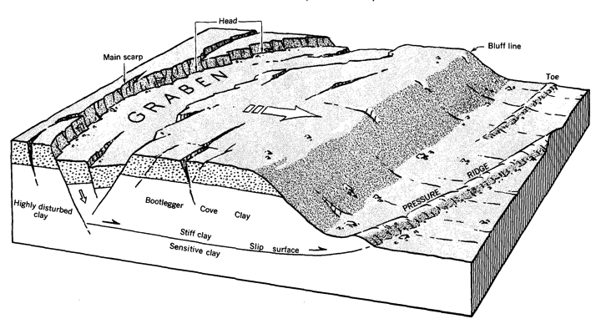

Figure 6. Block diagram of a translational landslide (from Hansen, 1966).

9:00 AM — Depart Sunset Park, drive 32 mi (41 min) to Bird Point
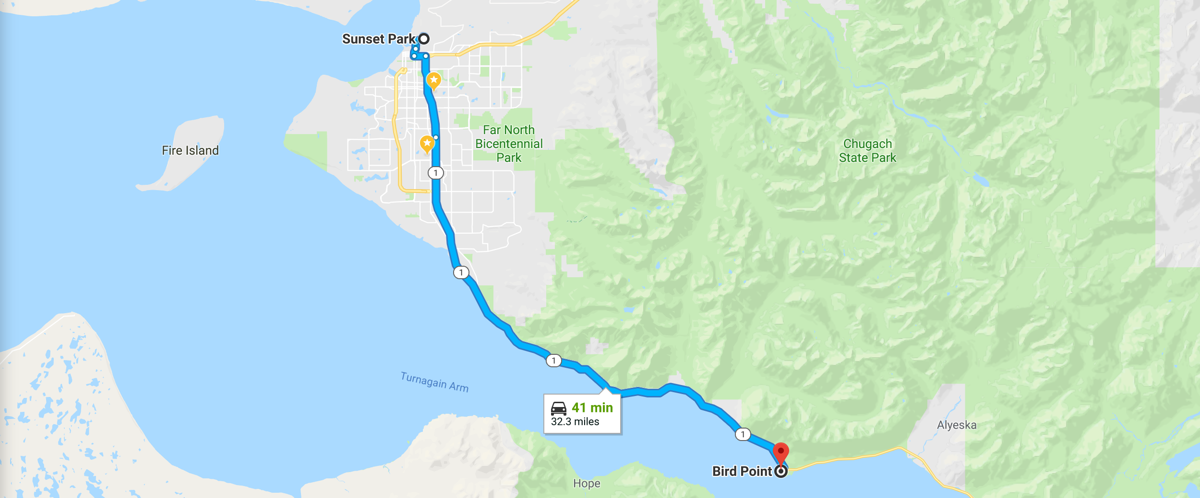

Stop 2. Bird Point, UNAVCO GPS Station (9:45–10:45 am)

The Global Positioning System station (AC20) at Bird Point State Wayside (Figure 7) near Girdwood is in the Network of the Americas (NOTA) GPS network, which is part of an international network of sensors. Along with over 1100 other GPS stations in North America (mostly in the USA’s western regions including Alaska), station AC20 helps us better understand tectonic motions and earthquake and tsunami hazards. This station was installed in 2005 and continues to collect three-component (north, east, height) position data (Figure 8) used to understand tectonics along the Alaska-Aleutian subduction zone.

At this stop we will take a short walk up an unimproved trail to view Station AC20. Discussion will focus on the following questions:

- What are the different parts of the GPS station and what functions do they serve?
- What do the three plots in Figure 8 indicate?
- In what direction has the station moved since it was installed in 2005?
- About how much has the station moved each year?
- About how much has the station moved since 1964, if we assume steady motion?

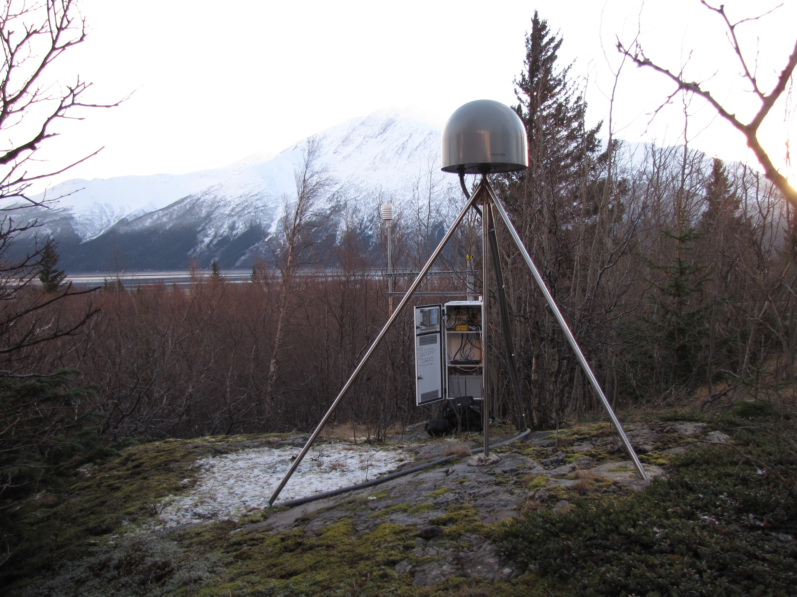

Figure 7. UNAVCO GPS station AC20 located at Bird Point along Turnagain Arm, Alaska. (https://www.unavco.org/instrumentation/networks/status/nota/overview/AC20)
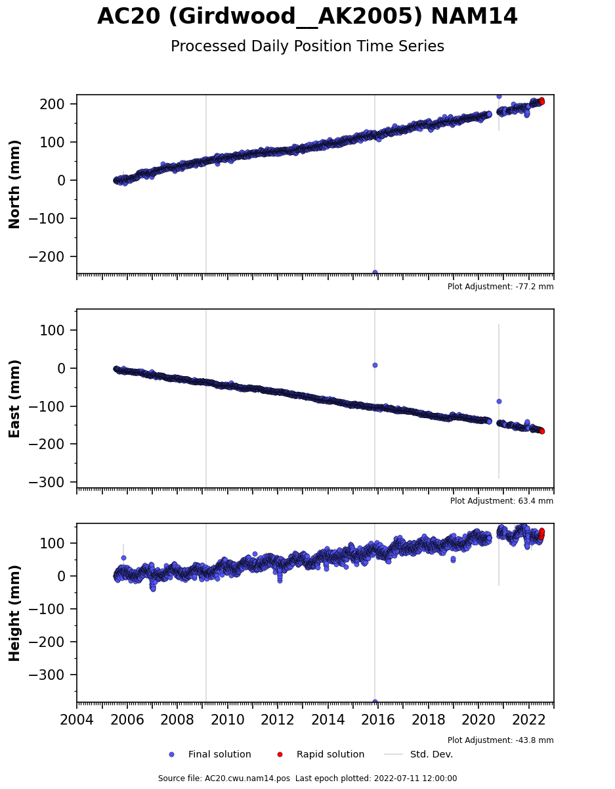

Figure 8. Three-dimensional position time series for UNAVCO GPS station AC20 at Bird Point. (https://www.unavco.org/instrumentation/networks/status/nota/overview/AC20)
10:45 AM — Depart Bird Point, drive 29 mi (54 min) to Whittier
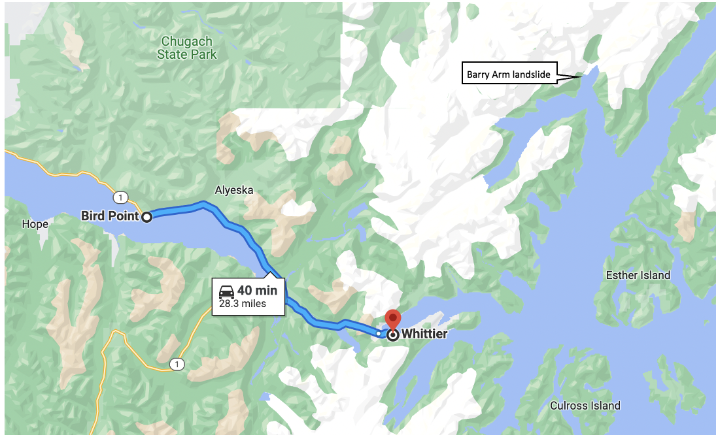

Portage Townsite
As we drive from Bird Point to Whittier tunnel, keep your eyes peeled for the prominent “Ghost Forest” caused by subsidence associated with the earthquake in this area. Also, look for what remains of the Portage townsite as we head toward the Whittier tunnel.

The abandoned townsite of Portage marks the location of the main route through the mountains to Prince William Sound used by native Alaskans and developed by miners in 1902 (Karl et al., 2011). The buildings west of the highway (Figure 9) were flooded by high tides following subsidence during the 1964 earthquake and partially buried by tidal silt deposition that covered more than 18 km2 (7 mi2) at the head of Turnagain Arm over the next two decades. Liquefaction and resulting lateral spreading were responsible for major damage to the highway, railroad, and bridges in the Portage area during the earthquake. Hundreds of fissures up to 4 feet wide developed, from which water and sand reportedly ejected as much as 25-30 feet high for about 2 minutes (Plafker et al., 1969).

At this location, near the axis of maximum subsidence in 1964, the Placer River Silt is up to 6 feet (~2 m) thick. Numerous abandoned buildings in the vicinity are filled with silt and, as at Girdwood, most of the trees on Portage flats were killed by saltwater flooding during the next high tides about two weeks (remarkably fast!) after the earthquake. The pre-1964 ground surface, associated peat layer, and numerous artifacts such as milled wood, cables, and pallets are visible in the bank exposures downstream from the bridge. The infilling of tidal sediment and rapid remaking of the pre-1964 landscape near Portage gives such soils the potential of recording recurrence intervals of great earthquakes that are quite short, on the order of decades (Atwater et al., 2001).
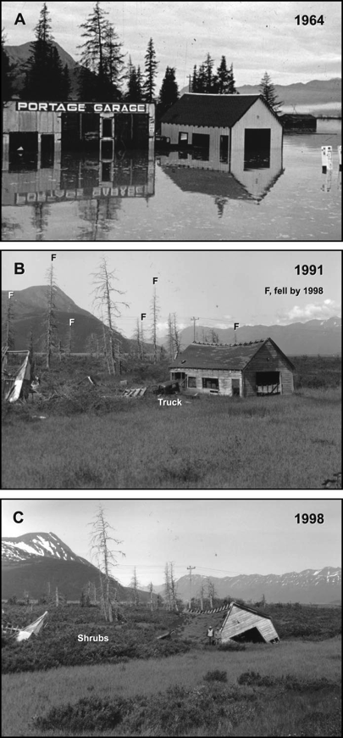

Figure 9. From Atwater et al. (2001). Photos documenting post-earthquake subsidence followed by relatively rapid (10 yrs) redeposition and gradual uplift of the Portage town site following the 1964 Earthquake.

Stop 3. Whittier and the 1964 tsunami (11:40 am-1:40 pm)

At this stop we will eat lunch and discuss underwater landsliding triggered by earthquake shaking in 1964 and the devastating impacts on Whittier. Also at this stop we will walk the tsunami evacuation route, and discuss preparedness issues and the importance of planning for earthquakes and tsunamis and practicing your plan.

Processes at work in Alaska’s fjords create the dangerous potential for underwater landslides triggered by earthquakes, which can generate local tsunamis that may hit nearby shorelines before seismic shaking stops. Of the 122 fatalities in Alaska after the 1964 earthquake, 106 (87%) were the result of tsunami impacts. Of the 106 deaths in Alaska caused by tsunamis, 85 of those (80%) were related to tsunamis generated by submarine landslides. In Alaska’s fjords, sediment transported to the sea by glacial-fed rivers form large deltas of unconsolidated materials that are highly susceptible to slumping during seismic shaking.

The effects of the 1964 tsunamis in Whittier were similar to those in other coastal communities in Alaska, including Seward, Valdez, and the village of Chenega, which lost a third of its population (Plafker et al., 1969). In Whittier, three waves were observed (Kachadoorian, 1965). The first wave arrived about 1-minute after the earthquake hit and water rose to an elevation of 8 m. The second tsunami was a muddy, breaking wave that arrived 1 to 1.5 minutes later and reached an elevation of 12.5 m. Forty-five seconds later, a third smaller wave arrived. Flooding by the tsunami waves was exacerbated by 5.3 feet of earthquake-related subsidence (Kachadoorian, 1965).

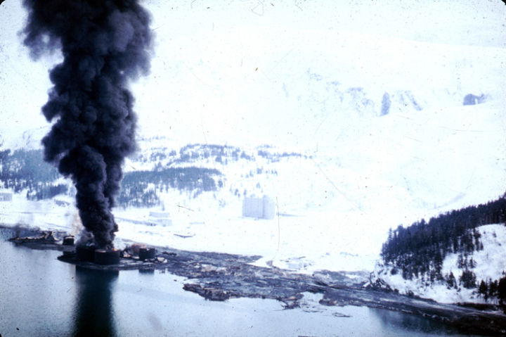
Figure 10. Alaska Earthquake March 27, 1964. The dock area, a tank farm, and railroad facilities at Whittier were severely damaged by surge-waves developed by underwater landslides in Passage Canal. The waves inundated the area of darkened ground, where the snow was soiled or removed by the waves (USGS).
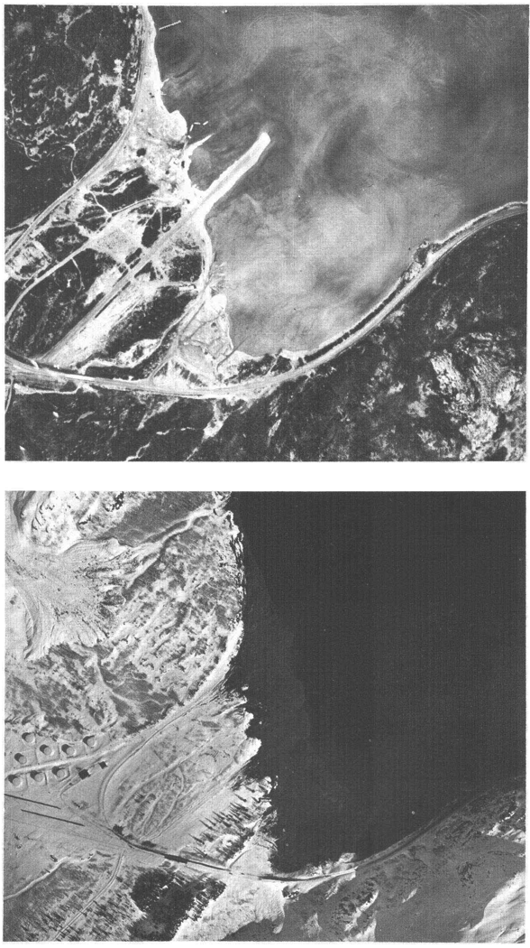

Figure 11. Aerial photographs of Whittier, Alaska, before and after the 1964 earthquake (Kachadoorian, 1965). Top: Whittier before the 1964 earthquake. Composite photograph by BLM, 23 September 1963. Bottom: Whittier after the earthquake. Photograph by U.S. Army, 28 March 1964.
After the 1964 earthquake and tsunami, Whittier suffered massive damage amounting to $10 million (~$74 million in 2012 dollars) and 13 of the city’s 70 inhabitants died (Kachadoorian, 1965). Much of Whittier’s harbor, railroad and sawmill facilities were completely wrecked, particularly buildings constructed on artificial fill or unconsolidated sediment. Only slight damage occurred to buildings constructed on bedrock. Fire destroyed the fuel oil tanks along the waterfront (Figure 10). The tsunami was attributed to the collapse of delta sediment at the west end of Passage Canal (Figure 11).
Figure 12. Detailed bathymetric studies of Passage Canal allow reconstruction of sizes of landslides (Nicolsky et al., 2011; Haeussler et al., 2014). In this figure, color depicts the initial thickness of the landslides.
Figure 13. Map of tsunami flow depth produced from modeled submarine landslides shown in Figure 12 (Nicolsky et al., 2011). The red colors indicate greater water depth than green colors. The yellow line marks the inundation caused by the 1964 tsunami observed in Whittier.
Studies since the devastating 1964 earthquake and tsunami in Whittier have explored the details of submarine landsliding and the tsunami it triggered. A study of bathymetric changes before and after the earthquake show evidence of collapse of the fjord head and Whittier Creek deltas, resulting in the mass displacement of 54.9 million yd³ (42 million m³) of landslide material (Figure 12). This volume is equivalent to the combined capacity of 132 supertankers. Individual landslide blocks within the deposit measured as much as 475 feet long by 82 feet tall (145 m by 25 m), or about one and a half football fields long and as tall as an 8-story building. Material continued down fjord as a debris flow deposit with an average thickness of ~18 feet (5.4 m). A plume of sediment, identified as a megaturbidite, continued to flow down the fjord for a distance of 6 miles (10 km).

Tsunami models that use the observed volume of landslides triggered by earthquake shaking can reproduce the tsunami inundation reasonably well (Figure 13). A study by Haeussler et al. (2014) showed that the landslides that generated tsunamis in Alaska’s fjords eroded the seafloor and involved large blocks that controlled the maximum tsunami runup. They concluded that the abundant glacial sediment produced by Little Ice Age glaciers loaded fjord-head deltas, which were highly susceptible to seismic shaking in 1964. The unusually long (~900 year) interval between the 1964 earthquake and its predecessor may have resulted in the high number and large volume of submarine landslides.

Barry Arm Landslide: North of Whittier, the retreating Barry glacier is exposing an unstable area of land that could cause a tsunami if it slid into the Barry Arm fjord. Scientists have been measuring the creeping movement of the landslide for decades. During the rapid recession of the Barry Glacier from 2010 - 2016, movement rates up to 26 ± 3 m/yr were measured. In March of 2017 movement rates slowed to approximately 1.3 ± 0.7 m/yr as the retreat of the Barry Glacier slowed. If the Barry Arm landslide were to suddenly fail and deposit in the fjord, scientists have modeled a tsunami that could arrive in Whittier within about 30 minutes.

After discussing the submarine landslide-generated tsunami at the Whittier waterfront, we will take part in a tsunami evacuation walk by following the Whittier tsunami evacuation map (Figure 14).
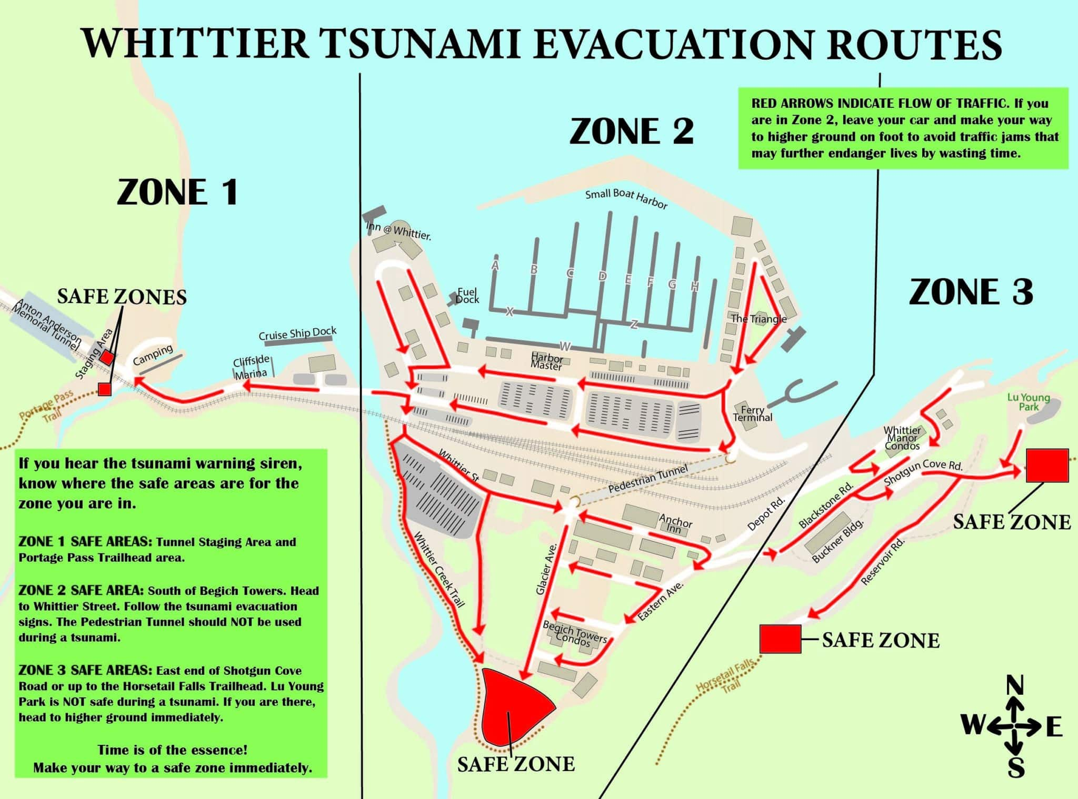

Figure 14. Tsunami evacuation map for Whittier, Alaska.

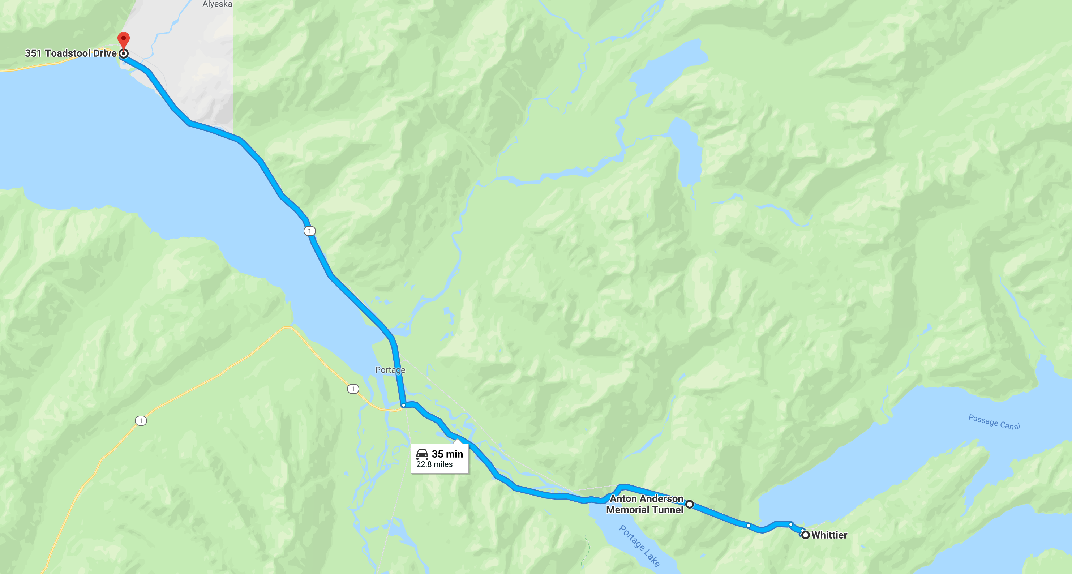
1:40 PM — Depart Whittier, drive 23 mi (49 min) to Girdwood Ghost Forest

Stop 4. Girdwood Ghost Forest (2:30-4:15 pm)

At this stop, (weather permitting) we’ll hike as a group out to the exposed edge of Girdwood Marsh, and examine tidal outcrops that expose evidence of earthquake-related subsidence. Low tide should be around 6:30 pm (Figure 15). Stratigraphy here has recorded the pattern of subsidence and uplift associated with the megathrust earthquake cycle in south-central Alaska. Don’t be afraid to get dirty, but please use caution: do not venture far onto tidal flats because it is difficult to get back to solid ground once stuck in the mud!
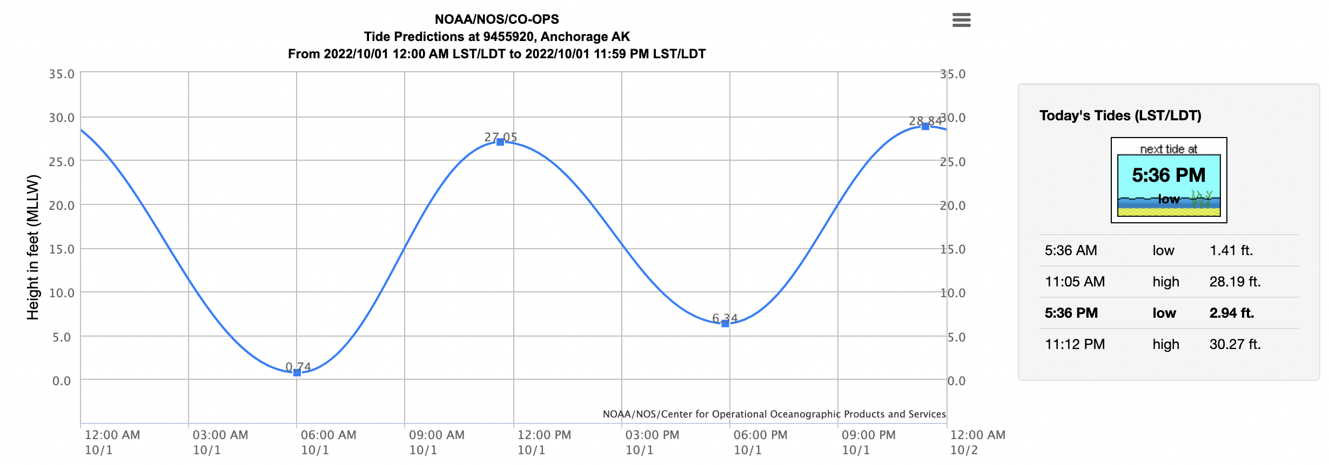

Figure 15. Tide predictions for Anchorage, AK. Low tide is 2.94 ft in Anchorage at around 5:36 pm on Oct. 1, 2022. At Girdwood, low tide is about 1hr later. Low tide at Girdwood should be around 6:30 pm.

The tidal marsh at Girdwood, Alaska, records 7 great earthquakes on the eastern Aleutian megathrust in the past ~3,900 years (Shennan et al., 2008). Predecessors of the 1964 earthquake occurred every ~600 years on average. However, some earthquakes were separated by longer or shorter intervals than 600 years and the amount of land-level change that accompanied some events differed from the ~1.5 m of subsidence in the Girdwood area during the 1964 earthquake.

The Girdwood marsh records vertical changes in land level related to the earthquake deformation cycle (Figure 16). The cycle involves the accrual of strain above a locked megathrust between earthquakes, which leads to slow, gradual uplift of Girdwood and Turnagain Arm. When stresses on the megathrust exceed the strength of the locked interface, the megathrust breaks (slips) and the land rebounds elastically in the opposite direction. Sudden slip on the megathrust during the 1964 earthquake resulted in a regional pattern of deformation: a wide belt of uplift raised coastal areas in Prince William Sound and a parallel trough of subsidence dropped areas along Turnagain Arm and Cook Inlet (Figure 17). Girdwood lies in the area that dropped by ~1.5 m. As a consequence, spruce forests along the shoreline subsided below tide level and were killed by encroaching seawater. The landscape was quickly buried by silt deposited by tides in the decade after the earthquake (Atwater et al., 2001).

Like a bar code, peaty soils buried by silt beneath the Girdwood marsh record seven episodes of sudden earthquake subsidence, including the 1964 soil in which Girdwood’s ghost forest is rooted (Figure 18). Three-to-six feet (1–2 m) of silt buries the 1964 soil and today, marsh plants and young trees indicate that the landscape has been restored to conditions similar to the 1964 landscape. Repeating layers of peaty soil buried by silt at the Girdwood marsh indicate that large earthquakes have dropped Turnagain Arm repeatedly in the past (Figure 18). Radiocarbon ages from samples near the top of each soil show some variability in the time between earthquakes, the earthquake recurrence interval. Some earthquakes were separated by only a few centuries, the time between 1964 earthquake and its predecessor may have been as long as 900 years.

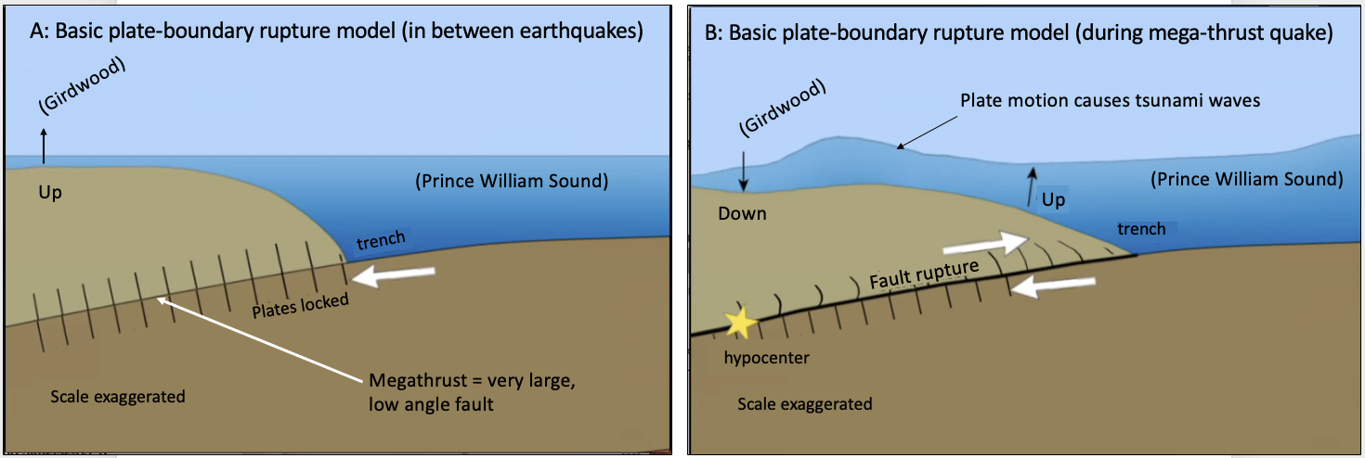

Figure 16. Earthquake deformation cycle of the megathrust and how seafloor dislocation during an earthquake generates a tsunami. (Modified from IRIS, https://www.iris.edu/hq/inclass/animation/subduction_zone_ tsunamis_generated_by_megathrust_earthquakes)

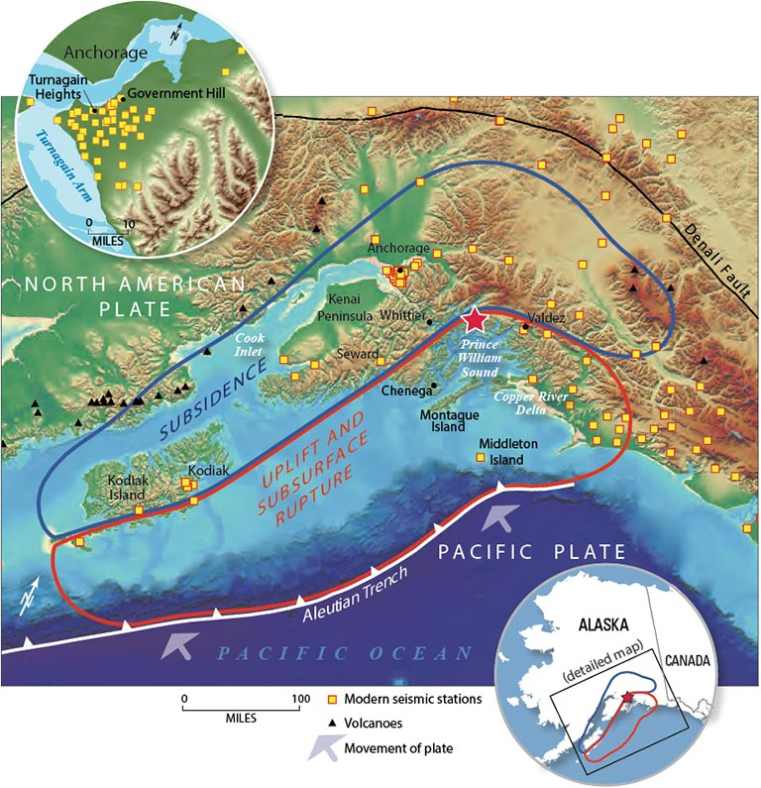

Figure 17. Map of southern Alaska showing the epicenter of the 1964 Great Alaska Earthquake (red star), caused when the Pacific Plate lurched northward underneath the North American Plate. There was extensive damage to coastal towns and infrastructure throughout the region, particularly in Anchorage, Seward, Whittier, and Valdez. Widespread uplift occurred seaward of Kodiak Island and the Kenai Peninsula, while subsidence occurred inland as a result of the magnitude 9.2 earthquake. In 1964, there were no instruments in Alaska capable of recording the earthquake, but now there is an extensive network of stations (yellow squares) that monitor the seismically active plate boundary along the Aleutian Trench (USGS).

Figure 18. Left: Girdwood marsh site. Right: Stratigraphy at Girdwood marsh consisting of interbedded peat and silt. Radiocarbon age estimates shown on right (Shennan et al., 2008). Below: Peat subsided by earthquakes and buried by intertidal mud at Girdwood, Alaska.

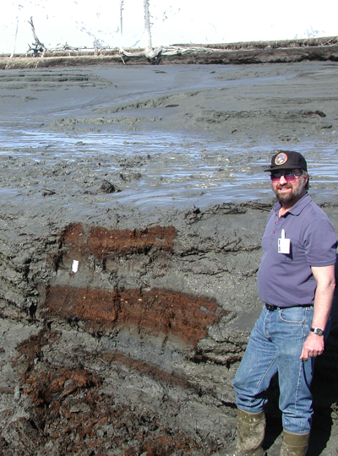
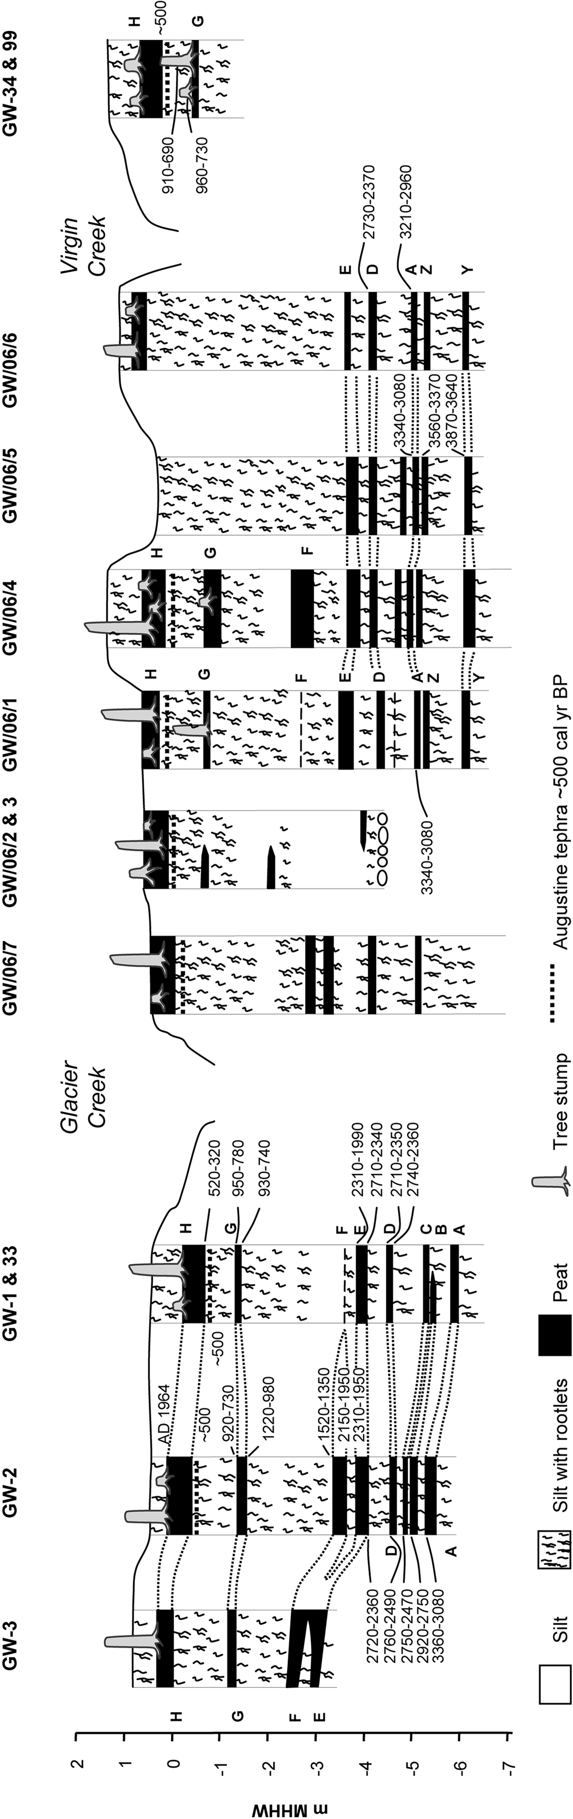
4:15 PM — Depart Girdwood Ghost Forest, drive 36.6 mi (43 min) to Gorsuch Commons
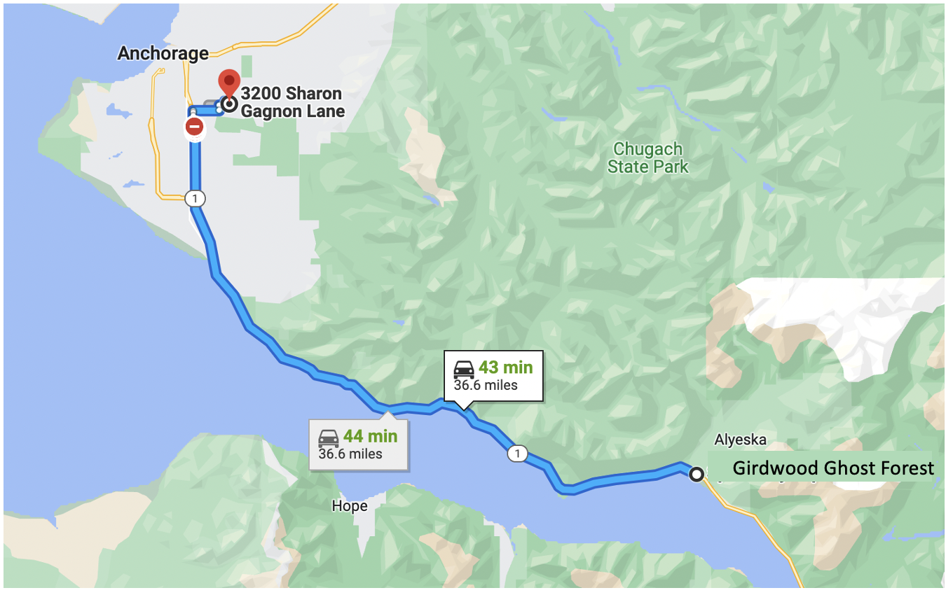

Stop 5. UAA Gorsuch Commons, return to Anchorage (arrive between 5:00-5:30 pm)

End of field trip

References and further reading
Atwater, B., Yamaguchi, D.K., Bondevik, S., Barnhardt, W.A., Amidon, L.J., Benson, B.E., Skjerdal, G., Shulene, J.A., Nanayama, F. (2001) Rapid resetting of an estuarine recorder of the 1964 Alaska earthquake. GSA Bulletin; v. 113; no. 9; p. 1193–1204;
Barclay DJ, Wiles GC, Calkin PE (2009) Holocene glacier fluctuations in Alaska. Quat Sci Rev 28(21–22):2034–2048. doi:10.1016/j.quascirev.2009.01.016
Bradley, D.C., and Miller, M.L., 2006, Field guide to south-central Alaska’s accretionary complex, Anchorage to Seward: Alaska Geological Society, 32 p.
Connelly, William, 1978, Uyak Complex, Kodiak Islands, Alaska: A Cretaceous subduction complex: Geological Society of America Bulletin, v. 89, no. 5, p. 755-769.
Haeussler, P.J., 2008, An overview of the neotectonics of interior Alaska: Far-field deformation from the Yakutat microplate collision, in Freymueller, J.T., Haeussler, P.J., Wesson, R.L., and Ekström, G., eds., Active Tectonics and Seismic Potential of Alaska: Washing- ton, D.C., American Geophysical Union Geophysical Monograph Series 179, p. 83–108.
Haeussler, P., and 9 others (2014), New Imaging of Submarine Landslides from the 1964 Earthquake Near Whittier, Alaska, and a Comparison to Failures in Other Alaskan Fjords, in S. Krastel et al. (eds.), Submarine Mass Movements and Their Consequences, Advances in Natural and Technological Hazards Research 37, DOI 10.1007/978-3-319-00972-8 32, © Springer International Publishing Switzerland 2014.
Hansen, W.R., 1966, The Alaska Earthquake, March 27, 1964, Effects on Communities – Anchorage: U.S. Geological Survey Professional paper 542-A, 68 p., 2 sheets, https://pubs.usgs.gov/pp/0541/.
Harding-Lawson Associates, Weems, S.M., and Combellick, R.A., 1997, Seismically induced ground-failure susceptibility, Anchorage, Alaska, 1979 (recompiled): Alaska Division of Geological & Geophysical Surveys Miscellaneous Publication 32, 1 sheet, scale 1:25,000.
Jibson, R.W., and Michael, J.A., 2009, Maps showing seismic landslide hazards in Anchorage, Alaska: U.S. Geological Survey Scientific Investigations Map 3077, 11 p., 2 sheets, scale 1:25,000, (http://pubs.usgs.gov/sim/3077).
Karl, S.M., Bradley, D.C., Combellick, R.A., Miller, M.L., (2011) Field guide to the Accretionary Complex and Neotectonicsof South-Central Alaska, Anchorage to Seward, Alaska Geological Survey
Kennedy, B.W., Trabant, D.C., Mayo, L.R., (2006) A Century of Retreat at Portage Glacier, South-Central Alaska. U.S. GEOLOGICAL SURVEY Fact Sheet 2006-3141
Kachadoorian R (1965) Effects of the earthquake of March 27, 1964, at Whittier, Alaska. US Geol Surv Prof Paper 542-B: B1–B21, 3 sheets, scale 1:4,800
Mayo, L.R., Zenone, C., and Trabant, D.C., 1977, Reconnaissance hydrology of Portage Glacier basin, Alaska: U.S. Geological Survey Hydrologic Investigations Atlas HA-583, 2 sheets.
Nicolsky, D.J., Suleimani, E.N., Combellick, R.A., and Hansen, R.A., 2011, Tsunami inundation maps of Whittier and western Passage Canal, Alaska, Report of Investigations 2011-7, State of Alaska Division of Geological and Geophysical Surveys, 65 pp.
O’Malley, J., 2014, Anchorage Daily News: http://www.adn.com/2014/03/22/3388654/march-27-1964-the-day-the-world.html
Plafker, G., 1969, Tectonics: U.S. Geological Survey Professional Paper 543-I, 74p.
Shannon and Wilson, Inc., 1964, Report on Anchorage area soil studies, Alaska, to U.S. Army engineer District, Anchorage, Alaska: Seattle, WA, 109 p.
Shennan, I., Barlow, N., and Combellick, R., 2008, Palaeoseismological records of multiple great earthquakes in southcentral Alaska – A 4000-year record at Girdwood, in Freymueller, J.T., Haeussler, P.J., Wesson, R., and Ekstrom, G., eds., Active Tectonics and Seismic Potential of Alaska: Geophysical Monograph Series, vol. 179, American Geophysical Union, Washington, p. 185-199.
Thoms, E., Haeussler, P.J., Anderson, R.D., McGimsey, R.G., 2014, 1964 Great Alaska Earthquake: a photographic tour of Anchorage, Alaska: U.S. Geological Survey Open-File Report 2014-1086, 48 pp, doi: 10.3133/ofr20141086
Updike, R.G., 1984, The Turnagain Heights landslide: An assessment using the electric cone-penetration test: Alaska Division of Geological & Geophysical Surveys Report of Investigations 84-13, 48 p.
U.S. Geological Survey Circular 491
U.S. Geological Survey Fact Sheet 2004-3072 (2003), available here: http://pubs.usgs.gov/fs/2004/3072/pdf/fs2004-3072.pdf.
U.S. Geological Survey Fact Sheet 2014–3018 (2014) , available here: http://pubs.usgs.gov/fs/2014/3018/.

