Name: Volcano Monitoring with GPS
Today’s Date:

PART I: Determining GPS Movements
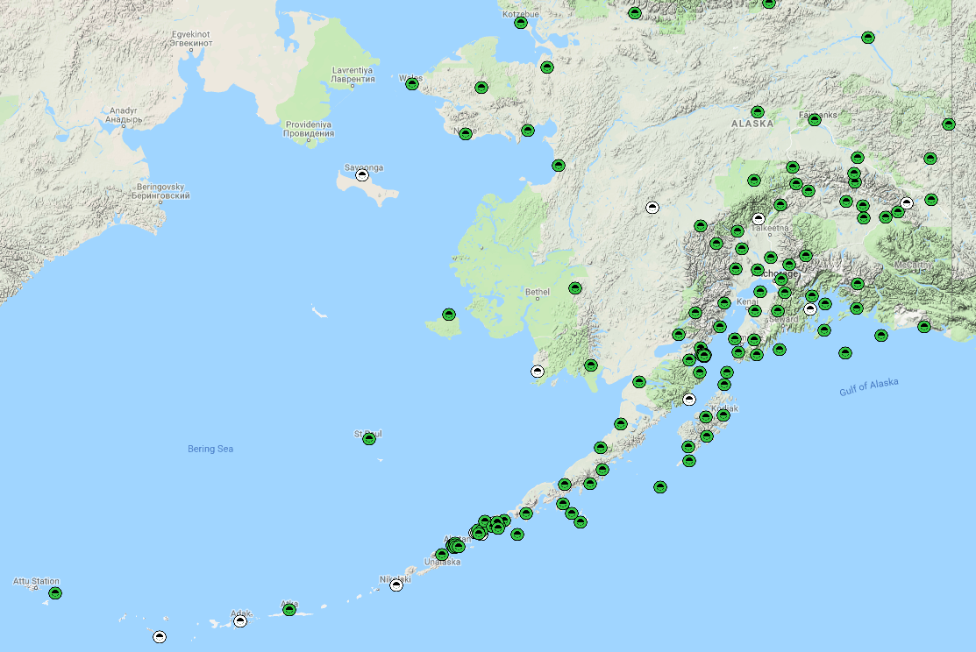
Plate Boundary Observatory (PBO) stations in Alaska. Red star shows Unimak Island.
Westdahl Volcano on Unimak Island, Alaska has six GPS stations from the Plate Boundary Observatory (PBO) to aid in monitoring for volanic activity. Ground movements of just millimeters can give indication of changing magma and pressures within the volcano.

You will analyze data from GPS stations to determine how the volcano is changing and decide whether this is suggests that an eruption could be happening soon and a warning should be given.

Your instructor will give you pictures and graphs of data for the station or stations you should analyze, along with a map to put your results on.
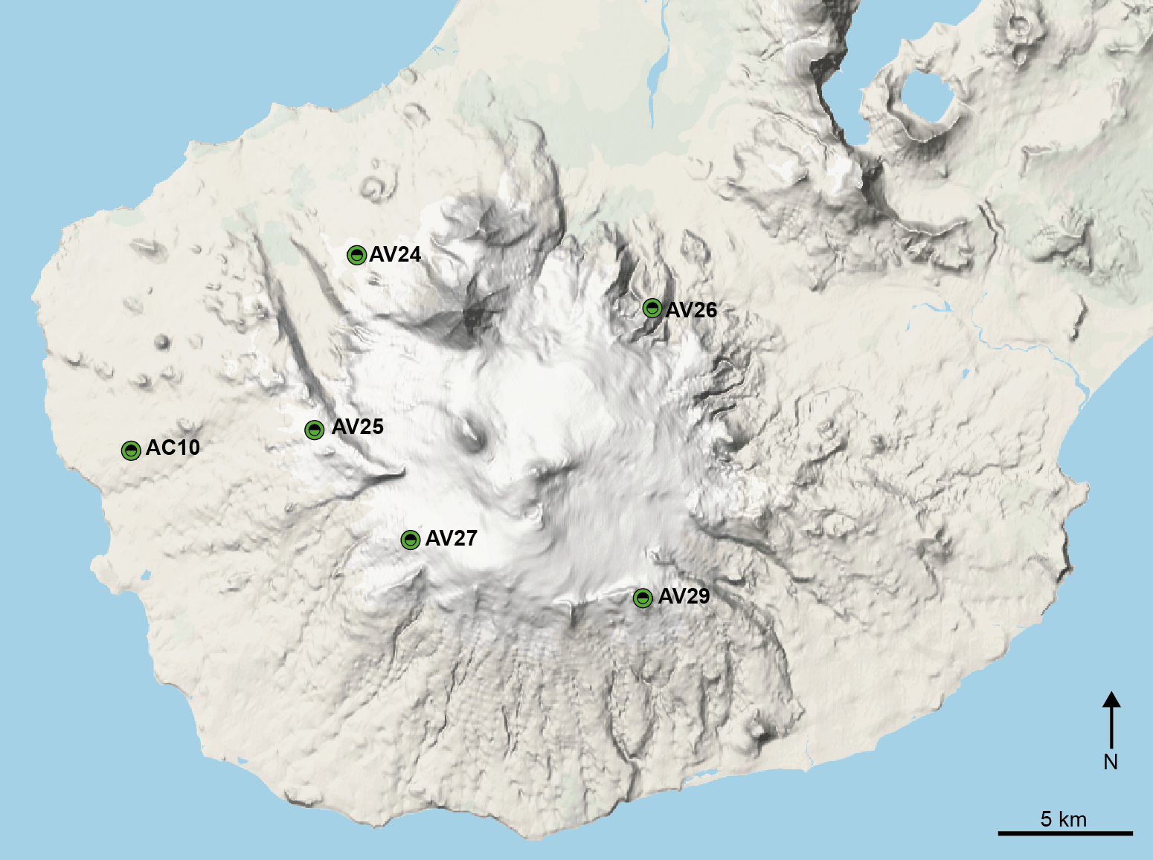
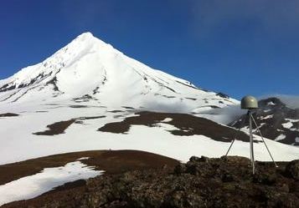
PBO stations around Westdahl Volcano on the south end of Unimak Island, Alaska. Photo shows station AV24.

PART II: Interpreting the results

Answer the following questions.

- Describe the overall movements observed
- What volcanic process could be leading to these movements on Westdahl volcano?
- If you were in charge of issuing warnings would you tell people an eruption was likely to happen soon? Why or why not?
- What other types of volcanic monitoring would you recommend and why?

Grading criteria

One point each for the questions that have definite right or wrong answers and for correctly drawn vectors. To receive full credit, students must show their work, where appropriate.

For open-ended questions, students are assessed based on a simple 4-point scale.
4 points = correct answer with thorough supporting evidence and/or complete description
1-3 point = answer not completely correct or lacking thorough supporting evidence or description
0 points = incorrect answer

