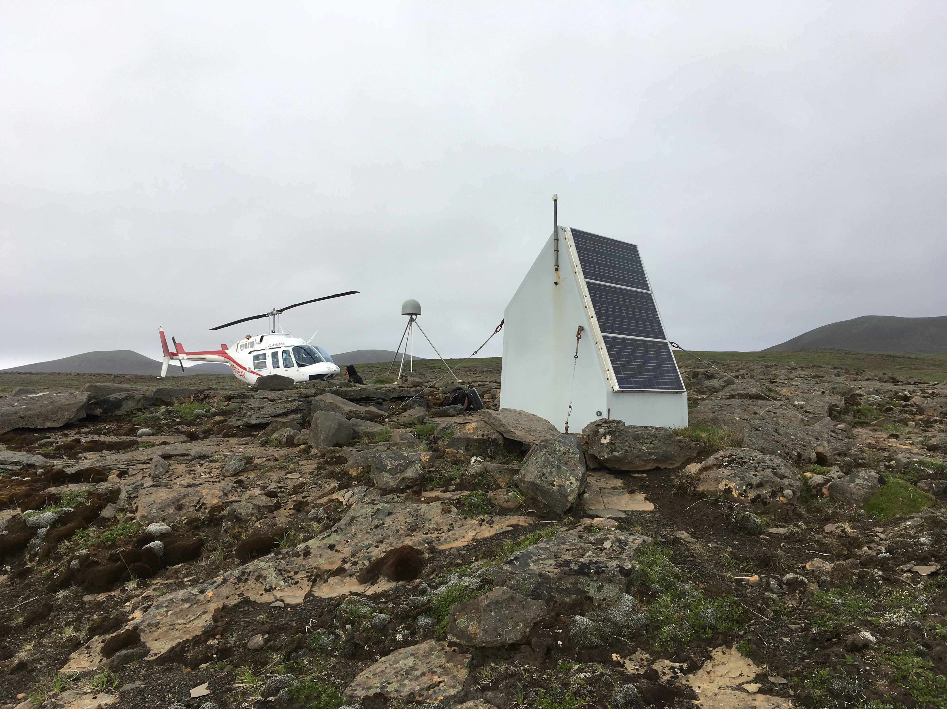
Station AC10 (https://www.unavco.org/instrumentation/networks/status/pbo/photos/AC10)

Refer to the graphs on the next page to make the following calculations. Use a ruler or straight edge to help you read the graph correctly.
Duration of the record _____________ years
Find the changes in positions.
Remember: Change = Final position - starting position (so you could have negative answers)
Change in NORTH _____________ mm
Change in EAST _____________ mm
Determine the velocities: NORTH _______________ mm/yr
EAST _______________ mm/yr
Use Pythagorean theorem to find total horizontal velocity _______________ mm/yr
$$horizontal velocity= \sqrt{{north}^{2} {+ east}^{2}}$$
Finally draw all 3 velocity vectors (arrows) on the map to show your findings.
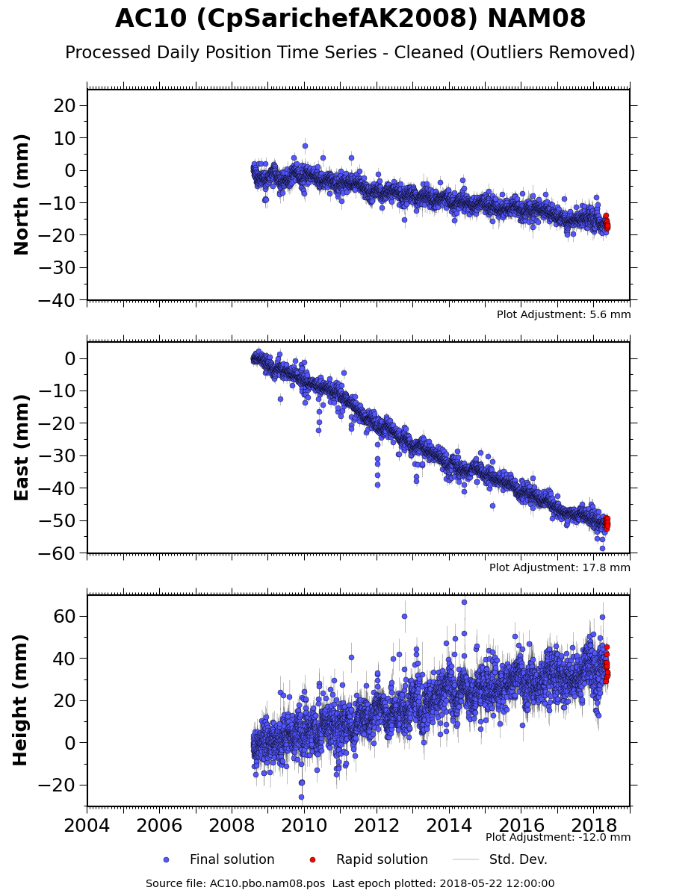

https://www.unavco.org/instrumentation/networks/status/pbo/overview/AC10
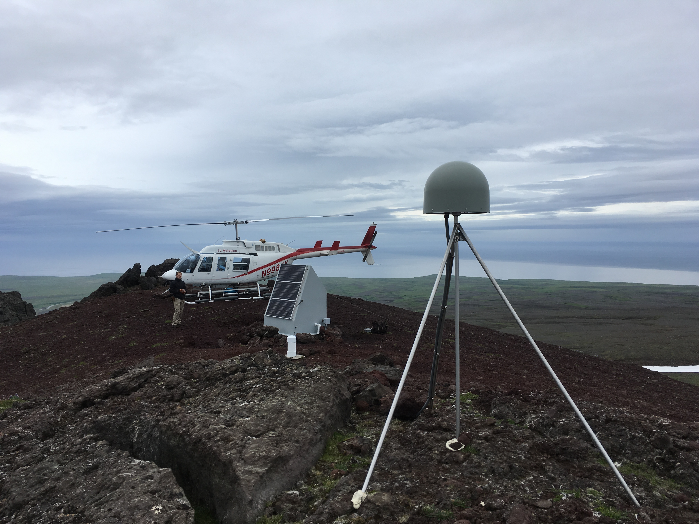
Station AV24 (https://www.unavco.org/instrumentation/networks/status/pbo/photos/AV24)
Refer to the graphs on the next page to make the following calculations. Use a ruler or straight edge to help you read the graph correctly.
Duration of the record _____________ years
Find the changes in positions.
Remember: Change = Final position - starting position (so you could have negative answers)
Change in NORTH _____________ mm
Change in EAST _____________ mm
Determine the velocities: NORTH _______________ mm/yr
EAST _______________ mm/yr
Use Pythagorean theorem to find total horizontal velocity _______________ mm/yr
$$horizontal velocity= \sqrt{{north}^{2} {+ east}^{2}}$$
Finally draw all 3 velocity vectors (arrows) on the map to show your findings.
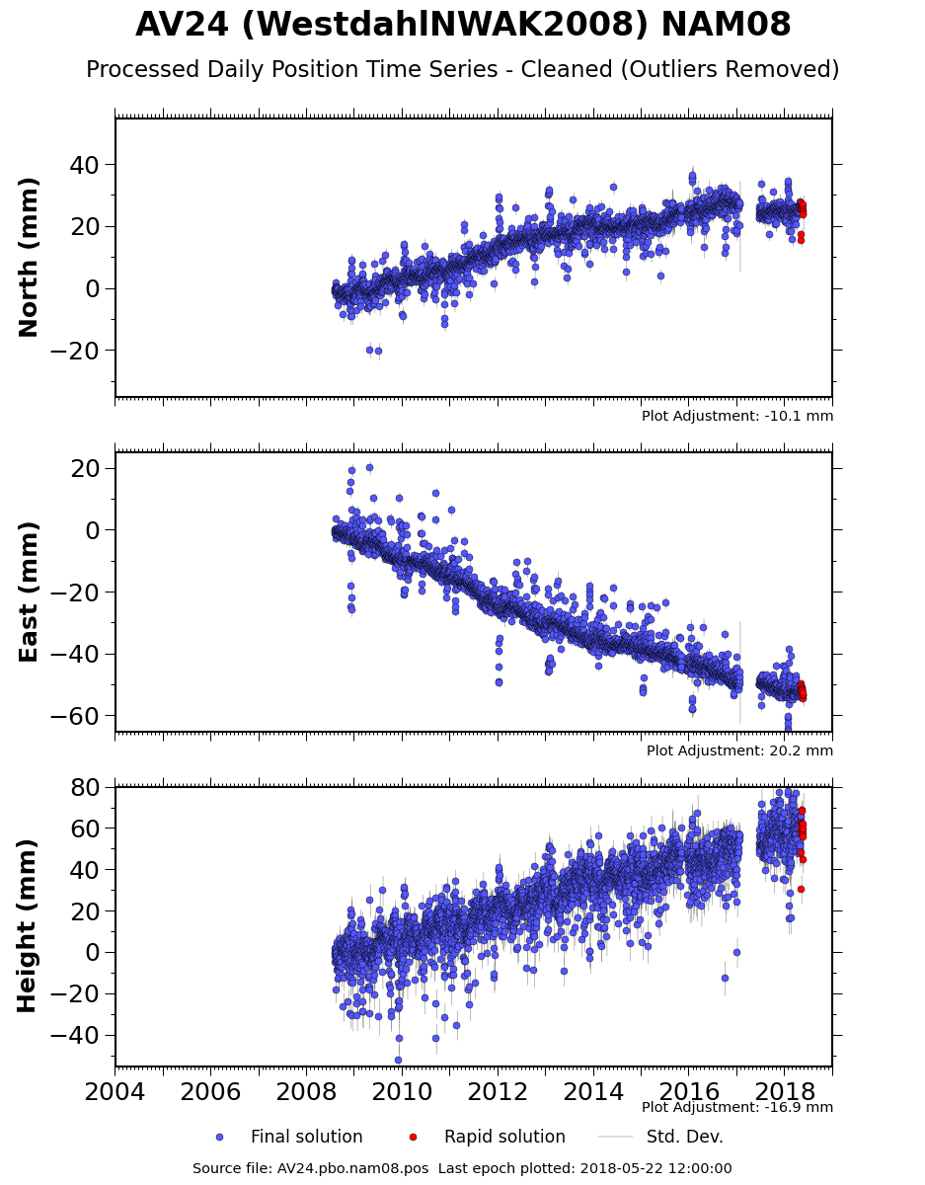

https://www.unavco.org/instrumentation/networks/status/pbo/overview/AV24
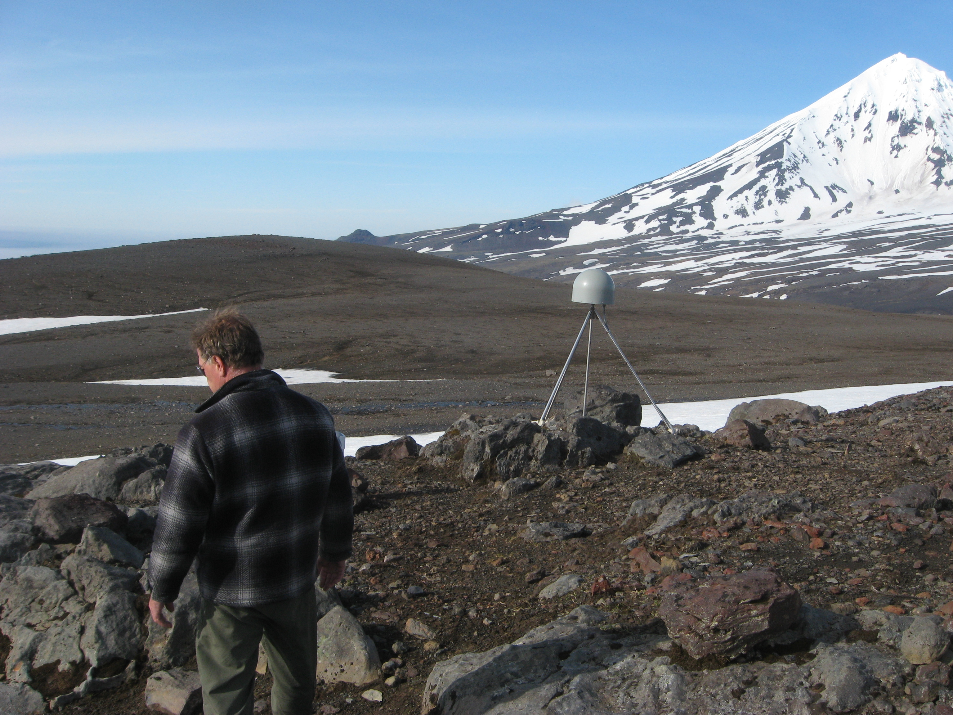
Station AV25 (https://www.unavco.org/instrumentation/networks/status/pbo/photos/AV25)

Refer to the graphs on the next page to make the following calculations. Use a ruler or straight edge to help you read the graph correctly.
Duration of the record _____________ years
Find the changes in positions.
Remember: Change = Final position - starting position (so you could have negative answers)
Change in NORTH _____________ mm
Change in EAST _____________ mm
Determine the velocities: NORTH _______________ mm/yr
EAST _______________ mm/yr
Use Pythagorean theorem to find total horizontal velocity _______________ mm/yr
$$horizontal velocity= \sqrt{{north}^{2} {+ east}^{2}}$$
Finally draw all 3 velocity vectors (arrows) on the map to show your findings.
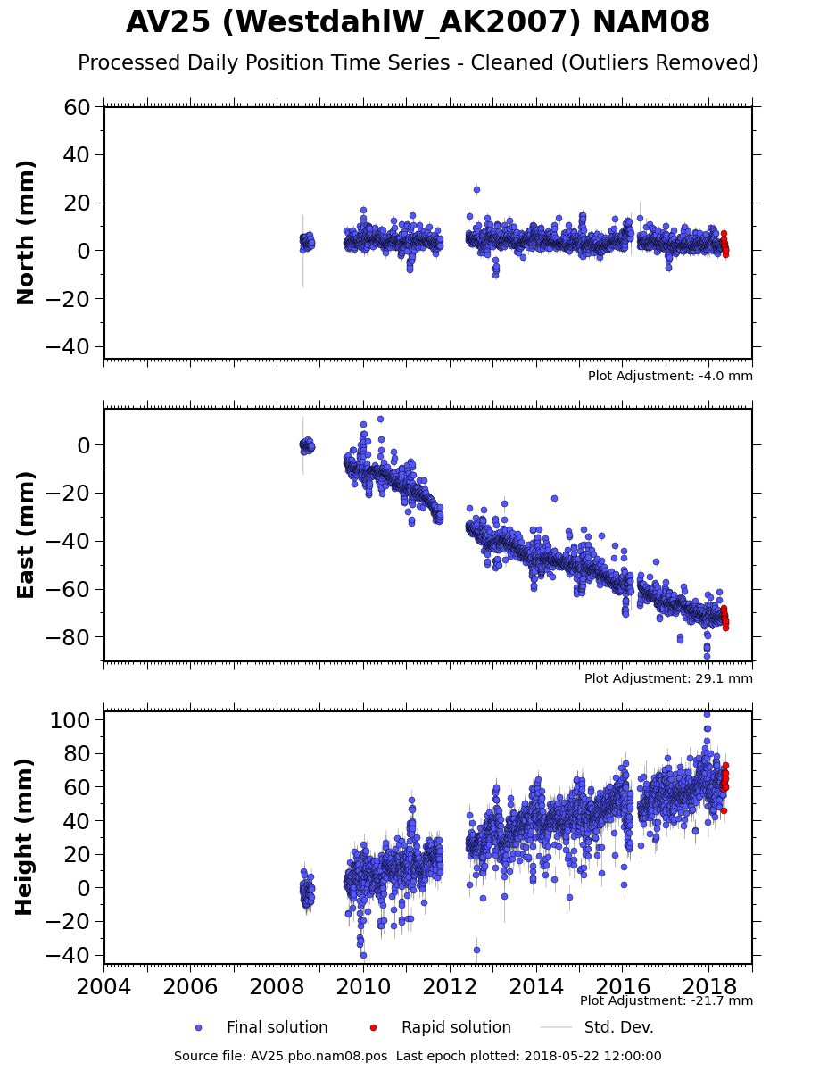

https://www.unavco.org/instrumentation/networks/status/pbo/overview/AV25

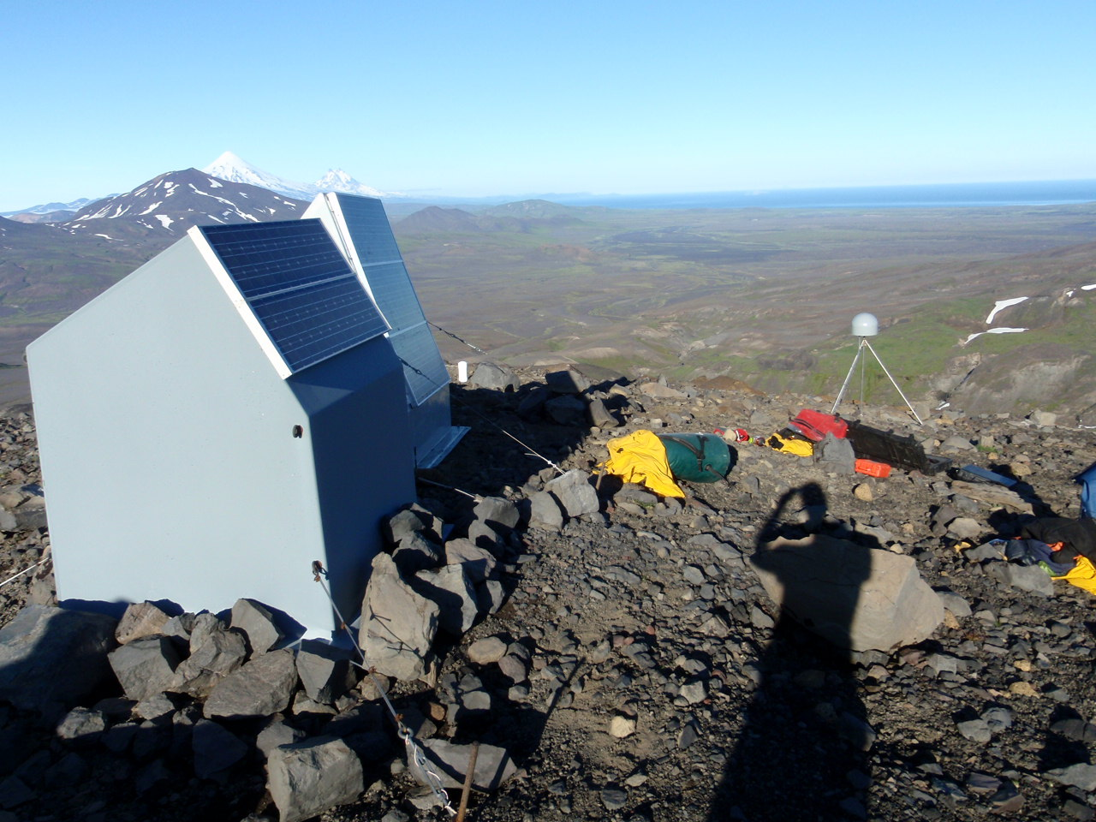Station AV26 (https://www.unavco.org/instrumentation/networks/status/pbo/photos/AV26)

Refer to the graphs on the next page to make the following calculations. Use a ruler or straight edge to help you read the graph correctly.
Duration of the record _____________ years
Find the changes in positions.
Remember: Change = Final position - starting position (so you could have negative answers)
Change in NORTH _____________ mm
Change in EAST _____________ mm
Determine the velocities: NORTH _______________ mm/yr
EAST _______________ mm/yr
Use Pythagorean theorem to find total horizontal velocity _______________ mm/yr
$$horizontal velocity= \sqrt{{north}^{2} {+ east}^{2}}$$
Finally draw all 3 velocity vectors (arrows) on the map to show your findings.
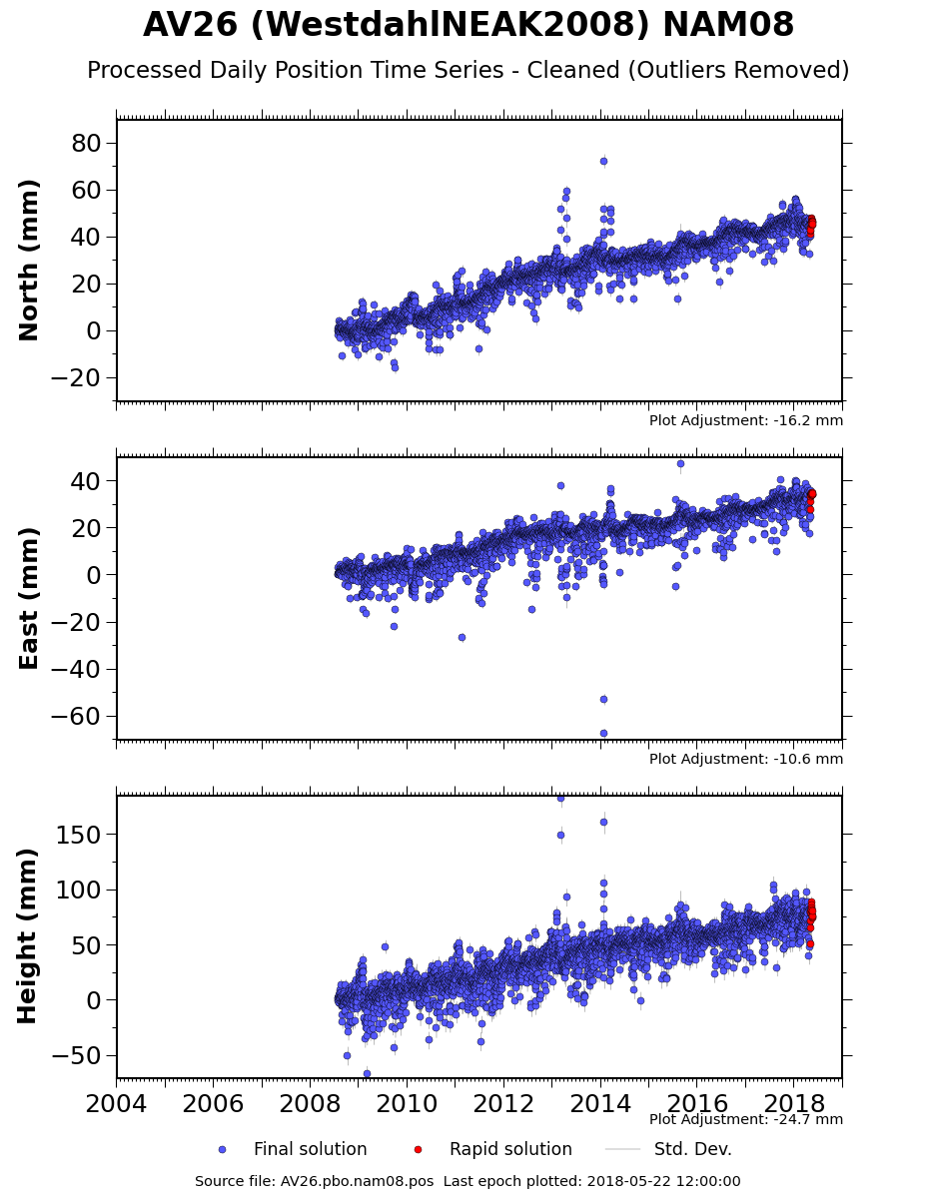

https://www.unavco.org/instrumentation/networks/status/pbo/overview/AV26
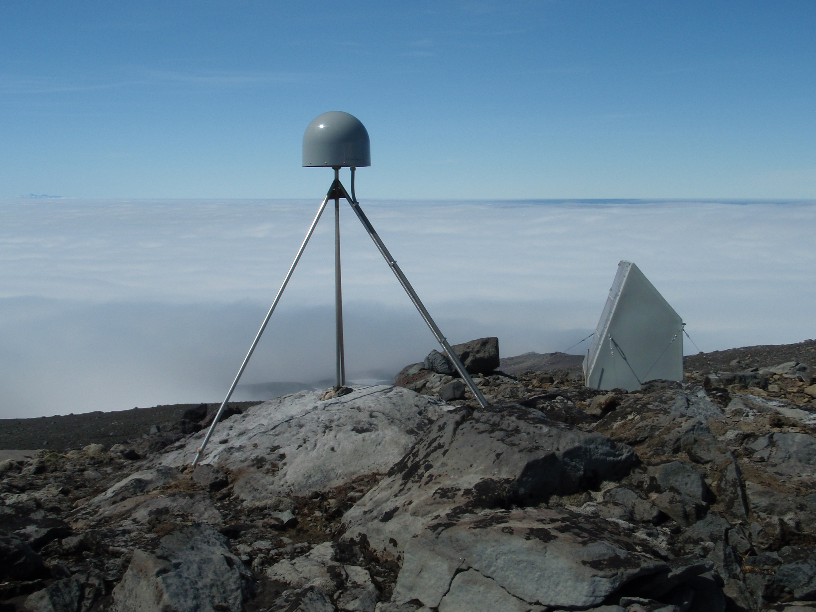
Station AV27 (https://www.unavco.org/instrumentation/networks/status/pbo/photos/AV27)

Refer to the graphs on the next page to make the following calculations. Use a ruler or straight edge to help you read the graph correctly.
Duration of the record _____________ years
Find the changes in positions.
Remember: Change = Final position - starting position (so you could have negative answers)
Change in NORTH _____________ mm
Change in EAST _____________ mm
Determine the velocities: NORTH _______________ mm/yr
EAST _______________ mm/yr
Use Pythagorean theorem to find total horizontal velocity _______________ mm/yr
$$horizontal velocity= \sqrt{{north}^{2} {+ east}^{2}}$$
Finally draw all 3 velocity vectors (arrows) on the map to show your findings.
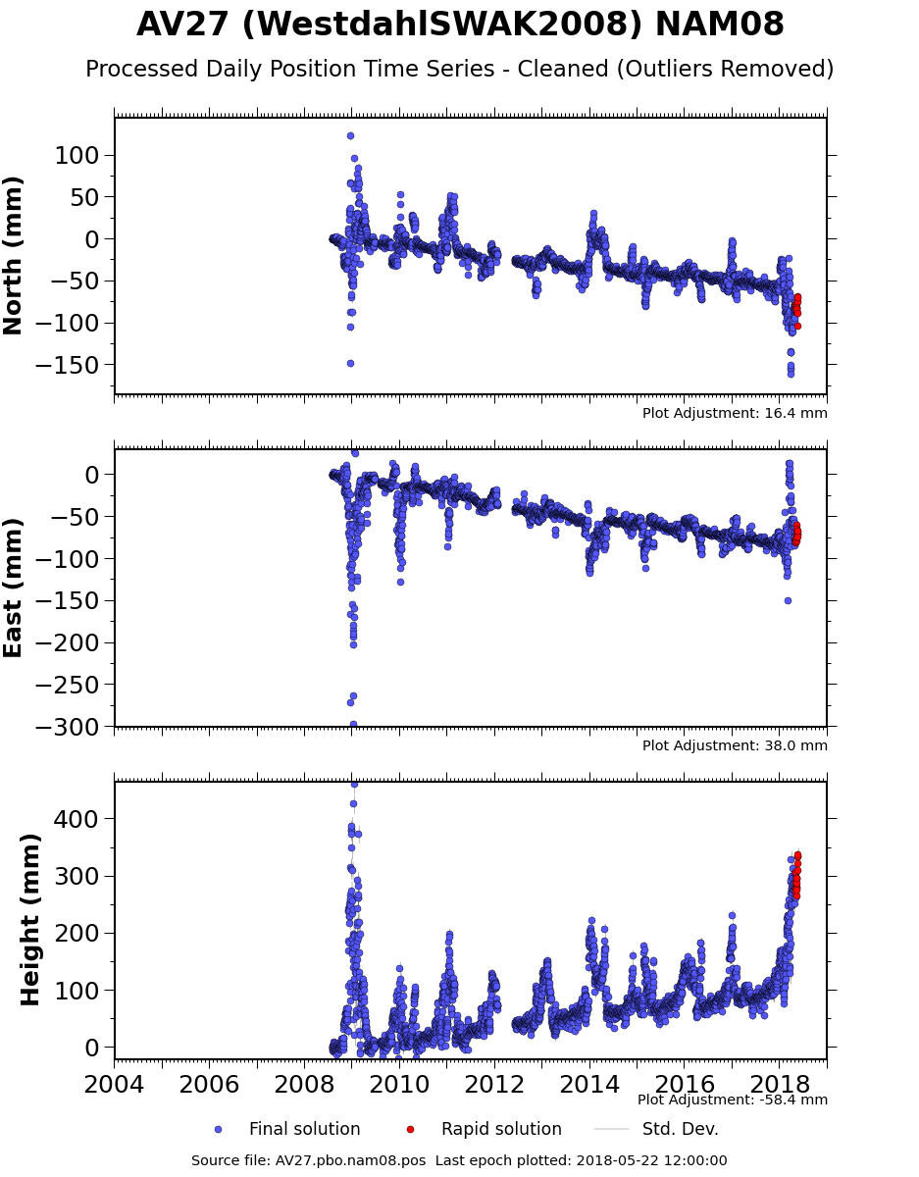

https://www.unavco.org/instrumentation/networks/status/pbo/overview/AV27
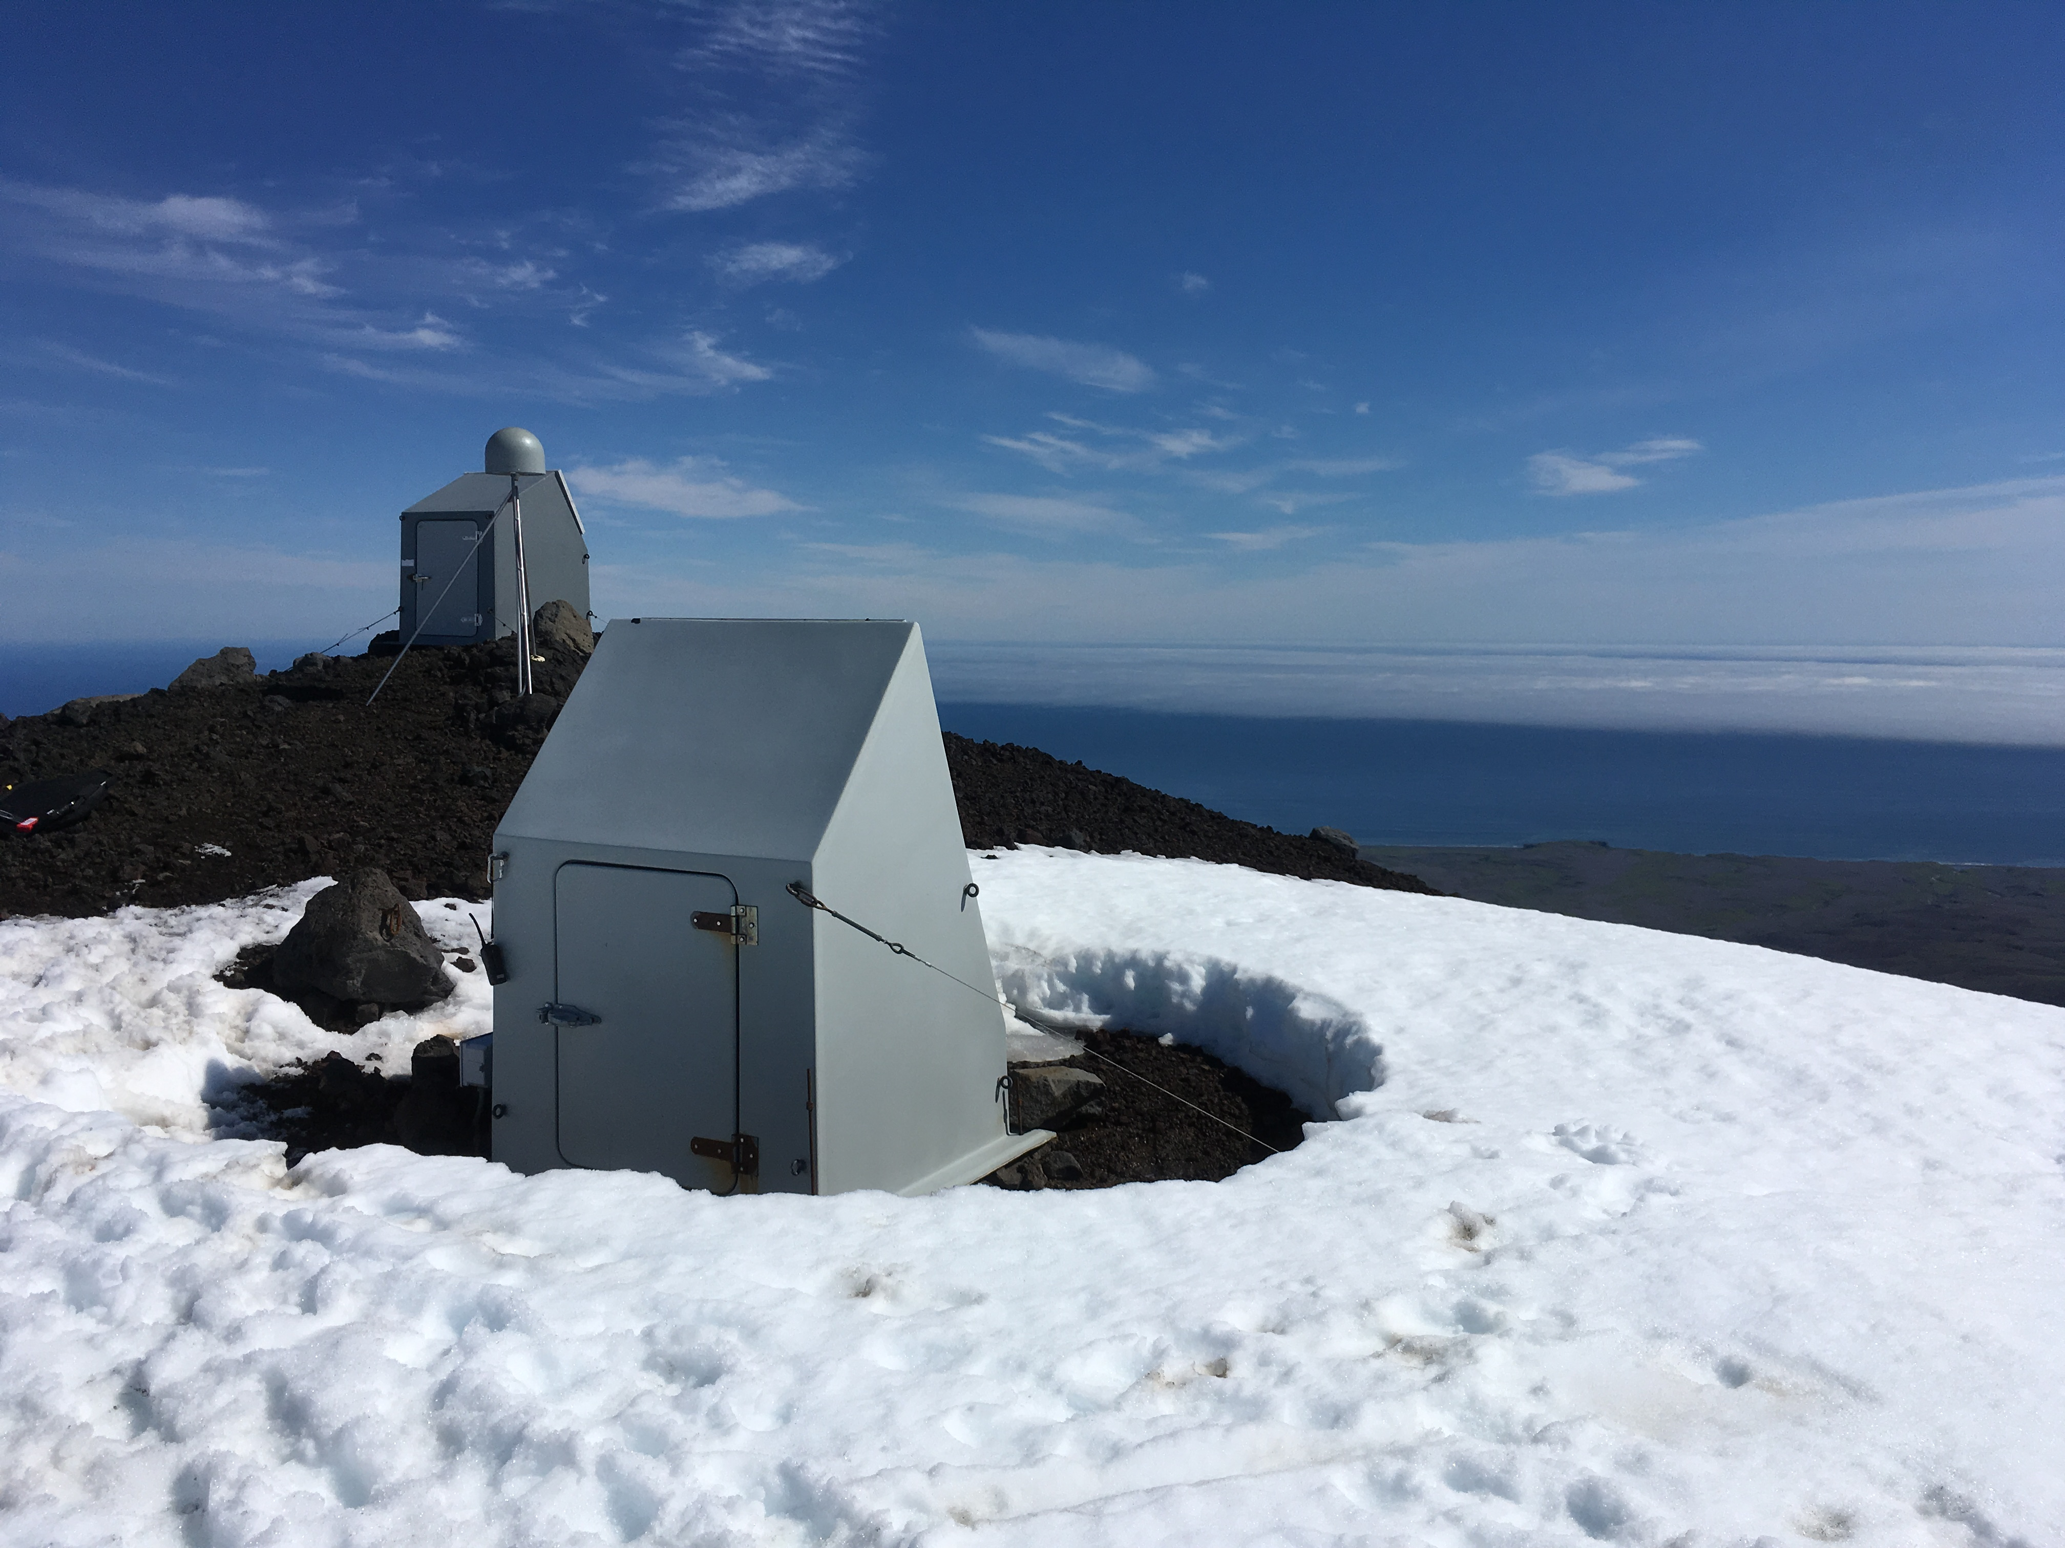
Station AV29 (https://www.unavco.org/instrumentation/networks/status/pbo/photos/AV29)

Refer to the graphs on the next page to make the following calculations. Use a ruler or straight edge to help you read the graph correctly.
Duration of the record _____________ years
Find the changes in positions.
Remember: Change = Final position - starting position (so you could have negative answers)
Change in NORTH _____________ mm
Change in EAST _____________ mm
Determine the velocities: NORTH _______________ mm/yr
EAST _______________ mm/yr
Use Pythagorean theorem to find total horizontal velocity _______________ mm/yr
$$horizontal velocity= \sqrt{{north}^{2} {+ east}^{2}}$$
Finally draw all 3 velocity vectors (arrows) on the map to show your findings.
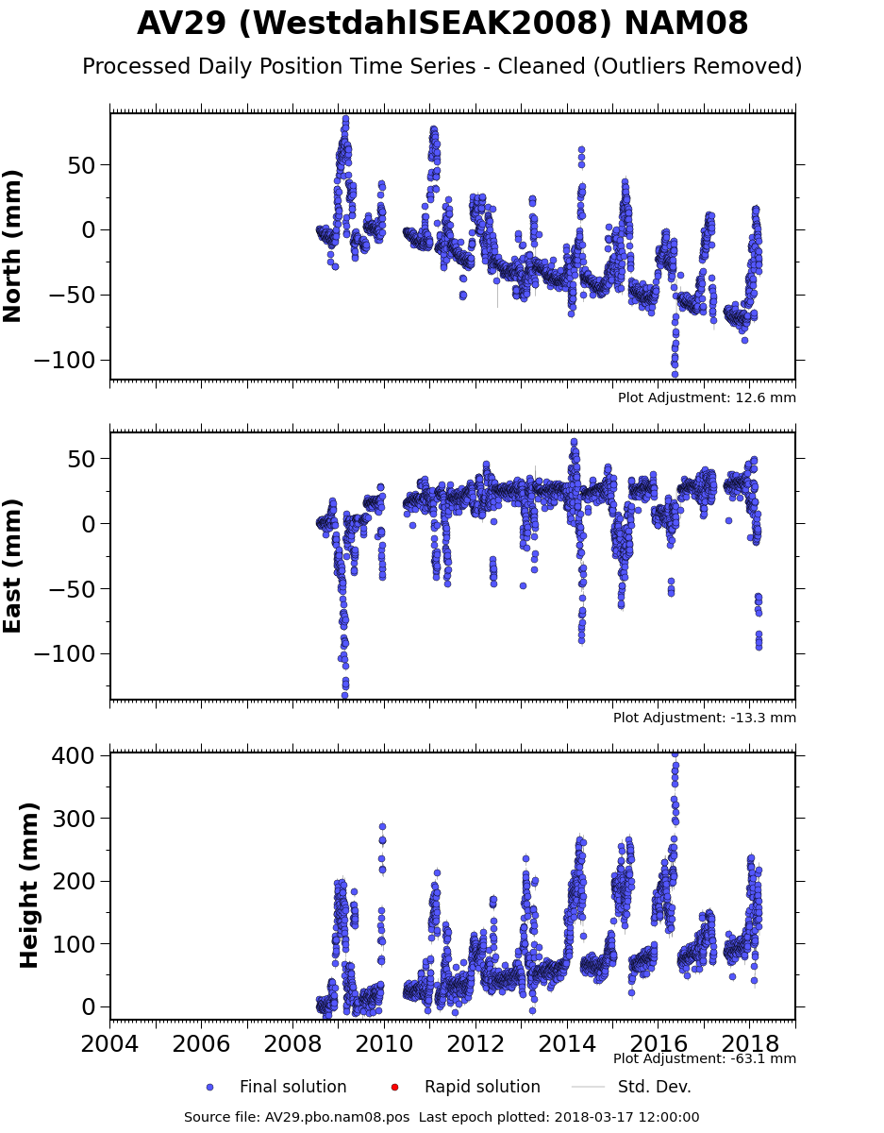

https://www.unavco.org/instrumentation/networks/status/pbo/overview/AV29

