ALASKA GPS Analysis of Plate Tectonics and Earthquakes
Name: Date:
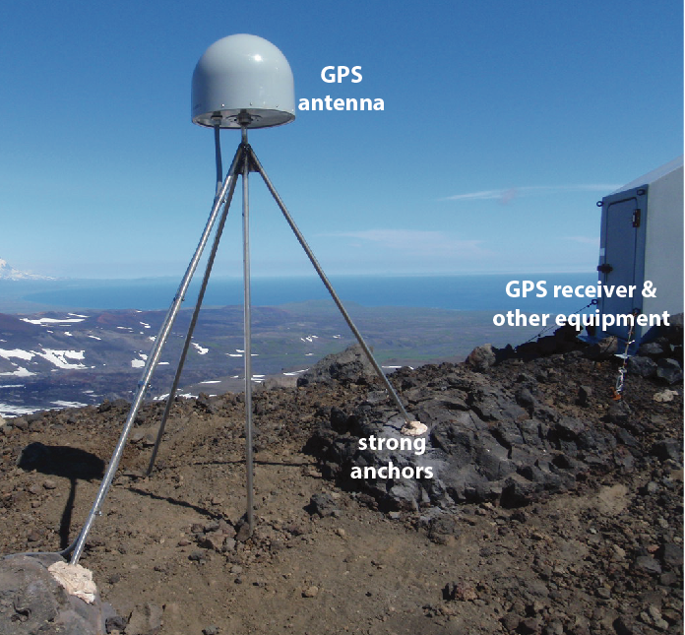

PART I: Building a GPS ‘Station’

Materials
4 toothpicks, 1 gumdrop, modeling clay, ruler, 1/4 sheet transparency

Procedure
1. Insert 3 toothpicks diagonally into the gumdrop. These will act as the legs.
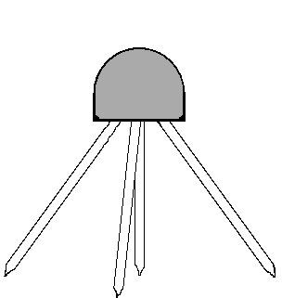
2. Insert a slightly shorter toothpick sticking straight down from the middle of the gumdrop. The tip of this toothpick should be just barely above the surface. This will be the ‘place marker’.
Gumdrop
Toothpick
Clay
3. Put very small pieces of clay on the bottom of the legs (not the place marker). The clay will act as a cement to hold the GPS station in place. In reality the legs of a GPS station are cemented deep into rock below the soil so when that rock moves, so does the station.
4. Position the GPS station on top of a piece of clear transparency.

PART II: How GPS Works to Pinpoint Location

1. What do the tops of the string holders on the walls represent?

2. What does the length of string represent?

3. How many satellites are needed to pinpoint a location on Earth’s surface?

4. Why wouldn’t one or two satellites work? Expain and draw a diagram to show this?

5. Draw the setup of the demonstration
in the space to the right.
PART III: Measuring Alaska GPS/Tectonic Movement

Materials:
Colored pencil (for drawing trend lines), clear ruler, calculator

- High precision GPS stations collect data in 3 parts shown in Time Series Plots:
  - North/South movement over time (abbreviated N/S)
  - East/West movement over time (abbreviated E/W)
  - Height (up/down) movement over time (not shown in this activity)
- X-axis measures time.
- Each dot on the time series plot is the average position of the station for one day.

AC79 Montague Island, Prince William Sound
Trend
Line

The first thing to do is draw a “trend line.” Position a ruler (clear works best) so there are an equal number of points above and below the line. Draw the line so that it crosses the axes on both sides. The first one has been done as an example above. Draw a trend line for the East portion of the Montague Island time series plot.

6. What are the units of measurement for these time series? Circle the best choice.

a) centimeters and months b) meters and years
c) millimeters and years d) centimeters and years
7. For how many years has this station been collecting data?

a) 5 years b) 7.5 years c) 11 years d) 14.5 years

8. How far North did the Montague Island station move on the time series? Hint: calculate the change in position over time.

a) 188 millimeters b) 260 milllimeters
c) 340 millimeters d) 450 millimeters

9. Did the station move South over the period of time relative to its starting position (1st measurement)?

a) No, because trend line only moves up.
b) Yes, because trend line moves down.
c) Can’t tell from time plots given.

10. How far West (down on the graph) did the station move on the time series plot? Remember to use a straightedge to help.

a) 125 millimeters b) 175 milllimeters
c) 220 millimeters d) 250 millimeters

11. What overall direction was this station moving?

a) North only b) Northwest
c) Northeast d) Southwest

12. What was the rate of movement in the North direction? (Hint: Divide distance traveled by # of years)

a) 15 mm/yr b) 25 mm/yr c) 35 mm/yr d) 45 mm/yr

13. Calculate the rate of movement in the West direction:

a) 12 mm/yr b) 17 mm/yr c) 24 mm/year d) 30 mm/yr

Using the time series plots below for Girdwood and Mt Susitna calculate N/S and E/W motion and answer questions for each plot. Start by drawing trend lines that cross both vertical axes.

Note that some positions (dots) are ‘off’ the general trend, or there is a gap in the data. Those might be times when maintenance was being done on the station, or there was some error that was being corrected. You can ignore those points when drawing your trend lines and doing calculations.
AC20 Girdwood

14. For how many years has this station been collecting data?

15. Was Girdwood moving North or South? How do you know?

16. How far North or South did it move since data has been recorded?

17. Overall, was Girdwood station moving East or West? How do you know?

18. How far East or West did it move over the whole time period of data collection?

19. Calculate rates of motions in N/S and E/W directions.

AC32 Mt Susitna

20. For how many years has this station been collecting data?

21. Was Mt Susitna moving North or South? If so, how far? Use the trend line to better estimate the starting position. Be careful with measurements because these data are somewhat messy.

22. Was Mt Susitna moving East or West? If so, how far? Again, be careful.

23. Calculate rates of motions in N/S and E/W directions.

PART IV: Plotting GPS Station Motion

Materials:
Alaska GPS Analysis Grid (next page of packet), 3 different colored pencils, ruler.
Procedure:
- Using one colored pencil, start at (0,0) and draw a faint arrow to show the rate of North movement of the Montague Island GPS station.

- From end point of the North arrow, draw an arrow to show the rate of West motion.

- Draw a diagonal arrow from (0,0) to the end point of the West arrow. This final arrow (vector) shows the overall rate and direction of motion of the Montague Island GPS station.

- Using a ruler, measure the length of the final arrow (vector) and label that arrow with overall rate in mm/year. Note: Scale on grid was adjusted to fit the page.

- Using different colors, draw arrows (vectors) for Girdwood and Mt Susitna GPS stations.

- Complete key indicating colors of your 3 GPS station vectors.

KEY: Color Station Location

0
10
10
20
30
0
10
10
20
30
40
50
0
10
10
20
30
0
10
10
20
30
40
50
Velocity (mm/yr)
Velocity (mm/yr)
North
South
West
East
Procedure (continued):
- Place gumdrop GPS station (on top of transparency) at 0,0 and move the transparency sheet along one of the arrows to simulate the direction and rate of motion of the land at that point.

PART V: Analysis of GPS Station Motion

24. The map below shows the direction and rate of motion of GPS stations in south-central Alaska. The motion of the Pacific Plate is indicated by the bold arrow.

a) How do the arrows you drew on the previous page for AC32 Mt Susitna, AC20 Girdwood, and AC79 Montague Island compare to the arrows for those stations shown on the map below?

b) How are the GPS stations in the Prince William Sound and southern Kenai Peninsula area moving?

c) How are the GPS stations near Anchorage moving?
AC79
AC20
AC32
Anchorage
Prince William Sound
Kenai Peninsula
Kodiak Island
Pacific Plate
North American Plate
Trench
Alaska –
Aleutian

25mm/yr
Cook Inlet
Alaska Range
Chugach
Mountains
56 mm/yr

25. Over time, what will happen to the distance between Prince William Sound and Anchorage?

a) Distance gets shorter
b) Distance gets longer
c) Distance stays the same

26. What does this indicate about the forces acting on the edge of the continent in south-central Alaska? Are they compressional? Extensional?

27. If these motions are what is measured between earthquakes, what general direction of motion would you predict Montague Island AC79 station will move during a subduction zone earthquake? Why?

28. Given the total horizontal rate of movement that you calculated for Montague Island (graph on pg 6), about how much movement would you expect during a subduction zone earthquake if one occurs every ~500 years? What is something in your school that approximates this distance?

