Is it a Restraining Bend or a Releasing Bend?

Determining whether a curve along a fault surface is a restraining bend or a releasing bend just by looking can be challenging. However, when you use gesture to mimic the fault geometry and motion, the difference becomes clear. After completing this exercise, you should be able to determine whether a curve on a fault surface forms a restraining bend or a releasing bend.

Exercise 1:
Put your hands into the position shown in the photograph on the left, below. Imagine that the surface between your two hands is a strike-slip fault, with a bend in it, as indicated in the photo on the right.

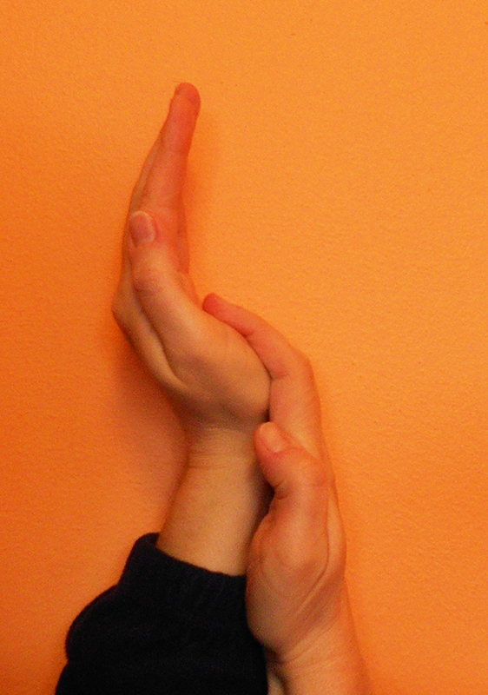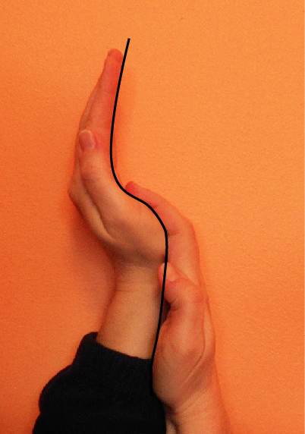

Part 1: Imagine that this fault is left-lateral, and move your hands to gesture motion along the fault. Do not skip this crucial step!! Does that direction of motion create a gap between your hands (as at a releasing bend), or is it difficult to move your hands because they form a restraining bend? Confirm your answer with the two students nearest you.

Part 2: Imagine that this fault is right-lateral, and repeat: move your hands to gesture motion along the fault. Does that direction of motion create a gap between your hands (as at a releasing bend), or is it difficult to move your hands because they form a restraining bend? Confirm your answer with the two students nearest you.

Exercise 2:
Put your hands into the position shown in the photograph on the next page. Imagine that the surface between your two hands is a strike-slip fault, with a bend in it, as you did before.

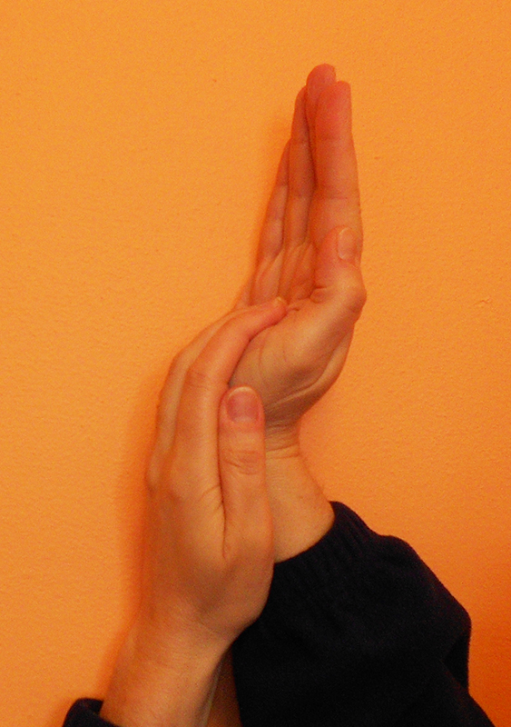
Part 1: Imagine that this fault is left-lateral, and move your hands to gesture motion along the fault. Do not skip this crucial step!! Does that direction of motion create a gap between your hands (as at a releasing bend), or is it difficult to move your hands because they form a restraining bend? Confirm your answer with the two students nearest you.

Part 2: Imagine that this fault is right-lateral, and repeat: move your hands to gesture motion along the fault. Does that direction of motion create a gap between your hands (as at a releasing bend), or is it difficult to move your hands because they form a restraining bend? Confirm your answer with the two students nearest you.

Exercise 3: The San Andreas Fault
Consider the map view of the San Andreas Fault, shown below. (This image is from the U.S. Geological Survey, published in the National Atlas, available online at http://nationalatlas.gov/articles/geology/features/sanandreas.html).

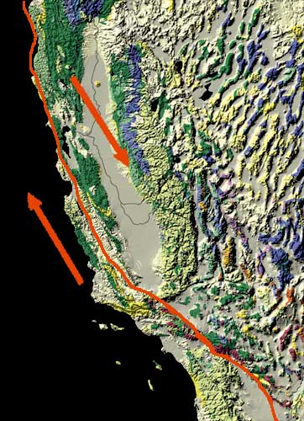
Do the arrows indicate left-lateral or right-lateral motion?

Assume that the segment of the fault near the arrows shows the general trend of the fault surface.

Is the bend in the fault trace near the top of the photograph a restraining bend or a releasing bend?

Is the bend that forms the bottom third of the fault trace in this image a restraining bend or a releasing bend?

