Folds and cleavage Name:

The geometric relationship between folds and cleavage can tell us a lot about deformation. After completing this exercise, you should be able to
- Define axial planar, fanning, and transecting cleavage;
- Use gesture to describe and illustrate axial planar, fanning, or transecting cleavage;
- Describe the geometric relationship between bedding/cleavage intersections and fold axes for each type of cleavage

For the exercises below, you may find it helpful to review the sections in your textbook that cover folding and cleavage development, particularly the figures.

Exercise 1: Axial planar cleavage
A cleavage that parallels the axial surface of a fold is called axial planar cleavage.

Hold one of your hands in a curve, representing a folded rock layer, in any orientation. Use your other hand to represent the axial surface, bisecting the curved surface of the fold. Keeping your hand in that orientation (parallel to the axial surface), move your hand around the fold surface. Pay attention to the geometric relationship between bedding and the axial surface as you move your hand. If you were at an outcrop of a fold, and it had axial planar cleavage, what would you see at each of the locations (A, B, and C) indicated in figure 1, below? Sketch the bedding and cleavage orientations you would see at each location, in the space above the figure.

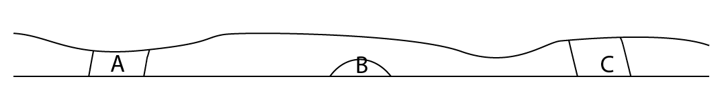
Figure 1: Outcrop of a fold

Now think about the line of intersection between bedding and cleavage. What is its relationship to the fold axis?

Exercise 2: Fanning cleavage
A cleavage that “fans out” around a fold (see figure 2, below) is called fanning cleavage.

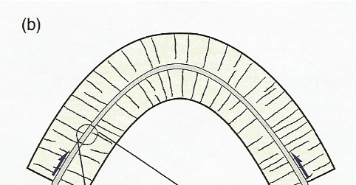
Figure 2: Fanning cleavage (from figure 12.14 in Structural Geology by Haakon Fossen, 2010).
Hold one of your hands in a curve, representing a folded rock layer, in any orientation. Use your other hand to show what a fanning cleavage would look like, moving your hand around the fold surface. Pay attention to the geometric relationship between “bedding” and “cleavage” as you move your hand. If you were at an outcrop of a fold, and it had fanning cleavage, what would you see at each of the locations (A, B, and C) indicated in figure 3, below? Sketch the bedding and cleavage orientations you would see at each location, in the space above the figure.

Figure 3: Outcrop of a fold

Now think about the line of intersection between bedding and cleavage. What is its relationship to the fold axis?

Exercise 3: Transecting cleavage
Cleavage that cuts across both the axial surface and the fold axis is called transected cleavage (see figure 4, below). Gesture the orientation of a folded surface and a transecting cleavage. Pay attention to the geometric relationship between “bedding” and “cleavage” as you move your hand. If you were at an outcrop of a fold, and it had transecting cleavage, what would you see at each of the locations indicated in figure 5, on the next page?

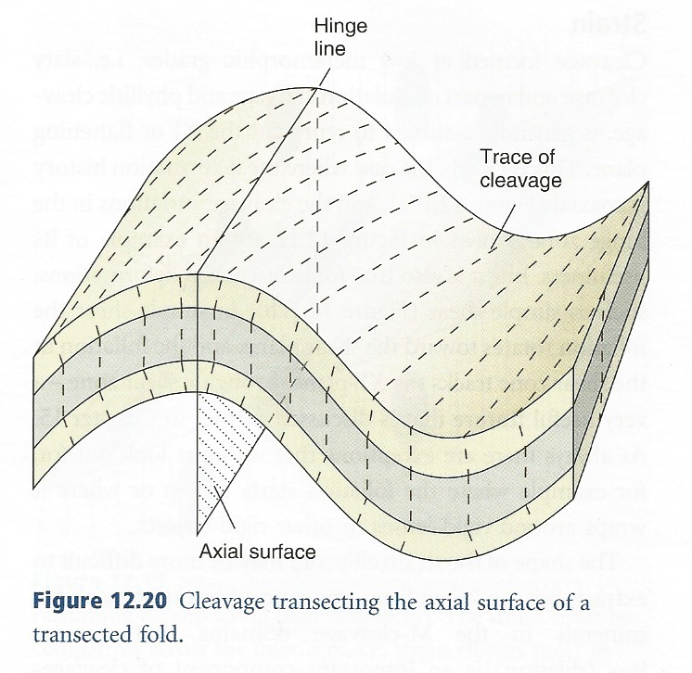
Figure 4: Transecting cleavage (figure 12.20 in Structural Geology by Haakon Fossen, 2010).
Sketch the bedding and cleavage orientations you would see at each location, in the space above the figure.

Figure 5: Outcrop of a fold

Now think about the line of intersection between bedding and cleavage. What is its relationship to the fold axis?

What would you look for, in the field, to distinguish transecting cleavage from axial planar or fanning cleavage?

