Evolution in Action?

**Learning objectives.** Upon completion of this activity students will be able to:

1. Design a scientific experiment with control s and replications.
2. Introduce students to the issues of misuse of antimicrobial products.
3. Critically read scientific literature.
4. Interpret and communicate scientific data.
5. Apply evolutionary concepts and knowledge to a real life situation.
6. Demonstrate the observable occurrence of evolution.

**Rationale.** Investigative case studies draw from students’ real life experiences which are then applied to scientific reasoning. This lab activity will not only draw on students’ real life experiences but will also draw on student’s previous readings, lectures, and lab experiences in proper laboratory techniques and data analysis performed in previous activities. The lab will incorporate the use of scientific inquiry methods and strategies while students develop reasonable answers to the questions asked.

**Scenario**

On the way home from class one day Christie and Jill stop at the local discount store to do some shopping. As the girls are walking through the store, Christie notices a display with samples of a new antibacterial soap. “I really like all the antibacterial products on the market today.” Christie says as the girls walk by the display.

“Why?” asks Jill

“Using them just makes me feel more protected against all the nasty germs from everyone.” Replies Christie.

“Are you and your family sick less frequently now then before these products were on the market?” asks Jill. “I don’t know what happened to just good old soap and water, don’t they work anymore?” Besides that, I read an article that said that we actually need some of the bacteria, and if we keep using all of these products the bacteria just evolve anyway.” Says Jill.

“No way” says Christie. “I’ll take my antibacterial products over all those nasty germs any day.”

**Case Analysis**

1. What is this case about? Write 2-3 biology (evolution)- related topic issues involved in this case.
2. Use the following table to assess what you already know about this topic by filling in the “what do I know column” and ask some questions that you would like to learn more about in the “what do I need to know” column.

|  |  |
| --- | --- |
| What do I know? | What do I need to know? |
|  |  |

1. Which of the above questions are you most likely to explore? Why?
2. Write a hypothesis (or a few hypotheses) that you could test.

**Critical Reading**

Read pages 491-493 in your text. Read the posted articles *Antibacterial household products: Cause for Concern* by Stuart B. Levy found at <http://www.cdc.gov/ncidod/eid/vol7no3_supp/levy.htm> and *Antimicrobial Drug Resistance: "Prediction Is Very Difficult, Especially about the Future* by Patrice Courvalin found at the following address, <http://www.cdc.gov/ncidod/EID/vol11no10/05-1014.htm> *Humans as the greatest evolutionary force* by Stephen Palumbi found at the following address <http://www.columbia.edu/itc/biology/pollack/w4065/client_edit/readings/science293_1786.pdf>

Then answer the following questions in your own words.

1. What is triclosan?
2. Why is there concern about the use of antibacterial chemicals in household products such as soaps and detergents? (List at least 3).
3. What is the difference between the intended result of antibiotic use and antibacterial product use?
4. Based on your current knowledge, why do consumers “buy into” the use of antibacterial products?
5. What are the two primary mechanisms that bacteria utilize to overcome and become resistant to triclosan?
6. Are humans influencing the evolution of microorganisms? How?
7. How do bacteria evolve to become resistant to antimicrobial drugs? Explain each of the mechanisms.
8. List 5 examples for Palumbi’s article that indicate humans are driving evolutionary processes.
9. The author suggests that the patterns of evolutionary change are clear based on………. (what?)
10. What is largest impact of human driven evolution? Give some examples.
11. List and explain each of the methods that could be used to slow evolution.

**Analyze and Design an Experiment**

To further explore triclosan and the possible role it plays in bacterial resistance, you will first analyze an experiment. Following your analysis, you and your lab partner will design an experiment to test a hypothesis that you have concerning resistance in the context of antibacterial products and antibiotics.

**Analyze**. In the following experiment, *Staphylococcus epidermidis (S. epidermidis)* were repeatedly exposed to an antibacterial soap containing 0.46% triclosan. *S. epidermidis* is a normal microbiota on human skin but is also an opportunistic pathogen. Also, recall the conversation about antibacterial products that Christie and Jill were having as they walked through the store.

The ZOI or zone of inhibition is a measure used in microbiology to determine the effectiveness of an antibiotic or antimicrobial agent. The clear area (if present) around each agent is measured, this is the ZOI. Using markers, identify the ZOIs on each plate in the photo below. The bacterial growth on each plate is called a bacterial lawn. Indicate the lawns in the photos below.

Rewrite your hypothesis (or hypotheses) or change it to better reflect the information you now have about bacteria, evolution and triclosan.

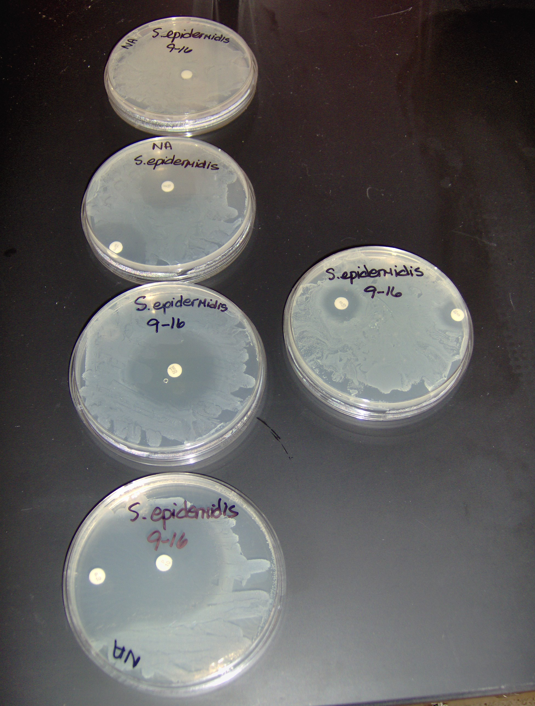

Figure 1

The data collected and presented below reflect some “testing” that was conducted and recorded on the exposure of *S. epidermidis* to triclosan.

Figure2. Mean widths of ZOI (in cm) through four rounds of exposure to 0.46% triclosan.



Round of testing refers to the number of exposures to 0.46 % triclosan. Error bars represent 95% confidence intervals on each mean.

1. What is ZOI? How is it measured and what does the measurement mean?
2. What is the general trend that you observe in the results shown in figure 2?
3. What is the reason for conducting multiple rounds?
4. If you were to set up an experiment similar to that shown in figures 1 and 2 what would you set up as your control?
5. What will you use as your experimental group on each of the above plates?

**Round 1 Data (in mm)**

|  |  |  |  |  |
| --- | --- | --- | --- | --- |
| **Student** | **Control** | **Plate 1** | **Plate 2** | **Plate 3** |
| 1 | 0 mm | 43 | 37 | 40 |
| 2 | 5 mm | 46 | 41 | 42 |
| 3 | 0 mm | 37 | 20 | 40 |
| 4 | 0 mm | 29 | 25 | 23 |
| 5 | 0 mm | 42 | 40 | 40 |
| 6 | 0 mm | 40 | 40 | 50 |
| 7 | 0 mm | 40 | 40 | 35 |
| 8 | 12 mm | 54 | 52 | 52 |

**Round 2 Data (in mm)**

|  |  |  |  |  |
| --- | --- | --- | --- | --- |
| **Student** | **Control** | **Plate 1** | **Plate 2** | **Plate 3** |
| 1 | 0 mm | 39 | 39 | 31 |
| 2 | 5 mm | 37 | 35 | 31 |
| 3 | 0 mm | 25 | 16 | 20 |
| 4 | 0 mm | 21 | 25 | 21 |
| 5 | 0 mm | 44 | 40 | 34 |
| 6 | 0 mm | 36 | 36 | 28 |
| 7 | 0 mm | 40 | 33 | 36 |
| 8 | 12 mm | 40 | 40 | 40 |

**Round 3 Data (in mm)**

|  |  |  |  |  |
| --- | --- | --- | --- | --- |
| **Student** | **Control** | **Plate 1** | **Plate 2** | **Plate 3** |
| 1 | 0 mm | 36 | 29 | 24 |
| 2 | 5 mm | 30 | 26 | 25 |
| 3 | 0 mm | 25 | 15 | 16 |
| 4 | 0 mm | 18 | 20 | 20 |
| 5 | 0 mm | 38 | 23 | 27 |
| 6 | 0 mm | 30 | 25 | 22 |
| 7 | 0 mm | 47 | 37 | 32 |
| 8 | 12 mm | 50 | 40 | 36 |

**Round 4 Data (in mm)**

|  |  |  |  |  |
| --- | --- | --- | --- | --- |
| **Student** | **Control** | **Plate 1** | **Plate 2** | **Plate 3** |
| 1 | 0 mm | 34 | 26 | 25 |
| 2 | 5 mm | 30 | 28 | 25 |
| 3 | 0 mm | 23 | 15 | 16 |
| 4 | 0 mm | 19 | 18 | 20 |
| 5 | 0 mm | 35 | 22 | 25 |
| 6 | 0 mm | 29 | 25 | 20 |
| 7 | 0 mm | 42 | 33 | 30 |
| 8 | 12 mm | 40 | 35 | 33 |

**Conclusions and Analysis**

1. Calculate the average for each set of plates in each round.
2. On a separate sheet of graph paper, graph the class results of the experiment that was conducted.
3. Did the results that you and your classmates obtained support the graph that you analyzed? Explain.
4. Based on the class results, should we be concerned about bacteria evolving resistance to antibacterial products? Why?
5. If you used a different species of bacteria, would expect the results to be the same? Why?

**References**

Aiello, A. E., and Larson, E. 2003. Antibacterial cleaning and hygiene products as an emerging risk factor for antibiotic resistance in the community. *The Lancet* 3, 501-506.

Cole, E. C., Addison, R.M., Rubino, J.R., Leese, K.E., Dulaney, P.D., Newell, M.S., Wilkins, J., Gaber, D.J., Wineinger, T., and Criger, D.A. 2003. Investigation of antibiotic and antibacterial agent cross-resistance in target bacteria from homes of antibacterial product users and nonusers. *Journal of Applied Microbiology.* 95, 664-676.

Courvalin, P. 2005. Antimicrobial Drug Resistance: "Prediction Is Very Difficult, Especially about the Future. *Emerging infectious diseases*. 11, 1503-1506. Accessed online 10/25/2008 @ <http://www.cdc.gov/ncidod/EID/vol11no10/05-1014.htm>

De la Cruz F, Davies J. 2005. Industrial revolution and microbial evolution. *In The Influence of Cooperative Bacteria on Animal Host Biology*, M McFall-Ngai, B Henderson, E Ruby (eds) pp 73–82. Cambridge, UK: Cambridge University Press.

Hadhazy, A.T. 2008. Antibacterials: Good for now, good for germs later? Scienceline: A project of NYUs science, health and environmental reporting program. Accessed online 5/5/2008 @ <http://scienceline.org/2008/02/15/health-hadhazy-antibacterials/>

Levy, S.B. 2002. Antibacterial household products: cause for concern. *Emerging infectious diseases.* 7, 512-515. Accessed online 2/16/2008 @ <http://www.cdc.gov/ncidod/eid/vol7no3_supp/levy.htm>

Stanley, E. and M. Waterman. 2008. Using investigative cases. Accessed online 10/25/2008 @ <http://serc.carleton.edu/introgeo/icbl/index.html> .

Stanley, E. and M. Waterman. 2005. Picture Perfect. *Biological inquiry: A workbook of investigative cases 2nd edition*. Benjamin Cummings. San Francisco, CA. pp iv-13.

Welden, C. W. and Hossler, R. A. 2003. Evolution in the lab: Biocide resistance in E. coli. *The American Biology Teacher.* 65, 56-61.