Todd Easton
Documented Problem Solving Exercise #1
The toughest problem on the exam was the last. Here’s a chance to understand the short-run Phillips Curve, long-run Phillips Curve framework better and, improve your exam score at least a bit. The exercise has two parts. Two be a candidate for extra credit on the exam, you need to complete both parts carefully.
Part 1: Solve the problem below as though it were a regular homework problem. Write it up neatly on a single sheet of paper.
Part 2: As you do Part 1, keep a mini-journal. In the mini-journal, keep track of each step you go as you solve the problem. When you’re done, type it up on a single sheet of paper. Put the letters a), b), and c) in the left margin to indicate which steps belong to which problem part. Then, staple the two sheets together.
Documenting your strategy for solving the problem will help you learn this framework and retain it. Reading your documentation will help me understand better how students address these sorts of problems. That will give me a better chance to clarify any issues ahead of the final exam.

The diagram at right shows an economy in which actual real GDP is below natural real GDP. Use it to answer the questions below in the context of the short-run Phillips Curve, long-run Phillips Curve framework. As you answer, assume:  i) The slope of each short-run Phillips Curve is +.5 and  ii) There are no supply shocks. | 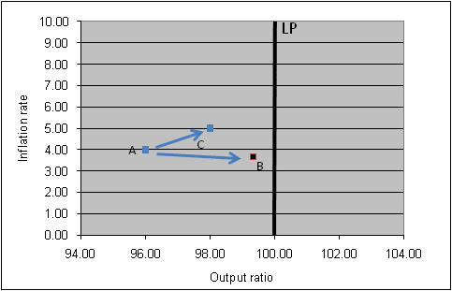

a) Suppose the economy is at A this year. What would keep the economy at A next year? Be specific about the inflation expectations and the growth rate of nominal demand that would do the trick. Remember that the growth rate of nominal GDP must equal the growth rate of real GDP plus the inflation rate.
b) Suppose monetary policy becomes expansionary next year and the economy moves from A to C. What is the growth rate of nominal aggregate demand from this year to next?
c) Suppose monetary policy becomes expansionary and the growth rate of nominal aggregate demand is whatever you calculated in b). What would influence whether the economy moved from A to B or from A to C?

