The True Cost of Eggs

If you go to the grocery store, you might find conventional eggs, cage-free eggs, hormone-free eggs, omega-3 enriched eggs, and pastured eggs. If you go to a farmers market or Bryn Athyn Bounty, you’ll find very fresh eggs, but they cost significantly more. How do you know whether or not Bryn Athyn Bounty eggs are worth the extra cost?

Here is some data that compares the nutrients found in 100 g of a few types of eggs,:
Vitamin A:
- Conventional: 487 IU
- Pastured avg: 792 IU
- Skagit Ranch: 1013 IU

Vitamin D:
- Conventional: 34 IU
- Pastured avg: 136 - 204 IU
- Skagit Ranch: [use 200 IU]

Vitamin E:
- Conventional: 0.97 mg
- Pastured avg: 3.73 mg
- Skagit Ranch: 4.02 mg

Beta-carotene:
- Conventional: 10 mcg
- Pastured avg: 79 mcg
- Skagit Ranch: 100 mcg

Omega-3 fatty acids:
- Conventional: 0.22 g
- Pastured avg: 0.66 g
- Skagit Ranch: 0.74 g

Open an excel worksheet. Organize the data found above. Clearly label your rows and columns, including the units used for the data.

The cost for each type of egg is typically $1.89 for conventional, $3.49 for pastured, and $4 for Bounty. Enter this data in your excel file.

While the cost of a Bounty egg is clearly more, it may be a better deal because of its higher nutrient levels.

Use excel to calculate the nutrients per dollar for different eggs.
In the cell where you want the calculation to be, type in an equals sign and type in the formula required to calculate the cost for that nutrient, being sure to use cell names rather than typing in the number values.

Again, label the row or columns of these clearly (e.g., “Vitamin A, IU/$”).

Hint: You should not need to type out the equation for every cell. You can copy and paste or you can drag the small blue square over the new area. Look at the new cells: do their formulas reference the right cells? How did excel adapt the formulas?

Hint: Using a “$” sign in front of either/both the letter or number of a cell name will mean that element stays static when you copy and paste. Practice using this technique.

Make a table representing the cost per nutrient data. Select the data, click “charts” and choose “clustered column.” Does this graph represent the data well? What could you conclude from this chart, and what was indecipherable?

Discuss what we can do about that. How can we represent the data so that we can compare the costs in a consistent way? (Use full sentences.) Create a third table using your modification.

Make a new clustered column graph with your data.

Using what you see in the table and in the graph, how might that have an effect on how you (or your family) choose to buy eggs?

What were the assumptions and limitations of this project? What could we do to get better data?

Contest: Make a poster for the Bounty to help them promote their eggs.
Be sure to present this information so that it is quickly understandable to the general public.

A comparison of commercial eggs (left) and local eggs (right):
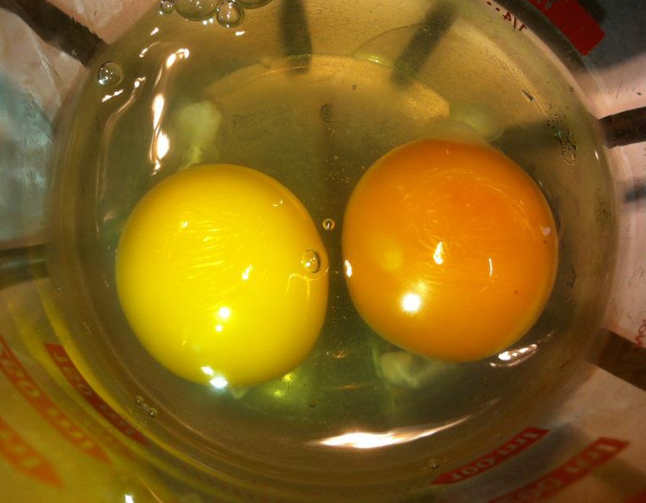

http://wholehealthsource.blogspot.com/2009/05/pastured-eggs.html
A brief research of Skagit Farms and their egg production methods showed that it is similar in style to Bryn Athyn Bounty eggs. http://www.motherearthnews.com/homesteading-and-livestock/skagit-river-ranch.aspx#axzz2a4AmNyqv

