Where’s the volcanic threat?

Explosive volcanic activity is usually associated with intermediate and felsic lavas. As shown in Table 1, these lavas solidify into volcanic rocks with 52%-65% and >65% silica (SiO₂), respectively. Consequently, geologists measure the amount of silica in volcanic rocks to better-understand the threat of explosive volcanic activity. In this activity, you will use the amount of silica in volcanic rocks to help you evaluate the threat of explosive volcanic activity at five sites (A through E) in Costa Rica (Figure 1).
____________________________________________________________

PERCENT SILICA | COMPOSITION
>65 | Felsic (F)
52-65 | Intermediate (I)
45-52 | Mafic (M)
<45 | Ultramafic (U)

Table 1. The composition of volcanic rocks.
____________________________________________________________

1. Use the information in Table 1 to assign a composition to each rock sample in Table 2. In the COMPOSITION column of Table 2, write “U” for ultramafic, “M” for mafic and so on. The compositions of the four samples from Site E have been entered for you as an example.

2. At which site are all samples intermediate? _______

3. At which site are all samples mafic? _______

4. Based on your answers to #2 and #3 above, at which site is the potential for explosive volcanic activity least. (Assume the samples are representative of the geology at the site.)
_____________________

5. Which site(s) yielded rocks indicating at least some potential for explosive volcanic activity?
_____________________

NOTE: More questions follow Table 2.

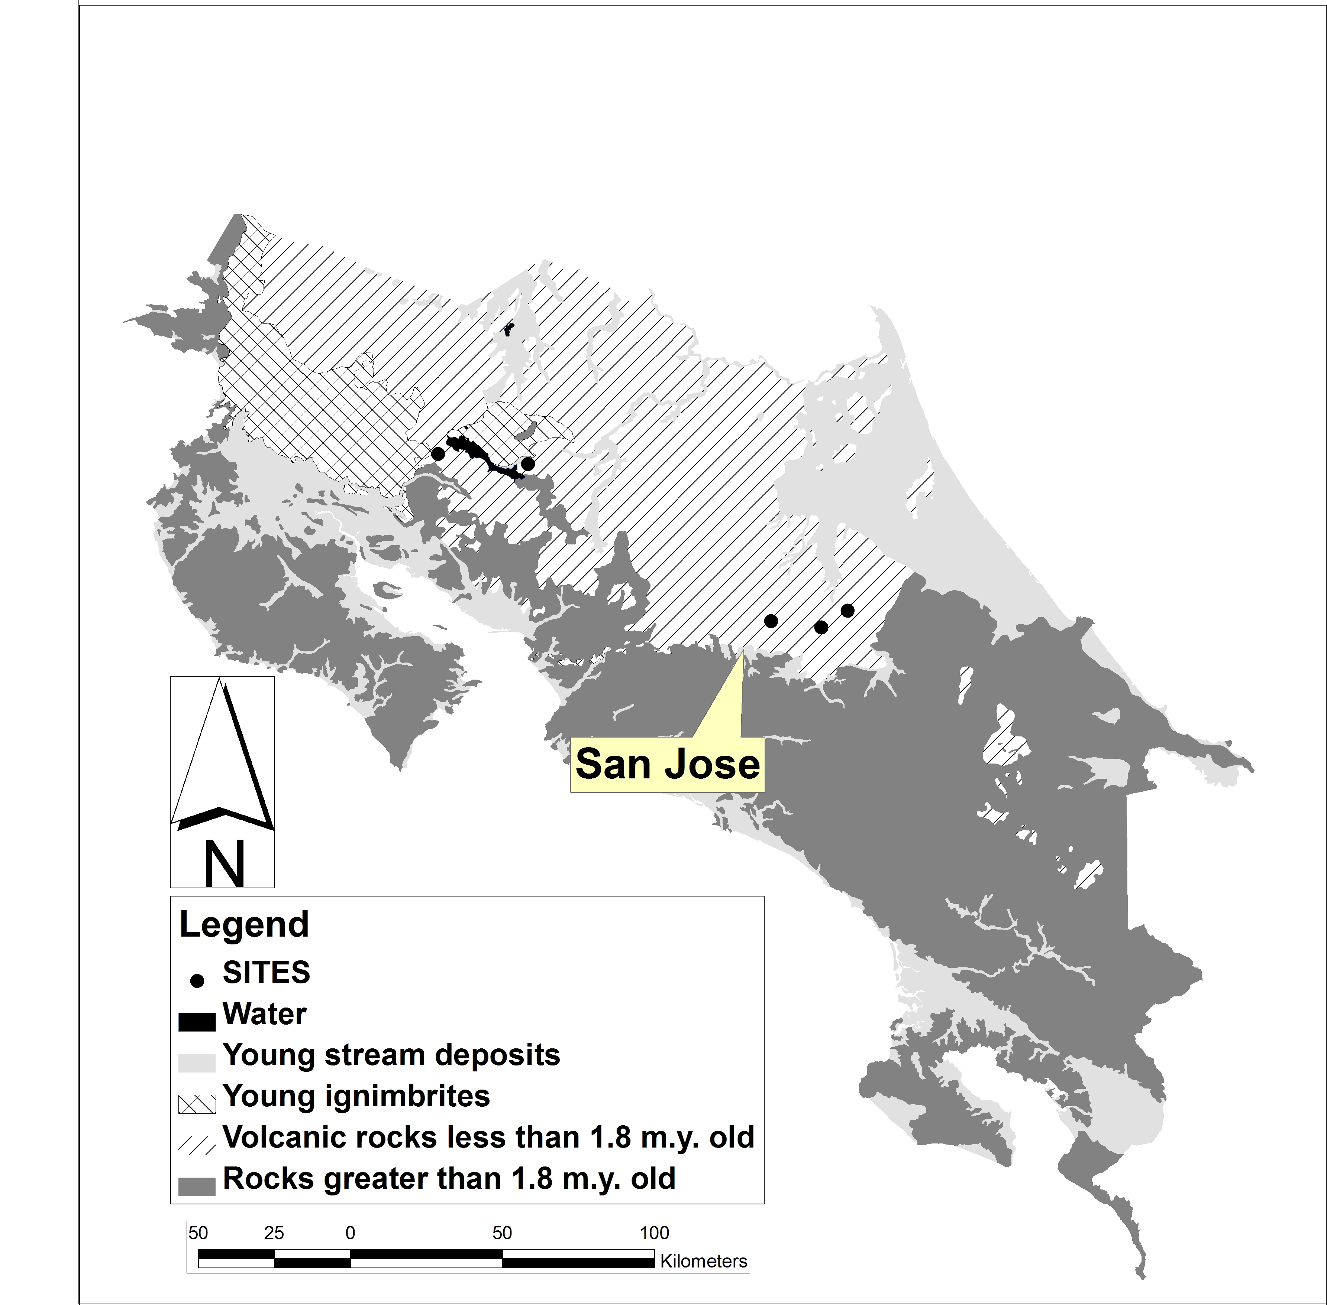
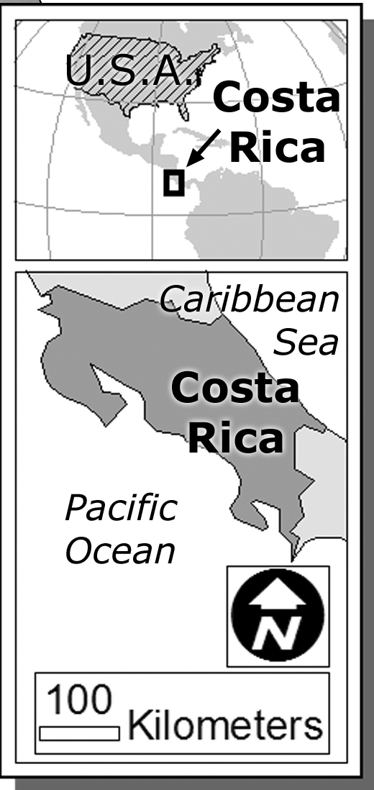
A
B
C
D
E
Geology of Costa Rica

Figure 1. Geology of Costa Rica and location of Sites listed in Table 2. Geology from a compilation prepared by the U.S. Geological Survey.
____________________________________________________________

SITE | SAMPLE | PERCENT SILICA | COMPOSITION
A | A-1 | 51.4
A | A-2 | 51.2
A | A-3 | 50.8
A | A-4 | 50.6
A | A-5 | 50.5
A | A-6 | 50.5
A | A-7 | 50.2
A | A-8 | 50.1
A | A-9 | 49.6
A | A-10 | 49.4
B | B-1 | 56.0
B | B-2 | 55.2
B | B-3 | 54.7
B | B-4 | 54.6
B | B-5 | 54.5
C | C-1 | 52.9
C | C-2 | 49.8
C | C-3 | 47.1
C | C-4 | 46.1
D | D-1 | 55.7
D | D-2 | 55.1
D | D-3 | 55.0
D | D-4 | 54.9
D | D-5 | 54.4
D | D-6 | 54.1
D | D-7 | 54.0
D | D-8 | 53.5
D | D-9 | 51.3
E | E-1 | 52.5 | I
E | E-2 | 52.3 | I
E | E-3 | 51.7 | M
E | E-4 | 51.6 | M

Table 2. The silica content and composition of volcanic rocks at five locations in Costa Rica. Silica data obtained through the earthchem.org portal on 27 November, 2006.
____________________________________________________________

6. In general, is the volcanic threat greatest in northern or southern Costa Rica? (Hint: Examine Figure 1. Where are most of the young volcanic rocks?)
____________

7. Extremely explosive volcanic activity can form an ignimbrite – a kind of felsic flow. Examine Figure 1. Which two Sites are relatively close to ignimbrites?
____________

8. Examine the Costa Rica night time image in costaricanight.ppt. Night lights indicate human settlements. List volcanic Sites in or touching settled areas.

_____________________________________

Sources

Costa Rica geologic map: http://pubs.usgs.gov/dds/dds19/
(accessed 27 November, 2006)

Silica data: earthchem.org (accessed 27 November, 2006)

