Web-based Interactive Landform Simulation Model -- Grand Canyon (WILSIM-GC) Parameters

6. Visualization Interval

Variable Description
The visualization interval variable determines when and how often data is visualized within the cross section and profile graphs. After drawing a cross section line on the model and running the simulation, topographic lines will appear on the cross section and profile graphs. The number of topographic lines on these two graphs is determined by the visualization interval value.

How to use the Model
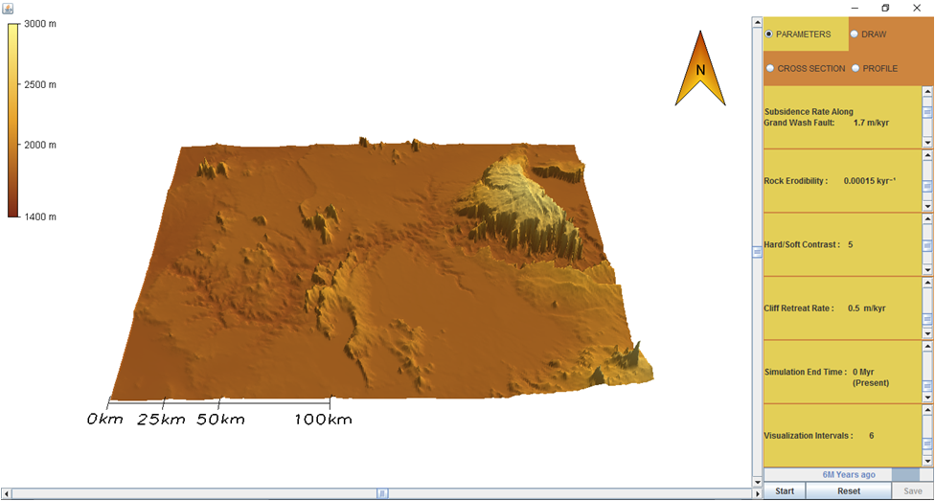
- To change the parameter values, move the Scroll Bar or click on the Arrows next to the parameters.
- Notice there are four tabs in the upper right corner labeled Parameters, Draw, Cross Section, and Profile. Click the DRAW tab. You can create a cross section line across the canyon developing area by clicking and dragging your cursor to form an arrow at that location. To remove a cross section line, select Clear.
- Click on the PARAMETERS tab and then hit the Start button to run the simulation.
- To pause the simulation, click Pause; to continue simulation, click Continue (the button toggles between Pause and Continue upon clicking).
- When the simulation is finished, view the resulting 3-D topography in the PARAMETERS tab. Click on the CROSS SECTION tab and view the topographic changes along the cross section line you created. Similarly, you can click on the PROFILE tab to view the topographic changes along the river. Horizontal and/or vertical grid lines can be viewed on the Cross Section and Profile graphs by selecting the empty boxes beneath the tabs. The default values of the model creates a topographic line for every passing million years resulting in a total of six lines.
- In the lower right corner next to the Start/Pause and Reset buttons is a Save button. The Save button provides an option to save the data from the current simulation and can be viewed in Microsoft Excel.
- To start a different simulation, click the Reset button and then click Start to begin the simulation.

Exercise
Draw a line across the canyon by selecting the DRAW tab. Then click and drag your mouse across the canyon and release the mouse to create an arrow. Draw an arrow similar to the image below.
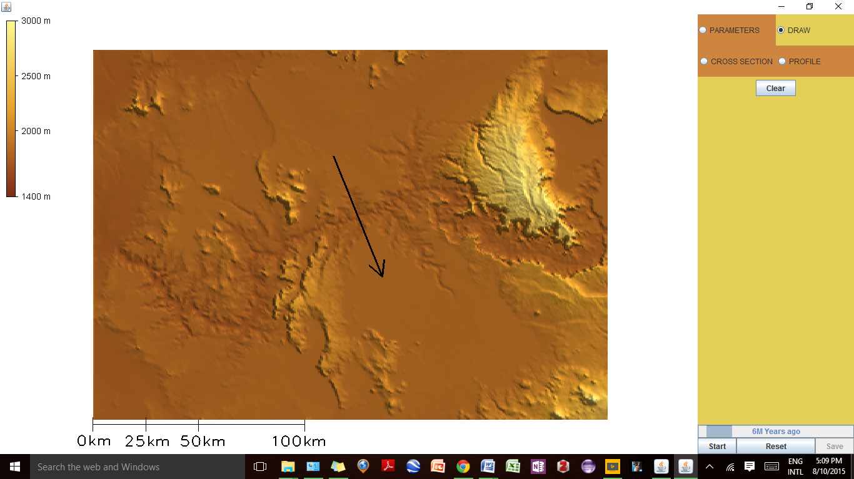
Under the PARAMETERS tab, set the model to the default parameters as shown below if not already. Now click on the CROSS SECTION tab, run the simulation, and view the cross-section graph as the simulation runs.

Subsidence Rate Along Grand Wash Fault: 1.7 m/kyr
Rock Erodibility: 0.00015 kyr⁻¹
Hard/Soft Contrast: 5
Cliff Retreat Rate: 0.5 m/kyr
Simulation End Time: 0 Myr (Present)
Visualization Interval: 6 equal interval saves

- Once the simulation has finished, describe the cross-section and profile graphs under the CROSS SECTION and PROFILE tabs by commenting on the topography, elevation, number of lines, and the purpose each line has.
- Hypothesize how the cross-section and profile graphs would change if the number of visualization intervals decreased and explain your prediction(s).
- Now change the visualization interval to 1 and run the simulation. How are the cross-section and profile graphs different than the default graphs? Were there any changes to the graphs that you didn't predict? If so, what were they and why did they occur?
- Now change the visualization interval to 12 and run the simulation. How are the cross-section and profile graphs different than the default graphs? Were there any changes to the graphs that you didn't predict? If so, what were they and why did they occur?
- How would you generalize the relationship between the visualization interval variable and the number of lines on the graphs and when the lines formed? For example, “as the number of visualization intervals increase, the number of times the topography is recorded and the number of lines on the cross-section and profile graphs ________ (decrease/increase).”
- For a physical scientist who studies landforms, is a lower or higher visualization interval value better? Why?

