Web-based Interactive Landform Simulation Model -- Grand Canyon (WILSIM-GC) Parameters

5. Simulation End Time

Variable Description
The simulation end time variable determines the duration and stopping time of the simulation. The default model simulates the Grand Canyon beginning 6 million years in the past and ending at the present era. WILSIM-GC possesses the ability to change the simulation end time value and extend the simulation up to 6 million years in the future. This variable therefore determines how long the landscape is influenced by erosional forces which are characterized by other parameters including the subsidence rate, rock erodibility, hard/soft contrast, and cliff retreat values.

How to use the Model
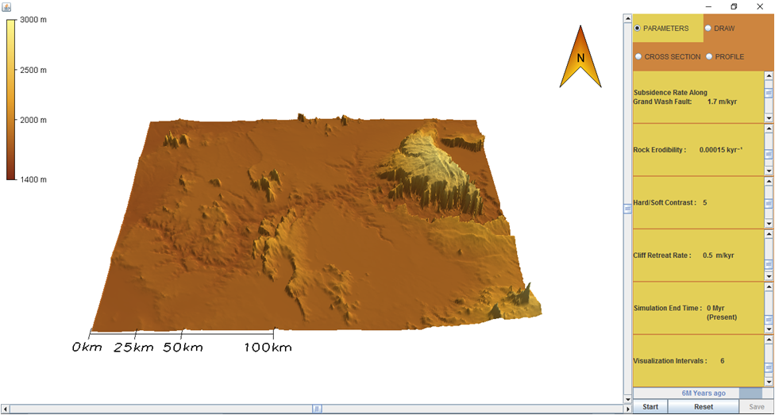
- To change the parameter values, move the Scroll Bar or click on the Arrows next to the parameters.
- Notice there are four tabs in the upper right corner labeled Parameters, Draw, Cross Section, and Profile. Click the DRAW tab. You can create a cross section line across the canyon developing area by clicking and dragging your cursor to form an arrow at that location. To remove a cross section line, select Clear.
- Click on the PARAMETERS tab and then hit the Start button to run the simulation.
- To pause the simulation, click Pause; to continue simulation, click Continue (the button toggles between Pause and Continue upon clicking).
- When the simulation is finished, view the resulting 3-D topography in the PARAMETERS tab. Click on the CROSS SECTION tab and view the topographic changes along the cross section line you created. Similarly, you can click on the PROFILE tab to view the topographic changes along the river. Horizontal and/or vertical grid lines can be viewed on the Cross Section and Profile graphs by selecting the empty boxes beneath the tabs. The default values of the model creates a topographic line for every passing million years resulting in a total of six lines.
- In the lower right corner next to the Start/Pause and Reset buttons is a Save button. The Save button provides an option to save the data from the current simulation and can be viewed in Microsoft Excel.
- To start a different simulation, click the Reset button and then click Start to begin the simulation.

Exercise
Run the simulation using the default parameters as shown below.

Subsidence Rate Along Grand Wash Fault: 1.7 m/kyr
Rock Erodibility: 0.00015 kyr⁻¹
Hard/Soft Contrast: 5
Cliff Retreat Rate: 0.5 m/kyr
Simulation End Time: 0 Myr (Present)
Visualization Interval: 6 equal interval saves

- How has the landscape changed?
- Hypothesize how the landscape would change if the erosional forces acting upon the landscape occurred for a longer period of time, and explain your prediction(s).
- Now change the simulation end time to 3 Myr (in the future) and run the simulation. How is the shape of this landscape different than the default landscape? Were there any changes to the landscape that you didn't predict? If so, what were they and why did they occur?
- Now change the simulation end time to 6 Myr (in the future) and run the simulation. How is the shape of this landscape different than the default landscape? Were there any changes to the landscape that you didn't predict? If so, what were they and why did they occur?
- How would you generalize the relationship between the simulation end time variable and the shape of the resulting canyons? For example, “as the simulation end time or the time the landscape is under erosional forces increases, the length, width, and depth of the canyon and tributaries (side canyons) ________ (decreases/increases).”
- How does the simulation end time variable relate to geological properties and processes? That is, how would you extrapolate from these simulation results to real-world landscape evolution?

