Web-based Interactive Landform Simulation Model -- Grand Canyon (WILSIM-GC) Parameters

3. Hard/Soft Contrast

Variable Description
The hard/soft contrast is a dimensionless number that controls the relative erosion rate of strong and weak rocks. Simply put, a value of 5 means that the soft rock layers are 5 times more erodible than the hard rock layers in the simulation. The rocks that are the most resistant to fluvial erosion in the Grand Canyon sequence are the limestones (Kaibab, Redwall, and Muav). This can be deduced from the fact that fluvial channels steepen significantly when they encounter those rock types. The clastic sedimentary rocks are more fractured and thinly bedded and hence require less power to pluck bedrock from the channel bed. The actual sequence of rock strata represented in the model is a simplified version of the stratigraphy present in the Grand Canyon. The sequence represented in the model has a strong layer located 400 m below the canyon rim, representing the Redwall limestone. The greater resistance of the Redwall limestone relative to rocks above and below it results in the largest single "step" in the cross-sectional shape of the Grand Canyon.

How to use the Model
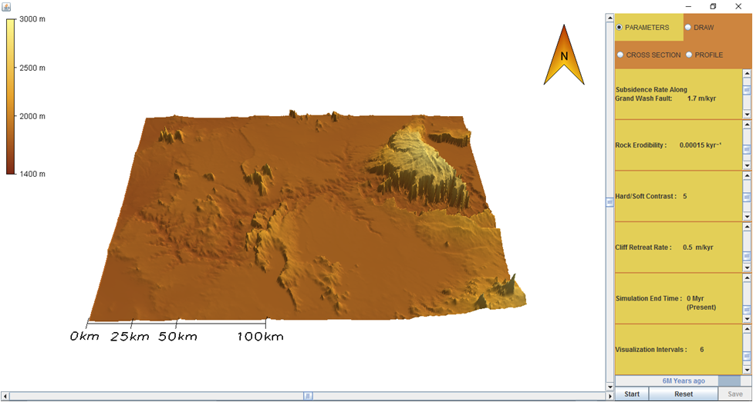
- To change the parameter values, move the Scroll Bar or click on the Arrows next to the parameters.
- Notice there are four tabs in the upper right corner labeled Parameters, Draw, Cross Section, and Profile. Click the DRAW tab. You can create a cross section line across the canyon developing area by clicking and dragging your cursor to form an arrow at that location. To remove a cross section line, select Clear.
- Click on the PARAMETERS tab and then hit the Start button to run the simulation.
- To pause the simulation, click Pause; to continue simulation, click Continue (the button toggles between Pause and Continue upon clicking).
- When the simulation is finished, view the resulting 3-D topography in the PARAMETERS tab. Click on the CROSS SECTION tab and view the topographic changes along the cross section line you created. Similarly, you can click on the PROFILE tab to view the topographic changes along the river. Horizontal and/or vertical grid lines can be viewed on the Cross Section and Profile graphs by selecting the empty boxes beneath the tabs. The default values of the model creates a topographic line for every passing million years resulting in a total of six lines.
- In the lower right corner next to the Start/Pause and Reset buttons is a Save button. The Save button provides an option to save the data from the current simulation and can be viewed in Microsoft Excel.
- To start a different simulation, click the Reset button and then click Start to begin the simulation.

Exercise
Run the simulation using the default parameters as shown below.

Subsidence Rate Along Grand Wash Fault: 1.7 m/kyr
Rock Erodibility: 0.00015 kyr⁻¹
Hard/Soft Contrast: 5
Cliff Retreat Rate: 0.5 m/kyr
Simulation End Time: 0 Myr (Present)
Visualization Interval: 6 equal interval saves

- How has the landscape changed?
- Hypothesize how the landscape would change if you increased the hard/soft contrast factor, and explain each of your predictions.
- Now change the hard/soft contrast value to 2 and run the simulation. How is the shape of this landscape different than the default landscape? Were there any changes to the landscape that you didn't predict? If so, what were they and why did they occur?
- Now change the hard/soft contrast value to 8 and run the simulation. How is the shape of this landscape different than the default landscape? Were there any changes to the landscape that you didn't predict? If so, what were they and why did they occur?
- How would you generalize the relationship between the hard/soft contrast variable and the shape of the resulting canyons? For example, “as the hard/soft contrast value increases, the length, width, and depth of the canyon and tributaries (side canyons) ________ (decreases/increases).”
- How does the hard/soft contrast variable relate to geological properties and processes? That is, how would you extrapolate from these simulation results to real-world landscape evolution?

