Web-based Interactive Landform Simulation Model -- Grand Canyon (WILSIM-GC) Parameters

4. Cliff Retreat Rate

Variable Description
The cliff retreat rate determines the speed or pace at which cliffs wear back laterally. The cliffs adjacent to Grand Canyon wear back in a slope-retreat style. That is, they maintain a near-vertical form as they wear back. Slope retreat is a common style of hillslope evolution in weathering-limited environments (those where weathered rock is transported off of hillslope as fast as it is weathered into transportable material). Weathering-limited conditions tend to occur in relatively arid climates such as that of the southwestern United States. Cole and Mayer (1982) used fossil packrat middens to measure the rate at which the most resistant rocks (those of the Redwall limestone) wear back by retreat. They obtained a value of approximately 0.5 m kyr⁻¹, but you can increase or decrease this value to see how having rocks more or less resistant to weathering would affect the shape of the canyon.

How to use the Model
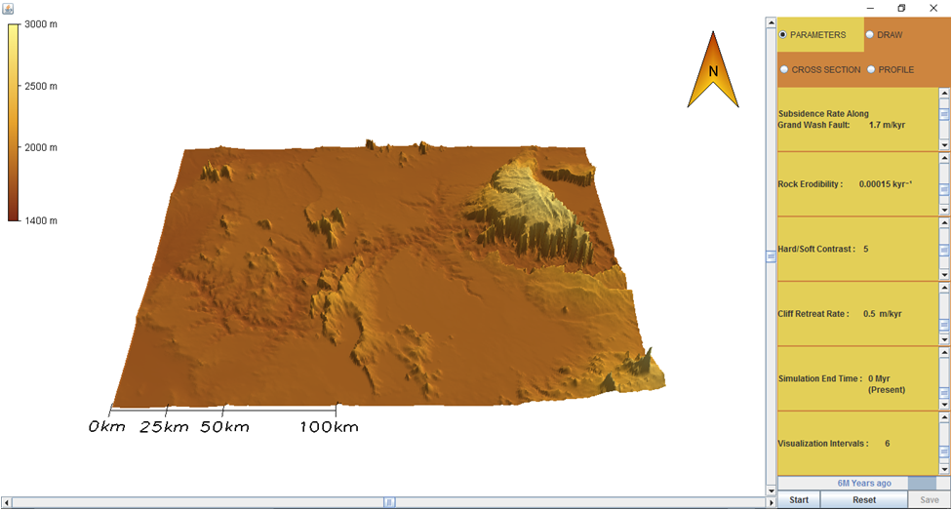
- To change the parameter values, move the Scroll Bar or click on the Arrows next to the parameters.
- Notice there are four tabs in the upper right corner labeled Parameters, Draw, Cross Section, and Profile. Click the DRAW tab. You can create a cross section line across the canyon developing area by clicking and dragging your cursor to form an arrow at that location. To remove a cross section line, select Clear.
- Click on the PARAMETERS tab and then hit the Start button to run the simulation.
- To pause the simulation, click Pause; to continue simulation, click Continue (the button toggles between Pause and Continue upon clicking).
- When the simulation is finished, view the resulting 3-D topography in the PARAMETERS tab. Click on the CROSS SECTION tab and view the topographic changes along the cross section line you created. Similarly, you can click on the PROFILE tab to view the topographic changes along the river. Horizontal and/or vertical grid lines can be viewed on the Cross Section and Profile graphs by selecting the empty boxes beneath the tabs. The default values of the model creates a topographic line for every passing million years resulting in a total of six lines.
- In the lower right corner next to the Start/Pause and Reset buttons is a Save button. The Save button provides an option to save the data from the current simulation and can be viewed in Microsoft Excel.
- To start a different simulation, click the Reset button and then click Start to begin the simulation.

Exercise
Run the simulation using the default parameters as shown below.

Subsidence Rate Along Grand Wash Fault: 1.7 m/kyr
Rock Erodibility: 0.00015 kyr⁻¹
Hard/Soft Contrast: 5
Cliff Retreat Rate: 0.5 m/kyr
Simulation End Time: 0 Myr (Present)
Visualization Interval: 6 equal interval saves

- How has the landscape changed?
- Hypothesize how the landscape would change if you increased the cliff retreat rate factor, and explain each of your predictions.
- Now change the cliff retreat rate value to 0.25 m/kyr and run the simulation. How is the shape of this landscape different than the default landscape? Were there any changes to the landscape that you didn't predict? If so, what were they and why did they occur?
- Now change the cliff retreat rate value to 1.5 m/kyr and run the simulation. How is the shape of this landscape different than the default landscape? Were there any changes to the landscape that you didn't predict? If so, what were they and why did they occur?
- How would you generalize the relationship between the cliff retreat rate variable and the shape of the resulting canyons? For example, “as the cliff retreat rate value increases, the width of the canyon and tributaries (side canyons) ________ (decreases/increases).”
- How does the cliff retreat rate variable relate to geological properties and processes? That is, how would you extrapolate from these simulation results to real-world landscape evolution?

