Game Theory, Collective Action and Climate Change
By Susan Spierre, Global Institute for Sustainability, Arizona State University

Noncooperative Game Theory Review

An assumption used in traditional economic theory is that an individual making a decision in isolation will typically make a decision based on what option is the most beneficial to him or her. That is, they want more rather than less of a good, and they choose options that are likely to yield the greatest satisfaction to them. Noncooperative game theory, on the other hand, is a tool used to understand the strategic interactions among two or more agents, where what is best for one decision maker may depend on what the other is doing and vice versa. Through prior readings, lectures, and exercises you have already been exposed to various noncooperative games, such as the prisoner’s dilemma example. To review, the classic prisoner’s dilemma situation is modeled in the payoff matrix below, where the potential outcomes of both the suspects’ decisions are outlined.

 | Suspect A Cooperates | Suspect A Betrays
Suspect B Cooperates | Each serves 6 months  I | Suspect A: goes free  Suspect B: 10 years II
Suspect B Betrays | Suspect A: 10 years  Suspect B: goes free III | Each serves 5 years  IV

The table shows that it is collectively rational for the suspects to cooperate by staying silent, given that it results in the least total prison time for the suspects (quadrant I). However, it is individually rational for the suspects to betray because they will each receive a higher payoff (lesser sentence) than they would by cooperating (quadrant II and III). The paradox of this type of game is that if both players reason the same way and they both betray, they both get a lower payoff (more prison time). As seen in this example, a defining feature of noncooperative game theory problems is that the players benefit more through cooperation than they do when acting in their personal self-interest.
Studying noncooperative games allows us to understand the ethical ramifications of decisions players make. The lack of a third party enforcer (e.g., an Organized Crime Boss) forces the players to decide the best course of action on their own. That is, there is no government or authoritative figure guiding players to make responsible decisions. By thinking only of themselves, both prisoners would choose to betray the other and would both serve lengthy prison sentences. If each prisoner instead considered the effect that their decision would have on the other, together they would have been much better off. The advantage of studying the Prisoner's Dilemma is that it models situations in which there is a conflict between the interests of individuals and the well-being of the group, also known as collective action problems.

Collective Action Problems
Perhaps the first major insight into the concept of collective action was the Coase (1960) theorem, developed by Nobel Prize winner Ronald Coase. The theorem states that when transaction costs are low and property rights are determined, optimal allocation of resources is achievable without government intervention. The polluting and damaged parties will negotiate a transfer of payments between them to either accept damage or reduce pollution on the basis of which was more profitable. However, in practice, obstacles to bargaining or poorly defined property rights can prevent Coasian bargaining. Collective action theory thus illustrates how individuals within a group or organization may lose if each acts in his or her own self-interest, but benefit from group cooperation. Mancur Olson's 1965 book The Logic of Collective Action: Public Goods and the Theory of Groups, analyzes the problems of public good provision (Olsen, 1965). According to Olsen, a common or collective good is one that is available to every individual, regardless of whether or not he or she pays for it. Olsen shows how even if there is a common interest in a collective good being sought by a group, there is seldom a common interest in paying for that good. Each member of the group wants other members to pay the costs of providing it because, by definition, each member will benefit from the good regardless of whether or not he or she pays for it (Harris, 2007).
The concept of collective action was popularized by Garrett Hardin’s Tragedy of the Commons, in which he describes how individuals, acting independently and rationally in their own self-interest, will ultimately deplete a shared limited resource even when it is apparent that it is not in anyone's long-term interest for this to happen (Hardin, 1968). Hardin’s theory applies directly to over-extraction problems of limited resources (e.g. over fishing in a fishery or over logging a forests) but can also be used to explain problems of pollution, such as the emissions of green-house gases (GHG), the cause of global climate change.
Eleanor Ostrom provides insight about conditions most likely to favor sustainable uses of common-pool resources at the local and regional level but stresses the challenge of maintaining the global commons, such as biodiversity, climate change, and other ecosystem services (Ostrom, 1999). These new global challenges are extremely difficult to manage, according to Ostrom, for at least the following reasons:
- The large number of participants in the global commons increases the difficulty of organizing, agreeing on rules, and enforcing rules.
- Increased cultural diversification can decrease the likelihood of finding shared interests and understandings. The problem of cultural diversity is exacerbated by “north-south” conflicts stemming from economic differences between industrialized and less-industrialized countries.
- The trend toward increased specialization has made it more difficult to comprehend the significance of global common-pool resources and how we need to work together to govern these resources successfully.
- The accelerating pace of change in population growth, economic development, capital and labor mobility, and technological change push us past environmental thresholds quickly. “Learning by doing” is increasingly difficult, as past lessons are less and less applicable to current problems.
- The requirement of unanimous agreement as a collective-choice rule for global resource management allows some national governments to hold out for special privileges before they join others in achieving regulation, this strongly affecting the kinds of resource management policies that can be adopted.
- At the global level, there is no room for mistakes; we have only one globe with which to experiment.
Ostrom concludes by stating, “building from lessons of past successes will require forms of communication, information, and trust that are broad and deep beyond precedent, but not beyond possibility.” Common-pool resources, especially global resources, are unfortunately at risk for proper management because such difficulty exists in negotiating and enforcing proper governing rules. In the following text we focus on the specific difficulties in addressing the collective action problem of climate change.

The Collective Action Problem of Climate Change
In the context of climate change, the collective or shared resource at stake is the Earth’s atmosphere, which has a limited capacity to store GHG emissions. Climate change is a problem of collective action because everyone has a common interest in preserving the atmosphere, but few individuals are willing to sacrifice emissions for the cause. Individuals are incentivized to free-ride on the altruism of others that do sacrifice, since everyone will benefit from decreased emissions regardless if they personally make the sacrifice.
Climate change can be thought of in terms noncooperative game theory and modeled similarly to the prisoner’s dilemma. The players in this case are those responsible for the GHG emissions: countries, institutions, companies, and/or individuals. The strategies of each player can be simplified into two categories: mitigate by decreasing emissions of GHG or continue to conduct business as usual (BAU). Similar to the prisoner’s dilemma problem, the climate change payoff matrix is provided below. In this case, the players are referred to as Country A and Country B.

 | Country B Mitigates | Country B BAU
Country A  Mitigates | - Both countries benefit from long-term sustainable eco-system services, better human health, diversified and independent economies, as well as an improved sense for justice and the well-being of others  I | - Country A: : disadvantaged economically in the short term due to conservation efforts including reduced industry and decreased production  - Country B: benefits economically by maximizing industry and production  - Over the long-term both countries suffer from heightened GHG concentrations in the atmosphere II
Country A  BAU | - Country A: benefits economically in the short-term by maximizing industry and production  - Country B: disadvantaged economically in the short term due to conservation efforts including industry and production  - Over the long-term both countries suffer from heightened GHG concentrations in the atmosphere III | - Both suffer from environmental and economic degradation in the long-term  - Both benefit economically in the near term  IV

In the table above, it is collectively rational to cooperate and restrict overall emissions because each country prefers the outcome produced by everyone restricting pollution over the outcome produced by no one doing so. However, it is individually rational for each country not to restrict its own pollution because when each agent has the power to decide whether or not to restrict emissions, each (rationally) prefers not to do so, whatever the others do (Gardiner, 2006). As seen in the climate change payoff matrix above, countries are incentivized in the short-term to conduct business as usual to maximize economic gain, but the consequences of not mitigating will be wide-spread suffering in terms of environmental and economic degradation over the long-term (quadrant IV). Furthermore, in the absence of collective action and enforcement countries that voluntarily curb GHG emissions will have the practical effect of incentivizing others to increase emissions. For example, Americans who reduce consumption of fossil fuel resources will undoubtedly reduce fossil fuel prices – thereby enabling increased consumption of fossil fuels by others. The end result may not in fact be beneficial to the future people for whom they are concerned, but instead transfer the greatest benefits to those individuals or countries that do not voluntarily curb emissions.
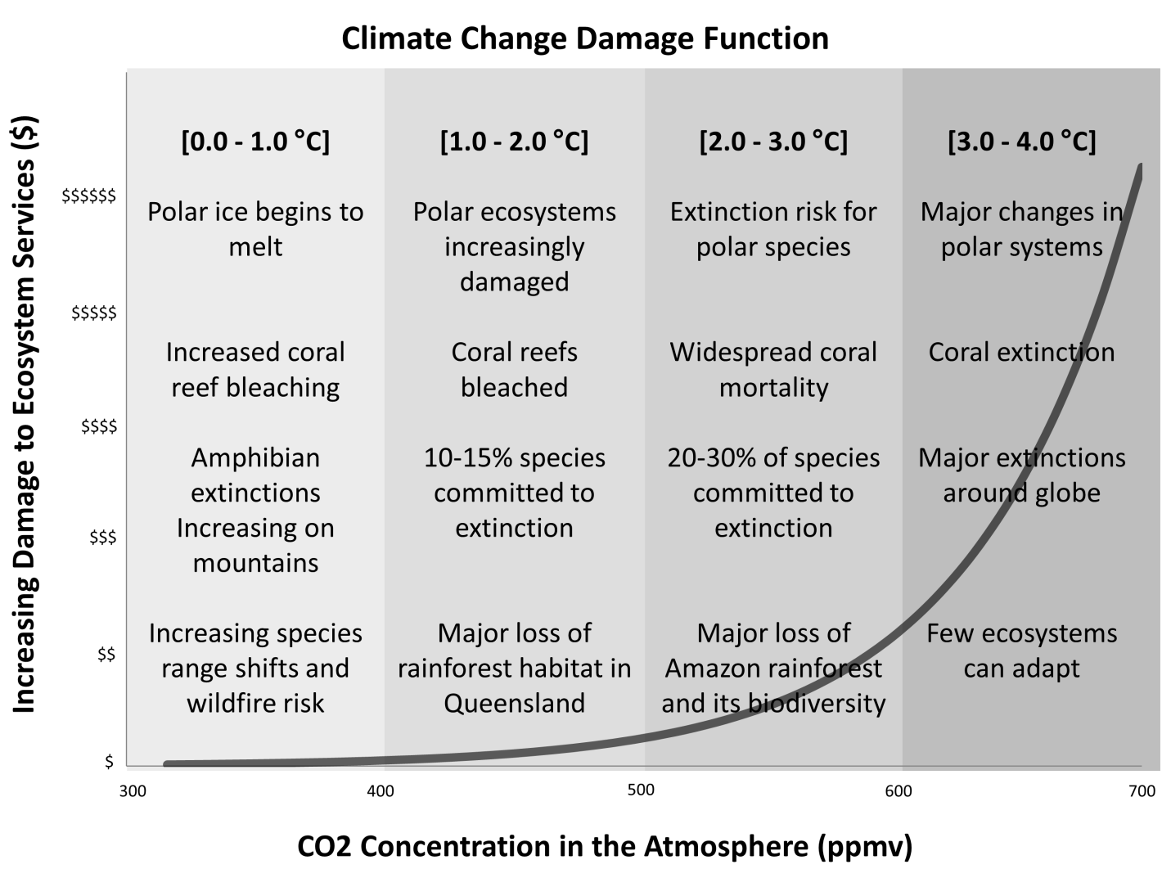
Climate change is a truly global phenomenon. Emissions of GHG from any geographical location on the Earth’s surface travel to the upper atmosphere and play a role in affecting climate globally. Hence, the impact of any particular emission of greenhouse gases is not realized solely at its source, either individual or geographical; rather impacts are dispersed to other actors and regions of the Earth. GHG emissions are responsible for a myriad of impacts including changes to Earth's climate system, manifested in events such as drought, floods, sea-level rise, temperature changes, extinction of species, and spread of vector-borne diseases. In failing to cooperate and limit overall emissions, the current generation does not simply pass an existing problem along to future people, rather it adds to it, making the problem worse. For example, failing to act now increases the magnitude of future climate change and increases mitigation costs. Also, waiting to act allows additional investment in fossil fuel based infrastructure in developed and especially less developed countries. Hence, inaction raises transition costs, making future change harder than change now. Furthermore, the current generation does not add to the problem in a linear way. Rather, it rapidly accelerates the problem, since global emissions are increasing at a substantial rate (Gardiner, 2006). Figure1 shows how the net global climate response becomes increasingly more severe as CO₂ levels, and the associated global temperature change, continue to increase.

.Figure 1. The exponential climate change damage function shows escalating damages to ecosystem service as the concentration of CO2 increases in the atmosphere. The example temperature changes and damages are adapted from the IPCC 2007 report. Figure created by Susan Spierre

Because climate is a non-linear, complex global system in which the total effects are greater than the sum of those attributable to individual emissions, collective action is the appropriate scale for mitigation. In other words, climate change must be viewed as a collective action problem because together (past generations of people included), have more or less, all contributed in some form or another to the overall problem.

Climate Change and Human Development
Ethical considerations are fundamental to adequately address the issues surrounding climate change. For example, where the global limit of GHG concentration is set depends on how the interests of the current generation are weighed against those of future generations; and how emissions are distributed under the global gap depends in part on various beliefs about the appropriate role of energy consumption in people’s lives, the importance of historical responsibility for the problem, and the current needs and future aspirations of particular societies (Gardiner, 2006). That is, we need to think about how our own actions and policies affect the interests and welfare of others living across the globe, now and in the future. Mitigating climate change is a particularly interesting moral problem mainly because a small fraction of the population emits a large percentage of harmful greenhouse gases (GHG), such as carbon dioxide (CO₂) (IPCC, 2007). However, the availability of energy services, and pollution it creates, is often necessary for advancing many aspects of human development and maintaining economic stability. Therefore, we see that the countries that are most responsible for climate change are also those that are (for the most part) suffering the least.
The figure below shows the relationship between CO₂ emissions per capita and human development for many countries. Human development is represented here using the United Nation’s Human Development Index (HDI), which is a composite index of a country’s average life expectancy, education in terms of enrollment and literacy rates, as well as income. It is apparent in the figure that there is a diminishing returns relationship between the level of human development a country obtains and the per capita CO₂ emissions it produces. In the early stages of development, when the need for energy production is low, a country’s HDI value and per capita CO₂ emissions tend to be small. Also at this early stage, a country typically earns high returns in HDI to small increases in energy production and the resulting CO₂ emissions. Adversely, at high levels of development, the relationship between HDI and CO₂ flattens and there are minimal returns in HDI improvements to increases in energy production and CO₂ emissions. Ethical considerations question the fairness of current distribution of GHG emissions, because countries that are emitting the most CO2 per capita (such as Norway, Canada and the United States) could presumably maintain a high level of human development even at lower emissions levels.
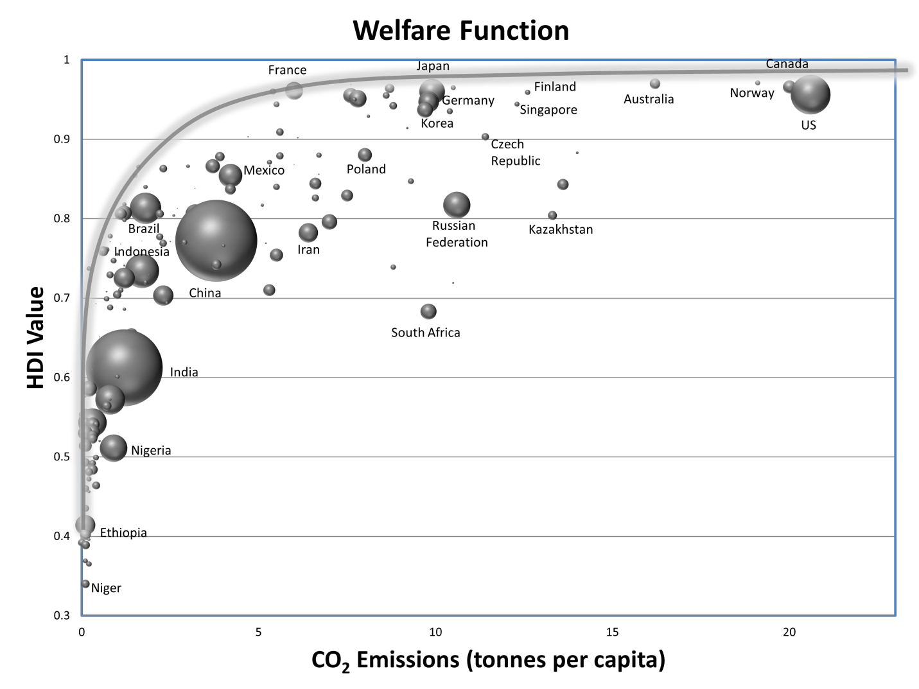
Figure 2. A diminishing returns relationship is displayed between each country’s CO2 emissions per capita and HDI value. The area of the bubbles represents the size of the population of each country. Data is from the Human Development Report 2007/2008. Figure created by Susan Spierre.

The moral complexities surrounding global climate change beg the ethical questions, "What are the developed world’s obligations to the developing countries? And should the developed countries risk their own sense of well-being to meet these obligations?" It is easy to speculate from an outsiders view that certain countries should take action to limit GHG emissions, but actually achieving global cooperation in climate policy negotiations is extremely difficult. For example, there has been a number of climate mitigation strategies proposed at the international level, including the Kyoto Protocol, the Copenhagen Accord, and most recently, the Cancun Accord. Despite these policy agreements, and the acknowledgement for the need to respond to climate change, countries have yet to commit to a global system of responsibility in controlling emissions. Successfully implementing a system of global compliance requires collective, social decision making that is unprecedented among people with radically different values and radically different needs (Gowdy, 2008).

The Externalities Game
To immerse the class in the concepts presented above, you will be participating in a non-cooperative educational game called the Externalities Game (TEG). The underlying structure of the game will provide you and your classmates with a first-hand experience at making decisions that will affect others. The common-pool resource in this game is grade points. That is, there are only so many grade points to go around, and the decisions you make individually will have an effect on the grades of your fellow classmates. Please refer to the separate documentation provided to review the specific rules of the game before play.

References:
Coase, Ronald H. 1960. The Problem of Social Cost. Journal of Law and Economics. Chicago IL, 1-23. October 1960.
Gardiner, S. 2006. A Perfect Moral Storm: Climate Change, Intergenerational Ethics and the Problem of Moral Corruption. Environmental Values, 15:397-413.
Gintis, H. 2009. Game Theory Evolving, Second Edition: A Problem-Centered Introduction to Modeling Strategic Interaction. Princeton University Press.

Gowdy JM. 2008. “Behavioral economics and climate change policy,” Journal of Economic Behavior & Organization, 68: 632-644.
Harris, P. G. 2007. Collective action on climate change: the logic of regime failure. Natural
Resources Journal, 47: 195-224.

Hardin, G. 1968. The tragedy of the commons. Science, 162:1243-1248.

Human Development Report 2007/2008, Fighting Climate Change: Human Solidarity in a
Divided World, New York.

IPCC, 2007: Summary for Policymakers. In: Climate Change 2007: The Physical Science Basis. Contribution of Working Group I to the Fourth Assessment Report of the Intergovernmental Panel on Climate Change [Solomon, S., D. Qin, M. Manning, Z. Chen, M. Marquis, K.B. Averyt, M. Tignor and H.L. Miller (eds.)]. Cambridge University Press, Cambridge, United Kingdom and New York, NY, USA.

Nicholson, W., Snyder, C. 2008. Microeconomic Theory: Basic Principles and Extensions. Thomson Learning, Inc.

Olson, M. 1971. The Logic of Collective Action: Public Goods and the Theory of Groups (Revised edition ed.). Harvard University Press.

Ostom et al. 1999. Revisiting the Commons: Local Lessons, Global Challenges. Science, 284: 278-282.

Poundstone, W. 1992. Prisoner's Dilemma. Doubleday, NY, NY.

