- As a group you have 10 minutes to answer the following questions. You should develop an answer which is clearly organized and includes sufficient explanation so that a person outside your group may understand them. Please place your answer on a separate sheet of paper. When your answer is complete, or time has been called, place your answer in the attached envelope.

In order to make the best use of your limited time, students will take on the following roles:
Facilitator: The student with a last name which appears first in the alphabet is charged with reading the scenario presented below, participating in the discussion and keeping this discussion on task.

Reflector: The student with a last name which appears last in the alphabet is charged with participating in the discussion and making certain that discussion points raised by other group members are clearly understood by all in the group.

Summarizer: The remaining student is charged with participating in and summarizing the discussion as it pertains to the problem at hand, and recording this as a well-organized answer.

The Problem:
Because of your economics knowledge, your family asks you to explain a graph that they saw in the newspaper over break. Specifically, they ask you to explain why consumer confidence matters and the channels through which it affects economy. Be specific and relate to the AE-PC model.
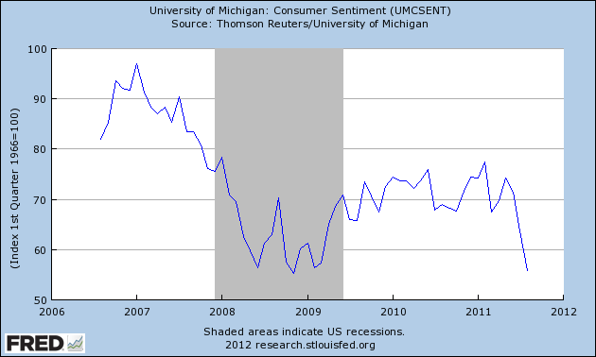
Follow up question for groups that finish the exercise earlier than their peer groups.
Describe the way central bank policy makers may react to this information.

- As a group you have 10 minutes to answer the following questions. You should develop an answer which is clearly organized and includes sufficient explanation so that a person outside your group may understand them. Please place your answer on a separate sheet of paper. When your answer is complete, or time has been called, place your answer in the attached envelope.

In order to make the best use of your limited time, students will take on the following roles:
Facilitator: The student with a last name which appears last in the alphabet is charged with reading the scenario presented below, participating in the discussion and keeping this discussion on task.

Reflector: The student with a last name which appears first in the alphabet is charged with participating in the discussion and making certain that discussion points raised by other group members are clearly understood by all in the group.

Summarizer: The remaining student is charged with participating in and summarizing the discussion as it pertains to the problem at hand, and recording this as a well-organized answer.

The Problem:
You are working as a manager for the Ritz-Carlton hotel chain. Your boss sees the following graph while surfing the Internet and she asks you to explain what it means. (Note: net equity extraction refers to home equity.) Explain what this graph means for consumption of hotel services and the channels through which it affects economy. Be specific and relate to the AE-PC model.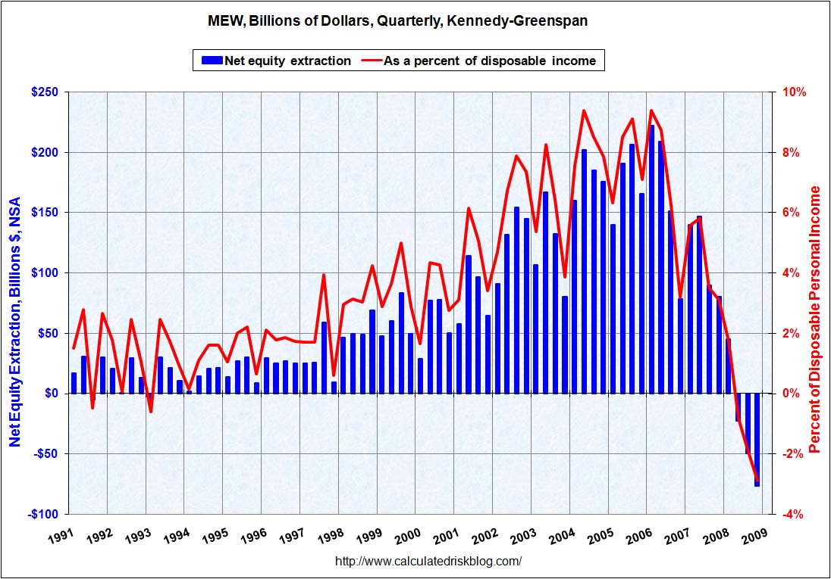
Follow up question for groups that finish the exercise earlier than their peer groups.
Describe the way central bank policy makers may react to this information.

- As a group you have 10 minutes to answer the following questions. You should develop an answer which is clearly organized and includes sufficient explanation so that a person outside your group may understand them. Please place your answer on a separate sheet of paper. When your answer is complete, or time has been called, place your answer in the attached envelope.

In order to make the best use of your limited time, students will take on the following roles:
Facilitator: The student with a first name which appears first in the alphabet is charged with reading the scenario presented below, participating in the discussion and keeping this discussion on task.

Reflector: The student with a first name which appears last in the alphabet is charged with participating in the discussion and making certain that discussion points raised by other group members are clearly understood by all in the group.

Summarizer: The remaining student is charged with participating in and summarizing the discussion as it pertains to the problem at hand, and recording this as a well-organized answer.

The Problem:
Over your summer break you are working a as lifeguard. Your fellow lifeguards are trying to decide whether to start a pool cleaning business. To open their business they will need a loan from a bank and have recently seen this graph in the WSJ. They ask you to explain what this graph means for the likelihood of getting a loan and the channels through which it affects economy. Be specific and relate to the AE-PC model.
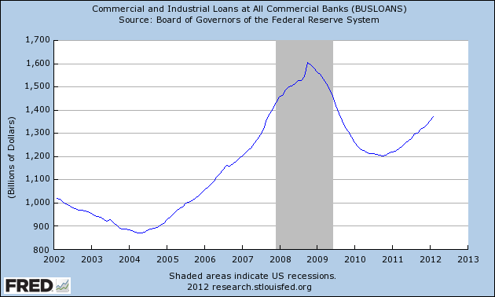
Follow up question for groups that finish the exercise earlier than their peer groups.
Describe the way central bank policy makers may react to this information.

