GEOLOGY at Northwest Missouri State University

PROGRAM DESCRIPTION
Northwest Missouri State University is the place to study geology in the state of Missouri focused on the undergraduate experience. The availability of instrumentation and mapping software along with faculty expertise allows us to train our undergraduate students using the latest technology. Our student-focused curriculum, rigorous laboratories, field studies, and opportunities for undergraduate research provide valuable hands-on experience to undergraduates.

We have a large number of geology majors relative to the number of faculty in the geology programs. According to the 2009 American Geological Institute report on trends in geosciences at 4-year colleges and universities, the average geoscience department includes 6.6 full-time faculty serving 49 undergraduate geology majors. At Northwest, 4.5 full-time faculty members serve approximately 75 undergraduate geology majors.

The geology program at Northwest has a long history of providing field experiences to enrich undergraduate education. Our field opportunities are designed to pique interest by going to cool places and seeing awesome geology. Field-based educational experiences range from day trips to look at local fossils to three-week international field courses that retrace the steps of James Hutton along the east coast of Scotland.

Our faculty values undergraduate research experience as a critical aspect of baccalaureate education at Northwest. Faculty work closely with undergraduates pursuing original research projects in geosciences. In many cases students apply for Undergraduate Research Funding (UGR) from the Dean of the College of Arts and Sciences. Completed projects are presented at local, regional, and national conferences. Research of exceptional quality has been published in peer-reviewed scientific journals, with undergraduate students serving as the primary author. Recent publications include:
- Travis Doughty and Aaron Johnson, “Heavy Metal Chemistry of Sediments in Caves of the Springfield Plateau, Missouri-Arkansas-Oklahoma: A Link to Subterranean Biodiversity?” http://digitalcommons.csbsju.edu/cgi/viewcontent.cgi?article=1018&context=compass
- Jessica Walter and Renee Rohs, “Mineralogical Composition of Diabase and Altered Dolostone from the St. Francois Mountains near Annapolis, Missouri, USA” http://digitalcommons.csbsju.edu/cgi/viewcontent.cgi?article=1003&context=compass

GOALS and OBJECTIVES
Two primary goals have been identified for the geology program at Northwest
- Prepare students for employment as professionals in geology and related fields.
- Prepare students for graduate studies in geology and related disciplines.
The following learning outcomes are designed to address the primary goals of geologic studies at Northwest.
- Students are able to communicate (both written and oral) understanding of scientific processes within the framework of geologic time including …
  - Development and alteration of the crust, mantle, and core
  - Formation of minerals and rocks
  - Influence of plate tectonics on the resulting surface features
  - Evolution of the fossil record
- Students can critically evaluate geologic information from peer-review literature or secondary sources
- Students are able to demonstrate an understanding of Earth systems as series of processes that impact one another
- Students are able to identify areas where our geologic understanding is lacking and recognize scientific problems
- Students are able to work as a team (supporting or leading) to address and solve scientific problems

PROGRAM REQUIRMENTS and ELECTIVES

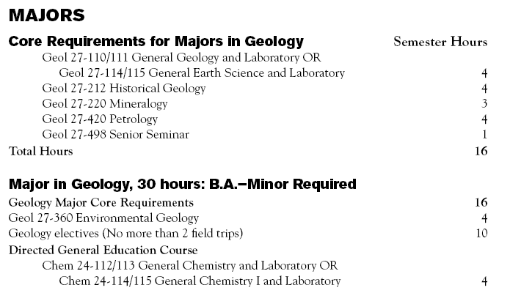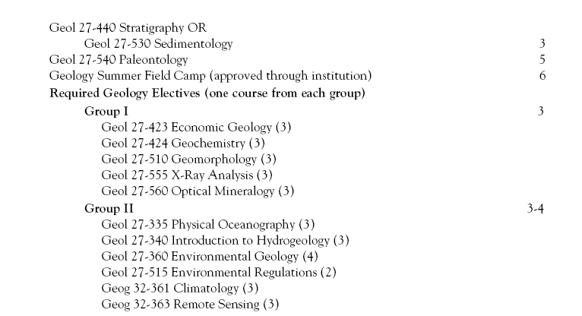

Capstone – Senior Seminar and Field Methods or Field Camp

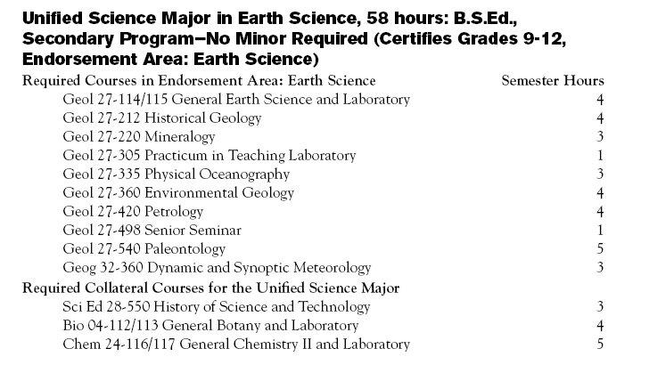

You should also write a 1-2 page essay describing your current understanding of how your program prepares students for the workforce, including a discussion of the areas in which your alumni are employed and the knowledge and skills that have been most important in supporting success.

PREPARING Geology students at Northwest
The processes that we use to prepare students at Northwest for careers in geology and related fields are embedded in the coursework and field experiences from freshman level up through their final term. In our general education courses, Earth Science and General Geology, we build a solid foundation for scientific inquiry by engaging students in the classroom with compelling examples while presenting content with relevancy to our students and the world in which they live. This engagement needs to come from a certain level of expertise and credibility, as established by the instructor and reinforced by the instructor’s actions and the verification by other faculty and students. The expertise and credibility comes at both the group level and with individual interaction. At the group level, or in a classroom setting, our faculty members share their own experiences, but even more importantly, the scientific experiences of students that have worked with them.

As our program has grown over the past 5-6 years we continue to build on a model of cyclical learning. This cyclical model starts with some knowledge in the classroom setting. That knowledge is then applied and expanded in a laboratory setting. The next step expands those experiences and draws on that knowledge in the field setting where the bigger picture becomes clearer and new pieces of information arise. That additional information is then taken back into the classroom, but now, the students are able to link a personal experience to the knowledge and that promotes a sense of relevancy. Not only does this new knowledge come back with the students but it gets added to the course through the use of photos or samples to improve the course the following year.

In addition to the geology courses, many of our students assist with introductory labs either as a teaching practicum or as a paid teaching assistant. Students may take on this increased level of responsibility as early as their sophomore year where they are guided through helping others to learn the Earth science content in an interactive setting.

After asking our current students, we found that there are some key factors that play into their success that do not take place in the classroom. One of those things is the investment of time and interest. For example, taking a few minutes to stop and talk with students in the hallway. Those short (or occasionally long) discussions build a support system and “family” atmosphere where you know you are welcome and valued for your input. It is also a degree of accountability so that students have some personal reminders of the high expectations we have for them. This “family” atmosphere is further strengthened with fieldtrips. We have field trip opportunities ranging from a 4-day fall field trip, to a single day course field trip, to a 17-day study abroad field trip. The number of students attending these field trips has ranged from 10 to 25 and usually consists of a mixture of upper level and lower level students. It is on those excursions, that the value of the program is shared between students at different levels.

The following quotes are from a current student and an alumnus

Cody Nichols, Senior Geology and Chemistry Major
“I love that geology immerses you in your field of study through hands-on and field experiences.”

Nathan Schmitz, Geologist Freeport McMoran copper and gold mining company
“I graduated from Northwest Missouri State University, and I consider higher education the key to not only the future of Missouri, but the future of our nation. Northwest has always been at the forefront of innovation, with going green, alternative energy power plant, laptops for students, and textbook rentals. I can speak for the geology program from which I graduated in 2011. I can say without a doubt that some of the best educators and people I have ever met are within the walls of Garrett-Strong science building, teaching students to the best of their ability, right now.”

PLACEMENT and EMPLOYMENT

Our undergraduate placement rate, in jobs in the field or in graduate school, within 6 months of graduation is annually at 100% among those graduates actively seeking employment. On average 30% of our graduates attend graduate school. Most of those attending graduate school in the last 10 years have done so at minimal cost receiving both tuition waivers and teaching or research assistantships.

Employers that have hired Geology graduates from Northwest Missouri State University:
Terracon
Burns and McDonnell
Black and Veatch
Resolution Copper Mining
Freeport McMoran Copper and Gold
Iowa Department of Natural Resources
U.S. Geological Survey
National Park Service
EPA
Alpha Natural Resources
Baker Hughes Inteq
URS Corporation
Rio Tinto
EOG Resources
Numerous Environmental Consulting Companies

