Lab #3 – Using cartography to communicate information regarding sea level rise and storm surge

OBJECTIVES:
This assignment involves creating a layout using raster and vector data . Specifically you will:
- Set up a project with three data frames, one of which is a locator map
- Symbolize the data to emphasize the important dimensions of SLR and storm surge impacts on Harpswell
- Include and symbolize both raster and vector data
- Label features road data and coastal infrastructure

Your goal for this project is to communicate information about impacts of sea level rise and storm surge on the town of Harpswell. Harpswell has the largest coast line of any community in Maine and is therefore potentially subject to a higher level of impact of sea level rise than other communities. You will be working with a database that has the results of a SLR and storm surge analysis done by Bowdon students.

PART A: SETTING UP YOUR PROJECT

- I’ve copied the folder “Lab3” from the Materials folder into your folder. This contains information on sea level rise in combination with storm surge impacts
- Examine the geodatabase (Coastal_Vulnerability.gdb) and how it has been set up. This provides some guidance in how you might set up the geodatabase for your project. See the attachment below, Guide to GIS data to explain the different data sets. Determine which feature classes you will be adding
- Set the pathway for the project and save to your folder.

PART B: MAPPING SEA LEVEL RISE IN HARPSWELL

Based upon what you have learned in Chapter 3 , you will map different dimensions of sea level rise and impacts. Include the following features in your map:
- The outline for Harpswell
- Lidar_raster (bare earth lidar) symbolized to show elevation
- First return Lidar for Cundy's Harbor area
- Infrastructure including roads and waterfront access
- Parcel data for Harpswell
- Buildings for Harpswell
- Roads
- Using the gridcode guide, indicate the different levels of SLR and storm surge based upon the different scenarios using symbolization – 1ft, 2ft, and storm surge levels of 3' and 4.3'.
- Select 2 aspects of the sea level rise or storm surge based upon features in the Coastal Vulnerability.gdb and include these in your map. Focus on areas where the impact of sea level rise and/or storm surge on these features are of concern (example, migration of marsh areas, inundation of buildings, number of parcels affected, coastal infrastructure impacted).

Your map should include three data frames.
- A locator map for Harpswell (showing the total town of Harpswell)
- Two data frames indicating areas of interest that you want to bring attention to based upon impacts of sea level rise or storm surge. Use the extent indicator (Find this by right clicking the Data Frame for the locator map of Harpswell, and select Extent Rectangle. Then include the names of the two data frames in your map showing the two areas of interest) to indicate these locations on your locator map. (Note these two frames can be at similar scales)

Sample of the type of layout for the lab:

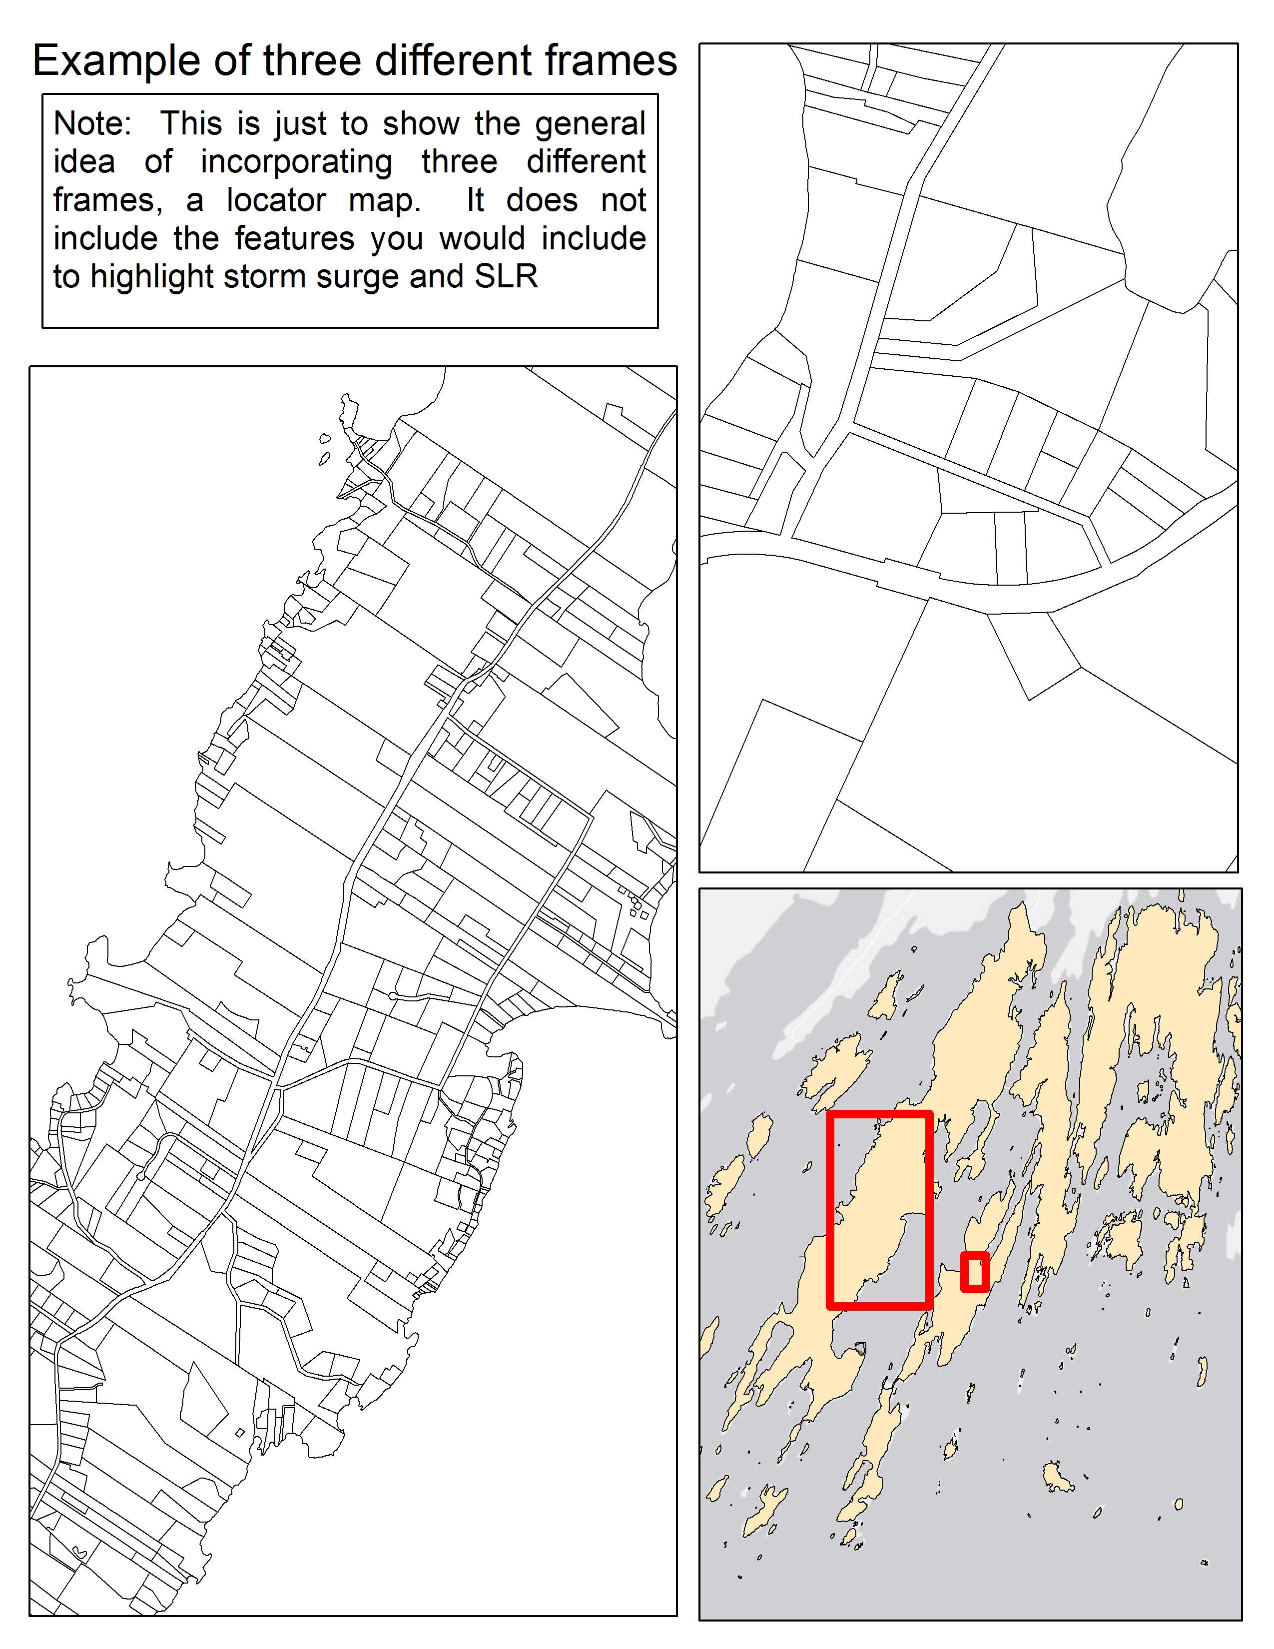
Note this map is very incomplete - but is just intended to illustrate what I am looking for in terms of including the three data frames

DELIVERABLE
- An ArcGIS Projects saved in your folder that includes the following data:
- Each of the features listed above and other features that you have included
- A project that includes three data frames for the main map, locator map and an inset map zoomed into an area
- Labeled roads and waterfront access points
- Symbolize raster by elevation and vector data

- A jpg of your map. Be sure to include all map elements that we talked about in lecture on Tuesday. Post this on blackboard. (Use Export>jpg in the Layout portion of ArcMap to generate this map

- A word document posted on your eportfolio with the following:
- Discuss the approach you took in highlighting the features you included
- Who is your audience for this map and how did this influence the features that you included
- Thinking about the lecture what cartographic techniques did you use to emphasize and communicate potential impacts

The lab will be graded on the following:

- Use of symbolization to indicate sea level rise and storm surge levels
- Use of three data frames
- Selection of features to indicate possible threats (you do not need to select all of the features in the Coastal_Vulnerability geodatabase)
- Use of labeling in your map
- Incorporation of all map elements.
- Communication of a particular theme or threat to focus the attention of your audience (road inundation, marsh impacts, facility impacts)
- Your word document described above.

We will print out maps and spend a portion of next week’s lab evaluating and learning from each other’s maps.
Guide to GIS data
Coastal_Vulnerability
The sea level rise analysis was completed using raster analysis and assigning the elevation values to vector data.

Sea_Level_Rise
-Harp_HAT_SLR
Base data for SLR scenarios (ref HAT)
HAT under each scenario
Scenario HAT Gridcode
current 6.27 1
0.61cm (2ft) 8.27 2
1m (3.28ft) 9.55 3
2m (6.56ft) 12.83 4
Dry (all above) 5
Storm_Surge
-Harp_ss_all
Base data for storm surge scenarios (Gridcode)
No surge 3' surge 4.3' surge
Current 4.59 (1) 7.59 (3) 8.89 (5)
2ft (0.61m) 6.59(2) 9.59 (6) 10.89 (8)
3.28ft (1m) 7.87 (4) 10.87 (7) 12.17 (10)
6.56ft (2m) 1.15 (9) 14.15 (11) 15.45 (12)
Building_and_Population
Buildings affected by sea level rise scenarios 1ft, 2ft, 2m and storm surge 2ft sea level rise with 3 foot storm surge (2ftslr_3ftss) and

Marsh_shift.
These files include existing marsh and areas where marsh are predicted to shift upward due to sea level rise. The feature dataset also includes conservation lands in order to determine which shifts will result in marsh migration towards conserved areas or which need to be identified for future conservation needs. The gridcode refers to low lying marsh areas (below mean high water) and higher marsh areas, those above mean high tide. Gridcode 2 refers to low and 3 refers to high

Piers.
This layer includes water front infrastructure and areas that may be affected by sea level rise or storm surge. Attribute information includes elevation above the SLR and SS scenarios. Negative numbers indicate facilities that will be inundated at the different levels of SLR and SS. For example under the elevsft –any features with a negative number such as Oak Ledge Road would be inundated with 2ft SLR.

Roads.
Includes existing roads and attributes indicate which portions will be inundated at the different SLR and SS scenarios.

LIDAR data:
- LIDAR_first_return- first return lidar showing the elevation of tops of buildings and trees
- LIDAR_bare_earth – interpolated for bare earth – used for Sea Level Rise inundation
- be_hillshade- shows hillshade for bare earth
- fr_hillshade – shows first return hillshade for bare earth

