**Using GPS data to analyze crustal strain**

**or**

**Where *is* the boundary between the Pacific and North American plates?**

**INTRODUCTION**

The theory of plate tectonics is typically described as follows:

*The outermost layers of the Earth (crust and uppermost mantle) make up the rigid lithosphere, which is broken up into a number of 50-300km thick plates. These plates move on top of the plastically deforming asthenosphere (middle mantle). Plate interiors are stable, and tectonic action is concentrated at plate boundaries*.

While this description of plate tectonics works for many purposes, we know that there is significant intra-plate activity and suspect that plate boundaries are not necessarily those infinitesimally thin lines shown on maps.

The San Andreas fault in California is typically assumed to mark the boundary between the Pacific and North American plates. This lab will test this assumption by investigating crustal strain in southern California – which is where we’ll be mucking about during the GEO373 spring break field trip!

Outline of the process:

**Part A:** Analyze by hand GPS time-series data from three stations in southern California, and characterize the crustal strain in the triangular area defined by the three stations.

**Part B:** After paying your dues, we’ll introduce you to Matlab code that does the same thing, and set you loose to characterize crustal strain in the entire area.

**Part C:** Interpret the results – locate and describe the displacement along the boundary between the Pacific and North American plates, and compare your interpretation to other data such as active faults and seismicity

**PART A: Analyzing crustal strain in a triangular area**

GPS data can be acquired from a variety of places, but accessible and easy to use data comes from the EarthScope Plate Boundary Observatory (PBO), which is managed by UNAVCO and freely available online. (UNAVCO is a NASA/NSF-funded consortium of universities and non-profit institutions that conducts and Earth science-related research and education using geodesy.)

1. Go to the interactive PBO map (<http://pbo.unavco.org/network/gps>) and zoom in to southern California. Search for Barstow, CA, to get you in the right vicinity, and then zoom out until you see something like the view on the map provided. The green dots mark stations that are functioning normally. Choose three stations that form an (approximately) equilateral triangle.
2. Clicking on a dot gives you a pop-up box that provides the name and location of the site as well as a clickable link to more information (which you will need) for that station. Click on a station dot, then click on the station name in the pop-up, to get to the information page for that station.
3. At bottom left of the station page is a box titled “GPS Monument Coordinates.” Under the subtitle “SNARF Reference Frame,” the station location is listed on the line that begins “WGS 1984 lat/log/elev (d/d/m).” The first number is the site latitude with positive values indicating north latitude. The second number is the longitude, with negative indicating west longitude. The third number is the elevation in meters relative to the WGS84 geoid – that is, it is not the elevation relative to mean sea level as is indicated on a typical USGS topographic map.

Record the latitude and longitude on your datasheet, with all of the decimal places.

1. To acquire the GPS velocity data for the site, click on the box labeled “Station Position” with the three time-series plots (location vs. time). Clicking on the box causes the window to expand, and show the motion of the station resolved into three components. These positions are measured relative to a reference frame that is computed relative to a set of GPS sites established in the stable interior of North America – Stable North American Reference Frame (SNARF).

* The upper plot shows the north-south component; a positive slope indicates motion toward north, negative to the south.
* The middle plot shows the east-west component, and positive slope indicates motion to the east, negative to the west.
* The lowermost plot shows the vertical component; a positive slope indicates motion up, negative indicates motion down.

You can toggle between the “raw data” view (all data) to a “cleaned” view (free of corrupt, incomplete, and/or inaccurate data) to a “detrended” view (subtracts the long-term linear trend to show residuals and short-term trends) using either the navigation arrows on your keyboard or the small control bar that appears when you hover near the bottom of the plot window. These are frequently updated as new data are collected. From the “cleaned” or “detrended” view, record the three components of GPS velocity (in mm/yr), including their signs and uncertainties.

1. Follow the same procedure and record information for your other two stations.
2. On the attached map of the study area, center a small piece of translucent graph paper at each of your stations, and in pencil, plot the horizontal vectors (2 for each station, 6 total).
3. In red, draw the sum vector with an arrow (1 for each station, 3 total).
4. Now see how your area of the crust has deformed through this strain. Lay a piece of translucent graph paper over your map. Make sure the edges of the pages line up, and N is oriented up. Mark the locations of the three stations and connect these points with a ruler.
5. Define the centroid of the triangle. Do this by lightly drawing three lines in pencil, one from each vertex, that bisect each side of the triangle. The place where they intersect is called the centroid. After marking the centroid, erase the pencil lines you used to locate it.
6. Using this centroid as the origin, draw in an x- and y- axis (these should be oriented N-S and E-W).
7. On a second piece of translucent graph paper, go through the same process with the endpoints but draw dashed lines connecting the vertices of the deformed triangle.
8. Lay the station point map (step 8) over the endpoint map so that your centroids and axes line up perfectly. Transfer the endpoints of deformed triangle onto the starting point map, and connect them with dashed lines to show the deformed triangle. (By this process you are removing the translation component of the deformation.)
9. Draw arrows from the station locations to the vertices on the deformed triangle. How would you describe the type of deformation? Is there any rotation? Does it appear to be pure shear or simple shear? Describe in a sentence or two on your graph paper what you see.
10. Now you will actually calculate the deformation that you have graphically depicted. To do this, you’ll be use either the Excel or Matlab version of a strain calculator developed by a UNAVCO development team (both available on Blackboard). After inputting the latitude, longitude, and GPS velocity components for each station, the strain calculator spits out a comprehensive strain analysis. Later on, we will consider the math in more detail, but for right now we’re using the strain calculators as “black boxes.” Run the strain calculator for your stations and record the specified strain values on your datasheet
11. In the center of the triangle on your graph paper, plot the two calculated strain axes and sketch the strain ellipse. Use the azimuth to properly orient them. Don’t worry about the absolute length of these lines; show how they differ in length relatively.
12. Sketch your strain ellipse on the provided map. Share your results with the rest of the class.

**PART B: Analyzing crustal strain in southern California, using the Matlab strain calculator**

1. Ok, you’ve paid your dues – now let’s have Matlab do the grunt work.

Make a map of the area with numerous strain ellipses by downloading and unzipping the file with Matlab code, and opening Matlab. Use File/Set Path/Add Folder to allow Matlab to find where you have stored the files AND the m.map folder (you’ll probably have do this twice). Get help from lab personnel if you have trouble. Then run the code as below to plot numerous strain ellipses on your map:

*Make a baseman:*

**>>load GPS_data**

**>>makemap(GPS_data)**

*and then run:*

**>>[coord d sigs] = pickstations(GPS_data);**

*allows you to click and pick triads of stations*

**>>[ellipse, m, msigs, prin] = calcstrain(coord, d, sigs);**

*plots the strain ellipse for that triad*

*If you need it:*

**>>delete(ellipse)**

*deletes the last ellipse you plotted*

Save your map, and print out a copy for submission with your report.

**PART C: INTERPRETATION –** a few well-written sentences/short paragraph for each. Illustrate your points by referring to (and annotating as appropriate) your strain ellipse map, Google Earth views, and other figures and information referred to below.

1. Describe the strain in this area of California. What is happening to the crust – in what directions is it strained, how much is it strained, and how is the strain distributed?
2. On your map, place a line that best describes the location of the Pacific/North American plate boundary. Then, especially if you were uncomfortable using a single line, lightly shade in a “plate boundary zone.” How would you describe the location/width of the plate boundary - where is the western edge of the North American plate?
3. How valid is the 1st order plate tectonic assumption of stable plate interiors separated by narrow plate boundaries that accommodate all of the relative motion between plates?
4. The boundary between the Pacific and North American plates is traditionally drawn along the San Andreas fault.
   1. What does the GPS data indicate about the sense of motion across it: normal, reverse, right-lateral strike-slip, left-lateral strike slip, or some combination?
   2. Is the strain data consistent with motion across the plate boundary being entirely accommodated by motion along the San Andreas fault?
5. How consistent is the GPS data with:

* Historic, Holocene and late Quaternary faulting in this area (see attached figure, also available in the Google Earth kmz file
* Recent seismicity in the area (see Google Earth kmz file)
* Focal mechanisms. See attached image from Kagan et. al., 2006 (also available as an image overlay in the Google Earth kmz file) and attached document which explains those beachballs)

1. GPS data gives you an *instantaneous, near real-time* assessment of plate motions. *Long-term average* motions can be derived from models based on geologic data such as hot spot tracks and mid-ocean ridge spreading rates. Each of these models defines some finite number of plates, assumes that plate interiors to not deform and assumes that motion is accommodated along very narrow plate boundaries (GPS doesn’t know anything about plate tectonics).

According to one of these models (GSRM v1.2), the Pacific plate is moving 49 mm/yr at an azimuth of 323 degrees relative to North America ([UNAVCO Plate Motion Calculator](http://www.unavco.org/community_science/science-support/crustal_motion/dxdt/model.html) using GSRM v1.2 model velocities and fixed North America, for a point on the Pacific plate located at 35.5°N latitude and -115.5° longitude).

How does this *long-term average* motion across the boundary compare to theGPS-derived *near real-time* motion?

**PART A DATA SHEET**

Date on which the data were acquired from the PBO website: _________________________

Geographic coordinates, WGS 1984 datum, Stable N. American Reference Frame

**Site Latitude (decimal degrees) Longitude (decimal degrees)**

_____ ______________________ _______________________

_____ ______________________ _______________________

_____ ______________________ _______________________

GPS site velocities relative to SNARF, in mm/year

**Site N Velocity ± Uncert E Velocity ± Uncert Height Velocity ± Uncert**

_____ ___________ ______ ___________ ______ ___________ ______

_____ ___________ ______ ___________ ______ ___________ ______

_____ ___________ ______ ___________ ______ ___________ ______

Deformation data from strain calculator (Excel or Matlab)

**Azimuth Speed**

Translation vector ________ ___________

**Degrees/yr Direction**

Rotation _________ ___________

**Magnitude (nano-strain) Azimuth**

Max horizontal (e1) ________ __________

Min horizontal (e2) ________ __________



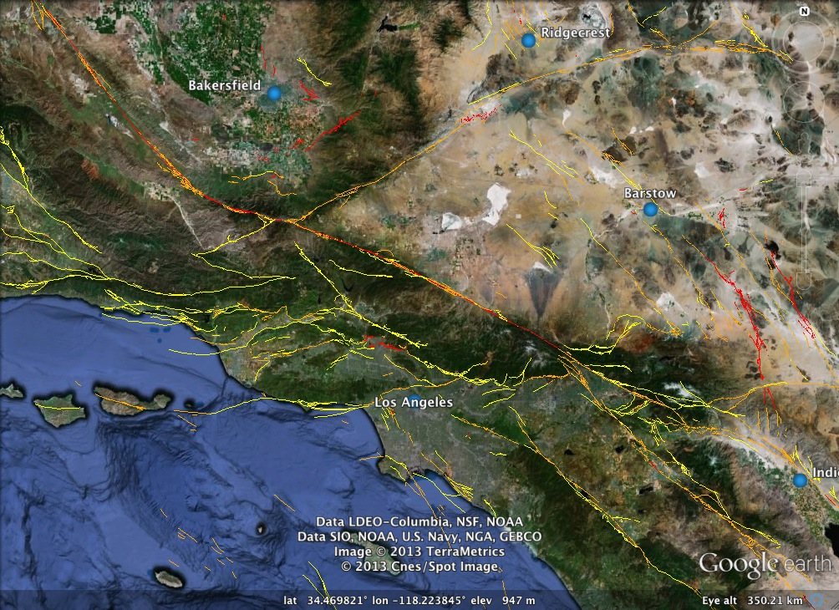

Macintosh HD:Users:laurelgoodell:Desktop:GEO373 Lab 1:Lab docs:A New Catalog of Southern California Earthquakes, 1800-2005.pdf